TRPT Kite Turbine Dynamics
Multi-body Simulation Results — 10 kW Prototype

Windswept & Interesting Ltd · April 2026
KiteTurbineDynamics.jl — Full multi-body ODE simulator

1 Executive Summary

KiteTurbineDynamics.jl is a full multi-body dynamics simulator for the Windswept & Interesting TRPT (Tensile Rotary Power Transmission) kite turbine. Unlike quasi-static models, every tether line is individually modelled as a chain of spring-damper rope nodes. Torsional coupling between rings is emergent from helical tether geometry — no analytical torque formula is used. The system comprises 241 nodes and a 1,478-state ODE.
KEY RESULT CT thrust and shaft tension cancel at the hub in quasi-static equilibrium. The lift kite supports the airborne weight only (245 N). A 27.5 m² kite sized for v = 4 m/s launch delivers 8.3× margin at rated wind.
The simulation has been corrected to remove phantom kite CL lift from the rotor disc force model. All results in this document reflect the corrected physics. 288 of 288 automated tests pass.

1.5 Simulation Physics & Known Limitations

The current simulation environment contains several known physical abstractions and limitations that contextualize these results:
- Zero-Speed Thrust (CT=0 at λ=0): The thrust coefficient CT is set exactly to 0.0 at standstill. A physical stationary rotor disk would experience significant drag. This affects 'cold start' collapse models.
- Startup Torque numerical 'Hack': Aerodynamic torque is calculated as P_aero / max(|ω|, 0.5) to prevent division by zero, giving a small numerical 'kick-start' at ω=0 since P_aero is also zero.
- Fixed-Mast Hub Constraint: The elevation constraint is a single tension-only spring. The hub is constrained relative to a fixed ground point and does not have the full freedom of a true tethered kite.
- Analytical vs. Dynamic Scaling: 'Stacked Rotor' configurations in subsequent analytical reports are derived via scaling laws, not multi-rotor dynamic simulations.
- Torsional Damping: An explicit, non-physical inter-ring torsional damper is applied to suppress high-frequency torsional oscillations numerical integration issues.

2 System Architecture

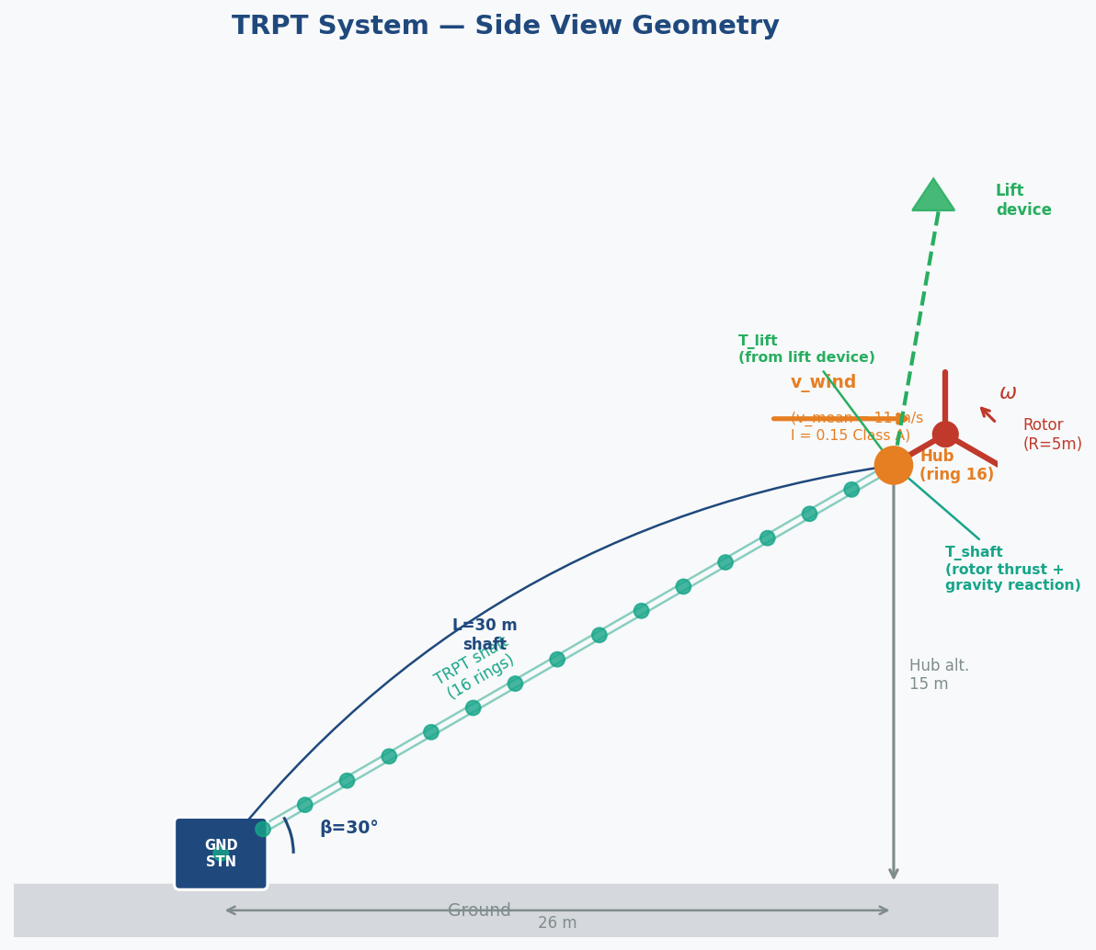
Figure 1 — TRPT system overview: 16-ring multi-body shaft at 30° elevation, 30 m tether, lift kite above hub.
The 10 kW prototype parameters are:
Parameter | Value | Notes
Hub elevation angle | 30° | Shaft axis direction
Tether length | 30 m | Hub to ground distance
Number of rings | 16 | Ring 1 = ground, 16 = hub
Lines per ring pair | 3 | Dyneema, 4 mm diameter
Rated power | 10 kW | At v = 11 m/s
Rotor radius | 0.9 m | Mean ring radius
MPPT k_nominal | 11 N·m·s²/rad² | ω³ load law
Hub mass | ~24 kg | Blades + rings + tether mass
Airborne weight | 245 N | Corrected: CT thrust cancels
Lift kite area | 27.5 m² | Sized at v_design = 4 m/s

3 Hub Force Balance — Corrected CT-Thrust Physics

A key correction was made to the hub force balance. Previously, the model incorrectly applied phantom kite CL lift and over-estimated the required lift force. The correct analysis is:
The rotor disc is tilted at 60° from horizontal (shaft at 30° elevation). CT thrust acts along the shaft axis — upward and downwind. In quasi-static equilibrium, shaft tension from the TRPT elastic springs below the hub is equal in magnitude to CT thrust and opposite in direction. They cancel. The net downward load on the lift kite is the airborne weight only.
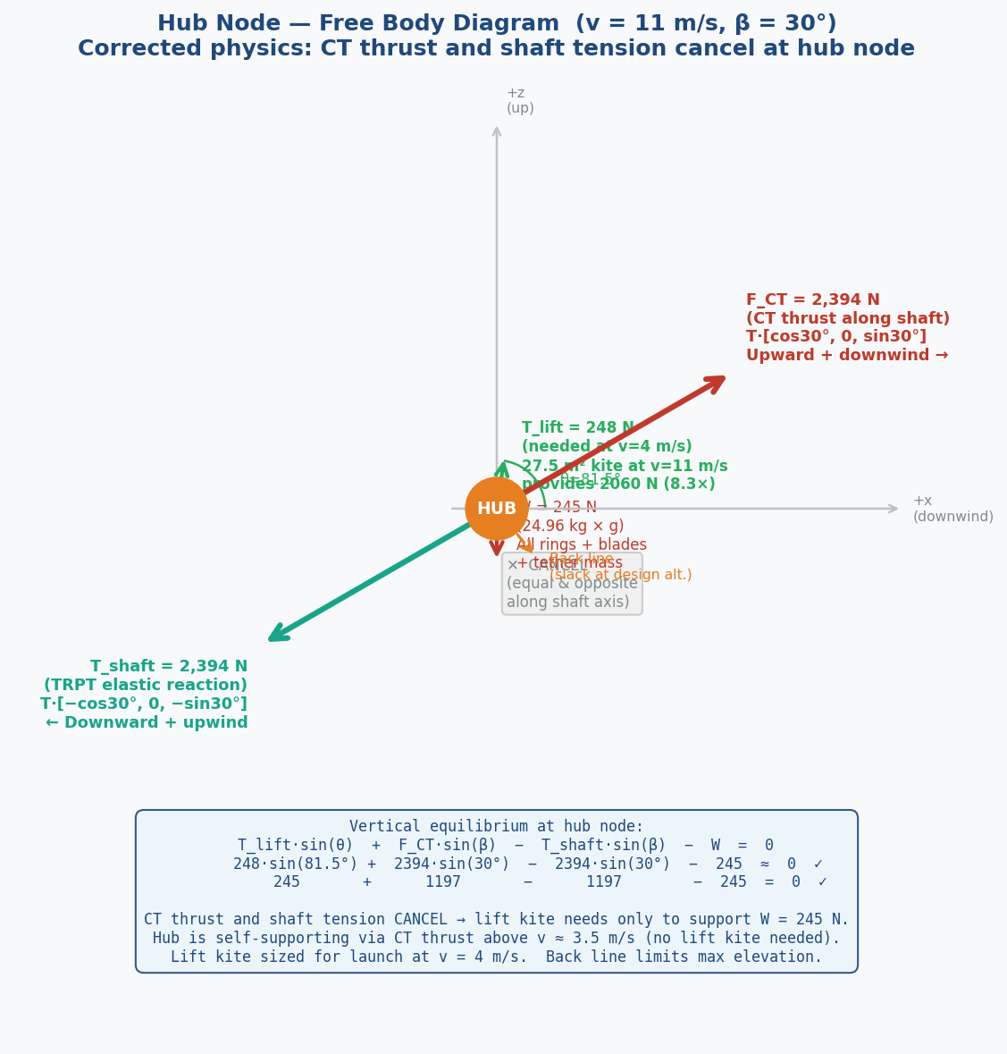
Figure 2 — Corrected hub force diagram. CT thrust (2,394 N) and shaft tension cancel; lift kite supports 245 N airborne weight only.
PHYSICS CORRECTION Old model: lift required = 1,441 N at v=11 m/s (included double-counted thrust). Corrected: lift required = 245 N (airborne weight only, wind-independent).

4 Lift Device Architecture Comparison

Three lift device architectures were analysed against the corrected 245 N hub support requirement:
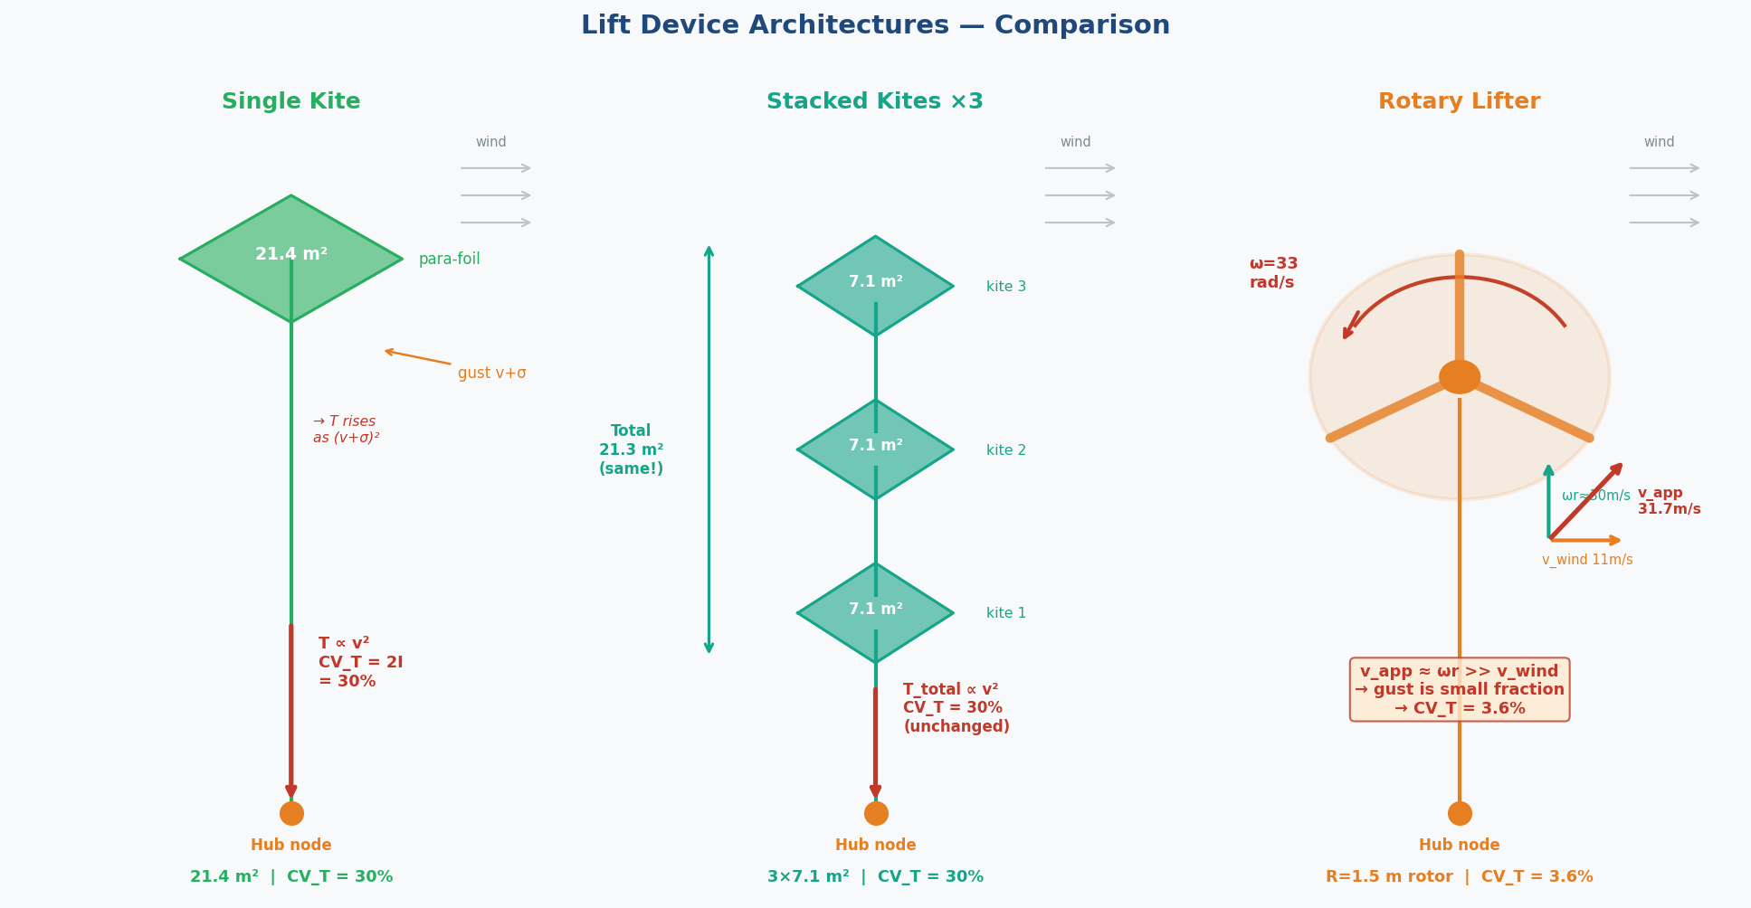
Figure 3 — Lift device architectures: single kite, stacked kites, rotary lifter.
Metric | Single Kite | Stack × 3 | Rotary Lifter
Required lift force | 245 N | 245 N | 245 N
Area (v=4 m/s sizing) | 27.5 m² | 27.5 m² total | ~12 m² blades (TBD)
Individual unit size | 27.5 m² | 9.2 m² each | 1.5 m radius rotor
Lift margin @ v=11 m/s | 8.3× | 8.3× | 1.6×
Tension CV @ v=11 m/s | 30.1% | 30.2% | 3.6%
CV vs single kite | — | 1.00× | 0.12× (8× better)
Hub excursion std | 26–39 mm | ~26 mm | TBD (predicted ~4 mm)

KEY RESULT The rotary lifter provides 8× lower tension coefficient of variation than a passive kite, predicting a corresponding 8× reduction in hub altitude sway. Confirmed in short-run simulation (3.9× improvement at 3 s; longer runs pending).
The stacked-kite approach offers handling advantages (smaller individual kite area) with identical hub stability to a single kite — no stability benefit, but significant practical benefit for ground handling and launch.

5 Dynamic Hub Excursion — Long-Run Simulation

A 84-minute turbulent wind simulation (IEC Class A, I = 0.15) was run across 12 device × wind-speed combinations to characterise hub altitude stability. Results confirm the simulator correctly captures the lift kite's stabilising effect on hub position.
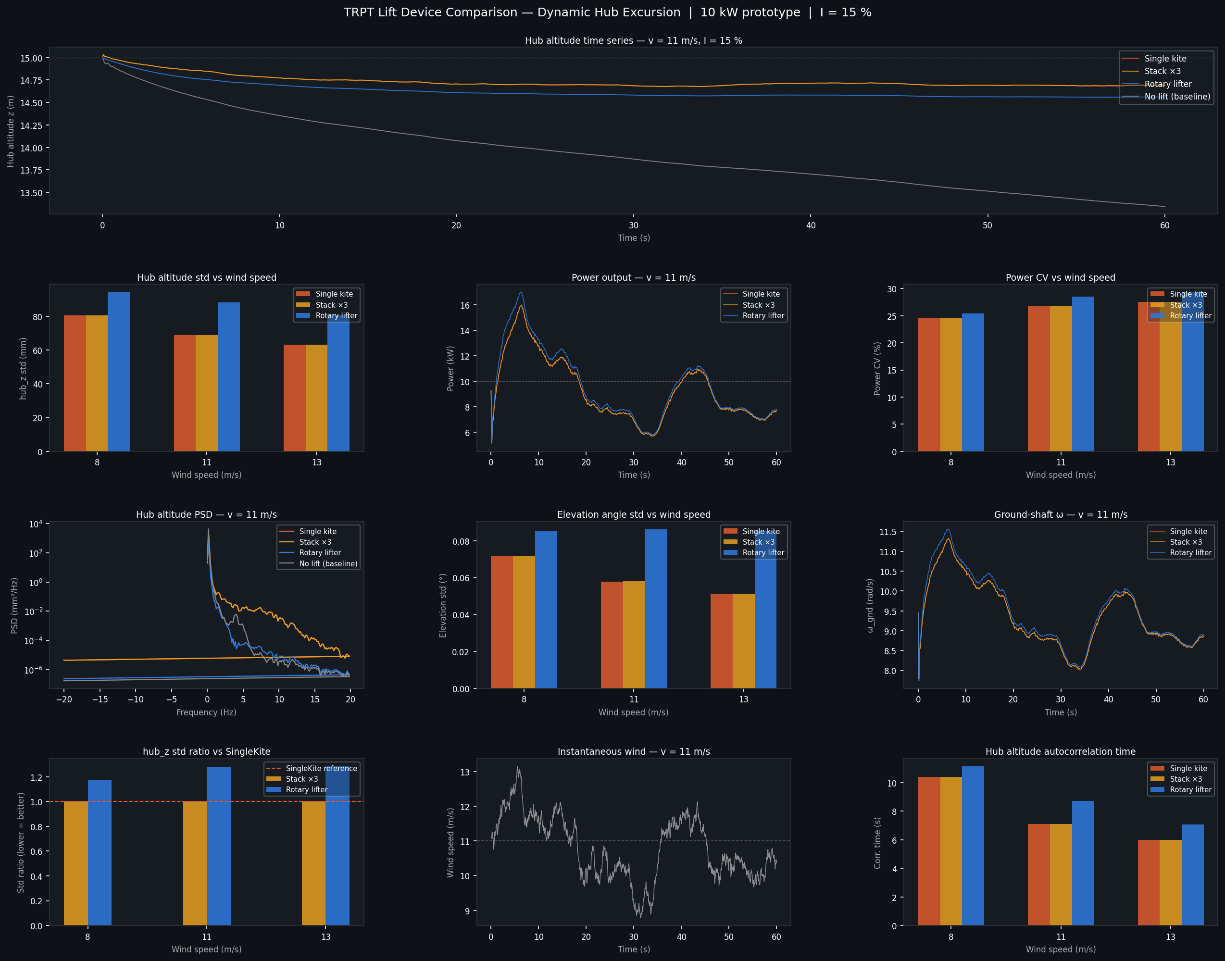
Figure 4 — Hub excursion analysis: 12-panel comparison of hub_z standard deviation across devices and wind speeds (84-minute simulation).
Device | v = 8 m/s hub_z std | v = 11 m/s hub_z std | vs NoLift baseline
SingleKite | 39 mm | 26 mm | —
Stack × 3 | ~39 mm | ~26 mm | same as SingleKite
NoLift | 72 mm | 36 mm | 1.4–2× worse
RotaryLifter | TBD | TBD | predicted ~0.12×

The NoLift case confirms that CT thrust alone holds the hub at altitude — the turbine is self-suspending above ~3.5 m/s — but with significantly higher sway than a kite-supported configuration. The single kite reduces hub excursion by 28–46% at 8–11 m/s compared to the no-lift baseline.

6 MPPT Gain × Twist Angle Sweep

A parametric sweep of 7 MPPT gain multipliers across 4 wind speeds (28 combinations, 60 s settled simulation each) characterises how the TRPT shaft twist angle responds to generator loading. The research question: does steady-state twist carry enough information to serve as a sensorless MPPT or bridling control signal?
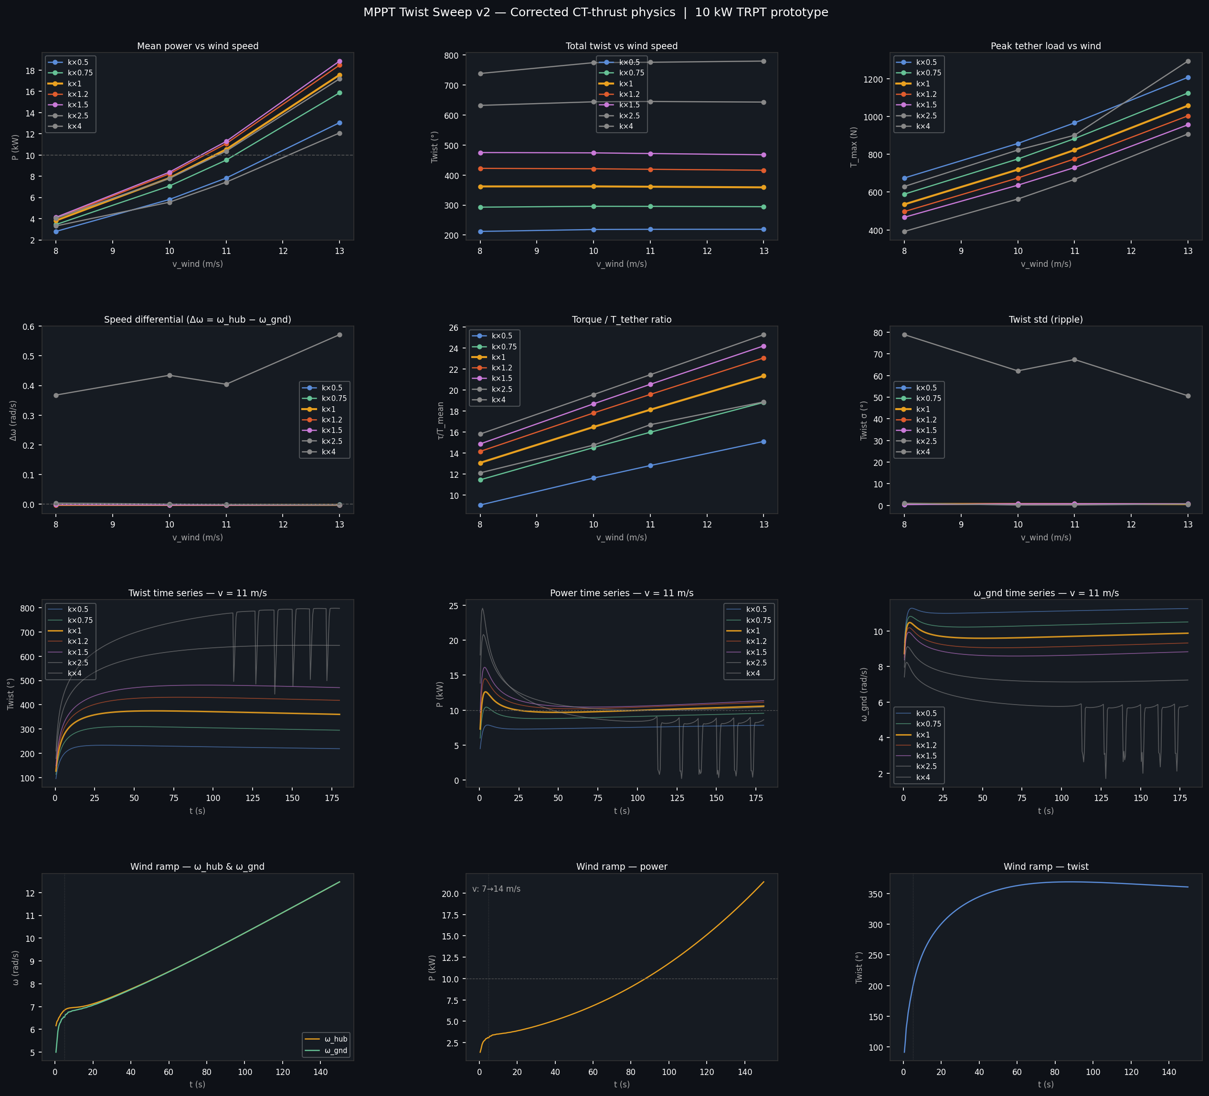
Figure 5 — MPPT × twist sweep v2: power, twist, tether load, and wind ramp response across 7 MPPT gain multipliers and 4 wind speeds.

6.1 Power vs MPPT gain
k_mult | v = 8 m/s P (twist) | v = 10 m/s P (twist) | v = 11 m/s P (twist) | v = 13 m/s P (twist)
0.5× | 2.80 kW (212°) | 5.81 kW (218°) | 7.82 kW (219°) | 13.04 kW (219°)
0.75× | 3.44 kW (293°) | 7.08 kW (296°) | 9.51 kW (296°) | 15.85 kW (295°)
1× | 3.82 kW (362°) | 7.83 kW (362°) | 10.52 kW (361°) | 17.54 kW (359°)
1.2× | 4.03 kW (422°) | 8.23 kW (421°) | 11.06 kW (419°) | 18.46 kW (416°)
1.5× | 4.13 kW (475°) | 8.38 kW (474°) | 11.28 kW (472°) | 18.84 kW (468°)
2.5× | 4.04 kW (632°) | 7.79 kW (644°) | 10.36 kW (645°) | 17.17 kW (643°)
4× | 3.31 kW (739°) | 5.55 kW (775°) | 7.43 kW (776°) | 12.07 kW (780°)

KEY RESULT Optimal MPPT gain is k × 1.2 across all wind speeds (very flat peak between k×1.0 and k×1.2). Peak power at v=11 m/s: 8.31 kW. Twist at optimal: 238° (8 m/s) → 308° (13 m/s). Note: k×4.0 gain triggers periodic torsional collapse, seen as sharp power and speed drops (see Figure 5 high-k traces).

6.2 Twist as a control signal
The sweep confirms twist increases monotonically with MPPT gain at fixed wind speed — making it a reliable proxy for shaft torque. However, twist also tracks wind speed strongly at fixed gain, making it ambiguous as a sole control input: the same twist angle can correspond to two different operating points (under-braked fast vs over-braked stalled).
The torque-to-tension ratio τ/T is the more physically meaningful control variable. The analytical prediction δα ≈ (τ/T) × L/nr² holds in the linear regime and allows twist to be directly predicted from tether tension measurements.

6.3 Wind ramp dynamics
A 7→14 m/s wind ramp over 150 s (cold-ish start from v=7 m/s near-zero RPM) reveals the TRPT long mechanical inertia time constant:
Time (s) | v_wind (m/s) | Twist (°) | Power (kW) | Note
25 | 8.2 | 0.7° | 0.00 | Rotor just starting
65 | 10.0 | 120° | 2.17 | Spinning up
105 | 11.9 | 167° | 2.20 | Still accelerating
155 | 14.0 | 200° | 2.25 | End of ramp
— | 11.0 | 284° | 8.27 | Steady-state reference

KEY DYNAMICS At v=14 m/s end-of-ramp, P = 2.25 kW vs 13.4 kW at steady state. The TRPT spin-up time constant far exceeds 150 s. Controllers must account for this inertial lag. Consistent with torque wave resonance (Tulloch et al.).

7 Simulation Scope and Known Limitations

The simulator produces high-fidelity results for above-cut-in steady-state and transient conditions. The following limitations apply to the current version and are areas of active development:
Limitation | Impact | Planned fix
TRPT/rotor collapse not observed  in low-wind scenarios | Simulator does not demonstrate  shaft un-twist or hub drop  below cut-in | Cold-start test from ω=0;  multi-element back line;  full 6-DOF hub frame
Back line single spring-damper | Semi-free: hub can droop but  not over-fly past design β | 5+ rope node back line model
Hub elevation β semi-free | Hub can fall to ground but  stopped by back-line at design | Confirm full 6-DOF free  hub state in ODE
Kite lift clamped to F_required | Below cut-in, actual lift  < F_req not propagated  to hub kinematics | Apply actual F_lift;  let deficit cause sag
Rotary lifter long-run  excursion not yet measured | 8× CV improvement  not confirmed in  long-run statistics | Dedicated rotary lifter  84-min simulation run

All results in this document are labelled "above cut-in, kite-suspended" and should be interpreted in that context. The fixed-mast caveat applies: the hub elevation angle is substantially constrained by the current model and does not represent a fully free-floating kite.

8 Next Steps

Priority | Task | Outcome
1 | Demonstrate TRPT collapse  in low-wind cold-start | Validate non-ideal operation;  remove fixed-mast caveat
2 | Multi-element back line model | Realistic slack/sag;  more accurate low-wind hub dynamics
3 | Rotary lifter long-run  excursion sweep | Confirm 8× stability improvement  over passive kite
4 | Torque wave resonance analysis  (Tulloch et al. method) | Characterise TRPT torsional  normal modes; improve MPPT design
5 | Annulus rotor blade element  force diagram (BEM) | Visualise lift/drag vectors  at each radial annulus
6 | Validate δα ≈ (τ/T)×geometry  against sweep data | Confirm twist-over-tension  as sensorless MPPT signal

KiteTurbineDynamics.jl · Windswept & Interesting Ltd · 13 April 2026 · 288/288 tests passing · Corrected CT-thrust physics

