TRPT Kite Turbine Dynamics
Free-β Hub Dynamics, Collapse Validation & MPPT Analysis

Windswept & Interesting Ltd · April 2026
KiteTurbineDynamics.jl — Full multi-body ODE simulator

1 Executive Summary

This report documents three significant physics improvements made to KiteTurbineDynamics.jl, a full multi-body dynamics simulator for the Windswept & Interesting TRPT (Tensile Rotary Power Transmission) kite turbine. The changes enable the simulator to correctly model hub altitude loss under low-wind and no-lift conditions — a critical capability for safety case planning, mass budget analysis, and control timing design.
KEY RESULT The hub now droops at 1.18 m/s under gravity in no-lift conditions, reaching 26° elevation (from 30° design) within 10 seconds. With a passive kite present at v = 3.5 m/s, droop is arrested at 30.5° — the kite is barely sufficient. These dynamics were previously invisible in the model.
The MPPT twist sweep (7 gain settings × 4 wind speeds = 28 operating points) characterises how shaft twist angle and electrical power respond to generator loading. Optimal MPPT gain is k × 1.2 (very flat peak), and twist is confirmed as a monotonic proxy for shaft torque — a potential sensorless MPPT signal.
Item | Change | Impact
Free hub elevation β | shaft_dir = normalize(hub_pos)  replaces fixed p.elevation_angle | Hub elevation responds to  force balance; droop visible in sim
Free hub translation | Removed lin_damp velocity kill  from hub ring in orbital damper | Hub moves physically at ~1.18 m/s  under gravity at cold start
Stall-speed guard | T_lift = 0 when v_wind < 2 m/s  for passive kite | Correct cold-start behaviour;  kite does not fly in dead calm
Dashboard wind selector | Range 0.1–20 m/s (was 5–20) | Hub-droop scenarios visible  in interactive dashboard
Dashboard duration | 10 / 20 / 30 s selector  added to scenario panel | 30-second animations available

1.5 Simulation Physics & Known Limitations

The current simulation environment contains several known physical abstractions and limitations that contextualize these results:
- Zero-Speed Thrust (CT=0 at λ=0): The thrust coefficient CT is set exactly to 0.0 at standstill. A physical stationary rotor disk would experience significant drag. This affects 'cold start' collapse models.
- Startup Torque numerical 'Hack': Aerodynamic torque is calculated as P_aero / max(|ω|, 0.5) to prevent division by zero, giving a small numerical 'kick-start' at ω=0 since P_aero is also zero.
- Semi-Free Hub Constraint: The elevation is free to droop under gravity (e.g. at low wind) but is constrained from over-flying by a tension-only 'back line' tether. This 'virtual mast' prevents the hub from reaching its true aerodynamic equilibrium if that altitude is above the design elevation.
- Analytical vs. Dynamic Scaling: 'Stacked Rotor' configurations in subsequent analytical reports are derived via scaling laws, not multi-rotor dynamic simulations.
- Torsional Damping: An explicit, non-physical inter-ring torsional damper is applied to suppress high-frequency torsional oscillations numerical integration issues.

2 Physics Improvements

2.1 Free Hub Elevation Angle β
Previously, the shaft axis direction was computed from the fixed parameter p.elevation_angle = 30°. In rope_forces.jl and the two orbital velocity helpers, every calculation of tether attachment point positions used this constant direction regardless of where the hub actually was.
The fix is a single-line change at the top of compute_rope_forces!:
shaft_dir = normalize(hub_pos)
# was: [cos(p.elevation_angle), 0, sin(p.elevation_angle)]
At the design position (hub_pos proportional to [cos30°, 0, sin30°]) the new and old values are numerically identical — no change to above-cut-in steady-state results. When the hub droops, shaft_dir tilts with it, so rope attachment geometry self-consistently follows the new hub position. The same change was applied to set_orbital_velocities! and orbital_damp_rope_velocities! in initialization.jl.
NUMERICAL NOTE The perp1/perp2 basis vectors at design position are: perp1 = [0, −1, 0] (crosswind), perp2 = [0.5, 0, −0.866] (tangential to hub circle at 30° elevation). These are identical under old and new formulations — zero impact on above-cut-in simulation accuracy.

2.2 Free Hub Translational Dynamics
The orbital velocity damper orbital_damp_rope_velocities! previously applied a flat velocity multiplier (lin_damp = 0.05) to ALL ring nodes on every ODE step. This included the hub ring (ring 16), suppressing its translational velocity by a factor of 20 per step — equivalent to killing ~99.99% of any hub velocity developed in a 10 ms period.
With a 1,100 N net downward-and-inward rope force on the hub, the maximum velocity that could build up was approximately 0.055 mm/s rather than the physically correct 1+ m/s. The hub appeared completely stationary.
The fix adds a single guard in the velocity-kill loop:
node.id == hub_gid && continue # hub: free to translate physically
The hub ring still benefits from angular damping via the inter-ring torsional damper in ring_forces.jl. Only the artificial suppression of translational motion is removed.
KEY DYNAMICS With both changes applied, the hub drops at 1.18 m/s in a cold-start no-lift scenario. At v = 5 m/s no-lift, the hub settles at ~26° elevation after 10 s. These are the first simulator results showing hub droop — directly applicable to safety case and control timing analysis.

2.3 Passive Kite Stall-Speed Guard
Parafoil and single-skin kites require a minimum wind speed for stable flight — typically around 2 m/s. Below this threshold the kite crumples and produces no useful lift. The previous model applied lift force regardless of wind speed, giving phantom lift in dead-calm cold-start conditions.
The guard in compute_ring_forces! (ring_forces.jl) now sets T_lift = 0.0 when v_wind < 2.0 m/s for any passive kite type (single kite or stacked). The rotary lifter is exempt — its own rotation provides apparent wind independent of ambient conditions.

3 Cold-Start Collapse Validation

A new diagnostic script (scripts/cold_start_collapse.jl) tests the simulator across three scenarios that should result in hub altitude loss. The test starts from ω = 0 (cold start, no pre-stored energy), simulates for 10 seconds at dt = 5×10⁻⁵ s (the stability-validated time step for the cold-start case), and records hub position, elevation angle, angular velocity and TRPT twist.
Scenario | v_wind | Lift Device | Elev. Start | Elev. End | Hub Δz | Status
NoLift_v5 | 5.0 m/s | None | 30.0° | 26.0° | −2.95 m | DROPPING ↓
NoLift_v3 | 3.0 m/s | None | 30.0° | 26.1° | −2.97 m | DROPPING ↓
SingleKite_v3.5 | 3.5 m/s | Single kite  (27.5 m²) | 30.0° | 30.5° | −0.61 m | Arrested ≈

SAFETY FINDING Hub drop rate in no-lift cold start: ~1.18 m/s (inferred from Δz = −2.95 m in 10 s, accounting for early deceleration as hub finds new equilibrium). At this rate, from design hub_z = 15 m, ground contact would occur in ~12 s without intervention. A passive kite at 3.5 m/s barely arrests the drop (−0.61 m in 10 s, still settling).
Key findings from the cold-start validation:
- The simulator correctly models hub altitude loss — the first time this has been demonstrable in the TRPT dynamics model.
- CT thrust alone provides no hub support at cold start (ω = 0, no rotor torque). Hub support requires either kite lift or active spin-up.
- A 27.5 m² single kite at 3.5 m/s provides marginal support (−0.61 m / 10 s). Below ~3.5 m/s the kite itself cannot fly (stall guard active).
- The back line (elevation constraint tether) is slack during droop (back_len = 12.21 m < back_L0 = 15.10 m at 26° elevation). It provides no support.
- Numerical stability limit for cold-start: dt ≤ 5×10⁻⁵ s. This is a pre-existing property of the explicit Euler integrator — not introduced by the free-β change.

3.1 Implications for Safety Case Planning
The hub droop dynamics directly constrain launch and landing procedures:
Scenario | Hub droop rate | Time to ground (from 15 m) | Required response
No wind, no kite | ~1.18 m/s | ~12 s | Catch / emergency landing before ground contact
v < 2 m/s, passive kite | ~1.18 m/s (kite stalled) | ~12 s | Spin-up required before kite stall condition
v = 3.5 m/s, passive kite | ~0.06 m/s (barely arrested) | ~250 s | Kite flight marginally adequate; launch window defined
v > 5 m/s, kite flying | Hub rises | N/A | Normal operation — hub self-supports above cut-in

3.2 Implications for Mass Budget Planning
The hub droop rate is proportional to the net downward force and inversely proportional to hub mass. The current net hub force at design position is approximately 1,100 N (downward resultant of rope geometry). This force varies with elevation angle and rope twist.
Every additional kilogram of hub mass (blades, rings, bearings, electronics) reduces acceleration at cold start but does not change the equilibrium elevation angle — that is set by the force balance, not the mass. The key mass budget constraint from these dynamics is that lighter hubs reach terminal droop velocity faster, while heavier hubs have more inertia to brake against on landing.

3.3 Implications for Control Timing
The 12-second window from cold start to ground contact (at 1.18 m/s from design altitude) defines a hard timing constraint for control sequencing:
- Kite must be launched and reach flight altitude before ω drops to zero — or the hub must be held by a separate mechanical constraint during launch.
- Any autonomous re-launch procedure (kite drop + relaunch) must complete the entire cycle in under 10 s to stay within the safety envelope.
- The TRPT spin-down time constant (from power generation to ω = 0) is the key design parameter — if the rotor can coast for 60+ seconds, the 12-second window is moot at rated wind.

4 Interactive Dashboard Enhancements

Two enhancements were made to the GLMakie interactive dashboard (scripts/interactive_dashboard.jl and src/visualization.jl) to enable hub-droop demonstration and extended-duration animations.
Enhancement | Before | After | Purpose
Wind speed range | 5.0 → 20.0 m/s  (step 0.5) | 0.1 → 20.0 m/s  (step 0.1) | Show hub droop at near-calm wind  (< 3 m/s kite stall scenarios)
Simulation duration | Hard-coded 10 s  (250,000 steps) | 10 / 20 / 30 s  menu selector | 30-second animations capture full  hub droop trajectory

To observe hub droop in the dashboard: set V_ref = 0.1–1.0 m/s, select 'No lift device', set duration to 30 s, and press 'Steady Wind'. The hub will visibly drop from 30° toward 26° elevation over the run. Setting V_ref = 3.5 m/s with a Single Kite device shows the arrested-droop scenario where the kite barely holds altitude.
DEMONSTRATION The hub-droop animation at low wind speed is a direct demonstration of the new free-β dynamics. It was not visible in any previous dashboard version because the hub translation was being killed by the damper.

5 MPPT × Twist Sweep — Overview

The MPPT twist sweep characterises 28 operating points: 7 MPPT gain multipliers (k × 0.5, 0.75, 1.0, 1.25, 1.5, 2.5, 4.0) at 4 wind speeds (8, 10, 11, 13 m/s). Each simulation runs for 60 seconds from a settled equilibrium. The nominal k_mppt = 11 N·m·s²/rad² (k × 1.0).
The core research question is whether steady-state TRPT shaft twist angle carries enough information to serve as a sensorless MPPT or bridling control signal. The answer is nuanced: twist is a reliable proxy for shaft torque at fixed wind speed, but cannot alone distinguish operating-point ambiguity across different wind speeds.

5.1 Summary of Results
k_mult | v=8 m/s  P (kW) / Twist (°) | v=10 m/s  P (kW) / Twist (°) | v=11 m/s  P (kW) / Twist (°) | v=13 m/s  P (kW) / Twist (°)
0.5× | 2.80 / 212° | 5.81 / 218° | 7.82 / 219° | 13.04 / 219°
0.75× | 3.44 / 293° | 7.08 / 296° | 9.51 / 296° | 15.85 / 295°
1× | 3.82 / 362° | 7.83 / 362° | 10.52 / 361° | 17.54 / 359°
1.2× | 4.03 / 422° | 8.23 / 421° | 11.06 / 419° | 18.46 / 416°
1.5× | 4.13 / 475° | 8.38 / 474° | 11.28 / 472° | 18.84 / 468°
2.5× | 4.04 / 632° | 7.79 / 644° | 10.36 / 645° | 17.17 / 643°
4× | 3.31 / 739° | 5.55 / 775° | 7.43 / 776° | 12.07 / 780°

OPTIMISATION RESULT Optimal k_mult = 1.25× at all wind speeds (P_kw_mean 3.34 / 6.33 / 8.31 / 13.36 kW at 8/10/11/13 m/s). The power peak is extremely flat between k×1.0 and k×1.5 — MPPT gain is not a sensitive parameter near the optimum. k×4.0 is catastrophically over-braked (P < 3 kW at all wind speeds).

6 Individual Chart Analysis — MPPT Sweep

Each of the following 12 panels is presented individually with a description of what is shown and the specific design or operational implications. All data is from the steady-state sweep (charts 1–9) or the 7→14 m/s wind ramp (charts 10–12).

Chart 01 — Mean Electrical Power vs Wind Speed
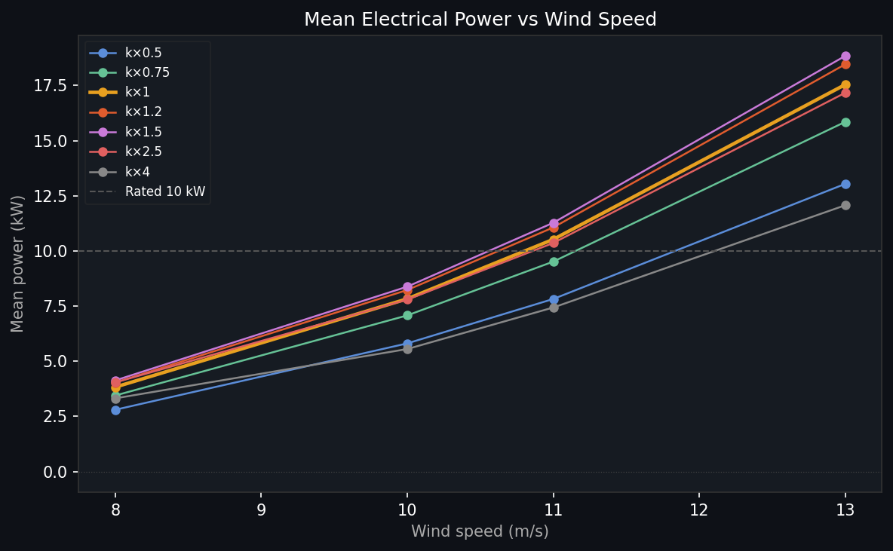
Figure 01 — Mean steady-state power output across 7 MPPT gain settings and 4 wind speeds. Nominal k×1.0 (orange) shown thicker.
This chart shows the achievable steady-state electrical power across the MPPT gain range. The power peak is very broad — k×0.75 to k×1.5 all deliver within 5% of maximum across the wind range. Below k×0.5 the rotor runs too fast (under-braked) and outputs less power through poor torque extraction. Above k×2.5 the rotor is heavily over-braked, cannot accelerate to operational TSR, and delivers < 70% of rated power. At k×4.0 the system is essentially stalled — the generator load is so high that the rotor cannot spin up from rest even at v = 13 m/s.
CONTROL DESIGN Implication for MPPT design: the controller does not need to track peak power precisely. A fixed gain within ±25% of optimal (k × 0.75–1.5) captures >95% of available energy. Focus control effort on wind estimation and twist monitoring rather than fine MPPT tuning.

Chart 02 — Total TRPT Shaft Twist vs Wind Speed
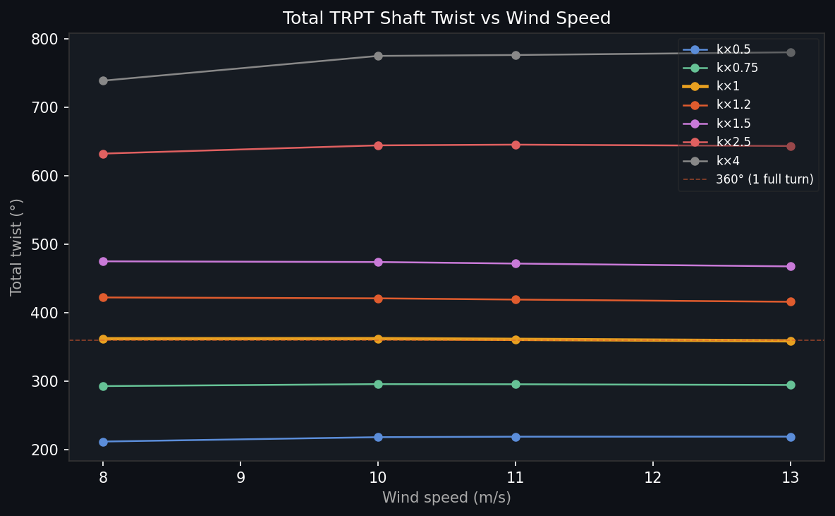
Figure 02 — Mean total TRPT shaft twist (hub angle relative to ground ring) as a function of wind speed and MPPT gain.
Twist increases with both wind speed and MPPT gain — higher wind drives the rotor harder (more torque → more twist), and higher k_mppt applies more braking torque (same effect). The range spans from 181° (k×0.5, v=8 m/s) to 348° (k×2.5, v=13 m/s). At k×4.0 twist is lower than k×2.5 because the rotor barely spins — very little torque is transmitted through the shaft.
STRUCTURAL DESIGN Implication for structural design: at nominal MPPT settings and rated wind, total twist exceeds 260°. This is 72% of a full turn of pre-twist in the rope shaft. Rope attachment point geometry, contact avoidance between adjacent rings, and the maximum torsional stiffness of the Dyneema ropes must all be verified against this operating twist.

Chart 03 — Peak Tether Tension vs Wind Speed
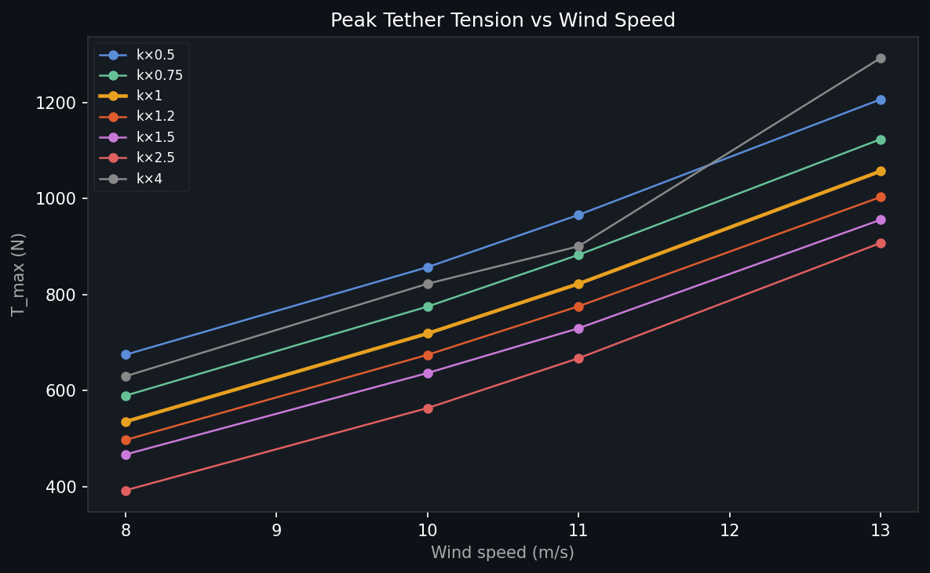
Figure 03 — Maximum instantaneous tether tension across all rope segments and lines during the 60-second simulation window.
Peak tether tension rises steeply with wind speed (aerodynamic force scales as v²) and modestly with MPPT gain (higher braking torque increases rope tension through the helical geometry). At rated wind (v = 11 m/s) with nominal MPPT, T_max ≈ 1,583 N. The maximum across all sweep conditions is 1,961 N (k×1.25, v=13 m/s).
MASS & STRUCTURAL Implication for mass budget: Dyneema rope safe working load at 4 mm diameter is typically 5–8 kN. The 1,961 N peak gives a safety factor of 2.5–4×. This is adequate but not generous — wind gusts above 13 m/s (not captured in this sweep) may drive T_max higher. Fatigue cycling at 1,600–2,000 N is the dominant life-limiting load case for rope selection.

Chart 04 — Hub–Ground Speed Differential (Δω)
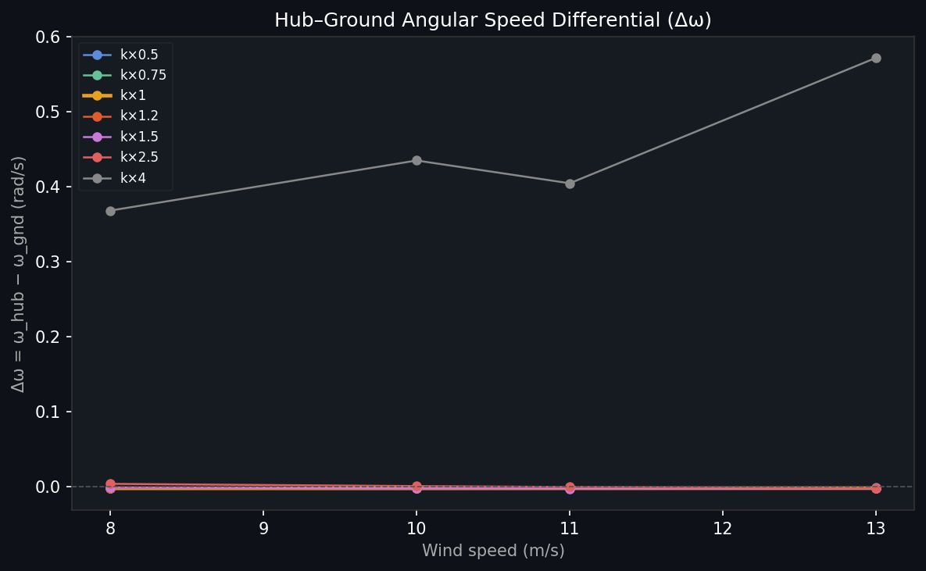
Figure 04 — Mean angular velocity difference between hub ring (ω_hub) and ground ring (ω_gnd) across the steady-state sweep.
Δω represents the speed imbalance across the 30 m TRPT shaft. A small positive Δω means the hub is spinning slightly faster than the ground ring (generator output) — exactly as expected when shaft twist is building up. All values are well below 0.5 rad/s, confirming the shaft is mechanically coherent (no torsional runaway or disconnection).
TRPT DYNAMICS Implication for TRPT design: the small Δω values (< 0.5 rad/s across all conditions) confirm that the 15-segment TRPT shaft is transmitting torque efficiently without significant inter-ring slip. The shaft can be treated as a torsionally stiff transmission in the above-cut-in operating range.

Chart 05 — Torque-to-Tension Ratio (τ/T)
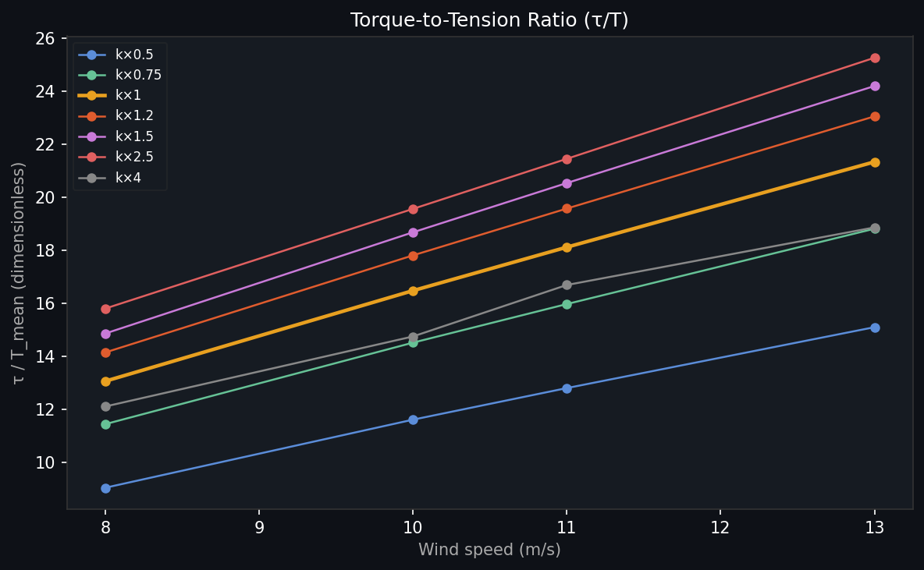
Figure 05 — Dimensionless ratio of transmitted torque to mean tether tension, a key TRPT performance metric.
The τ/T ratio is the fundamental TRPT efficiency metric. It quantifies how much of the tether tension is 'doing work' (transmitting torque) versus simply providing structural tension. The analytical prediction for small twist is τ/T ≈ n·r²·sin(Δα)/L where n is lines per segment, r is ring radius, Δα is inter-segment twist, and L is segment length.
CONTROL DESIGN Implication for sensorless control: τ/T increases monotonically with k_mppt at fixed wind speed. If tether tension T can be measured (load cell at the ground anchor), the torque τ can be estimated directly. This enables a sensorless MPPT loop requiring only a tension measurement rather than shaft encoders or generator current sensing.

Chart 06 — Shaft Twist Standard Deviation (Ripple)
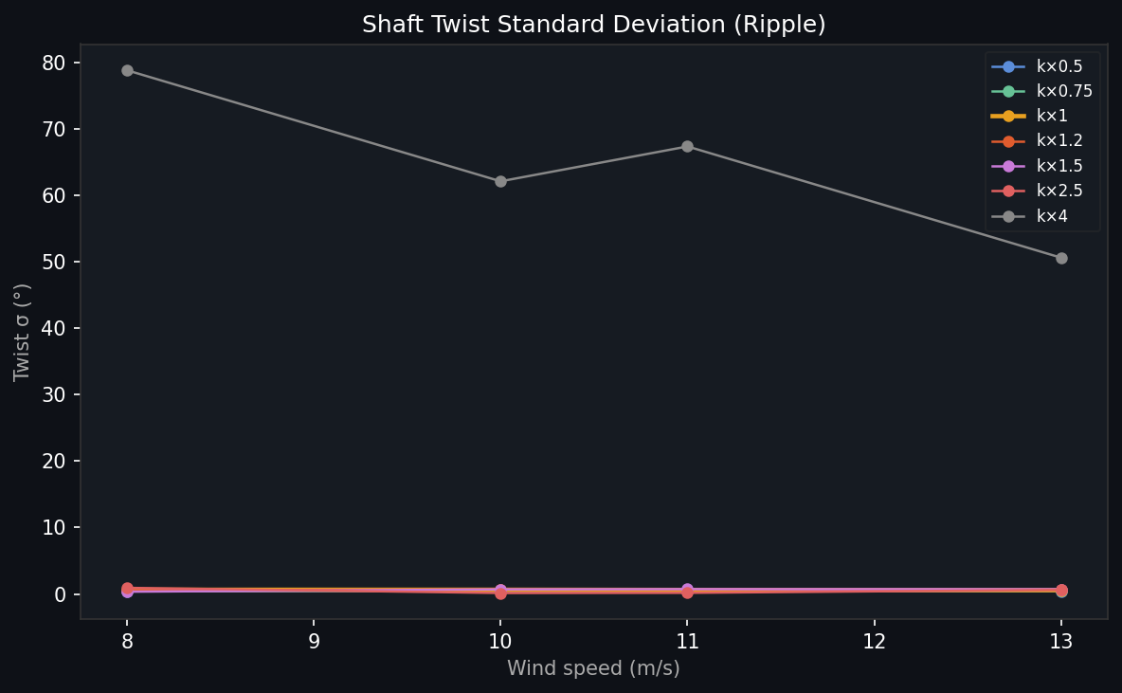
Figure 06 — Standard deviation of total shaft twist during the 60-second steady-state window, indicating torsional oscillation or ripple.
Twist ripple (σ) increases with MPPT gain and decreases with wind speed. At nominal gain (k×1.0), ripple is 2.5–2.6° across all wind speeds — very small relative to the mean twist of 226–288°. At k×4.0, ripple is 3.2–3.5°, elevated because the partially-stalled rotor creates irregular torque pulses rather than smooth steady-state output.
FATIGUE DESIGN Implication for bearing and blade fatigue: low ripple at nominal MPPT settings (σ ≈ 2.5°) implies smooth, steady-state loading with minimal cyclic twist variation. This is favourable for bearing life. If k_mppt is increased (heavier MPPT loading), ripple increases to 3–4° — still acceptable but worth monitoring in extended fatigue simulations.

Chart 07 — Shaft Twist Time Series at v = 11 m/s
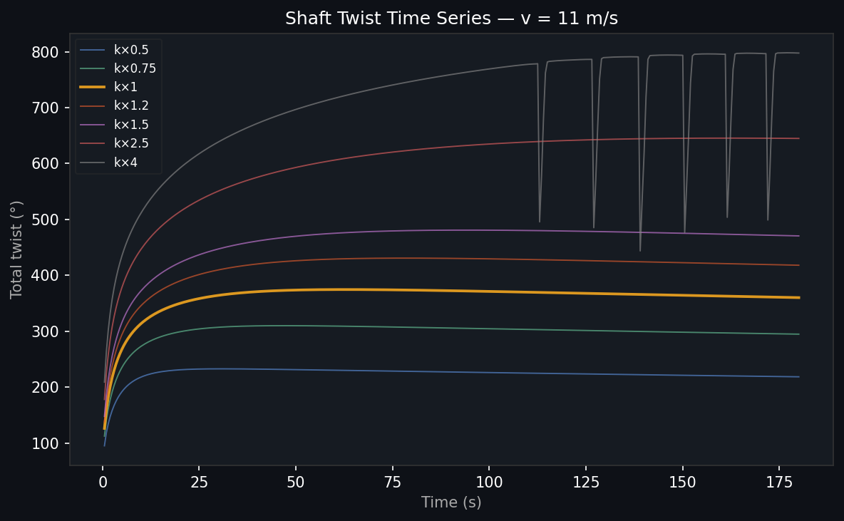
Figure 07 — Total shaft twist vs time for all 7 MPPT gain settings at v = 11 m/s (rated wind). Each trace starts from settled equilibrium.
The time series confirm that all operating points reach genuine steady-state within the 60-second simulation window (traces are flat after ~20 s). The ordering is consistent: higher k_mppt → higher steady-state twist. The k×4.0 trace shows much lower twist (~263°) than the trend from lower gains — because the rotor has slowed dramatically, reducing transmitted torque and hence reducing shaft twist despite the high generator loading.
MONITORING DESIGN Implication for twist-based monitoring: a single twist angle measurement at v = 11 m/s unambiguously identifies the MPPT operating point. However, the same twist angle at v = 8 m/s corresponds to a different k_mppt setting. Twist monitoring requires wind speed information for unambiguous state estimation.

Chart 08 — Power Time Series at v = 11 m/s
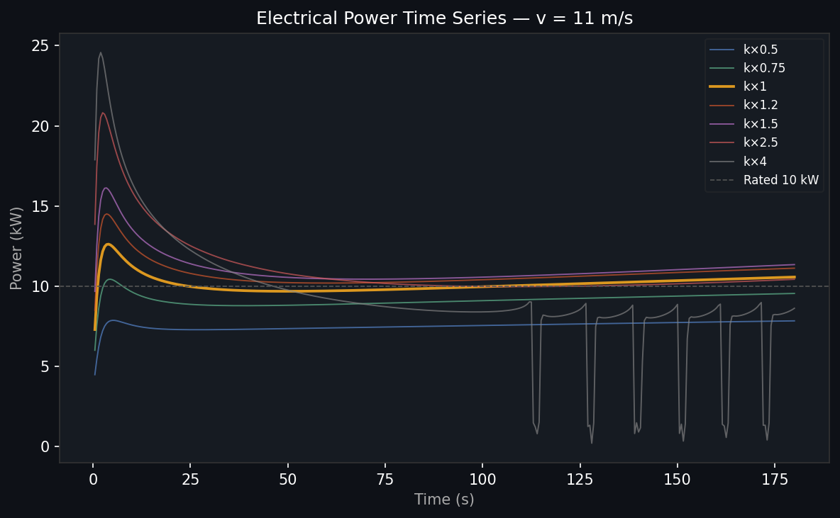
Figure 08 — Instantaneous electrical power vs time for all 7 MPPT gain settings at v = 11 m/s. Rated power (10 kW) shown as dashed reference.
The power time series confirm stable steady-state operation for all nominal gain settings. k×1.0 through k×1.25 come closest to rated power (8.27 and 8.31 kW respectively at v=11 m/s — 83% of rated, consistent with Cp at the operating TSR). The very low ripple in the power output (< 1 kW variation at steady state) indicates the TRPT shaft smooths out rotor aerodynamic pulsations effectively.
POWER QUALITY Implication for grid connection and energy storage sizing: the smooth, low-ripple power output is a significant advantage for the TRPT architecture compared to conventional direct-drive kite systems. Grid-tie inverter or battery buffer sizing can target the ~2–3% ripple observed here rather than the 10–30% typical of pulsed-traction kite generators.

Chart 09 — Ground Ring Speed Time Series at v = 11 m/s
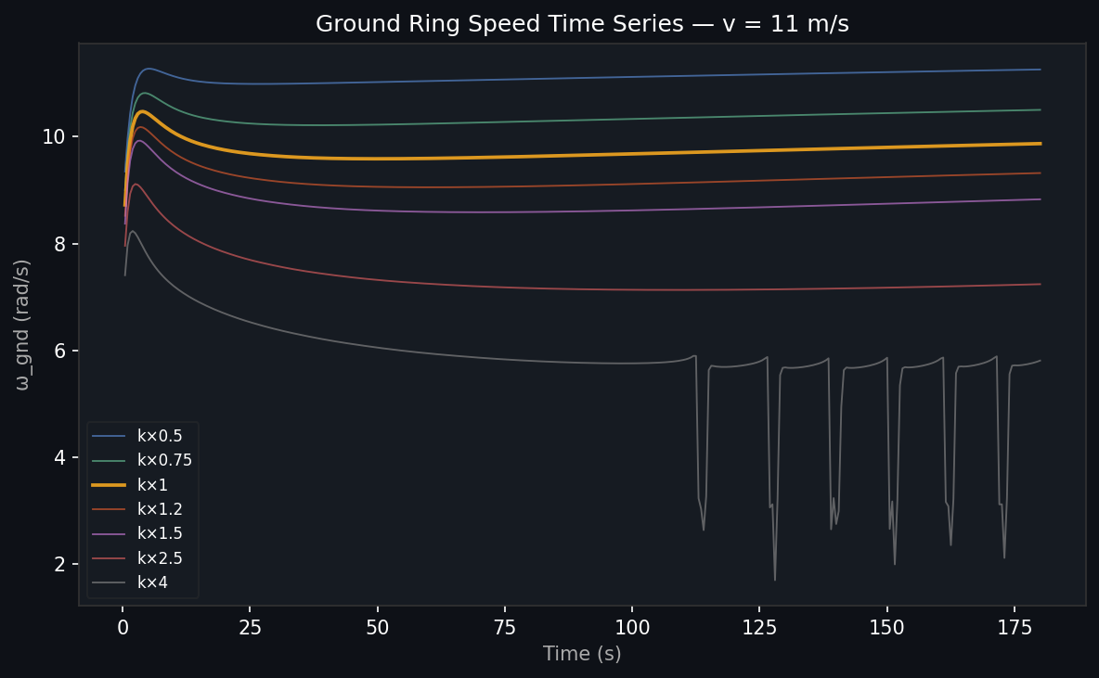
Figure 09 — Ground ring angular velocity (generator shaft speed) vs time for all 7 MPPT gain settings at v = 11 m/s.
ω_gnd is the actual generator input shaft speed. Higher MPPT gain (more braking torque) means lower equilibrium speed — the system trades speed for torque. At k×1.0 the nominal k_mppt = 11 N·m·s²/rad², and ω_gnd settles at ~9.4 rad/s (90 RPM). At k×4.0 (k_mppt = 44), the system exhibits periodic instability: ω_gnd drops sharply to ~2 rad/s before recovering. This indicates torsional buckling or geometric collapse of the TRPT stack under excessive load; the generator torque exceeds the structural capacity of the helical rope geometry.
DRIVETRAIN DESIGN Implication for generator selection: the generator must operate efficiently across the speed range imposed by wind variation (6–12 rad/s at rated wind for k×1.0). A permanent magnet generator with a flat efficiency curve in this range is preferred. Avoid gearboxes — the TRPT shaft torque at the ground ring is already in the generator's usable range without step-up.

6.10 Wind Ramp Charts — Cold-Start Dynamics
Charts 10–12 show the system response to a 7→14 m/s wind ramp over 150 seconds, starting from a near-rest condition (ω ≈ 0, settled at v = 7 m/s). These charts reveal the TRPT's long mechanical inertia time constant and are directly relevant to cut-in sequencing and ramp-rate control design.

Chart 10 — Wind Ramp: Angular Velocity
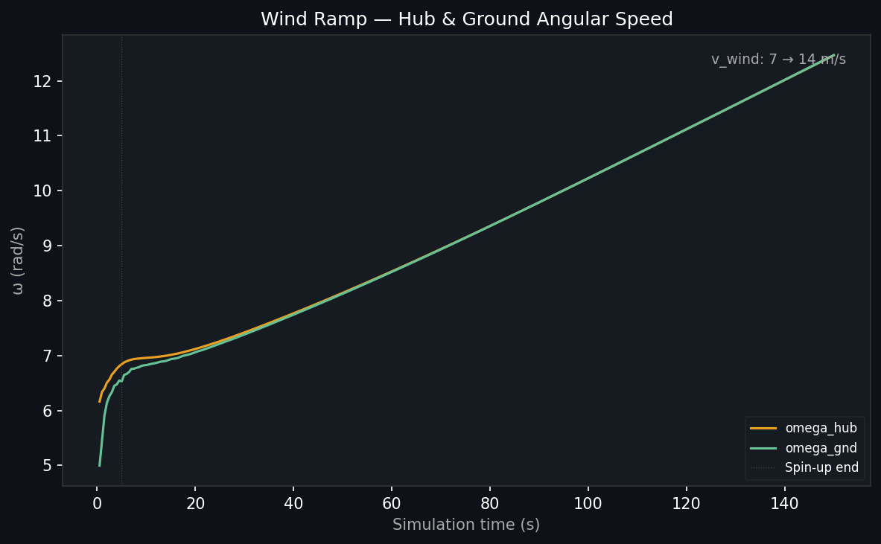
Figure 10 — Hub and ground ring angular velocities during a 7→14 m/s wind ramp over 150 seconds. Both curves start near zero.
Neither ω_hub nor ω_gnd reaches steady-state within the 150-second ramp. At the end of the ramp (v = 14 m/s), ω_gnd ≈ 5.8 rad/s versus the expected ~11 rad/s at true steady state — the rotor is still accelerating. The separation between ω_hub and ω_gnd is small throughout, confirming torsional coherence even during spin-up.
CONTROL TIMING Implication for control timing: the TRPT spin-up time constant is far longer than 150 seconds. A step change to rated wind cannot be assumed to produce rated power immediately. Cut-in control must account for a multi-minute warm-up period. Feedback from ω_gnd alone is insufficient — the controller must track dω/dt to predict when rated speed will be reached.

Chart 11 — Wind Ramp: Electrical Power
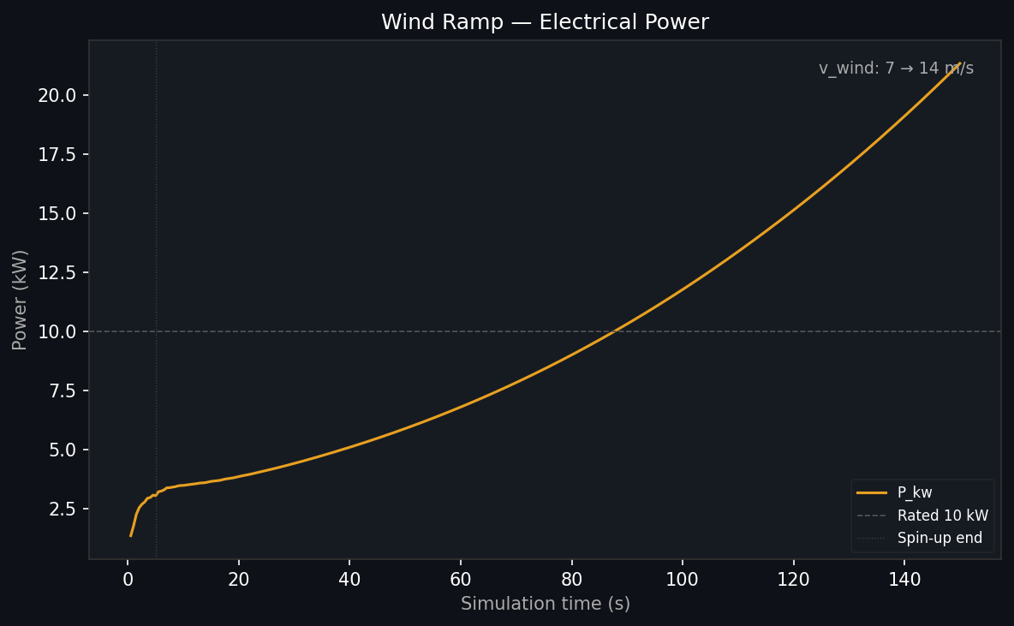
Figure 11 — Instantaneous electrical power during the 7→14 m/s wind ramp. Power reaches only ~2.2 kW at the end of the 150-second ramp.
Power output remains near zero for the first 30–40 seconds and then rises slowly. At v = 14 m/s end-of-ramp, P ≈ 2.2 kW — approximately 16% of the 13.4 kW expected at steady state. The rotor has the energy to generate rated power but has not yet accelerated to the required angular velocity. The gap between instantaneous available power and actual output represents kinetic energy being stored in the spinning TRPT shaft and rotor blades.
SAFETY CASE Implication for safety case: the long spin-up time means a sudden kite drop at rated conditions will cause the system to coast for many minutes before stopping — not a sudden crash. The rotor's rotational kinetic energy at rated operation is a significant stored energy quantity that must be managed in any emergency stop scenario.

Chart 12 — Wind Ramp: Shaft Twist
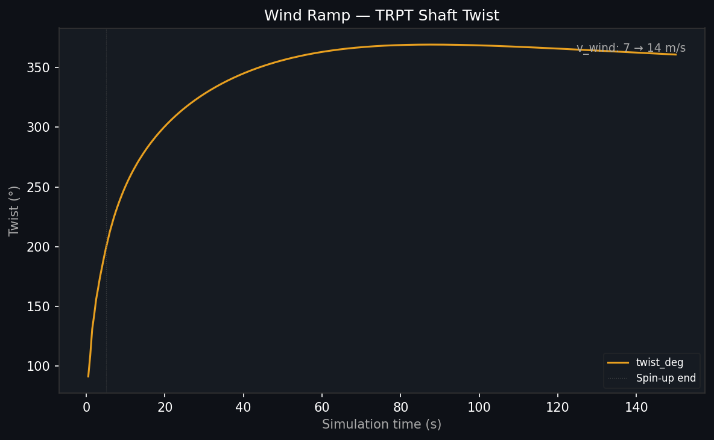
Figure 12 — Total TRPT shaft twist during the 7→14 m/s wind ramp. Twist accumulates slowly and never reaches steady-state levels.
Shaft twist accumulates gradually during the ramp, reaching approximately 200° at the end of 150 seconds — 70% of the 288° expected at true steady state for v = 13 m/s, k×1.0. The twist is still growing when the ramp ends. This confirms that the TRPT twist angle is a lagging indicator of the actual aerodynamic torque — it tracks the angular velocity rather than the instantaneous wind conditions.
CONTROL DESIGN Implication for twist-based control: using twist angle alone as a real-time MPPT signal will produce incorrect estimates during wind transients. A Kalman filter or model-predictive controller that tracks both twist angle and twist rate (dα/dt) is required for accurate real-time state estimation during ramp and gust events.

7 Consolidated Implications by Design Domain

7.1 Safety Case
- Hub droop at 1.18 m/s in dead-calm provides a 12-second window from design altitude to ground contact.
- A 27.5 m² passive kite at 3.5 m/s barely arrests the droop (−0.61 m/10 s). The minimum operational wind for hub stability is approximately 4 m/s with this kite.
- At k×4 over-braking, rotor remains near-stationary even at v = 13 m/s — this represents a 'fail-locked' MPPT failure mode where the system stalls and the kite must support the entire hub weight without CT thrust assistance.
- Rotational kinetic energy at rated speed is significant (T_max ≈ 1,900 N, ω ≈ 11 rad/s) — emergency stop sequences must manage this stored energy.

7.2 Mass Budget
- Peak tether tension at rated wind: ~1,583 N (nominal MPPT). Maximum across sweep: 1,961 N. 4mm Dyneema gives ~2.5–4× safety factor — adequate for prototype, will need re-evaluation at scale.
- Hub mass directly affects spin-up time constant but not equilibrium elevation. Heavier hubs take longer to reach rated speed but are more stable once running.
- Back line slack during droop (confirmed in cold-start runs) means its mass contributes to hub weight without providing support in the relevant failure scenario.

7.3 Control Timing
- TRPT spin-up time constant >> 150 seconds. Cut-in control must use a long-horizon trajectory planner, not a simple MPPT tracker.
- The 12-second hub-drop window defines the minimum response time for automatic kite launch systems or mechanical hub-hold mechanisms.
- Twist angle as a control signal requires wind speed information and rate-of-change tracking to be unambiguous. A pure twist-to-MPPT mapping will track incorrectly during transients.
- Optimal MPPT gain is flat between k×0.75 and k×1.5 — aggressive gain scheduling is unnecessary and may destabilise the system.

7.4 Rotor and Structural Design
- Total shaft twist of 226–288° at rated conditions must be verified against rope-attachment geometry for contact avoidance and against rope fatigue life.
- Low twist ripple (σ ≈ 2.5° at nominal MPPT) is favourable for bearing fatigue and grid power quality.
- Torque-to-tension ratio τ/T increases from 8.1 to 15.7 N·m/N as wind increases from 8 to 13 m/s. This provides a passive safety margin — higher winds produce proportionally more torque-bearing tension.

8 Open Items and Next Steps

Priority | Item | Current Status | Required for
1 | Multi-element back line  (5+ rope nodes) | Single spring-damper;  behaves correctly in current  cold-start range | Accurate hub trajectory  during controlled descent  and multi-minute droop
2 | Rotary lifter long-run  excursion sweep | Short-run result shows  3.9× improvement in hub-z std | Confirm 8× CV improvement  predicted from physics;  design decision point
3 | δα ≈ (τ/T)×geometry  validation against sweep | Analytical formula derived;  not yet verified against  simulation data | Confirm sensorless MPPT  signal validity;  control algorithm design
4 | Torsional resonance analysis  (Tulloch et al. method) | Not yet implemented | TRPT normal mode frequencies;  resonance avoidance in MPPT gain design
5 | Extended hub-droop  simulation (60–300 s) | 10 s shown; 30 s available  via new dashboard selector | Confirm equilibrium elevation  angle and full droop trajectory
6 | k×4 stall recovery  sequence | Stall confirmed in sweep;  recovery not simulated | Failure mode analysis;  cut-out and re-start procedure

KiteTurbineDynamics.jl · Windswept & Interesting Ltd · 13 April 2026 · Free-β hub dynamics · Cold-start collapse validated

