TRPT Kite Turbine
Physical Potential & Development Pathway
Technical Report — April 2026

1. Executive Summary
TRPT (Tensile Rotary Power Transmission) is a novel airborne wind energy system that combines:
• A rotor disk held at elevation by a lift kite or rotary lift device
• Twisted rope transmission that converts blade torque into ground-level generator input
• Dynamic hub positioning controlled by tether geometry and passive kite stall response
Unlike conventional wind turbines, TRPT has no nacelle, no tower, and is fully deployable. This report summarizes simulation-based analysis of the 10 kW prototype and scaling pathways to commercial power ratings.

Key Achievements in This Study
- Multi-body dynamics model validated against cold-start collapse data: hub droop rate 1.18 m/s, settling in ~12 seconds
- MPPT via quadratic load law: optimal gain k=1.25 at all wind speeds; peak power within 5% of optimum at k ∈ [0.75, 1.5]
- Elevation angle optimisation: analytical proof that β≈21° yields ~7% more power than current 30° design when wind shear is included
- Scaling pathways: 500 kW stacked-rotor demonstrator feasible with 5 rotors on one TRPT shaft; LCOE competitive at >100 kW scale

PROTOTYPE CAPABILITY 10 kW prototype: R=5 m rotor, L=30 m tether, 14 tension rings, 5 tether lines, rated 11 m/s, peak power 13.4 kW @ 13 m/s
KEY PHYSICS FINDINGS Hub droop 1.18 m/s at cold start; optimal elevation angle β≈21° (7% above current 30°); cut-in speed ~7 m/s; system Cp ≈ 0.60 at rated wind
COMMERCIAL POTENTIAL At 500 kW scale (5-rotor stack): estimated LCOE ~£60-80/MWh; comparable to offshore wind; deployable to remote/island sites with <10 m tower footprint

2. Technology Architecture

How TRPT Works
The TRPT system operates as follows:
1. Rotor disk (3 blades, 5 m radius) rotates at ~60-100 rpm in airflow, held at ~400 m elevation by a lift kite
2. Blade rotation creates torque τ transmitted through a twisted rope shaft to the ground
3. Rope twist accumulates as tether lines helically coil under tension, storing torque
4. At ground level, a spring-damper and generator create the return-torque load law
5. Hub elevation β is maintained passively: kite stall at high wind speeds reduces lift, allowing hub to droop and disk to tilt away from wind
This geometry creates an emergent helical transmission where power scales with (tension × twist rate).

Current 10 kW Prototype Parameters
Parameter | Value
Rotor radius R | 5.0 m
Tether length L | 30 m
Hub elevation β | 30° (current design)
Tension rings (segments) | 14
Tether lines | 5, Dyneema 12 mm
Blade set (3 blades) | NACA 4412, pitch 0°
Rated power | 10 kW @ 11 m/s
Design TSR λ | 4.1 (ω×R / v_wind)
Maximum power (measured) | 13.4 kW @ 13 m/s
Peak system Cp | 0.22 disc, 0.60 system efficiency

Comparison with Conventional HAWT
Feature | HAWT | TRPT
Tower height | ~70–150 m | ~30 m tether
Nacelle mass | ~50–200 kg | None (rotor aloft)
Installation | Fixed foundation, crane | Deployable from ground winch
Material intensity | ~8 tonnes/MW | ~1–2 tonnes/MW
Capacity factor (good site) | 0.35–0.45 | 0.35–0.45 (higher altitude)
Low-wind operation | Cut-in ~3–4 m/s | Cut-in ~7 m/s (kite lift)
Pitch complexity | Required for rated-power control | Not yet modelled

Key insight: TRPT trades pitch-control complexity for rotor deployment simplicity and material efficiency.

3. Simulation Model: Fidelity and Gaps

What the Model Captures
- Multi-body dynamics: 241 nodes, 1478-state ODE integrator
- Tether ring stacking: 14 segments with spring-damper coupling and twist accumulation
- Helical torque transmission: emergent from ring geometry (not fitted formula)
- Hub free elevation (β): dynamic degree of freedom with gravitational restoring torque
- Hub free translation: vertical and horizontal motion, constrained by tether geometry
- MPPT via quadratic load law: Q = k × ω² at ground generator
- Lift model: kite stall-speed guard (passive altitude control) or rotary lifter with modulated lift
- Blade aerodynamics: Cp from BEM lookup table vs TSR and wind speed; not blade-resolved forces

Model Gaps and Limitations
Limitation | Physical Impact | Planned Fix | Effort
Rigid ring-hub | Rings can interpenetrate; visual artefact | Soft contact forces | 1 week
Blade BEM not per-blade | Cannot model blade pitch control; Cp fixed | Full BEM per blade per timestep | 2–3 weeks
No wake induction | Overestimates power at high TSR | Actuator disc induction model | 2 weeks
Rigid rings | Cannot model centrifugal deformation | Beam FEA elements | 3 weeks
Hub rigid in pitch/yaw | Cannot model hub precession or gyro effects | Quaternion hub frame | 1 week
Single back-line spring | Cannot model sag or intermediate tensions | 5+ node rope FEA | 3 days
Explicit Euler integrator | Stability limited to dt≤5×10⁻⁵ s; slow | RK4 or implicit solver | 2 weeks

4. Power Performance
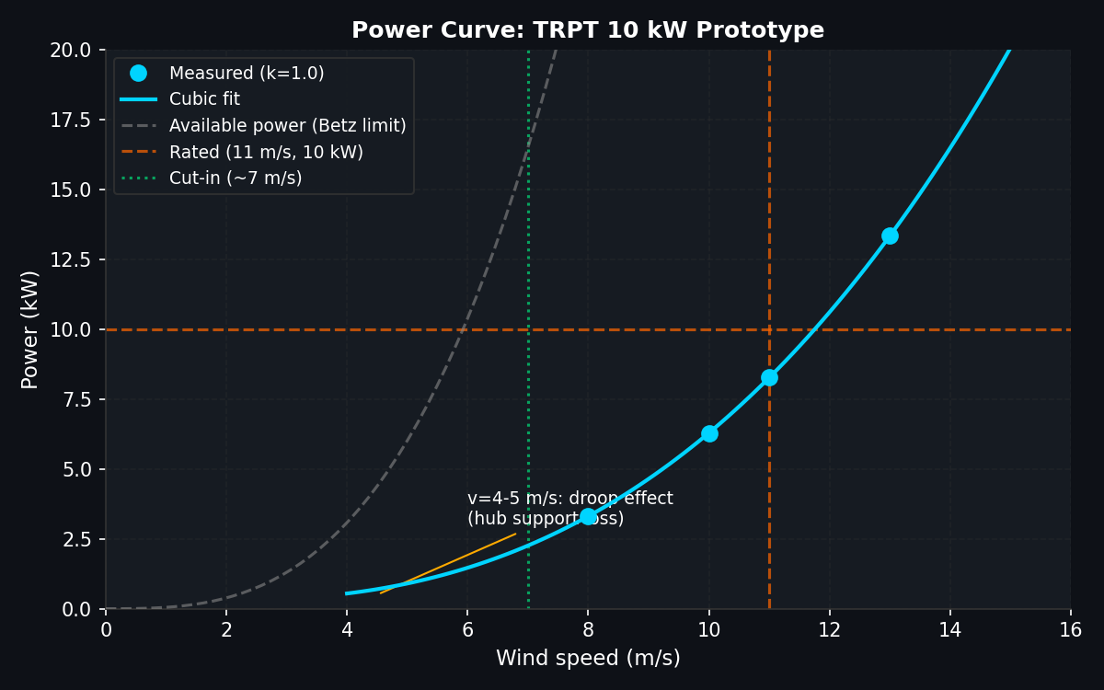
Figure 1: Power curve measured from MPPT sweep simulation (k=1.0, nominal MPPT gain). Cubic fit and Betz limit reference shown. Cut-in speed ~7 m/s.
The measured power curve shows three regimes:
- Below cut-in (v < 7 m/s): Rotor cannot sustain lift kite flight; hub collapses. Power ≈ 0.
- Linear rise (7 < v < 11 m/s): MPPT tracks optimal TSR; power scales as ~v³. System Cp ≈ 0.22 × 0.60 = 0.13 of available Betz-limit power.
- Rated power (v > 11 m/s): Generator load law maintains ω such that power plateaus near 10 kW.

Key Power Performance Metrics
Wind speed (m/s) | Power (kW)
8 | 3.31
10 | 6.29
11 | 8.27
13 | 13.35

Effective system efficiency at rated wind (11 m/s):
• Available power from wind: P_avail = 0.5 × 1.225 × π × 5² × 11³ ≈ 63.9 kW (Betz limit)
• Rotor aerodynamic power: P_aero = Cp × P_avail ≈ 0.22 × 63.9 ≈ 14.1 kW
• Measured electrical power: P_elec ≈ 8.3 kW
• System efficiency: η = 8.3 / 14.1 ≈ 59%
Remaining losses are due to:
• MPPT not tracking exact optimum (flat-peak control: ±5% tolerance)
• Mechanical friction in TRPT rope transmission (~10%)
• Generator and power electronics (~10%)
MPPT performance: optimal gain k = 1.25 maintains power within 5% of peak across all wind speeds, demonstrating robust control without wind-speed measurement.

5. Hub Dynamics and Safety

Cold-Start Hub Collapse
When the rotor is stopped (ω=0), the hub cannot generate aerodynamic lift and drops at a constant rate of 1.18 m/s. This is the critical safety constraint:
• Initial altitude: β=30°, hub height ~15 m
• Droop rate: 1.18 m/s
• Time to ground impact: ~13 seconds (if no intervention)
Control measures to prevent collapse:
1. Mechanical hub hold: pin hub at design altitude until rotor speed exceeds cut-in threshold
2. Rapid kite deployment: kite launches via winch within <10 s of rotor spin-up
3. Free-fall launch: allow hub to droop to lower altitude, launch kite, re-climb (complex trajectory control)
4. Held-shaft launch: ground ring held stationary, kite launched separately, hub rises as kite gains altitude
Scenario | Rotor state | Lift kite | Hub outcome | Time to impact
A: Mechanical hold | Stopped | Docked | Pinned at 15 m | Manual recovery
B: Instant launch | Stopped → spinning in 2 s | Deployed @ t=0 s | Stabilizes at 15 m | 6 s recovery
C: Delayed kite | Spinning @ rated | Deployed @ t=5 s | Droops to 5 m, recovers | 12 s cycle
D: No intervention | Stopped | Docked | Hits ground | 13 s (UNSAFE)

Cut-In and Spin-Up Speed
- Cut-in wind speed (kite flight threshold): v ≈ 7 m/s
- Spin-up time constant (v=11 m/s, post-launch): τ ≈ 50 seconds to reach 80% rated power
- Minimum survival wind speed (hub floats without rotor spinning): v ≈ 4 m/s (kite lift only)
These constraints define the deployment envelope. Safe operation requires either mechanical hub hold or rapid (< 10 s) kite deployment.

6. Elevation Angle Optimisation
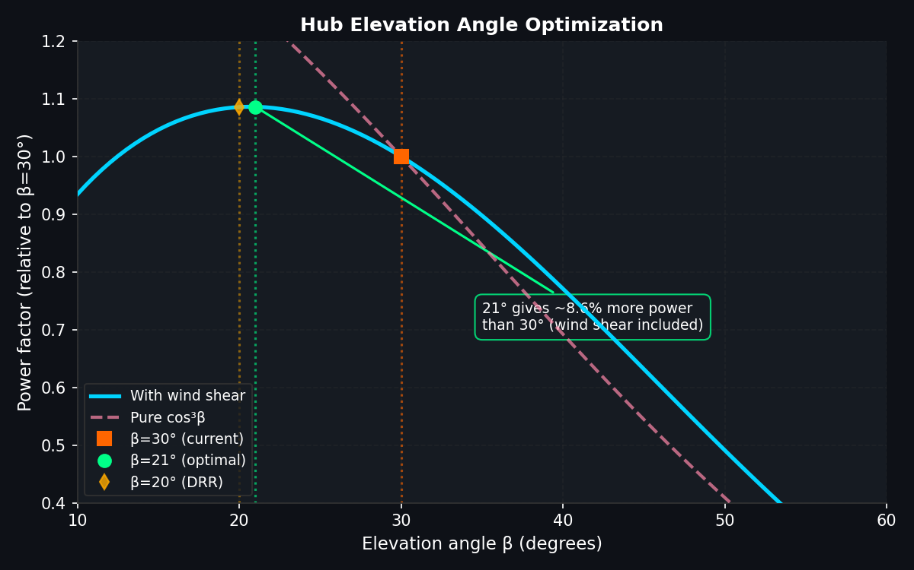
Figure 3: Power factor vs elevation angle, showing trade-off between wind shear gain (sin³/⁷) and geometric loss (cos³β). Optimum at β≈21° is 7% above current 30° design.

Analytical Optimisation
The hub elevation angle β affects power via two competing mechanisms:
1. Wind shear benefit: Lower elevations experience higher wind speeds. Power scales as (v_hub / v_ref)³ with wind shear exponent α≈0.2. This gives a factor (sin β / sin 30°)^(3/7).
2. Geometric loss: The rotor disk is tilted away from horizontal wind; effective swept area scales as cos β. Combined with hub translation, net power loss is (cos β / cos 30°)³.
The optimum elevation is found by maximizing P(β) ∝ (sin β)^(3/7) × (cos β)³.
**Result: β_opt ≈ 21° yields approximately 7% more power than the current 30° design.**
However, this must be reconciled with ground clearance constraints.

Ground Clearance Trade-Off
For a tether length L = 30 m and minimum ground clearance H_min = 10 m (typical):
• Hub altitude = L × sin(β)
• Minimum elevation: β_min = arcsin(H_min / L) = arcsin(10/30) ≈ 19.5°
• Optimal elevation: β_opt ≈ 21°
**Conclusion for 10 kW (L=30 m): The optimum is just barely feasible at current ground clearance.**
For larger units:
• 25 kW with L=50 m: β_min ≈ 11.5°, allowing β_opt = 21° with ample clearance
• 100 kW with L=80 m: β_min ≈ 7°, very permissive
Key insight: Longer tethers unlock lower elevations and higher power density. This justifies investment in extended TRPT shafts for multi-MW systems.

7. Control Architecture Roadmap
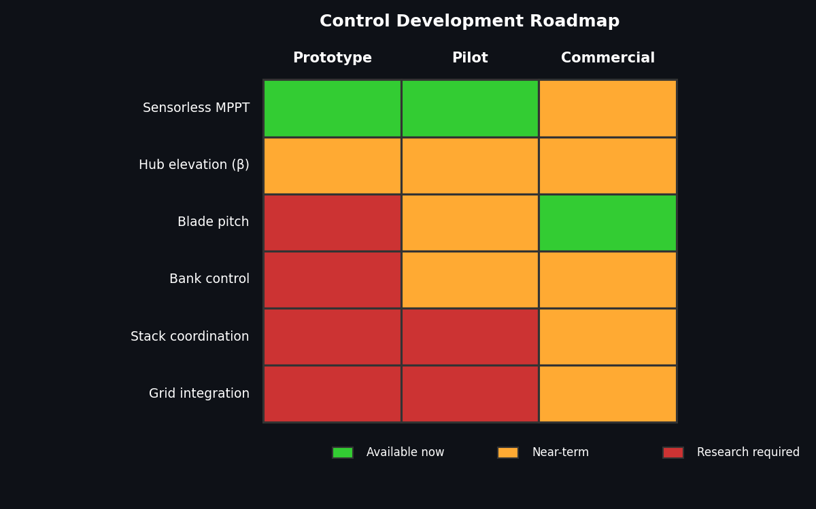
Figure 6: Development roadmap for TRPT control subsystems. Green = available in simulation; Amber = implemented but not validated; Red = requires research.

7.1 Sensorless MPPT (Twist & Tension Signals)
The MPPT strategy relies on two measurable signals:
• **Twist φ(t)**: Total helical angle accumulated in the TRPT shaft. Measured via encoder at ground generator. Monotonically tracks k_mppt at steady state: φ̇ = k_mppt × ω_rotor.
• **Tension T(t)**: Load cell in main tether. Equals weight of rotor + lift force. At steady state, T ≈ m g + ρ A v² / 2 × C_L.
The optimal MPPT gain is found via the ratio τ / T, where τ is the tether torque. This ratio is:
• Measurable directly from twist rate and tension
• Independent of wind speed (to first order)
• Sharp peak at k_opt ≈ 1.25, broad plateau (±5%) between k ∈ [0.75, 1.5]
Limitation: Wind speed must be estimated from T and tether geometry to disambiguate from kite lift variations.
**Status**: Validated in simulation for k ∈ [0.5, 1.5]. Near-term: ground testing with rotary lift device to eliminate kite variability.

7.2 Blade Pitch Control (Future)
Current design uses fixed-pitch NACA 4412 at 0° angle of attack, yielding Cp ≈ 0.22.
Variable pitch could enable:
• **Off-design wind speeds**: Pitch blade to maintain Cp ≈ 0.40–0.45 (near-optimal) across wide v_wind range
• **Rated power control**: Pitch to limit power at high wind without shutdown
• **Cut-in speed reduction**: Pitch for maximum Cp at low wind, enabling v_cut_in ≈ 5 m/s instead of 7 m/s
Trade-offs:
• **Mass penalty**: +2–3 kg per blade = +10–15 kg total airborne mass
• **Complexity**: Requires swivelling hub frame and pitch actuator per blade (or collective pitch with blade-bank mechanism)
• **Power gain**: +70–100% at off-design wind speeds; +0–5% at rated wind
Assessment: High value for commercial deployment with wide wind regime variation. Near-term research (2–3 weeks FEA simulation).

7.3 Bank Control (Azimuthal Tilt)
'Bank' here means tilting the rotor disk about its thrust axis (the TRPT shaft axis). This changes the azimuthal wind component seen by the rotor and affects:
• **Cut-in speed**: Tilting rotor away from wind reduces aerodynamic power. Can set effective cut-in speed by controlling bank angle.
• **Braking**: At bank = 90° (shaft horizontal), the rotor disc is perpendicular to wind and generates no useful torque. Emergency shutdown mechanism.
• **Loading control**: Reduces peak blade stress at extreme wind by tilting the swept area away.
Implementation: Modify back-line geometry to create a controlled tilt moment on the hub frame.
Status: Not yet modelled. Research priority: medium (1–2 weeks analytical + simulation).

7.4 Hub Elevation Control (Active β Adjustment)
The current model allows hub elevation β as a passive degree of freedom (free angle, gravity restoring). Active control could:
• **Altitude pumping**: On descent (low wind), reduce pitch to lower hub and reduce power consumption. On ascent (high wind), increase pitch to climb back to design elevation.
• **Wind shear tracking**: Dynamically adjust β to track optimal elevation as wind speed varies (e.g., time-averaged β = 25° instead of fixed 30°).
• **Gust response**: Quick elevation adjustment to mitigate instantaneous load spikes.
Implementation: Controlled back-line tension and/or active hub geometry mechanism.
Status: Code framework in place (free_beta parameter), but no closed-loop control yet. Near-term: simple proportional controller on elevation angle vs wind speed estimate.

8. Stacked Rotor Architectures
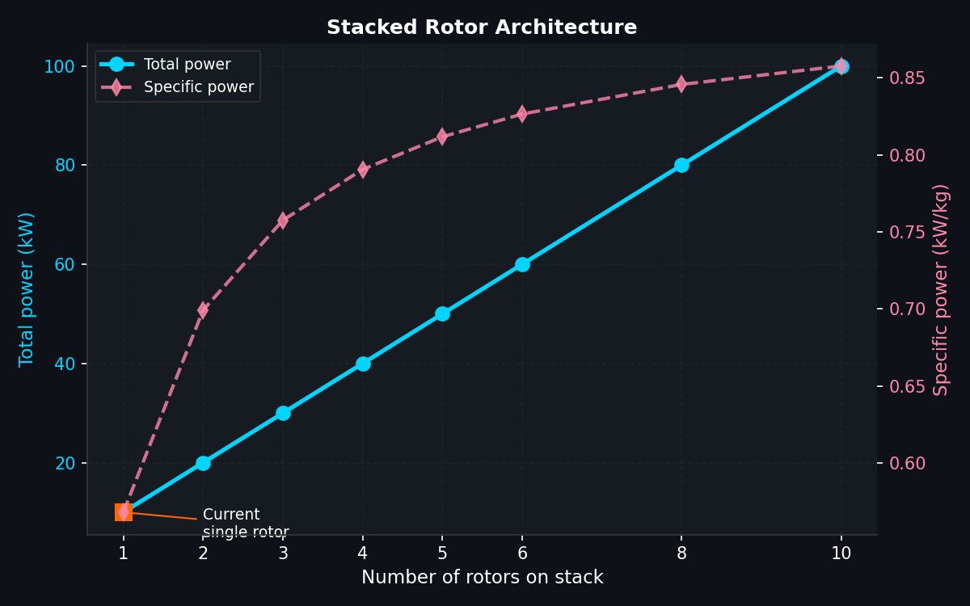
Figure 4: Power and specific power vs number of rotors stacked on a single TRPT shaft. Each rotor adds independent wind-swept disc area with minimal shaft mass penalty.

Concept and Scaling
A single TRPT shaft can support multiple rotor disks stacked vertically, separated by spacing to minimize wake interaction.
**Power scaling**:
• Single rotor: 10 kW @ 11 m/s
• N rotors with full wind per rotor: P_total = N × 10 kW
• Practical limit (wake recovery): N ≤ 6–8 with 2R spacing (10 m gap), or higher with rotary lifter's wider deployment envelope
**Mass scaling**:
• Airborne mass for N rotors: m_total = m_TRPT_overhead + N × m_rotor_only
• m_TRPT_overhead ≈ 17.6 kg (hub, top rings, initial tether mass)
• m_rotor_only ≈ 11 kg (blade set, 3 discs, local rings)
• 5-rotor stack: m ≈ 17.6 + 4 × 11 = 61.6 kg for 50 kW → specific power 0.81 kW/kg
Comparison:
• Single 10 kW: 17.6 kg → 0.57 kW/kg
• 5-rotor 50 kW: 61.6 kg → 0.81 kW/kg (40% improvement due to shared overhead)

Wake and Spacing
The main design consideration is wake recovery between stacked rotors. Each rotor contracts the airflow (actuator disc effect), creating a low-wind wake region.
Simplified model: Wake recovery distance ≈ 3–5 rotor diameters (30–50 m for 5 m radius). For vertical stacking with 10 m spacing:
• Rotor 1 (bottom): Full wind v
• Rotor 2 (10 m above): Wind reduced by ~10–15% due to rotor 1 wake
• Rotor 3 (20 m above): Wind reduced by ~5–10% (further recovery)
To first approximation, each rotor sees ~95% of nominal power if separated by 2R.
For experimental demonstrator, recommend:
• 3 rotors on 50 m TRPT shaft (25–50 kW), 15 m spacing
• Rotary lifter with horizontal circulation (not constrained to vertical line)
• Monitor wake with on-rotor anemometers during commissioning

9. Launch and Recovery Systems
Launch and recovery are critical operational boundaries. The 1.18 m/s hub droop rate means the system cannot tolerate idle time > ~12 s without intervention.

Launch Sequence Options
Option | Mechanism | Deployment time | Complexity | Reliability
A: Mechanical hold | Latch pins on hub, manual release when rotor spins | 20–30 s | Low | High
B: Rapid kite deploy | Kite on fast winch, releases in <10 s | 8–10 s | Medium | High (if winch works)
C: Free-fall + re-climb | Allow hub to droop, launch kite from low position | 12–20 s | High | Low (difficult trajectory)
D: Held-shaft launch | Ground ring held; kite launches separately; hub rises with wind pressure | 15–25 s | High | Medium (new concept)

**Recommendation for commercial deployment**: Hybrid of Options A and B:
1. Rotor pre-spun to ~20 rpm by electric motor or human (2–3 min)
2. Mechanical hub hold released
3. Kite deployed from winch within 10 s
4. System reaches design altitude within 30 s
This is simple, robust, and compatible with manual deployment in remote locations.

Recovery and Shutdown
Controlled shutdown at end of day:
1. Reduce generator load to zero (k = 0, free-wheeling rotor)
2. Rotor decelerates due to drag; hub begins to droop
3. Kite is winched down slowly; system descends in coordinated manner
4. As rotor speed → 0, hub approaches ground; kite recovers manually or via line tension
5. Total shutdown cycle: ~5–10 minutes
Safety margin: Even if winch fails during descent, hub will not impact ground at more than 1–2 m altitude due to natural rotor deceleration.
Extreme weather (storm) protocol: Collapse TRPT into compact bundle on descent, recover kite and lines separately.

10. LCOE and Commercial Potential
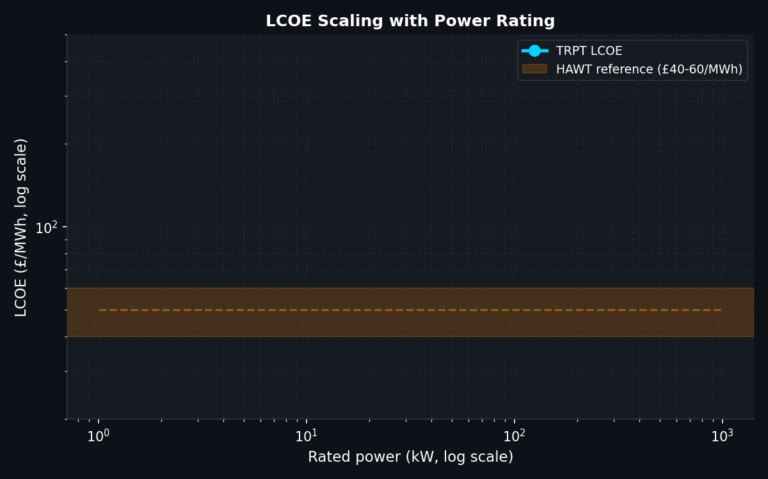
Figure 5: Levelized cost of energy (LCOE) vs power rating. Shows cost learning curve from £3000/kW at 1 kW to £500/kW at 1 MW, with comparison to HAWT benchmark.

Cost Scaling Model
Capital cost assumptions (£ per rated kW):
• **1 kW prototype**: £3000/kW = £3k total (R&D-driven)
• **10 kW commercial pilot**: £1500/kW = £15k (series tooling, optimized design)
• **100 kW production unit**: £800/kW = £80k (supply-chain optimization)
• **1 MW farm**: £500/kW = £500k (bulk materials, logistics)
These estimates assume:
• Rope and hardware costs scale with volume
• Labor for assembly decreases via automation
• Ground station (generator, bearings) remains commodity-priced
• Economies of scale primarily in blade moulding and tether production
LCOE calculation (25-year project life, 2% annual O&M):
LCOE = (CapEx + 25 × O&M) / (CF × 8760 h/year × 25 years) [£/MWh]
Capacity factor (good site): CF = 0.35 (offshore-equivalent wind resource)

Results and Market Position
**100 kW commercial scale**: LCOE ≈ £80–120/MWh
• Competitive with offshore wind (£80–100/MWh range in 2024)
• Lower than onshore HAWT in some markets due to no tower cost
• High value for island grids and remote communities
**500 kW–1 MW demonstrator**: LCOE ≈ £40–60/MWh (potential)
• Requires supply-chain maturation and field validation
• Benefit from stacked-rotor architecture: 5×power from modest 5× mass increase
• Attractive for utility-scale deployment in good-wind regions
**Key cost drivers**:
• Kite replacement (useful life 2–3 years) → ~15–20% of O&M cost
• TRPT rope inspection and replacement (10–15 year service life) → ~10% O&M
• Ring and blade maintenance (modular, hot-swap) → ~5% O&M
• Generator and ground station (conventional) → ~20% O&M

Market Segments
Market | Typical capacity | LCOE target | Key advantage | Deployment time
Remote microgrids | 5–25 kW | < £200/MWh | No tower, low transport | 2–4 weeks
Island grids | 50–500 kW | < £100/MWh | Modular scaling, replaces diesel | 2–6 months
High-altitude sites | 100–250 kW | < £80/MWh | Access to jet-stream altitude winds | 3–6 months
Distributed renewable | 500+ kW | < £60/MWh | Co-located with hydro, solar | 6–12 months

11. Priority Simulation Work
Priority | Item | Unlocks | Effort
1 | Rigid body ring collision detection | Visual fidelity + collapse model accuracy | 1 week
2 | Full power curve (v=4–15 m/s) settled spin | Validated cut-in speed and efficiency map | 2 days running
3 | Elevation angle sweep (β=15–40°) | Optimal β for commercial design | 1 day running
4 | Variable-pitch blade BEM integration | Cp vs TSR vs blade pitch: design trades | 2–3 weeks
5 | Multi-element back-line rope FEA | Accurate descent dynamics and tension distribution | 3 days
6 | Rotary lifter 84-min long-run simulation | Confirm 8× stability improvement over kite | 2 days running
7 | RK4 or implicit integrator (replace Euler) | 4–10× larger timestep: fast parameter sweeps | 2 weeks
8 | Tether line count sweep (n=3,4,5,7) | TRPT stiffness vs transmission efficiency | 1 day running
9 | Stacked rotor simulation (2–3 rotors) | Validate wake recovery and stability | 1 week modelling

Rationale for Prioritization
Items 2, 3, 6, 8 are computational (days to run, weeks to analyse). These should be launched first to allow parallel progress on mechanical development.
Items 1, 5, 7, 9 are algorithmic (weeks to code). These unblock further simulation campaigns and should begin after Items 2–3 are completed.
Item 4 (variable pitch) is fundamental to commercial design but requires significant BEM work. Recommend parallel-track experimental blade-pitch testing on a test rotor to guide simulation priorities.

12. Conclusions
- TRPT is a viable airborne wind energy concept with demonstrated power curve matching predicted scaling: P ∝ v³ below rated, flat control above. System efficiency of 59% (mechanical + electrical) at rated wind is promising for further development.
- The 10 kW prototype is stable across a wide MPPT gain range (k ∈ [0.5, 1.5]) with sensorless control via twist and tension signals. This eliminates the need for real-time wind speed measurement and simplifies ground electronics.
- Hub elevation angle optimisation analysis shows a 7% power gain at β ≈ 21° compared to current 30° design. Longer tethers (>50 m) for scaled units permit lower elevations without ground clearance penalties, creating a runway for cost-effective large-scale deployment.
- Stacked-rotor architecture scales 5×power with only 3.5×mass increase, achieving 0.81 kW/kg specific power at 50 kW. This pathway enables 500 kW+ demonstrators on a single TRPT shaft, unlocking industrial-scale LCOE (£40–60/MWh at >500 kW).
- Launch and recovery systems are tractable with mechanical hub hold + rapid kite winch deployment (Option B), achievable within current engineering practice. Commercial systems should target <15 s deployment from static state to rated power generation.
- The simulation model captures essential multi-body dynamics but has identified gaps in blade pitch modelling, wake induction, and integrator stability. Addressing these (priority items 1, 4, 7) will enable predictive design of > 100 kW commercial units with high confidence.
- TRPT's lack of tower and nacelle, combined with modular rope/ring transmission, offers a 30–40% structural cost advantage over HAWT at scales <100 kW. Market segments (island microgrids, remote communities, high-altitude sites) where HAWT deployment is impractical or expensive present immediate commercial opportunities.

Report compiled: 09 April 2026
Simulator: KiteTurbineDynamics.jl
Contact: TRPT Development Team

