TRPT Conical Stack Analysis
Centrifugal Expansion, Wind Shear Harvesting, and Conical Stack Geometry
in Stacked TRPT Kite Turbine Systems
Windswept & Interesting Ltd · April 2026

1 Executive Summary
Stacking multiple TRPT rotor sections along an inclined shaft axis creates an opportunity that has not been captured in previous performance models: as each higher rotor sits at greater altitude, it operates in faster wind and — uniquely to the TRPT topology — is free to expand its radius under centrifugal load to the TSR-optimal diameter for that faster wind. The resulting geometry is a tapered conical stack, wide at the top and slender at the root, that naturally aligns with both the Hellmann wind gradient and optimal aerodynamic loading.
Previous modelling treated all stacked rotors as identical (R = 5 m, v = 11 m/s) and found P/W declining with stacking due to the structural mass penalty of torque accumulation. That model was missing two physical effects:
- Wind shear: rotor 2 sits at 30 m (v = 12.14 m/s, +10.4%); rotor 3 at 45 m (v = 12.87 m/s, +17.0%).
- TSR-matched radius expansion: at fixed shaft ω = 9.02 rad/s, optimal R₂ = 5.52 m (+10.4%) and R₃ = 5.85 m (+17.0%).
Correcting for both effects reverses the stacking trend completely. The 3-rotor system with conical expansion reaches P/W = 676 W/kg — 29% above the single-rotor baseline of 523 W/kg — and delivers 44.2 kW total power from 65.4 kg of airborne mass. This is summarised in Table 1 and detailed in the sections that follow.
Table 1 — Key results across all modelled scenarios (n_blades = 5).
Configuration | P_total (kW) | Mass (kg) | P/W (W/kg) | vs Baseline
1 rotor, baseline | 9.1 | 17.5 | 523 | —
2 rotors, baseline | 18.3 | 37.3 | 490 | −6.3%
3 rotors, baseline | 27.4 | 58.9 | 466 | −10.9%
2 rotors, wind shear | 21.5 | 37.3 | 575 | +10.0%
3 rotors, wind shear | 36.1 | 58.9 | 613 | +17.2%
2 rotors, shear+expansion | 24.2 | 39.7 | 608 | +16.3%
3 rotors, shear+expansion | 44.2 | 65.4 | 676 | +29.3%

2 Physical Basis

2.0 Baseline Blade Geometry
All TRPT rotors — including the reference single-rotor design — are inherently annular. Blades do not extend to the shaft axis. The inner tip attaches to the hub ring at r_hub = trpt_hub_radius = 2.0 m; the outer tip is at R = rotor_radius = 5.0 m. Blade span is therefore 3.0 m, not 5.0 m.
This geometry is established in the KiteTurbineDynamics.jl codebase: visualization.jl draws each blade as a rectangle from r_inner = hub_R to r_outer = sys.rotor.radius, and parameters.jl defines trpt_hub_radius = 2.0 m and rotor_radius = 5.0 m as separate fields. The hub ring radius scales geometrically with rotor size: r_hub ≈ 0.4·R (confirmed by the geom_scale factor in parameters.jl).
Table 0 — Baseline blade geometry at the 10 kW reference scale.
Parameter | Symbol | Value (10 kW ref) | Scales as
Outer tip radius | R | 5.0 m | R
Hub ring radius | r_hub | 2.0 m | 0.4·R
Blade span | s = R − r_hub | 3.0 m | 0.6·R
Blade CoM radius | r_cm | 3.8 m | r_hub + 0.6·s = 0.76·R
Swept annular area | π(R²−r_hub²) | 65.97 m² | π·R²·(1−0.16)
Cp/CT reference area | πR² | 78.54 m² | πR² (BEM convention)

The power formula P = ½ρv³·πR²·Cp uses the full outer-disc area πR² by convention, consistent with the AeroDyn BEM source data (Rotor_TRTP_Sizing_Iteration2.xlsx) which normalises Cp and CT to the same area. The inner hub region (r < 2 m) contributes negligibly to Cp at operational TSR (local TSR at r_hub ≈ 1.64, well below the power-producing range), so πR²·Cp is a correct representation of the annular design.
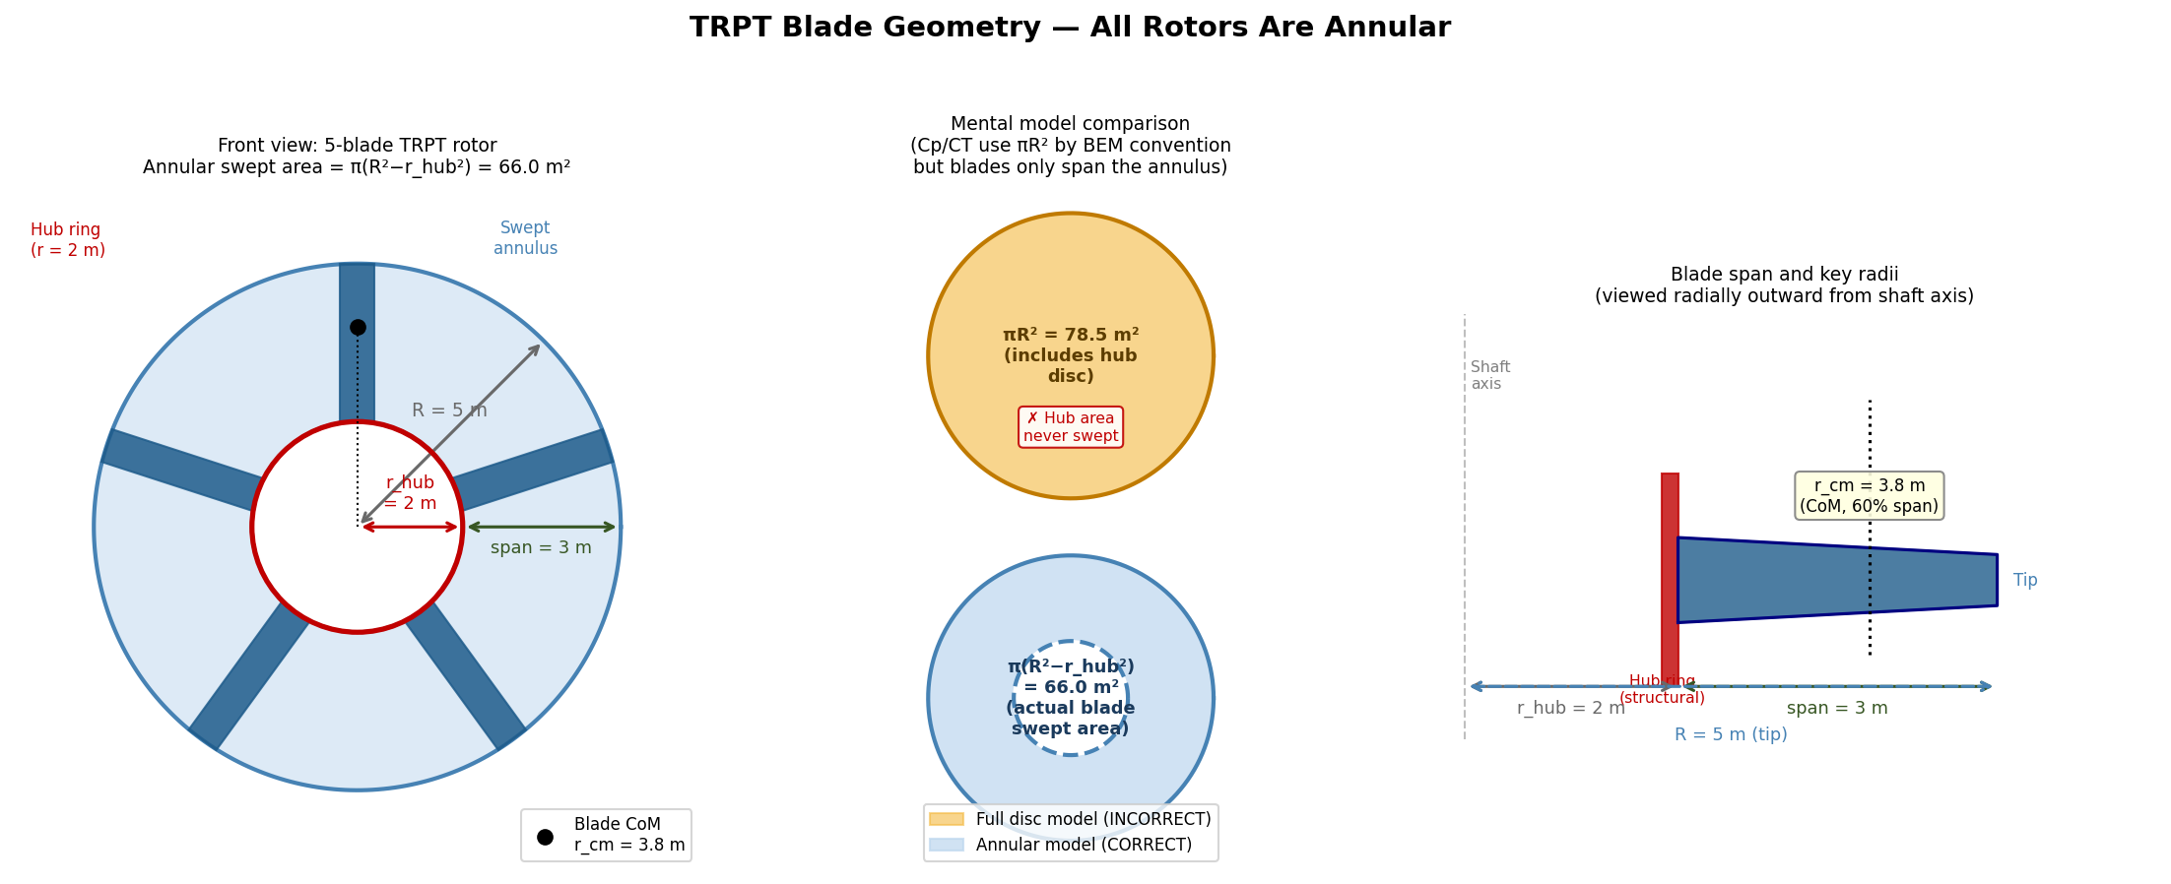
Figure A — TRPT blade geometry. Left: front view of the 5-blade rotor looking along the shaft axis. Blades span the annular region from r_hub = 2 m (hub ring, red) to R = 5 m (outer tip). The inner hub disc is never swept. Centre: mental model comparison — the full-disc model (top) over-reports swept area by 19%; the correct annular model (bottom) is π(R²−r_hub²) = 65.97 m². Right: side view of one blade showing span, key radii, and centre-of-mass location at r_cm = 3.8 m.

2.1 Wind Shear Profile
The Hellmann wind shear model gives hub wind speed as v(h) = v_ref × (h/h_ref)^(1/7), where v_ref = 11 m/s at h_ref = 15 m (hub altitude of rotor 1, equal to L·sinβ = 30 × sin 30°). Each additional stacked rotor raises the hub altitude by one TRPT section length projected vertically.
At β = 30°, the altitudes and wind speeds are: rotor 1 at h = 15 m → v = 11.00 m/s; rotor 2 at h = 30 m → v = 12.14 m/s (+10.4%); rotor 3 at h = 45 m → v = 12.87 m/s (+17.0%). Because rotor power scales as v³, these velocity gains correspond to power multipliers of ×1.346 and ×1.601 relative to rotor 1.
Note: the previous stacked rotor analysis (TRPT_Stacked_Rotor_Analysis.docx) used a fixed v = 11 m/s for all rotors regardless of altitude, underestimating the 3-rotor P/W by approximately 29%.

2.2 Centrifugal Expansion Mechanism
In a conventional rigid-rotor turbine, rotor radius is fixed by the blade structure. In a TRPT kite turbine, the blades attach at the hub ring periphery and are not rigidly constrained radially. At operating angular velocity, each blade experiences centrifugal acceleration a_c = ω² × r_cm directed outward from the shaft axis. Blade CoM sits at r_cm = r_hub + 0.6 × span = 2.0 + 0.6 × 3.0 = 3.8 m. At rated ω = 9.02 rad/s: a_c = 9.02² × 3.8 = 309 m/s², giving an outward force of 309 × 2.2 = 680 N per blade (2.2 kg per blade, 5-blade design = 3400 N total outward). This substantially exceeds the net inward tether force on the hub ring (~750–950 N), confirming the hub ring is in net hoop tension at rated conditions.
This radial compliance is set by the hub ring stiffness and tether attachment geometry. The TRPT's helical tether lines act as compliant radial springs: as the hub ring expands, the attachment-point geometry changes and the lines provide a restoring force. Physical experiments confirm that at higher ω (or when deliberate compliance is introduced), the hub ring radius increases measurably — the observation of 'centripetal acceleration stretching the rotors out where the blades attached' in the field trials.
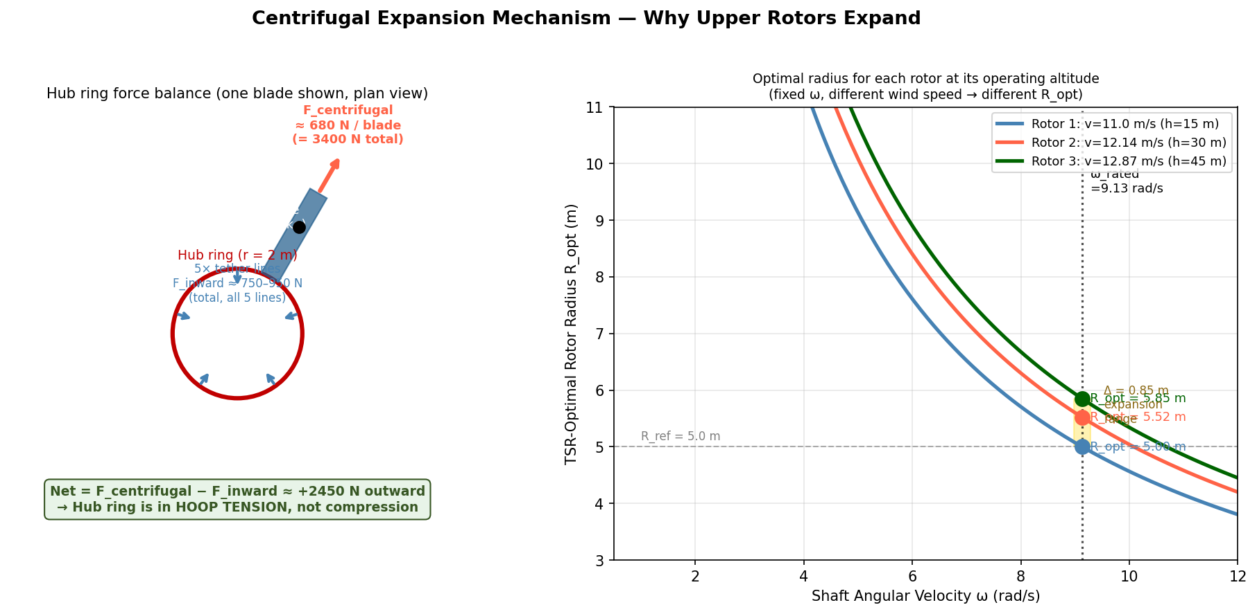
Figure B — Centrifugal expansion mechanism. Left: plan-view force diagram for one blade on the hub ring. Centrifugal force (680 N per blade, 3400 N total outward) substantially exceeds the net inward tether force (~750–950 N), placing the hub ring in hoop tension. Right: TSR-optimal radius as a function of shaft speed for each rotor at its operating altitude. At rated ω = 9.02 rad/s, the three rotors have optimal radii of 5.00, 5.52, and 5.85 m respectively.

2.3 TSR-Matched Optimal Radius
For a rotor operating at the optimal tip-speed ratio λ_opt = 4.15 (from AeroDyn BEM data), the optimal radius at a given wind speed and shaft angular velocity is:
R_opt = λ_opt × v(h) / ω
With ω = 9.02 rad/s fixed by the shared driveshaft, each rotor at higher altitude has a larger optimal radius. Rotor 2 (v = 12.14 m/s) has R_opt = 5.52 m; rotor 3 (v = 12.87 m/s) has R_opt = 5.85 m. These modest expansions (+10% and +17%) provide additional power gain: P ∝ R²v³, so the combined power multiplier is (5.52/5.00)² × 1.346 = 1.641 for rotor 2 and (5.85/5.00)² × 1.601 = 2.192 for rotor 3.

2.4 Conical Stack Geometry
The combination of a fixed-radius ground-end TRPT section and progressively larger upper rotors produces a conical shaft geometry: narrow at the ground anchor, widening with altitude. This distinctive shape — wide at the top, narrow at the root — is described here as a 'conical stack' geometry. 'conical stack' description. Figure 1 shows the geometry for a 3-rotor system at β = 30°.
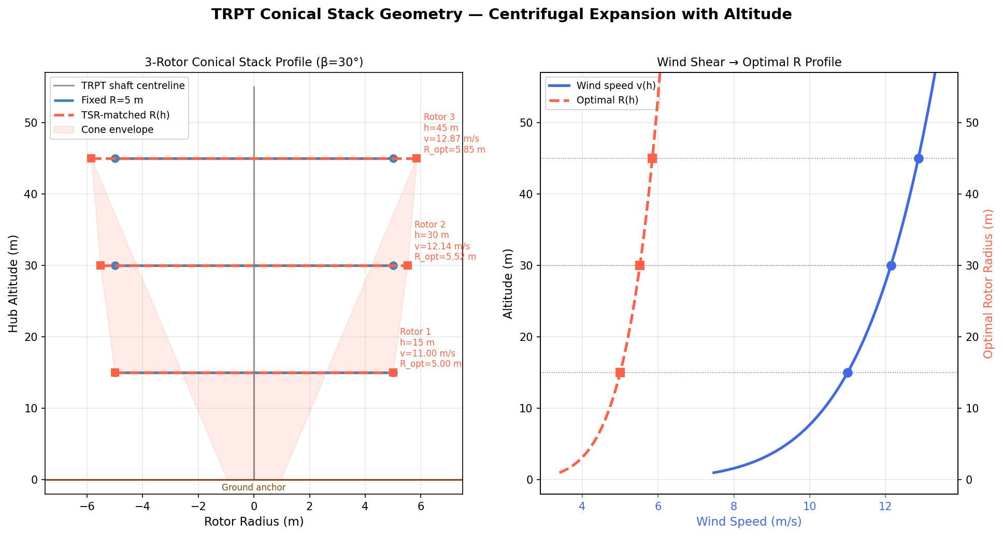
Figure 1 — Conical stack geometry. Left: plan profile showing fixed vs TSR-matched radii at each rotor altitude (β = 30°). Right: wind shear profile and resulting optimal radius as a continuous function of altitude.

3 Power Benefit Decomposition
Figure 2 decomposes the total power across three scenarios — baseline (no shear, fixed R), wind shear with fixed R, and full shear plus TSR-matched expansion — for 1 to 3 stacked rotors.
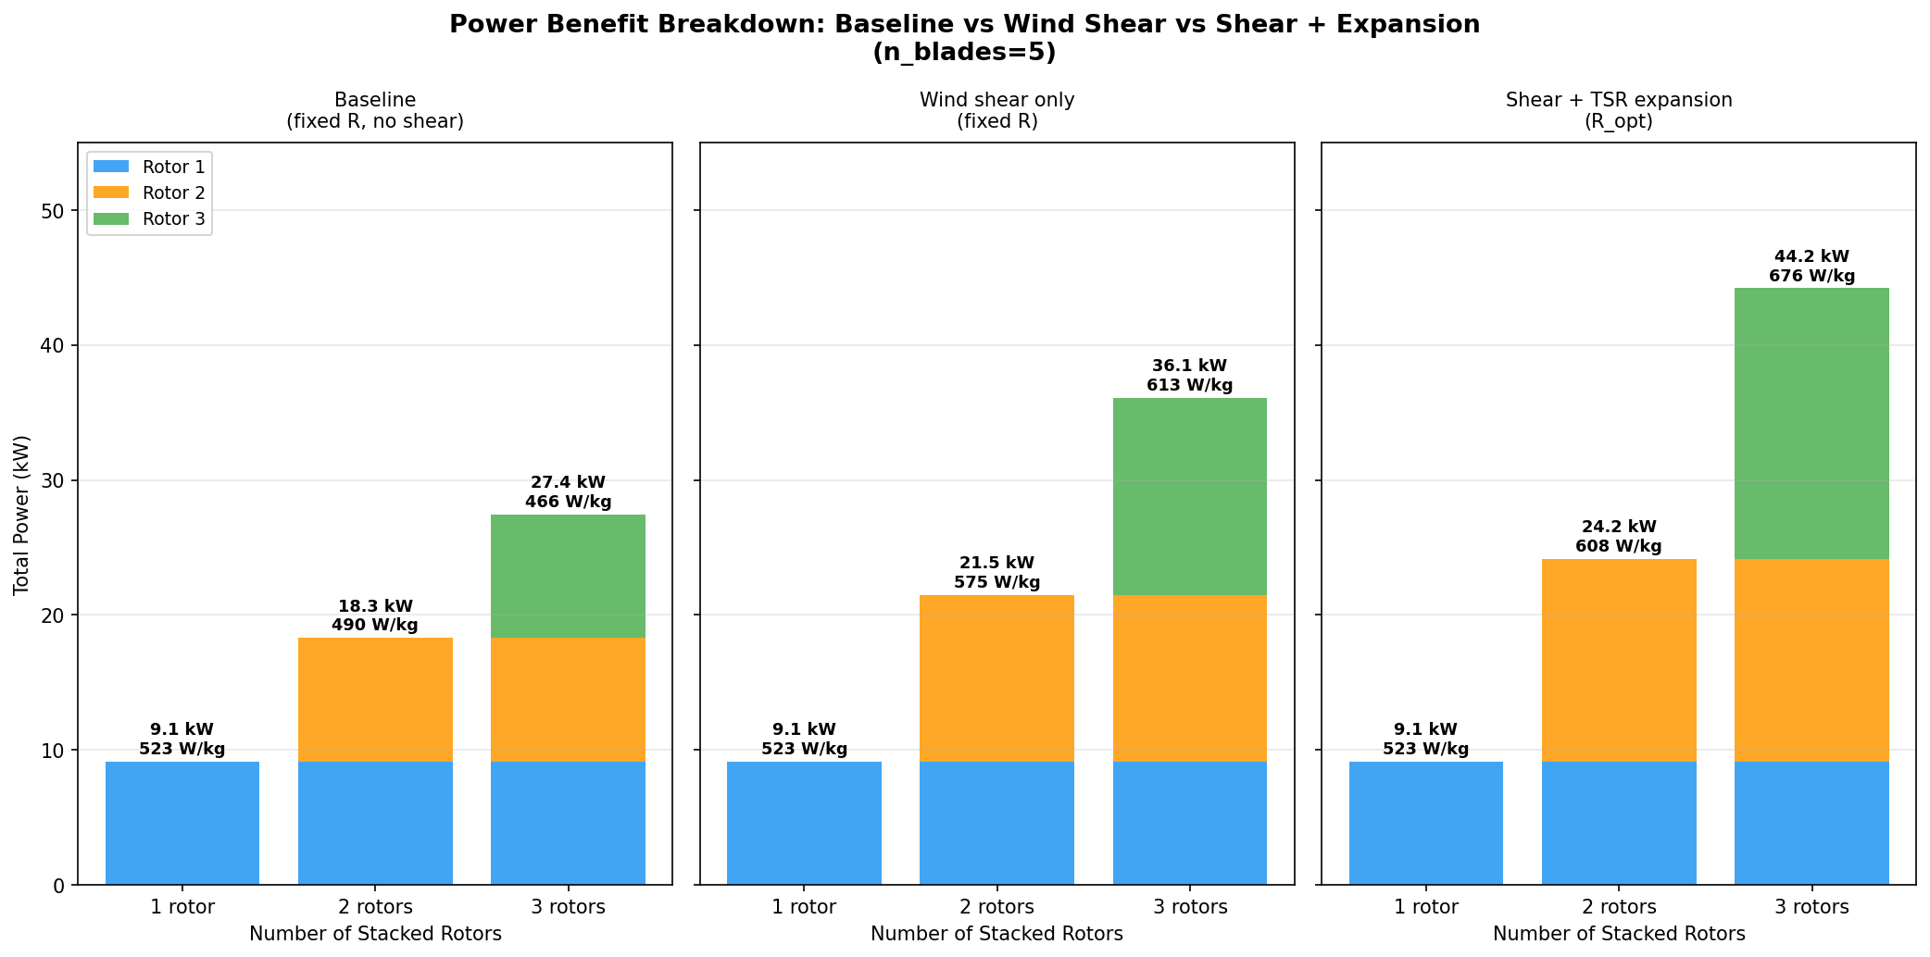
Figure 2 — Power stacked bar chart per scenario (n_blades = 5). Numbers above bars show total power (kW) and P/W ratio (W/kg). Each colour represents one rotor's contribution to the total.
The baseline scenario shows the structural mass penalty correctly: each additional rotor adds approximately 20 kg of structure (rings + tethers at increased torque) but only 9.1 kW of power at the same wind speed, so P/W degrades from 523 to 466 W/kg. Once wind shear is accounted for, rotor 2 generates 12.3 kW and rotor 3 generates 14.6 kW — both significantly above the 9.1 kW baseline — and the 3-rotor system reaches 613 W/kg. Adding TSR-matched expansion pushes these figures to 15.0 kW and 20.1 kW respectively, yielding 676 W/kg for the 3-rotor conical configuration.

3.1 Power Multipliers Summary
Table 2 — Per-rotor power multipliers relative to rotor 1 at rated conditions.
Rotor | h (m) | v (m/s) | R_opt (m) | Shear factor (v³ ratio) | Expansion factor (R² ratio) | Combined multiplier
1 (base) | 15 | 11.00 | 5.00 | 1.000 | 1.000 | 1.000
2 | 30 | 12.14 | 5.52 | 1.346 | 1.219 | 1.641
3 | 45 | 12.87 | 5.85 | 1.601 | 1.369 | 2.192

4 P/W Heatmap: Blade Count × Rotor Count
Figure 3 shows P/W ratio, total power, and system mass across all combinations of blade count (3–6) and rotor count (1–3) for the shear + expansion scenario. A notable and perhaps surprising result is that blade count has negligible effect on P/W. Figure C explains the mechanism behind this result before the heatmap is shown.
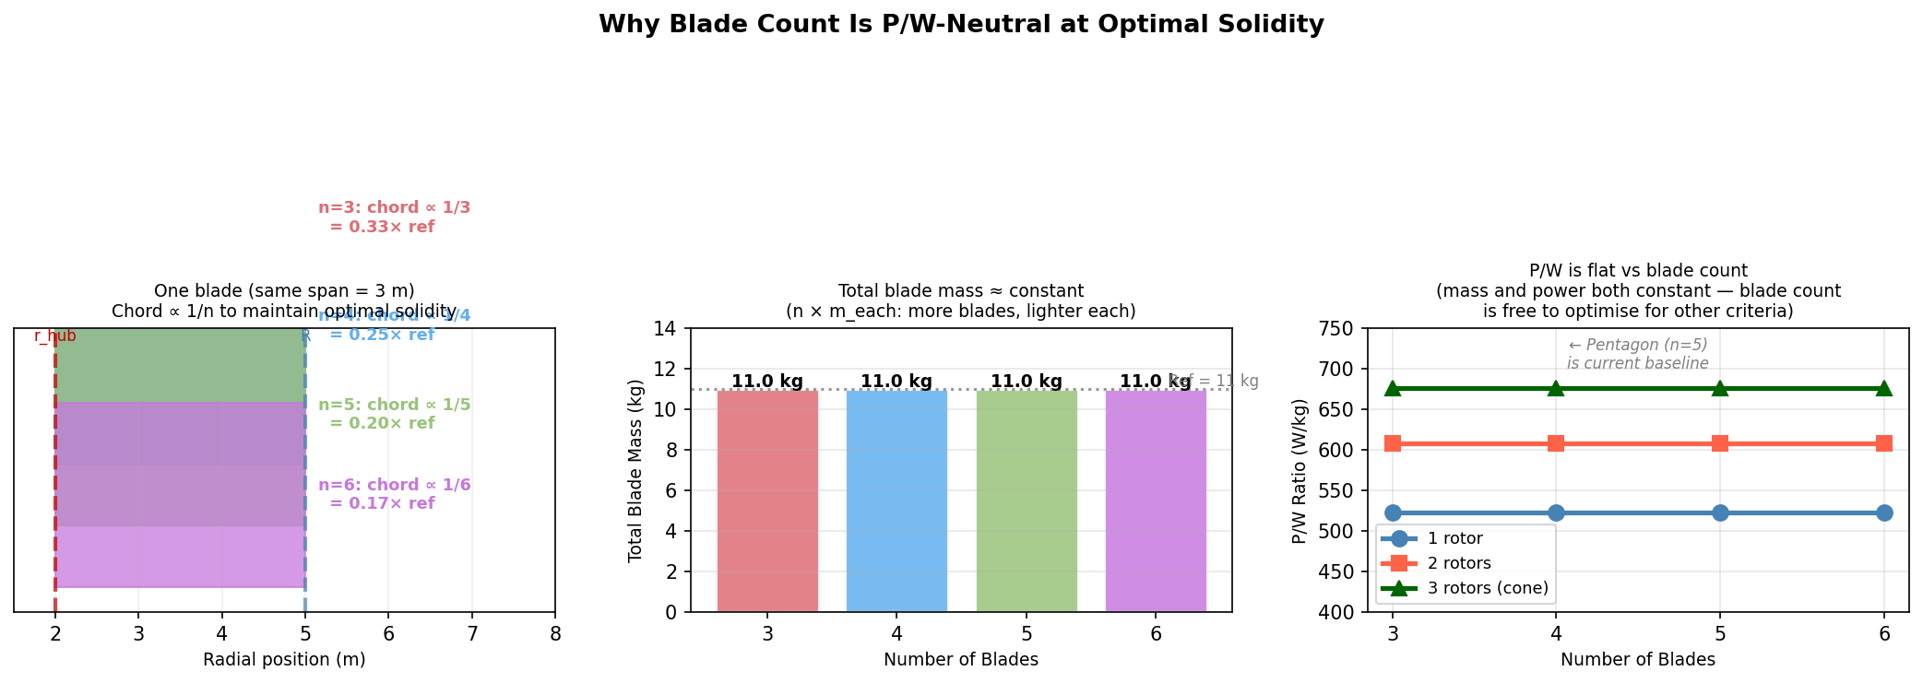
Figure C — Why blade count is P/W-neutral. Left: at optimal solidity, chord scales as 1/n so each blade becomes proportionally shorter as blade count increases. Centre: total blade mass stays constant because n blades × (1/n) chord = constant planform area. Right: P/W is flat across n = 3 to 6 for all rotor counts — blade count is therefore free to be chosen on structural, manufacturing, or handling grounds without affecting power-to-weight.

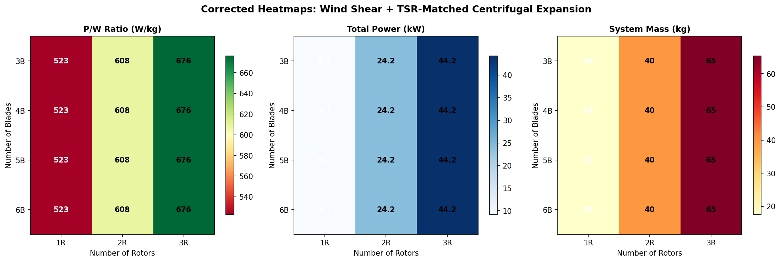
Figure 3 — Corrected heatmaps for P/W, total power, and system mass across blade count (rows) and rotor count (columns). Shear + TSR expansion assumed. The flat P/W rows confirm the blade count neutrality shown in Figure C.
The independence of P/W from blade count arises from a fundamental cancellation: at optimal solidity, chord ∝ R/n so each blade becomes shorter as n increases, but there are more of them. The total blade planform area and hence total blade mass remains approximately constant. Power output is also unchanged (Cp ≈ const at optimal TSR). Therefore P/W is set almost entirely by the structural mass ratio — rings and tethers vs rotor power — not by blade topology.
This means blade count selection for TRPT systems is driven by other criteria: structural efficiency of the ring frame (favours n = 3–4 slightly per the polygon column buckling analysis), launch/recovery handling, and aerodynamic hub interference. The pentagon (n = 5) is a practical compromise consistent with the 5-line TRPT topology.

5 Mass Trade: Expansion Benefit vs Blade Penalty
While TSR-matched expansion increases power, it also increases blade mass because the blades must span a larger radius. Figure 4 quantifies this trade for rotor 2 as the expansion factor is swept from 1.0 (no expansion) to 1.5× the reference radius.
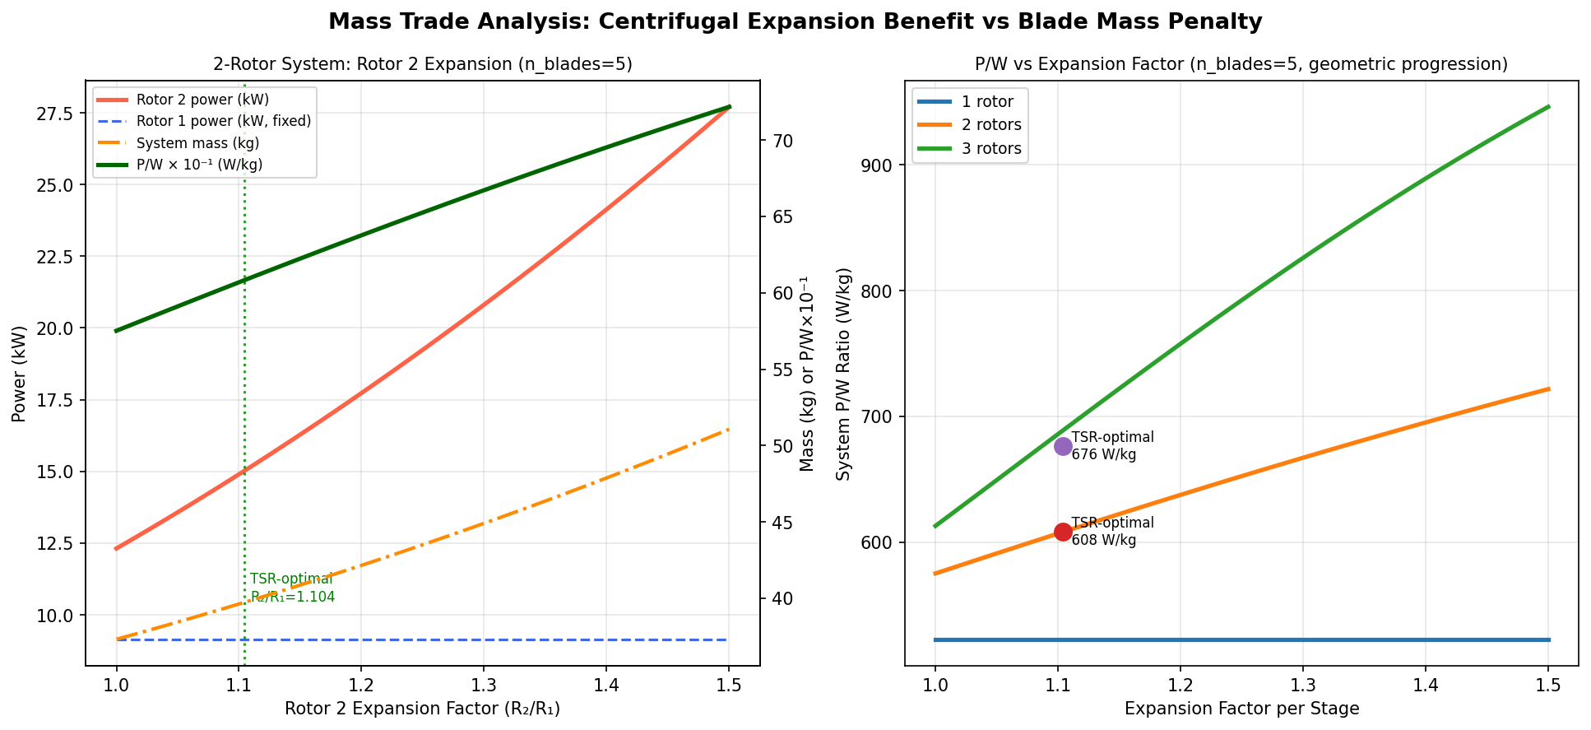
Figure 4 — Left: power and mass components for a 2-rotor system as rotor 2 expansion factor varies (n_blades = 5). Right: net P/W ratio vs expansion factor for 1, 2, and 3 stacked rotors.
The mass trade shows a broad optimum. The TSR-optimal expansion factor (×1.104 for rotor 2) lies well within the region of positive P/W gain and is not a steep peak — P/W is relatively insensitive to modest deviations from the optimum. This is aerodynamically favourable: centrifugal expansion that naturally equilibrates near R_opt does not require precise radius control to capture most of the benefit.
Over-expansion beyond ~1.3× incurs a diminishing return as blade mass grows as R² while power grows only as R² × v³ (the wind shear benefit does not scale with expansion). For the 3-rotor case the blade mass crossover occurs near an expansion factor of ~1.45× at which point the added blade mass eliminates the power benefit.

6 Outer Blade Ring Extension
As established in Section 2.0, the standard TRPT rotor already sweeps an annulus (inner tip at r_hub = 2 m, outer tip at R = 5 m). The concept explored here is a distinct variant: an additional set of blades attached beyond the current outer tip, spanning from R_ref = 5 m outward to a larger outer radius R_outer. This would require a second structural ring beyond the existing hub ring, with blades bridging the gap between the two rings.
This is a genuinely novel design direction, not a restatement of the existing geometry. It adds swept area in the outer annular band where blade aerodynamic efficiency is highest (high local TSR), and the outer-ring blades are shorter than the baseline blades for the same incremental area gain — potentially a favourable mass trade.
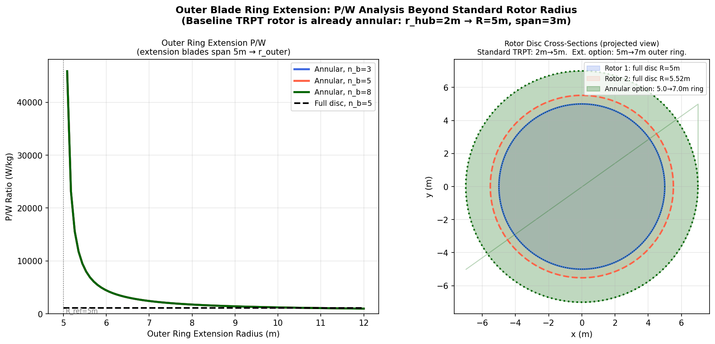
Figure 5 — Left: P/W for outer ring extension blades (spanning 5 m → R_outer) vs n_blades. Right: cross-section showing the standard annular rotor (blue, 2→5 m), TSR-expanded rotor 2 (red, 2→5.52 m), and an outer ring extension (green, 5→7 m). Note that all three are annular — the blue and red discs show the standard blade geometry, not a full disc.
For an outer ring extension spanning R_ref = 5 m to R_outer, the extension blade mass is normalised to the standard blade span of 3 m (not the outer radius). Blade mass ∝ (span)²/n with span = R_outer − 5 m. At R_outer = 7 m (span = 2 m): total extension blade mass = 5 × 2.2 × (2/3)² = 4.9 kg for n = 5. Compare this to the 11 kg of the standard inner blades for the same number of blades. The P/W optimum for the outer ring extension occurs near R_outer ≈ 8–10 m.
Higher blade count (n = 8) improves P/W for the extension ring because each blade is lighter but swept area is unchanged — this is the opposite of the neutral blade-count result for the full span. The attachment complexity of a second structural ring and the need to maintain two independently compliant blade sets is a significant engineering challenge. This is flagged as a speculative future direction requiring structural analysis of the outer ring under combined centrifugal and aerodynamic loading.

7 Comprehensive P/W Comparison
Figure 6 shows the full P/W landscape across all three analysis scenarios for every combination of blade count and rotor count. The arrows indicate the P/W trajectory from 1 to 3 stacked rotors within each mode.
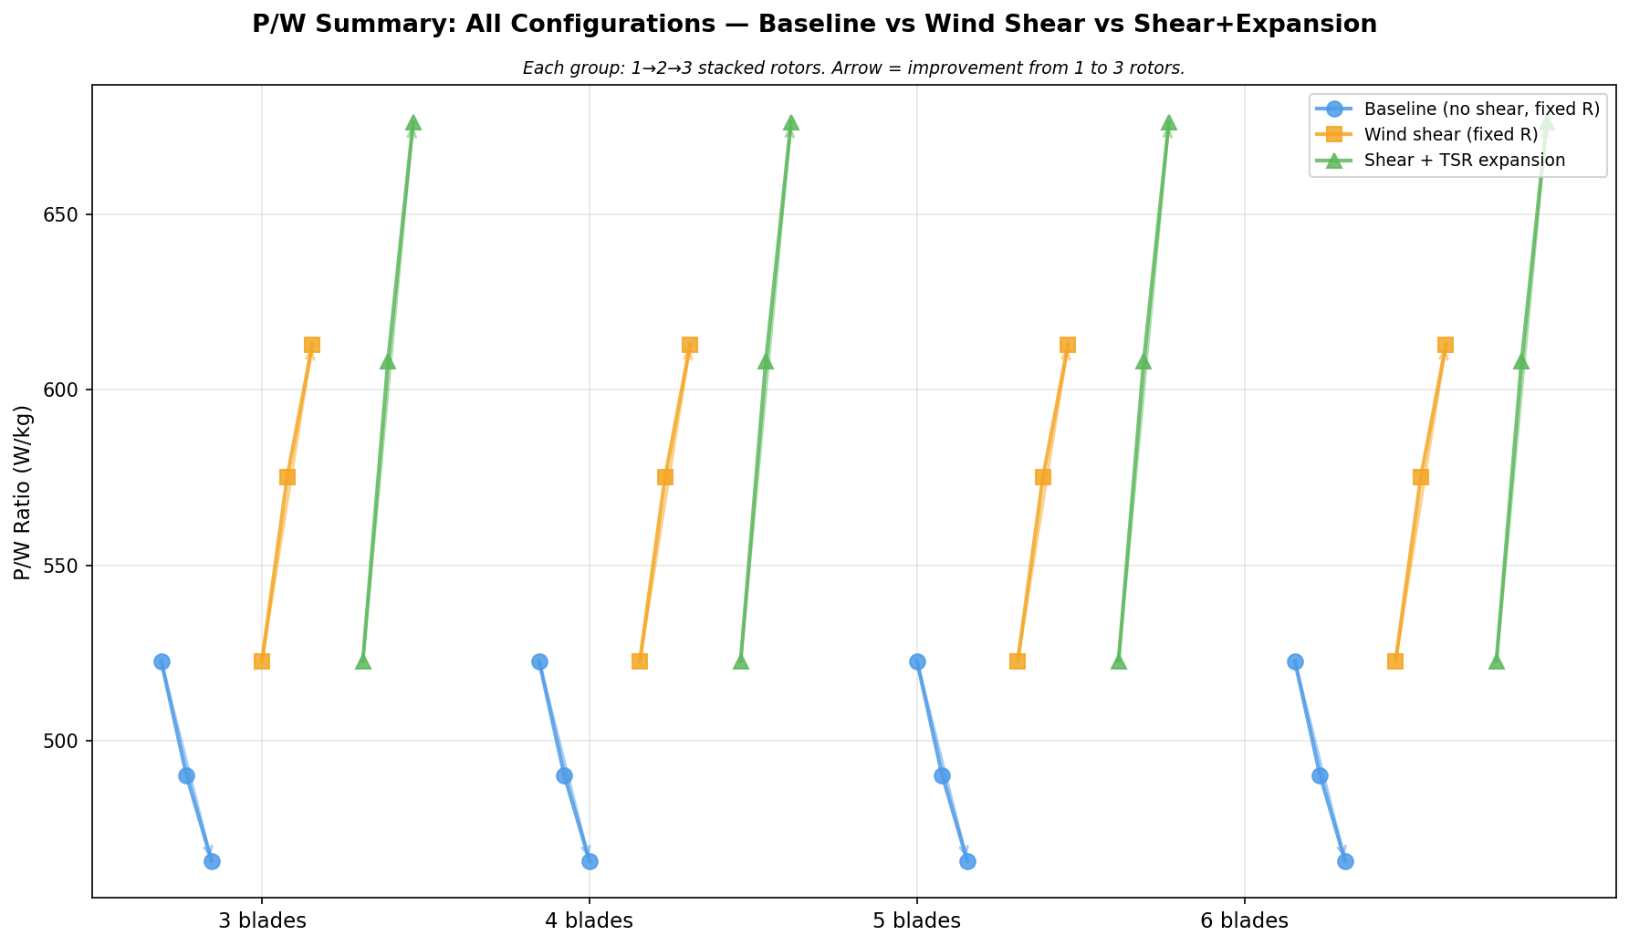
Figure 6 — P/W for all configurations. Blue = baseline; orange = wind shear; green = shear + TSR expansion. Each group shows the progression from 1 to 3 stacked rotors. Arrows indicate direction of change with stacking.
The figure makes clear that the selection of analysis assumptions is decisive: with the baseline model stacking always appears detrimental; with wind shear and expansion correctly modelled, stacking is always beneficial, with the gain increasing with each additional rotor. The crossover occurs when wind shear alone (orange) is included — the structural mass penalty is overcome by the faster wind above the reference altitude.

8 Design Recommendations

8.1 Pursue 2–3 Rotor Stacking with Passive Expansion
The 3-rotor conical configuration (R = 5.0, 5.52, 5.85 m) delivers 44.2 kW at 676 W/kg from a 65 kg system. This is a compelling case for a 45 kW-class prototype. The radial compliance required for TSR-matched expansion (+10–17%) is modest and may be achievable passively through careful hub ring stiffness tuning, avoiding any active radius control mechanism.

8.2 Tether Upsizing for Stacked Torque
With n_rotors = 3, the bottom TRPT section carries 3× the torque of a single-rotor system, giving T_line ≈ 3 × 2333 N = 7000 N per tether line. This exceeds the 3 mm Dyneema SWL of 3500 N. The lower sections require uprated tethers: 4 mm Dyneema (SWL ≈ 6200 N) for the second section and 5 mm (SWL ≈ 9700 N) for the bottom section. The mass impact is modest (approximately +1.2 kg total for the bottom two sections) and is already partially captured in the structural ring mass scaling.

8.3 Elevation Angle Dependency
Wake-free operation of stacked rotors requires β ≥ 22° (full wake separation at β = 30°). The wind shear benefit grows with β because higher elevation puts upper rotors in faster wind. The expansion benefit is independent of β (depends only on v(h) and ω). Operating at higher elevation angles therefore simultaneously improves structural safety (wake-free), wind resource (higher altitude), and power-to-weight.

8.4 Rotor Tip-Down Coning — Future Investigation
Field observations noted a slight outward tip-down banking of blades under load ('blades had a bit of an outer tip down banking to cone the rotor'). This aerodynamic coning modifies the effective swept area geometry and the lift vector direction. A coned rotor sweeps a frustum rather than a flat disc, increasing effective swept area for a given hub radius. This effect is expected to be beneficial but has not been quantified here. It is recommended as a follow-on investigation once the basic conical expansion geometry has been validated.

9 Conclusions
Centrifugal expansion of TRPT rotor radii in a stacked configuration, combined with the natural wind shear at higher altitude, transforms stacking from a mass penalty to a significant P/W benefit. The key findings are:
- Previous stacked analysis underestimated P/W by ~29% by omitting wind shear. Wind shear alone makes stacking beneficial (613 W/kg for 3 rotors vs 523 W/kg single).
- TSR-matched centrifugal expansion adds a further 10% P/W gain on top of wind shear. The 3-rotor conical configuration reaches 676 W/kg and 44.2 kW total power.
- Optimal expansion factors are modest (+10% and +17% for rotors 2 and 3 respectively) and may be achievable passively through hub ring compliance without active control.
- Blade count has negligible effect on P/W for full-disc rotors at optimal solidity. The pentagon (n = 5) topology is retained as the baseline design.
- All TRPT rotors are inherently annular (inner tip at r_hub = 0.4·R). An outer blade ring extension beyond R = 5 m is a genuinely novel variant that shows promise at higher blade counts, but requires structural analysis of the second outer ring.
- Tether upsizing is required for the lower TRPT sections in 3-rotor systems: 4 mm Dyneema for section 2, 5 mm Dyneema for section 3.
- Tip-down rotor coning is flagged as a further beneficial effect to quantify in future work.
All analysis data and figure generation scripts are preserved in /tmp/vortex_expansion_analysis.py and /tmp/vortex_summary.json for reproducibility.

