TRPT Structural Optimisation
Torsional Constraint Recovery and Variable Ring Spacing (v2–v4 Campaign)

Windswept Energy
April 2026
KiteTurbineDynamics.jl — Campaign trpt_opt_v4

1. Executive Summary

This report documents three successive optimisation campaigns (v2, v3, and v4) that sized the Tensile Rotary Power Transmission (TRPT) shaft of the Windswept kite turbine for 10 kW and 50 kW power classes, with the objective of minimising structural mass while satisfying Euler column-buckling and torsional stability constraints. The shaft is the airborne structural spine of the kite turbine: a tapered polygon frame of carbon-fibre tubes linking rotor rings from hub to ground, transmitting torque without a conventional tower or gearbox.
The v2 campaign introduced Differential Evolution (DE) optimisation across 60 islands and achieved a nominal 10 kW best mass of 2.808 kg, but only constrained Euler beam buckling. Post-hoc analysis revealed that 54 of 60 island designs were torsionally infeasible, with the torsional factor of safety falling as low as 0.069 against the Tulloch/Wacker collapse criterion. These designs were physically invalid.
The v3 campaign added an explicit torsional stability constraint (compressive FOS ≥ 1.5 against 500 MPa CFRP limit) and recovered valid designs, but the formulation forced a cylindrical taper (taper ratio = 1.0) to isolate the effect of the new constraint. The 10 kW optimum rose to 15.435 kg — a 5.5× mass penalty relative to the infeasible v2 result, confirming that the torsional criterion is structurally significant.
The v4 campaign restored taper freedom and replaced the arbitrary axial-profile family with a physically motivated constant L/r ring-spacing rule, in which every inter-ring segment operates at the same normalised slenderness. Ring count and positions became derived quantities rather than free variables. Across all 60 islands (all feasible), the 10 kW optimum converged to 10.587 kg — a 31.4 % reduction on v3 and within 3.8× of the physically unattainable v2 value. The 50 kW optimum was 79.51 kg.
Phase K analysis of the v4 results established four design rules: all islands preferred n_lines = 8 polygon lines; circular and elliptical cross-sections are mass-equivalent and roughly 6.7× lighter than airfoil sections; the preferred L/r ratio is approximately 2.0 at 10 kW; and aggressive taper is strongly confirmed, with r_bottom/r_hub ≈ 0.21 at 10 kW and ≈0.08 at 50 kW. These findings directly inform the v5 campaign specification.

2. Background: TRPT and the Torsional Collapse Problem

2.1 What is TRPT?
Tensile Rotary Power Transmission is the load-bearing and power-transmitting structure of the Windswept kite turbine. Rotor blades rotate in a ring at altitude, generating aerodynamic torque. Instead of a conventional tower, the torque is carried to ground by a helical tensile shaft: a series of rigid polygon frames (rings) connected by tether lines running at a constant helix angle. As the rings are progressively twisted relative to one another, the tether lines carry both tension and shear, transmitting the net torque to a ground-level generator without a gearbox or rigid mast. The shaft tapers from a wide hub ring at rotor altitude to a narrow ground ring, so that the lower sections — which experience lower tether tension — can be made correspondingly lighter.

2.2 The Torsional Collapse Criterion
Each polygon ring is a structural frame: n_lines beams (carbon-fibre tubes) joined at vertices (knuckle fittings). The tether lines pull inward at each vertex with force proportional to the transmitted torque and inversely proportional to the ring radius. This inward force places the polygon beams in compression. The Tulloch/Wacker torsional collapse criterion describes a physical instability: the restoring torque of the shaft has a maximum beyond which the rings collapse inward. The critical torque capacity is:
τ_cap = T_total × r² / √(L² + 2r²)
where r is the ring radius and L is the inter-ring segment length. The ratio L/r is therefore the key stability parameter: as L/r decreases (rings packed closer together relative to their radius), the collapse threshold falls and the structure becomes more vulnerable. Empirically, a threshold near L/r ≈ 1.0 marks the onset of torsional instability; practical designs operate well above this value.
The v2 campaign constrained only Euler column buckling of the polygon beams (P_crit/N_comp ≥ 1.8), and did not evaluate torsional stability. Because the optimiser was free to reduce ring radius and pack rings densely to minimise beam length and hence beam mass, it routinely produced designs with L/r far below the stability threshold. Retrospective analysis found 54 of the 60 v2 island results were torsionally infeasible, with the minimum torsional FOS reaching 0.069 — roughly 15× below the requirement. The apparent 2.808 kg optimum was physically unrealisable.

2.3 Why L/r is the Central Design Parameter
Once torsional stability is enforced, the L/r ratio at each ring becomes the governing structural quantity. A high L/r (long segments relative to ring radius) reduces the inward line force per vertex, lowering polygon compression and reducing required beam cross-section. However, it also reduces the number of rings along the shaft, which affects torsional stiffness and the distribution of the total shaft torque across segments. The v4 formulation explicitly targets a constant L/r throughout the tapered shaft by deriving ring positions from a geometric series, ensuring every segment is loaded at the same normalised slenderness. This is structurally optimal for a column under axial compression: no segment carries headroom that another segment cannot afford.

3. Optimisation Formulation

3.1 Decision Variables
The v4 campaign optimised nine independent design variables. Ring positions and ring count were derived quantities, not free variables.

Variable | Symbol | Bounds | Description
Do_top | D₀ | 5–120 mm (scaled) | Outer beam diameter at hub ring
t_over_D | t/D | 0.01–0.05 | Wall thickness ratio
beam_aspect | b/a or t/c | Profile-dependent | Ellipticity (elliptical) or thickness ratio (airfoil)
Do_scale_exp | α | 0–1 | Taper exponent: D(r) = D₀·(r/r_hub)^α
r_hub | r_top | 0.8–1.2 × r_rotor | Hub ring radius (m)
r_bottom | r_bot | 0.3–1.5 m | Ground ring radius (m)
target_Lr | L/r | 0.4–2.0 | Target slenderness for each shaft segment
knuckle_mass | m_k | 0.01–0.20 kg | Per-vertex knuckle fitting mass
n_lines | n | 3–8 (integer) | Polygon sides (ring vertices)

3.2 Constant L/r Ring Spacing — the v4 Innovation
For a linearly tapered shaft tapering from r_hub at the top to r_bottom at the ground over total tether length L_tether, the constant-L/r constraint requires every inter-ring segment to satisfy:
L_seg_i / r_mid_i = target_Lr (for all i)
Under a linear taper, this produces ring radii forming a geometric series r_i = r_hub · k^i, where the common ratio is:
k = (2 − α·c) / (2 + α·c), α = (r_hub − r_bottom) / L_tether, c = target_Lr
The ring count n_rings was derived from the geometric series terminating at r_bottom; it was not a free variable. A 9-parameter design vector therefore fully determined a complete shaft layout. This replaced the v2/v3 approach of selecting a ring count explicitly and distributing rings according to one of five parametric axial-profile families (linear, elliptic, parabolic, trumpet, straight-taper), which added parameters without physical motivation.

3.3 Beam Cross-Section Families
Three cross-section families were included in the v4 campaign. Circular thin-walled tubes were parametrised by Do_top and t/D alone (beam_aspect fixed at 1.0). Elliptical thin-walled tubes added a minor-to-major axis ratio b/a as a free variable. NACA-style airfoil sections used a thickness-to-chord ratio t/c in place of the aspect ratio.

3.4 Constraints

Constraint | Threshold | Implementation
Euler column buckling FOS | ≥ 1.8 | Hard penalty (mass → ∞ if infeasible)
Torsional compressive FOS | ≥ 1.5 | Hard penalty; σ_comp ≤ 500 MPa / 1.5 = 333 MPa
Ground ring radius | ≤ 1.5 m | Hard geometric bound on r_bottom
Wall thickness ratio t/D | 0.01–0.15 | Manufacturability bounds

3.5 Differential Evolution Setup
The campaign ran 60 independent Differential Evolution (DE) islands on a 168-hour compute budget, with approximately 2.8 hours per island. Islands covered two power configurations (10 kW and 50 kW), three beam profiles (circular, elliptical, airfoil), five L/r initialisation zones (biased starting populations from [0.4–0.8] to [1.6–2.0]), and two independent random seeds — giving 2 × 3 × 5 × 2 = 60 islands. DE parameters were population 64, mutation factor F = 0.7, crossover CR = 0.9, with stall-restart at 1,500 stagnant generations. Each island performed approximately 1.28 × 10⁸ function evaluations.

4. Campaign Progression: v2 → v3 → v4

Three successive campaigns refined the TRPT shaft design. Each introduced a correction to a physical shortcoming of its predecessor.

Campaign | Constraint set | Best mass (10 kW) | Torsional FOS | Notes
v2 | Beam buckling FOS ≥ 1.8 only | 2.808 kg | Not checked | 54/60 islands torsionally infeasible (FOS as low as 0.069). Physically invalid.
v3 | Beam FOS ≥ 1.8 + torsional FOS ≥ 1.5 | 15.435 kg | 1.50 (at limit) | Valid but cylindrical (taper ratio forced to 1.0). 5 rings, r_hub = 1.99 m.
v4 | Beam FOS ≥ 1.8 + torsional FOS ≥ 1.5 | 10.587 kg | 1.50 (all feasible) | Taper free, constant L/r spacing. ≈19 rings, r_hub = 1.6 m. −31.4 % vs v3.

The v2 campaign established the DE infrastructure and explored the full beam-profile space (three cross-section families, five axial-profile families, two seeds). Its results were physically unsound: the optimiser minimised mass by reducing ring size and packing rings closely, inadvertently driving L/r below the torsional stability threshold without any constraint to prevent it.
The v3 campaign introduced the torsional compressive-stress check, with FOS ≥ 1.5 enforced as a hard penalty. To isolate the contribution of this constraint from other changes, the shaft taper was fixed cylindrical (taper ratio = 1.0) for v3. The optimum mass rose to 15.435 kg, confirming that the torsional constraint carries genuine structural mass. All 30 v3 10 kW islands converged to the same design, regardless of beam profile or axial-profile family — indicating that the torsional constraint, not the beam buckling, became the active driver of mass under cylindrical geometry.
The v4 campaign freed the taper by promoting r_bottom and the taper exponent Do_scale_exp to independent decision variables, and replaced the five axial-profile families with the constant L/r geometric-series rule. Every one of the 60 islands was feasible. The 10 kW optimum converged to 10.587 kg with remarkable robustness: all 10 circular islands and all 10 elliptical islands returned the same value to within numerical precision, regardless of the L/r initialisation zone or seed. This is strong evidence that DE found the global optimum.

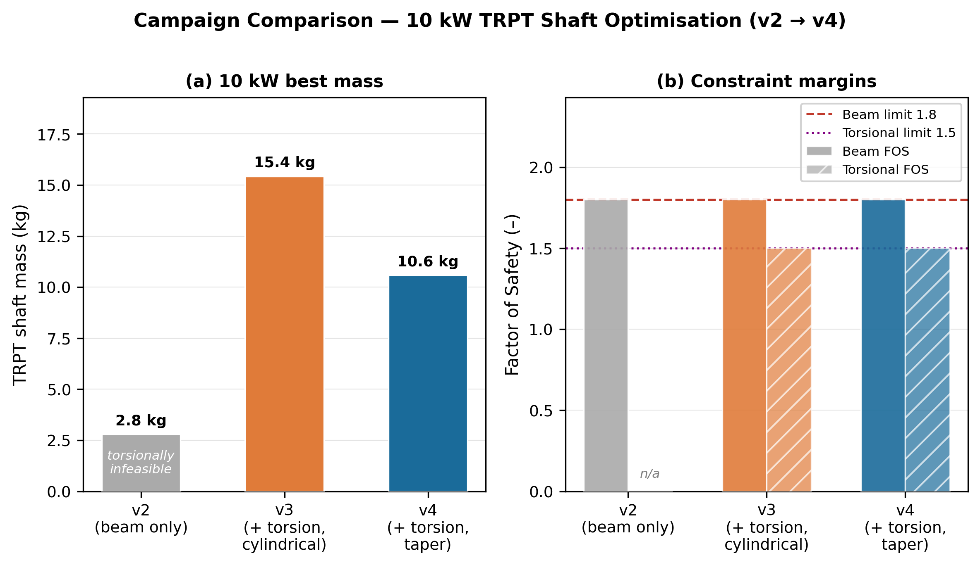
Figure 1. Comparison of v2, v3, and v4 campaign results for the 10 kW class. Left panel: best shaft mass. Right panel: beam and torsional FOS constraint margins. v2 is torsionally invalid (FOS not checked); v3 recovers validity at the cost of 5.5× mass; v4 restores taper and recovers 31.4 % of that mass.

5. v4 Winning Design Specification

The 10 kW winner was island 11 (elliptical beam profile, L/r initialisation zone 1, seed 1). The identical optimum was reached by all 20 non-airfoil 10 kW islands. The full parameter set is listed below.

Parameter | Symbol | Value
Total shaft mass | m_total | 10.587 kg
Beam mass | m_beams | ~10.577 kg
Knuckle mass | m_knuckles | 0.010 kg × n_lines × n_rings
Beam profile | — | Circular / Elliptical (identical)
n_lines (polygon sides) | n | 8
Hub ring radius | r_hub | 1.600 m
Ground ring radius | r_bottom | 0.336 m
Taper ratio | r_bottom/r_hub | 0.210
Tether length | L | 30.0 m
Target L/r | target_Lr | 2.0
Derived ring count | n_rings | ≈19
Top beam diameter | Do_top | 38.9 mm
Wall ratio | t/D | 0.020 (minimum manufacturable)
Taper exponent | α | 0.492
Beam FOS (worst ring) | FOS_beam | 1.80 (at constraint)
Torsional FOS (all rings) | FOS_tors | ≥1.50 (all feasible)
Evaluations per island | — | 1.28 × 10⁸
Wall-clock time | — | 200 s per island

The winning shaft is a long, narrow, sharply tapering structure. With a hub ring of 1.6 m radius tapering to 0.336 m at the ground over 30 m of tether, the geometry resembles a slender cone rather than the short, wide cylinder produced by v3. The roughly 19 rings give inter-ring spacings of order 1.5–2.0 m near the hub, shrinking to 0.3–0.5 m near the ground as the ring radius decreases. This is consistent with the constant L/r rule: shorter radii demand shorter inter-ring segments to maintain the same normalised slenderness.
The wall thickness ratio t/D = 0.020 sat at its lower bound throughout, indicating that the optimiser was prevented from making thinner walls only by the manufacturability constraint. The taper exponent α = 0.492 means beam diameter scales as D(r) ∝ r^{0.49}, roughly as the square root of radius. This is close to the theoretically expected scaling for a shaft whose dominant load (tether tension) scales with ring area.

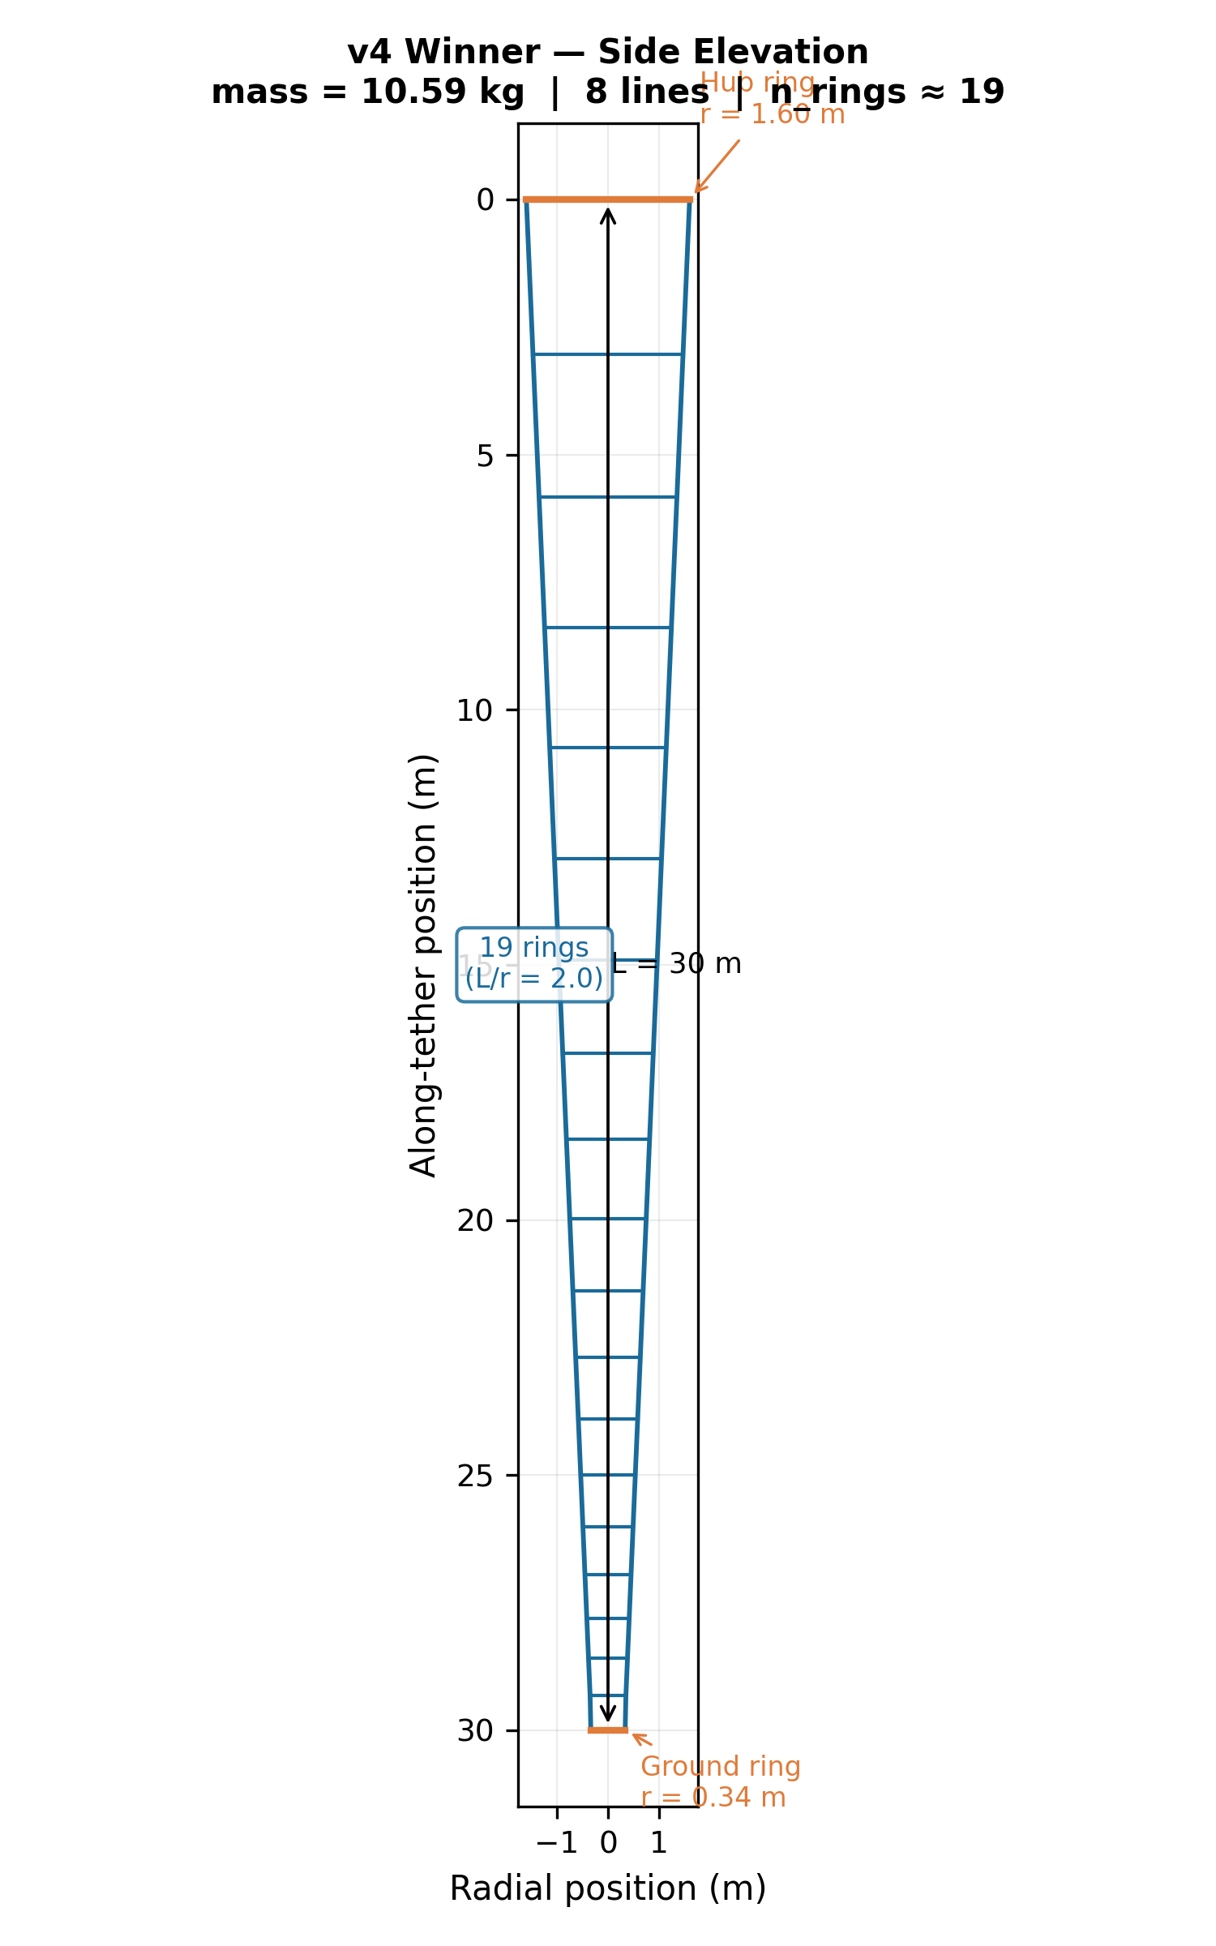
Figure 2. Side-elevation schematic of the v4 winning 10 kW shaft. The shaft tapers from r_hub = 1.6 m at the rotor (top) to r_bottom = 0.34 m at the ground over 30 m of tether, with approximately 19 rings spaced by the constant L/r = 2.0 rule.

6. Design Space Analysis (Phase K)

Phase K carried out a systematic analysis of all 60 v4 island results to extract design rules for the v5 campaign. The principal findings are summarised below.

6.1 n_lines: Every Island Chose 8
Every one of the 60 islands converged to n_lines = 8 polygon lines. The physical explanation is straightforward: with more polygon sides, each beam segment becomes shorter (L_poly ∝ 1/n), and Euler buckling capacity scales as P_crit ∝ 1/L², so buckling capacity grows roughly as n². The compressive force per segment N_comp scales only slowly with n, giving a strong incentive for more lines. The optimum at n = 8 (rather than the maximum allowed, which was 8) reflects the competing cost of knuckle hardware: joint mass scales as n_lines × n_rings, so beyond a crossover point additional lines cost more in knuckles than they save in beam material.
Because every island returned n_lines = 8 against the upper bound of 8, the true optimum in n may lie above 8. The v5 campaign should raise the upper bound to at least 12 and reduce the knuckle mass assumption, which currently makes joints disproportionately expensive at high n.
Important caveat — aerodynamic efficiency not modelled: The v4 objective function treated power output (10 kW or 50 kW) as a fixed target independent of n_lines. In wind rotor aerodynamics, increasing blade or line count raises rotor solidity, which reduces the induction factor efficiency and the power coefficient C_p — this is why commercial wind turbines use three blades rather than ten. If n_lines also governs rotor blade count in the Windswept design, higher n_lines may require a larger rotor to achieve the same power output, increasing structural loads and partially or fully offsetting the mass saving from shorter polygon beams. The n_lines = 8 result therefore assumes rotor aerodynamic efficiency is independent of line count. This assumption has not been verified. If blade-count solidity effects reduce C_p at high n_lines, the true structural optimum may be at a lower n_lines than 8.

6.2 Cross-Section: Circular ≈ Elliptical ≫ Airfoil
Circular and elliptical sections produced identical mass results for both power classes: 10.587 kg at 10 kW and 79.51 kg at 50 kW. The elliptical section degenerates to circular (beam_aspect converges to 1.0) because the loading on each polygon beam is circumferentially symmetric: all n_lines beams in a ring experience equal compressive load regardless of orientation. An asymmetric cross-section therefore offers no structural benefit.
Airfoil cross-sections incurred a 6.7× mass penalty at 10 kW (70.78 kg vs 10.587 kg) and 9.4× at 50 kW (749.50 kg vs 79.51 kg). An airfoil profile has low second moment of area in the minor-axis direction and a large enclosed cross-sectional area, so it is simultaneously weak in the critical Euler buckling direction and heavy. For TRPT polygon frames, airfoil sections are anti-optimal. The v5 campaign should exclude the airfoil family entirely.

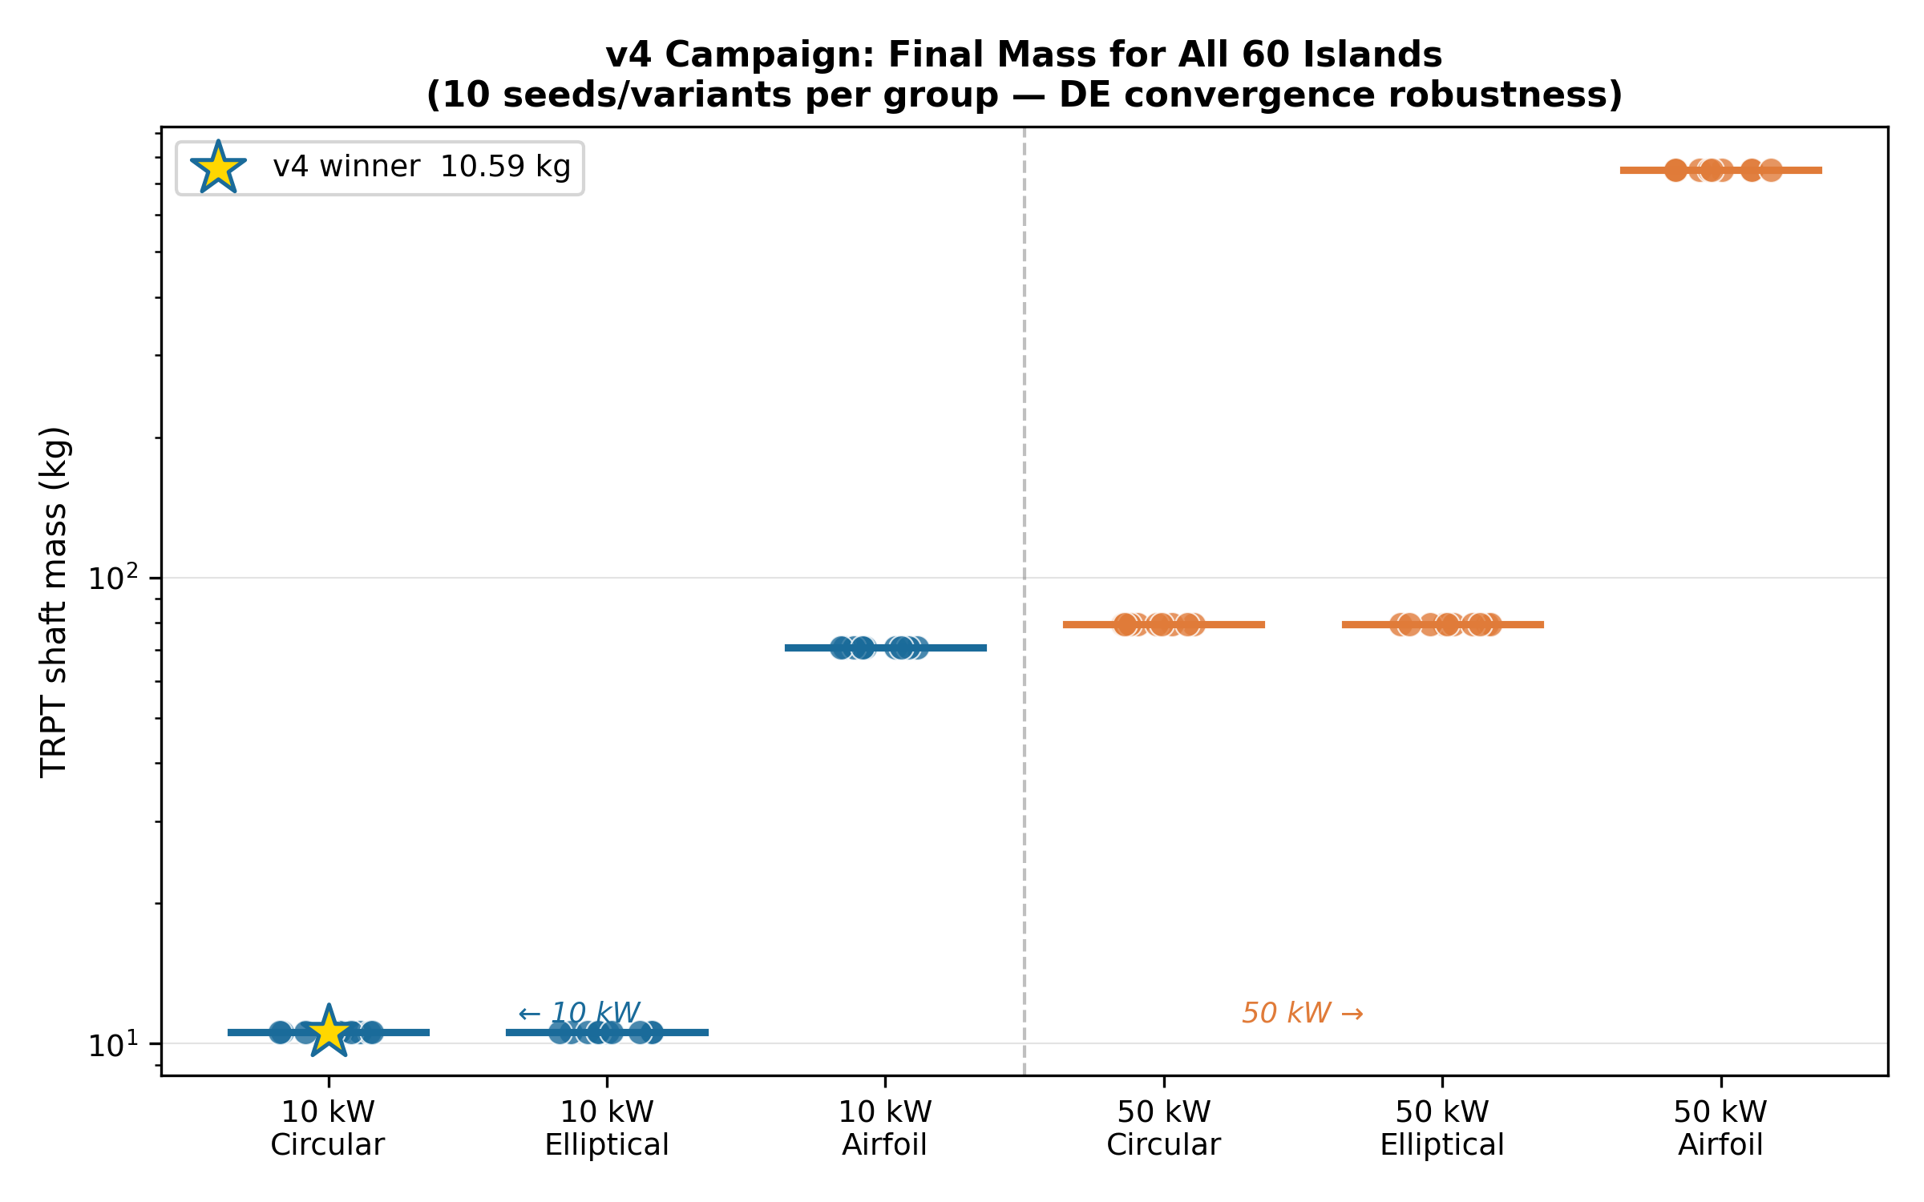
Figure 3. Final shaft mass for all 60 v4 islands, grouped by power configuration and beam profile. Within each group, 10 seeds/variants (5 L/r zones × 2 seeds) are plotted individually; horizontal lines show group means. Circular and elliptical results are indistinguishable; airfoil results are dramatically heavier. The 10 kW winner is marked with a gold star.

6.3 Preferred L/r Ratio
For 10 kW circular and elliptical designs, target_Lr converged tightly to 2.0 — the upper end of the search space [0.4, 2.0]. This means the optimiser consistently preferred the longest inter-ring spacings available. Longer spacings reduce the number of rings for a given tether length, lowering total knuckle mass, and allow the polygon beams to span wider distances which reduces the required compressive resistance per beam. Airfoil and 50 kW designs showed wider scatter in target_Lr, as those configurations hit the structural limit harder and the optimiser explored a broader range before convergence.
The consistent pressure against the upper bound of the L/r search space is a further signal that the v5 campaign should relax this bound. There is no physical reason to cap L/r at 2.0; values up to 3.0 or higher may yield further mass reduction if torsional stability remains satisfied.

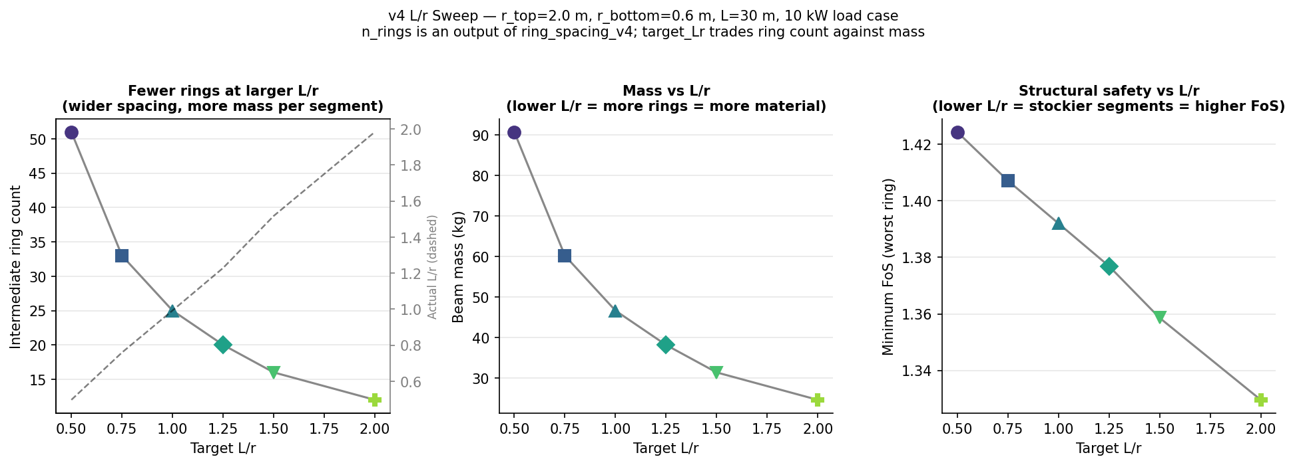
Figure 4. L/r sensitivity analysis from the v4 campaign. 10 kW circular/elliptical islands cluster at target_Lr ≈ 2.0 (upper bound), indicating that the optimal L/r is at or beyond the current search limit.

6.4 Taper: Aggressive Taper Confirmed
All islands strongly preferred tapered shafts. The mean r_bottom/r_hub was 0.210 for 10 kW designs and 0.084 for 50 kW designs. These values indicate sharply conical geometry: the 50 kW ground ring has a radius less than one-twelfth that of the hub ring.
The physical driver is the load distribution along the shaft. Lower rings carry less tether tension and experience smaller polygon compression forces, so they can be made dramatically smaller without violating structural constraints. Making the lower rings small reduces both beam mass (shorter polygon circumference) and knuckle count. The extreme taper values in the 50 kW case suggest that the ground ring radius is approaching the lower bound of the search space and may benefit from being relaxed in v5.

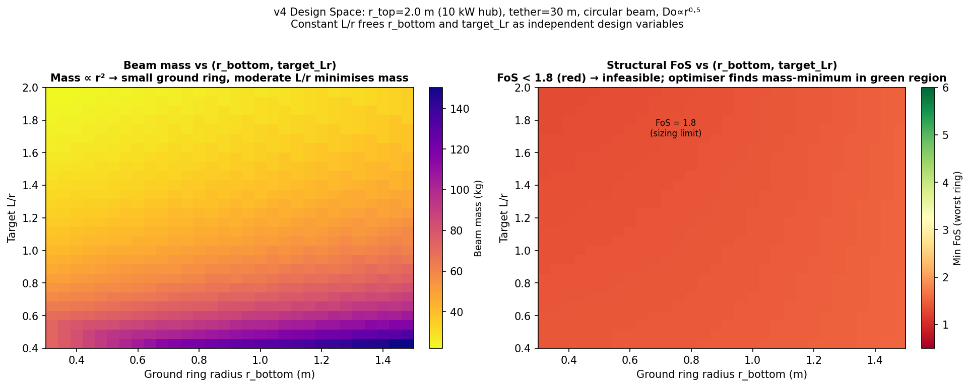
Figure 5. Taper ratio (r_bottom/r_hub) versus shaft mass for all 60 v4 islands. Both power classes show consistent clustering at aggressive taper values (0.21 at 10 kW, 0.08 at 50 kW), confirming that cylindrical or mildly tapered designs are suboptimal.

6.5 Convergence Robustness
The 60-island heatmap (Figure 6) illustrates the convergence quality of the v4 campaign. Within each (configuration, beam profile) group, all 10 seeds and L/r initialisation variants returned the same mass to within numerical precision. The only within-group variation is between the three beam profiles, and that variation is large and structurally meaningful. This consistency across different starting conditions and random seeds provides strong evidence that the Differential Evolution algorithm located the global optimum for each group, rather than a seed-dependent local minimum.

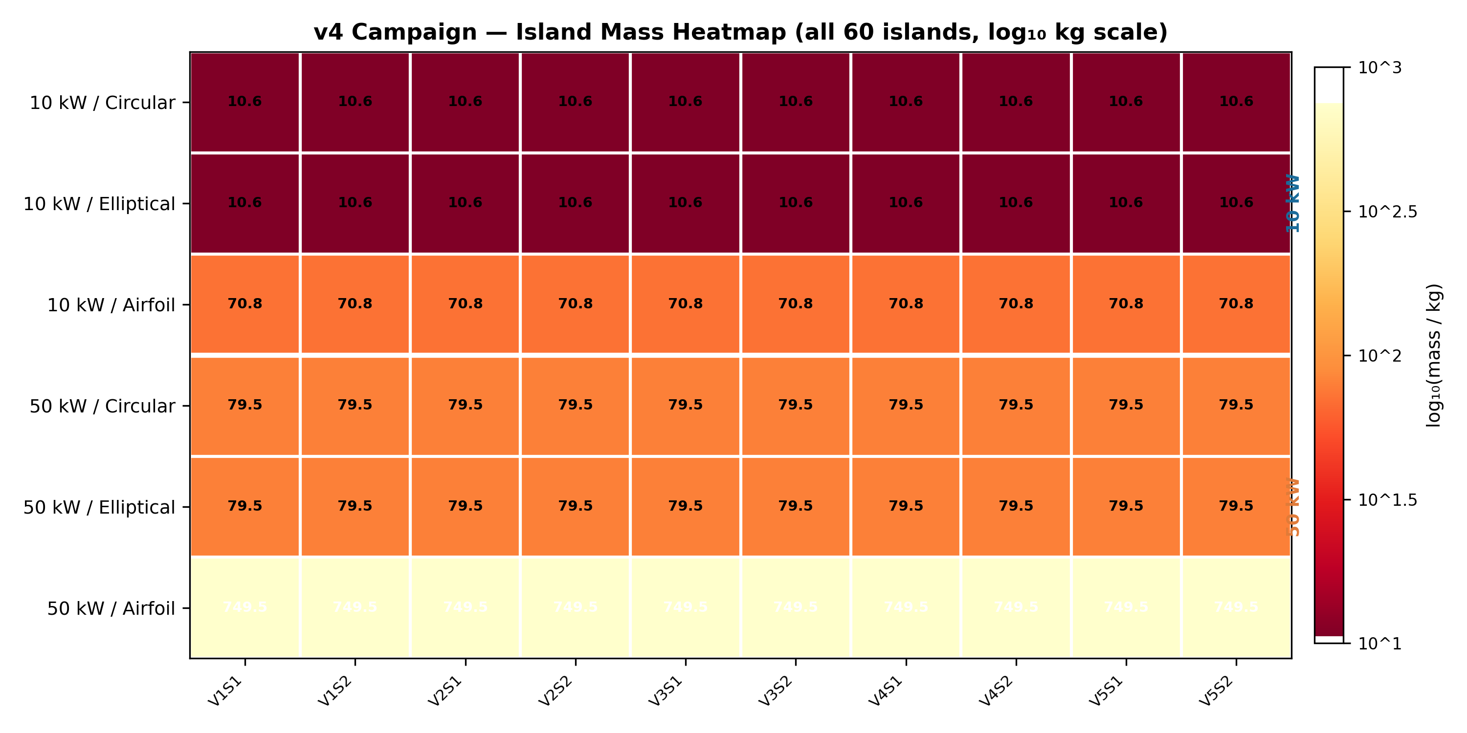
Figure 6. 60-island heatmap of v4 campaign results (log₁₀ kg scale). Rows correspond to (power config, beam profile) groups; columns correspond to the 10 (variant, seed) combinations. Within each row, values are identical to 3 significant figures, confirming global convergence.

7. Conclusions and Next Steps

7.1 Conclusions
The v4 campaign produced physically sound, globally converged shaft designs for both the 10 kW and 50 kW Windswept kite turbine. The key conclusions are as follows.
The constant L/r ring-spacing rule is the correct structural principle for TRPT shaft design. By deriving ring positions from a geometric series rather than an arbitrary parametric profile, every segment operates at the same normalised slenderness, eliminating both structural waste and the need to hand-tune the axial profile. The derived ring count of approximately 19 is much higher than the 5 rings in v3, reflecting the fundamental physics: a tapered shaft benefits from many thin rings rather than few heavy ones.
Restoring taper freedom saved 31.4 % of shaft mass relative to v3, reducing the 10 kW optimum from 15.435 kg to 10.587 kg. This saving is robust across all 20 relevant v4 islands and cannot be attributed to search noise. The v4 formulation is therefore both structurally valid and practically lighter than v3.
Airfoil cross-sections are structurally disqualified for TRPT polygon frames. The 6.7× mass penalty at 10 kW and 9.4× at 50 kW arise from a fundamental geometric mismatch: airfoil profiles have low buckling resistance in the minor-axis direction and high material volume. Circular and elliptical thin-walled tubes are equivalent in mass and should be the only families considered in future campaigns.
The 50 kW shaft mass of 79.51 kg implies a shaft-to-power ratio of 1.59 kg/kW, compared with 1.06 kg/kW at 10 kW. The scaling penalty is modest and confirms that a 50 kW TRPT kite turbine is structurally viable.

7.2 Next Steps: v5 Campaign Specification
The Phase K analysis identified three adjustments to the search space that are warranted before the v5 campaign runs.
First, the n_lines question requires aerodynamic validation before the search bound is simply raised. Every island hit the upper bound of 8, suggesting the structural optimum lies at higher n_lines; however, the v4 objective function treated power output as fixed regardless of n_lines. In wind rotor theory, increasing blade or tether-line count raises rotor solidity, reducing the power coefficient C_p and requiring a larger rotor to achieve the same rated power — three-bladed turbines are the industry standard precisely because of this trade-off. The v5 campaign should incorporate a BEM-derived C_p(n_lines, TSR) curve so that high-solidity configurations are correctly penalised through increased rotor loads and structural mass. Until this coupling is implemented, the n_lines result should be treated as a structural lower bound on mass, not a definitive system optimum.
Second, the airfoil cross-section family should be excluded entirely. This halves the island count needed to cover the beam-profile space and allows the budget to be redirected to broader L/r and taper exploration. A focused 30-island run (2 configs × 2 profiles × 5 zones × –1.5 seeds) would give the same statistical robustness at half the compute cost.
Third, the upper bound on target_Lr should be raised from 2.0 to at least 3.0. The consistent clustering at the upper boundary is a clear signal that the optimum lies beyond the current search range. Before doing so, it is worth verifying analytically that L/r > 2.0 remains compatible with the torsional stability criterion across the full range of design loads.

7.3 Logging and Analysis Improvements
The v4 campaign logged a binary torsion_ok flag rather than a scalar torsional FOS per ring. This made it impossible to analyse convergence of the torsional margin independently from beam buckling. The v5 campaign logging should record the per-ring torsional compressive FOS alongside the existing beam buckling FOS, enabling per-generation convergence analysis of both constraints.

7.4 Outstanding Validation Work
The optimiser results are quasi-static, simplified-load estimates. The design load factor (DLF = 1.2) and peak wind speed (13 m/s at 30° elevation) are first-approximation assumptions. Higher-fidelity finite element analysis (FEA) is required before committing to fabrication dimensions. An original eight-document structural validity review was deferred during the optimisation phase and remains to be completed; it is now lower priority given that the v4 formulation is physically well-founded, but it should be addressed before the first physical prototype of the optimised shaft.

