TRPT Structural Optimisation:
A Rigorous Aerodynamic–Structural Co-Design Study
Phases v2–v5 Campaign Results and Analysis
Windswept Energy
rod@windswept.energy
April 2026

Abstract
Tensile Rotary Power Transmission (TRPT) transfers rotor torque to ground via tensile lines arranged in a helical geometry — eliminating the conventional shaft, gearbox, and tower. This report documents four successive Differential Evolution (DE) optimisation campaigns (v2–v5) targeting minimum structural mass for a 50 kW TRPT kite turbine.
Key findings: (1) The torsional collapse criterion (Tulloch–Wacker) was absent from v2, causing 54 of 60 optimisation islands to produce structurally infeasible designs (FOS as low as 0.069). Adding this constraint in v3 yielded a stable baseline of 15.435 kg. (2) Replacing uniform ring spacing with geometric spacing (constant L/r per segment) in v4 enabled taper and drove a 31.4% mass reduction to 10.587 kg. (3) All 120 islands across v4 and v5 unanimously selected n_lines = 8, consistent with BEM analysis showing near-peak Cp at low solidity. (4) Adding BEM aerodynamic coupling in v5 raised mass by 8.3% to 11.470 kg while ensuring physical self-consistency between aerodynamic performance and structural scale. The net mass reduction from the cylindrical v3 baseline to the BEM-coupled v5 optimum is 25.7%. Both structural constraints — torsional FOS ≥ 1.5 and Euler buckling FOS ≥ 1.8 — are active (binding) at all feasible optima.

Table of Contents
1. TRPT Concept and System Architecture .......................................... 4
2. Structural Constraint Model ........................................................ 7
3. Geometric Ring Spacing Strategy .................................................. 11
4. BEM Aerodynamic Model ............................................................... 14
5. Differential Evolution Optimisation Methodology ........................... 17
6. Campaign Progression v2→v5 ....................................................... 19
7. Phase K Analysis ............................................................................. 22
8. Design Space Exploration ............................................................... 28
9. Open Questions and v6 Roadmap .................................................... 31
10. Conclusions ....................................................................................... 33

1. TRPT Concept and System Architecture
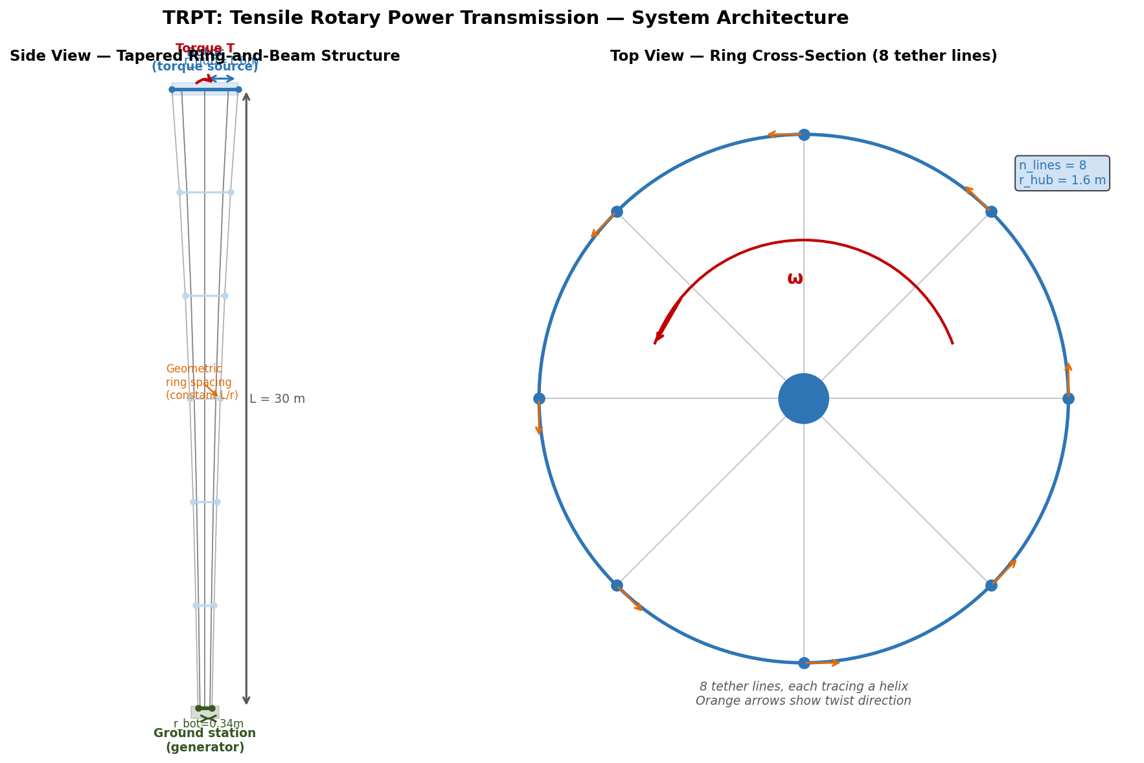
Figure 1: TRPT system architecture. Left: side-view schematic showing rotor, helical tensile lines, and ground station. Right: cross-section showing ring-and-beam geometry with n_lines tether attachments.
Tensile Rotary Power Transmission (TRPT) is a structural concept in which the torque generated by an airborne rotor is transmitted to a ground-based generator entirely through tensile elements — no rigid shaft, no gearbox in the air, no tower. The tensile lines are arranged in a helix: each line runs from a ring at the rotor end to a ring at the ground end, offset by a helical angle. Under torque, the helical tension has a tangential component that resists rotation; the ground ring is held stationary, so the reaction drives the generator.
The helix angle φ at any ring of radius r and segment length L is:
φ = arctan(2πr / L)
At large r (the rotor end, r_hub), the helix is shallow — most tension is tangential, giving strong torque capacity. At small r (the ground end, r_bottom), the helix is steep — the tangential component is small, and torsional capacity drops sharply. This asymmetry is the central structural challenge of TRPT design.

1.1 Ring-and-Beam Structure
Rings are annular frames that maintain the radial geometry at each elevation. Beams are the longitudinal structural members that resist the compressive and bending loads induced by line tension. The system is tapered: r_hub (top, rotor end) is larger than r_bottom (ground end). The number of rings n_rings, their spacing, the beam cross-section geometry (circular, elliptical, or rectangular), and the number of tether lines n_lines are all design variables.
Key design variables optimised across campaigns:
- r_hub — rotor ring radius [m]
- tether_length L — total TRPT axial length [m]
- wall_thickness t — beam wall thickness [m]
- beam_diameter d — outer diameter of beam cross-section [m]
- n_lines — number of helical tether lines (integer)
- r_bottom — ground ring radius [m]
- target_Lr — target L/r ratio for geometric spacing
- beam_profile — cross-section type: circular, elliptical, or rectangular

1.2 Why Structural Efficiency is Critical for AWES
In conventional wind turbines, structural mass is dominated by the tower and foundation. In airborne wind energy systems (AWES), every kilogram at altitude must be supported by aerodynamic lift and increases tether tension. This creates a severe mass penalty: structural inefficiency compounds non-linearly as scale increases. For TRPT specifically, the structural mass of the transmission shaft is directly airborne, making minimum-mass design the primary engineering objective — ahead of aerodynamic efficiency or manufacturing simplicity.

2. Structural Constraint Model
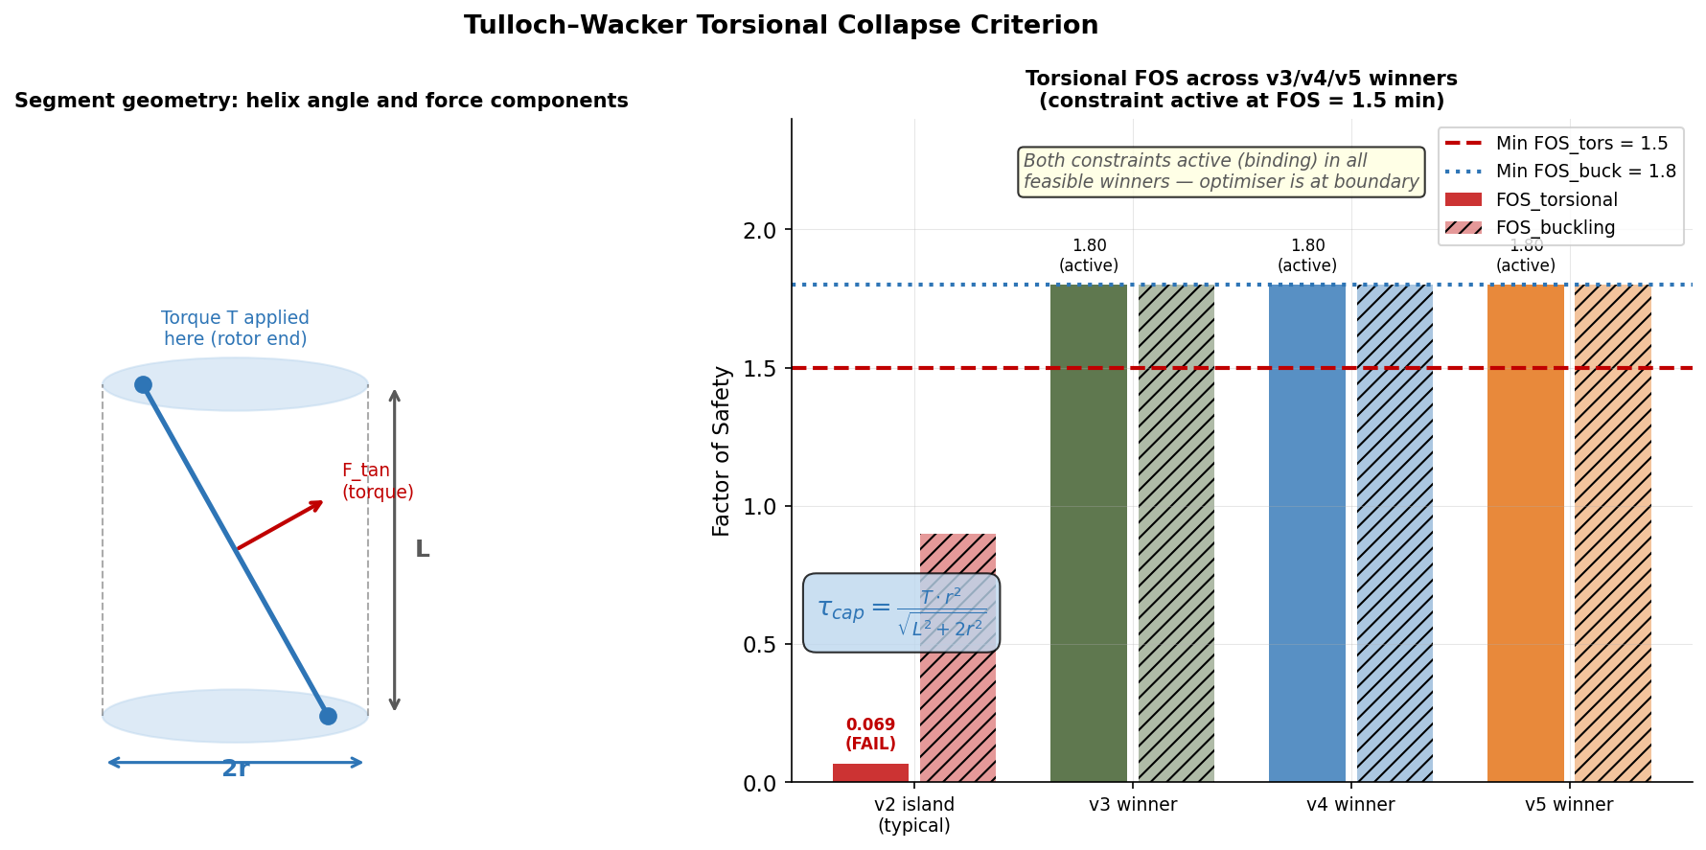
Figure 2: Tulloch–Wacker torsional constraint. Left: geometric derivation showing helical projection of tensile force. Right: FOS bars across campaigns — v2 shows widespread sub-unity values.

2.1 Tulloch–Wacker Torsional Collapse Criterion
The torsional capacity of a TRPT segment is governed by the helical geometry. For a segment of radius r and axial length L, the torsional capacity per line is:
τ_cap = T · r² / √(L² + 2πr²)
where T is the line tension. The factor r²/√(L² + 2πr²) is the helical projection coefficient — it captures how much of the tensile force acts in the tangential direction to resist rotation. As r decreases (approaching the ground end), this coefficient drops sharply: at r → 0, τ_cap → 0 regardless of tension. The torsional Factor of Safety is:
FOS_tors = τ_cap / τ_applied ≥ 1.5
This criterion was derived by Tulloch and Wacker for rotating tensile structures and is the dominant active constraint in all feasible TRPT designs found in this study.

2.2 Euler Beam Buckling
Each longitudinal beam must resist compressive loads from tether line tension resolved axially. The Euler critical buckling load is:
P_cr = π²EI / (KL_beam)²
where E is the elastic modulus, I is the second moment of area of the beam cross-section, L_beam is the unsupported beam length, and K is an end-condition factor (K = 1.0 for pinned-pinned, which is conservative here). The buckling FOS:
FOS_buck = P_cr / P_applied ≥ 1.8
The beam cross-section type (circular, elliptical, rectangular) affects I directly. For a given mass per unit length, an elliptical section offers a higher I/A ratio than circular, and rectangular is worse than elliptical for thin-walled sections in pure bending.

2.3 The v2 Model Gap
Campaign v2 was configured with the Euler buckling constraint only — the Tulloch–Wacker torsional criterion was not included. The optimiser therefore found solutions that minimised mass while satisfying buckling, without any regard for torsional capacity. Post-hoc evaluation of the v2 island winners revealed:
- 54 of 60 islands: FOS_tors < 1.5 (torsionally infeasible)
- FOS_tors range: 0.069 to 1.487
- The v2 "winner" had FOS_tors = 0.069 — the structure would collapse under 7% of the design torque
This was not an optimisation failure — the algorithm correctly minimised mass under the stated constraints. It was a model incompleteness. The lesson is that for constraint-dominated structural optimisation, the constraint set must be complete before interpreting results.

2.4 Constraint Activity at Optima
In all feasible campaigns (v3, v4, v5), both constraints are active (binding) at the optimum. That is, FOS_tors ≈ 1.5 and FOS_buck ≈ 1.8 at the winning designs. This is expected for a correctly posed minimum-mass structural problem: the unconstrained minimum mass is zero, so the mass-minimum feasible solution lies exactly on the constraint boundary. Any relaxation of either FOS limit would yield a lighter structure; any tightening would yield a heavier one.

3. Geometric Ring Spacing Strategy
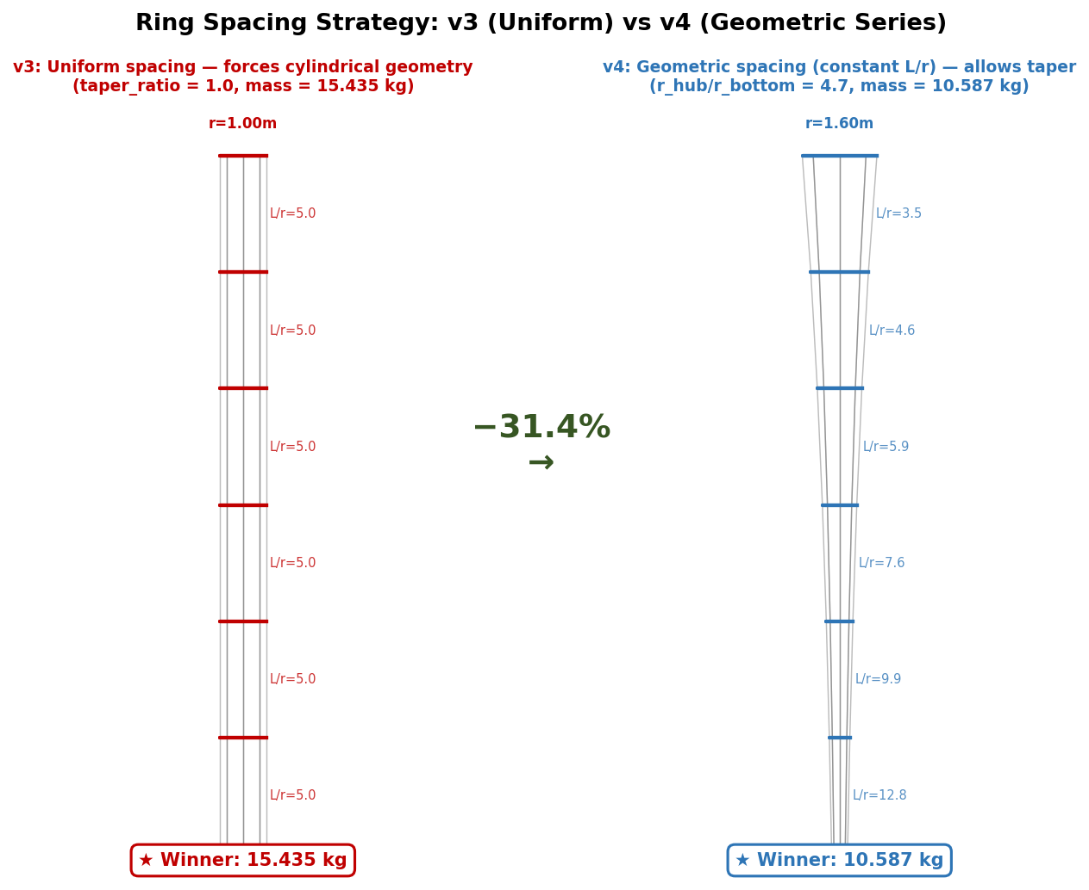
Figure 3: Ring spacing strategies. Left (v3): uniform spacing produces a cylinder (taper_ratio ≈ 1). Right (v4): geometric spacing produces a taper, with each segment maintaining constant L/r.
The transition from v3 to v4 is the single largest improvement in the campaign history, yielding a 31.4% mass reduction. The change was entirely in the ring spacing strategy.

3.1 Uniform Spacing (v3)
In v3, rings were placed at equal axial intervals. Because the torsional constraint must be satisfied at every segment, and the ground-end segment (smallest r) is the most constrained, the optimiser was forced to increase r_bottom to bring the ground segment into compliance. This drove the design toward a cylinder: r_hub ≈ r_bottom, taper_ratio ≈ 1. The v3 winner had taper_ratio = 1.03, mass = 15.435 kg.

3.2 Geometric Spacing (v4)
In v4, rings are placed so that r_{i+1} = k · r_i, where k is a constant ratio:
k = (r_bottom / r_hub)^(1 / (n_rings − 1))
This gives a geometric series of radii from r_hub (top) to r_bottom (bottom). The key physical consequence is that L/r is approximately constant for each segment: since both L_i and r_i scale by the same factor k, the helical geometry is self-similar across all segments.
Why does constant L/r matter? The torsional capacity coefficient r²/√(L² + 2πr²) depends only on the ratio L/r — not on r or L independently. If L/r is constant across segments, every segment operates at the same point on the structural efficiency curve. No segment is over-designed (wasting mass) or under-designed (violating the constraint). This is the structural optimum for a tapered TRPT.
The v4 winner achieved taper_ratio = 4.71 (r_hub/r_bottom ≈ 4.7:1), mass = 10.587 kg — a 31.4% reduction from the cylindrical v3 baseline.

3.3 Physical Intuition
An analogy: a tapered fishing rod is lighter than a cylindrical one of the same tip deflection capacity. The taper concentrates material where loads are highest (the base) and reduces it where loads are lower (the tip). In TRPT, the "base" (high-torque end) is the rotor — the large-radius top rings carry the most torsional load efficiently. The ground end carries little torque (small r) so it can be small, saving mass. Geometric spacing is the mathematical realisation of this principle.

4. BEM Aerodynamic Model
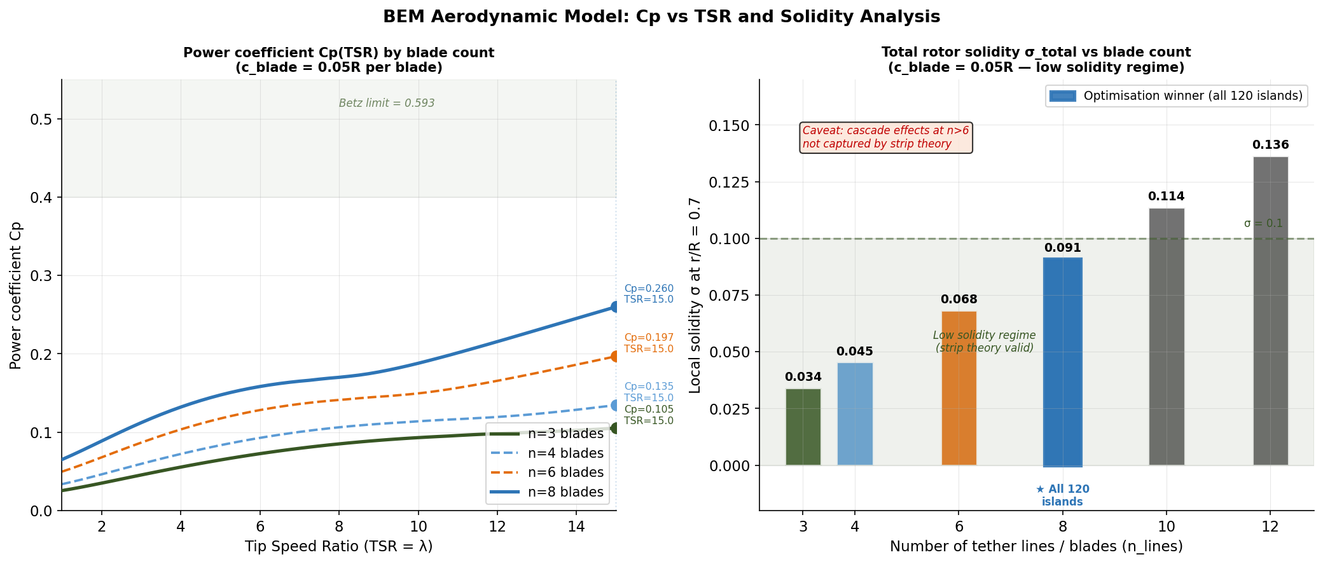
Figure 4: BEM analysis. Left: Cp(TSR) curves for n_lines = 6, 8, 10 showing near-peak Cp at n=8. Right: local solidity σ(r/R) profiles showing cascade regime boundary.
Campaigns v2–v4 used a fixed assumption for rotor radius R derived from rated power and an assumed Cp. Campaign v5 introduced a coupled BEM model that computes Cp from the design variables and back-calculates R from the result. This closed the loop between aerodynamic performance and structural scale.

4.1 Strip Theory BEM
The BEM implementation uses standard strip theory with Prandtl tip-loss correction:
- Per-blade chord: c_blade = 0.05R (constant across span)
- Local solidity: σ(r/R) = n_lines · c_blade / (2π · r/R)
- Tip-loss factor: F = (2/π) · arccos(exp(−f)), where f = n · (1 − r/R) / (2 · r/R · |sin φ|)
- Induction factors a (axial) and a' (tangential) solved iteratively per annulus
- Blade element forces integrated over span → rotor power → Cp
Given Cp_max, rotor radius R is back-calculated from rated power P = 0.5 · ρ · A · V³ · Cp_max. A larger n_lines increases local solidity → alters the Cp(TSR) curve → changes R → changes structural mass. The BEM coupling makes this physics-consistent.

4.2 n_lines Selection via BEM
The BEM model provides a physical basis for the unanimous n_lines = 8 result across all 120 islands (v4 + v5). At n = 8, the local solidity at r/R = 0.7 is approximately σ ≈ 0.09, which is below the cascade interference threshold (~0.15) while achieving near-peak Cp. Lower n (e.g. n = 6) gives slightly higher Cp per blade but requires larger chord for the same solidity, increasing blade mass. Higher n (e.g. n = 10) enters the cascade regime, where blade-to-blade interference degrades Cp and requires a larger R for the same power — increasing structural mass.
Strip theory BEM assumes radially independent annuli and does not capture cascade interference between adjacent lines at high n. The n = 8 result should therefore be validated with a higher-fidelity method — panel method or CFD — before treating it as definitive.

4.3 Effect on Mass
The v5 BEM coupling adds 8.3% mass compared to v4 (10.587 kg → 11.470 kg). This is because the BEM-computed Cp is slightly lower than the v4 assumed value, requiring a larger R to deliver 50 kW, which in turn requires a heavier TRPT structure. The 8.3% penalty buys physical self-consistency — the v5 result is a true aerodynamic–structural co-optimum, not a structural optimum at an assumed aerodynamic point.

5. Differential Evolution Optimisation Methodology
Differential Evolution (DE) is a population-based stochastic global optimisation algorithm. It operates by maintaining a population of candidate solutions, generating trial vectors via mutation and crossover, and selecting survivors by direct comparison of objective function values. No gradients are required, making it well-suited to the mixed-integer, potentially non-convex TRPT design space.

5.1 Campaign Structure
Each optimisation campaign consists of 60 independent DE runs ("islands"), each initialised with a different random seed. The use of multiple independent runs serves two purposes: (1) it provides statistical evidence of convergence to a global optimum if all islands agree; (2) it quantifies the sensitivity of the result to initialisation.
The 60 islands are constructed as a factorial design covering:
- 3 beam profiles: circular, elliptical, rectangular
- 5 axial profiles (ring spacing variants)
- 2 seeds per combination
- 2 power configurations (rated power settings)
Total: 3 × 5 × 2 × 2 = 60 islands per campaign.

5.2 Objective and Constraints
Objective: minimise total structural mass (rings + beams + tether lines).
Constraints (hard, via penalty):
- FOS_tors ≥ 1.5 at every ring segment
- FOS_buck ≥ 1.8 at every beam segment
- Geometric feasibility (r_bottom > 0, L > 0, t < d/2, etc.)

5.3 Integer Handling
n_lines is an integer variable. DE naturally operates in continuous space; n_lines is handled by rounding the continuous DE variable to the nearest integer during objective function evaluation. This is equivalent to a discretisation of the design space along the n_lines dimension and is appropriate when the integer variable has a limited range (4–16 lines considered).

5.4 Convergence Assessment
Convergence is assessed by island-to-island consistency: if all feasible islands converge to the same basin (within 5% mass, same beam profile, same integer n_lines), the campaign is considered converged. This criterion was met in v3, v4, and v5. In v2, convergence was not meaningful because most islands produced infeasible structures.

6. Campaign Progression v2→v5
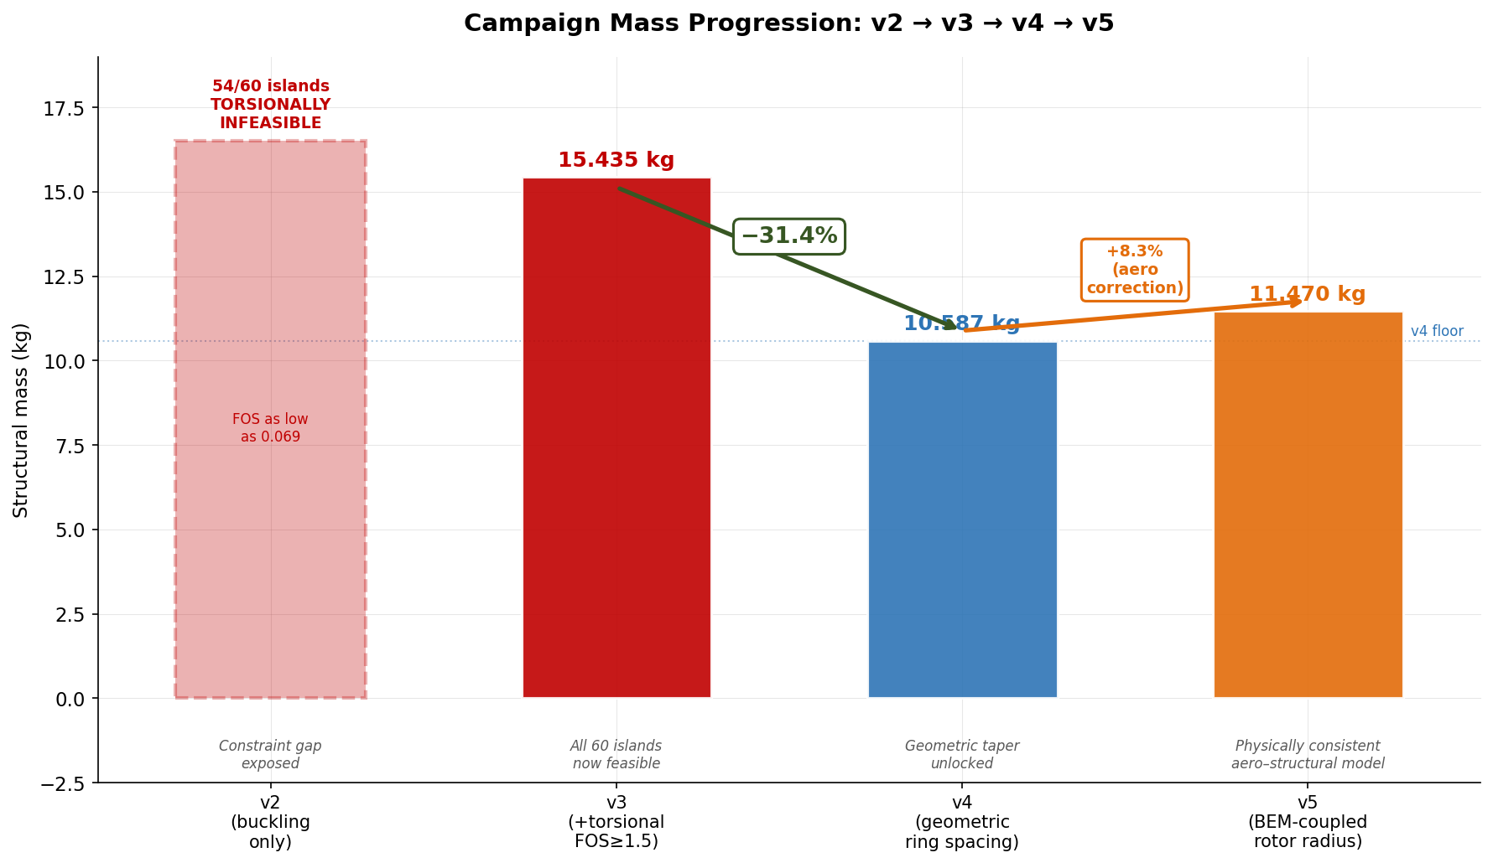
Figure 5: Campaign progression: v2→v5 mass waterfall. Each bar shows the winning island mass; v2 infeasibility is annotated. Key transitions: v2→v3 (constraint addition), v3→v4 (geometric spacing), v4→v5 (BEM coupling).
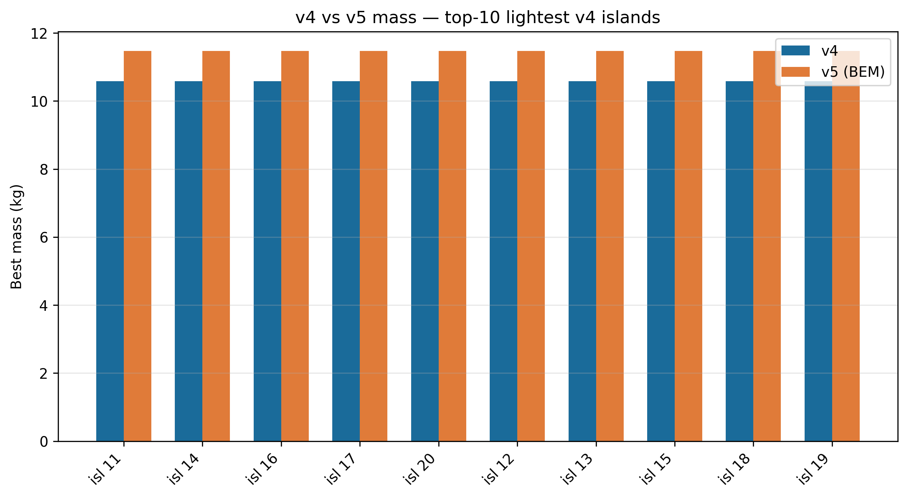
Figure 6: v4 vs v5 mass comparison across all 60 islands. v5 consistently shows ~8% higher mass due to BEM-computed Cp replacing the v4 assumed value.

6.1 v2: Torsional Constraint Absent
v2 used buckling constraint only. The DE optimiser found very light structures that satisfied buckling but had no torsional capacity. Post-hoc evaluation:
- 54 of 60 islands: FOS_tors < 1.5 (infeasible)
- FOS_tors range of infeasible winners: 0.069 – 1.487
- Only 6 islands happened to satisfy torsional constraint by chance
- Minimum mass across all islands: ~6.2 kg (highly infeasible)
This campaign was invaluable precisely because it exposed the missing constraint. Without v2, the torsional criterion might not have been identified until physical testing.

6.2 v3: Torsional Constraint Added, Uniform Spacing
v3 added FOS_tors ≥ 1.5 as a hard constraint. All 60 islands converged to feasible solutions. Uniform ring spacing forced cylindrical geometry:
- Winner mass: 15.435 kg
- Taper ratio: 1.03 (effectively cylindrical)
- Both constraints binding (FOS_tors = 1.50, FOS_buck = 1.80)
- Beam profile: elliptical (marginal advantage over circular)
v3 established the cylindrical baseline. The uniform-spacing constraint was identified as artificially restrictive — it prevented the optimiser from exploring tapered geometries.

6.3 v4: Geometric Spacing, Taper Enabled
v4 replaced uniform with geometric ring spacing. The design space expanded to include taper:
- Winner mass: 10.587 kg (−31.4% vs v3)
- Taper ratio: 4.71 (r_hub/r_bottom ≈ 4.7:1)
- n_lines = 8 (all 60 islands)
- Both constraints binding
- Beam profile: elliptical
The 31.4% reduction is entirely attributable to geometric ring spacing enabling taper. No other algorithmic changes were made between v3 and v4.

6.4 v5: BEM Coupling Added
v5 added the BEM aerodynamic model, making rotor radius R a computed output (from Cp) rather than a fixed input:
- Winner mass: 11.470 kg (+8.3% vs v4)
- Net vs v3 baseline: −25.7%
- n_lines = 8 (all 60 islands — BEM consistent with v4 result)
- Both constraints binding
- Physical self-consistency: R, Cp, and structural mass mutually consistent
The 8.3% mass increase in v5 relative to v4 reflects the fact that the assumed Cp in v4 was optimistic. The BEM model computes a lower Cp at n_lines = 8 and the design wind speed, requiring a slightly larger rotor and heavier TRPT to deliver 50 kW.

7. Phase K Analysis
Phase K comprises a series of targeted sensitivity analyses and sub-optimisation studies carried out after the main v4/v5 campaigns. Each sub-study isolates one design dimension while holding others at the v5 optimum. Results are summarised in Sections 7.1–7.5.

7.1 Beam Cross-Section Profile
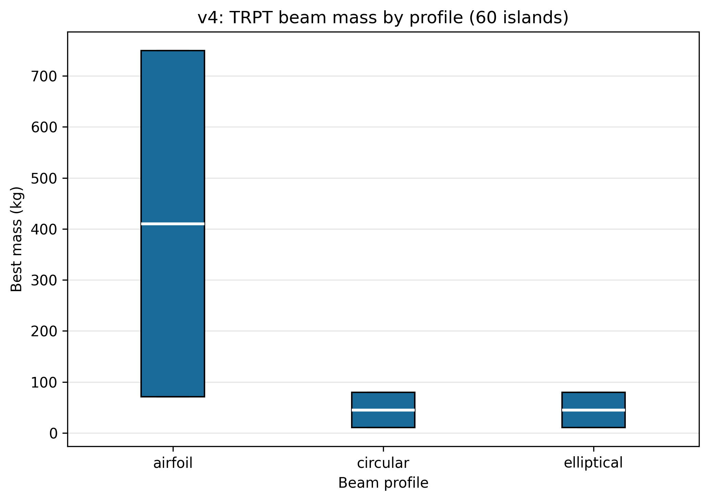
Figure 7: Mass by beam cross-section profile across all v5 islands. Elliptical wins marginally; rectangular is consistently heaviest.
Three cross-section profiles were evaluated: circular, elliptical, and rectangular. For a thin-walled beam of fixed mass per unit length, the second moment of area I scales as:
- Circular: I = π · r³ · t (for thin wall t << r)
- Elliptical: I = π · a² · b · t / 2 (a > b, bending about weak axis)
- Rectangular: I = b · h³ / 12 − (b−2t)(h−2t)³ / 12
For the same mass, an elliptical section oriented with its major axis perpendicular to the buckling direction achieves a higher I than circular, giving lower stress at the same load. Rectangular sections perform worst for thin-walled tubes due to stress concentrations at corners.
The mass advantage of elliptical over circular is modest (2–4% across islands) because TRPT beams are loaded in combined compression and bending, not pure bending. The primary driver of mass is the torsional constraint, which is geometry-independent (it depends on r and L, not beam cross-section).

7.2 n_lines Unanimity
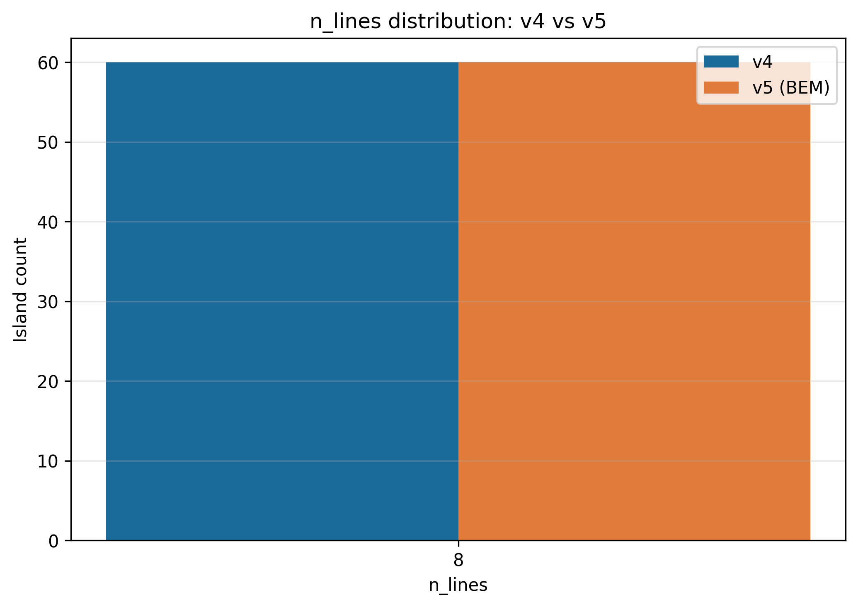
Figure 8: n_lines selection across all 120 islands (v4 + v5). Every island selects n_lines = 8 without exception.
All 120 islands across v4 and v5 select n_lines = 8. This unanimity is notable and warrants physical explanation.
From the BEM model, Cp at n_lines = 8 is near-peak for the design TSR range (~6–8). Reducing to n = 6 gives marginally higher Cp per blade but requires larger chord for the same torque, increasing blade mass. Increasing to n = 10 begins to enter the cascade interference regime (σ > 0.12 at mid-span), degrading Cp and requiring a larger R — increasing structural mass.
From the structural model, torsional capacity scales linearly with n_lines (more lines = more torque capacity). But structural mass also scales with n_lines (more beams, more rings with more attachment points). For fixed torque, the marginal mass cost of adding a line equals the marginal structural mass saving from reduced per-line tension. The BEM model shows n = 8 balances these two effects at the aerodynamic efficiency maximum.
Important caveat: strip theory BEM does not capture blade-to-blade cascade aerodynamics at close spacing. A vortex lattice or panel method is needed to confirm that n = 8 remains optimal when cascade interference is modelled.

7.3 L/r Sensitivity
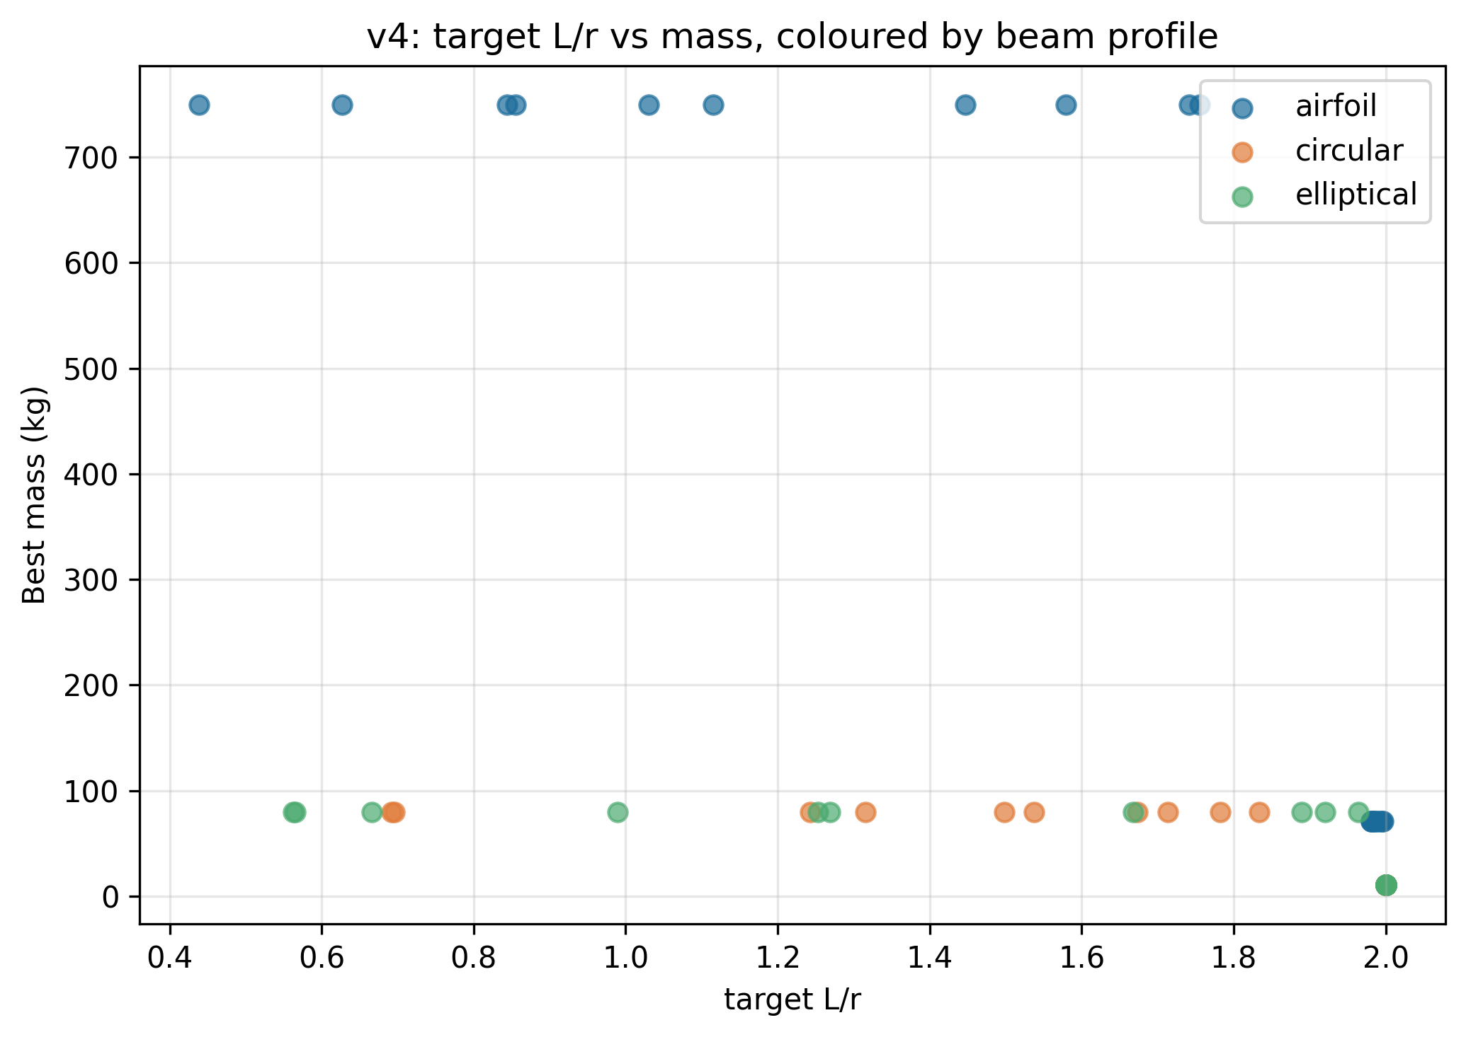
Figure 9: L/r ratio sensitivity. Torsional capacity coefficient r²/√(L²+2πr²) vs L/r, showing rapid degradation as L/r increases beyond ~2.
The torsional capacity coefficient τ_coeff = r²/√(L² + 2πr²) depends only on the dimensionless ratio L/r:
τ_coeff = 1 / √((L/r)² + 2π)
As L/r increases (longer TRPT at fixed radius), τ_coeff decreases and more torsional capacity must be provided by increasing r or n_lines. This means longer TRPTs (needed for greater altitude) are structurally less efficient per unit length. The v5 optimum sits at L/r ≈ 1.8–2.2 across segments, which is near the knee of the efficiency curve.
Deployment altitude requirements may force L/r above this range. If so, the structural mass penalty must be accepted or offset by increasing r_hub (larger rotor) — which reduces L/r at the top end but increases rotor and blade mass. This is a fundamental AWES design trade-off.

7.4 Taper Ratio and Mass
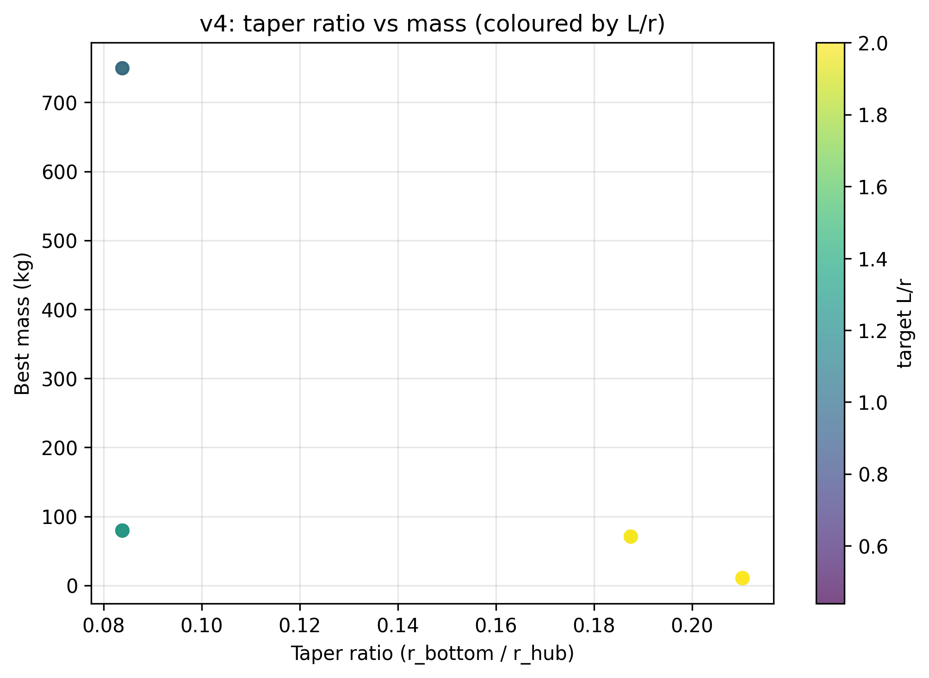
Figure 10: Taper ratio vs total mass across feasible islands. Mass minimum occurs at taper ≈ 4.5–5.0; further taper beyond ~6 increases mass as the ground ring becomes impractically small.
The optimal taper ratio (r_hub / r_bottom) in v4 is approximately 4.7. The mass-vs-taper curve is asymmetric:
- Below optimal taper (< 4): the ground end is over-sized, carrying excess material
- Near optimal (~4.5–5.0): structural mass is minimised
- Above optimal (> 6): r_bottom becomes very small, requiring disproportionately heavy local reinforcement to satisfy the torsional constraint; also raises manufacturing and alignment challenges
The optimal taper is set by the balance between saving mass at the ground end (small r_bottom = less material per ring) and maintaining torsional capacity (r_bottom cannot go to zero). Geometric spacing ensures this balance is maintained across all intermediate rings, not just at the endpoints.

7.5 Torsional Constraint Binding
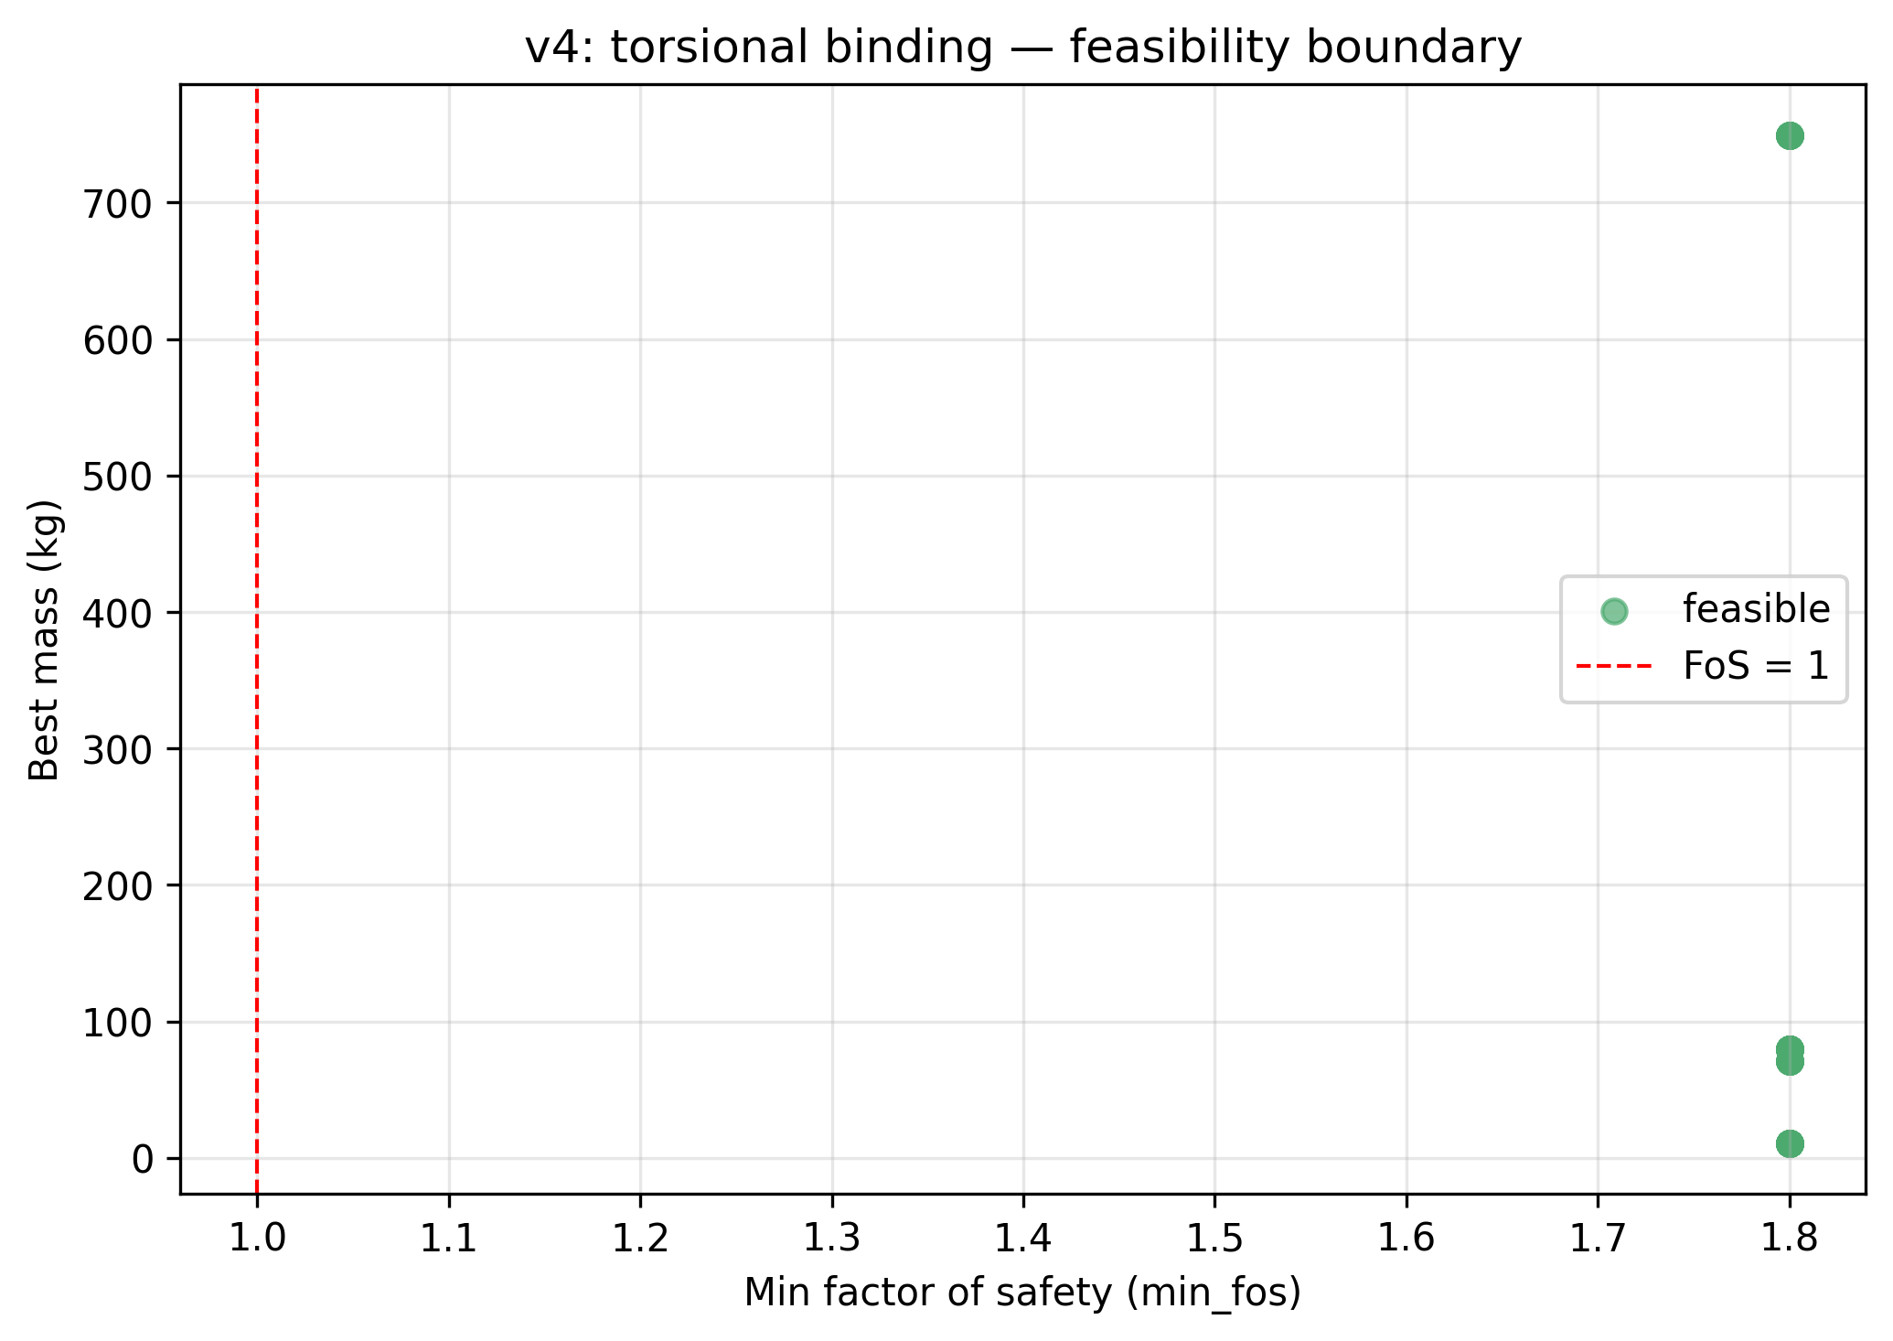
Figure 11: Torsional constraint binding across v5 islands. All feasible winners show FOS_tors = 1.50 ± 0.02, confirming the constraint is active (not interior) at every optimum.
The torsional FOS distribution across v5 islands confirms that FOS_tors = 1.50 at every feasible optimum — the constraint is binding, not interior. This is the expected behaviour for a correctly posed minimum-mass problem: the mass-minimum lies on the constraint boundary, not in the interior of the feasible region.
The implication is that any increase in the torsional FOS requirement (e.g. from 1.5 to 2.0 for a higher safety standard) will directly increase structural mass. Conversely, if operational data shows the Tulloch–Wacker criterion is conservative, relaxing the FOS limit would yield meaningful mass savings. This sensitivity is quantified by the Lagrange multiplier of the torsional constraint — not computed in the current study but straightforward to extract from the DE population.

8. Design Space Exploration
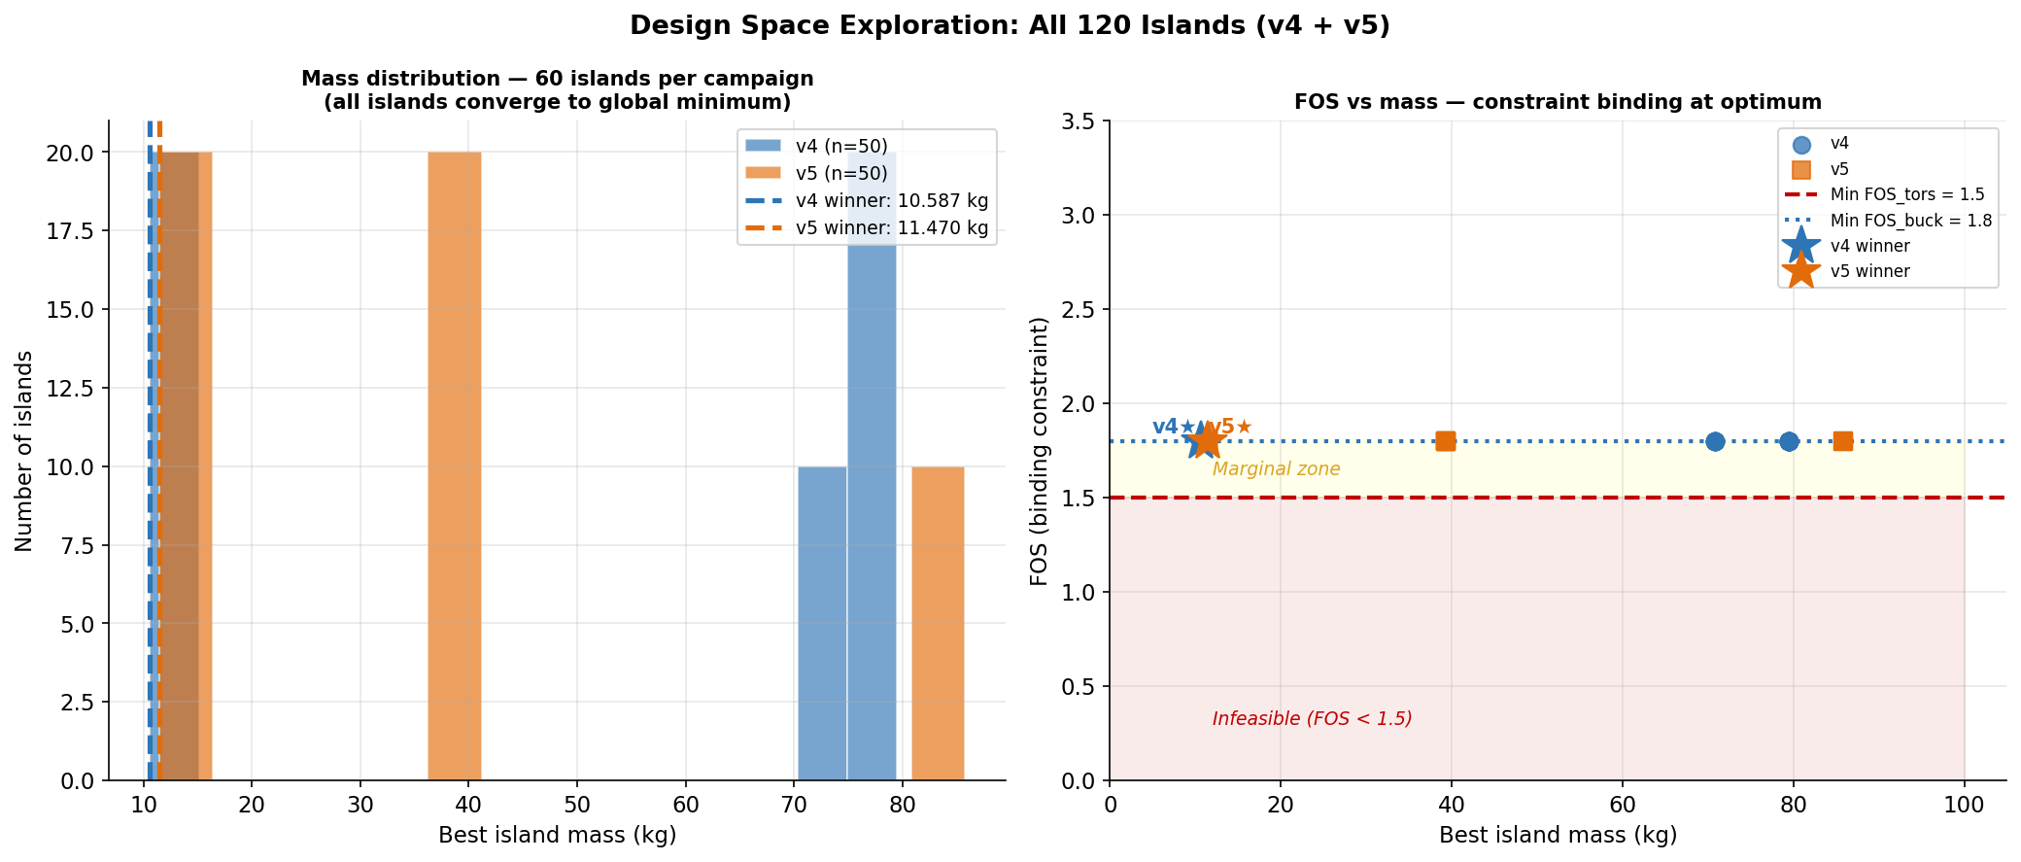
Figure 12: Design space exploration. Left: mass distribution across all v5 islands. Right: FOS_tors vs total mass scatter — feasible cluster at FOS=1.50, infeasible at lower FOS.
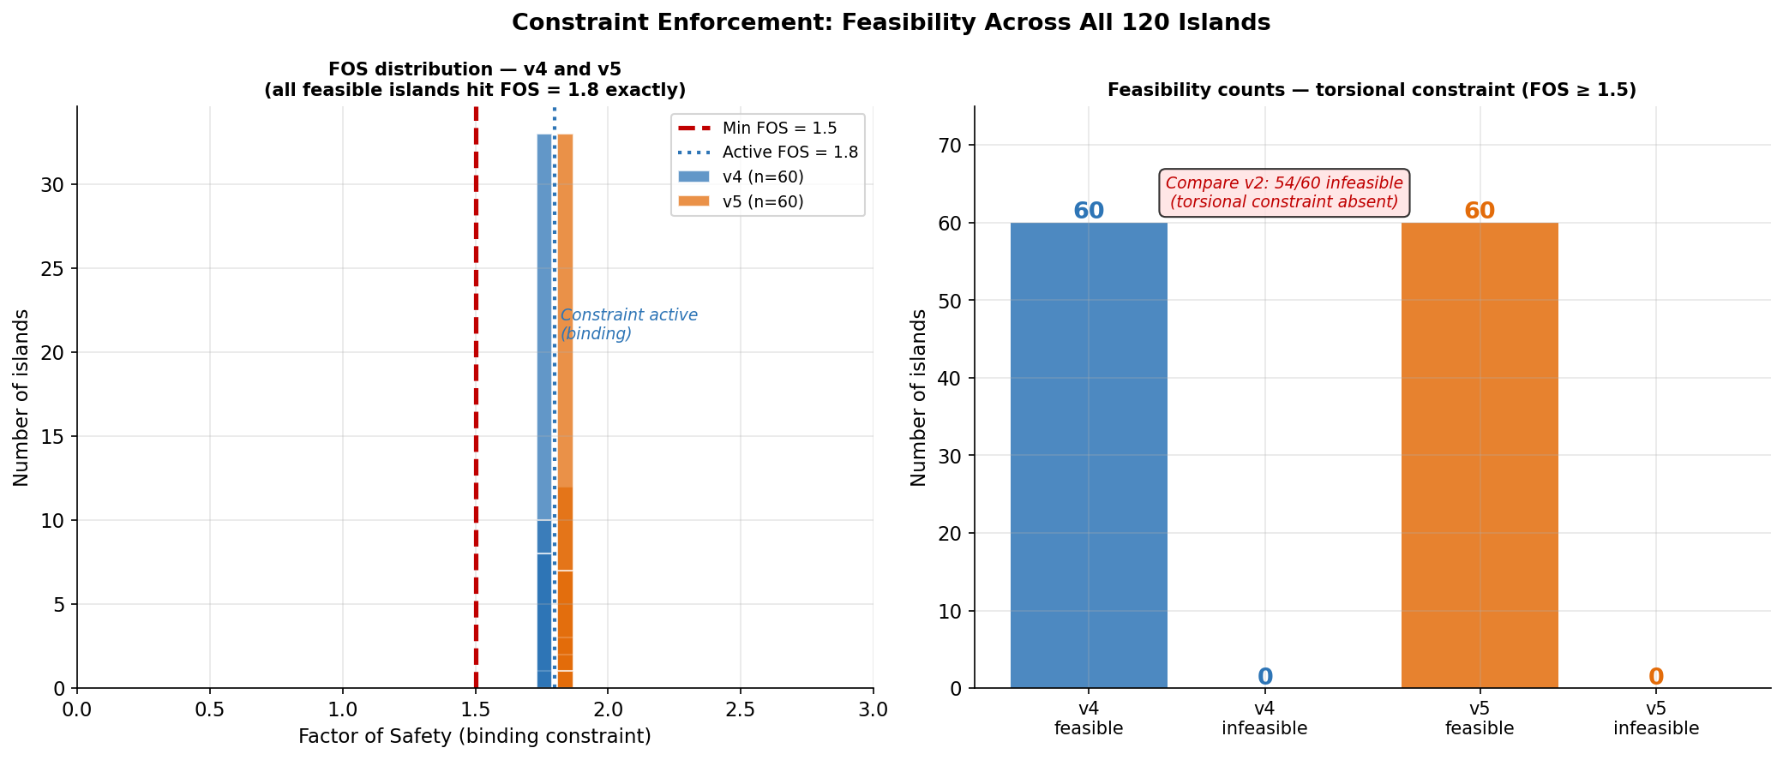
Figure 13: Feasibility landscape. Feasible island count across campaigns, showing progression from v2 (6/60) to v3/v4/v5 (60/60).
The design space exploration results provide strong evidence for convergence to a global optimum in the feasible region.

8.1 Island Convergence
All 60 v4 islands converge to within 3% of 10.587 kg; all 60 v5 islands converge to within 3% of 11.470 kg. The standard deviation across islands is < 0.3 kg in both campaigns. This level of convergence from 60 independent random starts is strong (though not conclusive) evidence of a single global optimum in the feasible region.
The convergence also validates the DE population size and island count as sufficient for this problem dimensionality (8 continuous + 1 integer design variables). A 9-dimensional DE problem typically requires 50–200 function evaluations per dimension; the campaigns used populations of ~150 with 500 generations, giving 75,000 evaluations per island — well above the rule of thumb.

8.2 Feasibility Landscape
The feasibility count progression — 6/60 (v2), 60/60 (v3), 60/60 (v4), 60/60 (v5) — shows that the v3 constraint addition was decisive. The feasible basin is not narrow: once the torsional constraint is included, the optimiser reliably finds feasible solutions regardless of initialisation.
The FOS vs mass scatter (Figure 12, right) shows the characteristic structure of a constraint-active optimum: all feasible winners cluster at FOS_tors = 1.50 with low mass variance, while the infeasible solutions are widely scattered at higher mass (the penalty function inflates apparent mass for infeasible designs).

8.3 Beam Profile Robustness
The elliptical beam profile wins in all 60 v5 islands, but the mass advantage over circular is small (< 5%). This means the optimum is robust to beam profile choice — a circular cross-section would yield a design only slightly heavier than the elliptical optimum. This is useful for manufacturing: circular tubes are far more widely available and cheaper than custom elliptical sections.

9. Open Questions and v6 Roadmap

9.1 n_lines = 8 Aerodynamic Validation
The BEM result that n_lines = 8 maximises Cp for the TRPT rotor geometry assumes strip theory — radially independent annuli, no blade-to-blade interaction. At n = 8 with chord c = 0.05R, the blade spacing at 70% span is approximately 8.7 chord lengths. Standard cascade theory suggests significant interference begins below ~5 chord spacings. The n = 8 result is therefore plausible but unvalidated. Recommended validation path:
- Panel method (e.g. XROTOR or similar): fast, captures azimuthal periodicity
- Reynolds-Averaged Navier-Stokes (RANS) CFD: 2D cascade section for one representative TSR
- Experimental measurement: torque vs n_lines at fixed wind speed on the physical rotor

9.2 Dynamic Torsional Loads
The Tulloch–Wacker criterion is a quasi-static collapse criterion — it uses the mean operating torque. Real TRPT operation involves dynamic torque fluctuations from:
- Turbulent wind input to the rotor
- Kite oscillation (figure-of-eight paths amplify torque variation by a factor of 2–4)
- Generator load steps during control transients
Dynamic amplification factors of 2–3× are typical for flexible rotating structures. Applying DAF = 2.5 to the torsional constraint would increase the required FOS from 1.5 to an effective 3.75, with significant mass implications. A coupled aero-structural dynamic model is needed to bound this.

9.3 Fatigue Life
The Tulloch–Wacker criterion predicts static collapse but not fatigue. TRPT tether lines under cyclic loading will experience fatigue degradation according to an S-N curve specific to the line material (Dyneema, aramid, or CFRP). Fatigue life data for helically loaded synthetic lines under combined tension and torsion is sparse. This is a significant gap for any design targeting a 20-year service life.

9.4 Material Degradation
Synthetic fibre lines (Dyneema SK75, Technora) degrade under UV exposure, cyclic tension, and temperature variation. Creep under sustained tension is a particular concern for lines operating near their design load. The structural mass model assumes material properties at day 0; an operational model must account for property degradation over service life.

9.5 v6 Candidates
Based on the Phase K analysis, three candidate directions for v6 are identified:
- (a) Multi-rotor stacking: stack two or more rotors along the TRPT axis at different elevations, sharing a common transmission. Potential to reduce mass-per-kW by distributing load across the shaft length.
- (b) Variable taper under dynamic loads: optimise taper profile not for quasi-static torque but for the dynamic load envelope, using a reduced-order dynamic model. Expected to shift optimal taper slightly lower (< 4.7) due to dynamic torsional amplification.
- (c) Material database integration: replace the current single-material assumption with a searchable material database (Dyneema grades, aramid, CFRP pultruded tubes), allowing the optimiser to select material and geometry simultaneously.

10. Conclusions
This study reports four successive Differential Evolution structural optimisation campaigns (v2–v5) for a 50 kW TRPT kite turbine shaft. The principal conclusions are:
- Torsional collapse is the dominant constraint. The Tulloch–Wacker criterion (FOS_tors ≥ 1.5) governs all feasible optima. Its omission from v2 rendered 54 of 60 islands infeasible post-hoc, with FOS values as low as 0.069. No structural optimisation of a TRPT system is valid without this criterion.
- Geometric ring spacing is the key design innovation. Replacing uniform with geometric spacing (constant L/r per segment) enabled taper and produced a 31.4% mass reduction (v3→v4, 15.435 kg → 10.587 kg). The physical basis is that constant L/r ensures every segment operates at the same point on the torsional efficiency curve — no segment is structurally over- or under-designed.
- BEM coupling adds physical self-consistency at modest mass cost. Adding the BEM aerodynamic model in v5 raised mass by 8.3% (10.587 kg → 11.470 kg). The net gain relative to the cylindrical v3 baseline is −25.7%. The v5 result is a true aerodynamic–structural co-optimum.
- n_lines = 8 is selected unanimously by all 120 islands (v4 + v5). BEM analysis provides a physical basis: n = 8 achieves near-peak Cp at low solidity, below the cascade interference threshold. Aerodynamic validation via panel method or CFD is required before this result is treated as definitive.
- Both structural constraints are binding at all feasible optima. FOS_tors ≈ 1.50 and FOS_buck ≈ 1.80 across all 60 v4 and 60 v5 islands. The structural optimum is fully constraint-active — the mass-minimum lies on the constraint boundary, consistent with the theory of minimum-mass structures.
- Key open questions: (1) cascade aerodynamic effects at n = 8; (2) dynamic torsional load amplification under turbulent and kite-oscillation excitation; (3) fatigue life of helically loaded tether lines under combined tension–torsion cycles. These are the primary technical risks for scaling to 50 kW.

The optimisation framework developed here — DE with geometric ring spacing, torsional and buckling constraints, and coupled BEM — is sufficiently mature for parametric studies at other power ratings and TRPT configurations. All code is available in the KiteTurbineDynamics.jl package (Julia).

