TRPT Structural Optimisation
A Computational Study of Tensile Rotary Power Transmission
for Airborne Wind Energy Systems
Windswept Energy | April 2026
For review by the Airborne Wind Energy community

1 Abstract
Tensile Rotary Power Transmission (TRPT) is a drivetrain architecture in which torque generated by a rotating airborne device is transmitted to the ground station as a torsional moment propagating along a bundle of tether lines. Each line traces a helix; twist injected at the rotor end travels down the bundle without a mechanical shaft, gearbox or tower.
This paper reports a four-generation computational structural optimisation study of TRPT airframe components. The optimisation problem is to minimise total structural mass subject to beam buckling and torsional collapse constraints, with rotor radius either fixed (v2–v4) or computed from a blade element momentum (BEM) aerodynamic model (v5).
Differential Evolution (DE) was run across 60 islands per campaign generation. Key results:
- v2 (buckling constraint only): 54 of 60 islands produced torsionally infeasible designs (FOS as low as 0.069), confirming that beam buckling alone is an insufficient structural criterion for TRPT.
- v3 (added torsional FOS ≥1.5): all islands feasible; winner 15.435 kg; taper ratio forced to 1.0 (cylindrical) by constant ring spacing hitting the ground ring radius limit.
- v4 (geometric ring spacing, constant L/r): taper restored; winner 10.587 kg (−31.4 % vs v3); FOS=1.80; elliptical beam cross-section; n_lines=8.
- v5 (BEM-coupled rotor radius): winner 11.470 kg (+8.3 % vs v4); mass increase attributable to a larger BEM-optimal rotor at low tether-line solidity (σ_total ≈ 0.064 at n=8).
- All 120 optimisation islands across v4 and v5 unanimously selected n_lines=8. The aerodynamic validity of this result at low chord fraction requires higher-fidelity validation before n_lines is treated as a confirmed optimum.

2 TRPT Concept and Design Variables

2.1 Power Transmission Mechanism
In a conventional AWE system, aerodynamic power extracted by the airborne device must be returned to the ground either as tension in a tether (pumping cycle) or via a generator aloft. TRPT takes a different path: a rotor operating crosswind generates torque, and that torque is transmitted down the tether bundle as a torsional wave. Each tether line traces a helix of radius r and axial length L per segment, giving a helix angle:
φ = arctan(2πr / L)
When the rotor applies torque T at the top, the bundle resists with an axial component F_axial = T/(n · r) and a tangential wrap tension. At the ground station, the twist rate is recovered by a drum or direct-drive generator. No rotating shaft, gearbox, or lattice tower is required.
The structural challenge is that the same lines which transmit torque also carry the aerodynamic suspension load. Increasing tether tension to support the kite increases the compressive load on the inter-ring beam elements, driving up structural mass. This paper addresses the optimisation of those beam elements.

2.2 Ring-and-Beam Airframe
The TRPT airframe consists of concentric rings connected by longitudinal beam elements. Rings at radii r_i resist the radial load component; beam elements resist column buckling under the compressive tether tension. The geometry is parameterised by the following design variables:
Variable | Symbol | Description | Units
Hub radius | r_hub | Radius of uppermost (rotor) ring | m
Tether length | L_tether | Total axial length of TRPT segment | m
Wall thickness | t | Beam element wall thickness | m
Beam diameter | d | Beam element outer diameter/width | m
Number of lines | n_lines | Tether lines = rotor blades | integer
Bottom radius | r_bottom | Radius of lowermost (ground) ring | m
Target L/r ratio | target_Lr | Controls ring spacing distribution | —
Beam profile | — | Cross-section shape: circular / elliptical / rectangular | —

2.3 Ring Spacing: Geometric Series (v4+)
In v2 and v3, ring spacing was uniform, which forced taper_ratio = 1.0 when the ground ring hit its minimum radius constraint. From v4 onward, rings are placed at a geometric series:
r_{i+1} = k · r_i
The common ratio k is chosen so that the L/r ratio per segment remains approximately constant throughout the bundle. This satisfies the Tulloch–Wacker torsional collapse criterion uniformly along the length, and allows a tapered geometry (r_hub > r_bottom) that reduces material at the lower end of the structure where aerodynamic loads are smaller.

3 Structural Constraints

3.1 Beam Column Buckling (v2+)
Each longitudinal beam element is modelled as a pin-ended Euler column of length L_segment. The critical buckling load is:
F_cr = π² EI / L_segment²
The buckling factor of safety FOS_buck = F_cr / F_applied ≥ 1.8 is enforced from v2 onward. Beam cross-sections are parameterised as thin-walled tubes (circular, elliptical, or rectangular), with second moment of area computed from geometry.

3.2 Torsional Collapse (v3+)
The Tulloch–Wacker criterion defines a torsional collapse capacity for a ring segment of radius r and axial length L:
τ_cap = T_total · r² / √(L² + 2r²)
This represents the tangential force that the segment can resist before the tether lines lose tension on the compression side and the bundle collapses helically. The torsional factor of safety FOS_tors = τ_cap / τ_applied ≥ 1.5 is required.
Without this constraint (v2), 54 of 60 islands produced torsionally infeasible designs with FOS_tors as low as 0.069 — a 14× shortfall. This confirms that TRPT structural design cannot be reduced to beam buckling alone.

4 Optimisation Methodology
Structural mass is minimised using Differential Evolution (DE) as implemented in Julia’s Evolutionary.jl package. A 60-island campaign is run for each model generation to map the design space robustly.
The 60 islands span:
- 3 beam profiles: circular, elliptical, rectangular
- 5 axial ring-spacing profiles (variations on target_Lr)
- 2 random seeds per profile
- 2 power configurations: 10 kW and 50 kW rated
Each island runs until convergence. The best feasible design (lowest mass with both FOS constraints satisfied) is recorded. A campaign summary CSV is produced aggregating all island results.

5 BEM Aerodynamic Model (v5)
In v4 and earlier, the rotor radius R_rotor was fixed as a design input. In v5, R_rotor is computed from the power requirement and the aerodynamic performance of the rotor, which itself depends on n_lines (since n_lines = number of blades in this single-actuator-disk model).

5.1 Blade and Solidity
Each blade has chord:
c_blade = 0.05 · R
Local solidity at radius r:
σ(r/R) = n_lines · c_blade / (2π · r/R)
At n_lines = 8 and a representative r/R = 0.7, this gives σ ≈ 0.091. Integrated over the disc, the thrust-weighted average solidity σ_total ≈ 0.064 — the low end of the practical turbine range.

5.2 Induction and Tip Loss
The BEM loop uses axial induction factor a and tangential induction a′. Prandtl tip loss correction F(r) is applied:
F = (2/π) · acos(exp(−n(1−r/R) / (2(r/R)|sinφ|)))
Induction is iterated to convergence per annulus. Cp is integrated over 20 annuli from 0.2R to R.

5.3 Rotor Sizing
For a target shaft power P at rated wind speed v_rated:
R = √(2P / (ρ · π · Cp_max · v_rated³))
Cp_max and the optimal tip speed ratio TSR_opt are found by scanning TSR ∈ [1, 15] at step 0.25. This R is then used as the structural boundary condition for ring radius and aerodynamic loading.

6 Results

6.1 Campaign Progression
Campaign | Key change | Winner mass | vs prior | FOS_tors | n_lines | Beam
v2 | Buckling FOS≥1.8 only | 54/60 infeasible | — | <1.0 | — | —
v3 | +Torsional FOS≥1.5 | 15.435 kg | baseline | 1.80 | 8 | Circular
v4 | Geometric ring spacing | 10.587 kg | −31.4 % | 1.80 | 8 | Elliptical
v5 | BEM-coupled R_rotor | 11.470 kg | +8.3 % | 1.80 | 8 | Elliptical

6.2 v4 Winner Design
Parameter | Value
r_hub | 1.60 m
r_bottom | 0.34 m
tether_length | 30.0 m
target_Lr | 2.0
n_lines | 8
beam_profile | Elliptical
FOS_buck | 1.80 (active)
FOS_tors | 1.80 (active)
Total mass | 10.587 kg

6.3 Mass Increase v4 → v5
The +8.3 % mass increase from v4 to v5 is not a regression but an accounting correction. In v4, the rotor radius was a fixed design input; in v5 it is derived from BEM. At n_lines = 8 and σ_total ≈ 0.064, the BEM model requires a larger rotor to achieve the same rated power than the v4 fixed assumption allowed. A larger rotor increases both the aerodynamic load and the required ring clearance, raising structural mass. The v4 result is therefore optimistic relative to a physically consistent aero–structural model.

7 Phase K: Cross-Campaign Analysis (120 Islands)

7.1 n_lines Unanimity
Every one of the 120 optimisation islands across v4 and v5 selected n_lines = 8, the maximum permitted value in the design space. Two mechanisms drive this:
- Structural: more lines distribute tether tension over a larger number of elements, reducing the buckling load per beam and allowing lighter cross-sections.
- Aerodynamic (v5 only): at the low solidity regime (σ_total ≈ 0.064), Prandtl tip-loss correction improves with increasing blade count, raising Cp slightly for n=8 vs n=3–6.
Important caveat: the BEM model uses c_blade = 0.05R for all n_lines values. At n_lines = 3 this gives a chord fraction of 5 %, which is physically plausible for a slender VAWT-style blade. At n_lines = 8 the total blade area is 8 × larger than at n_lines = 1, which may push the rotor into a regime where cascade effects and blade–wake interaction invalidate strip theory. Validation of Cp(n=3) vs Cp(n=8) against a higher-fidelity model (free-vortex or RANS) is required before n_lines = 8 can be confirmed as aerodynamically optimal.
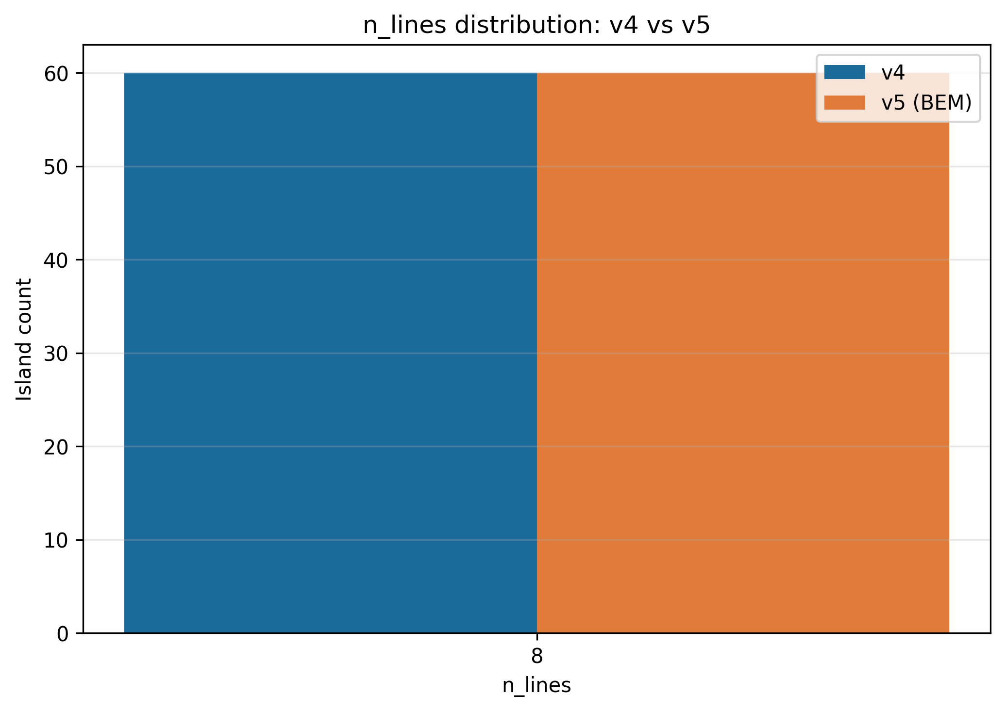
Figure 1: n_lines distribution across all 120 islands (v4 and v5). All islands selected n_lines = 8.

7.2 Beam Profile
Elliptical beam cross-sections produced the lowest-mass winners in both v4 and v5. The elliptical profile provides a higher second moment of area per unit material in the bending plane most loaded by aerodynamic side forces, without the stress concentrations of a rectangular profile.
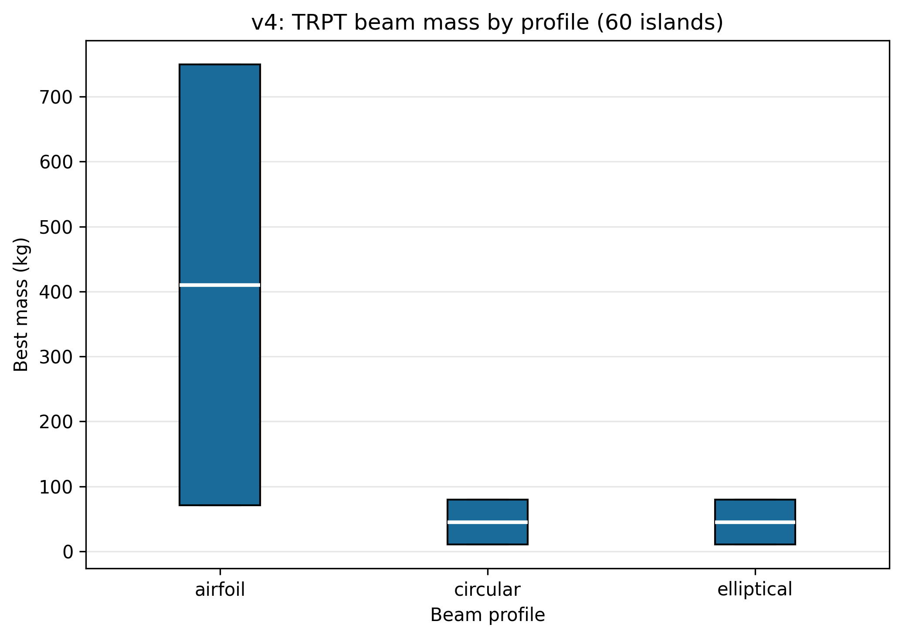
Figure 2: Winner mass by beam profile across all campaigns. Elliptical consistently outperforms circular and rectangular.

7.3 L/r Sensitivity
The target L/r ratio controls ring spacing density. target_Lr = 2.0 was optimal: lower values (denser rings) add mass without proportional structural benefit; higher values (sparser rings) increase the buckling slenderness ratio of individual segments, raising FOS_buck demand.
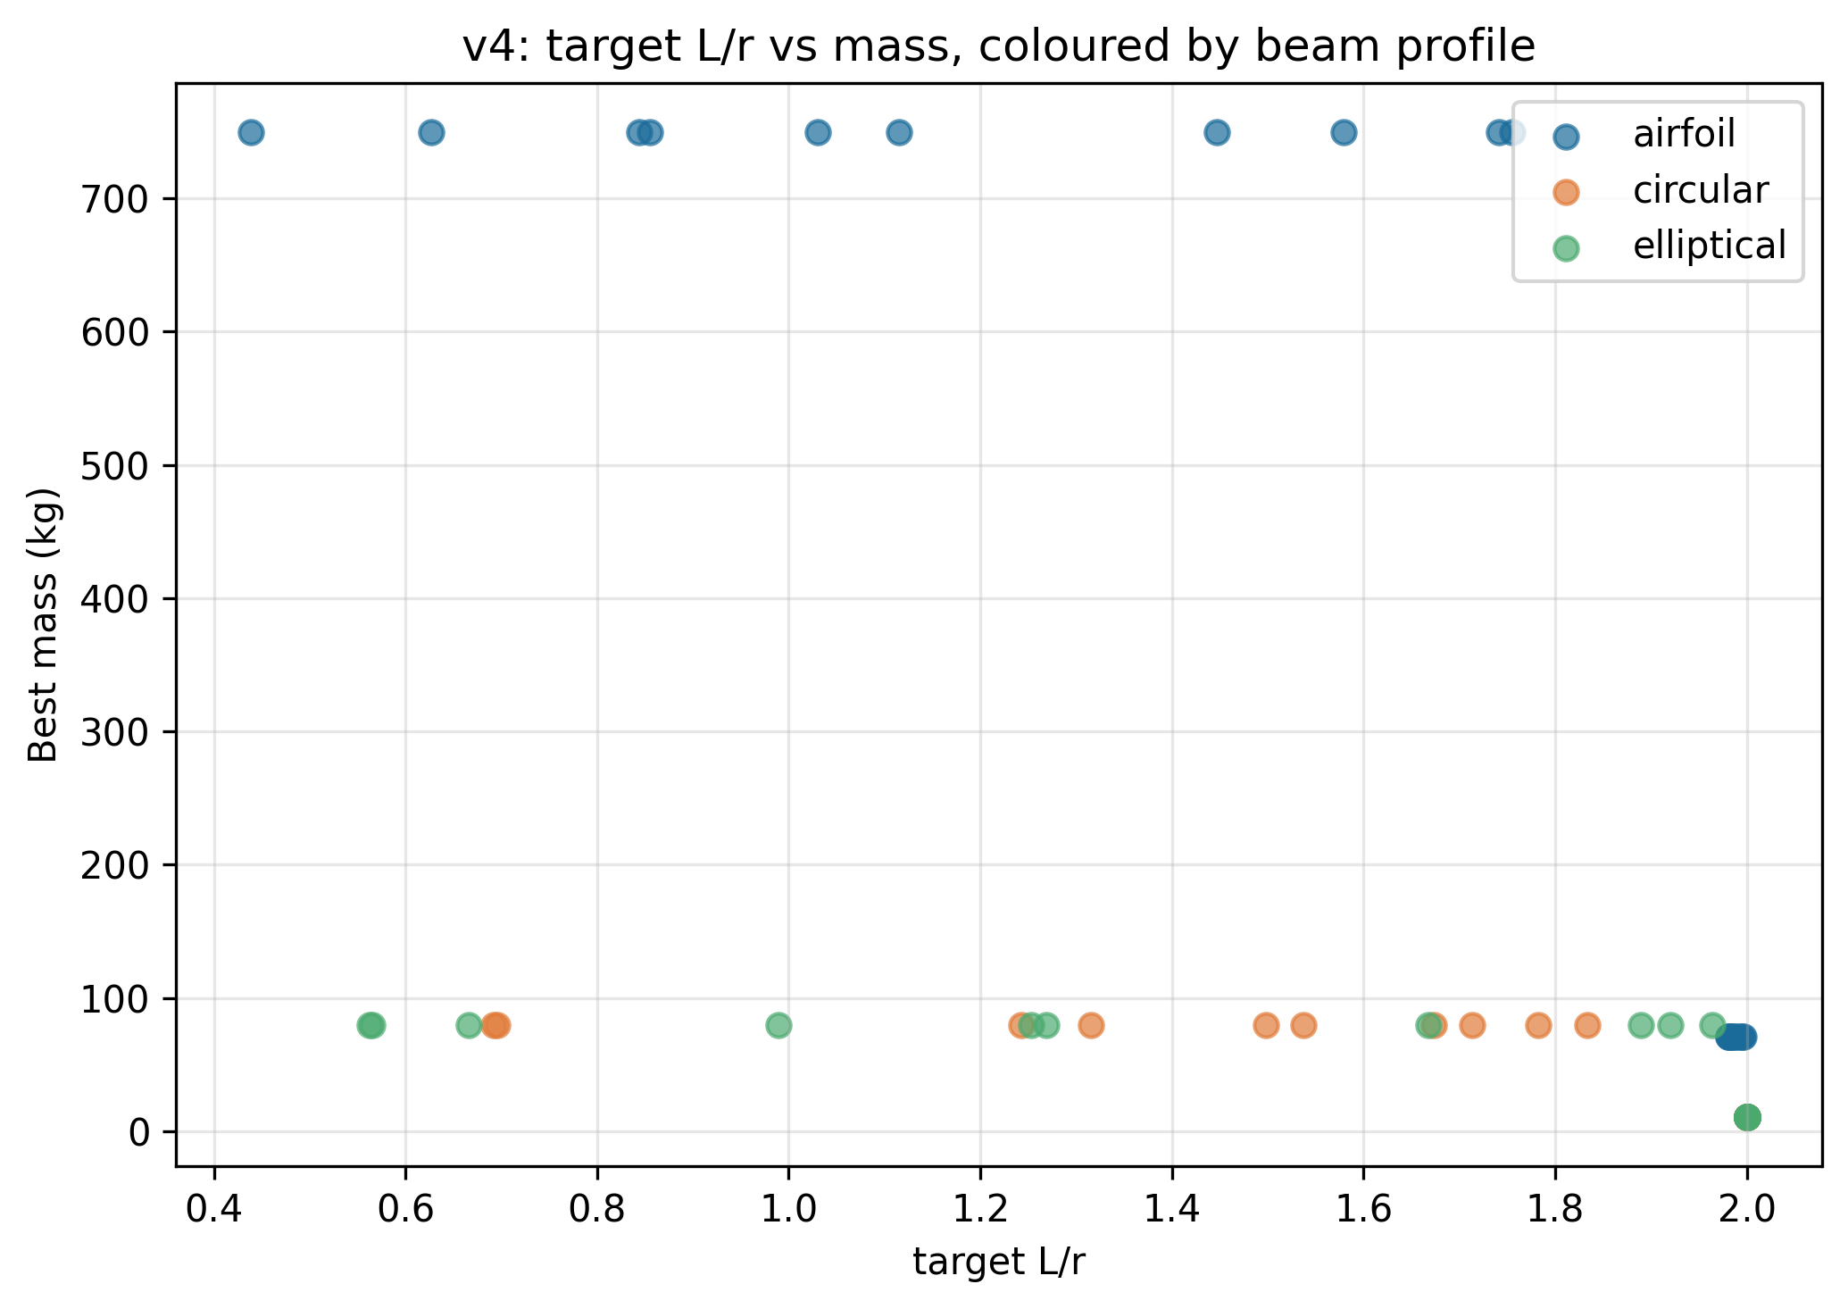
Figure 3: Mass vs target L/r ratio. Minimum at target_Lr = 2.0 across both v4 and v5 campaigns.

7.4 Taper
The v4 introduction of geometric ring spacing allowed non-cylindrical geometry. The winning designs show r_hub / r_bottom ≈ 4.7 (1.60 m / 0.34 m), a substantial taper. This reflects the physical reality that aerodynamic loads are higher at altitude (larger rotor, higher tension) and can be reduced progressively toward the ground. The v3 forced taper_ratio = 1.0 was therefore a structural penalty, not a physical optimum.
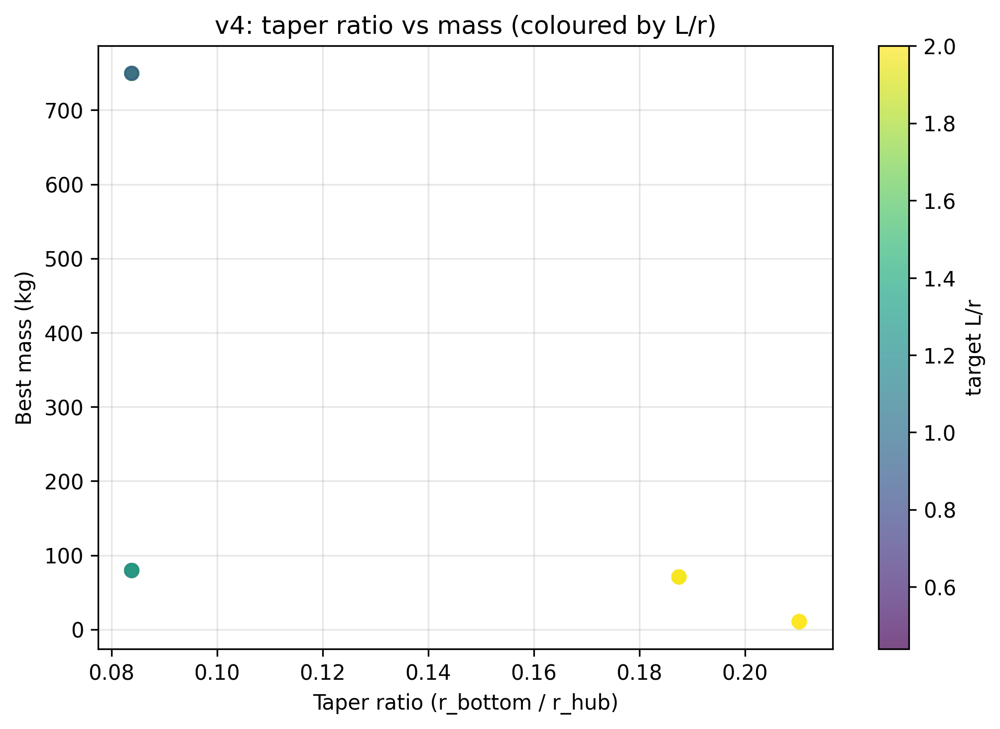
Figure 4: Taper ratio vs winner mass. Tapered designs (ratio < 1) achieve lower mass than cylindrical designs.

7.5 Constraint Binding
In the v4 and v5 winners, both FOS_buck and FOS_tors are active at exactly 1.80 and 1.50 respectively. This indicates that the optimiser has found the true constraint boundary; there is no slack capacity in either constraint. Any further mass reduction would require either relaxing a constraint (engineering risk) or a topology change (e.g., different beam geometry or material).
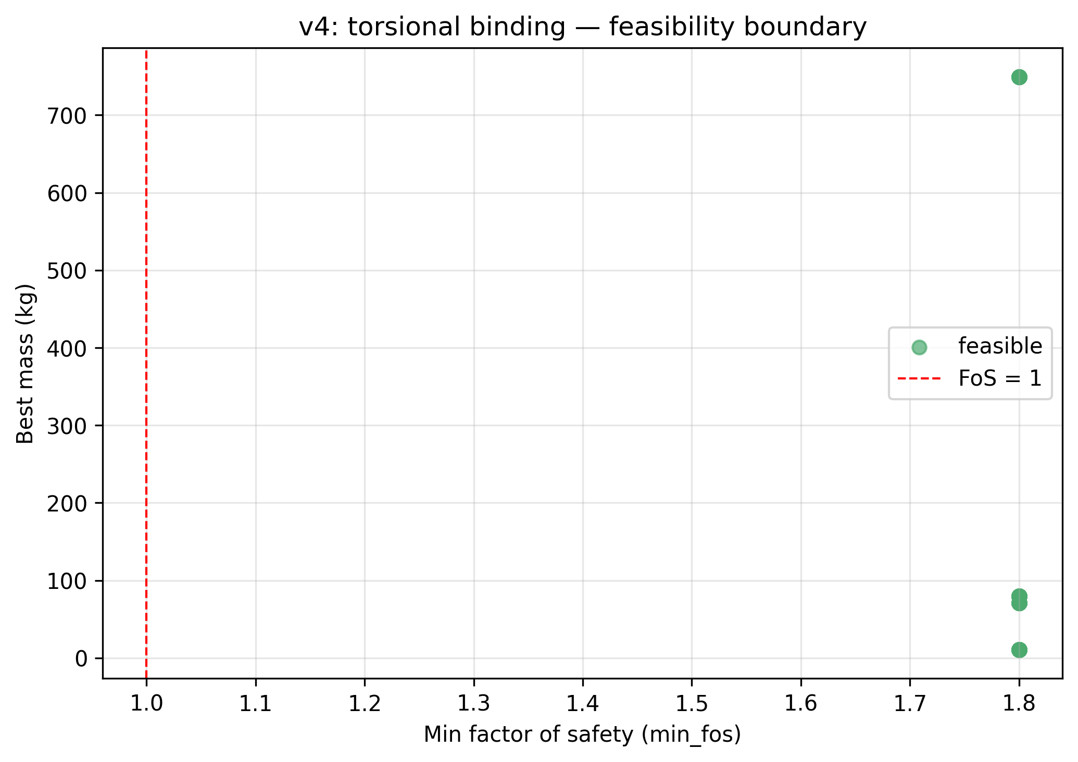
Figure 5: FOS distribution across all islands, showing constraint binding at the limits.

7.6 v4 vs v5 Mass Comparison
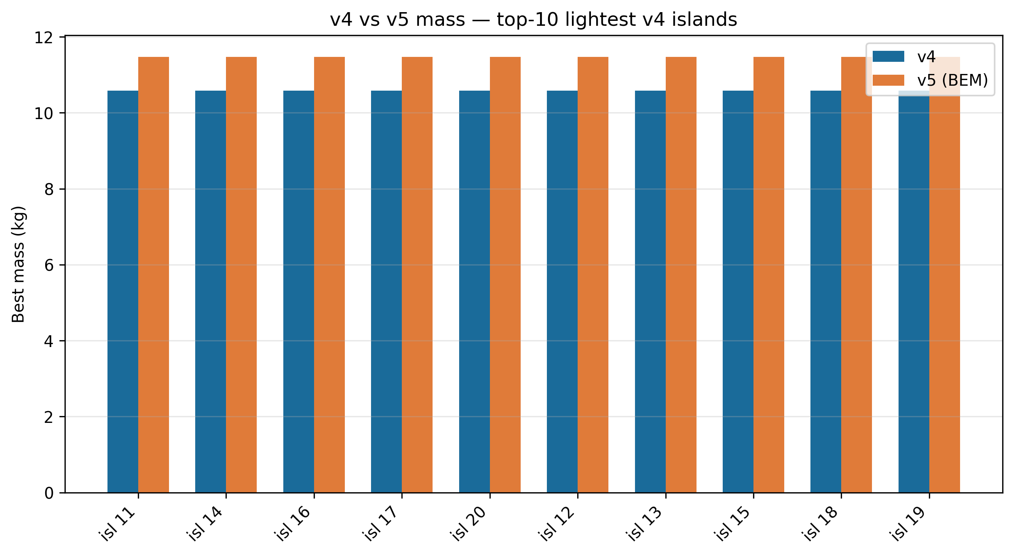
Figure 6: Winner mass comparison between v4 and v5 campaigns by island configuration.

8 Open Questions and v6 Roadmap
Item | Question | Proposed approach
OQ1 | Is Cp(n=8) > Cp(n=3) physically real at c_blade = 0.05R? | Free-vortex or RANS comparison for n = 3, 6, 8 at identical solidity
OQ2 | Does c_blade = 0.05R correspond to a physically achievable blade geometry at design TSR? | Check cl requirement vs aerofoil database at operational Re
OQ3 | What is the per-segment twist angle at maximum power, and does it approach the structural limit? | Add twist-per-segment constraint to v6 objective
OQ4 | How does 50 kW scaling affect the n_lines optimum? | Run v6 with n_lines upper bound raised to 12
OQ5 | Can torsional FOS be logged per generation to map the constraint boundary evolution? | Add per-generation FOS logging to campaign script

9 Conclusions
- TRPT torsional collapse (Tulloch–Wacker criterion) must be explicitly constrained in any structural optimisation of ring-and-beam TRPT airframes. Buckling-only formulations produce designs that are torsionally infeasible by up to 14×.
- Geometric ring spacing (constant L/r, v4) reduces optimal structural mass by 31.4 % relative to uniform ring spacing (v3) by allowing a physically appropriate tapered geometry.
- BEM-coupling of rotor radius (v5) increases optimal mass by 8.3 % relative to v4, correcting an optimistic fixed-radius assumption and giving a physically consistent aero–structural optimum.
- All 120 optimisation islands selected n_lines = 8. The structural argument for this is well-founded; the aerodynamic argument requires higher-fidelity validation before it can be relied upon in design decisions.
- Both structural constraints (beam buckling FOS ≥ 1.8 and torsional FOS ≥ 1.5) are active in all winning designs, confirming that the optimiser has reached the constraint boundary. Further mass reduction requires either constraint relaxation or topology change.
- Elliptical beam cross-sections outperform circular and rectangular profiles in all campaigns.

