The kite turbine: a search over its design space
Internal engineering report. Draft v0.67. Date 2026-10-19.
Status DRAFT. Data commit dd3cc6a. Launch commit a76c5e9. The physics era is post-95c385d_wind-authority, with the bank derate applied throughout. Numbers come only from signed register rows, cited by row ID.
Draft status. This is an internal draft. Sections 1 to 6 carry their text. Nomenclature and references stay incomplete. A section marked [PENDING] waits on a gate.
Abstract. This report presents a search for a 5 kW-class ground-generation rotary kite turbine with a tensile rotary power transmission (TRPT). The search varies ring geometry, polygon count, rotor count, blade bank angles and blade scale. A differential-evolution campaign evaluated 930 candidate designs under one fixed power-law generator load, each scored on the measurement window (NR-001).
The campaign winner is the best feasible candidate under the modeled objective and gates. Its mean power is 5.309 kW at the site wind, 11.01 m/s at 9.41 m (NR-008, NR-032). All checked TRPT rings and twist segments operate below their failure boundaries at the final operating point (NR-021, NR-022). The minimum factor of safety is 14.972 (NR-009).
At the winner operating point, the least segment torque margin is 2.03, at S1, the first of the five segments between the rings (NR-040). The margin is torque capacity over the segment torque it carries, and the least value governs.
All numbers carry the physics era post-95c385d_wind-authority, with the bank derate applied. The study is simulation-only. Blade integrity is not yet gated, and the outer stiffening bridles sit outside the model. Lifter kite modulation for steady lift tension across wind speeds remains an assumption. The search is a screen, not a survey. The report does not claim a global optimum.
Keywords. airborne wind energy, kite turbine, ground-generation, tensile rotary power transmission, differential evolution, multibody simulation, design search, factor of safety.
Summary for decision. The project completed a 930-design simulation screen of a 5 kW-class ground-generation rotary kite turbine with a tensile rotary power transmission (NR-001). The screen found a feasible candidate under the model and gates. The decision metrics read as follows.
Decision metric | Value | Rows
Designs evaluated | 930 | NR-001
Feasible candidates | 508 of 930 | NR-002
Campaign winner mean power | 5.309 kW | NR-008
Winner airborne mass | 25.698 kg | NR-018
Minimum factor of safety | 14.972 | NR-009
Least segment torque margin | 2.03, at S1 | NR-040
Objective improvement, seed to winner | 36.109 to 27.364 kg-equivalent | NR-006, NR-005
Of the 930, 508 designs pass every gate. The other 422 read 301 reject, 110 clearance_reject and 11 reject_twist (NR-002).
All checked TRPT rings and twist segments operate below their failure boundaries at the final operating point (NR-021, NR-022). The ODE path reproduces every recorded winner field (NR-012). The rapid path takes the rope-break gate placement fix (NR-013 ext2).
The report shows that a feasible 5 kW-class candidate exists in the searched space under the model and gates. It does not show flight readiness, a global optimum, or full structural safety. Blade integrity, lifter modulation, launch and recovery, and atmospheric realism remain open work items.

1 Introduction
The wind above tower height is stronger and steadier than the wind exploited by traditional wind turbines. Airborne wind energy systems (AWES) are kite-based machines that chase that stronger wind.
Two families of AWES exist. Fly-gen machines carry the generator and turbine aloft. A conducting tether sends the electrical power to the ground. Ground-gen machines keep the generator on the ground. The tether carries force, and the ground station converts tether motion to electrical power.
The field splits a second way, on the wing. Soft wings use fabric. They survive crashes and pack small. Rigid wings use composite airframes. They are more efficient and more costly.
A third split matters for this report. It is the force transmission of ground-gen systems. A pumping (yo-yo) machine sends intermittent tension down a moving tether. A rotary machine sends steady torque down a turning set of tethers.
A rotary machine runs continuously. It needs no reel-in phase. That continuity is where the kite-turbine family sits.
The machine in this report is a kite turbine. Kite turbines exploit multiple, short rigid blades. The blades sit on a ring and form a wide diameter rotor. The rotor and further rings tie together as a tensile rotary shaft. The shaft turns the ground generator.
A tensile rotary power transmission (TRPT) is a shaft made of tensioned lines. Rings sit at fixed distances under tether tension. Torque passes from ring to ring, over multiple tethers. The TRPT shaft is prone to bending and twisting, especially in low tension. It is not a rigid driveshaft. Its capacity to transmit torque comes from the tension in the kite lines.
This report presents a search over the design space of kite turbines. The search varies ring geometry, polygon count, rotor count, blade bank angles and blade scale. The objective is to find the feasible geometries for a 5 kW-class machine, and then characterise them. The generator load law and the safety gates stay fixed. The search asks whether one compact machine can hold the power, mass, structural, clearance and twist constraints at once. The report reads the gate and the winner outcome for each constraint in the results.
The report states what the record supports. It also states several classes of failure in developing this system, each with its lesson. One frame holds throughout. The machine flies only in simulation. The analysis pipeline is the instrument. The report treats the instrument with the same distrust it treats the machine.
The field context rests on the literature. Loyd showed that both crosswind modes share one theoretical power ceiling. Diehl set the classification axes. Trevisi built one power model for both modes and found the glide-ratio flip. Cherubini mapped the ground-gen and fly-gen taxonomy. Van der Burg found no dominant wing design.
Both wing families stay in play. Van de Kaa and Kamp found no dominant generation architecture. Pereira ranked the design factors and found that many small units beat few large ones.
Flather recorded the rope-drive physics that the TRPT descends from. Benhaïem and Schmehl analysed the torque path of a rotating reel. Tulloch modelled the Daisy TRPT and checked the model against measured flight windows. Daisy is the experimental prototype rotary kite turbine whose measured flight data anchor the model (NR-056). This report extends that line of work.

2 Methods

2.1 The kite turbine and its terms
A line is a tension member, like a tether or a bridle. It carries a load only in tension. A pull at one end passes along the line to the other end. It never pushes.
A ring is a polygon of nodes and tubular beams. A ring with blades works as a rotor. Rings without blades work as line spacers. They hold the TRPT lines apart against the line torsion from torque transfer. Holding the lines apart is what preserves torque transmission and prevents torsional collapse.
The polygon count names the number of lines (n_lines). e.g. A hexagonal polygon connects six lines. Each line meets the ring at one vertex.
For an active rotor, the polygon count equals the blade count. It also equals the number of TRPT line attachments around the ring. A rotor is a set of blades on a ring. A pentagonal rotor carries five blades.
Inactive genome slots may hold bank or blade-scale values. They do not create physical blades unless the rotor count selects them. The topmost ring carries the main rotor. The lowest ring is the ground station power take-off (PTO) ring. The PTO ring anchors the shaft at the ground and turns about its central axis.
Bank is the blade angle away from the plane of rotation about its chord axis at the ring. The equivalent term in e.g AeroDyn is pre-cone.
Blade scale sets the blade size. The scale multiplies the blade span and chord, and the blade mass follows the span cubed. The base span reads 0.75 of the power-sized rotor radius, and the base chord reads 0.113 of it. The power sizing sets that radius for the rotor at its local wind speed (NR-050).
That radius is not the ring radius. The ring radius r_hub is a separate structural gene. The blade radius r_rotor is the aerodynamic size the blade spans from. The power sizing inverts the power equation (NR-050):
$$r_{rotor}=\sqrt{\frac{P}{f_{proj}C_{p}0.5ρπv^{3}}}$$
P reads the rotor power share and v the local wind speed at the ring. Cp reads the blade-element table coefficient at the sizing tip-speed ratio. $f_{proj}$ reads the bank-and-elevation projection factor. The winner decode reads r_rotor 2.434 m (NR-050).
The search treats each of these as a gene. The ring geometry sets the topmost-ring and ground radii, and the rotor count sets how many rings carry blades. The shaft transition cone holds one fixed angle, 22 degrees, by construction. It is not a search gene (NR-049).
At the top of the shaft the rotor turns in the wind. The whole shaft turns with the rotor. The shaft passes the torque from ring to ring. The lowest ring turns the generator at the ground station.
The shaft works only under tension. Tension gives the shaft its capacity to transmit torque. With low tension the shaft bends and twists. A slack shaft cannot carry the load.
Under the generator load the machine settles onto one operating point. In the settled state the shaft runs twisted along its length.
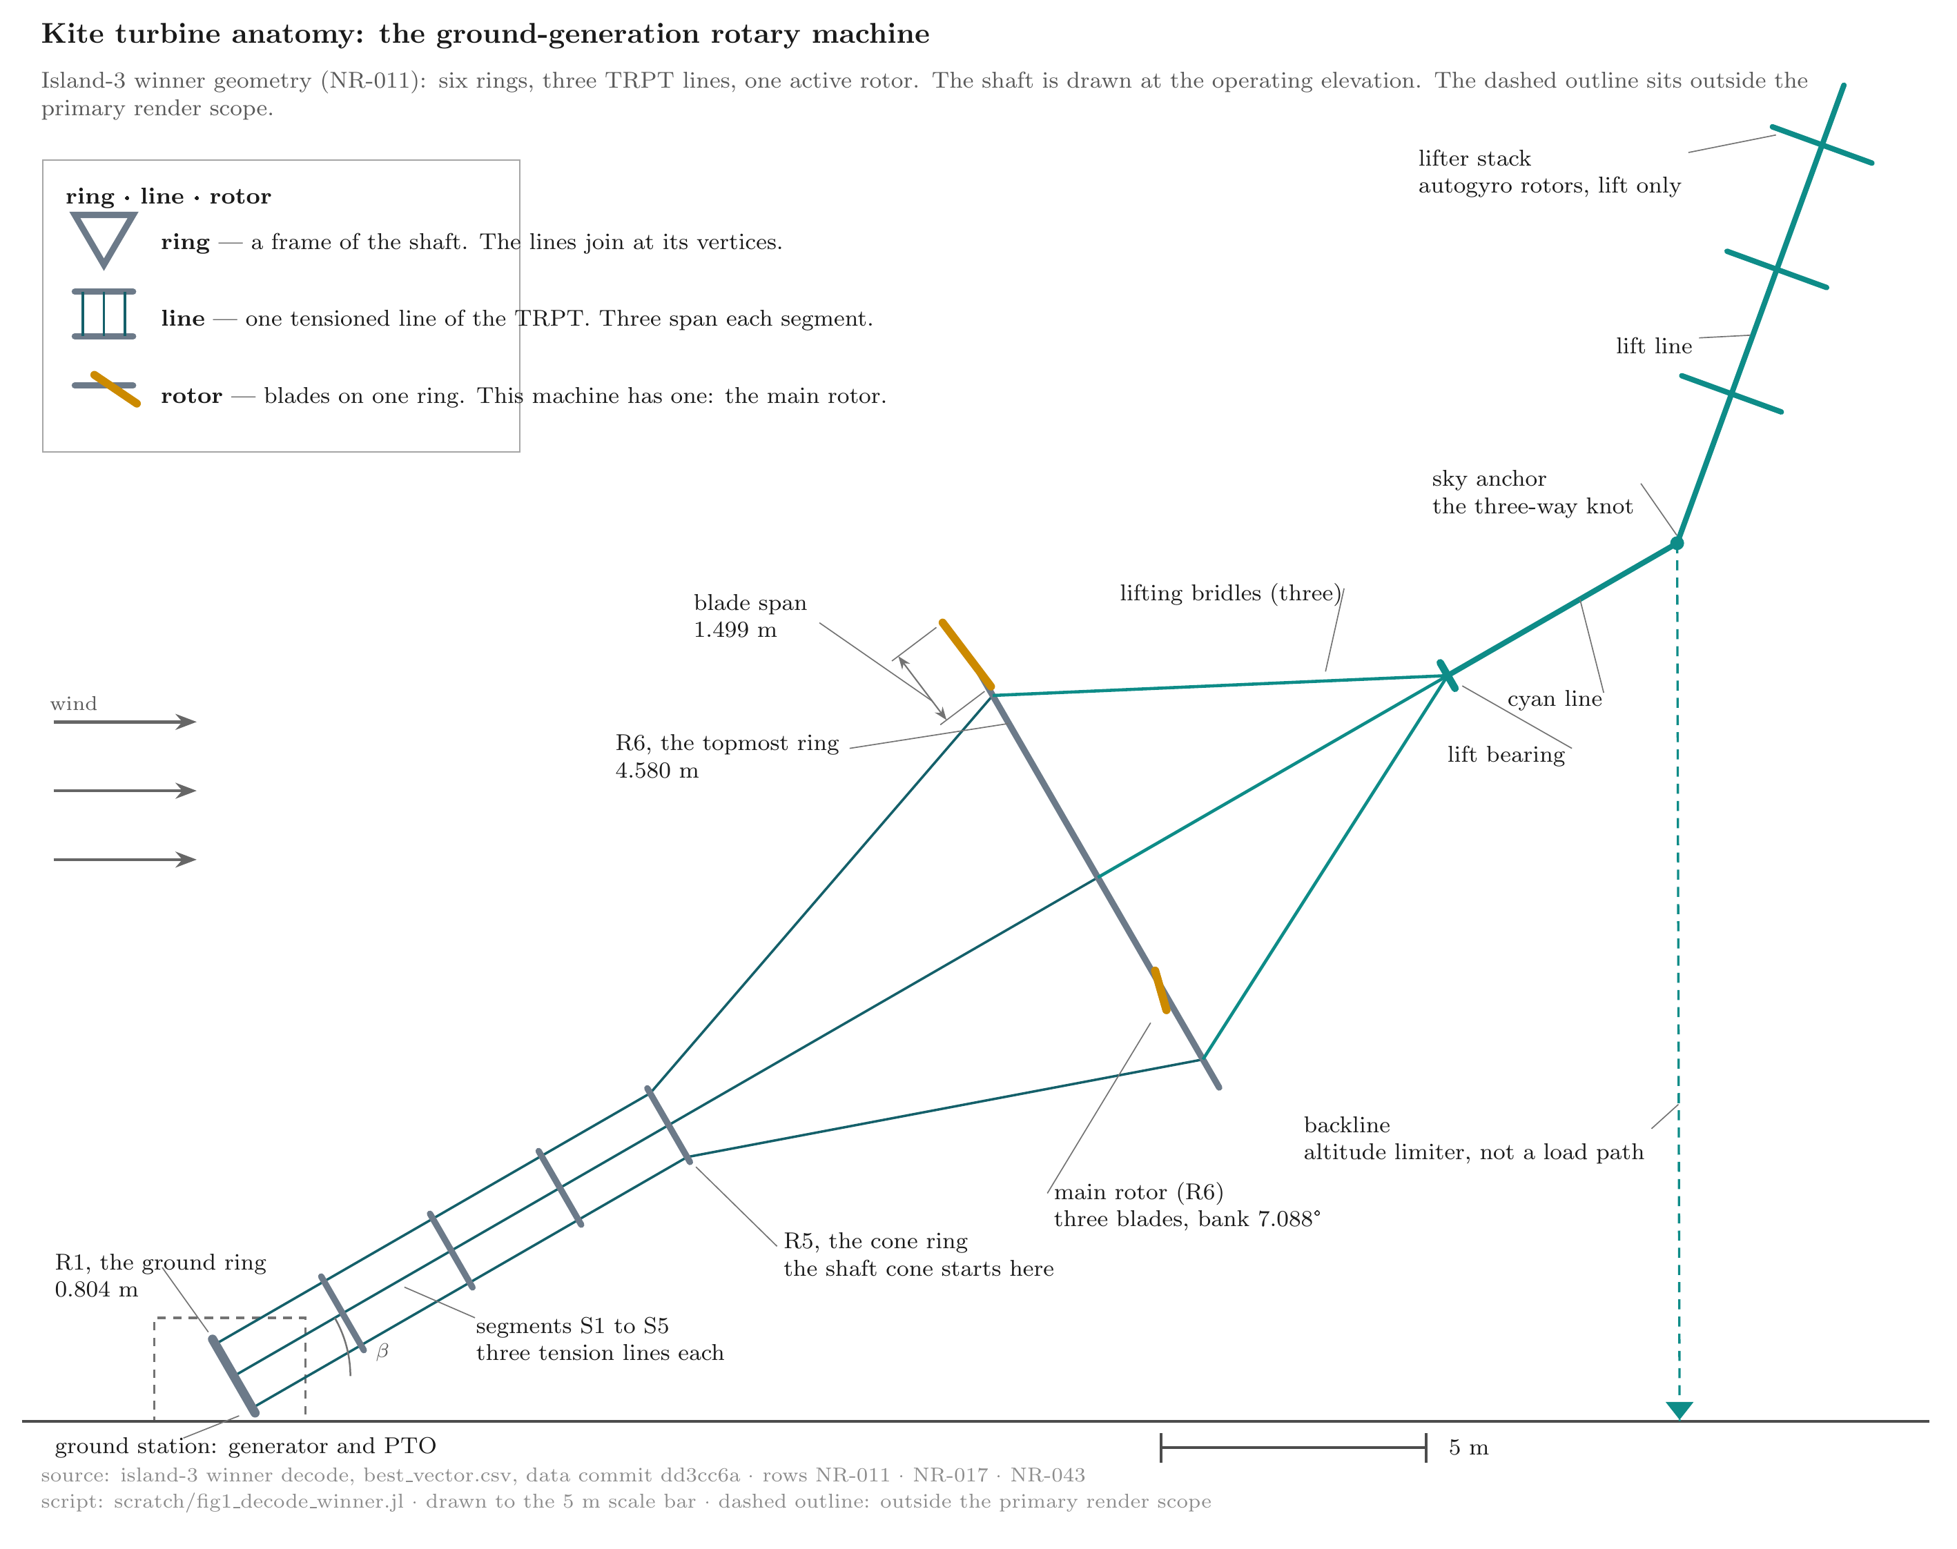
system-anatomy
Figure (roster row 2) · system-anatomy
This figure shows the whole machine and the names of its parts, from the lifting autogyro kite stack in the sky to the ground station that takes the power.
The plate shows the campaign winner in a side view. Six triangular rings run from the ground ring (R1, 0.804 m radius) to the topmost ring (R6, 4.580 m radius). Three tension lines span each of the five segments S1 to S5. The main rotor sits on R6 only. Its three blades bank at 7.088°. The lift chain runs from the lifter stack, down the lift line, through the sky anchor and the cyan line, to the lift bearing. Three lifting bridles run from the bearing into the main rotor. The lifter gives lift only. It does not drive the rotor. Torque runs down the TRPT rings to the ground station. The dashed outline marks the ground station: the generator and the power take-off. That outline sits outside the primary render scope. The dashed backline is an altitude limiter, not a load path. The scale bar is 5 m.
Source: data dd3cc6a · script 9241b23 · rows NR-011, NR-017, NR-043

2.2 The simulation analysis pipeline instrument and its terms

2.2.1 The gene
The search uses differential evolution (DE) to assess kite turbine design variants. DE assesses machine genomes. A genome is a design vector that describes the physical character of one machine. The decoder reads it, and the builder builds the machine from it.
The evaluation then feeds the comparison before DE tries a new gene. The genes set the ring geometry, the polygon count, the rotor count, the bank angles and the blade scales. The winner genome names its genes in the decode fields (NR-011).
The genome carries ten slots, x1 to x10. The table lists each slot, its meaning and its search bounds.
Slot | Meaning | Bounds
x1 | hub ring radius r_hub | 0.700 to 7.776 m
x2 | ground ring radius r_bottom | 0.398 to 1.195 m
x3 | common length-to-radius target L/r | 1.0 to 2.94
x4 | polygon side count n_lines | 3 to 9
x5 | ring density bias | -0.8 to 0.8
x6 | rotor count | 1 to 3
x7 | bank at the topmost rotor | 0 to 22 deg
x8 | bank at the lowest rotor | 0 to 22 deg
x9 | blade scale at the topmost rotor | 0.2 to 1.0
x10 | blade scale at the lowest rotor | 0.2 to 1.0
The decoder reads x6 as a rotor count. It rounds the gene to an integer between one and three. Inactive slots may hold values with no physical effect. The winner carries one active rotor, so x8 and x10 stay unused (NR-011). The decoder also rounds x4, the polygon side count, to an integer (NR-011).
The ring count builds separately. A spacing pass lays the intermediate rings along the shaft from the length-to-radius target and the density profile. The builder then adds the ground ring and the hub ring at the ends. The winner reads six rings (NR-011).

2.2.2 The evaluator
The builder builds the machine from the genome. The evaluator runs the machine and measures its performance. Every evaluation has two phases: a relax run and a measurement window. The run starts from a settle state.
That state comes from a simplified power balance (NR-025). The relax run takes 10 seconds. It lets the startup transient decay, and the machine moves to its operating point. The measurement window takes 40 seconds.
It measures the settled machine. The evaluator scores the power over the measurement window only (NR-015). A short window can sample the decay and misstate the power. The team sized the window to outlast the decay.
The evaluator names two scoring quantities. P_score reads the tail-5 power, the mean of the last five seconds of the window (NR-046, NR-041). The draft prints it as the end power. The twist ratio reads the absolute segment twist divided by the crossing limit, the worst segment over the window (NR-046). The crossing limit reads (NR-053):
$$δα^{}=2arcsin\left(\frac{L_{seg}}{\sqrt{2\left(L_{seg}^{2}+2r_{seg}^{2}\right)}}\right)$$
The term $r_{seg}$ reads the larger of the two ring radii at the segment. The term $L_{seg}$ reads the segment length between the two rings.

2.3 The operating point and load selection
The generator load follows a power law. The commanded torque reads τ = k·ω², so the drawn power reads P = k·ω³. The constant k sets the load, and the load sets the speed at which the machine settles.
The operating point uses a power-law constant k of 2.24 N·m/(rad/s)², a relax time of 10 seconds, a window of 40 seconds, a factor of safety (FoS) target and hard floor, both 2.5, and a line length of 18.8 metres (NR-015). The campaign fixed k at 2.24 N·m/(rad/s)² for every candidate design (NR-015). One load applies to the whole search.
A fixed k couples the radius search to the tip-speed ratio. The load curve fixes the torque-speed relation, and the radius sets the tip speed for a given speed. So the radius gene and the operating tip-speed ratio are not independent. Changing the radius with k held fixed moves that ratio.
The search explored radius under that coupling. The load law kept the same form for every candidate, and the speed and radius stay coupled. The team selected the value in a load sweep of the seed machine (2026-08-22). The sweep ran the seed at a range of loads, each over the same measurement window.
At the light end the seed reads under the power floor. At the heavy end the power levels off. The selected value sits in the working range between them.
The sweep rows read as follows (NR-047).
k | status | P_mean (kW) | omega_final (rad/s) | FoS_min
0.5 | reject | 3.49 | 19.14 | 51.8
1.0 | ok | 5.45 | 17.64 | 47.8
1.5 | ok | 6.78 | 16.59 | 42.8
1.94 | ok | 7.56 | 15.80 | 40.1
2.24 | ok | 8.00 | 15.34 | 36.4
3.0 | ok | 8.89 | 14.42 | 24.3
At the light end the seed spins up. The k 1.0 row settles at omega 17.6, tip about 85 m/s, near the 100 m/s ceiling. The ceiling is a hard evaluator gate (TIP_SPEED_CEILING_MPS). The selected k 2.24 settles at omega 15.3, tip about 73 m/s (NR-047).
The power is measured, not computed from a mean speed. The evaluator samples the electrical power at one hertz inside the window. At each sample it reads the generator torque times the ground-ring speed. The window mean of those samples is P_mean. The window-mean ground-ring speed is a separate average (NR-029).
The delivered-torque basis (NR-030) is P_mean divided by the window-mean ground-ring speed, a derived ratio, not the instantaneous k times omega squared. The two differ slightly: P_mean 5.309 kW against k times the cube of the window-mean ground-ring speed, 5.366 kW, a 1.07 per cent gap.
The exact source of the gap is open. It may come from a slow speed trend across the window, from ground-ring drag, or from how the instantaneous power is averaged.
At the heavy end the load raises the torque and the line tension, so FoS falls. The FoS_min column reads 36.4 at k 2.24, down to 24.3 at k 3.0 (NR-047). The heavy end also carries a score cost. The objective charges 5 kg-equivalent per excess kW squared above the 5.0 kW ceiling (NR-046).
The load choice also has a structural side. The team sizes the beam for a bounded generator load step: twice the nominal load (NR-048). The top-segment helix force reads about 1278 N/vertex (NR-048). A low-wind lull is harmless under the load law. The team refuses to ease k as the high-wind substitute. The rotor spins up to 87.9° of twist against the 78.8° collapse limit (NR-048).
The campaign also fixed the shaft length. The search does not vary it: every candidate runs at one length, 18.8 metres (NR-015). The length follows the Daisy anchor. It scales with the machine to this size.
It sets how high the machine stands above the ground station. A longer shaft reaches stronger wind. The length screen history sits in section 3.3 with the era record.
FoS is the design load margin. It is the ratio of what the line can carry to what the load demands. The model tests the TRPT beam element FoS for buckling risk the same way.
The dynamics run as a coupled multibody model. Every node, line and ring carries state. The evaluator holds the whole set as one matrix of ordinary differential equations (ODEs). The evaluator advances that matrix at a fixed step. The scheme is semi-implicit. Each step advances the velocities before the positions.
The generator brake torque enters implicitly. Read from the last step alone, the load law is positive feedback. Take a ground ring that runs a little fast: the brake pushes too hard, and the next step over-corrects, so the swing grows. The implicit form solves the brake with the new speed, so the step stays stable. The evaluator derives the step per machine from the shortest shaft sub-segment.
The run is deterministic by construction. That determinism is what makes reproduction possible. The search carries the same property. The campaign runner fixes one random seed per island.
NaN and Inf clamps guard the state. A broken line ends the run.

2.4 The campaign
The campaign runs a differential evolution (DE). A DE keeps a design population. Each generation breeds new designs from random members of the population. A gate scores each design and culls the failures.
Three islands run in parallel. An island is an independent population with its own drift. Each island evaluates 310 designs.
The DE holds ten members per island, three islands, and thirty evolution steps after the initial population. The seed is the first member of each population. The other nine members draw at random inside the bounds. Each island runs 31 generations in total, generation indices 0 to 30, ten rows per generation, 310 evaluations per island (NR-045).
Each island starts from its own random seed (42 plus the island number minus one), so the three islands drift apart. No member moves between islands. Each new member forms by a standard DE rule. The mutation takes the difference of two members, scales it by a factor F, and adds it to a third. F draws at random in 0.5 to 0.8 per trial.
The crossover rate CR draws in 0.7 to 0.9 per trial, and one gene always crosses. The trial replaces the parent only if its score is not worse. The campaign evaluates 930 designs in total (NR-001).
Four statuses result: ok, reject, clearance_reject and reject_twist (NR-002). The ok designs pass every gate. The rejects fail a gate. Clearance rejects fail the clearance gate. Twist rejects fail the twist gate.
The campaign minimizes a kg-equivalent objective score: the airborne mass plus the soft constraint penalties. A lower score is better. The objective score is not the physical airborne mass. One kilogram of airborne mass adds 1.0 to the score (NR-046). The penalty charges read in kg-equivalent.
The score builds along one chain. The chain runs genome, decoder, builder, evaluator, window statistics, gate status, soft constraint penalties, score and rank. The score adds three soft constraint penalties to the airborne mass (NR-046):
$$f=mass+5.0max{\left(P_{score}−5.0,0\right)}^{2}+20.0{\left(\frac{2.5}{{FoS}_{min}}\right)}^{2}+1.0{\left(\frac{r}{1−r}\right)}^{2}$$
The ratio reads $r=min\left(twist_{r}atio,1\right)$. The score then adds the stationarity add-on (NR-046):
$$10.0max\left(0,swing−0.20\right)$$
The over-power charge reads P_score, the end power, against the 5.0 kW ceiling (NR-046). The utilisation charge reads the window-minimum factor of safety against the 2.5 floor (NR-046). The twist charge reads the worst segment twist ratio against the crossing limit (NR-046). The stationarity add-on reads the window swing against 20 per cent (NR-046).
The swing reads P_range over P_mean, the window power range over its mean (NR-046). The twist charge clamps r to one. At r equal to one the segment reaches the crossing limit, so the ratio r over (1 minus r) would divide by zero.
The code floors the denominator at 1e-6. The ratio reads one million at the limit and stays finite. The twist gate flags a segment that passes its limit, so a design at the limit exactly reaches the floor (NR-046).
Two hard gates sit outside the soft penalties. A rotor tip below 1.5 m of ground clearance fails the clearance gate. A segment past its crossing limit fails the twist gate. These reject the design outright, and a rejected design carries no score (NR-046).
The evaluator carries Inf for a rejected design. The runner stamps the search cost 1e9 on every non-ok design (NR-046). No reject ranks above an ok design. The search cannot trade power or safety against mass.
The differential-evolution campaign fixed the configuration below.
Setting | Value | Source
Islands | 3 | NR-001
Designs per island | 310 | NR-001
Evaluations, total | 930 | NR-001
Objective | Airborne mass + penalties, kg-equivalent | NR-036, NR-039
Power floor | 5.0 kW | NR-027, NR-039
Power ceiling | 5.0 kW | NR-046
Structural FoS floor | 2.5 | NR-015
Clearance floor | 1.5 m | NR-042
Tip-speed ceiling | 100.0 m/s | NR-047
Torsional FoS floor | 1.5 | NR-052
Twist gate | geometric crossing check | NR-052, NR-053
Relax run | 10 s | NR-015
Measurement window | 40 s | NR-015
Load constant k | 2.24 N·m/(rad/s)² | NR-015
Line length | 18.8 m | NR-015

2.5 Fidelity paths
Two paths score a design. The ODE path builds the machine, settles it, and runs the full dynamics over the measurement window. The rapid path pre-solves a static state and starts from it.
The report names map to the code. The ODE path is :cold. The rapid path is :warm. The campaign scored every design on the cold path (NR-012).
The probes that compare the paths sit in scripts/probe_rapid_vs_ode_winners.jl and scripts/probe_warm_reject_cause.jl. The register header pins their commits.

2.6 Reproducibility
Every dataset carries a provenance stamp. The stamp names the commit, the physics era and the geometry fingerprint. The report names the commits in the register header. The dataset sits at data commit dd3cc6a on the bankderate2-results branch.
The launch commit is a76c5e9. The Phase 0 audit sits at master 31ca00d. The campaign runner script, scripts/run_v13_5kw_masslift.jl, pins the island seeds.

3 Results

3.1 The search at scale
The campaign evaluated 930 designs (NR-001). The status mix reads 508 ok, 301 reject, 110 clearance_reject and 11 reject_twist (NR-002). The reject class splits three ways (NR-055). 96 ran below the 5 kW power floor. Four ran at or above 5 kW with a factor of safety below 2.5. The remaining 201 carried no logged cause at campaign time.
A re-run probe now names those 201 (NR-061). They split six ways. 93 rotors cannot reach 80 per cent of the power floor on their swept area and power coefficient. 37 settle at the torsional realisability cliff. 36 refuse on rotor spacing.
30 break a line. Three cross the Betz ceiling. Two diverge at the hub tip speed. Only the last class is a numerical divergence. The others are geometry or design refusals that the telemetry left blank.
Each island starts its population from the same seed genome. The recorded common seed genome scores 36.109 kg-equivalent under the campaign objective (NR-006). The other members of each population draw at random under a fixed seed per island. This campaign is the first search campaign of the wind-authority era. Larger and wider campaigns sit ahead.

3.2 Convergence
The best recorded objective score on island 1 is 30.578 kg-equivalent at generation 30 (NR-003). Island 2 reaches 30.637 kg-equivalent at generation 30 (NR-004). Island 3 reaches 27.364 kg-equivalent at generation 26 (NR-005). The physical airborne mass of the winner is 25.698 kg (NR-018). The objective score adds 1.665 kg-equivalent of penalties (NR-039). The surviving ok designs hold a mean power between 5.02 and 6.32 kW (NR-007).
Convergence in this section reads the search, not the window. The three results above read the best score per island against generation. The window test is a separate reading.
It compares P_mean and P_end. The two agree below 0.5 per cent at every row of the load sweep (NR-041). The heavy-end rows of that sweep sit in a band, 8.9475 to 8.9511 kW at 4 dp. The register reads that band as a plateau.

3.3 The winner
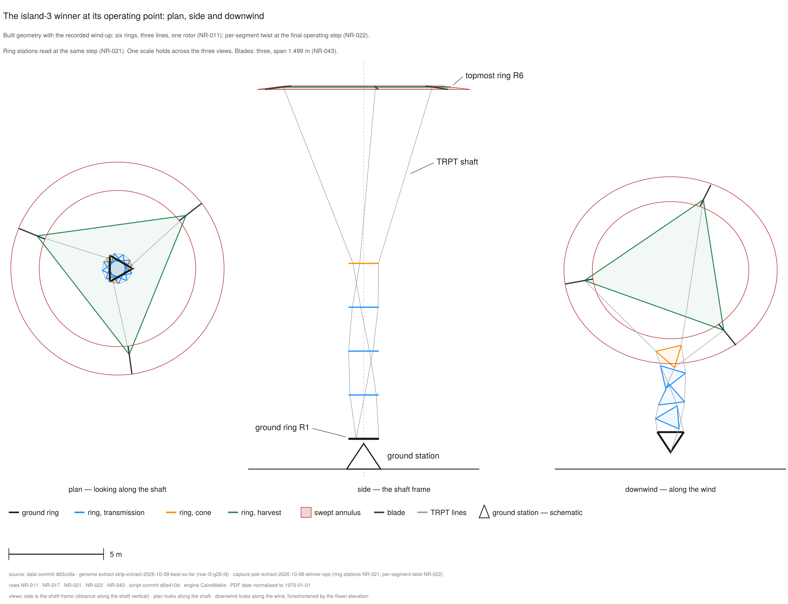
machine-winner-hero
Figure (roster row 10) · machine-winner-hero
The campaign winner, drawn three ways: down the shaft, from the side, and along the wind. The machine stands at its settled operating point. The six rings sit at their recorded stations. The shaft carries its recorded wind-up. Each ring turns against the ring below it. All three views share one scale, so the drawn size reads true.
The island-3 winner at its final operating step. The machine reads six rings, three lines and one active rotor (NR-011). The ring stations and the per-segment twist come from the signed capture (NR-021, NR-022). The main rotor carries three blades of span 1.499 m and a bank of 7.088 degrees (NR-043, NR-017). The plan view looks along the shaft. It draws each ring as its node polygon. The side view uses the shaft frame. Distance along the shaft is vertical, and the operating elevation is not drawn. The downwind view looks along the wind, so the shaft reads foreshortened. The swept annulus draws as one truncated cone in the side view. It draws as a ring band in the plan view and as a flattened band in the downwind view. One scale holds across the three views. A 5 m scale bar sits in the footer.
Source: pair-extract-2026-10-08-winner-ops · data dd3cc6a · script d0e410d · rows NR-011, NR-017, NR-021, NR-022, NR-043
Island 3 carries the campaign winner, the best feasible candidate under the modeled objective and gates. Its mean power reads 5.309 kW and its end power 5.314 kW (NR-008). Its factor of safety reads 14.972 (NR-009). That value is the window minimum. The capture topmost ring reads a factor of safety of 15.033 at the final step (NR-021).
Its operating point reads as follows.
Quantity | Value | Source
Mean power, measurement window | 5.309 kW | NR-008
End-of-window power | 5.314 kW | NR-008
Minimum factor of safety | 14.972 | NR-009
Window power swing | 0.029 kW | NR-014
Settle angular speed | 10.170 rad/s | NR-016
Window-mean speed | 13.38 rad/s | NR-029
Delivered torque | 396.76 N·m | NR-030
Airborne mass | 25.698 kg | NR-018
Topmost ring radius | 4.580 m | NR-011
Ground radius | 0.804 m | NR-011
Ring count | 6 | NR-011
Polygon count | 3 | NR-011
Active rotors | 1 | NR-011
Main-rotor bank, ring 6 | 7.088 deg | NR-017
Lift-line elevation | 70 deg | NR-026
Lift-line tension | 324.1 N | NR-010
Reference wind speed | 11.01 m/s at 9.41 m | NR-008, NR-032
Shear law | Hellmann power law, exponent 1/7, from the measured Daisy pair 10.0 m/s at 4.8 m | NR-056
Shaft elevation | 30 deg, hub at 9.4000 m | NR-057
Ring speed ratio | 5.566 | NR-031
Tip-speed ratio | 6.8415 | NR-032
Its window swing reads 0.029 kW on 5.309 kW, half a per cent (NR-014). The reported trace runs steady wind, so the swing reads as a steady-wind response, not a stability property (NR-058). The machine held a steady operating point through the measurement window. Steady and drifting describe two observables on two timescales. The power settles: the window swing reads half a per cent of the mean (NR-014). The extension speed spread reads 0.009 per cent (NR-059).
The bow creeps slowly: each five-second step reads smaller than the last (NR-059). At the hub the extension steps fall from 0.0254 m to 0.00053 m (NR-059). So the machine holds its operating point while the shaft still creeps toward its bowed shape. The settle state starts the machine at 10.170 rad/s (NR-016). The machine accelerates through the relax run.
The shaft axis bows off its design line, sagging straight down. At the midpoint ring the bow reads 0.002 m at settle, and 0.105 to 0.310 m through the measurement window (NR-059). The maximum sits at the hub and reads 0.209 to 0.613 m through the window (NR-059).
An extension run past the window ends at 0.422 m at the midpoint and 0.833 m at the hub (NR-059). Every measured state at the midpoint ring and the hub reads below the 1.5 m comparison bar (NR-059). The record ends at 200 seconds, so the report claims no bound past the measured span (NR-059).
The settle hands off a straight stack while the run bows it. The two do not agree on the bowed shape. The disagreement reads as an instrument finding, not a design question (NR-059).
The cause of the bow is open. Gravity, frame drag and line drag all act in the wind-height plane. The model carries each. The straight-down direction does not by itself attribute the split between them.
The swept area reads 45.9733 square metres raw and 39.4912 square metres on the wind-normal basis (NR-033). The air density reads 1.225 kilograms per cubic metre (NR-034).
The rotor Cp reads from the AeroDyn v5.0.0 blade element momentum (BEM) table. The value reads 0.2944 at the ring speed ratio, and 0.2258 at the tip-speed ratio (NR-031, NR-032). The Betz ceiling reads 19.1304 kW, and the winner delivers 27.75 per cent of it (NR-034).
The winner clears each checked gate.
Gate | Threshold | Winner outcome | Margin | Source
Power floor | 5.0 kW | pass, P_end 5.314 kW. Margin +0.314 kW / +6.28 per cent | NR-008, NR-027, NR-039
Structural FoS floor | 2.5 | pass, 14.972 minimum. 14.972 on 2.5, margin +12.472 / +498.9 per cent, 5.99 times | NR-009, NR-015
Clearance | blade-tip gate | pass, 5.468 m, margin +3.968 m | +264.5 per cent, 3.65 times | NR-042
Twist | per-segment limits | pass, all five segments within limit | S1 binds: 33.946 deg against the 72.25 deg realisability floor, 2.13 times (NR-053). Against 98.859 deg δcrit, 2.91 times (NR-022). Crossing ratio 0.4393, 2.28 times (NR-052) | NR-022, NR-052, NR-053
Torsional capacity | capacity/demand | least margin 2.03 at S1 | +102.9 per cent above unity, 2.03 times | NR-040
Rope break | none on the window | pass on the cold path | the warm path rejects healthy winners | NR-012, NR-013
The gate set reads per class. The structural members and the lines hold a factor of safety of 2.5 or higher (NR-015). Torsion keeps its own criteria. The collapse factor of safety reads 1.5 or higher, and the twist stays within the crossing limit (NR-052). The realisability floor reads 72.25 degrees (NR-053). As run, the 2.5 gate does not cover torsion (NR-052).
A lifter kite holds the machine aloft. The lifter gives lift only. It gives no torque and no drive. Its load path runs from the lifter kite down the lift line to the sky anchor, the three-way knot. Then it runs down the cyan line to the lift bearing, and down the lifting bridles to the main rotor.
In the field the lifter launches first. It lifts the rig into tension. The rotor turns after that. The lift acts throughout operation, not only at spin-up.
The team sizes the lift line up front. The lifter sizing holds a 1.5 margin on the vertical load at the lift bearing. The sizing mass is the airborne mass without the lifter itself, 20.698 kilograms. The kite carries its own weight (2026-08-21 ruling).
The vertical load is 1.5 × 20.698 × 9.81 = 304.6 newtons. The lift line runs at 70 degrees of elevation (NR-026). The line tension is that load over sin 70 degrees: 324.1 newtons (NR-010).
The lifter is a stack of autogyros. The report assumes the stack can modulate to meet the lift requirement at all wind speeds. A fixed kite cannot: its pull grows as the square of the wind speed. Without modulation, each weather band would need its own single kite. That kite would reach giant sizes and be too hard to handle.
The report applies the lift force the machine needs and tests the machine on that basis. Designing a lifter that delivers that force across wind speeds is outside this report. The report states the presumption as one (2026-08-05). The report also assumes a staged launch of the stack. A staged launch is easier to handle than one giant kite.
The winner genome contains two blade-scale slots. The main-rotor slot, blade_scale_top, reads 0.8213 and decodes to the single active rotor. It is quoted 0.82. The second-rotor slot, blade_scale_bottom, reads 0.20 and stays inactive because the rotor count is one (NR-011).
The winner genome contains two bank-angle slots. Ring 6 decodes the active main-rotor bank angle as 7.088 degrees (NR-017). The second bank slot holds bank_bottom. It reads 22 degrees at the top of its search box. It does not decode to a physical rotor at a rotor count of one (NR-011, NR-017).
This result differs from earlier eras for recorded reasons. The bank derate, the measurement window and the tightened gates moved the search space. Numbers across the eras would compare models, not machines.
The three movers carry their records. The bank derate is a calculated depowering of the main-rotor disc (NR-019, NR-020). The window basis sits at section 2.2.2, and the gate set at section 2.4.
Era | Effect on the search space | Data status
Before the bank derate | Earlier winners read different bank-angle physics, so they are not directly comparable. | Superseded as era record.
The bank-derate basis | The measured bank derate applies to main-rotor disc power throughout (NR-019, NR-020). | Current campaign basis.
The cp fix and the folded class | The span shrink and the cp fix moved the screen readings. The pre-fold rows failed the floor (NR-027). | Recorded: the folded class passes at 18.8 metres (NR-028).
The wind-authority era (post-95c385d_wind-authority) | One wind authority reads the scored results. | Current physics era.
This run also trades breadth for fidelity: fewer evaluations, each on the measurement window. It stopped early: a screen, not a survey. This report covers the wind-authority era campaign and the recorded corrections that shaped it.
The length screen ran 2026-10-05 on the pre-fold island-3 winner. Two terms name the two states of that design. The pre-fold winner is the island-3 genome as it then stood, r_hub 3.8347 m and blade_scale_top 0.6994.
The fold is the 2026-10-05 re-centering that pinned r_hub to 4.32 m and blade_scale_top to 1.0 (the S2-fold seed). The folded class is the set of designs after that re-centering.
Two further terms name the two code changes in play. The cp fix is the 2026-10-05 power-coefficient correction (era a82cafd). The span shrink is the D1 re-decode that reduced the blade span, which cut the pre-fold power below the floor. The screen covered 18.8, 21.2 and 25.0 metres, twice, before and after the cp fix. All six rows failed the power floor (NR-027).
The cause is recorded. The screen measured the pre-fold winner under the post-landing decode, whose span shrink took the power below the floor. The folded class passes at 18.8 metres (NR-028). The campaign searched the folded class, so the launch carries the passing physics.

3.4 The levers of performance
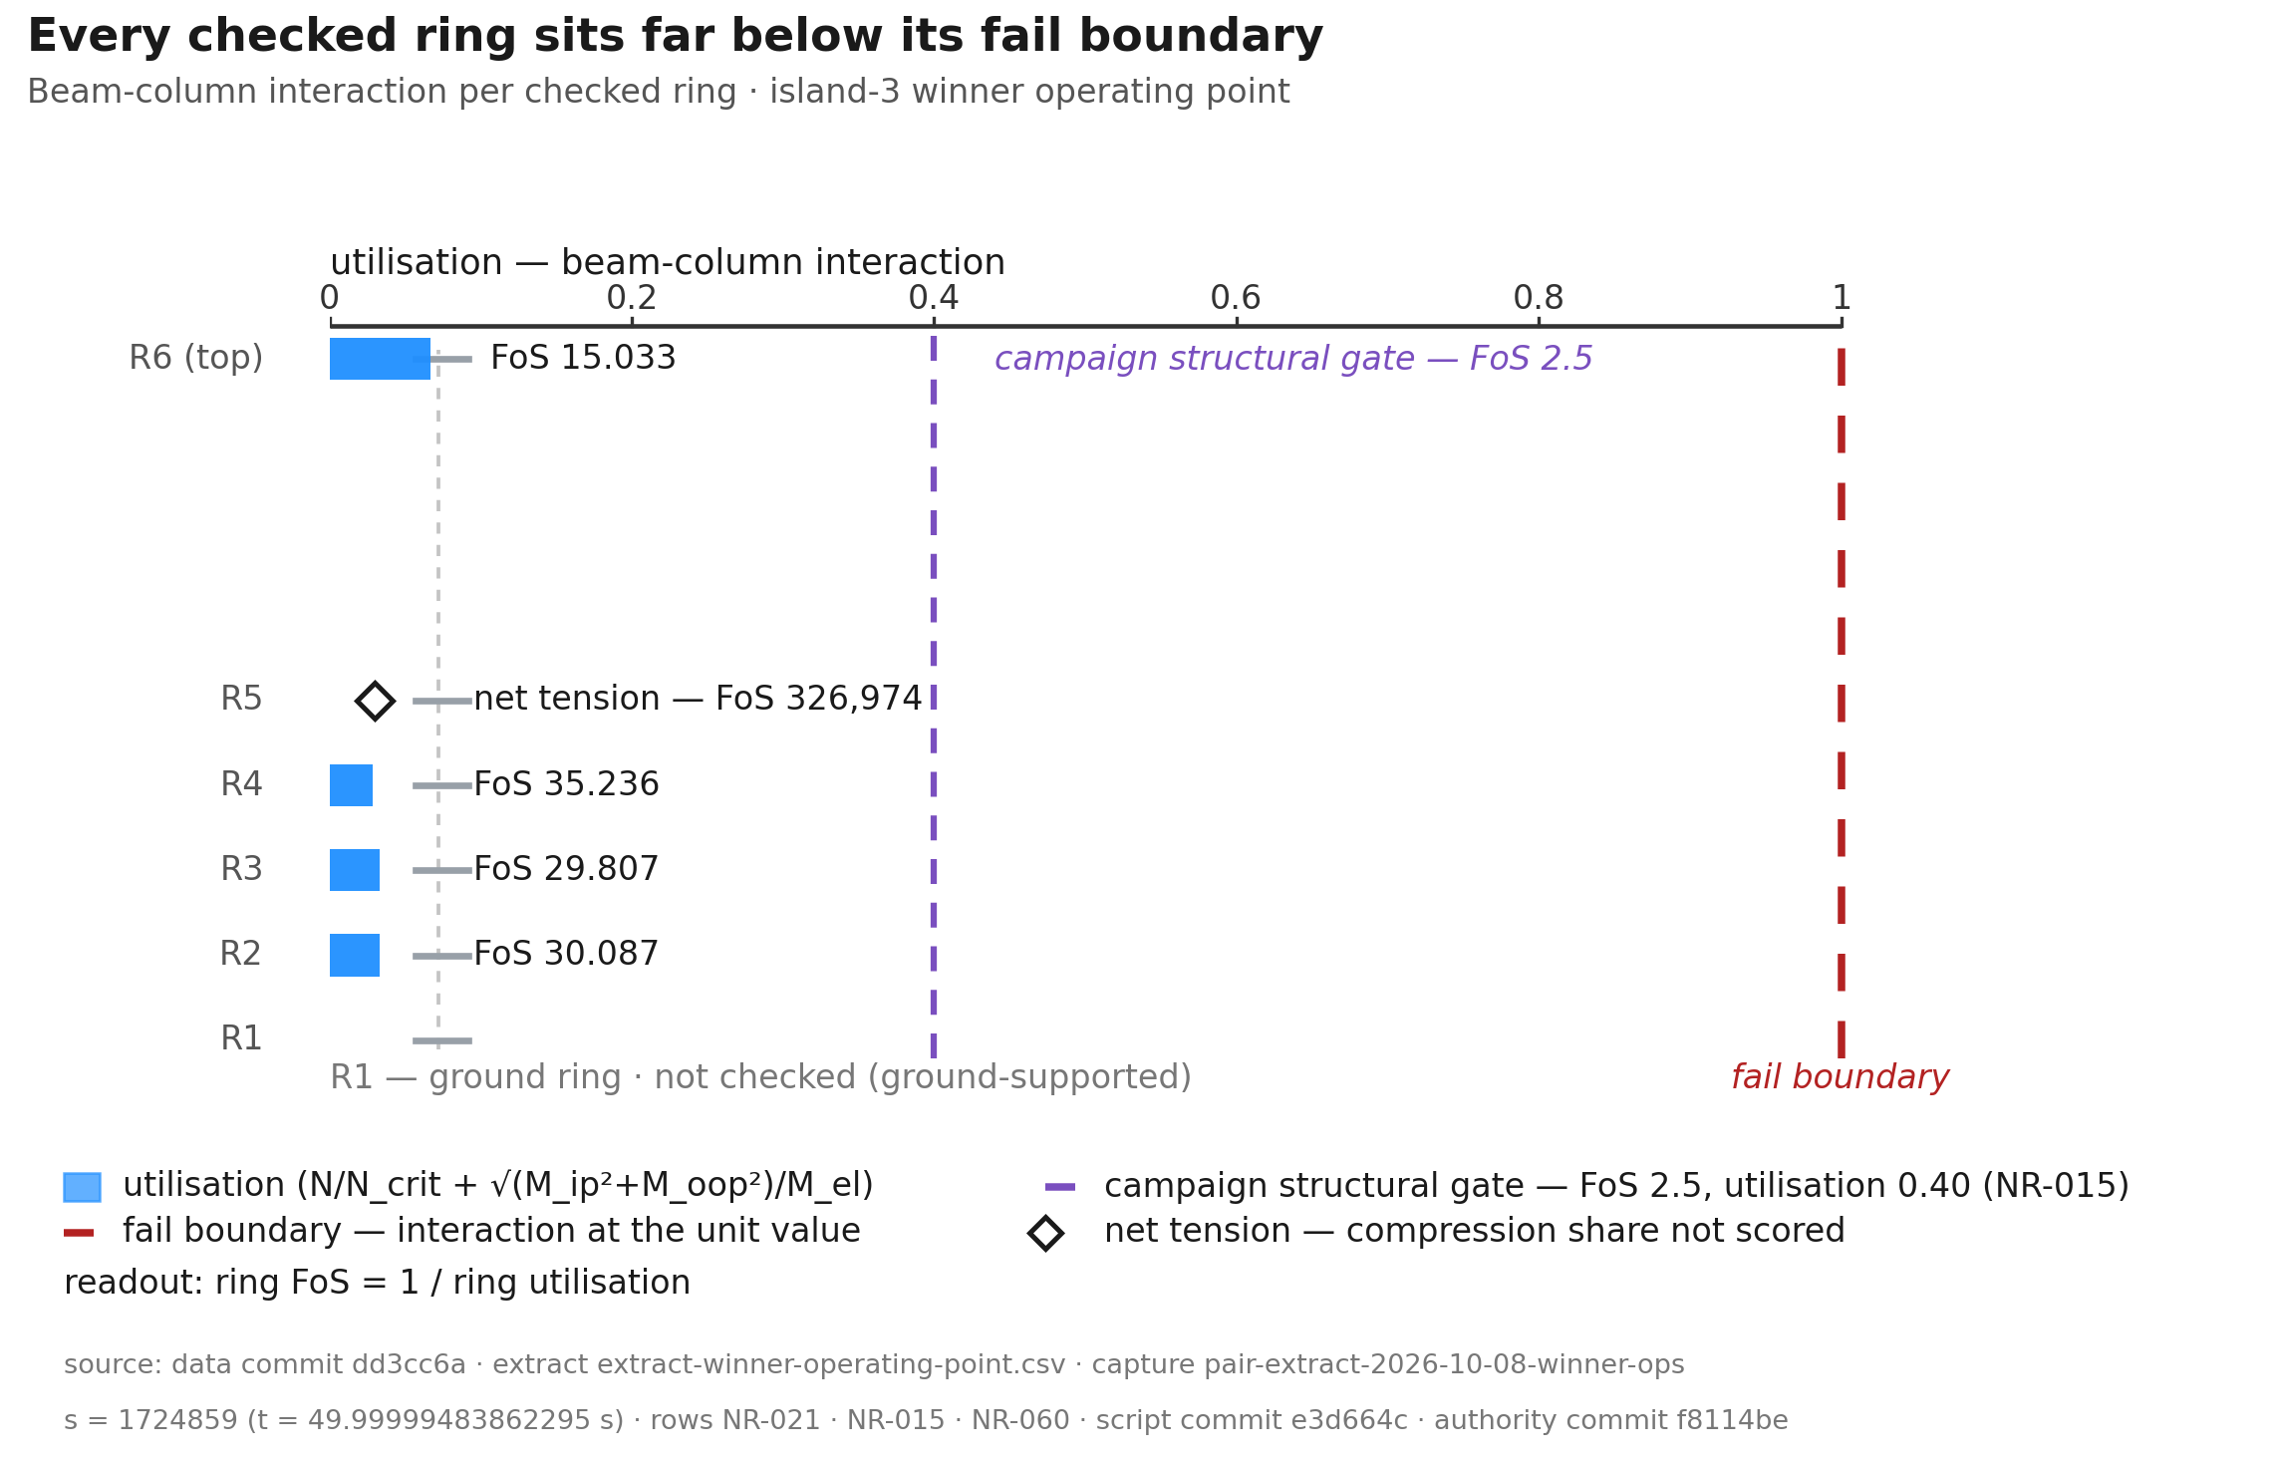
ring-utilisation
Figure (roster row 6) · ring-utilisation
Every airborne ring passes its structural check with a wide margin.
The topmost rotor ring R6 governs the structural check at FoS 15.033. All other airborne rings hold much larger margins (NR-021). Each bar shows one checked ring. The bar end reads the ring utilisation: the beam-column interaction on the worst beam, the axial share N/N_crit plus the bending share √(M_ip²+M_oop²)/M_el. The rows run from R2 at the base to R6 at the top. Utilisation is demand over capacity. The axis is linear from zero to the unit value. The margin of every ring reads as a direct fraction of capacity. The red dashed line is the fail boundary at the unit value, the physical interaction limit at FoS 1. The purple line is the campaign structural gate. It draws at utilisation 0.40, the reciprocal of FoS 2.5 (NR-015). The readout at the row end gives the ring FoS: capacity over demand, the reciprocal of the interaction. The model tracks torsion outside the interaction formula. The figure covers every airborne ring. The check does not cover the ground ring, which sits on ground support. The figure includes and marks the topmost ring. The values come from the campaign winner at its final operating point. R5 reads far below the other rows, so it draws a tension badge instead of a bar. It carries net axial tension from the cone flare (NR-060). The check scores compression only, so the axial share enters the interaction as zero. The badge readout prints the true value, FoS 326,974 (NR-021). For every other checked ring, the bending share sits below 0.05 per cent of the ring utilisation.
Source: pair-extract-2026-10-08-winner-ops · data dd5a9dd · script 9c4646a · rows NR-021 · NR-015 · NR-060
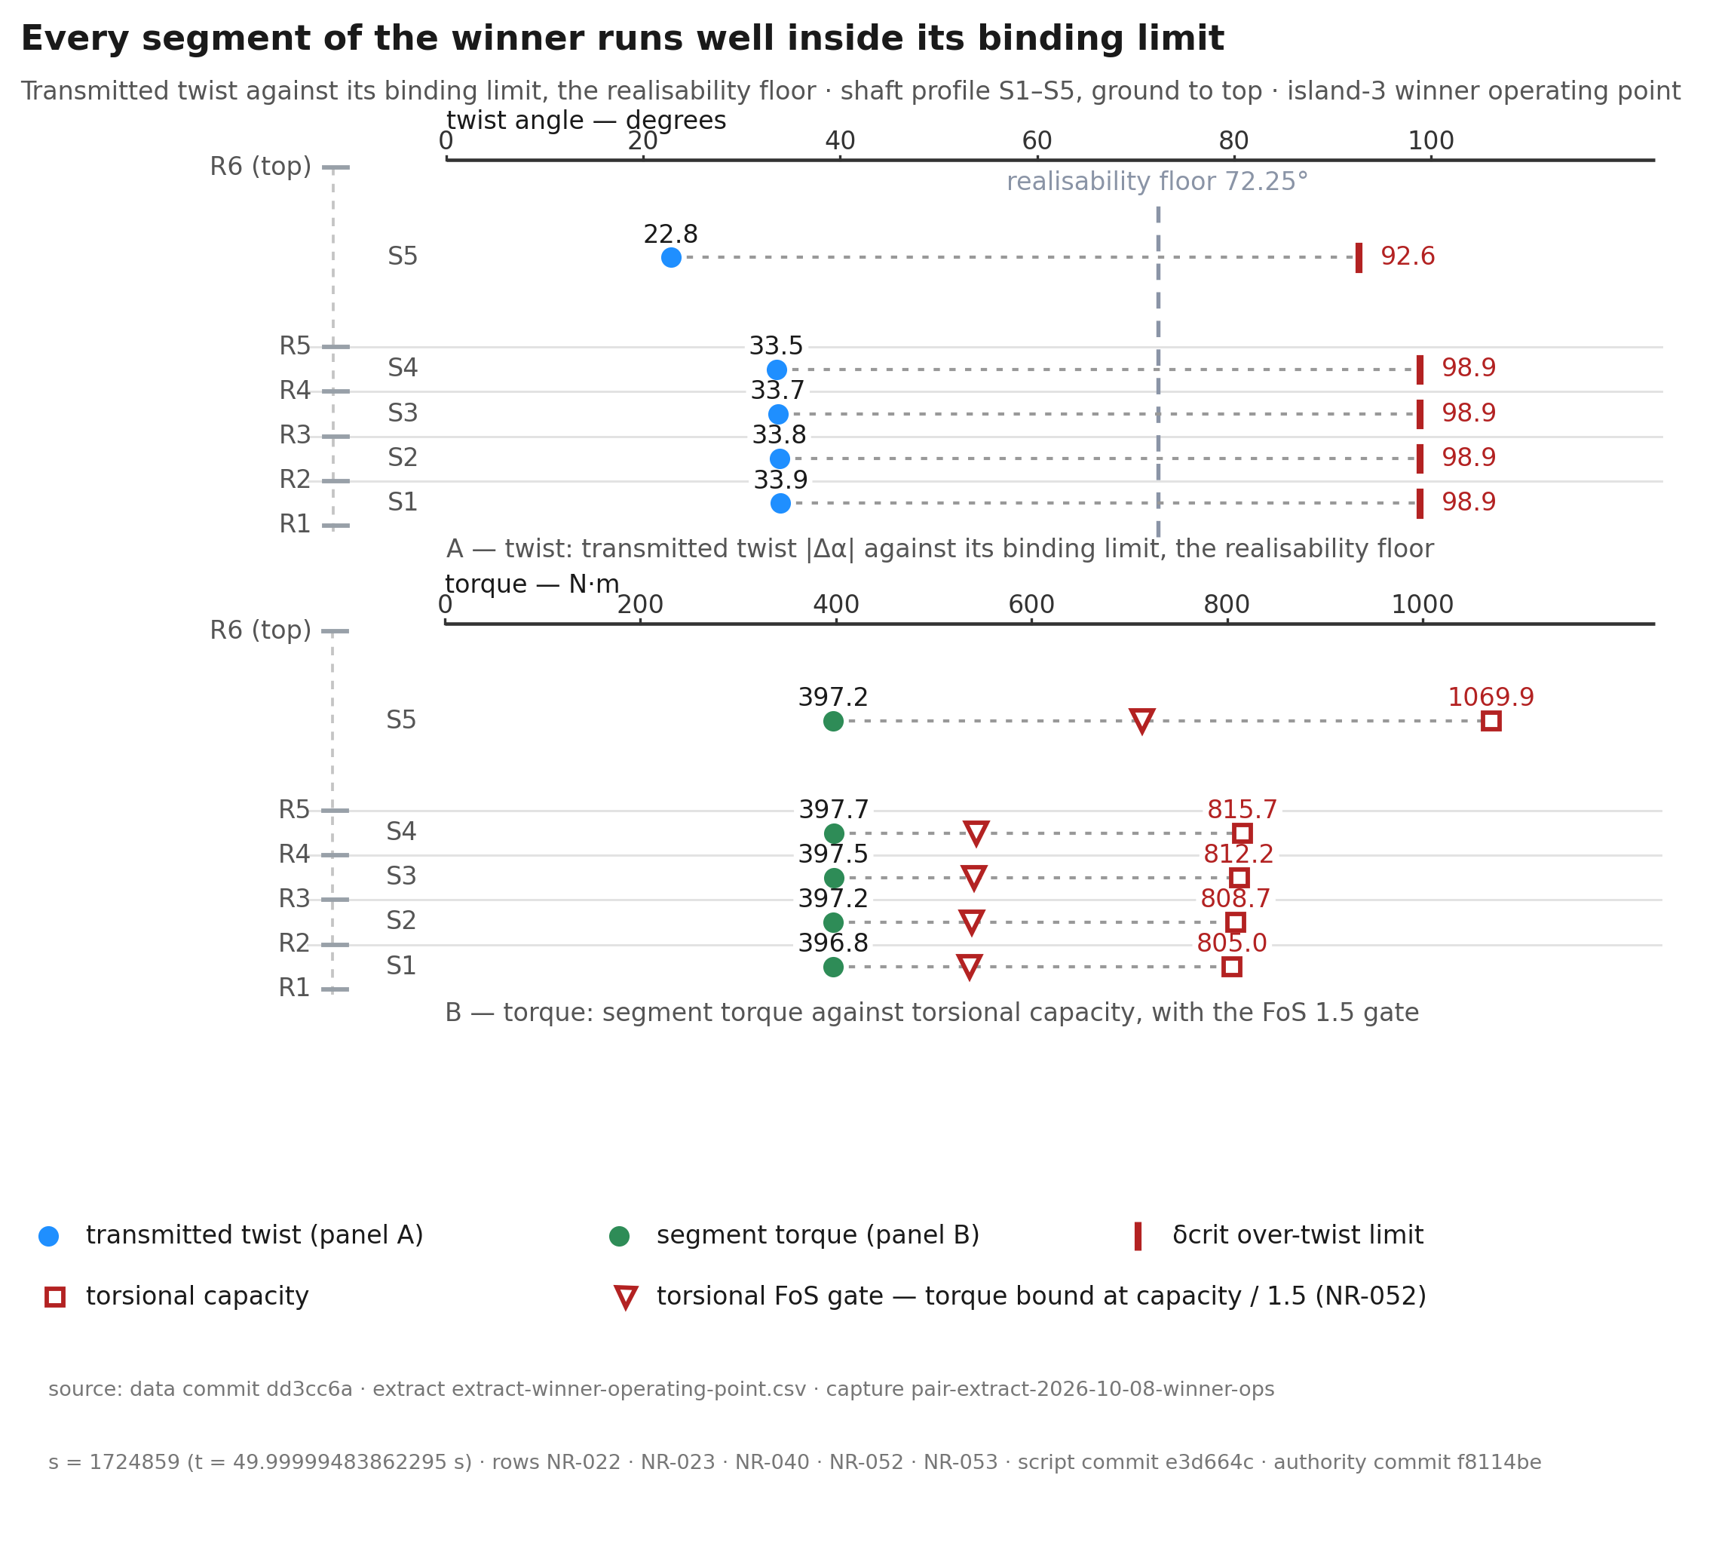
twist-limit
Figure (roster row 7) · twist-limit
The shaft passes its twist and torque checks along its whole length.
All five TRPT segments remain inside their over-twist limits at the winner's final operating point. S1 carries the least segment torque margin, 2.03 (NR-040). Panel A draws the transmitted twist of each segment as a magnitude, against its limits: the over-twist limit δcrit and the realisability floor. δcrit comes from the committed authority trpt_twist_limit. The floor follows sin Δα ≤ 1/1.05 and holds the geometry only to 72.25° (NR-053). The crossing limit δα* is a per-segment collapse-detector limit. It is not the over-twist limit. A no limit segment carries no torsional ceiling. Its lines cannot reach the axis, so no over-twist limit exists. The figure draws no ratio for such a segment. Tether break strain and ring compression carry its limit instead. Panel B pairs segment torque against torsional capacity at the final operating point of the campaign winner. Each segment draws the torsional FoS gate at capacity divided by 1.5 (NR-052). Pair a capacity only with the load of the same state.
Source: pair-extract-2026-10-08-winner-ops · data dd5a9dd · script 58f0022 · rows NR-022 · NR-023 · NR-040 · NR-052 · NR-053
The topmost rotor ring R6 governs the structural check at the winner operating point (NR-021). The window-minimum factor of safety is 14.972 (NR-009). At the final step, R6 reads 15.033 (NR-021). R2 to R4 read 29.8 to 35.2 (NR-021).
R6 binds because its beams carry compression. The ring check charges compressive axial load, not tension. R6 reads the largest axial share, 0.0665 (NR-021). Compression drives the buckling term, so the most compressed ring binds.
R5 carries net axial tension, not no load (NR-060). Its beams read -157.6 to -142.8 N of tension. The check does not charge tension, so its axial share reads zero and its factor of safety reads far above the others (NR-060, NR-021).
The beam load and the line load differ. The lift line carries 324.1 N of tension (NR-010). The ring beams hold compression at R6 and at R2 to R4, and tension at R5 alone. The ground ring sits on ground support and stays outside the ring check.
All five TRPT segments remain inside their over-twist limits at the winner operating point (NR-022). S1 to S4 transmit 33.5 to 33.9 degrees against a 98.9 degree limit (NR-022). S5 transmits 22.8 degrees against its 92.6 degree limit (NR-022). The least segment torque margin is 2.03, at S1 (NR-040). S5 carries the largest segment torque margin, 2.69 (NR-040).
The winner is not close to ring buckling, over-twist or segment torque saturation at this operating point. The margins are conditional. They cover the checked TRPT rings and segments only. They do not yet include blade integrity or lifter loads across wind bands. The next steps add the blade checks and the gust cases.
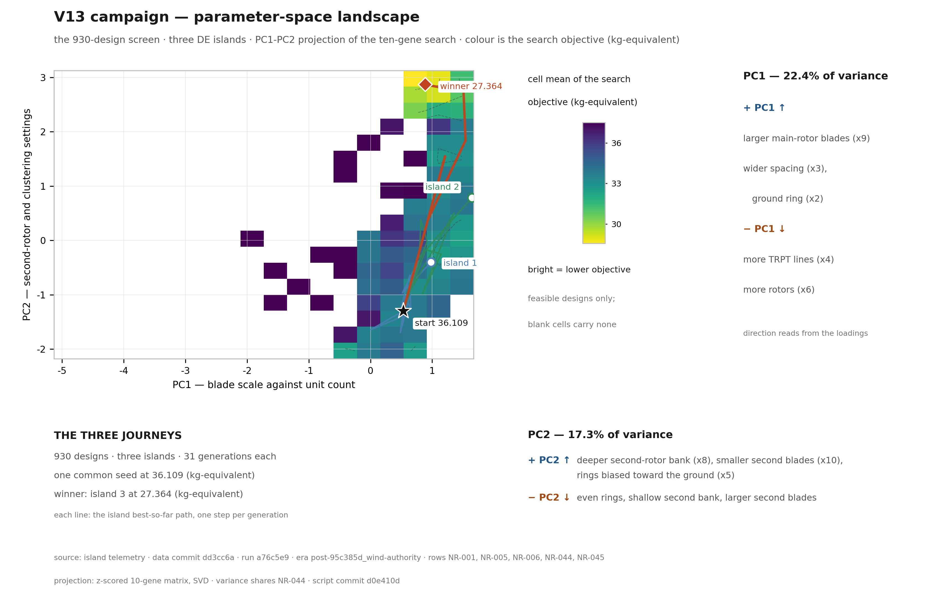
pca-landscape
Figure (roster row 20) · pca-landscape
One seed, three islands: this figure maps the search journeys in gene space and shows where the light machines live.
The figure projects the 930-design screen of the v13 5 kW campaign on its first two principal components (NR-001). The axes come from a z-scored matrix of the ten genes. Colour is the cell mean of the search objective in kg-equivalent. Bright reads lower. Three lines trace the island best-so-far paths, one step per generation. The common seed starts at 36.109 (NR-006). The winner ends at 27.364 (NR-005). The PC1 inset reads larger main-rotor blades, wider ring spacing and a wider ground ring to the right, and more TRPT lines and more rotors to the left. The PC2 inset reads a deeper second-rotor bank, smaller second blades and rings biased toward the ground upward. The variance shares read PC1 22.4 per cent and PC2 17.3 per cent (NR-044).
Source: data dd3cc6a · script d0e410d · rows NR-001, NR-005, NR-006, NR-044, NR-045
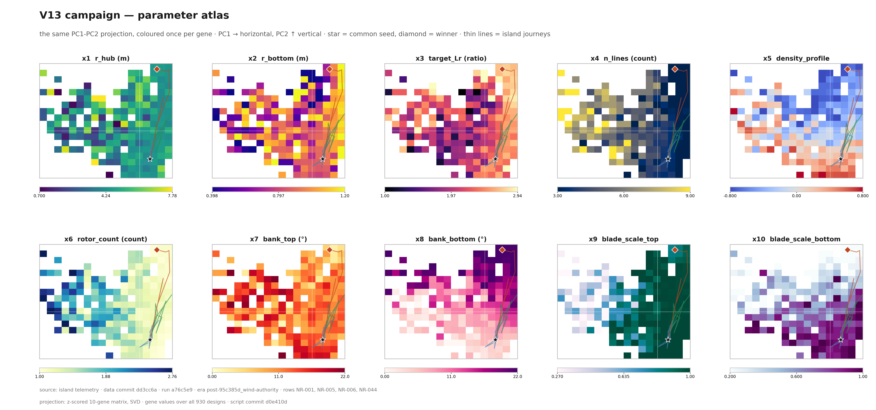
pca-atlas
Figure (roster row 21) · pca-atlas
One map of the search space, coloured ten times: each panel shows where one design gene runs high or low across the search.
The figure repeats one PC1-PC2 projection of the 930-design screen ten times, once per gene slot (NR-001). The projection and the journey marks match the levers landscape plate. Each panel colours the cell mean of that gene over all 930 designs. The star marks the common seed (36.109, NR-006). The diamond marks the winner (27.364, NR-005). The thin lines trace the island journeys. The colour bars print each gene at three significant figures. The projection reads NR-044: PC1 22.4 per cent, PC2 17.3 per cent.
Source: data dd3cc6a · script d0e410d · rows NR-001, NR-005, NR-006, NR-044
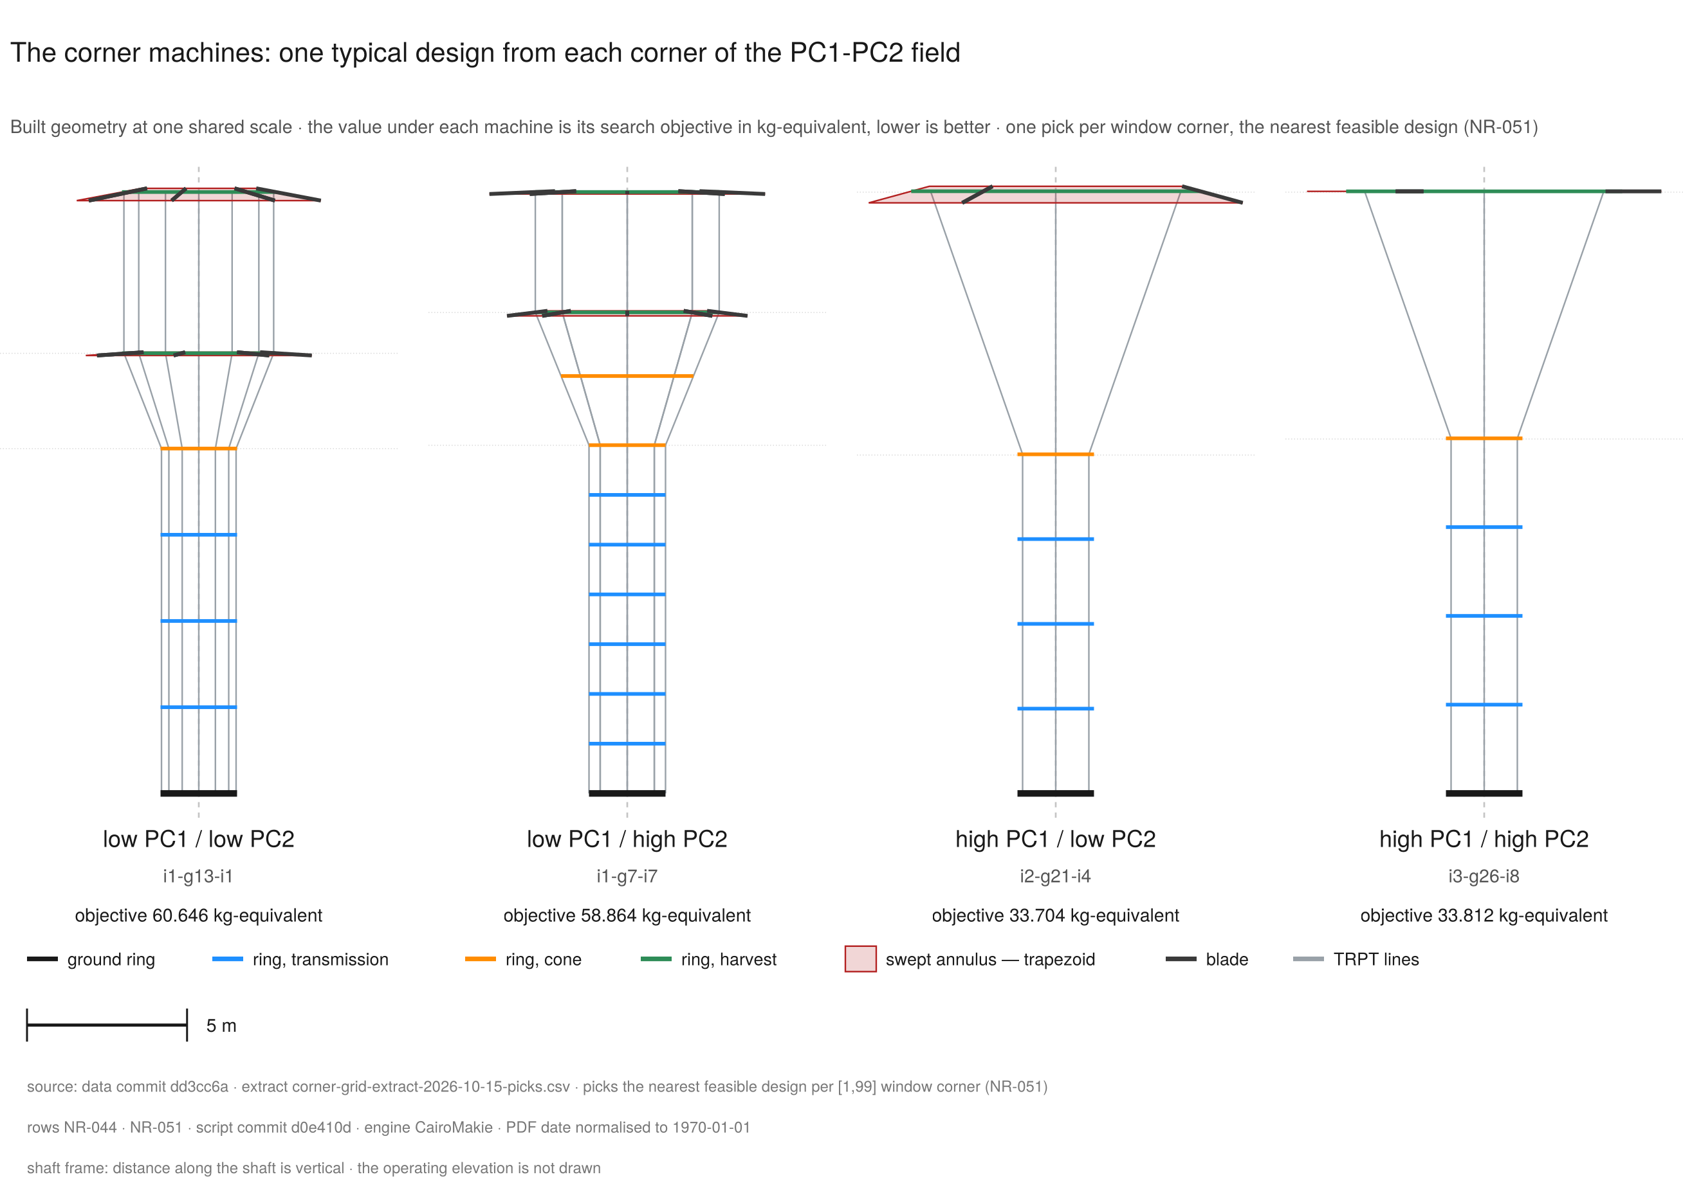
machine-corner-grid
Figure (roster row 23) · machine-corner-grid
The four corner designs show how widely the machine changes across the search field, from multi-line two-rotor stacks to single-rotor cones.
Four panels show the nearest feasible design to each corner of the [1,99] percentile window of the certified PC1-PC2 projection (NR-044, NR-051). The picks read i1-g13-i1, i1-g7-i7, i2-g21-i4 and i3-g26-i8. Their search objectives read 60.646, 58.864, 33.704 and 33.812 kg-equivalent at 3 dp. Each panel draws the built state of that genome at one shared scale. The drawing shows the ring segments in their section colours, the TRPT lines between rings, the blade segments, and the swept annulus of each rotor as one truncated cone. Distance along the shaft is vertical, and the operating elevation is not drawn. The picks are typical machines for their corners, not optima. All four objectives sit above the winner value (NR-005). The plate claims geometry and the search objective. It prints no power value and no airborne mass value.
Source: data dd3cc6a · script d0e410d · rows NR-044, NR-051
The two plates map the same search in two views. They project the 930 designs of the campaign onto the first two principal components of the ten-gene search (NR-001). Those axes hold 22.4 and 17.3 per cent of the variance in the search, 39.7 per cent together (NR-044).
The horizontal axis is PC1: blade scale against unit count. Its inset reads larger main-rotor blades, wider ring spacing and a wider ground ring to the right. It reads more TRPT lines and more rotors to the left. The top loadings read -0.5385 for the TRPT line count, -0.5222 for the rotor count and +0.5180 for the main-rotor blade scale (NR-044).
The vertical axis is PC2: second-rotor and clustering settings. Its inset reads a deeper second-rotor bank, smaller second blades and rings biased toward the ground upward. It reads even rings, a shallow second bank and larger second blades downward. The top loadings read +0.5621 for the second-rotor bank, -0.5605 for the second-rotor blade scale and -0.5018 for the ring density profile (NR-044).
The second-rotor bank and blade-scale slots are inactive at a rotor count of one (NR-011, NR-017). The winner carries one rotor, so those two slots hold no physical blade. PC2 therefore reads mostly unused genes for the winner and for every one-rotor design in the field. The axis is real, but the inactive second-rotor slots dominate it. The active ring-density gene also loads it, at -0.5018 (NR-044).
The colour is the mean search objective in each cell, in kg-equivalent. Bright reads lower, and only feasible designs shade the field. The low-objective cells gather toward the upper right, where the winner sits.
Three lines trace the island best-so-far paths, one step per generation (NR-045). Each island ran 31 generations. All three start at the common seed, 36.109 kg-equivalent (NR-006). Island 3 reaches the winner value, 27.364, at generation 26 and holds it to the end (NR-005). Islands 1 and 2 finish lower in the field.
The atlas repeats the projection ten times, once per gene slot. Each panel colours the mean value of one gene across the field. The star marks the common seed and the diamond marks the winner. The atlas lets a reader follow one gene at a time across that ground.
The two plates fix the search frame. They show where the search went, how light the designs get and how each gene tracks across that ground. The gene-level effects wait on the landscape extracts.

3.5 The evolution story
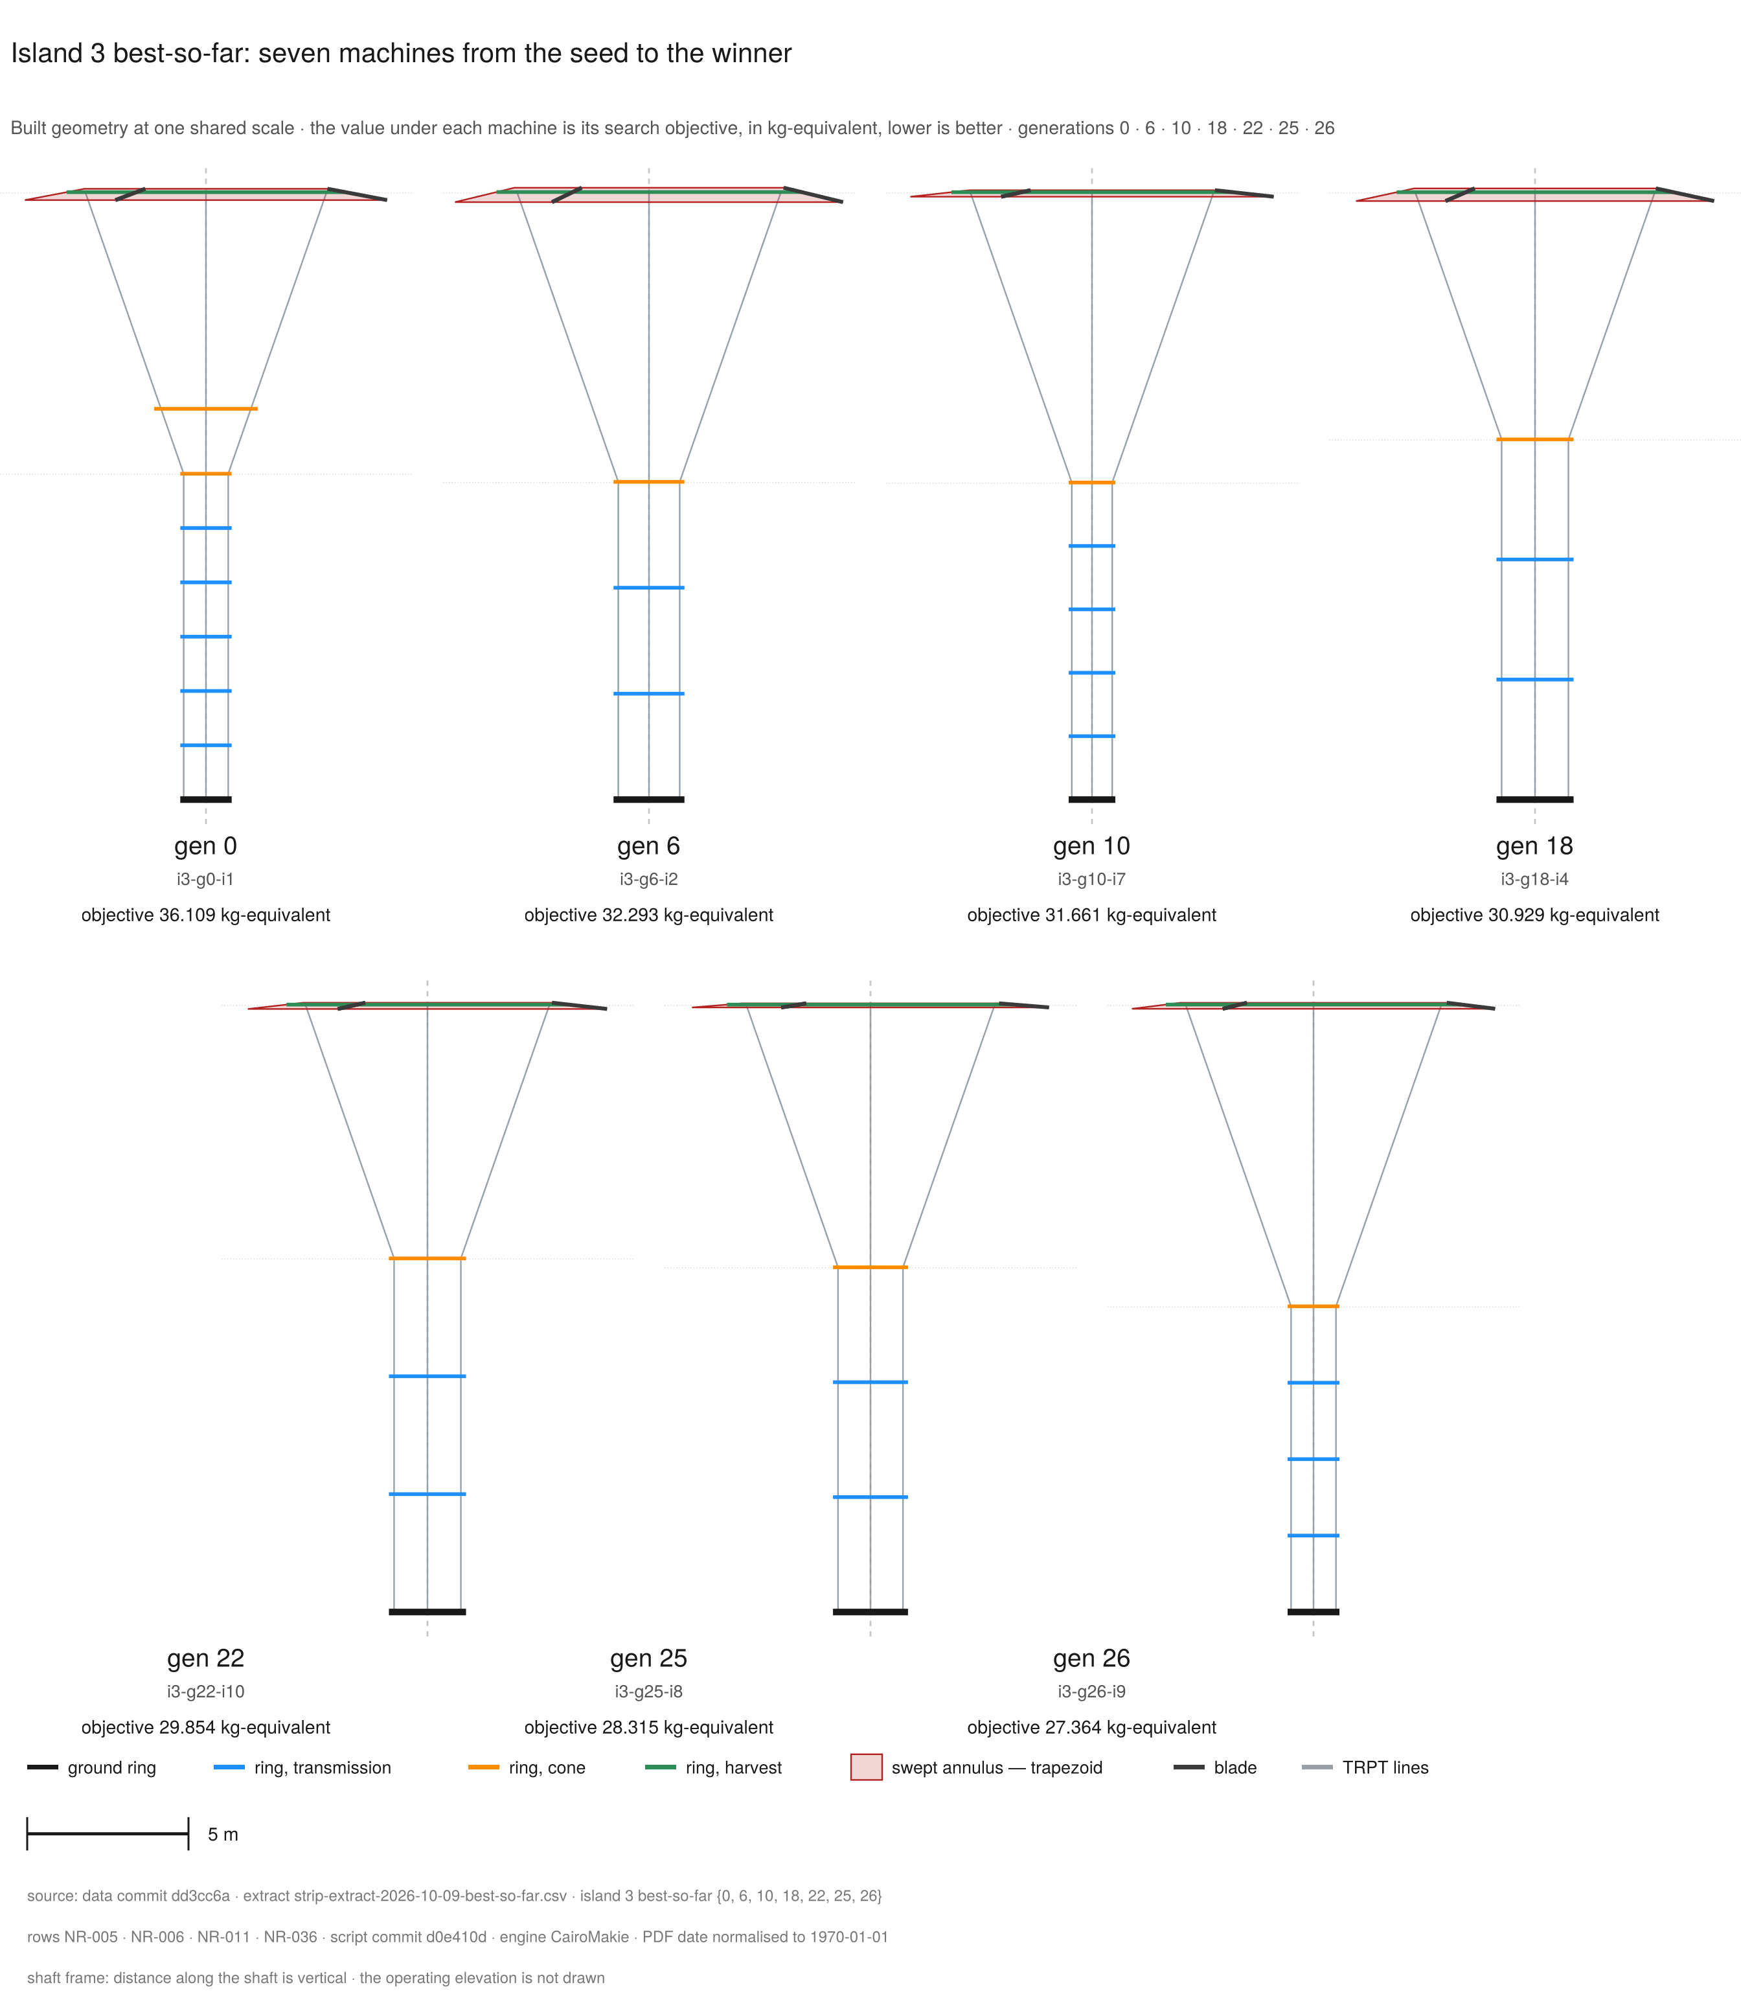
machine-evolution-strip
Figure (roster row 9) · machine-evolution-strip
The search improves the machine at every recorded step, from the common seed to the campaign winner.
Island 3's best-so-far objective falls from 36.109 to 27.364 kg-equivalent. The built geometry converges to the register winner (NR-006, NR-005). Seven panels show the best machine of island 3 at generations 0, 6, 10, 18, 22, 25 and 26. The labels match the recorded generations. Each panel draws the built state of that genome. The drawing shows the ring segments in their section colours, the TRPT lines between rings, the blade segments, and the swept annulus of the main rotor as one truncated cone. The value under each machine is the search objective in kg-equivalent. The drawings use the shaft frame. Distance along the shaft is vertical, and the operating elevation is not drawn. One fixed scale holds across the set. A 5 m scale bar sits in the footer. The set reads in two rows: four panels above, three below. The machines differ in drawn size only where their built size differs. The final panel carries the campaign winner. It matches the register machine: three lines, six rings, topmost ring radius 4.580 m, ground radius 0.804 m, blade scales 0.82 and 0.20. The strip claims geometry and the search objective. It prints no power value and no airborne mass value.
Source: data dd3cc6a · script d0e410d · rows NR-005, NR-006, NR-011, NR-036
The machine evolution strip traces the search on island 3 from the common seed to the campaign winner (NR-036). The objective falls from 36.109 kg-equivalent at generation 0 to 27.364 kg-equivalent at generation 26 (NR-036). The largest recorded drop falls between generations 0 and 6, from 36.109 to 32.293 (NR-036). The final recorded step reads 28.315 to 27.364, a drop of 0.951 (NR-036).
The winner value is the search objective, not a mass reading. The objective reads the airborne mass 25.698 kg plus 1.665 kg-equivalent of penalties (NR-018, NR-039). The sum at three decimals reads 27.363, not the 27.364 the register quotes. The full-precision values add to 27.36354, which rounds to 27.364. The independent three-decimal rounding of mass and penalty is the 0.001 gap.
The final panel matches the register winner. The panel reads three lines and six rings (NR-011). The topmost ring radius is 4.580 m and the ground radius is 0.804 m. The blade scales read 0.82 and 0.20 (NR-011). The winner genome carries inactive slots at a rotor count of one (NR-011, NR-017).
The shaft transition cone holds one fixed angle, 22 degrees, in every machine of the campaign (NR-049). A later campaign can vary it.
The strip shows built geometry and the search objective only. The strip prints no power value and no airborne mass value. The trace reads one island of the campaign. It does not prove a global optimum. A longer or broader run would extend the search.

3.6 Design implications
The record supports four implications. First, the searched TRPT family contains a compact feasible candidate under the modeled objective and gates. Second, the winner holds large structural and twist margins at the final operating point. The margins suggest room for further mass reduction. Any reduction waits on blade integrity and lifter validation.
Third, future searches should treat clearance as a design constraint in its own right. The status mix reads 110 clearance_reject designs (NR-002). Future searches can steer away from low-clearance geometry with a clearance map or a shaped penalty.
Fourth, part of the winner genome stays inactive at one active rotor (NR-011, NR-017). Conditional genes can improve the search efficiency without changing the machine problem. The implications hold under the modeled objective and gates. They do not prove an optimal gene set.
Recommended next steps:
- Use the rapid path for screening under its fixed rope-break gate (NR-013 ext2).
- Add blade root factor-of-safety checks to the structural gate set.
- Validate lifter modulation across the wind bands.
- Extend the wind cases beyond the steady sheared profile.
- Extend the model to the launch and recovery sequence.
- Extract the lever statistics from the campaign telemetry.
- Re-run a short campaign with conditional genes and a clearance-aware decoder.

4 Discussion

4.1 Evaluation fidelity
The ODE path reproduces every recorded winner field at the precision the record stores. Island 3 agrees at full precision (NR-012). The rapid path once rejected all three winners at the rope-break gate (NR-013). The cause was gate placement, not the machine.
The rapid start injects ring velocities from the static pre-solve. The evaluator ran the rope-break gate across the relax run as well as the window. The injected transient over-strain tripped the gate at once.
The team has solved this pattern twice on record. On 2026-08-14 the rule was: the check judges only real operation. The settle transients must not break healthy machines. On 2026-09-16 the ruling was: breaks on the measurement window only, with break detection off during the relax run. The fix here is the same pattern applied to the evaluator.
The fix has landed. The evaluator arms the rope-break check at the relax boundary (NR-013 ext2). ext2 names the second extension note of the row. Detection runs on the measurement window only.
The fix removes false rejections. It never allows breaks. A rope break in the measurement window always rejects the design. No design passes with a broken rope at its operating point.
The lesson stands. The rapid path is the evaluator default. Any consumer that does not pass the cold flag measures the instrument, not the machine. Every healthy winner reads reject on the default path. Pass the cold flag, and every recorded winner field reproduces (NR-012).

4.2 The failure ledger
Candidate entries. Each failure enters with its lesson.
Date / event | Class | What happened | Detection | Correction / lesson | Status
2026-08-13 k-alignment fault | Gain misalignment | The evaluator ran 5-kilowatt designs at k_mppt 10.0, the 50-kilowatt default gain. That gain is about five times the scaled system's own gain, near 1.94. | Acceptance test | One constant, one source file. | Caught and corrected.
2026-08-14 inverted-taper divergence | Geometry/decoder failure | An invalid genome diverged within seconds. The ground instruments still read normal power. | Divergence review | The decoder must refuse what the builder cannot make. The refusal lands at gate time. | Lesson applied.
2026-08-22 blade-mass-law correction | Model correction | The correction voided prior campaign winners. | Physics review | Void the affected data. Keep the record. | Data voided, record kept.
2026-08-22 FoS=Inf guard gap | Gate near-miss | The guard never reached several scoring paths. The re-gate screens winners. | Telemetry review | A gate must pin a measured number. Drift must fail the suite. | Near-miss, no corrupted survivor found.
2026-08-24 stale-gain re-gate | Stale configuration | The winner re-gate ran at a superseded gain. The check caught it. | Pre-push review | The re-gate at the campaign gain returned 5.18 kilowatts. | Corrected.
2026-08-26 rotor-to-ring off-by-one | Decoder mapping error | The middle rotor landed on the topmost ring. Every expansion rotor shifted one ring. | Visual geometry check (preview_genome_geometry.jl) | Validate the rotor-to-ring map against the built geometry. | Corrected.
- The dead geometry genes. The search proposes genomes that cannot build. An off-by-one in the rotor-to-ring map put the middle rotor on the topmost ring (2026-08-26).
- An inverted-taper genome diverged within seconds, while the ground instruments still read normal power (2026-08-14).
- Lesson: the decoder must refuse what the builder cannot make, at gate time.
- The voided campaigns. A later finding can break a model or a geometry. The data from before it then counts no more.
- The blade-mass-law correction landed on 2026-08-22. It voided the campaign winners. The rotor-count data was doubly void: it predated the FoS fix, and its rotors sat one ring toward the top.
- Superseded is the milder class, not void. The pre-derate campaign stands as era record, because the bank derate moved the search space.
- Lesson: void the data, keep the record.
- The k-alignment faults. Twice, a check ran at a different generator gain than the machine it scored.
- On 2026-08-13 the evaluator ran 5 kW designs at the 50 kW default gain. On 2026-08-24 a winner re-gate ran at a stale gain, the superseded 20-second-window value.
- A misaligned gain scores a different machine, and the data voids. Lesson: one constant, one source file.
- The retired load anchors. The anchor 3.55 was a mass-scaled value with no anchor. The anchor 5.39 was the 3-blade anchor chosen on the broken machine. That load forces about 9 kW from the seed (NR-047).
- An earlier round swept the generator gain k on earlier machines. At the top of that sweep the TRPT shaft entered a destructive resonance. That round shares no number with this campaign, because the machine and the model differ.
- The stale-gate near-miss. The FoS floor gate fell behind the model it guarded.
- The FoS=Inf exploit fix landed in one scoring path only. The mass-minimum objective and the older fitness functions never received the guard. The campaign ran through them unguarded (2026-08-22).
- Telemetry shows no surviving design carried the infinite value. That is a near-miss, not a corrupted dataset. Lesson: a gate must pin a measured number, so drift fails the suite.

4.3 Model boundaries
The report states these boundaries plainly. They are part of the valid-science case, not footnotes.
- The model does not check blade integrity. The blade root factor of safety sits at infinity in the model. The team deferred the full beam-on-supports blade model (PRD 0006:147). The rotor blades are not yet structurally gated in this analysis.
- Flown blades carry tether-to-blade bridling that resists thrust and expansion better than the unbridled model assumes. That bridling also adds drag. The model does not include it.
- The model does not simulate launch or recovery. Each run starts with the machine already aloft at its operating point. The full launch sequence and the recovery are outside this report.
- The lift system must also carry the machine during hoisting, after a TRPT break and in high wind. The record does not quantify those cases.
- The campaign wind is steady and sheared. Its speed rises with altitude on the site wind profile. The profile comes from wind measured at the Daisy machine. Gusts and turbulence do not occur in a scored run. The wind direction stays fixed. The scored profile is a base case, not a full weather envelope.

5 Conclusion
The report screened 930 rigid-wing ground-generation rotary kite turbine designs with a tensile rotary power transmission (NR-001). The campaign scored each design on the ODE path over the measurement window (NR-015). One fixed power-law generator load and one fixed gate set held for every design (NR-015).
The search found 508 feasible candidates in the searched space (NR-002). The 301 rejects split three ways (NR-055). 96 ran below the 5 kW power floor. Four ran at or above 5 kW with a factor of safety below 2.5. The remaining 201 carried no logged cause at campaign time.
The re-run probe (NR-061) names them. 93 rotors cannot reach 80 per cent of the power floor on their swept area and power coefficient. 37 settle at the realisability cliff.
36 refuse on rotor spacing. 30 break a line. Three cross the Betz ceiling. Two diverge at the hub tip speed.
The campaign winner, the best feasible candidate under the modeled objective and gates, reads 5.309 kW of mean power (NR-008). All checked TRPT rings and twist segments operate below their failure boundaries at the final operating point (NR-021, NR-022).
The result shows that a compact TRPT machine can satisfy the power, clearance, twist and structural gates in simulation. That result holds under the modeled load and wind. It does not show flight readiness, a global optimum, or full structural safety. Blade integrity is not yet gated, and lifter modulation remains an assumption. The rapid path takes the rope-break gate placement fix (NR-013 ext2).
The Daisy anchor ties the model to a measured flight reference. The next work closes the model gaps. The recommended next steps sit in section 3.6.
Where this goes.
The instrument sizes and scores kite-turbine designs. Its physics model follows the published TRPT lineage, and the cross-check names the matches and the mismatches. Each dataset carries its era, its commits and its geometry fingerprint.
The ladder instrument screens every power level, or rung, and each length on the corrected model. The register, the test suite and the pipeline hold every number. Findings, corrections and retractions stay in the record with their lessons.
The search already moves ten genes, so the same pipeline can probe wider parameter regimes. The expansion rotor model ships with tests, so the pipeline can study multi-rotor and expansion-class machines.
The validated rung is the machine this report covers. The programme targets form the ladder above it, 7, 10, 15, 25, 35 and 50 kW. Each rung above it is a programme target, not a result. No repo artifact backs the rungs.
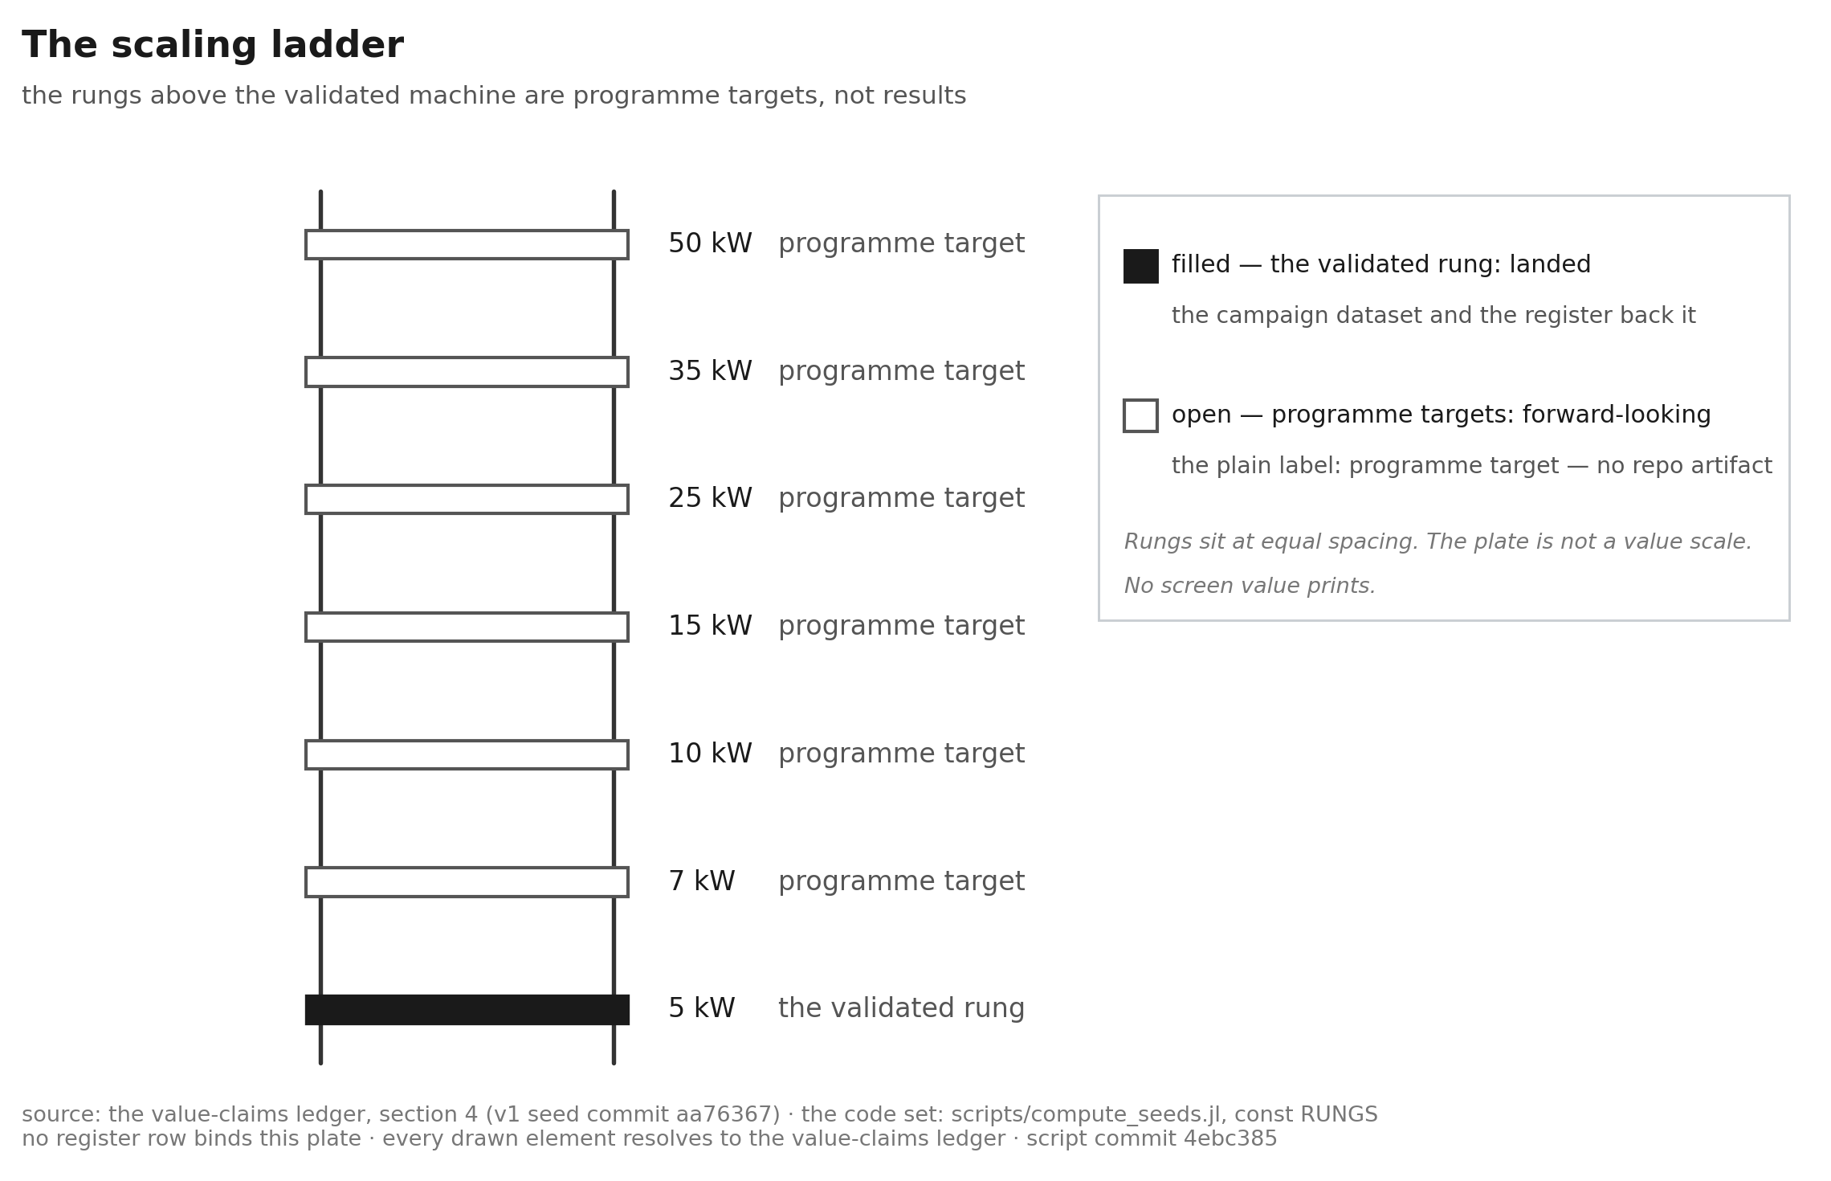
scaling-ladder
Figure (roster row 24) · scaling-ladder
The ladder climbs from the machine this report validates to the programme targets above it. None of the rungs above is a result yet.
The ladder draws the seven rungs of the scale-up programme at equal spacing. The bottom rung is the validated machine, drawn solid. The campaign dataset and the register back it. The six rungs above are programme targets, drawn open, each under the plain label "programme target — no repo artifact". The plate is not a value scale. It carries no measured value and no screen value. No rung above the validated machine reads as a proven design.
Source: data aa76367 · script 4ebc385
Wider parameter regimes, flying higher on longer shafts, and the scale where multi-rotor machines win are programme targets too. The axial-length study runs to 60 m as a plan probe. That figure is not a signed row.
The signed length screen varied length alone on one pre-fold genome. Every screened row read below the power floor. The folded class passed at the base length. The record sits in section 2.3.
The programme takes one validation step at the Daisy scale. The mission target is a displaced-cost metric, set out in phase G of the programme strategy.

6 Potential extension work
The report answers the questions it set. It also opens questions it cannot answer yet. This section sets out three of them. Each one states the question, the reason the current model cannot close it, and the test that would. None of the three carries a scored result.

6.1 Cyclic pitch and the lift kite
The v1 BEM carries collective pitch only. Azimuth-dependent (cyclic) pitch is not modelled. The model source sits in CoaxialAutogyroStacking.jl: one scalar pitch value per rotor in src/bem.jl, with no azimuth term.
That BEM belongs to the lifter stack. The lifter stack carries a swashplate with three actuators on the stationary ring. That geometry can produce cyclic pitch. The stack uses it for collective pitch only. The model and its tests do not exercise the cyclic case.
This report studies a different rotor. The main rotor is a three-blade ring with fixed pitch and a fixed bank angle. The search chooses the blade bank angle for each design. That angle is not a control input. So a cyclic input would be a new degree of freedom on this rotor.
The question splits in two. The two parts carry different risk.
The first part is control authority. Cyclic pitch is a control mechanism, not a lift source. One pitch cycle per revolution tilts the tip-path plane. The two-blade teetering hub on the stack gives a 90 degree rotor phase lag by construction. A delta-3 link or an underslung teeter would shorten that lag. Blade flexibility would shorten it too, though the model carries no flap dynamics.
That lag belongs to the stack. The ring rotor has no teeter, and neither model carries a flap hinge for it. So the lag on the ring is a ring-and-tether property, not a flap response.
The tilt azimuth turns whenever the rotor phase lag is not zero. The tilt and steer then act off the intended axis. If the lag exceeds 90 degrees, the part of the tilt along the intended axis reverses sign. The tilt gives side force and moment: steer and load relief. This part is still plausible and cheap to study.
The second part is self-lift. The autogyro thrust of the rotor is one source of shaft tension. The lifter supplies the other source and sets the floor.
A cyclic tilt trades axial thrust for side force. The moment capacity of the shaft rises with its tension. A lift taken here is torque capacity given up. Any added axial thrust also carries an induced-power cost.
The two duties trade along one curve. A rotor that drives a generator runs below its zero-torque autorotation speed, and lift falls as extraction rises. The stack hardware already takes a small generator load. The model solves the zero-extraction limit. So "cyclic blades, no lift kite" is an energy-budget question, not a hinge question. The test should measure the trade curve, not a binary.
One structural constraint decides the architecture. A TRPT shaft carries tension and torque, and almost no bending. A cyclic-commanded thrust tilt must therefore leave through something other than the shaft.
The stack shows that a teetering hub works at this scale. That is existence proof for a component, not a path for this rotor. A ring rotor would take the tilt reaction through its rim bridle. So the structural question moves to the bridle. The per-revolution pitch linkage is the part neither machine carries. A stiff-mast helicopter swashplate on a TRPT rotor is the wrong machine.
The test has two legs. First, can one-per-rev cyclic pitch on a TRPT rotor give useful tilt and steer authority with no bending-capable shaft? Second, what Cp cost does any axial component carry?
Close it with an azimuth-resolved BEM on the 50 kW ring rotor. Add the azimuth term to the pitch input. Add the tilt degree of freedom to the model. Sweep the tilt from 0 to 10 degrees. That range is a plan value, not a signed row. Sweep the rotor phase lag as a free parameter, not as a fixed 90 degrees.
Report the change in Cp at fixed thrust. Report the lift against extracted power at fixed wind. Report the hub moment against the offset of a hub the study would add. Run a lateral-mode check against the existing shaft model. Check the ring tilt against the rim bridle. Until they run, the rotor phase lag stays a free parameter.
A tether-to-blade bridle holds the blade tip down, from the underside, the concave side of the chord. The model carries no tether-to-blade bridle. It gives every blade one bank angle, all the way round. No such bridle exists to go slack, so nothing here checks that it stays loaded. So the bridle rule binds only on a design the genome cannot yet generate.
The repo holds the platform, the shaft model and the BEM. The azimuth term is one addition. The tilt degree of freedom is the second. The torque sign through the zero-torque crossing is the third.
Below the zero-torque crossing the model consumes power, while the machine drives its generator. The branch comes first. The trade curve means nothing without it.

6.2 Cost of energy with scale
The campaign scores power, mass and load. It does not score cost. The report cannot state the cost of energy at any rung, because no signed row for it exists.
The study is a crossover curve from the 10 kW rung to a 500 kW utility-scale study point. The 50 kW rung sits in between. The 500 kW point sits above the ladder. It is an extrapolation, not a programme rung. Each point takes the same method, on the current model, with one stated capacity factor for the whole curve.
Two outputs carry the value. The first is the rung where the kite turbine meets onshore wind. The second is the rung where the curve flattens, and further scale stops paying.
The enabling step comes before the curve. The value-claims ledger classes every economics reading the project holds today as either held or unsigned. Its rule of use governs this section as it governs section 5. No value prints here until a fresh read produces a signed row for it.
That statement is the anchor. The report does not know the cost of energy at scale, and it says so.
The test: one curve and one method. Each printed point needs a signed row. The curve states one capacity factor.

6.3 Failure modes and effects
The model runs a healthy machine. The failure ledger records campaign failures: a run that stops, a row that reads below the floor. It does not record how the system fails. It does not record what each failure does to the machine, the ground equipment or the site.
The prior art exists. The Daisy machine carries an FMEA and a fault tree to 5 kW, held in DaisyKiteTurbineControl. That work covers the rotor, the control set and the ground equipment on that machine. It does not cover this one.
The extension lifts the Daisy method onto the full system: the airborne rotor, the TRPT shaft and the ground station. Each failure mode takes a severity score, an occurrence score and a detection score. Each mitigation points at a test.
The test: a fault tree. Every top event traces to a component, a mitigation and a test that exercises the mitigation. A score without a test does not enter the record.

7 Nomenclature [PENDING. Track D ratifies the glossary.]

8 References
Seeded in references.bib. Seventeen sources. Sixteen carry verified sources. The Hancock deck stands on the weaker standard (slides held, no public archive). The Ranneberg entry was dropped.

9 Data availability and reproducibility
The dataset commits to the repo at dd3cc6a on bankderate2-results. The launch commit is a76c5e9. The Phase 0 audit sits at master 31ca00d. The fidelity probes sit on the bank-derate-cos2p65 branch. The campaign runner script, scripts/run_v13_5kw_masslift.jl, pins the island seeds.
Every figure will ship with its generating script and its data commit. Every public post will cite register rows by ID.

Document control
The version history, the working notes, the open requests to the analysis room and the seat notes sit in docs/reporting/draft-tracker.md. This document carries only reader-facing material.

Appendix: Claims and evidence
The table ties each headline claim of this report to its evidence and its signed register rows.
Claim | Evidence | Report location | Register rows
Campaign scale and status mix | 930 designs. The status mix reads 508 ok, 301 reject, 110 clearance_reject and 11 reject_twist. | §3.1 | NR-001, NR-002
Winner power | Mean power 5.309 kW over the measurement window. | §3.3 | NR-008
Winner mass | Airborne mass 25.698 kg. | §3.3 | NR-018
Structural margin | Window-minimum factor of safety 14.972. The checked ring utilisations stay below the failure boundary. | §3.3, §3.4 | NR-009, NR-021
Twist and torque margin | All five segments stay inside their over-twist limits. The least segment torque margin is 2.03 at S1. | §3.4 | NR-022, NR-040
Search improvement | The search improved the best objective from the common seed to the winner. It reads 36.109 to 27.364 kg-equivalent. | §3.2 | NR-003 to NR-006, NR-036
Instrument fidelity | The cold path reproduces the recorded winner fields. The rapid path once rejected all three winners at the rope-break gate. The placement fix has landed. | §4.1 | NR-012, NR-013 ext2
Model boundaries | Blade integrity is not gated. The report assumes lifter modulation. Launch and recovery sit outside this report. Gusts and turbulence are not modelled. | §4.3 | PRD 0006:147, assumptions

Appendix: Figure provenance
One row per built exhibit. Eight read dataset commit dd3cc6a. The ladder reads the code rung set.
All nine read the current physics era, post-95c385d_wind-authority, so the era sits here once instead of in a table column.
Exhibit | Source extract | Cited rows | Script commit
Ring utilisation plate | pair-extract-2026-10-08-winner-ops | NR-021, NR-015, NR-060 | e3d664c
Twist limit plate | pair-extract-2026-10-08-winner-ops | NR-022, NR-023, NR-040, NR-052, NR-053 | e3d664c
Machine evolution strip | strip-extract-2026-10-09-best-so-far | NR-005, NR-006, NR-011, NR-036 | 74cfef9
System anatomy plate | scratch/fig1_decode_winner.jl · best_vector.csv | NR-011, NR-017, NR-043 | 9241b23
Levers landscape | scripts/results/v13_5kw_masslift_len18.8_rotorcount_bankderate2/island_{1,2,3}/telemetry.csv | NR-001, NR-005, NR-006, NR-044, NR-045 | e23f226
Parameter atlas | scripts/results/v13_5kw_masslift_len18.8_rotorcount_bankderate2/island_{1,2,3}/telemetry.csv | NR-001, NR-005, NR-006, NR-044 | e23f226
Machine winner | strip-extract-2026-10-09-best-so-far · pair-extract-2026-10-08-winner-ops | NR-011, NR-017, NR-021, NR-022, NR-043 | 1af63fc
The corner machines | corner-grid-extract-2026-10-15-picks | NR-044, NR-051 | a4b4057
Scaling ladder | scripts/compute_seeds.jl const RUNGS · value-claims ledger section 4 | none | 4ebc385
Output pins.
Each figure kit under docs/reporting/figures/<slug>/ carries the canonical pins for its exhibit.
The kit manifest.json holds the rendered-output pins (png, svg, pdf, ledger). The check-log pin reads as the sha256 of the kit checks.log.
This appendix cites the kits once instead of reprinting the 64-character hashes.

Data register (cited rows)
Every number in this draft traces to a signed row in the numbers register. A missing row here is a release blocker.
Row | Quantity | Value | Units | Source | Status
NR-001 | Campaign size | 930 (3 islands × 310) | evals | island_*/telemetry.csv | signed (science-validator, 2026-10-08)
NR-002 | Status mix | 508 ok / 301 reject / 110 clearance_reject / 11 reject_twist | designs | telemetry status column | signed (science-validator, 2026-10-08)
NR-003 | Island 1 best fitness | 30.578 (found gen 30) | kg-equivalent | island_1/convergence.csv | signed (science-validator, 2026-10-08)
NR-004 | Island 2 best fitness | 30.637 (found gen 30) | kg-equivalent | island_2/convergence.csv | signed (science-validator, 2026-10-08)
NR-005 | Island 3 best fitness | 27.364 (found gen 26) | kg-equivalent | island_3/convergence.csv | signed (science-validator, 2026-10-08)
NR-006 | All-island start point | 36.109 (gen 1, common seed) | kg-equivalent | convergence.csv | signed (science-validator, 2026-10-08)
NR-007 | P_mean range, ok rows | 5.02–6.32 | kW | telemetry, ok only | signed (science-validator, 2026-10-08)
NR-008 | Winner P_mean (island 3) | 5.309 / P_end 5.314 | kW | island_3 telemetry / re-eval (§4, Phase 0 audit) | signed (science-validator, 2026-10-08)
NR-009 | Winner FoS (island 3) | 14.972 | — | island_3 telemetry / re-eval (§4, Phase 0 audit) | signed (science-validator, 2026-10-08)
NR-010 | Winner T_lift (island 3) | 324.1 | N | island_3 telemetry / re-eval (§4, Phase 0 audit) | signed (science-validator, 2026-10-08)
NR-011 | Winner geometry (island 3) | n_lines 3, rings 6, n_active 1, r_hub 4.580 m, r_bot 0.804 m, bank_bot 22°, blade scales 0.821326/0.20 (quote 0.82/0.20) | — | decode of best_vector.csv | signed (science-validator, 2026-10-08)
NR-012 | Cold-path reproduction | :cold re-eval matches recorded P_mean, P_end, FoS, fitness, T_lift to 3 dp on all three winners | — | probe_rapid_vs_ode_winners.jl | signed (science-validator, 2026-10-08)
NR-013 | Rapid-path result on winners | :warm rejects all three winners — rope-break gate (broken=true), transient line over-strain during relax | — | probe_rapid_vs_ode_winners.jl + probe_warm_reject_cause.jl | signed (science-validator, 2026-10-08)
NR-014 | Winner window swing | P_range 0.029 on 5.309 kW (0.5%) | kW / % | re-eval (§4, Phase 0 audit) | signed (science-validator, 2026-10-08)
NR-015 | Operating point | k 2.24, relax 10 s + window 40 s, FoS gate 2.5/2.5, length 18.8 m | — | runner provenance | signed (science-validator, 2026-10-08)
NR-016 | Winner ω (ODE) | 10.170 | rad/s | re-eval (§4, Phase 0 audit) | signed (science-validator, 2026-10-08)
NR-017 | Winner main-rotor bank (island 3) | 7.088° at ring 6. Slot 8 = 22° reaches no rotor at n_active 1 | deg | decode probe d219b6c. Threading src/objective_v10.jl:339 | signed (science-validator, 2026-10-08)
NR-018 | Winner airborne mass (island 3) | 25.70 | kg | audit §4 + probe 0c4046b | signed (science-validator, 2026-10-08)
NR-019 | Bank-derate exponent in use (main-rotor disc power) | 2.65 (power × cosd(bank)^2.65, the same exponent the elevation factor uses) | — | one authority BEM.projection_factor (src/bem.jl, landed b835ebc, record 779fa55). Application sites src/ring_forces.jl:234-235, src/initialization.jl:1033-1037, src/sim_frame.jl:158-159, 480-481 (94223eb, Rod ruling 2026-10-01). Guard test/test_ring_forces.jl "main-rotor bank derate" | signed (aero-validator, 2026-10-08)
NR-020 | Measured bank retention at the Cp peak | 0.854 at 20°. cos^2.65 predicts 0.848 (a match to 0.7 per cent). cos^3 predicts 0.830 | — | 10-precone-sweep.md sections 3 to 5. The precone rows of 10-precone-sweep.csv at commanded lambda 4.0 (Cp 0.22540 vs 0.26386) | signed (aero-validator, 2026-10-08)
NR-021 | Ring check at the winner operating point (island 3): interaction, shares and FoS per checked ring | R2 0.03324, FoS 30.087. R3 0.03355, FoS 29.807. R4 0.02838, FoS 35.236. R5 3.058e-6, FoS 326974. R6 hub 0.06652, FoS 15.033 | — | Extract docs/reporting/figures/pair-extract/extract-winner-operating-point.csv, ring block. Emitted by capture_extended; max_util re-derived via ring_element_analysis; A1 identity checked, residual 0.0 at every ring | signed (aero-validator, 2026-10-08)
NR-022 | Segment twist and over-twist limit at the winner operating point | |Δα|: S1 33.95°, S2 33.81°, S3 33.68°, S4 33.55°, S5 22.82°. δ_crit: S1 to S4 98.86°, S5 92.64°. has_limit true on all five | deg | Extract, segment block. Raw reads from the stored alpha block; trpt_twist_limit on the rope_forces C1 call pattern (node radii, mean line rest length) | signed (aero-validator, 2026-10-08)
NR-023 | Segment torque pair at the winner operating point | segment_torque: S1 396.8, S2 397.2, S3 397.5, S4 397.7, S5 397.2. torque_capacity: S1 805.0, S2 808.7, S3 812.2, S4 815.7, S5 1069.9 | N·m | Extract, segment block. Capacity = trpt_torque_capacity_axial at trpt_axial_force of the same state. One instant for both series | signed (aero-validator, 2026-10-08)
NR-025 | Cold-start protocol (campaign setting) | Settle settle_to_operational_state (n_op 150000 steps, about 6 s simulated; ω_rated_max 60.0 rad/s), then kickstart off (kickstart_s 0.0; the legacy kick is -60.0 N·m·s²/rad², about 115 times the MPPT torque), then one combined relax+window run, 10 s + 40 s, rope breaks enabled across both. Winner run: 1724859 steps | s, steps | src/objective_evaluator.jl:774, 840-842, 856-892, 978-989; src/initialization.jl:2184-2190; scripts/run_v13_5kw_masslift.jl:157 | signed (aero-validator, 2026-10-08)
NR-026 | Lifter sizing margin (campaign regime) | margin 1.5 (vertical force at the lift bearing = 1.5 × m_airborne × g); line tension = F_vert / sin(70°), flat at all wind speeds; m_airborne excludes the lifter's own 5 kg (the kite carries itself) | — | src/lift_kite.jl:197-228; regime line scripts/run_v13_5kw_masslift.jl:111 | signed (aero-validator, 2026-10-08)
NR-027 | 10-05 length screen on the pre-fold island-3 genome (both rounds, arrow = round 1 to round 2) | P_mean 18.8 m: 3.7955 → 4.2332; 21.2 m: 3.8645 → 4.3055; 25.0 m: 3.9747 → 4.4122. All six rows FAIL (P<5.0) | kW | scripts/results/length_variants_island3/variants.csv (f225e95, 2026-10-05T10:10Z); scripts/results/length_variants_island3-cpfix/variants.csv (a82cafd, 2026-10-05T11:25Z) | signed (science-validator, 2026-10-10)
NR-028 | 18.8 m fold comparison at the cpfix era | pre-fold genome 4.2332 (fail), folded class P_end 5.3691 (ok) | kW | Pre-fold: NR-027 round 2. Folded: scripts/compute_seeds.jl:50-56; docs/validation/2026-10-05-s2-fold-flight.md | signed (science-validator, 2026-10-10)
NR-029 | Winner operating speed, window-mean ground ring | 13.38 (quote 13.38, 127.772 rpm) | rad/s | scripts/probe_window_trace.jl (b665e6e), parity against the recorded cold re-eval (NR-012) | signed (science-validator, 2026-10-11)
NR-030 | Winner delivered torque, window-mean basis | 396.8 (quote 396.76) | N·m | P_mean (NR-008) divided by NR-029. Cross-reads: S1 panel 396.8 (0.0075 % above), S5 hub 397.2 | signed (science-validator, 2026-10-11)
NR-031 | Winner operating coefficients: tip-speed ratio, rotor Cp, system coefficient | lambda_gnd 5.566 (quote 5.566, hub value 5.566 agrees inside 1.1e-4), Cp 0.2944 (quote 0.2944), system coeff 0.1016 (quote 0.1016) | - | lambda from NR-029, r_ring 4.580 m, v_ref 11.01 m/s. Cp at lambda 5.566 from the measured n = 3 surface (src/aerodynamics.jl:263, anchor a82cafd). Coeff from NR-008 divided by 0.5 rho A v^3, A 63.9 m², rho 1.225 | signed (science-validator, 2026-10-11)
NR-032 | Winner tip-speed ratio and rotor Cp, tip reference | lambda_tip 6.842 (quote 6.8415, hub value 6.841 agrees inside 5.5e-5), Cp 0.2258 (quote 0.2258) | - | lambda from the NR-029 window trace, r_out 5.630 m, v_ref 11.01 m/s. Cp at the hub-basis lambda from the measured n = 3 surface (src/aerodynamics.jl:263, anchor a82cafd). Receipts: scratch/sv_probe_winner_areas.jl, scratch/av_probe_tipref_counter.jl | signed (science-validator, 2026-10-11)
NR-033 | Winner swept-area set | A_raw 45.97 (quote 45.9733), A_bank 45.60, A_zn 39.49 (quote 39.4912), A_zy 39.81 (elevation-only cross-check), A_hub_bot 63.87 (retired basis) | m² | Built radii through annulus_area (src/bem.jl). A_zn is the ruled wind-normal basis (objective_evaluator.jl). Receipts: scratch/sv_probe_winner_areas.jl, scratch/av_probe_tipref_counter.jl | signed (science-validator, 2026-10-11)
NR-034 | Winner Betz ceiling and re-based coefficients | ceiling (16/27) x 0.5 rho A_zn v^3 = 19.13 kW (quote 19.1304), delivered share 0.2775 (quote 27.75 %), system coeff 0.1413 on A_raw and 0.1644 on A_zn | kW / - / - | v_ref 11.01 m/s, rho 1.225. The code gate charges the rounded 0.593 form: 19.14 kW. Arithmetic route: scratch/sv_rebase_arithmetic.py | signed (science-validator, 2026-10-11)
NR-036 | Island 3 running-best search objective at the seven strip milestones | 36.109 (gen 0), 32.293 (gen 6), 31.661 (gen 10), 30.929 (gen 18), 29.854 (gen 22), 28.315 (gen 25), 27.364 (gen 26) | kg-equivalent | docs/reporting/figures/machine-evolution-strip/extract-best-so-far.csv (certified 2026-10-09). This seat re-checked all seven against island_3/telemetry.csv: each is an ok row and the least ok fitness of its window. Figure label: search objective | signed (science-validator, 2026-10-11)
NR-039 | Island-3 fitness decomposition, NR-005 against NR-018 | fitness 27.36 = mass 25.70 + over-power 0.4933 + utilisation 0.5577 + twist 0.6141. Penalty total 1.665 (quote 1.665) | kg-equivalent | island_3/convergence.csv gen-26 row + scratch/sv_p0_winner_reeval.txt + evaluator chain at launch a76c5e9 | signed (science-validator, 2026-10-12)
NR-040 | Winner segment torque margin | S1 2.029, S2 2.036, S3 2.044, S4 2.051, S5 2.694. S1 governs (quote 2.03). The S1 to S4 band reads 2.029 to 2.051. | — | NR-023 strings, segment by segment: torque_capacity / segment_torque. Recipe: 805.0 / 396.8 = 2.029. Cross-read: docs/reporting/figures/pair-extract/extract-winner-operating-point.csv, segment block, bit for bit | signed (science-validator, 2026-10-12)
NR-041 | Honest-window k sweep of the 5 kW seed (2026-08-22): window-mean power by load | P_mean at 2 dp: 3.49 reads reject. Then 5.45, 6.78, 7.56, 8.00, 8.89. Then 8.95 at the last four. | kW | scripts/results/k_sweep_daisy_5kw.csv, blob d17d1377b191dde5b44df7f5534d0cdc4c48d0f3, landed adea1a3 (2026-08-22 14:11:49 +0100). Column line and ten data rows | signed (science-validator, 2026-10-12)
NR-042 | Winner blade-tip clearance and the gate floor | floor 1.5, winner 5.468 at decode. Margin +3.968 (3.65 times, +264.5 per cent) | m | pair-extract log line 11 (docs/reporting/figures/pair-extract/extract-winner-operating-point.log, sha256 7579e84a5724a2a41f9ada08200b0dc59e0a03177ce9193c4978abc1d71474f8). Runner scripts/run_v13_5kw_masslift.jl:76 and :254-257. Knob probe scratch/av_probe_clearance_knob.jl | signed (science-validator, 2026-10-13)
NR-043 | Winner blade span (island 3, main rotor) | 1.499 (quote 1.499) | m | scratch/sv_probe_winner_areas.log, the span (built) line, sha256 in the manifest. R_main 5.630 minus blade_hub_radius 4.130. The decode convention src/objective_v10.jl:374-376. Figures decode log scratch/fig1_decode_winner.log. Counter-read: the aero tip-reference receipt (2026-10-11) | signed (science-validator, 2026-10-13)
NR-044 | PCA projection summary (v13 5 kW screen, 930 draws): variance shares, top loadings, bin rule | PC1 22.434667 (quote 22.4), PC2 17.263044 (quote 17.3), pair total 39.697710 (quote 39.7) per cent. Loadings at four decimals, the abs(v) >= 0.2 set: PC1 n_lines -0.5385, rotor_count -0.5222, blade_scale_top +0.5180, target_Lr +0.2517, r_bottom +0.2036. PC2 bank_bottom +0.5621, blade_scale_bottom -0.5605, density_profile -0.5018, bank_top -0.2444. The field bins at 18 x 18 cells over the 1 to 99 percentile rectangle | per cent, -, cells | Recipe: z-score the 930 x 10 matrix of x1..x10 (three island telemetry files, data commit dd3cc6a), one SVD, shares from the squared singular values. Reproduction below | signed (science-validator, 2026-10-13)
NR-045 | Island generation counts (v13 5 kW screen) | 31 generations per island (gen index 0 to 30), 10 rows per generation (idx 0 to 9), 310 rows per island, 930 in total | generations / rows | island_*/telemetry.csv, gen and idx columns, data commit dd3cc6a | signed (science-validator, 2026-10-14)
NR-046 | The objective seam forms, the weights, the thresholds and the reject placement | f = mass + 5.0 * max(P_score - 5.0, 0)^2 + 20.0 * (2.5 / FoS_min)^2 + 1.0 * (r / (1 - r))^2 with r = min(twist_ratio, 1), plus the stationarity add-on 10.0 * max(0, swing - 0.20) with swing = P_range / P_mean. P_score reads the tail-5 power (P_end). Winner closure: 25.70 + 0.4933 + 0.5577 + 0.6141 = 27.36 (NR-039). Rejects carry no score: the evaluator returns Inf and the runner stamps the search cost 1e9 on every non-ok design (422 of 930 rows) | kg-equivalent: 5.0 per kW², 1.0 per twist-ratio², 20.0 per FoS-ratio², 10.0 per swing fraction. Mass reads kg. The 1e9 stamp is a search cost, not an objective unit | Source read at 7b8c101, the tip at read time. Byte-stable from launch a76c5e9. Sites: src/objective_v12.jl:114-116 (weights), :145-168 (seam body). src/objective_evaluator.jl:90-91, 1148, 1161, 1192-1194, 1200-1203. scripts/run_v13_5kw_masslift.jl:153-156, 256-257, 266, 272, 281-283. Census over island_*/telemetry.csv. Checker: scratch/sv_nr046_objective_seam_check.py and its log | signed (science-validator, 2026-10-14)
NR-047 | The k-sweep display rows for section 2.3: six loads of the honest-window sweep, one row per k | P_mean at 2 dp: k 0.5 reads reject. Then 5.45, 6.78, 7.56, 8.00, 8.89. omega_final at 2 dp: 19.14, 17.64, 16.59, 15.80, 15.34, 14.42. FoS_min at 1 dp: 51.8, 47.8, 42.8, 40.1, 36.4, 24.3 | kW, rad/s, - | scripts/results/k_sweep_daisy_5kw.csv, blob d17d1377b191dde5b44df7f5534d0cdc4c48d0f3, landed adea1a3 (2026-08-22). Column line and ten data rows. The six rows read at omega_final | signed (science-validator, 2026-10-14)
NR-048 | The sizing-side pair for the k = 2.24 story: the load-step sizing case and the k-easing refusal | Sizing load case = a bounded generator load step (nominal k_mppt × 2), measured F_helix ≈ 1278 N/vertex on the hub segment. The lull is benign under MPPT. k easing refused as the high-wind substitute: the rotor spins up to twist 87.9° against the 78.8° collapse limit | N/vertex, degrees | DECISIONS.md [2026-09-06] entry; docs/plans/2026-09-06-closed-form-beam-sizing.md section 7.1 and the scenario list; evidence script scratch/scenario_sweep.jl | signed (science-validator, 2026-10-14)
NR-049 | The shaft transition cone angle, one fixed half-angle across the campaign | cone_slope_deg 22.0 | degrees | scripts/run_v13_5kw_masslift.jl:172, src/objective_v10.jl:207 and :259, src/objective_evaluator.jl:148. Census: 41 cone_slope_deg sites across src/, scripts/, test/ and the figure scripts, each a literal 22 or a cfg plumb. Probe scratch/sv_fb5_source_reads_probe.jl | signed (science-validator, 2026-10-14)
NR-050 | The blade-scale base: the sized rotor radius, the base span at 0.75 of it, the base chord at 0.113 of it | Winner decode: r_rotor 2.434, base span 1.826, span 1.499 (NR-043), chord 0.2259 | m | src/objective_v10.jl:355-377, src/bem.jl:156-179, probe scratch/sv_fb5_source_reads_probe.jl and its log | signed (science-validator, 2026-10-14)
NR-051 | The corner-grid picks (v13 5 kW screen): four machines, one per PC1-PC2 window corner, at the least feasible distance | The picks stand in the blocks below | kg-equivalent, PC units | scratch/fig_cg_picks.py and its log. The island telemetry files (data commit dd3cc6a, run a76c5e9). Projection per NR-044. Checker scratch/sv_r6_count_nr051_check.jl and its log | signed (science-validator, 2026-10-14)
NR-052 | The torsion criteria as implemented, and the 2.5 boundary | Criterion 1: the geometric crossing check is the campaign's twist gate (form in NR-053). Criterion 2: the torsional-stability FoS hard constraint reads 1.5, on the design-verification path. Winner: least segment torque margin 2.03 at S1 (NR-040), 1.35 times the 1.5 floor. Worst crossing ratio 0.4393, margin 2.28 | deg, - | Constant src/trpt_optimization.jl:39 (OPT_TORSION_FOS_REQUIRED = 1.5), per segment :872-882, feasibility and message :1100-1123. Crossing detector src/objective_evaluator.jl:454, 913-920, hard reject :1024. Policy boundary per software-validator-2026-10-11-item13-torsion-gate.md. Winner cell: island_3/telemetry.csv, gen 26, idx 9 | signed (science-validator, 2026-10-15)
NR-053 | The realisability floor and its 1.05 margin | sin(Δα) <= 1/1.05 = 0.9524 (quote 0.9524). The continuum floor angle reads 72.25 deg (quote 72.25). The discrete crossing limit reads δα* = 2asin(L_seg / sqrt(2(L_seg^2 + 2*r_seg^2))), r_seg = max(r_i, r_{i+1}). Winner cross-reads: S1 twist 33.95 deg, margin 2.13 to the floor and 2.91 to δ_crit (NR-022) | deg, - | Constant src/initialization.jl:1691 (TRPT_REALISABILITY_TENSION_MARGIN = 1.05), basis :1663-1691. Crossing form src/objective_evaluator.jl:444-462 and src/initialization.jl:1414-1456. Ruling DECISIONS [2026-09-20] | signed (science-validator, 2026-10-15)
NR-055 | The reject class of the status mix, split three ways for print | The plain reject class reads 301. Subgroup A, ran with power below the 5 kW floor: 96. Subgroup B, ran at or above 5 kW with FoS below 2.5: 4. Subgroup C, fields zeroed and the cause not logged: 201 | designs | Read of the three campaign telemetry files, scripts/results/v13_5kw_masslift_len18.8_rotorcount_bankderate2/island_{1,2,3}/telemetry.csv. Subgroup rule and counts: docs/reporting/figures/figure-generation-notes.md:135-147. Checker scratch/sv_301_split_check.py and its log | signed (science-validator, 2026-10-15)
NR-056 | The shear law and its exponent | Hellmann power law, exponent 1/7 (0.1429). One authority: the measured Daisy pair, 10.0 m/s at 4.8 m. Reads: 11.01 m/s at 9.412 m (the table pair reads 11.01 at 9.41), 11.01 m/s at the 9.400 m design hub, 10.92 m/s at the settled hub 8.914 m | -, m/s, m | src/wind_profile.jl:50,54 (SITE_DAISY, SITE_ANCHOR), :110-112 (site_shear), :130-137 (wind_at_altitude). Guard test/test_wind_authority.jl. Landing record docs/validation/2026-10-03-d1-wind-landing-verification.md | signed (science-validator, 2026-10-15)
NR-057 | The shaft-elevation angle and the hub altitude | 30.0 degrees (pi/6), the model convention. Angles do not scale. The design hub reads 18.8 * sin 30 deg = 9.4000 m. The rung reference reads 9.4117 m (gap 0.0117 m, immaterial). The flown settled read: mean elevation 28.64 deg at mean z 8.914 m | deg, m | src/parameters.jl:294,369,606. Campaign runner scripts/run_v13_5kw_masslift.jl:73 (ELEV = pi/6). Register boundary note 5 (docs/reporting/numbers-register.md:618-622) | signed (science-validator, 2026-10-15)
NR-058 | The steady-wind basis of the reported trace | The evaluator wind closure reads altitude only, so the reported trace runs steady wind. The steady_wind constructor returns a constant. Ramp, gust and turbulence tools exist and none is engaged. The NR-014 window swing (0.029 kW on 5.309 kW, 0.5 per cent) is a steady-wind response, not a stability property. The register reads 0.54 per cent on the same quotient | -, kW | src/objective_evaluator.jl:792-795. src/wind_profile.jl:160-164. Harris review docs/reporting/feedback/2026-10-10-harris-review.md:184. Register :826 | signed (science-validator, 2026-10-15)
NR-059 | Winner bow (island 3) | midpoint ring settle 0.002 m, window 0.105 to 0.310 m. Hub max settle 0.002 m, window 0.209 to 0.613 m. Extension end midpoint 0.422 m, hub 0.833 m. Settle and run do not agree on the bowed shape | m | probe scratch/av_bow_probe.jl (sha256 24a1601718dcb2d8536872ca975b6a823fed640e72686486c434fdc6216c73a4), its log scratch/av_bow_probe.log (sha256 eacc0ce3acbcdeb66b6dd9db975b177ceb401a2929bee2c40fd258e22f2bf987), both first landed at c6d2885. Re-run scratch/sv_bow_probe_recheck.log. Checker scratch/sv_bow_sign_check.py and its log | signed (science-validator, 2026-10-16)
NR-060 | R5 signed axial force at the winner capture | -157.6 to -142.8 (tension), three beams, N/Ncrit -0.09240 to -0.08371 | N | Own re-run at the science seat, scratch/sv_r5_axial_sign/sv_r5_axial_sign.jl, same evaluator chain as scripts/extract_pair_capture.jl, parity bit-exact on nine recorded cold re-eval fields | signed (science-validator, 2026-10-18)
NR-061 | Six-class split of the 201 FoS=Inf rejects, classified with the producing code | betz_cp_floor 93, settle_fail 37, spacing 36, rope_break 30, betz_ceiling 3, hub_tip 2 (total 201) | count | Own sharded re-derivation at a76c5e9 (scratch/sv_reject_sixclass_a76c5e9/sv_reject_sixclass_a76c5e9.jl, eight shards over the 201 recorded rejects). Merge scratch/sv_reject_sixclass_a76c5e9/sv_reject_sixclass_merge.py, 317 checks, 0 fail | signed (science-validator, 2026-10-18)

Build record (builder output)
This block is builder output. It sits outside the report proper and does not pass the STE gate.
Draft: 249b5e6 (scratch/sw_probe_full_G5.md)
Register: v1 ROWS SIGNED (2026-10-08, science-validator). See the sign-off — file at 55cc665
Citation check: 56 cited, every one signed (63 signed rows total), uncited: NR-024, NR-035, NR-037, NR-038, NR-054, NR-062, NR-063 — checker exit 0
Seats resolved: 9 of 9 — system-anatomy, machine-winner-hero, ring-utilisation, twist-limit, pca-landscape, pca-atlas, machine-corner-grid, machine-evolution-strip, scaling-ladder
Embed route: SVG vector-first, PNG fallback; kits embedded as shipped, nothing re-rendered
Toolchain: pandoc 3.1.3 → DOCX (A4 reference doc, LibreOffice review copy)
Built: 2026-10-19T21:45:01Z

