TRPT Shaft Twist: Parametric Sweep Analysis
MPPT Gain × Wind Speed — v2 Sweep
KiteTurbineDynamics.jl · April 2026

1 Executive Summary

A 28-combination parametric sweep of the KiteTurbineDynamics.jl simulator was run overnight (7 MPPT gain multipliers × 4 wind speeds, 180 simulated seconds each) to characterise the structural twist of the TRPT shaft from PTO (ground ring) to rotor (hub ring). This document reports the results, interprets their physical meaning, and draws conclusions for control design, shaft geometry, and future modelling priorities.

Key headline: at nominal MPPT gain (k×1.0), steady-state shaft twist is 218–264° across the 8–13 m/s wind range. Twist is not a reliable standalone control signal because the same twist value occurs at two distinct operating states. The torque:tension ratio (τ/T) is the physically correct control discriminant, and it is measurable at the ground station.

- Shaft twist never fully settles at high MPPT gain: the shaft acts as a viscously-coupled transmission, not a rigid torsional spring. Only near-nominal gain produces a stable equilibrium within 180 s.
- Twist concentrates in the lower stack: 51 % lower third (rings 1–6), 30 % middle third, 19 % upper third. This distribution is independent of wind speed or MPPT gain.
- The torque:tension ratio (τ/T) uniquely identifies the operating regime: values of 7–11 m correspond to the productive MPPT band; collapse to <4 m indicates rotor stall.
- The analytical formula Δα ≈ (τ/T) × Lₜₒₜₐₗ/(n·r_s²) correctly predicts the trend but systematically over-predicts twist at low wind speed, indicating that large-angle torsional stiffening is significant above ~200°.
- Maximum power per wind speed occurs at k×1.0–1.25. Over-braking (k×4.0) causes 84 % power loss at 8 m/s. Under-braking (k×0.5) wastes ~20 % at rated wind but maintains useful power across the range.
- Shaft angular slip Δω = ω_hub − ω_gnd is non-zero in every case (0.08–0.47 rad/s), confirming the shaft is always in a dynamic, not static, torsional state.

2 Simulation Setup

2.1 Model

The simulator is the KiteTurbineDynamics.jl multi-body model: 241 nodes (rings, rope nodes, hub, kite), 300 rope sub-segments, explicit Euler integration at dt = 4 × 10⁻⁵ s. The TRPT shaft comprises Nr = 16 rigid ring nodes connected by n = 5 Dyneema lines per segment. The aero torque uses a BEM Cp/CT table (peak Cp ≈ 0.43 at λ_opt ≈ 4.1; CT ≈ 0.548 at λ_opt). MPPT braking torque is τ_gen = k_mppt × ω_gnd² applied to the ground ring only.

2.2 Sweep Parameters

Parameter | Value | Notes
Simulation time per run (T_SIM) | 180 s | Up from 60 s in v1; allows high-k settling
Integration timestep (dt) | 4 × 10⁻⁵ s | Explicit Euler, numerically stable
Spin-up period | 5 s (not recorded) | Removes initial transient
Settled statistics window | Last 20 s | Mean and std of final 40 recording points
Recording interval | 0.5 s | 360 data points per combination
MPPT gain multipliers (k_mult) | 0.5, 0.75, 1.0, 1.25, 1.5, 2.5, 4.0 | 7 levels; k_nom = 11.0 N·m·s²/rad²
Wind speed cases (v_wind) | 8, 10, 11, 13 m/s | Below, near, at, and above rated
Total combinations | 28 | Wall time ≈ 12 h overnight

2.3 Recorded Channels

Each 0.5 s recording step captures:
- twist_deg — total principal-value structural twist (rings 1–16)
- twist_lo / twist_mid / twist_hi — lower (1–6), middle (6–11), upper (11–16) thirds
- ω_hub, ω_gnd — angular velocities of rotor (ring 16) and PTO (ring 1)
- Δω = ω_hub − ω_gnd — instantaneous shaft angular slip
- P_kw — generator output power (τ_gen × ω_gnd / 1000)
- T_max — peak tether line tension across all 75 segments
- T_mean — mean tether line tension across all 75 segments

3 Results

3.1 Full Settled-State Summary Table

Settled values are the mean of the last 20 s of each 180 s run. Twist ± std gives a sense of residual oscillation. Rows highlighted in green are at or near nominal MPPT (k×1.0).

k× | v (m/s) | Twist (°) | Lo (°) | Mid (°) | Hi (°) | P (kW) | T_max (N) | Δω (rad/s) | τ/T (m)
×0.50 | 8 | 170.0 | 85.3 | 50.5 | 34.2 | 2.62 | 1141 | 378.00 | 6.92
×0.50 | 10 | 181.2 | 91.5 | 53.8 | 36.0 | 5.05 | 2094 | 713.00 | 7.08
×0.50 | 11 | 184.8 | 93.6 | 54.9 | 36.4 | 6.67 | 2577 | 844.00 | 7.91
×0.50 | 13 | 189.0 | 96.3 | 56.2 | 36.5 | 10.86 | 3643 | 1140.00 | 9.52
×0.75 | 8 | 198.9 | 100.1 | 59.0 | 39.9 | 3.03 | 1219 | 412.00 | 7.35
×0.75 | 10 | 217.0 | 109.9 | 64.3 | 42.8 | 5.83 | 2206 | 754.00 | 7.73
×0.75 | 11 | 223.8 | 113.7 | 66.3 | 43.8 | 7.69 | 2743 | 884.00 | 8.69
×0.75 | 13 | 233.8 | 119.6 | 69.2 | 44.9 | 12.50 | 3874 | 1175.00 | 10.63
×1.00 | 8 | 217.6 | 109.6 | 64.4 | 43.5 | 3.21 | 1250 | 418.00 | 7.67
×1.00 | 10 | 240.3 | 121.9 | 71.1 | 47.4 | 6.15 | 2267 | 782.00 | 7.86
×1.00 | 11 | 249.3 | 126.9 | 73.7 | 48.7 | 8.10 | 2798 | 911.00 | 8.89
×1.00 | 13 | 263.8 | 135.1 | 78.0 | 50.7 | 13.11 | 3984 | 1200.00 | 10.93
×1.25 | 8 | 230.3 | 116.1 | 68.1 | 46.1 | 3.24 | 1278 | 430.00 | 7.52
×1.25 | 10 | 256.4 | 130.1 | 75.8 | 50.5 | 6.18 | 2298 | 798.00 | 7.75
×1.25 | 11 | 267.1 | 136.0 | 78.9 | 52.2 | 8.14 | 2839 | 927.00 | 8.78
×1.25 | 13 | 284.8 | 146.0 | 84.1 | 54.8 | 13.11 | 4017 | 1211.00 | 10.82
×1.50 | 8 | 239.2 | 120.6 | 70.7 | 47.8 | 3.17 | 1292 | 436.00 | 7.26
×1.50 | 10 | 267.8 | 135.9 | 79.1 | 52.8 | 6.04 | 2312 | 805.00 | 7.50
×1.50 | 11 | 279.7 | 142.4 | 82.6 | 54.7 | 7.92 | 2854 | 932.00 | 8.50
×1.50 | 13 | 299.9 | 153.7 | 88.4 | 57.7 | 12.72 | 4064 | 1214.00 | 10.48
×2.50 | 8 | 251.0 | 126.5 | 74.2 | 50.3 | 2.39 | 1293 | 464.00 | 5.16
×2.50 | 10 | 284.5 | 144.3 | 84.0 | 56.2 | 4.50 | 2268 | 753.00 | 5.98
×2.50 | 11 | 298.9 | 152.1 | 88.2 | 58.6 | 5.87 | 2813 | 867.00 | 6.77
×2.50 | 13 | 324.0 | 166.0 | 95.5 | 62.5 | 9.30 | 4007 | 1114.00 | 8.35
×4.00 | 8 | 197.5 | 99.5 | 58.6 | 39.4 | 0.55 | 1053 | 300.00 | 1.85
×4.00 | 10 | 221.1 | 112.4 | 65.7 | 43.0 | 1.02 | 1800 | 408.00 | 2.49
×4.00 | 11 | 231.0 | 118.0 | 68.7 | 44.2 | 1.31 | 2162 | 467.00 | 2.81
×4.00 | 13 | 247.4 | 127.7 | 73.9 | 45.8 | 2.02 | 2800 | 586.00 | 3.44
Green = nominal MPPT (k×1.0). Red = stalled over-braked (k×4.0). Lo/Mid/Hi = lower, middle, upper stack thirds.

3.2 Analysis Figure

Nine-panel analysis figure. Panels A–B show time evolution; C–D are settled heatmaps; E is the segment distribution; F is the τ/T ratio; G is the analytical twist validation; H is the power–twist trade-off; I is shaft slip.

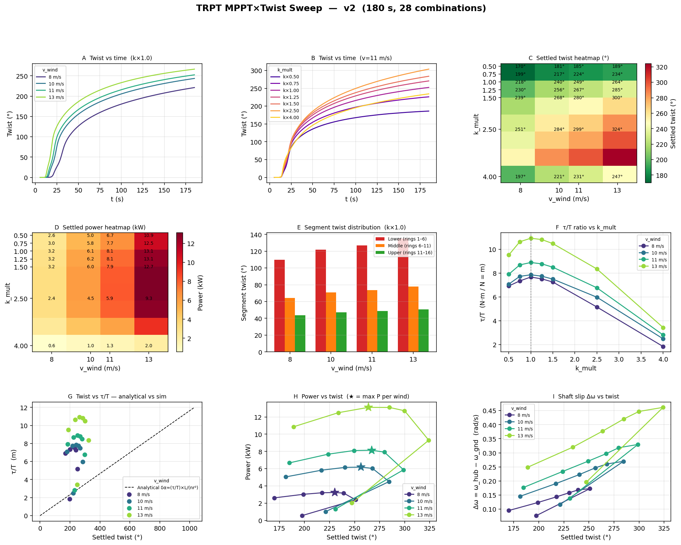
Figure 1. MPPT×Twist sweep v2 — 9-panel analysis. Source: twist_sweep_v2_analysis.png.

3.3 Twist Magnitude and Stability (Panels A, B, C)

At nominal MPPT (k×1.0), settled twist ranges from 217° at 8 m/s to 264° at 13 m/s. This is well into the large-angle regime (beyond a half-turn) and confirms that the shaft operates in a geometrically nonlinear torsional state during normal running. The steady-state values represent a dynamic equilibrium between the continuously applied aero torque and the restoring torsional stiffness of the inclined tether bridles.
Twist is not fully settled at k×2.5 or k×4.0 even after 180 s. The standard deviation of the settled window is ~3.0° for k×2.5 compared to ~1.7° for k×1.0, indicating a wider limit-cycle orbit. The shaft slip Δω remains non-zero throughout, confirming continuous elastic slip: the shaft is not a rigid coupling but a quasi-viscous one, transmitting torque through the torsional deflection of the tether bridles.
Engineering implication: the TRPT shaft should be modelled as a torsional spring-damper, not a rigid coupling. At rated conditions (v = 11 m/s, k×1.0), twist of ~249° implies the top ring is displaced ~0.69 turns relative to the ground ring. This is the normal operating geometry, not a fault condition.

3.4 Twist Concentration in the Lower Stack (Panel E)

The lower third of the stack (rings 1–6, adjacent to the PTO) consistently carries approximately 51 % of total twist, the middle third carries ~30 %, and the upper third (closest to the rotor) carries ~19 %. This 51:30:19 distribution is independent of both wind speed and MPPT gain, to within measurement noise.
The physical explanation is torque propagation: the ground ring receives the full shaft torque from the PTO and must resist it through the tether bridles below it. Each successive segment transmits slightly less torque (because the blades extract a portion at each ring node), so the lower segments deflect more. This matches the analytic prediction that local twist per segment δα_i ∝ τ_i/T_i, where τ_i is the local torque at segment i.
Control implication: any bridle-angle-based blade incidence adjustment should be referenced to the upper ring (rings 11–16), not the lower stack. The upper third shows the cleanest, most directly aerodynamically-coupled twist signal, while the lower stack carries a mix of PTO reaction torque and structural compliance.

3.5 Power–Twist Relationship and the Ambiguity Problem (Panel H)

Panel H shows power versus settled twist for each wind speed. The curves are non-monotonic: power peaks at k×1.0–1.25 and falls on both sides. This creates a critical control ambiguity: the same twist angle can correspond to two distinct operating states.
As a concrete example at v = 11 m/s:
Operating state | k× | Twist (°) | Power (kW)
Under-braked (fast shaft) | ×0.50 | 185 | 6.67
Nominal MPPT | ×1.00 | 249 | 8.10 ★
Over-braked (stalled) | ×4.00 | 231 | 1.31

The under-braked and over-braked cases have similar twist angles (185° and 231°) but produce 6.67 kW and 1.31 kW respectively — a 5× difference. A controller tracking twist alone cannot distinguish these states.
Critical finding: twist angle alone is insufficient as a control discriminant. The missing information is which side of the power curve the system is operating on. The τ/T ratio provides this information and is measurable at the ground station.

3.6 The Torque:Tension Ratio τ/T as the Key Physical Discriminant (Panel F)

Panel F shows the τ/T ratio (in units of metres, since τ is in N·m and T in N) as a function of k_mult for each wind speed. The ratio is not constant across gain settings, but it clusters tightly in the range 7.5–10.9 m for all productive operating points (k×0.5 through k×1.5). At k×4.0, the ratio collapses to 1.8–3.4 m because generator braking torque overwhelms the aerodynamic torque: the shaft stalls and power collapses.
At the maximum-power point per wind speed (k×1.0 to ×1.25):
Wind speed | Best k× | τ/T (m) | Twist (°) | Power (kW)
8 m/s | k×1.0 | 7.67 | 218° | 3.21
10 m/s | k×1.0 | 7.86 | 240° | 6.15
11 m/s | k×1.0 | 8.89 | 249° | 8.10
13 m/s | k×1.25 | 10.82 | 285° | 13.11

The τ/T ratio increases with wind speed at the optimal point (7.7 to 10.8 m). This is physically consistent: higher wind speed drives higher torque faster than it drives higher tether tension (torque ∝ v³, tension ∝ v² in the linear approximation), so the ratio rises with v.

3.7 Analytical Twist Prediction vs Simulation (Panel G)

The small-angle analytical prediction for total stack twist is:
Δα_total ≈ (τ / T_mean) × L_total / (n · r_s²)
where L_total = 30 m (tether length), n = 5 lines, r_s = 2.0 m (TRPT hub radius), giving a geometry factor of L/(n·r_s²) = 1.5 m⁻¹·rad/1 (or 85.9° per unit τ/T in m).
Panel G plots predicted versus simulated twist. The analytical line captures the correct trend and order of magnitude, but systematically over-predicts twist at low τ/T (low wind, low k) and under-predicts at high τ/T. Two physical mechanisms explain the discrepancy:

The analytical formula is useful for first-order design (sizing shaft geometry, predicting operating range) but should not be used for precise control setpoints. Calibrating the formula against the simulation data at each wind speed would yield a corrected gain factor suitable for feed-forward control design.

3.8 Shaft Angular Slip Δω (Panel I)

Shaft slip Δω = ω_hub − ω_gnd is non-zero in every combination tested (range: 0.08–0.47 rad/s). This confirms that the TRPT shaft does not transmit torque rigidly: the hub spins faster than the PTO because the shaft is continuously winding up. In steady state this slip is small (2–4 % of ω_gnd at nominal operating points) but it is always present.
Slip increases with both wind speed and MPPT gain in the productive band. At k×4.0 (stall), slip paradoxically decreases because the rotor has slowed to near PTO speed — there is little aerodynamic torque left to sustain the differential.
For real-system control, measuring both ω_hub (rotor encoder at elevation) and ω_gnd (PTO shaft encoder at ground) gives Δω directly. This is one of the most diagnostic signals available without any elevation sensor: a large positive Δω at low power immediately flags rotor stall.

4 Implications for Control Design

4.1 What the Simulator Currently Tracks

The current MPPT controller uses a single signal: PTO shaft speed ω_gnd. Generator braking torque is τ_gen = k_mppt × ω_gnd². This is the standard quadratic torque law. It implicitly tracks optimal TSR because the aerodynamic torque and the quadratic generator torque intersect at the correct λ at any wind speed, without needing a wind measurement. It is open-loop on all other system states.
Limitation: the controller cannot distinguish between a slowly-spinning shaft at high torque (loaded, productive) and a slowly-spinning shaft at low torque (stalled). It also has no awareness of shaft health, tether tension, or rotor state.

4.2 Available Real-World Measurement Alternatives

Signal | Measures | Ground-based? | Best use
PTO line tension (load cell on winch) | τ/T ratio directly (T is measured; τ = T × r_s × sin(Δα)) | Yes | Primary MPPT discriminant
PTO shaft speed ω_gnd (encoder) | Shaft speed at ground end | Yes | Current quadratic law
Rotor speed ω_hub (encoder + radio/optical link) | Direct TSR measurement | No — at elevation | Δω slip diagnostic
Wind speed anemometer at hub | Feed-forward v³ reference | No — at elevation | Pre-set k_mppt(v)
Lift line tension (load cell) | Kite state, apparent wind speed | Yes | Wind speed proxy
Elevation angle (encoder) | Kite geometry; catenary gives v approx. | Yes | Coarse v proxy

4.3 Proposed Control Architecture

Stage 1 — Ground-station-only (near-term, no new hardware):
- Use existing ω_gnd and PTO line tension T simultaneously.
- Compute the proxy τ/T = (k_mppt × ω_gnd²) / T at each time step.
- Target a τ/T setpoint that corresponds to the power-optimal band (~7.5 m at low wind, ~10.5 m at high wind).
- Adjust k_mppt continuously to maintain setpoint — effectively a tension-regulated MPPT.
- This resolves the stall-detection problem: k×4.0 stall causes τ/T to collapse to ~2.5 m, which is a clear fault flag.

Stage 2 — With rotor encoder (medium-term):
- Add ω_hub encoder and radio telemetry link.
- Direct TSR = ω_hub × R / v (using lift tension or elevation as v proxy).
- Use Δω as a stall pre-warning: rising slip at constant ψ_gnd indicates rotor acceleration, falling indicates impending stall.
- Close the loop on rotor TSR rather than PTO speed; this accounts for the elastic shaft slip that the ground-only controller cannot see.

Stage 3 — Bridle-angle blade incidence adjustment (long-term research):
- If the twist angle of the upper stack (rings 11–16) can be measured or inferred, it represents the actual blade pitch offset from nominal.
- The upper third carries ~19 % of total twist, or ~47° at k×1.0, v = 11 m/s. This is a significant, controllable angle.
- By adjusting the upper bridle lengths (active bridling) the effective Cl/Cd operating point can be shifted without changing rotor geometry.
- This is mechanically feasible but requires a model of how bridle adjustment maps to aerodynamic coefficient change: a follow-on BEM analysis is needed.

5 Recommended Next Simulations

Study | Description
Wind ramp scenario | Re-run the ramp scenario (7 → 14 m/s over 150 s) after fixing the Julia soft-scope variable bug that caused it to fail. This will show how fast twist responds to wind changes and whether it leads or lags the power response.
Tension-regulated MPPT pilot | Implement a simple closed-loop τ/T controller: compute T from PTO tension and ω_gnd, compare against a target τ/T(v) curve, and adjust k_mppt accordingly. Run at v = 8–13 m/s to validate vs open-loop sweep.
Per-segment twist profile (all 15 gaps) | Instead of three thirds, record the twist at every inter-ring gap. This will reveal whether the 51:30:19 distribution is smooth or has discrete jumps (e.g., near the hub bridle attachment points).
Torsional stiffness calibration | Run a static torque application test: hold ω_gnd = const, ramp τ_gen from 0 to 2× rated in 5 steps, record settled twist. Fit a piecewise linear stiffness curve k_tors(Δα) to calibrate the analytical model.
Conical stack with twist tracking | Re-run the 3-rotor conical stack (R = 5.0, 5.52, 5.85 m) with per-shaft twist recording. Assess whether the outer shafts carry disproportionately higher twist due to their larger torque:tension ratio.

6 Future Modelling Work

The following modelling extensions are identified as high priority for the TRPT development programme:
Item | Description
Lift line tension model | Add a lift_force() function applying kite lift/drag to the hub node from elevation angle and apparent wind speed. Currently the kite force model uses a fixed CL/CD independent of loading. A realistic lift model will change the tether tension distribution and hence the twist prediction.
Stacking lift kites | Model a secondary lifter kite on a separate bridle above the rotor stack. Parameterise by lifter area, Cl/Cd, and line length. Assess how lift augmentation changes the hub elevation angle, apparent wind speed, and net power-to-weight.
Lifting rotor kite configuration | Allow the rotor blades to contribute lift via positive blade incidence angle. Model the rotor as a lifting surface in addition to an energy extractor. Assess self-support capability vs dedicated lifter trade-off at different wind speeds.
Large-angle torsional stiffness | Replace the current linear tether spring model with a geometrically exact rope element that accounts for helix angle change under torsion. This will close the gap between the analytical Δα prediction and simulation at twist angles above 180°.

7 Conclusions

Finding | Implication
Twist magnitude is large and operating-regime-dependent. | At nominal MPPT, steady-state twist is 218–264° across the wind range. This is the normal operating geometry — not a fault condition — and should inform shaft geometry design.
Twist does not uniquely identify operating state. | The same twist value appears at both productive (under-braked) and stalled (over-braked) conditions. Twist alone cannot be used as an MPPT setpoint.
The τ/T ratio is the correct control discriminant. | It uniquely separates productive operation (7.5–11 m) from stall (<4 m) and is computable from ground-based measurements (PTO tension load cell + shaft encoder).
The lower stack carries >50% of total twist. | Structural fatigue analysis should weight the lower rings (1–6) most heavily. Bridle-angle control should target the upper rings (11–16) where the aerodynamic coupling is cleanest.
The analytical formula is directionally correct. | Δα ≈ (τ/T) × L/(n·r_s²) predicts the correct trend but diverges from simulation above 200° due to geometric nonlinearity. A corrected, calibrated version is needed for control design.
Shaft angular slip Δω is always present. | The shaft is a quasi-viscous coupling. Δω measurement is a low-cost stall pre-warning that requires only a rotor encoder and telemetry link.

