The kite turbine: a search over its design space
Internal engineering report. Draft v0.37. Date 2026-10-14.
Status DRAFT. Data commit dd3cc6a. Launch commit a76c5e9. Numbers come only from signed register rows, cited by row ID.
A section marked [PENDING] waits on a gate.
Draft status. This is an internal draft. Sections 3.4 to 3.6 carry their text. Nomenclature and references stay incomplete.
The physics era is post-95c385d_wind-authority. The bank derate applies throughout.
Abstract. This report presents a search for a 5 kW-class ground-generation rotary kite turbine with a tensile rotary power transmission (TRPT). The search varies ring geometry, polygon count, rotor count, blade bank angles and blade scale.
A differential-evolution campaign evaluated 930 candidate designs under one fixed power-law generator load, each on the measurement window (NR-001).
The campaign winner is the best feasible candidate under the modeled objective and gates. Its mean power is 5.309 kW at the site wind, 11.01 m/s at 9.41 m (NR-008, NR-032).
All checked TRPT rings and twist segments operate below their failure boundaries at the final operating point (NR-021, NR-022).
The minimum factor of safety is 15.0 (NR-009).
At the winner operating point, the least segment torque margin is 2.03, at S1, the first of the five segments between the rings (NR-040). The margin is torque capacity over the segment torque it carries, and the least value governs.
All numbers are in the repo and come from the physics era post-95c385d_wind-authority, with the bank derate applied. The bank derate is a calculated depowering of the ring output, because banked blades sweep less streamtube frontal area.
The study is simulation-only. Blade integrity is not yet gated, and the outer stiffening bridles sit outside the model.
Lifter kite modulation for steady lift tension across wind speeds remains an assumption. The rope-break gate placement fix stays open.
The search is a screen, not a survey. The report does not claim a global optimum.
Keywords. airborne wind energy, kite turbine, ground-generation, tensile rotary power transmission, differential evolution, multibody simulation, design search, factor of safety.
Summary for decision. The project completed a 930-design simulation screen of a 5 kW-class ground-generation rotary kite turbine with a tensile rotary power transmission (NR-001).
The screen found a feasible candidate under the model and gates. The key findings follow.
- The differential-evolution campaign evaluated 930 candidate designs (NR-001).
- Of the 930, 508 designs pass every gate. The other 422 designs read 301 reject, 110 clearance_reject and 11 reject_twist (NR-002).
- The campaign winner is the best feasible candidate under the modeled objective and gates. Its mean power is 5.309 kW and its airborne mass 25.698 kilograms (NR-008, NR-018). Its minimum factor of safety is 15.0 (NR-009).
- All checked TRPT rings and twist segments operate below their failure boundaries at the final operating point (NR-021, NR-022). The least segment torque margin is 2.03, at S1 (NR-040).
- The seed genome scores 36.109 kg-equivalent (NR-006). Island 3 reaches 27.364 kg-equivalent (NR-005).
- The ODE path reproduces every recorded winner field (NR-012). The rapid path awaits its rope-break gate fix (NR-013).
The report shows that a feasible 5 kW-class candidate exists in the searched space under the model and gates.
It does not show flight readiness, a global optimum, or full structural safety. Blade integrity, lifter modulation, launch and recovery, and atmospheric realism remain open work items.

1 Introduction
The wind above tower height is stronger and steadier than the wind exploited by traditional wind turbines. Airborne wind energy systems (AWES) are kite-based machines that chase that stronger wind.
Two families of AWES exist.
Fly-gen machines carry the generator and turbine aloft. A conducting tether sends the electrical power to the ground.
Ground-gen machines keep the generator on the ground. The tether carries force, and the ground station converts tether motion to electrical power.
The field splits a second way, on the wing.
Soft wings use fabric. They survive crashes and pack small.
Rigid wings use composite airframes. They are more efficient and more costly.
A third split matters for this report. It is the force transmission of ground-gen systems.
A pumping (yo-yo) machine sends intermittent tension down a moving tether. A rotary machine sends steady torque down a turning set of tethers.
A rotary machine runs continuously. It needs no reel-in phase. That continuity is where the kite-turbine family sits.
The machine in this report is a kite turbine.
Kite turbines exploit multiple, short rigid blades. The blades sit on a ring and form a wide diameter rotor.
The rotor and further rings tie together as a tensile rotary shaft. The shaft turns the ground generator.
A tensile rotary power transmission (TRPT) is a shaft made of tensioned lines. Rings sit at fixed distances under tether tension. Torque passes from ring to ring, over multiple tethers.
The TRPT shaft is prone to bending and twisting, especially in low tension. It is not a rigid driveshaft. Its capacity to transmit torque comes from the tension in the kite lines.
This report presents a search over the design space of kite turbines. The search varies ring geometry, polygon count, rotor count, blade bank angles and blade scale.
The objective is to find the feasible geometries for a 5 kW-class machine, and then characterise them.
The generator load law and the safety gates stay fixed. The search asks whether one compact machine can hold the power, mass, structural, clearance and twist constraints at once.
The report reads the gate and the winner outcome for each constraint in the results.
The report states what the record supports. It also states several classes of failure in developing this system, each with its lesson.
One frame holds throughout. The machine flies only in simulation. The analysis pipeline is the instrument. The report treats the instrument with the same distrust it treats the machine.
The field context rests on the literature.
Loyd showed that both crosswind modes share one theoretical power ceiling.
Diehl set the classification axes.
Trevisi built one power model for both modes and found the glide-ratio flip.
Cherubini mapped the ground-gen and fly-gen taxonomy.
Van der Burg found no dominant wing design. Both wing families stay in play. Van de Kaa and Kamp found no dominant generation architecture.
Pereira ranked the design factors and found that many small units beat few large ones.
Flather recorded the rope-drive physics that the TRPT descends from. Benhaïem and Schmehl analysed the torque path of a rotating reel.
Ranneberg gave the rotary family a momentum frame with flight data.
Tulloch modelled the Daisy TRPT and checked the model against measured flight windows. This report extends that line of work.

2 Methods

2.1 The kite turbine and its terms
A line is a tension member, like a tether or a bridle. It carries a load only in tension. A pull at one end passes along the line to the other end. It never pushes.
A ring is a polygon of nodes and tubular beams. A ring with blades works as a rotor.
Rings without blades work as line spacers. They hold the TRPT lines apart against the line torsion from torque transfer. Holding the lines apart is what preserves torque transmission and prevents torsional collapse.
The polygon count names the number of lines (n_Lines). A hexagonal polygon connects six lines. Each line meets the ring at one vertex.
For an active rotor, the polygon count equals the blade count. It also equals the number of TRPT line attachments around the ring. A rotor is a set of blades on a ring. A pentagonal rotor carries five blades.
Inactive genome slots may hold bank or blade-scale values. They do not create physical blades unless the rotor count selects them.
The topmost ring carries the main rotor. The lowest ring is the ground station power take-off (PTO) ring. The PTO ring anchors the shaft at the ground and turns about its central axis.
Bank is the blade angle away from the ring plane about its chord axis at the ring. The equivalent term in AeroDyn is pre-cone.
Blade scale sets the blade size. The scale multiplies the blade span and chord, and the blade mass follows the span cubed.
The search treats each of these as a gene. The ring geometry sets the hub and ground radii, and the rotor count sets how many rings carry blades.
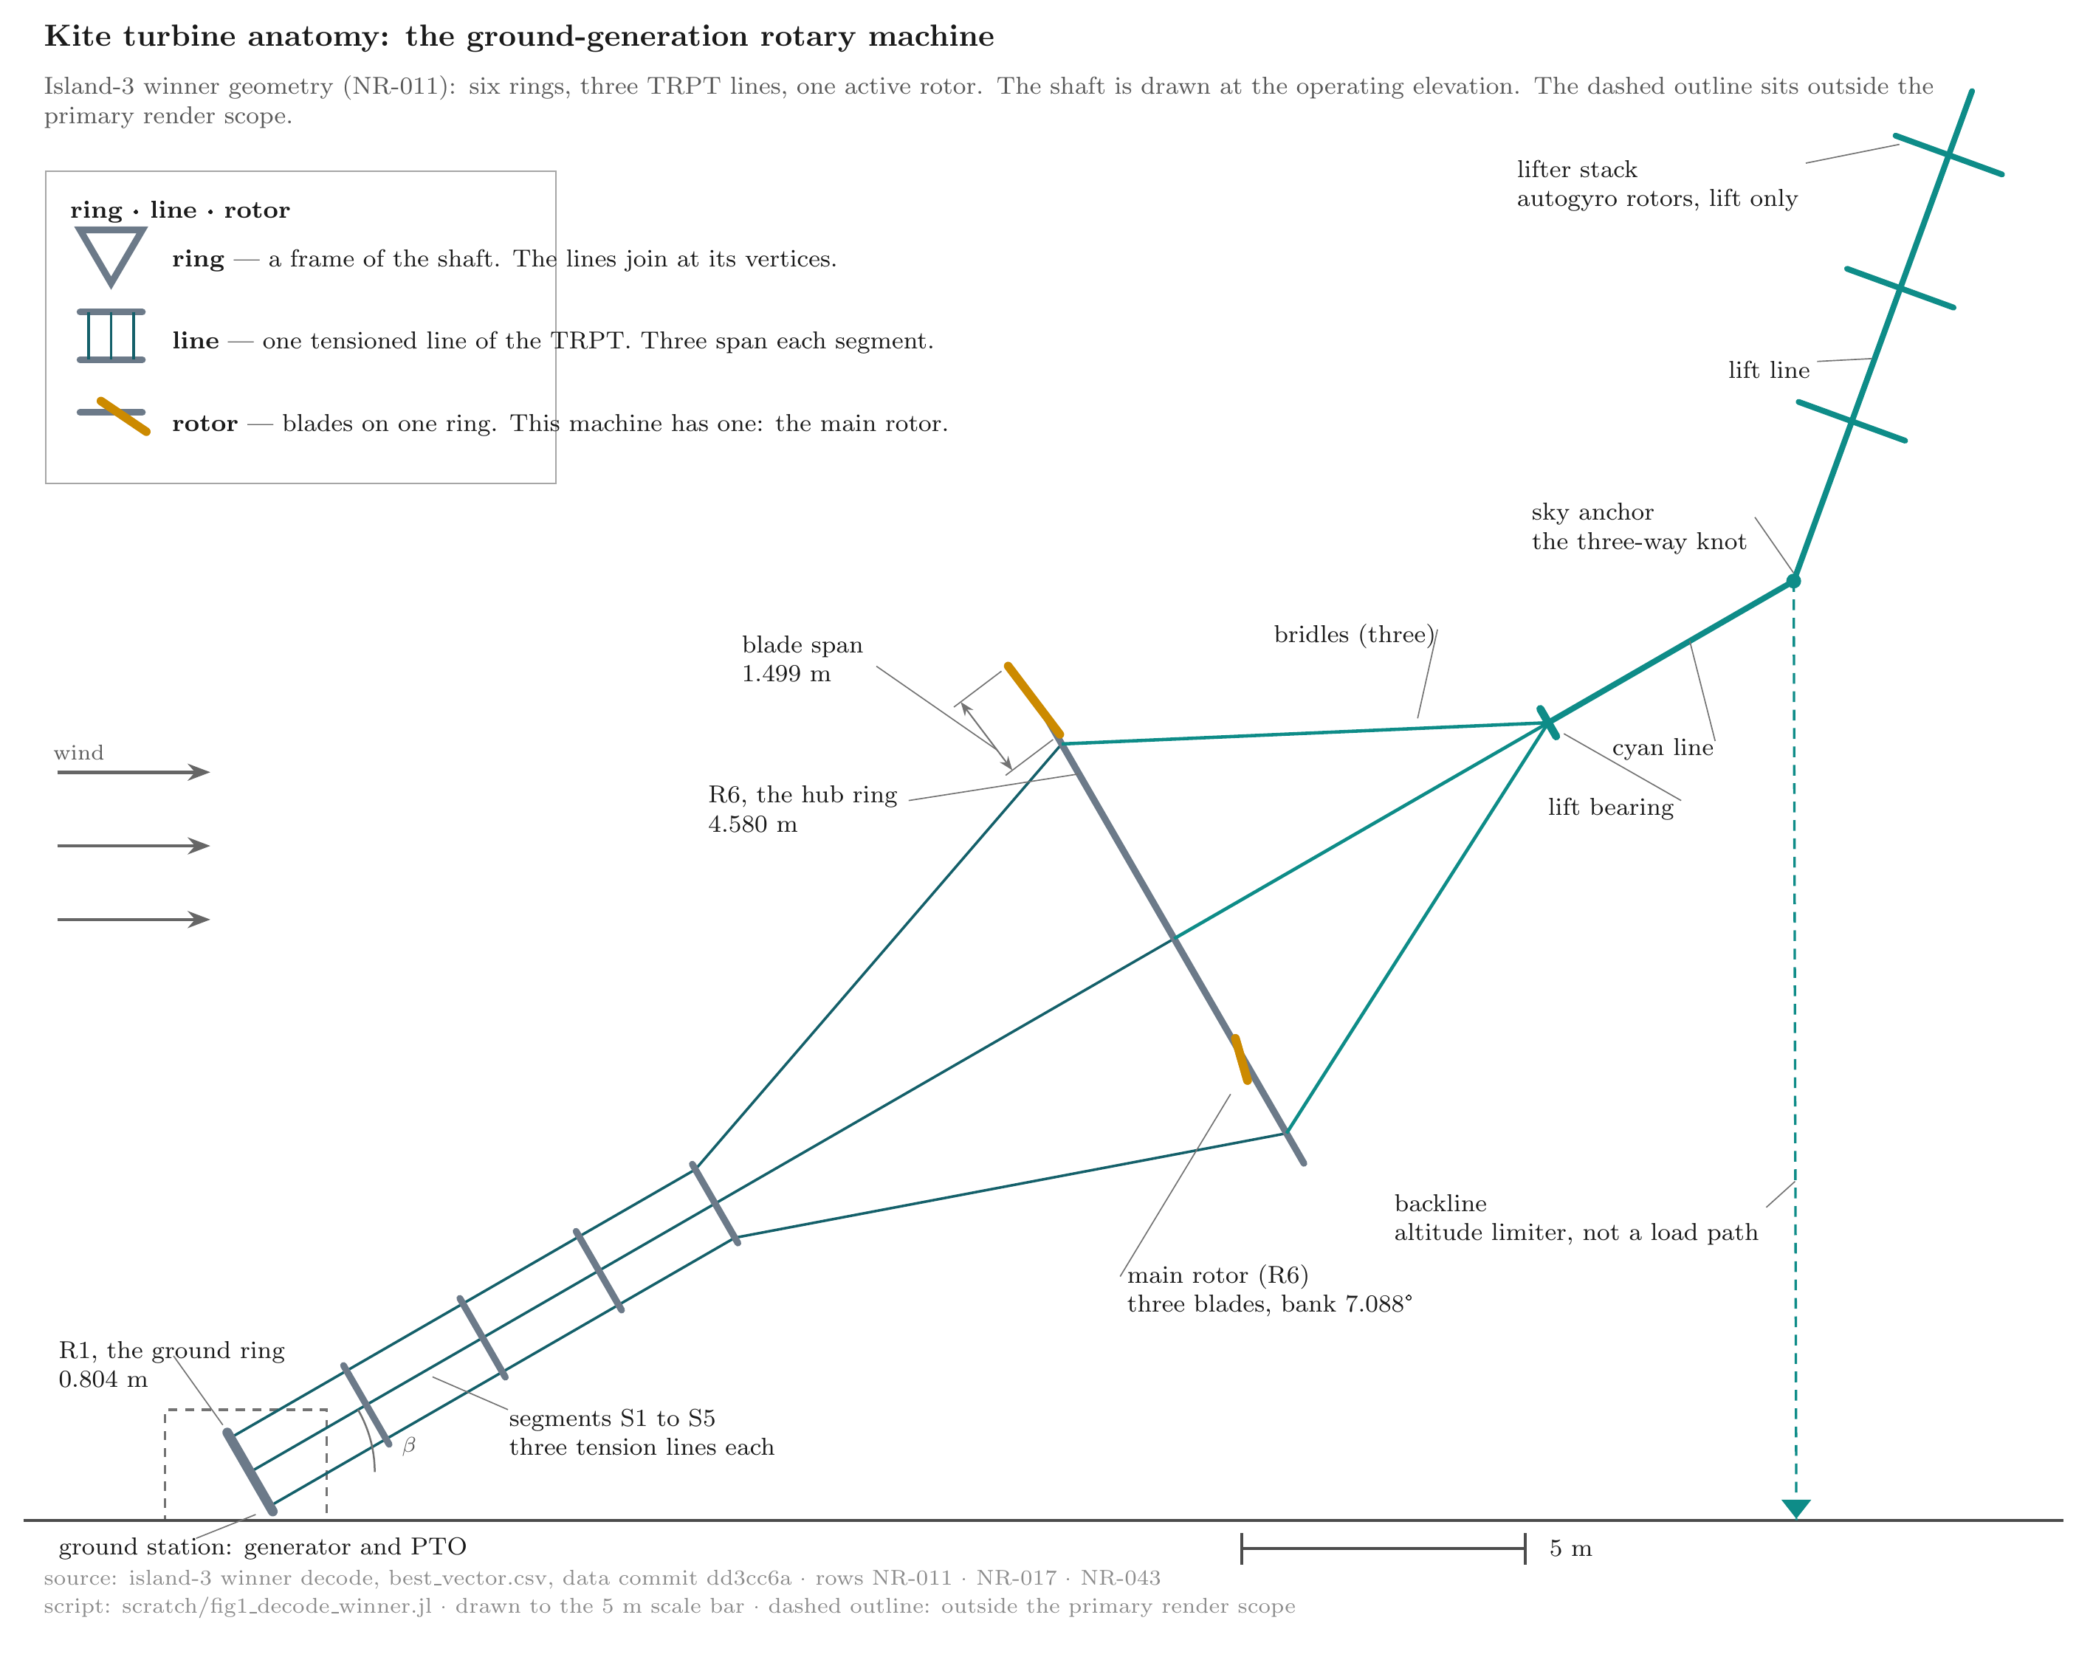
system-anatomy
Figure (roster row 2) · system-anatomy
This figure shows the whole machine and the names of its parts, from the lifting autogyro kite stack in the sky to the ground station that takes the power.
The plate shows the campaign winner in a side view. Six triangular rings run from the ground ring (R1, 0.804 m radius) to the hub ring (R6, 4.580 m radius). Three tension lines span each of the five segments S1 to S5. The main rotor sits on R6 only. Its three blades bank at 7.088°. The lift chain runs from the lifter stack, down the lift line, through the sky anchor and the cyan line, to the lift bearing. Three bridles run from the bearing into the main rotor. The lifter gives lift only. It does not drive the rotor. Torque runs down the TRPT rings to the ground station. The dashed outline marks the ground station: the generator and the power take-off. That outline sits outside the primary render scope. The dashed backline is an altitude limiter, not a load path. The scale bar is 5 m.
Source: data dd3cc6a · script 9cecee3 · rows NR-011, NR-017, NR-043

2.2 The simulation analysis pipeline instrument and its terms

2.2.1 The gene
The search uses differential evolution (DE) to assess kite turbine design variants. DE assesses machine genomes. A genome is a design vector that describes the physical character of one machine.
The decoder reads it, and the builder builds the machine from it. The evaluation then feeds the comparison before DE tries a new gene.
The genes set the ring geometry, the polygon count, the rotor count, the bank angles and the blade scales. The winner genome names its genes in the decode fields (NR-011).

2.2.2 The evaluator
The builder builds the machine from the genome. The evaluator runs the machine and measures its performance. Every evaluation has two phases: a relax run and a measurement window.
The run starts from a settle state. That state comes from a simplified power balance (NR-025). The relax run takes 10 seconds. It lets the startup transient decay, and the machine moves to its operating point.
The measurement window takes 40 seconds. It measures the settled machine. The evaluator scores the power over the measurement window only (NR-015).
A short window can sample the decay and misstate the power. The team sized the window to outlast the decay.
The generator load follows a power law. The commanded torque reads τ = k·ω², so the drawn power reads P = k·ω³. The constant k sets the load, and the load sets the speed at which the machine settles.
The operating point uses a power-law constant k of 2.24 N·m/(rad/s)², a relax time of 10 seconds, a window of 40 seconds, a factor of safety (FoS) target and hard floor, both 2.5, and a line length of 18.8 metres (NR-015).
The campaign fixed k at 2.24 N·m/(rad/s)² for every candidate design (NR-015). One load applies to the whole search.
The team selected the value in a load sweep of the seed machine (2026-08-22). The sweep ran the seed at a range of loads, each over the same measurement window.
At the light end the seed reads under the power floor. At the heavy end the power levels off. The selected value sits in the working range between them.
The campaign also fixed the shaft length. The search does not vary it: every candidate runs at one length, 18.8 metres (NR-015).
The length follows the Daisy anchor. It scales with the machine to this size. It sets how high the machine stands above the ground station.
A longer shaft reaches stronger wind. The length screen ran 2026-10-05 on the pre-fold island-3 winner.
It covered 18.8, 21.2 and 25.0 metres, twice, before and after the cp fix. All six rows failed the power floor (NR-027).
The cause is recorded. The screen measured the pre-fold winner under the post-landing decode, whose span shrink took the power below the floor. The folded class passes at 18.8 metres (NR-028).
The campaign searched the folded class, so the launch carries the passing physics.
FoS is the design load margin. It is the ratio of what the line can carry to what the load demands. The model tests the TRPT beam element FoS for buckling risk the same way.
The dynamics run as a coupled multibody model. Every node, line and ring carries state. The evaluator holds the whole set as one matrix of ordinary differential equations (ODEs).
The evaluator advances that matrix at a fixed step. The scheme is semi-implicit. Each step advances the velocities before the positions.
The generator brake torque enters implicitly. Read from the last step alone, the load law is positive feedback. Take a ground ring that runs a little fast: the brake pushes too hard, and the next step over-corrects, so the swing grows.
The implicit form solves the brake with the new speed, so the step stays stable. The evaluator derives the step per machine from the shortest shaft sub-segment.
The run is deterministic by construction. That determinism is what makes reproduction possible.
The search carries the same property. The campaign runner fixes one random seed per island (scripts/run_v13_5kw_masslift.jl). The same code and configuration then repeat the search.
NaN and Inf clamps guard the state. A broken line ends the run.

2.4 The campaign
The campaign runs a differential evolution (DE). A DE keeps a design population. Each generation breeds new designs from the best. A gate scores each design and culls the failures.
Three islands run in parallel. An island is an independent population with its own drift. Each island evaluates 310 designs.
The campaign evaluates 930 designs in total (NR-001).
Four statuses result: ok, reject, clearance_reject and reject_twist (NR-002).
The ok designs pass every gate. The rejects fail a gate. Clearance rejects fail the clearance gate. Twist rejects fail the twist gate.
The campaign minimizes a kg-equivalent objective score: the airborne mass plus the soft constraint penalties. A lower score is better. The objective score is not the physical airborne mass.
One kilogram of airborne mass adds 1.0 to the score (NR-046). The penalty charges read in kg-equivalent.
The score builds along one chain. The chain runs genome, decoder, builder, evaluator, window statistics, gate status, soft constraint penalties, score and rank.
The score adds three soft constraint penalties to the airborne mass (NR-046): f = mass + 5.0 * max(P_score - 5.0, 0)^2 + 20.0 * (2.5 / FoS_min)^2 + 1.0 * (r / (1 - r))^2 with r = min(twist_ratio, 1), plus the stationarity add-on 10.0 * max(0, swing - 0.20).
The over-power charge reads P_score, the end power, against the 5.0 kW ceiling (NR-046). The utilisation charge reads the window-minimum factor of safety against the 2.5 floor (NR-046). The twist charge reads the worst segment twist ratio against the crossing limit (NR-046). The stationarity add-on reads the window swing against 20 per cent (NR-046).
Every charge is continuous. None is step-like (NR-046).
Rejected designs carry no score. The evaluator carries Inf for a rejected design. The runner stamps the search cost 1e9 on every non-ok design (NR-046). No reject ranks above an ok design. The search cannot trade power or safety against mass.
The differential-evolution campaign fixed the configuration below.
Setting | Value | Source
Islands | 3 | NR-001
Designs per island | 310 | NR-001
Evaluations, total | 930 | NR-001
Objective | Airborne mass + penalties, kg-equivalent | NR-036, NR-039
Power floor | 5.0 kW | NR-027, NR-039
Structural FoS floor | 2.5 | NR-015
Relax run | 10 s | NR-015
Measurement window | 40 s | NR-015
Load constant k | 2.24 N·m/(rad/s)² | NR-015
Line length | 18.8 m | NR-015

2.5 Fidelity paths
Two paths score a design. The ODE path builds the machine, settles it, and runs the full dynamics over the measurement window.
The rapid path pre-solves a static state and starts from it.
The report names map to the code. The ODE path is :cold. The rapid path is :warm.
The probes that compare the paths sit in scripts/probe_rapid_vs_ode_winners.jl and scripts/probe_warm_reject_cause.jl. The register header pins their commits.

2.6 Reproducibility
Every dataset carries a provenance stamp. The stamp names the commit, the physics era and the geometry fingerprint. The report names the commits in the register header.
The dataset sits at data commit dd3cc6a on the bankderate2-results branch. The launch commit is a76c5e9. The Phase 0 audit sits at master 31ca00d.

3 Results

3.1 The search at scale
The campaign evaluated 930 designs (NR-001). The status mix reads 508 ok, 301 reject, 110 clearance_reject and 11 reject_twist (NR-002). Each island starts its population from the same seed genome. The recorded common seed genome scores 36.109 kg-equivalent under the campaign objective (NR-006). The other members of each population draw at random under a fixed seed per island (scripts/run_v13_5kw_masslift.jl).

3.2 Convergence
The best recorded objective score on island 1 is 30.578 kg-equivalent at generation 30 (NR-003). Island 2 reaches 30.637 kg-equivalent at generation 30 (NR-004). Island 3 reaches 27.364 kg-equivalent at generation 26 (NR-005). The physical airborne mass of the winner is 25.698 kg (NR-018). The objective score adds 1.665 kg-equivalent of penalties (NR-039).
The surviving ok designs hold a mean power between 5.02 and 6.32 kW (NR-007).

3.3 The winner
Island 3 carries the winner. Its mean power reads 5.309 kW and its end power 5.314 kW (NR-008). Its factor of safety reads 15.0 (NR-009). That value is the window minimum.
The capture hub ring reads 15.033 at the final step (NR-021).
Its operating point reads as follows.
Quantity | Value | Source
Mean power, measurement window | 5.309 kW | NR-008
End-of-window power | 5.314 kW | NR-008
Minimum factor of safety | 15.0 | NR-009
Window power swing | 0.029 kW | NR-014
Settle angular speed | 10.170 rad/s | NR-016
Window-mean speed | 13.38 rad/s | NR-029
Delivered torque | 396.76 N·m | NR-030
Airborne mass | 25.698 kg | NR-018
Hub radius | 4.580 m | NR-011
Ground radius | 0.804 m | NR-011
Ring count | 6 | NR-011
Polygon count | 3 | NR-011
Active rotors | 1 | NR-011
Main-rotor bank, ring 6 | 7.088 deg | NR-017
Lift-line elevation | 70 deg | NR-026
Lift-line tension | 324.1 N | NR-010
Its window swing reads 0.029 kW on 5.309 kW, half a per cent (NR-014).
The settle state starts the machine at 10.170 rad/s (NR-016). The machine accelerates through the relax run.
Its window-mean speed reads 13.38 rad/s, 127.772 rpm (NR-029). Its airborne mass reads 25.698 kilograms (NR-018).
The winner clears each checked gate.
Gate | Threshold | Winner outcome | Source
Power floor | 5.0 kW | pass, P_mean 5.309 kW | NR-008, NR-027, NR-039
Structural FoS floor | 2.5 | pass, 15.0 minimum | NR-009, NR-015
Clearance | blade-tip gate | pass | NR-036
Twist | per-segment limit δcrit | pass, all five segments within limit | NR-022
Rope break | none on the window | pass on the cold path | NR-012, NR-013
A lifter kite holds the machine aloft. The lifter gives lift only. It gives no torque and no drive.
Its load path runs from the lifter kite down the lift line to the sky anchor, the three-way knot. Then it runs down the cyan line to the lift bearing, and down the bridles to the main rotor.
In the field the lifter launches first. It lifts the rig into tension. The rotor turns after that.
The lift acts throughout operation, not only at spin-up. The team sizes the lift line up front.
The lifter sizing holds a 1.5 margin on the vertical load at the lift bearing. The sizing mass is the airborne mass without the lifter itself, 20.698 kilograms. The kite carries its own weight (2026-08-21 ruling).
The vertical load is 1.5 × 20.698 × 9.81 = 304.6 newtons. The lift line runs at 70 degrees of elevation (NR-026). The line tension is that load over sin 70 degrees: 324.1 newtons (NR-010).
The lifter is a stack of autogyros. The report assumes the stack can modulate to meet the lift requirement at all wind speeds. A fixed kite cannot: its pull grows as the square of the wind speed. Without modulation, each weather band needs its own kite, up to a giant.
The report applies the lift force the machine needs and tests the machine on that basis. Designing a lifter that delivers that force across wind speeds is outside this report. The report states the presumption as one (2026-08-05).
Its geometry reads three lines, six rings and one active rotor. The hub radius is 4.580 metres and the ground radius 0.804 metres (NR-011).
The winner genome contains two blade-scale slots. Slot 1 reads 0.82 and decodes to the single active rotor. Slot 2 reads 0.20 and stays inactive because the rotor count is one (NR-011).
The winner genome contains two bank-angle slots. Ring 6 decodes the active main-rotor bank angle as 7.088 degrees (NR-017).
A second bank slot reads 22 degrees. It does not decode to a physical rotor at a count of one (NR-011).
This result differs from earlier eras for recorded reasons. The bank derate, the measurement window and the tightened gates moved the search space. Numbers across the eras would compare models, not machines.
This run also trades breadth for fidelity: fewer evaluations, each on the measurement window. It stopped early: a screen, not a survey. This report covers the wind-authority era campaign and the recorded corrections that shaped it.

3.4 The levers of Performance
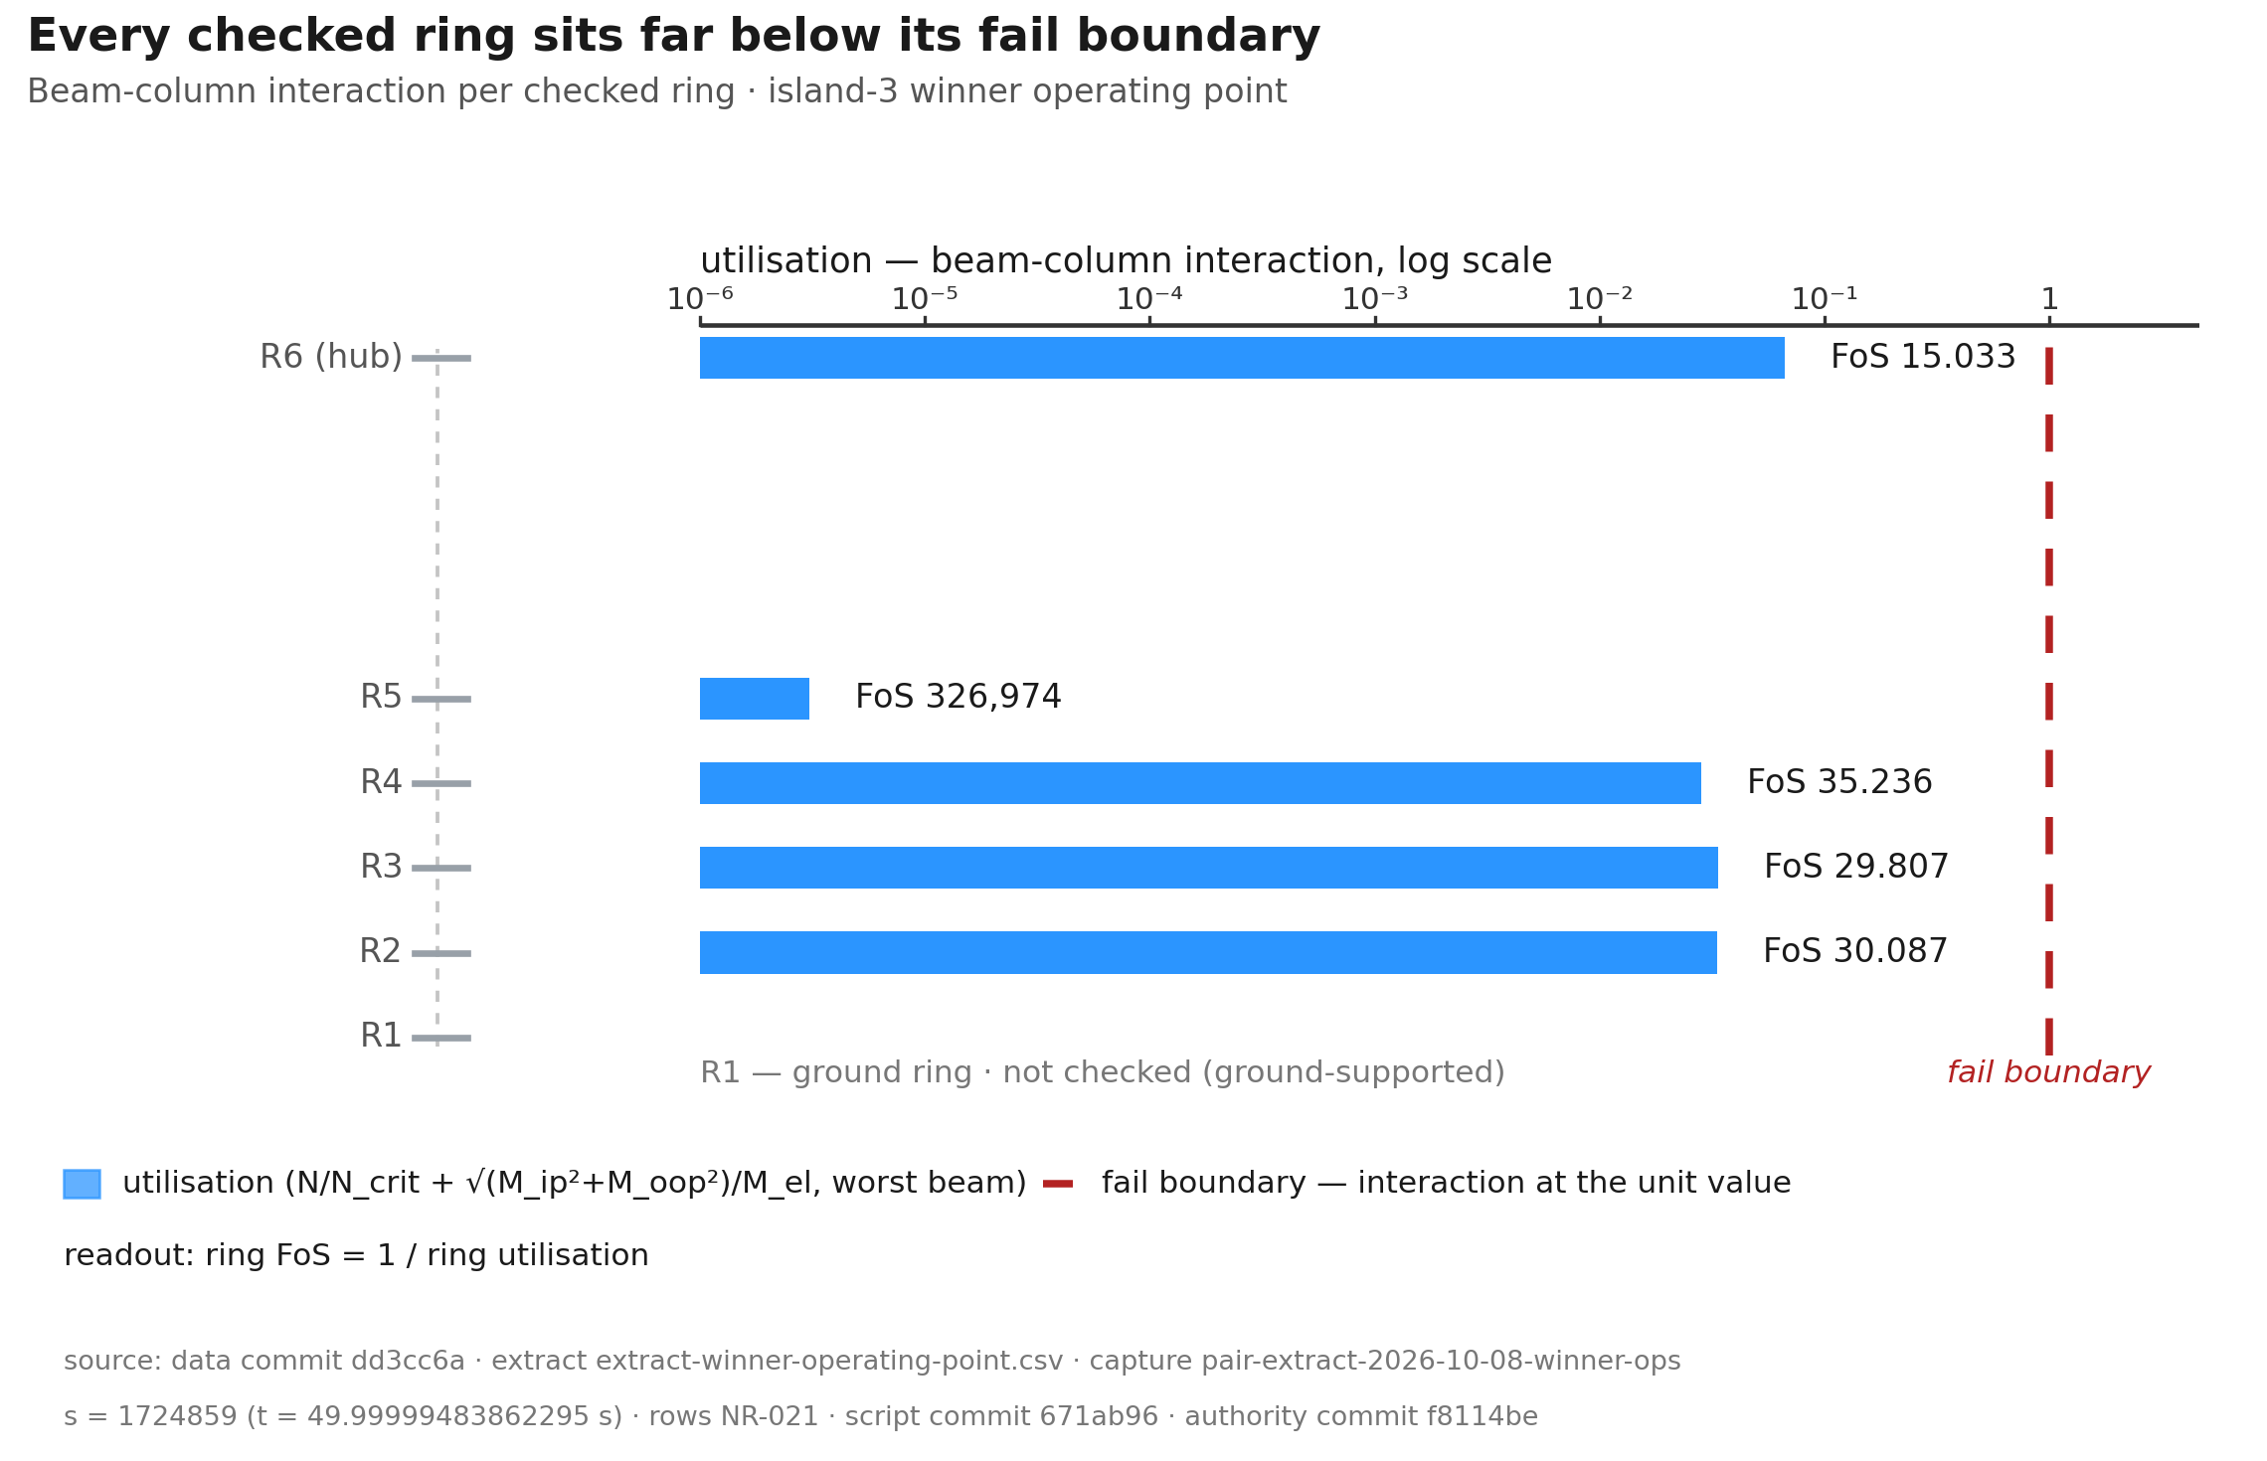
ring-utilisation
Figure (roster row 6) · ring-utilisation
The hub ring R6 governs the structural check at the winner's final operating point, and every other airborne ring holds a much larger margin.
The hub ring R6 governs the structural check at FoS 15.033. All other airborne rings hold much larger margins (NR-021). Each bar shows one checked ring. The bar end reads the ring utilisation: the beam-column interaction on the worst beam, the axial share N/N_crit plus the bending share √(M_ip²+M_oop²)/M_el. The rows run from R2 at the base to R6 at the hub. Utilisation is demand over capacity. The axis is logarithmic across six decades to the unit value, so the margin of every ring reads at its own scale. The dashed line is the fail boundary at the unit value, the physical interaction limit at FoS 1. The campaign structural gate is stricter, at FoS 2.5 or above (NR-015). The readout at the row end gives the ring FoS: capacity over demand, the reciprocal of the interaction. The model tracks torsion outside the interaction formula. The figure covers every airborne ring. The check does not cover the ground ring, which sits on ground support. The figure includes and marks the hub ring. The values come from the campaign winner at its final operating point. R5 reads far below the other rows. It carries bending alone. Its worst checked beam holds no axial share. The readout prints the true value, FoS 326,974 (NR-021). For every other checked ring, the bending share sits below 0.05 per cent of the ring utilisation.
Source: pair-extract-2026-10-08-winner-ops · data dd5a9dd · script 224e916 · rows NR-021
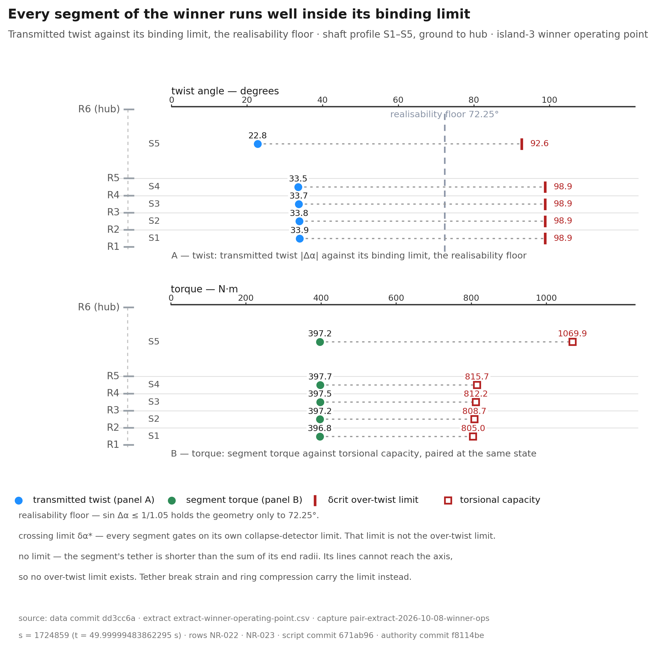
twist-limit
Figure (roster row 7) · twist-limit
All five segments stay inside their over-twist limits at the winner's final operating point, and the smallest torque margin sits at S1.
All five TRPT segments remain inside their over-twist limits at the winner's final operating point. S1 carries the least segment torque margin, 2.03 (NR-040). Panel A draws the transmitted twist of each segment as a magnitude, against its limits: the over-twist limit δcrit and the realisability floor. δcrit comes from the committed authority trpt_twist_limit. The floor follows sin Δα ≤ 1/1.05. A no limit segment carries no torsional ceiling. The figure draws no ratio for such a segment. Tether break strain and ring compression carry its limit instead. Panel B pairs segment torque against torsional capacity at the final operating point of the campaign winner. Pair a capacity only with the load of the same state.
Source: pair-extract-2026-10-08-winner-ops · data dd5a9dd · script 75d82de · rows NR-022 · NR-023
The hub ring R6 governs the structural check at the winner operating point (NR-021). The window-minimum factor of safety is 15.0 (NR-009). At the final step, R6 reads 15.033 (NR-021). R2 to R4 read 29.8 to 35.2 (NR-021). R5 carries almost no load in the checked beam (NR-021).
The ground ring sits on ground support and stays outside the ring check. All five TRPT segments remain inside their over-twist limits at the winner operating point (NR-022). S1 to S4 transmit 33.5 to 33.9 degrees against a 98.9 degree limit (NR-022). S5 transmits 22.8 degrees against its 92.6 degree limit (NR-022). The least segment torque margin is 2.03, at S1 (NR-040).
S5 carries the largest segment torque margin, 2.69 (NR-040). The winner is not close to ring buckling, over-twist or segment torque saturation at this operating point. The margins are conditional. They cover the checked TRPT rings and segments only. They do not yet include blade integrity or lifter loads across wind bands.
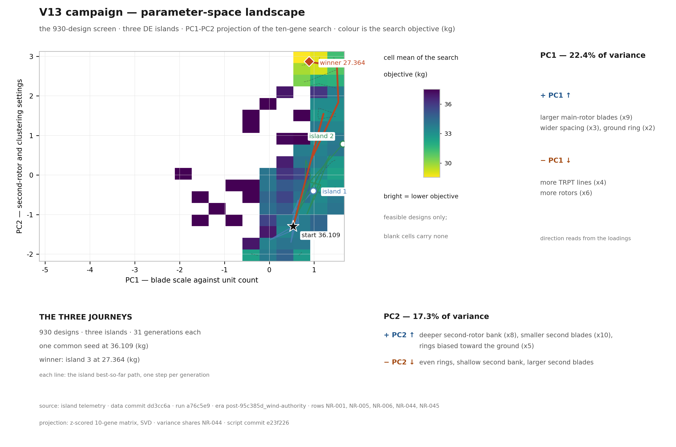
pca-landscape
Figure (roster row 20) · pca-landscape
One seed, three islands: this figure maps the search journeys in gene space and shows where the light machines live.
The figure projects the 930-design screen of the v13 5 kW campaign on its first two principal components (NR-001). The axes come from a z-scored matrix of the ten genes. Colour is the cell mean of the search objective in kg-equivalent. Bright reads lower. Three lines trace the island best-so-far paths, one step per generation. The common seed starts at 36.109 (NR-006). The winner ends at 27.364 (NR-005). The PC1 inset reads larger main-rotor blades, wider ring spacing and a wider ground ring to the right, and more TRPT lines and more rotors to the left. The PC2 inset reads a deeper second-rotor bank, smaller second blades and rings biased toward the ground upward. The variance shares read PC1 22.4 per cent and PC2 17.3 per cent (NR-044).
Source: data dd3cc6a · script e23f226 · rows NR-001, NR-005, NR-006, NR-044, NR-045
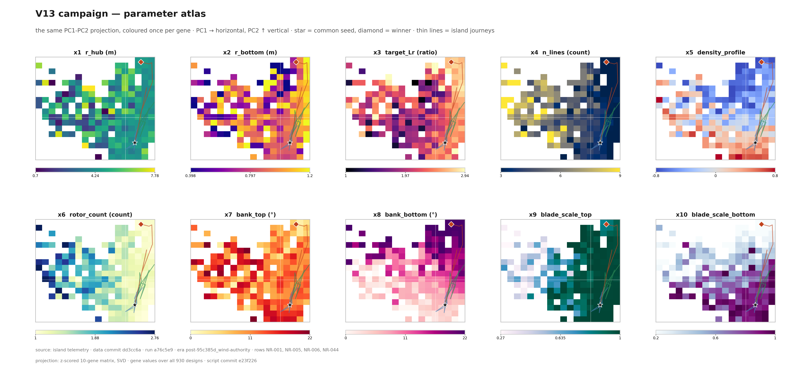
pca-atlas
Figure (roster row 21) · pca-atlas
One map of the search space, coloured ten times: each panel shows where one design gene runs high or low across the search.
The figure repeats one PC1-PC2 projection of the 930-design screen ten times, once per gene slot (NR-001). The projection and the journey marks match the levers landscape plate. Each panel colours the cell mean of that gene over all 930 designs. The star marks the common seed (36.109, NR-006). The diamond marks the winner (27.364, NR-005). The thin lines trace the island journeys. The colour bars print each gene at three significant figures. The projection reads NR-044: PC1 22.4 per cent, PC2 17.3 per cent.
Source: data dd3cc6a · script e23f226 · rows NR-001, NR-005, NR-006, NR-044
The two plates map the same search in two views. They project the 930 designs of the campaign onto the first two principal components of the ten-gene search (NR-001). Those axes hold 22.4 and 17.3 per cent of the variance in the search, 39.7 per cent together (NR-044).
The horizontal axis is PC1 — blade scale against unit count. Its inset reads larger main-rotor blades, wider ring spacing and a wider ground ring to the right. It reads more TRPT lines and more rotors to the left. The top loadings read -0.5385 for the TRPT line count, -0.5222 for the rotor count and +0.5180 for the main-rotor blade scale (NR-044).
The vertical axis is PC2 — second-rotor and clustering settings. Its inset reads a deeper second-rotor bank, smaller second blades and rings biased toward the ground upward. It reads even rings, a shallow second bank and larger second blades downward. The top loadings read +0.5621 for the second-rotor bank, -0.5605 for the second-rotor blade scale and -0.5018 for the ring density profile (NR-044).
The colour is the mean search objective in each cell, in kg-equivalent. Bright reads lower, and only feasible designs shade the field. The low-objective cells gather toward the upper right, where the winner sits.
Three lines trace the island best-so-far paths, one step per generation (NR-045). Each island ran 31 generations. All three start at the common seed, 36.109 kg-equivalent (NR-006). Island 3 reaches the winner value, 27.364, at generation 26 and holds it to the end (NR-005). Islands 1 and 2 finish lower in the field.
The atlas repeats the projection ten times, once per gene slot. Each panel colours the mean value of one gene across the field. The star marks the common seed and the diamond marks the winner. The atlas lets a reader follow one gene at a time across that ground.
The two plates fix the search frame. They show where the search went, how light the designs get and how each gene tracks across that ground. The gene-level effects wait on the landscape extracts.

3.5 The evolution story
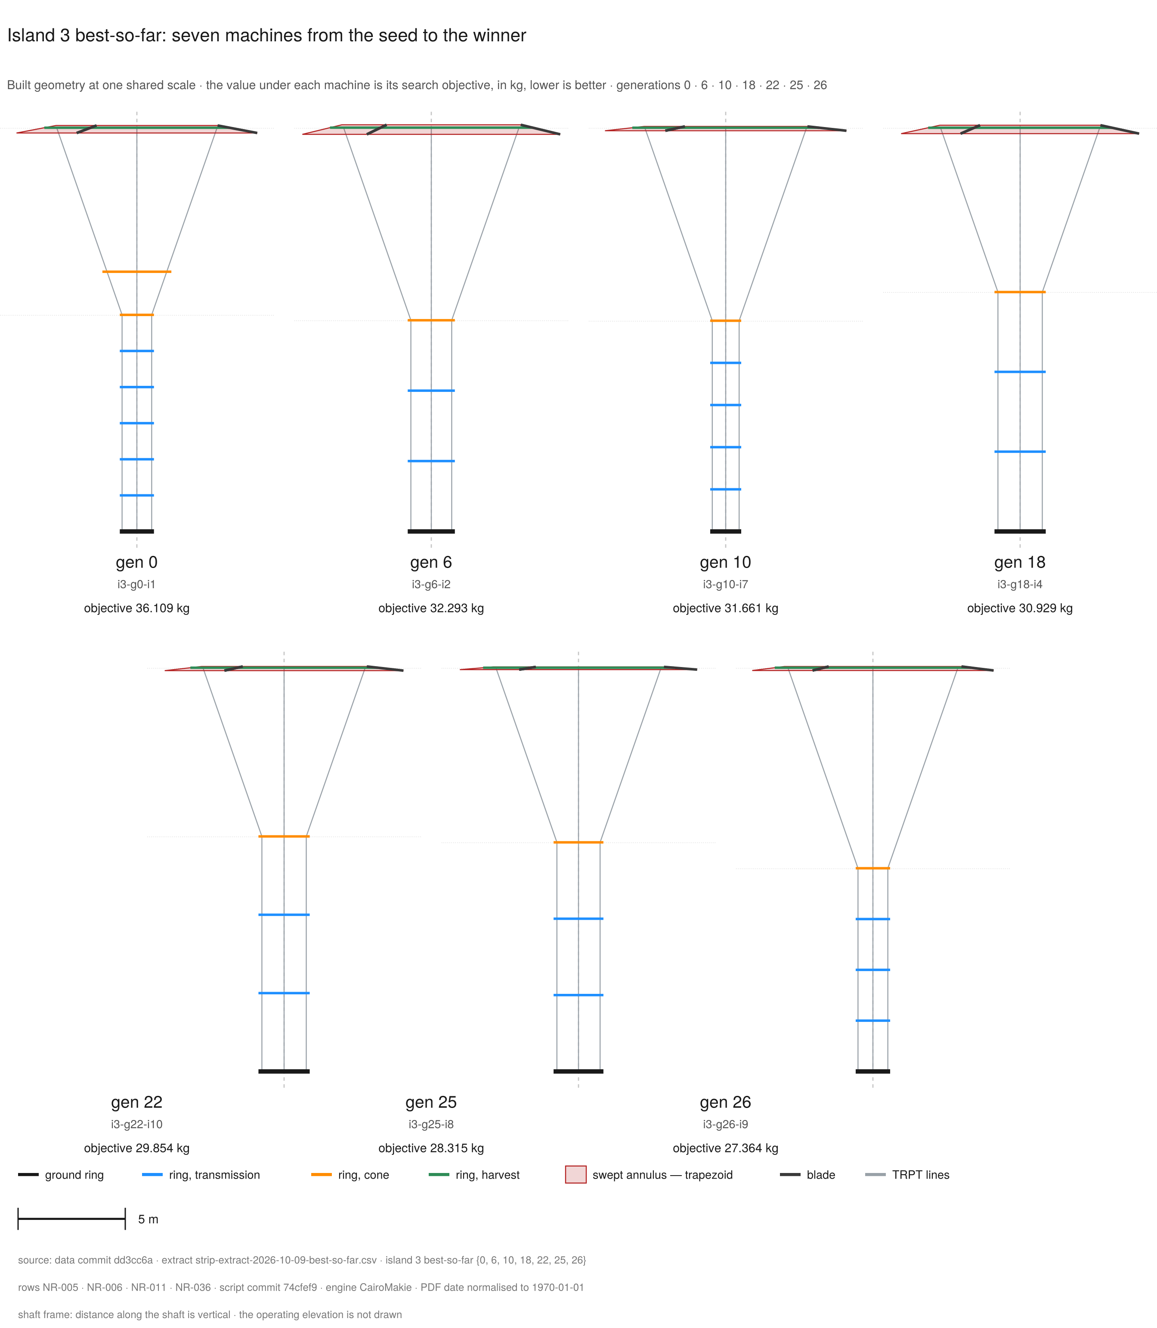
machine-evolution-strip
Figure (roster row 9) · machine-evolution-strip
Island 3's best-so-far objective falls as the built geometry converges to the register winner. The row starts at the common seed and ends at the campaign winner. Each machine is drawn from its built geometry, and all seven share one scale. The number under each machine is its search objective, in kg-equivalent. A lower number is better.
Island 3's best-so-far objective falls from 36.109 to 27.364 kg-equivalent. The built geometry converges to the register winner (NR-006, NR-005). Seven panels show the best machine of island 3 at generations 0, 6, 10, 18, 22, 25 and 26. The labels match the recorded generations. Each panel draws the built state of that genome. The drawing shows the ring segments in their section colours, the TRPT lines between rings, the blade segments, and the swept annulus of the main rotor as one truncated cone. The value under each machine is the search objective in kg-equivalent. The drawings use the shaft frame. Distance along the shaft is vertical, and the operating elevation is not drawn. One fixed scale holds across the set. A 5 m scale bar sits in the footer. The set reads in two rows: four panels above, three below. The machines differ in drawn size only where their built size differs. The final panel carries the campaign winner. It matches the register machine: three lines, six rings, hub radius 4.580 m, ground radius 0.804 m, blade scales 0.82 and 0.20. The strip claims geometry and the search objective. It prints no power value and no airborne mass value.
Source: data dd3cc6a · script 74cfef9 · rows NR-005, NR-006, NR-011, NR-036
The machine evolution strip traces the search on island 3 from the common seed to the campaign winner (NR-036). The objective falls from 36.109 kg-equivalent at generation 0 to 27.364 kg-equivalent at generation 26 (NR-036). The largest recorded drop falls between generations 0 and 6, from 36.109 to 32.293 (NR-036). The final recorded step reads 28.315 to 27.364, a drop of 0.951 (NR-036).
The winner value is the search objective, not a mass reading. The objective reads the airborne mass 25.698 kg plus 1.665 kg-equivalent of penalties (NR-018, NR-039).
The final panel matches the register winner. The panel reads three lines and six rings (NR-011). The hub radius is 4.580 m and the ground radius is 0.804 m. The blade scales read 0.82 and 0.20 (NR-011). The winner genome carries inactive slots at a rotor count of one (NR-011, NR-017).
The strip shows built geometry and the search objective only. The strip prints no power value and no airborne mass value.

3.6 Design implications
The record supports four implications.
First, the searched TRPT family contains a compact feasible candidate under the modeled objective and gates. The winner produces 5.309 kW of mean power with an airborne mass of 25.698 kilograms (NR-008, NR-018).
Second, the winner holds large structural and twist margins at the final operating point. The window-minimum factor of safety is 15.0 (NR-009). The least segment torque margin is 2.03, at S1 (NR-040). The margins suggest room for further mass reduction. Any reduction waits on blade integrity and lifter validation.
Third, future searches should treat clearance as a design constraint in its own right. The status mix reads 110 clearance_reject designs (NR-002). Future searches can steer away from low-clearance geometry with a clearance map or a shaped penalty.
Fourth, part of the winner genome stays inactive at one active rotor (NR-011, NR-017). Conditional genes can improve the search efficiency without changing the machine problem.
Recommended next steps:
- Fix the rapid-path rope-break gate before using the rapid path for screening (NR-013).
- Add blade root factor-of-safety checks to the structural gate set.
- Validate lifter modulation across the wind bands.
- Extend the wind cases beyond the steady sheared profile.
- Extend the model to the launch and recovery sequence.
- Extract the lever statistics from the campaign telemetry.
- Re-run a short campaign with conditional genes and a clearance-aware decoder.

4 Discussion

4.1 Evaluation fidelity
The ODE path reproduces every recorded winner field at the precision the record stores. Island 3 agrees at full precision (NR-012).
The rapid path rejects all three winners at the rope-break gate (NR-013). The cause is gate placement, not the machine.
The rapid start injects ring velocities from the static pre-solve. The evaluator runs the rope-break gate across the relax run as well as the window. The injected transient over-strain trips the gate at once.
The team has solved this pattern twice on record. On 2026-08-14 the rule was: breaks only during real operation. The settle transients must not break healthy machines.
On 2026-09-16 the ruling was: breaks on the measurement window only, with break detection off during the relax. The fix here is the same pattern applied to the evaluator.
Until it lands, the discrepancy stands. The evaluator enables rope breaks across the relax and the window. The ruling enables them on the window only.
The lesson stands. The rapid path is the evaluator default. Any consumer that does not pass the cold flag measures the instrument, not the machine.
Every healthy winner reads reject on the default path. Pass the cold flag, and every recorded winner field reproduces (NR-012).

4.2 The failure ledger
Candidate entries. Each failure enters with its lesson.
- The dead geometry genes. The search proposes genomes that cannot build. An off-by-one in the rotor-to-ring map put the middle rotor on the hub (2026-08-26).
- An inverted-taper genome diverged within seconds, while the ground instruments still read normal power (2026-08-14).
- Lesson: the decoder must refuse what the builder cannot make, at gate time.
- The voided campaigns. A later finding can break a model or a geometry. The data from before it then counts no more.
- The blade-mass-law correction landed on 2026-08-22. It voided the campaign winners. The rotorcount data was doubly void: it predated the FoS fix, and its rotors sat one ring toward the hub.
- Superseded is the milder class, not void. The pre-derate campaign stands as era record, because the bank derate moved the search space.
- Lesson: void the data, keep the record.
- The k-alignment faults. Twice, a check ran at a different generator gain than the machine it scored.
- On 2026-08-13 the evaluator ran 5 kW designs at the 50 kW default gain. The scaled system gain sat near 1.94. The window power read roughly double. An acceptance test caught it.
- On 2026-08-24 a winner re-gate ran at a stale gain, the superseded 20-second-window value. The pre-push review caught it. The re-gate at the campaign gain returned 5.18 kW.
- A misaligned gain scores a different machine, and the data voids. Lesson: one constant, one source file. [2.24 holds a register row (NR-015). The other values need rows first.]
- The stale-gate near-miss. The FoS floor gate fell behind the model it guarded.
- The FoS=Inf exploit fix landed in one scoring path only. The mass-minimum objective and the older fitness functions never received the guard. The campaign ran through them unguarded (2026-08-22).
- Telemetry shows no surviving design carried the infinite value. That is a near-miss, not a corrupted dataset. Lesson: a gate must pin a measured number, so drift fails the suite.

4.3 Model boundaries
The report states these boundaries plainly. They are part of the valid-science case, not footnotes.
- The model does not check blade integrity. The blade root factor of safety sits at infinity in the model. The team deferred the full beam-on-supports blade model (PRD 0006:147). The rotor blades are not yet structurally gated in this analysis.
- Flown blades carry tether-to-blade bridling that resists thrust and expansion better than the unbridled model assumes. That bridling also adds drag. The model does not include it.
- The model does not simulate launch or recovery. Each run starts with the machine already aloft at its operating point. The full launch sequence and the recovery are outside this report.
- The lift system must also carry the machine during hoisting, after a TRPT break and in high wind. The record does not quantify those cases.
- The campaign wind is steady and sheared. Its speed rises with altitude on the site wind profile. The profile comes from wind measured at the Daisy machine. Gusts and turbulence do not occur in a scored run. The wind direction stays fixed. The scored profile is a base case, not a full weather envelope.

5 Conclusion
The report screened 930 rigid-wing ground-generation rotary kite turbine designs with a tensile rotary power transmission (NR-001). The campaign scored each design on the ODE path over the measurement window (NR-015). One fixed power-law generator load and one fixed gate set held for every design (NR-015).
The search found a feasible candidate in the searched space. Its mean power is 5.309 kW and its airborne mass is 25.698 kilograms (NR-008, NR-018). Its window-minimum factor of safety is 15.0 (NR-009). All checked TRPT rings and twist segments operate below their failure boundaries at the final operating point (NR-021, NR-022). The least segment torque margin is 2.03, at S1 (NR-040).
The result shows that a compact TRPT machine can satisfy the power, clearance, twist and structural gates in simulation. That result holds under the modeled load and wind. It does not show flight readiness, a global optimum, or full structural safety. Blade integrity is not yet gated, and lifter modulation remains an assumption. The rapid path awaits its rope-break gate fix (NR-013).
The Daisy anchor ties the model to a measured flight reference.
The next work closes the model gaps. Add blade structural checks and validate lifter modulation. Extend the model to the launch and recovery sequence. Extend the wind cases beyond the steady sheared profile. The large structural margins suggest room for mass reduction, once those checks hold.
[Daisy values need register rows before the final report quotes them.]

6 Nomenclature [PENDING. Track D ratifies the glossary.]

7 References
Seeded in references.bib. Fifteen of eighteen sources verified. Three source calls pending: Ranneberg EK_FT_0018, the Jamieson deck and the Hancock deck.

8 Data availability and reproducibility
The dataset commits to the repo at dd3cc6a on bankderate2-results. The launch commit is a76c5e9. The Phase 0 audit sits at master 31ca00d. The fidelity probes sit on the bank-derate-cos2p65 branch.
Every figure will ship with its generating script and its data commit. Every public post will cite register rows by ID.

Document control
The version history, the working notes, the open requests to the analysis room and the seat notes sit in docs/reporting/draft-tracker.md. This document carries only reader-facing material.
The title stays a working form pending the founder decision.

Appendix: Claims and evidence
The table ties each headline claim of this report to its evidence and its signed register rows.
Claim | Evidence | Report location | Register rows
Campaign scale and status mix | 930 designs. The status mix reads 508 ok, 301 reject, 110 clearance_reject and 11 reject_twist. | §3.1 | NR-001, NR-002
Winner power | Mean power 5.309 kW over the measurement window. | §3.3 | NR-008
Winner mass | Airborne mass 25.698 kg. | §3.3 | NR-018
Structural margin | Window-minimum factor of safety 15.0. The checked ring utilisations stay below the failure boundary. | §3.3, §3.4 | NR-009, NR-021
Twist and torque margin | All five segments stay inside their over-twist limits. The least segment torque margin is 2.03 at S1. | §3.4 | NR-022, NR-040
Search improvement | The search improved the best objective from the common seed to the winner. It reads 36.109 to 27.364 kg-equivalent. | §3.2 | NR-003 to NR-006
Instrument fidelity | The cold path reproduces the recorded winner fields. The rapid path rejects all three winners at the rope-break gate. | §4.1 | NR-012, NR-013
Model boundaries | Blade integrity is not gated. The report assumes lifter modulation. Launch and recovery sit outside this report. Gusts and turbulence are not modelled. | §4.3 | PRD 0006:147, assumptions

Appendix: Figure provenance
One row per built exhibit. All six read dataset commit dd3cc6a.
Exhibit | Source extract | Cited rows | Script commit | Era
Ring utilisation plate | pair-extract-2026-10-08-winner-ops | NR-021 | 671ab96 | post-95c385d_wind-authority
Twist limit plate | pair-extract-2026-10-08-winner-ops | NR-022, NR-023 | 671ab96 | post-95c385d_wind-authority
Machine evolution strip | strip-extract-2026-10-09-best-so-far | NR-005, NR-006, NR-011, NR-036 | 74cfef9 | post-95c385d_wind-authority
System anatomy plate | scratch/fig1_decode_winner.jl · best_vector.csv | NR-011, NR-017, NR-043 | 9cecee3 | post-95c385d_wind-authority
Levers landscape | scripts/results/v13_5kw_masslift_len18.8_rotorcount_bankderate2/island_{1,2,3}/telemetry.csv | NR-001, NR-005, NR-006, NR-044, NR-045 | e23f226 | post-95c385d_wind-authority
Parameter atlas | scripts/results/v13_5kw_masslift_len18.8_rotorcount_bankderate2/island_{1,2,3}/telemetry.csv | NR-001, NR-005, NR-006, NR-044 | e23f226 | post-95c385d_wind-authority
Output hashes (SHA-256). The short labels name the exhibit files. png, svg and pdf are the file types. ledger is the label ledger. checks is the check log.
Ring utilisation plate:
- png f49aaaa1bda8d1699c6db556fd20188d892cfcd42e3163ab8fb56bbea1eee837
- svg 41a557862e0f3a1eb1b40ecb2224089014fff7c26ee8d7c6d64bdd1b3bf670c0
- pdf fc4974d6e462b22ca3a45aaae009001bdf46c8d0245862227255ca3e42d69c75
- ledger 3b4bc8c1c9b0c5d474a1acabe6c2b7684058234414d96870e41b015e04b4a5ff
Twist limit plate:
- png 00cd857a5769be853142a4e35cc701d283cb17e66c2e20f40e562177813f6248
- svg 45104b967009ef52c54f2ca4f4877f30c204daf64544161d907dc5dc41e59f5f
- pdf 49c473a8ff2dac0cc15fed7b17bece2a10ecaae6d4ab157e801754cf6b40dfa2
- ledger 2225062a0146f62ac1c0a18add36f38d26df73682f56f4fd5cdac6a0a691c8e9
Machine evolution strip:
- png 8e9d1d40684b984059601f31d5fb2daed8f835f6f8184a716280f8cd779e1cb6
- svg 6c36b0ff1de3b664dac23f8c754481d7a844e7d24d60488e87e6d0a90246d59e
- pdf 6ce4daba18e3972e5284f7a813aff91be723ee9816deac5f113cfc1eb30a2844
- checks b8c654ea55b26f97a03c7fc6acd1049300bda5c188a972136e7eb12ce2c94bde
System anatomy plate:
- png f1c322bc20068299651bea7978bde254991b4037bf02fe689a15e1e3297a09ea
- pdf 9beffb6bf8463d39a5808164630d04d8c286184a4990a083296e7fc6d512f2cf
- ledger b250c1a187132f68c37747b70f3d6081eb89e677ba378b12e6eb14b8a05a2389
- checks 0e857cbfb288ff7110aafec99c11211bae1c46e4d3b2a5594d5949f318d9f279
Levers landscape:
- png 4b1bd3453a6aa20d9b9b0af75eb989212b16df8986c752766edd625ae13d9892
- svg 94d518bb13c604d4949f9c1011845050d150c4122a357449a8e185f506ae48dc
- pdf 712e918b0b6ac73335ef2355113f59a2f3c6f63a421407ee122c98cfa6a2ecd7
- ledger 91282957dd23b9a9919756e9db578404497e1f0a58d11c4824a7550ad5a91c5e
Parameter atlas:
- png 1e46b70ae65f5557d23bb1a78ab7a75fdc2550a712ac9b2652d31562c67096e8
- svg 28c032cf27c7412c9e76e0d756967143b7201c1ec4b6fe819498f40fe2021b9c
- pdf aede4d29da694a23e9af14c0ccb72f1932bf09a23b61adcf2095391c69a375b8
- ledger d3a2bcb1208db0bf0a4e5eb061620d9e73e99e776dc091dd26c067a2324d6f76

Data register (cited rows)
Every number in this draft traces to a signed row in the numbers register. A missing row here is a release blocker.
Row | Quantity | Value | Units | Source | Status
NR-001 | Campaign size | 930 (3 islands × 310) | evals | island_*/telemetry.csv | signed (science-validator, 2026-10-08)
NR-002 | Status mix | 508 ok / 301 reject / 110 clearance_reject / 11 reject_twist | designs | telemetry status column | signed (science-validator, 2026-10-08)
NR-003 | Island 1 best fitness | 30.578 (found gen 30) | kg | island_1/convergence.csv | signed (science-validator, 2026-10-08)
NR-004 | Island 2 best fitness | 30.637 (found gen 30) | kg | island_2/convergence.csv | signed (science-validator, 2026-10-08)
NR-005 | Island 3 best fitness | 27.364 (found gen 26) | kg | island_3/convergence.csv | signed (science-validator, 2026-10-08)
NR-006 | All-island start point | 36.109 (gen 1, common seed) | kg | convergence.csv | signed (science-validator, 2026-10-08)
NR-007 | P_mean range, ok rows | 5.02–6.32 | kW | telemetry, ok only | signed (science-validator, 2026-10-08)
NR-008 | Winner P_mean (island 3) | 5.309 / P_end 5.314 | kW | island_3 telemetry / re-eval (§4, Phase 0 audit) | signed (science-validator, 2026-10-08)
NR-009 | Winner FoS (island 3) | 14.972 | — | island_3 telemetry / re-eval (§4, Phase 0 audit) | signed (science-validator, 2026-10-08)
NR-010 | Winner T_lift (island 3) | 324.1 | N | island_3 telemetry / re-eval (§4, Phase 0 audit) | signed (science-validator, 2026-10-08)
NR-011 | Winner geometry (island 3) | n_lines 3, rings 6, n_active 1, r_hub 4.580 m, r_bot 0.804 m, bank_bot 22°, blade scales 0.82/0.20 | — | decode of best_vector.csv | signed (science-validator, 2026-10-08)
NR-012 | Cold-path reproduction | :cold re-eval matches recorded P_mean, P_end, FoS, fitness, T_lift to 3 dp on all three winners | — | probe_rapid_vs_ode_winners.jl | signed (science-validator, 2026-10-08)
NR-013 | Rapid-path result on winners | :warm rejects all three winners — rope-break gate (broken=true), transient line over-strain during relax | — | probe_rapid_vs_ode_winners.jl + probe_warm_reject_cause.jl | signed (science-validator, 2026-10-08)
NR-014 | Winner window swing | P_range 0.029 on 5.309 kW (0.5%) | kW / % | re-eval (§4, Phase 0 audit) | signed (science-validator, 2026-10-08)
NR-015 | Operating point | k 2.24, relax 10 s + window 40 s, FoS gate 2.5/2.5, length 18.8 m | — | runner provenance | signed (science-validator, 2026-10-08)
NR-016 | Winner ω (ODE) | 10.170 | rad/s | re-eval (§4, Phase 0 audit) | signed (science-validator, 2026-10-08)
NR-017 | Winner main-rotor bank (island 3) | 7.088° at ring 6. Slot 8 = 22° reaches no rotor at n_active 1 | deg | decode probe d219b6c. Threading src/objective_v10.jl:339 | signed (science-validator, 2026-10-08)
NR-018 | Winner airborne mass (island 3) | 25.69846825623688 | kg | audit §4 + probe 0c4046b | signed (science-validator, 2026-10-08)
NR-021 | Ring check at the winner operating point (island 3): interaction, shares and FoS per checked ring | R2 0.03323714455441065 = 0.033223570205929 + 1.3574348481652112e-5, FoS 30.086820435580936. R3 0.033548608446737266 = 0.03354237801917142 + 6.230427565848155e-6, FoS 29.80749563987516. R4 0.028380221733419368 = 0.028374815022862057 + 5.40671055731162e-6, FoS 35.23580644975869. R5 3.058346201008972e-6 = 0.0 + 3.058346201008972e-6, FoS 326974.1011237028. R6 hub 0.06652238395895148 = 0.06652164721153939 + 7.36747412096439e-7, FoS 15.032534020684876 | — | Extract docs/reporting/figures/pair-extract/extract-winner-operating-point.csv, ring block. Emitted by capture_extended; max_util re-derived via ring_element_analysis; A1 identity checked, residual 0.0 at every ring | signed (aero-validator, 2026-10-08)
NR-022 | Segment twist and over-twist limit at the winner operating point | abs(dalpha): S1 33.94561934829036°, S2 33.811870056223555°, S3 33.67952027817454°, S4 33.54707806507812°, S5 22.821871326820364°. dcrit: S1 to S4 98.85908296054023°, S5 92.64281134151318°. has_limit true on all five | deg | Extract, segment block. Raw reads from the stored alpha block; trpt_twist_limit on the rope_forces C1 call pattern (node radii, mean line rest length) | signed (aero-validator, 2026-10-08)
NR-023 | Segment torque pair at the winner operating point | segment_torque: S1 396.791634149159, S2 397.1554424859068, S3 397.45360112890063, S4 397.68800908436924, S5 397.1777954649229. torque_capacity: S1 805.0097155967861, S2 808.6780945063998, S3 812.213802301376, S4 815.650844050359, S5 1069.9324759682652 | N·m | Extract, segment block. Capacity = trpt_torque_capacity_axial at trpt_axial_force of the same state. One instant for both series | signed (aero-validator, 2026-10-08)
NR-025 | Cold-start protocol (campaign setting) | Settle settle_to_operational_state (n_op 150000 steps, about 6 s simulated; ω_rated_max 60.0 rad/s), then kickstart off (kickstart_s 0.0; the legacy kick is -60.0 N·m·s²/rad², about 115 times the MPPT torque), then one combined relax+window run, 10 s + 40 s, rope breaks enabled across both. Winner run: 1724859 steps | s, steps | src/objective_evaluator.jl:774, 840-842, 856-892, 978-989; src/initialization.jl:2184-2190; scripts/run_v13_5kw_masslift.jl:157 | signed (aero-validator, 2026-10-08)
NR-026 | Lifter sizing margin (campaign regime) | margin 1.5 (vertical force at the lift bearing = 1.5 × m_airborne × g); line tension = F_vert / sin(70°), flat at all wind speeds; m_airborne excludes the lifter's own 5 kg (the kite carries itself) | — | src/lift_kite.jl:197-228; regime line scripts/run_v13_5kw_masslift.jl:111 | signed (aero-validator, 2026-10-08)
NR-027 | 10-05 length screen on the pre-fold island-3 genome (both rounds, arrow = round 1 to round 2) | P_mean 18.8 m: 3.7955 → 4.2332; 21.2 m: 3.8645 → 4.3055; 25.0 m: 3.9747 → 4.4122. All six rows FAIL (P<5.0) | kW | scripts/results/length_variants_island3/variants.csv (f225e95, 2026-10-05T10:10Z); scripts/results/length_variants_island3-cpfix/variants.csv (a82cafd, 2026-10-05T11:25Z) | signed (science-validator, 2026-10-10)
NR-028 | 18.8 m fold comparison at the cpfix era | pre-fold genome 4.2332 (fail), folded class P_end 5.3691 (ok) | kW | Pre-fold: NR-027 round 2. Folded: scripts/compute_seeds.jl:50-56; docs/validation/2026-10-05-s2-fold-flight.md | signed (science-validator, 2026-10-10)
NR-029 | Winner operating speed, window-mean ground ring | 13.380259861740395 (quote 13.38, 127.772 rpm) | rad/s | scripts/probe_window_trace.jl (b665e6e), parity against the recorded cold re-eval (NR-012) | signed (science-validator, 2026-10-11)
NR-030 | Winner delivered torque, window-mean basis | 396.76205834512626 (quote 396.76) | N·m | P_mean (NR-008) divided by NR-029. Cross-reads: S1 panel 396.791634149159 (0.0075 % above), S5 hub 397.1777954649229 | signed (science-validator, 2026-10-11)
NR-032 | Winner tip-speed ratio and rotor Cp, tip reference | lambda_tip 6.8415060395190075 (quote 6.8415, hub value 6.841451124645552 agrees inside 5.5e-5), Cp 0.22578839742146659 (quote 0.2258) | - | lambda from the NR-029 window trace, r_out 5.629560432565964 m, v_ref 11.01 m/s. Cp at the hub-basis lambda from the measured n = 3 surface (src/aerodynamics.jl:263, anchor a82cafd). Receipts: scratch/sv_probe_winner_areas.jl, scratch/av_probe_tipref_counter.jl | signed (science-validator, 2026-10-11)
NR-036 | Island 3 running-best search objective at the seven strip milestones | 36.109 (gen 0), 32.293 (gen 6), 31.661 (gen 10), 30.929 (gen 18), 29.854 (gen 22), 28.315 (gen 25), 27.364 (gen 26) | kg | docs/reporting/figures/machine-evolution-strip/extract-best-so-far.csv (certified 2026-10-09). This seat re-checked all seven against island_3/telemetry.csv: each is an ok row and the least ok fitness of its window. Figure label: search objective | signed (science-validator, 2026-10-11)
NR-039 | Island-3 fitness decomposition, NR-005 against NR-018 | fitness 27.3635412663488 = mass 25.69846825623688 + over-power 0.49333696413175443 + utilisation 0.5576509889014662 + twist 0.6140850570787014. Penalty total 1.6650730101119215 (quote 1.665) | kg | island_3/convergence.csv gen-26 row + scratch/sv_p0_winner_reeval.txt + evaluator chain at launch a76c5e9 | signed (science-validator, 2026-10-12)
NR-040 | Winner segment torque margin | S1 2.0287970973051634, S2 2.036175280501402, S3 2.0435436991749936, S4 2.0509817379918016, S5 2.6938375915900292. S1 governs (quote 2.03). The S1 to S4 band reads 2.03 to 2.05. | — | NR-023 strings, segment by segment: torque_capacity / segment_torque. Recipe: 805.0097155967861 / 396.791634149159 = 2.0287970973051634. Cross-read: docs/reporting/figures/pair-extract/extract-winner-operating-point.csv, segment block, bit for bit | signed (science-validator, 2026-10-12)
NR-043 | Winner blade span (island 3, main rotor) | 1.4994019682084492 (quote 1.499) | m | scratch/sv_probe_winner_areas.log, the span (built) line, sha256 a7c6e343b4cfba7f790fe0c2c3fd81638c06548c0d98d23407737c9ae0d9b0ab: R_main 5.629560432565964 minus blade_hub_radius 4.130158464357515. The decode convention src/objective_v10.jl:374-376. Figures decode log scratch/fig1_decode_winner.log. Counter-read: the aero tip-reference receipt (2026-10-11) | signed (science-validator, 2026-10-13)
NR-044 | PCA projection summary (v13 5 kW screen, 930 draws): variance shares, top loadings, bin rule | PC1 22.434667 (quote 22.4), PC2 17.263044 (quote 17.3), pair total 39.697710 (quote 39.7) per cent. Loadings at four decimals, the abs(v) >= 0.2 set: PC1 n_lines -0.5385, rotor_count -0.5222, blade_scale_top +0.5180, target_Lr +0.2517, r_bottom +0.2036. PC2 bank_bottom +0.5621, blade_scale_bottom -0.5605, density_profile -0.5018, bank_top -0.2444. The field bins at 18 x 18 cells over the 1 to 99 percentile rectangle | per cent, -, cells | Recipe: z-score the 930 x 10 matrix of x1..x10 (three island telemetry files, data commit dd3cc6a), one SVD, shares from the squared singular values. Reproduction below | signed (science-validator, 2026-10-13)
NR-045 | Island generation counts (v13 5 kW screen) | 31 generations per island (gen index 0 to 30), 10 rows per generation (idx 0 to 9), 310 rows per island, 930 in total | generations / rows | island_*/telemetry.csv, gen and idx columns, data commit dd3cc6a | signed (science-validator, 2026-10-14)
NR-046 | The objective seam forms, the weights, the thresholds and the reject placement | f = mass + 5.0 * max(P_score - 5.0, 0)^2 + 20.0 * (2.5 / FoS_min)^2 + 1.0 * (r / (1 - r))^2 with r = min(twist_ratio, 1), plus the stationarity add-on 10.0 * max(0, swing - 0.20) with swing = P_range / P_mean. P_score reads the tail-5 power (P_end). Winner closure: 25.69846825623688 + 0.49333696413175443 + 0.5576509889014662 + 0.6140850570787014 = 27.3635412663488 (NR-039). Rejects carry no score: the evaluator returns Inf and the runner stamps the search cost 1e9 on every non-ok design (422 of 930 rows) | kg-equivalent: 5.0 per kW², 1.0 per twist-ratio², 20.0 per FoS-ratio², 10.0 per swing fraction. Mass reads kg. The 1e9 stamp is a search cost, not an objective unit | Source read at 7b8c101, the tip at read time. Byte-stable from launch a76c5e9. Sites: src/objective_v12.jl:114-116 (weights), :145-168 (seam body). src/objective_evaluator.jl:90-91, 1148, 1161, 1192-1194, 1200-1203. scripts/run_v13_5kw_masslift.jl:153-156, 256-257, 266, 272, 281-283. Census over island_*/telemetry.csv. Checker: scratch/sv_nr046_objective_seam_check.py and its log | signed (science-validator, 2026-10-14)

Build record (builder output)
This block is builder output. It sits outside the report proper and does not pass the STE gate.
Draft: 7dd91a9 (docs/reporting/drafts/2026-10-08-report-first-draft.md)
Register: v1 ROWS SIGNED (2026-10-08, science-validator). See the sign-off — file at 9d96a4b
Citation check: 35 cited, every one signed (46 signed rows total), uncited: NR-019, NR-020, NR-024, NR-031, NR-033, NR-034, NR-035, NR-037, NR-038, NR-041, NR-042 — checker exit 0
Seats resolved: 6 of 6 — system-anatomy, ring-utilisation, twist-limit, pca-landscape, pca-atlas, machine-evolution-strip
Embed route: SVG vector-first, PNG fallback; kits embedded as shipped, nothing re-rendered
Toolchain: pandoc 3.1.3 → DOCX (A4 reference doc, LibreOffice review copy)
Built: 2026-10-14T14:15:28Z

