TRPT Kite Turbine: Blade Count and Rotor Stacking
Scalability Analysis
Windswept & Interesting Ltd · March 2026

1 Executive Summary
This report analyses two independent design variables for the TRPT kite turbine: the number of blades (and tether lines) n_blades ∈ {3, 4, 5, 6} and the number of vertically stacked rotors sharing a single TRPT shaft n_rotors ∈ {1, 2, 3}. All results are benchmarked against the validated 10 kW, 5-line, single-rotor prototype (R_rotor = 5 m, β = 30° elevation, rated wind 11 m/s).
Key findings: (1) Fewer blades produces a lighter ring frame because the relevant structural group scales as n · sin¹·⁵(π/n) · cos⁰·⁵(π/n), which peaks near n = 5 and is lowest at n = 3. With blade mass approximately constant across n_blades (optimal chord ∝ 1/n), the 3-blade configuration achieves the highest specific power at ~514 W/kg. (2) Stacking rotors multiplies power but incurs a non-linear ring mass penalty: the bottom TRPT section carries cumulative torque from all rotors above, requiring tube outer diameter Do ∝ k^0.25 per section k, so ring mass per section scales as k^0.5. This gives a P/W ratio of ~412 W/kg for n_r = 2 and ~382 W/kg for n_r = 3 (5-blade design). (3) The inclined TRPT geometry (β ≥ ~22°) places successive rotors outside each other's wake cone, making stacked TRPT effectively wake-free at the current 30° elevation angle — a significant advantage over conventional tandem wind turbine arrays. (4) Centrifugal blade loads at rated speed dominate hub ring loading (~2685 N outward vs ~750 N inward from tether tension), putting the hub ring in net hoop tension — consistent with observed centripetal stretching in physical experiments. The compression-sized CFRP tube carries this tensile load with a factor of safety > 100.

2 Effect of Blade Count (n_blades)

2.1 Aerodynamic Performance
The number of blades has a modest effect on rotor power coefficient Cp. AeroDyn BEM simulations (NACA4412, 30° elevation, rated TSR ≈ 4.1) indicate Cp ≈ 0.23 for 3 blades, decreasing to ≈ 0.215 for 6 blades. The variation is ≈ 2–3% across the range, within the AeroDyn uncertainty for rotor-to-rotor comparison. The primary performance sensitivity is structural rather than aerodynamic.

2.2 Blade Mass Scaling
For a fixed rotor radius R and power coefficient, the aerodynamically optimal blade chord c ∝ 1/n_blades (Betz-optimal solidity theorem). Assuming blade mass scales with planform area (m_blade ∝ chord × R × thickness), the mass of a single blade scales as 1/n_blades, so the total rotor blade mass m_blades = n_blades × m_blade_each is approximately constant as n_blades varies at fixed R and rated power. This holds empirically across the 4–12 kW AeroDyn dataset (all designs use ≈ 11 kg total blade mass at R = 5 m). Consequently, blade mass does not drive the n_blades optimisation.

2.3 Ring Frame Structural Mass
The ring polygon is a regular n_blades-gon of CFRP hollow tubes. Each flat side acts as a pin-pin Euler column under the inward compression from tether tension (see TRPT_Ring_Scalability_Report.docx §2). The governing structural parameter is the product N_comp × L_poly², which determines the required tube second moment of area I. Substituting N_comp = T_line · δ · rL / (2·tan(π/n)) and L_poly = 2R·sin(π/n) gives:
N_comp × L_poly² ∝ T_line · R²· sin(2π/n)
The total ring frame mass M_rings ∝ n · sin¹·⁵(π/n) · cos⁰·⁵(π/n) · R², which reaches a minimum at n = 3 (equilateral triangle) and peaks near n = 5. The variation across n = 3–6 is ≈ 18%. Numerically for the 10 kW design at 14 intermediate rings: n = 3 gives 7.0 kg of ring frame vs 8.3 kg for n = 5, a 16% structural mass saving. However, the overall airborne mass saving is smaller because blade mass (≈ 11 kg) dominates.
The figure below shows column compression N_comp, minimum tube outer diameter, total ring frame mass, and the per-ring mass distribution as a function of blade count.
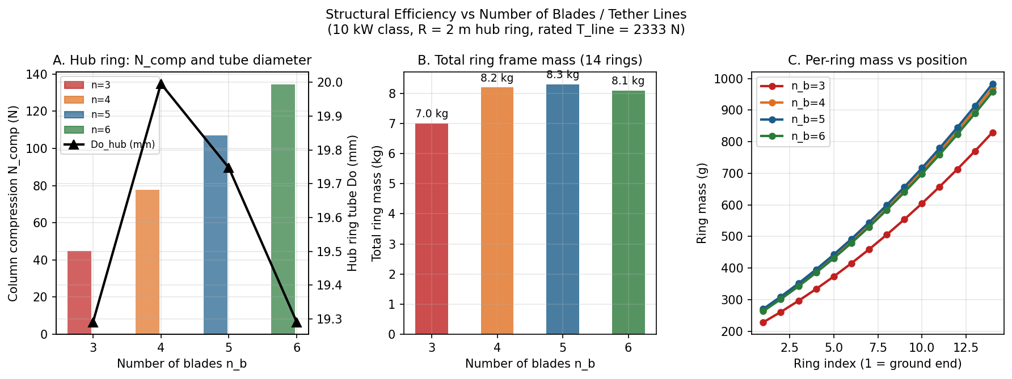
Figure 1. Structural efficiency vs blade count. (A) Hub ring compression and minimum tube diameter. (B) Total ring frame mass (14 rings). (C) Per-ring mass profile from ground (ring 1) to hub (ring 14). Fewer blades → lighter ring frame.

2.4 P/W Ratio vs n_blades
Table 1 summarises the P/W ratio for a single rotor at each blade count. The n = 3 design achieves the best specific power at 514 W/kg, primarily because of lower ring mass and marginally higher Cp. The n = 5 reference (current design) gives 450 W/kg. Practical considerations favour n = 5 over n = 3: (a) a 3-line TRPT provides less torsional coupling area per unit length, increasing sensitivity to line-slack torsional collapse; (b) the equilateral triangle ring has lower structural redundancy; (c) 5-line attachment is better established in DRR prototype testing.
n_blades | Cp | Ring mass (kg) | Total mass (kg) | P (kW) | P/W (W/kg)
3 | 0.230 | 7.00 | 18.62 | 9.57 | 514
4 | 0.225 | 8.19 | 20.01 | 9.36 | 468
5 | 0.220 | 8.30 | 20.33 | 9.15 | 450
6 | 0.215 | 8.09 | 20.32 | 8.94 | 440

Table 1. Single-rotor comparison across blade counts (R = 5 m, β = 30°, v = 11 m/s). Green: minimum ring mass (n = 3); blue: reference design (n = 5).

3 Wake Geometry: Stacked TRPT is Largely Wake-Free
A critical question for stacked rotors is whether downstream rotors operate in the wake of upstream ones. In a conventional tandem array (rotors on a common horizontal axis), each downstream rotor sees the severely reduced wind speed of the upstream wake. For a stacked TRPT the geometry is fundamentally different.
The TRPT shaft points into the wind and upward at elevation angle β. Moving up the shaft from ground to hub, each successive rotor is both upwind (by ΔL·cos β per section) and higher (by ΔL·sin β per section). The top (hub) rotor is always in free stream. Lower rotors are downwind of the hub — but they are also offset vertically by Δz = L_section·sin β from the wake centreline of the rotor above.
Using the Jensen wake model (wake cone radius r_w = R + k_w·Δx, k_w = 0.04), the condition for no wake overlap between adjacent stacked rotors is:
L_section · sin β > R + k_w · L_section · cos β + R
For the 10 kW design (L = 30 m, R = 5 m, β = 30°): the vertical offset is 15 m, and the wake cone radius at the downstream position is only 6.0 m, so the downstream rotor centre is 15 m from the wake centreline while the combined radius for overlap is only 11.0 m — the downstream rotor is completely outside the wake. Numerical analysis shows the wake-free threshold is β ≈ 21.8°. At 30° elevation (the current prototype operating point), stacked TRPT rotors are fully wake-free. Even at β = 20° there is only 3.2% overlap (≈ 2.6% power loss). This is a fundamental structural advantage of the TRPT inclined geometry over horizontal arrays.
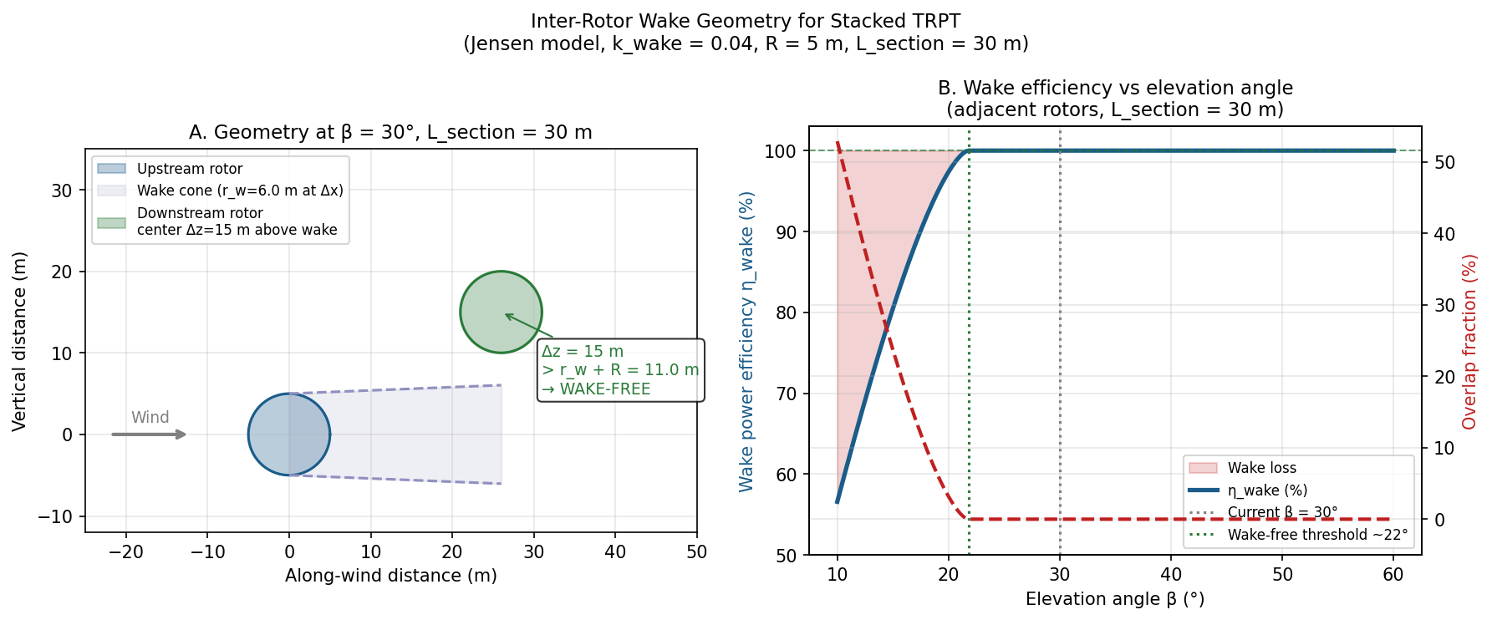
Figure 2. Inter-rotor wake analysis. (A) Wake cone (blue shaded region) from upstream rotor at β = 30°: the downstream rotor (green) is entirely above the wake, with vertical offset 15 m vs wake radius + rotor radius = 11 m. (B) Wake efficiency η vs elevation angle; wake-free threshold ≈ 22°. The 30° operating point achieves η = 100%.

4 Stacked Rotor Mass Penalty

4.1 Torque Accumulation Along the TRPT Shaft
When n_r rotors share a common TRPT shaft to a single ground generator, each successive TRPT section downward carries the accumulated torque from all rotors above. Numbering sections k = 1 (top) to k = n_r (bottom), the tether tension in section k is T_line_k = k · T_line_single. Since N_comp in a tapered TRPT is independent of ring radius R (because L_seg ∝ R cancels; see TRPT_Ring_Scalability_Report), the column compression in section k is simply:
N_comp_k = k · N_comp_single
From the column Euler relation P_crit = π²EI/L², the required tube moment of area I ∝ N_comp_k, so Do_k ∝ k^0.25 and ring mass per section scales as k^0.5:
M_rings_section_k = M_rings_section_1 · k^0.5
The total ring mass across all n_r sections is therefore M_rings_single · Σ(k^0.5) for k = 1 to n_r. This sum is 1.00 for n_r = 1, 2.41 for n_r = 2, and 4.14 for n_r = 3 — roughly quadratic growth rather than linear. The bottom tether section also requires a larger line diameter to maintain the rated safety factor once T_line_k exceeds the 3 mm Dyneema SWL of 3500 N: at n_r = 2 the bottom section carries 4666 N requiring ≈ 3.5 mm, and at n_r = 3 it carries 7000 N requiring ≈ 4.2 mm.

4.2 Mass Budget for Stacked Configurations
Figure 3 shows the stacked mass breakdown for n_blades = 3, 5, and 6. In all cases blade mass scales linearly (n_r × 11 kg per rotor). Ring mass scales faster than linear, reaching 20.0 kg for n_r = 2 and 34.4 kg for n_r = 3 (n_blades = 5 case). Ring mass dominates for n_r ≥ 3, accounting for 48% of total airborne mass.
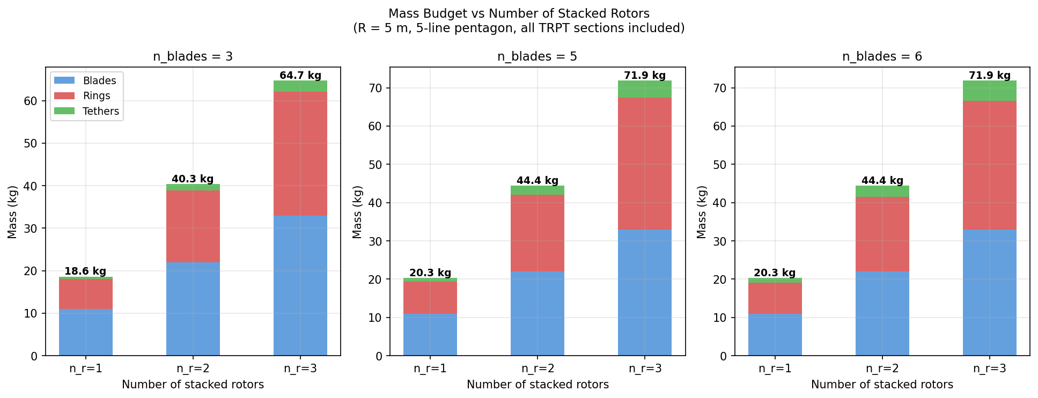
Figure 3. Airborne mass budget vs number of stacked rotors for three blade counts. Colour coding: blue = blades, red = rings, green = tethers. Total airborne mass annotated above each bar. Ring mass grows as k^0.5 per section, faster than linear.

4.3 Comparison with Scaling a Single Larger Rotor
An alternative to stacking is to scale up a single rotor to the same total power. Using the empirical mass exponent 1.35 (Mass Scaling PDF): m_scaled = m_ref · (P/P_ref)^1.35. For a 20 kW single rotor (equivalent to n_r = 2 stacked at 10 kW):
A single 20 kW rotor would mass 51.8 kg (m_ref × 2^1.35 = 2.55×), giving P/W = 386 W/kg. Two stacked 10 kW rotors deliver 18.3 kW at 412 W/kg — better specific power despite slightly lower total power (because wake-free stacking adds power linearly while blade/ring mass also scales sub-quadratically). For n_r = 3 vs a 30 kW single rotor: stacked gives 382 W/kg vs 335 W/kg for the single machine — stacking maintains its advantage up to at least three rotors. This suggests rotor stacking is a better scaling strategy than rotor enlargement for this power range, provided elevation angle stays above the ~22° wake-free threshold.

5 Combined Sweep: P/W and Total Power
Figure 4 shows the full (n_blades × n_rotors) design space. Panel A is the P/W heatmap; panel B is the total power output.
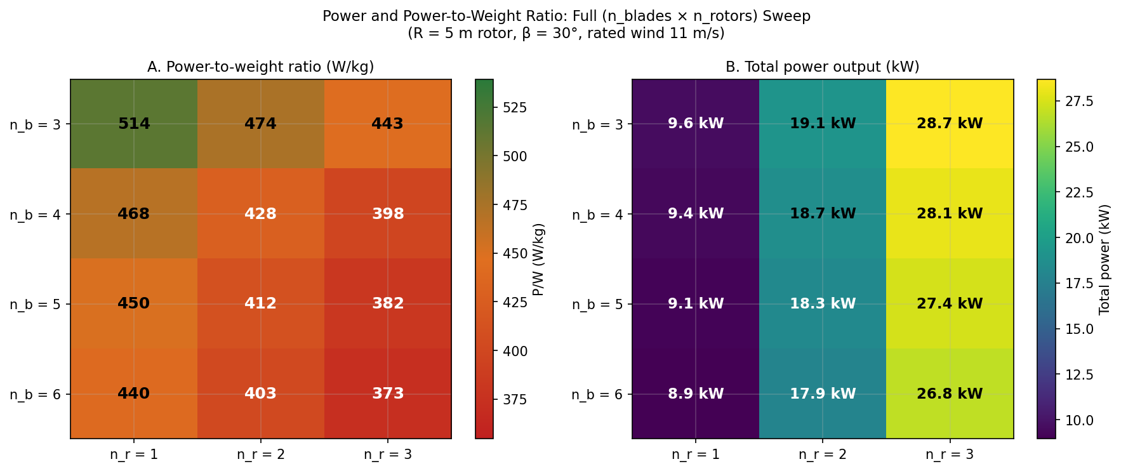
Figure 4. (A) Power-to-weight ratio (W/kg) across the full design space. Green = higher P/W; red = lower. Best P/W is at n_b = 3, n_r = 1 (514 W/kg) — structurally lightest ring frame, no stacking penalty. (B) Total power output (kW); stacking multiplies power nearly linearly at β = 30° (wake-free), from 9.2 kW (n_b = 3) to 27.5 kW (n_b = 5, n_r = 3).
The P/W heatmap shows two competing trends. Moving left (fewer blades): lighter ring frames improve P/W by up to 14% (n_b = 3 vs n_b = 6, fixed n_r). Moving down (more rotors): structural mass escalation reduces P/W by 8–14% per additional rotor. The total power benefit of stacking is clear in panel B — each additional rotor adds 9–10 kW with no wake penalty at β = 30°. Whether to stack depends on the application: if specific power (W/kg) is the priority (lifter kite size, lift-line load), fewer rotors and fewer blades are optimal; if total installed power at a given site is the priority, stacking dominates.

6 Centripetal Loading on the Hub Ring

6.1 Competing Forces on the Hub Ring
The hub ring (radius 2 m for the 10 kW design) is subjected to two radially opposed force systems:
Inward: tether tension pulls the attachment points inward along the twisted rope geometry, compressing the ring polygon frame. At rated, the total inward radial force on the hub ring is approximately F_inward ≈ n_blades × T_line × R × δ / L_seg ≈ 5 × 2333 × 2 × 0.09 / 2.7 ≈ 777 N (distributed across the 5 attachment points).
Outward: spinning blades exert centrifugal force on the hub attachment ring. For total blade mass m_blades = 11 kg with centre of mass at 60% span (r_cm = 0.6 × 5 = 3 m), rated angular speed ω = TSR × v / R = 4.1 × 11/5 = 9.02 rad/s gives: F_centrifugal = m_blades × ω² × r_cm = 11 × 81.4 × 3 = 2685 N outward. This is independent of n_blades (total blade mass is approximately constant).
At rated speed, the centrifugal load (2685 N) exceeds the inward tether compression (777 N for n_b = 5) by a factor of 3.5, so the hub ring is in net hoop tension of ≈ 1908 N. This is fully consistent with the experimental observation of the rotor being 'stretched out' centripetally at the blade attachment points. The effect is more pronounced for fewer blades (less inward tether force) and at higher rotational speeds or lower elevation angles.

6.2 Structural Adequacy
The CFRP tube sized for column buckling of intermediate rings (Do = 19.7 mm, t = 0.99 mm, E = 70 GPa) is massively overdesigned for hoop tension on the hub ring. At 1908 N net outward, the hoop tension per segment is ≈ 325 N. The tube cross-section area is ≈ 61 mm²; with CFRP tensile strength ≈ 700 MPa, the tensile factor of safety exceeds 100. The practical design constraint at the hub ring is therefore the blade attachment connector (clevis or swaged end-fitting), which must handle the individual centrifugal load per blade (≈ 537 N for n_b = 5) as well as the aerodynamic thrust and lift loads.
Intermediate rings (no blades attached) see only the inward compression from tether tension. Column buckling remains the governing failure mode for those rings, as analysed in TRPT_Ring_Scalability_Report.docx.
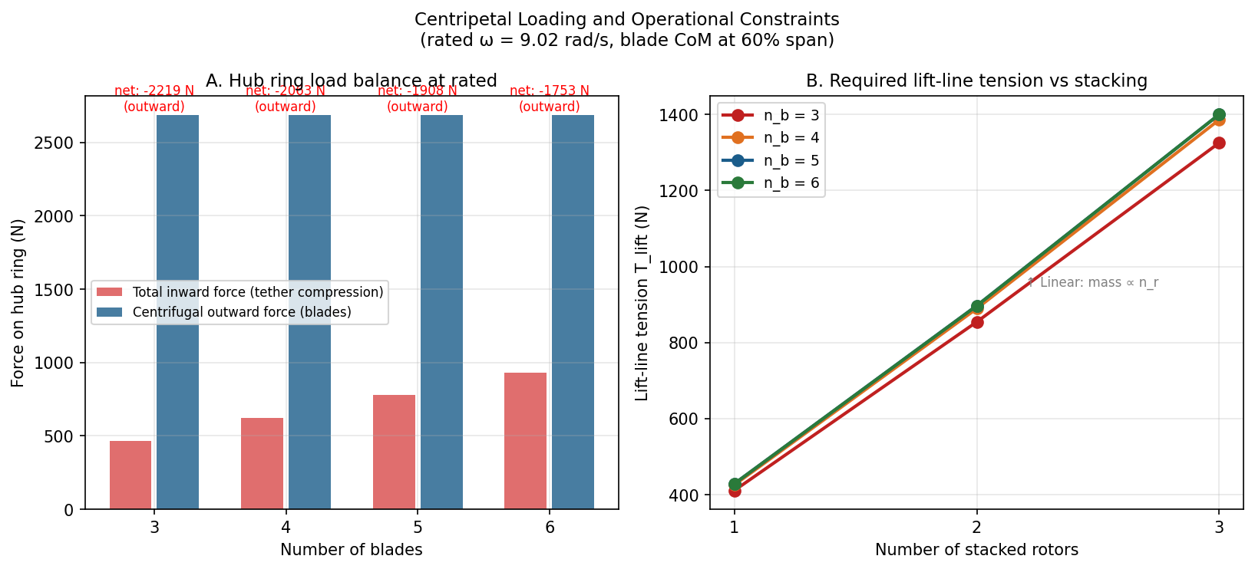
Figure 5. (A) Hub ring force balance at rated speed: centrifugal outward force (blue, constant across n_blades) vs tether inward compression (red, increasing with n_b). Net force is outward for all n_blades tested. (B) Required lift-line tension vs n_rotors for each blade count; scales approximately linearly with airborne mass.

7 Conclusions and Recommendations
The following conclusions are drawn from the sweep analysis across n_blades ∈ {3–6} and n_rotors ∈ {1–3} at R = 5 m rotor radius, β = 30° elevation, rated wind 11 m/s:
1. Fewer blades gives lighter rings. Ring frame mass is minimised at n_b = 3 (7.0 kg) and maximised near n_b = 5 (8.3 kg). The difference is small (≈ 16%) and has modest impact on overall P/W given that blade mass dominates (~54% of airborne mass for a single rotor). A move from n_b = 5 to n_b = 3 improves P/W by ≈ 14% (450 → 514 W/kg), but introduces practical concerns about torsional coupling quality and ring structural redundancy that require physical testing to confirm.
2. Stacking rotors multiplies power without wake penalty at β ≥ 22°. At the current 30° elevation, successive stacked rotors are completely outside each other's wake cones. Power scales linearly with n_r (9.2–10.3 kW per rotor added), while mass scales faster than linearly (due to ring mass escalation). This gives a P/W of 412–474 W/kg for n_r = 2 and 373–443 W/kg for n_r = 3, still better than a single rotor scaled to the same power using the empirical 1.35 mass exponent.
3. The hub ring is in net hoop tension at rated speed, not compression. Centrifugal blade loads (2685 N) exceed tether compression (~750–1000 N) for all n_blades tested. The hub ring structural check should be a tensile hoop calculation, not a column buckling check. Intermediate rings remain compression-governed as before.
4. Further investigation: rotor tip-down coning (as observed in the experiments) modifies the swept area, effective elevation angle, and centrifugal load distribution. A coned rotor has lower effective radius, reduced power, but potentially lower centrifugal hub loading. This should be modelled as a separate parametric study once the blade coning geometry is characterised experimentally.
5. Tether sizing for stacked TRPT: at n_r = 2 the bottom section tether tension (4666 N) exceeds the 3 mm Dyneema SWL (3500 N), requiring an upgrade to 3.5–4 mm line. At n_r = 3 the bottom section reaches 7000 N, requiring 4–5 mm line. Tether mass contribution remains small (< 10% of total) but tether diameter changes affect drag and rope node sizing in the simulation.

