Orderna

Members:
- Zein Eldin Ayman 16004518
- Maya Ahmed 16002577
- Nada Mohamed 16005354
- Rodaina Mohamed 16009293
- Ammar Abdullah 16009518
- Anas Salama 16003121
- Yassin Hesham 16004361
- Mohamed hassan 16004565

1.INTRODUCTION
1.1 Purpose
The purpose of GIU food truck system is a web-based application that is designed to enable the members of the GIU community to order items from food trucks on campus for pick up within a time range thus solving the problem of long waiting time for food and beverages during gaps. This system enables order placement and management for GIU
1.2 Scope
The Food Truck System is an online platform that allows university members, truck owners and admins to browse nearby food trucks, view menus, place orders. Food truck owners can manage their menu and update availability. The system supports, user accounts, and administrative control.
1.3 Audience
User: A customer/student who browses and orders from food trucks.
A food truck Owner: A food truck operator who manages the truck’s menu and orders.
Admin: The system administrator who oversees the platform, adds or delete new restaurants.

1.4 Overview
The GIU Food-Truck System is a web app that makes food ordering on campus easier. It lets students, faculty, and staff view menus, place orders This helps reduce long waiting lines during busy hours and makes the process faster and more convenient for everyone.
2.Product vision
2.1 Product Perspective
The Food Truck System is a web app. It serves as a bridge between GIU members and multiple food trucks. It will support order placement, and account management.
2.2 Product Functions
The system will provide:
- User registration and login
- Browse food trucks
- View menus and prices
- Add items to cart
- Pick up orders at specific time slots
The system won’t provide:
- No online payment
- Vendor dashboard for menu and order management
- Admin tools for monitoring and user management
- No delivery service
2.3 Operating Environment
- Web browsers
3.High-Level Architecture
1.Presentation Layer (Frontend)
  - web interface
  - Used by GIU members, vendors, and admins
  - Handles login, browsing menus, picking up orders
2. Application Layer (Backend)
  - Server-side logic and APIs
  - Manages authentication, order processing, menu updates
  - Connects the frontend to the database
3. Data Layer (Database)
  - Stores all system data, including:
    - User information
    - Food truck details
    - Menu items
    - Orders
- Data Flow:
  - Users and vendors interact with the frontend
  - Frontend sends requests to backend
  - Backend processes requests and updates or retrieves data from the database
- Benefits:
  - Scalable
  - Easy to maintain
  - Supports multiple user roles efficient
4.Functional Requirements
User story:
- As a GIU member
The member can securely log in using GIU credentials.
The member can view a list of available food trucks nearby.
The member can open a truck’s menu and see item names, prices, and availability.
The member can add items to the cart and confirm the order for pickup.
The system should schedule the order for a selected pickup time range (e.g., between classes).
The member can view the order summary and pickup details after placing the order.

- As a food truck owner,
I want to receive and manage orders through a dashboard,
so that I can prepare food efficiently and update my menu.
- As an admin,
I want to add, edit, or remove food trucks from the website,
so that only active vendors appear on the platform.

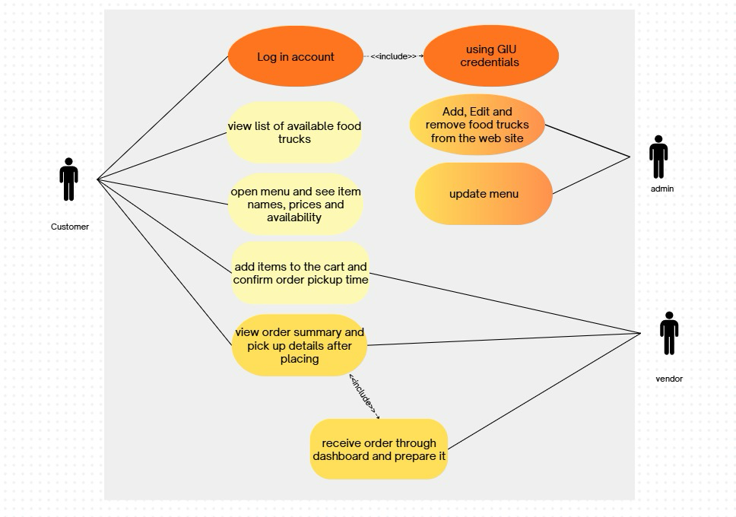
1. User Management:
- Users can register and create accounts
- Users can log in and log out.
2. Vendor Management:
- Vendors can create and manage a food truck account
- Vendors can add, edit, or remove menu items
- Vendors can update availability

3. Menu and Browsing
- Users can browse available food trucks
- Users can view menus and prices
4. Ordering System
- Users can add items to their cart and specify specific pickup time slots
- Order summary and confirmation are shown
5.Non-Functional Requirements
1. Performance:
- The system should respond in a reasonable time to user requests
- It should handle multiple users at the same time
2. Security:
- Low Security
3. Usability
- The interface should be easy to navigate
- The system should work on mobile phones
4. Availability
- System should be accessible during GIU working hours.
5. Scalability
- The system should be able to handle all GIU members who use the platform without performance issues.
6. Compatibility
- The system should work across major browsers (Chrome, Firefox, Edge, Safari) and mobile devices.

6.Interface Requirements:
1. User Interface
- Login/register screen
- Home page with food trucks and menus
- Cart and checkout access for users
- Simple, readable, and consistent design
2. Device/Platform Compatibility
- Works on mobile
7.System Constraints
- Limited Working Hours:
The system can only be used during GIU working hours
- Access Limited to GIU Members:
Only students, staff, members of the German International University (GIU) can use the system.
- Order Capacity Limitation:
The system must not allow more than 500 members to place orders at the same time.
8.Future Scope / Possible Extensions
- Real-Time Order Tracking
Enable GPS tracking to show when will it arrive to the user
- Multiple Payment Gateways
Support additional online payment methods like (Apple Pay, Vodafone Cash, etc...)
- Rating & Reviews System
Allow users to rate food trucks and leave feedback after orders.
- Multi-language Support
Add Arabic, German, or other language options.

