Assignment Description

Language: Oracle SQL
Number of Questions: 38
Duration: 3 hours

Programming Assignment

Assignment 1 – Database Creation and Querying Exercises

Objectives:

In this assignment you will create a database along with tables for which you will Write SQL queries for the instructions specified. These will include addition of constraints, modifications, deletions, insertions and updates. You will also be asked to perform Oracle SQL Joins, sub-queries, functions, triggers, views and indexes as well as packages and procedures. This will be used to assess your overall knowledge of Oracle SQL.

STRUCTURE REQUIREMENTS:

- Ensure proper syntax and naming convention for example: ensuring the table and column names are all lower case.
- Set up the primary keys for each table with constraints listed.
- Because you will not be asked to create an actual database in your environment, it is important that your answers clearly illustrate that you understand the questions being asked as well as how to properly structure your answers.

REPORTING REQUIREMENTS:
- Make sure that you list the section number for each question and title/headings as well as question numbers when submitting your answer.
- Please enter all of your answers in a Microsoft Word Doc.
SUBMISSION REQUIREMENTS:

Submissions will be in the Oracle material GitHub repository.
Activities:

Section 1-

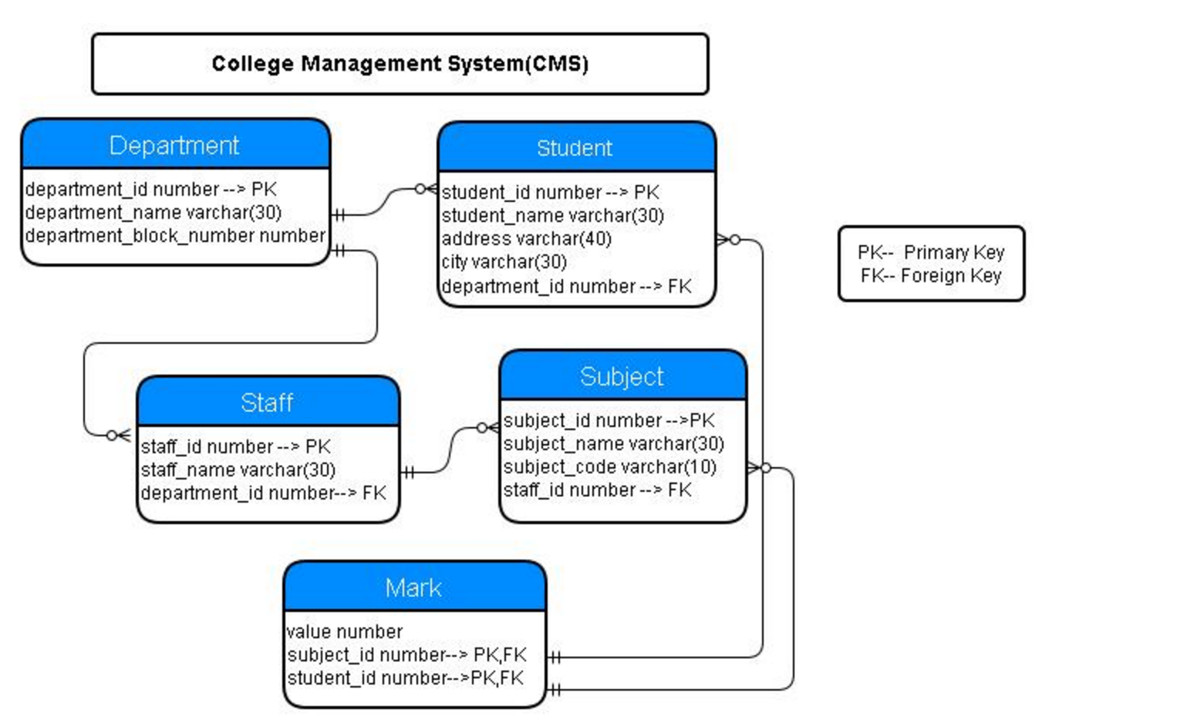

Creating Tables:

Referring to the schema above for reference and using Oracle SQL, create the tables identified below using the following order:

TABLES TO CREATE:

1-department (department_id number PK, department_name varchar(30), department_block_number number)

create table department(
department_id number primary key,department_name varchar(30),
department_block_number number);

2-student (student_id number, student_name varchar(30), address varchar (40), city varchar(30), department_id number FK)

create table student
(
student_id number,
student_name varchar(30),
address varchar (40),
city varchar(30),
department_id number,
constraint fk_department_id foreign key (department_id)
references department(department_id)
);

3-staff (staff_id number, staff_name varchar(30), department_id number FK)
create table staff(
staff_id number primary key,
staff_name varchar(30),
department_id number,
constraint fk_N_department_id foreign key (department_id)
references department (department_id)
);
4- subject (subject_id number PK, student_name varchar (30), student_code varchar(10), staff_id number FK)

create table subject(
subject_id number primary key,
subject_name varchar(30),
subject_code varchar(10),
staff_id number,
constraint fk_staff_id foreign key (staff_id)
references staff(staff_id)
);
5- mark (value number, subject_id number PK FK, student_id number PK FK)

CREATE TABLE mark
(
value_mark number,
SUBJECT_ID VARCHAR2(20 BYTE),
subject_id number,
CONSTRAINT MARK_PK PRIMARY KEY ,
constraint fk_subject_id foreign key (subject_id)
references subject(subject_id),
constraint fk_student_id foreign key (student_id)
references student(student_id)
);

6-Add a constraint by writing a query to add a not null constraint to the column staff_name in the staff table.

ALTER TABLE staff
MODIFY staff_name not NULL;

7-Add a column by writing a query named emailid of type varchar (20) to the student table.

ALTER TABLE student
ADD emailid varchar (20);

8-Modify the size of the type of field emailid on the student table by writing a query to change it to varchar(50);

alter table student modify
(
emailid varchar(50)
);

9-Remove the emailid column on the student table by writing a query.

alter student
student table drop column
(
emailid varchar(50);
);

Section 2-
Inserting Into Tables

10 - Download the following excel sheet in LMS under Documents -> Week 3 -> Oracle hands on:
- DEPARTMENT
- STAFF
- MARK
- SUBJECT
- STUDENT
11 - Insert those excel sheets to their corresponding tables

Section 3-
Updating Records

12 - Update a record by writing a query to update the subject_name in the subject table from Sales to Computer Science and subject_code from 1842 to 1919.

UPDATE subject
SET subject_name = 'Computer Science',
where subject_code = '1919';

Section 4-

Deleting Records

13 - Delete the row from the subject table where subject name is Accounting by writing the appropriate query.

DELETE FROM subject
WHERE subject_name = 'Accounting';

Section 5-

Basic Selection of Records

14 - Display the names of the department in the college by writing the appropriate query. Please note that these must be displayed in ascending order.

SELECT department_name
FROM department
ORDER BY department_name

15- Display the names of the departments where departments block number is between 3 and 10 by writing the appropriate query.

Select department_name from department
Where department_block_number between 3 and 10;

16- Display the names of all the students in the college by writing the appropriate query. Please note these must be displayed in ascending order.

SELECT student_name FROM student
ORDER BY student_name ASC;

Section 6-

Selecting Single Rows

17- Display the names of the students who are from Chicago, Taylor and San Jose. Please note these must be displayed in ascending order of their respective id.

Select student_name from student
Where
Order by student_id;

18- Writing the correct query, display the address and city of the students table give the alias as Address_Student.

Select (address + city) as address_Student from student;

19- Display all of the student’s names whose names are of 6 characters in length by writing the correct query.

Select student_name from student
Where LENGTH(student_name )=6;

Section 7-
Selecting Groups

20- Display the blocknumber and number of departments in each block by writing the correct query that is ordered by block id. Make sure it is displayed as count (department_name)

Select department_block_number ,count(department _name)
From department
Group by( department_block_number) ,order by

21- Display the number of students in the college by writing the correct query and give an alias as stud_count.

Select count (student_id) as stud_count from Student;

Section 8-

SQL Joins

22- Display the names of the department and the student count in each department by writing the correct query. The student count in each department must be in ascending order based on the department name and an alias of student_count for the student count.

select department_name,
count(stud.student_id) as student_count
from department dept inner join student stud
on dept. department_id = stud.deptid
group by dept. department_id

23- Display the Student_Name from STUDENT and the Subject_name from SUBJECT where the Subject_code from SUBJECT is greater than 1600.

SELECT student_Name FROM student
UNION
SELECT subject_name FROM subject
where subject_code>1600;

24- Display the Stundent_Name from STUDENTS and the Subject_name from SUBJECT where the value on MARK table is less than 3.

SELECT student.student_name subject.subject_name
FROM student, subject

INNER JOIN student
ON student.student_id = mark.value_mark;
INNER JOIN student subject.subject_id= mark.value_mark;
where mark.value_mark< 3;

Section 9 –

Selecting Sub-Queries

25- Display the block number in which the maximum number of departments is located by writing the correct sub-query.

select department_block_number
from (select department_block_number, count(department_block_number)
from department
group by department_block_number
order by count(department_block_number) DESC);

26- Display the names of the staff who are not handling any subjects by ascending order using the correct sub-query.

Select staff_name from Staff
Where staff_id not in (select staff_id from subject);

Section 10-

Functions

27- Write a function that takes department_id as the input and returns the department_name.
Use the function name below:

Function name: find_dept_name

create or replace function find_dept_name (department_id in number,department_name out varchar2 )

as
begin
select department_name into department_name from department
where department_id= department_id
return getDepID();
end

28- Write a function that takes department id as the input and returns the block number.
Use the function name below:

Function name: find_dept_block

create or replace function find_dept_block (department_id in number, department_block_number out varchar2 )
as
begin
select department_block_number into department_block_number from department
where department_id= department_id
return getDepID();
end

29- Write a function that takes the staff id as the input and returns the staff name.

Use the function name below:

Function name: find_staff_name

create or replace function find_staff_name (staff_id in number,staff_name out varchar2 )
as
begin
select department_block_number into department_block_number from department
where department_id= department_id

return staff_name ;
end

Section 11-

Triggers

30- Create a trigger with the name 'trigger_department_af_update' which will display “DEPARTMENTS table has been updated” after an attempt to update the DEPARTMENTS has been made.

Trigger name: trigger_department_af_update

CREATE OR REPLACE TRIGGER trigger_department_af_update
AFTER UPDATE
ON department
FOR EACH ROW

DECLARE
DBMS_OUT.PUT_LINE(' department table has being updated');
BEGIN

31- Create a trigger with the name ‘trigger_department_bf_delete’ which will display “A row has been deleted from DEPARTMENT” before an attempt to delete a row is execute on DEPARTMENT.

Trigger name : trigger_department_bf_delete

CREATE OR REPLACE TRIGGER trigger_department_bf_delete
before DELETE
ON department
FOR EACH ROW

DECLARE
DBMS_OUTPUT.PUT_LINE('A row has been deleted from department');
BEGIN

Section 12-

Views and Index

32- Create an Index command that will reference all of the students names containing the letter ‘b’ on the Student table.

create index on_student on student(student_name)
where student_name like '%b%';

33- Create a view from the staff table that will display staff names.

CREATE VIEW staff_name AS
SELECT staff_name
FROM staff

Section 13-
Cursors

36- Declare an explicit cursor using the STUDENT table to select of column. Fetch the rows using a loop and display each data retrieved.

CREATE OR REPLACE PROCEDURE STUDENT
IS
CURSOR stucur IS SELECT * FROM student;
myvar stucur%ROWTYPE;
BEGIN
OPEN stucur;
LOOP
FETCH stucur INTO myvar;
EXIT WHEN stucur%NOTFOUND;
DBMS_OUTPUT.PUT_LINE(myvar .student_id||
Myvar.Student_name || myvar.address|| myvar.city || myvar.department_id);
END LOOP;
CLOSE stucur;
END;

Section 14-

PACKAGES AND PROCEDURES

37 - Define a package give it the name of College. The definition should include a procedure give it the name of select_departments. It should also include a function that takes a argument of type number and returns a variable of type VARCHAR, give it the name of select_student.

CREATE PACKAGE College AS

Create or Replace PROCEDURE as select_department ()

create or replace function select_student (student_id in number,student_name out varchar2 )
return varchar

END College;
38 - Implement the body of College department. the select_departments procedure should display all column from DEPARTMENT. The select_student function should take the id of the student and return that student name.

CREATE PACKAGE body College AS

Create or Replace PROCEDURE as select_departments ()
Begin
CURSOR stucur IS SELECT * FROM department;
myvar stucur%ROWTYPE;
BEGIN
OPEN stucur;
LOOP
FETCH stucur INTO myvar;
EXIT WHEN stucur%NOTFOUND;
DBMS_OUTPUT.PUT_LINE(myvar.department_id || myvar. Department_name || myvar. Department_block_number);
END LOOP;
CLOSE stucur;
END;

create or replace function select_student (st_id in number,student_name out varchar2 )
as
begin

select student_name into student_name from student
where student .student_id= st_id;
return student_name ;
end;

END College;

