Unique selling proposition statement:

All contact information clearly shown above the fold

29 Lee Ave , Jindabyne NSW 2627 (google map link)
PH 02 64562170 (call us button)
SMS 0440 130 302 (text us button)
hello@snowcountryauto.com.au
https://www.facebook.com/snowcountryautos/
(creating instagram account, TBA)

Similar look:
https://www.wix.com/website-template/view/html/wh-1123?originUrl=https%3A%2F%2Fwww.wix.com%2Fwebsite%2Ftemplates%3Fcriteria%3Dmechanic&tpClick=view_button&esi=64488ce2-2af5-4fae-ad2d-7e23c782c47a

Corporate Colors:
#2d4664,#2596be, #abdbea

Fonts:
Century Gothic
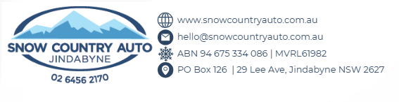

Separate pages for each section as there is a lot of content

Podium Pop up (see podium)
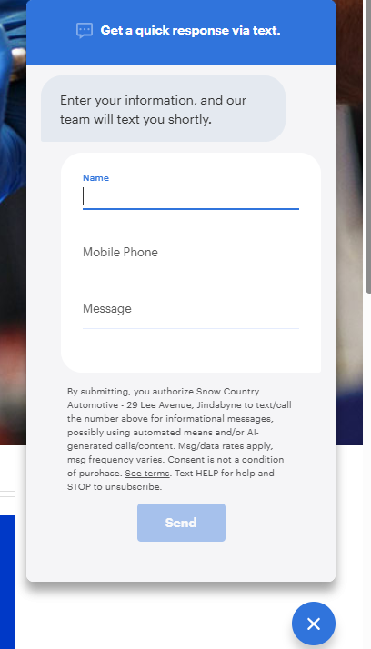

About us:
Snow Country Auto
Diesel Mechanic & 4WD Specialist in Jindabyne, Snowy Mountains
At Snow Country Auto, we provide reliable, professional automotive servicing and repairs for locals and visitors across Jindabyne and the Snowy Mountains region.
Our workshop specialises in diesel vehicles, four-wheel drives, diagnostics, and performance tuning, while still offering full servicing and repairs for all makes and models. Whether you need routine maintenance, complex diagnostics, or a full 4WD upgrade, our experienced team delivers practical solutions that keep vehicles running safely and reliably in alpine conditions.
Located in Jindabyne, Snow Country Auto has built a strong reputation as a trusted local mechanic in the Snowy Mountains, providing honest advice, quality workmanship, and friendly service.
Service with Altitude is more than a tagline — it’s how we approach every vehicle that comes through our workshop.

Why Choose Snow Country Auto
When you're searching for a mechanic in Jindabyne you want someone you can trust. At Snow Country Auto, we focus on clear communication, strong technical expertise, and reliable results.

Experienced Diesel Mechanics
Our workshop is led by qualified diesel mechanics with extensive experience in diagnostics, repairs, and performance upgrades for modern diesel engines.

4WD & Touring Vehicle Specialists
The Snowy Mountains demand a lot from vehicles. We help prepare vehicles for touring, towing, off-road travel, and alpine driving conditions.

Dyno Tuning & ECU Remapping
Snow Country Auto offers professional diesel ECU tuning with in-house dyno testing, allowing us to measure vehicle performance before and after tuning for improved power, towing performance and fuel efficiency.

Local Workshop You Can Trust
We’re proud to be a locally owned automotive workshop in Jindabyne, trusted by both local residents and visitors travelling through the Snowy Mountains.

Honest Advice & Transparent Pricing
Our team believes in straightforward, honest mechanical advice. We explain what your vehicle needs, why it matters, and what the work will cost before we begin.

Diesel & 4WD Specialists in the Snowy Mountains
Snow Country Auto is recognised across the region as a diesel and 4WD specialist workshop in Jindabyne.
We regularly work on vehicles used for:
- Heavy towing and caravanning
- Snow and alpine driving conditions
- Long-distance touring
- Work vehicles and diesel utes
- Off-road and recreational four-wheel driving
Our workshop provides a full range of mechanical services in Jindabyne, including:
- Logbook servicing
- Diesel diagnostics and repairs
- 4WD suspension upgrades
- Diesel ECU tuning and dyno testing
- Tyres and wheel upgrades
- Brake, steering and suspension repairs
- Vehicle inspections and pink slips
- General mechanical repairs and maintenance
Our focus is always on reliable repairs and upgrades that improve real-world performance.

A Local Jindabyne Workshop Serving the Snowy Mountains
Operating a mechanical workshop in the Snowy Mountains means understanding the unique challenges local vehicles face.
Cold winters, steep mountain roads, heavy towing loads and long distances all place additional strain on vehicles.
Snow Country Auto works with:
- Local residents in Jindabyne and surrounding areas
- Visitors travelling through the Snowy Mountains
- Touring and 4WD enthusiasts exploring the region
- Local businesses and work vehicles that rely on dependable transport
During the busy winter snow season, we often assist travellers experiencing mechanical problems while visiting the region. Throughout the rest of the year we focus on helping local customers keep their vehicles maintained and ready for changing alpine conditions.

Built on Reputation, Trust and Community
Snow Country Auto has grown through word of mouth, repeat customers and strong local relationships.
Customers choose our workshop because they know they will receive:
✔ Honest mechanical advice
✔ Reliable diagnostics and repairs
✔ Friendly and professional service
✔ Clear communication throughout the job
✔ Work carried out by experienced diesel mechanics
We’re proud to support our local community and contribute to events and organisations across the Snowy Mountains region.

Your Local Mechanic in Jindabyne
If you’re looking for a reliable mechanic in Jindabyne or the Snowy Mountains, Snow Country Auto is here to help.
From routine servicing to complex diagnostics and 4WD upgrades, our experienced team is ready to keep your vehicle performing at its best.
Snow Country Auto — Service with Altitude.

