# Environmental Sustainability Analysis Using the YALE-EPI Dataset and Composite indicator creation

Author: Rodions Barannikovs

1. Introduction

This project aimed at analyzing the environmental sustainability performance of countries using the Yale Environmental Performance Index (YALE-EPI) dataset. The dataset provides yearly environmental indicators from 2013 to 2022, covering aspects like air quality, biodiversity, and climate impact. My goal was to preprocess the data, explore relationships between indicators, reduce dimensionality, cluster countries based on environmental performance, and construct a composite indicator to rank countries by sustainability.

## Data Loading and Preprocessing

### 2.1

### Data Cleaning

To prepare the YALE-EPI dataset (YALE-EPI.xlsx) for analysis, I calculated 10-year averages (2013–2022) for 13 key indicators, including PM2.5 exposure and greenhouse gas emissions. Missing values were addressed using linear interpolation, and any remaining gaps or zero values were filled with medians to ensure completeness.

The original dataset had several structural issues. Indicators were arranged as rows instead of columns, with multiple years spread across columns, making it unsuitable for multivariate or cluster analysis. It also included missing values, inconsistent units, and extra metadata (e.g., Attribute fields, Partner) that weren’t relevant for the project.

To clean and restructure the dataset, I removed unnecessary columns like Economy ISO3 and Attributes 1–3, pivoted the table so each row represents a country and each column an indicator, and dropped precomputed aggregate indices and redundant variables to reduce multicollinearity. This transformation produced a manageable, normalized structure, ready for normalization, index creation, and visualization.

### Selection of Variables

Out of the original 53 variables, I retained 13 after evaluating their relevance and uniqueness. Aggregate indices were dropped because they summarize underlying components and would distort PCA or clustering by introducing overlapping information. Air quality variables were streamlined by keeping PM2.5 Exposure, SO2 Exposure, Household Solid Fuels, and Ozone Exposure—dropping those with overlapping effects like NOx and CO Exposure. For climate, I kept CO2 and Methane Emissions Growth Rates and GHG Emissions per Capita, discarding less relevant or redundant metrics.

In the water and waste category, I retained Unsafe Drinking Water, Unsafe Sanitation, Ocean Plastics, and Recycling. Wastewater Treatment and Controlled Solid Waste were excluded due to conceptual overlap. For biodiversity and ecosystems, I selected the Biodiversity Habitat Index, Terrestrial Biome Protection (Global Weights), and Tree Cover Loss, dropping others due to redundancy or narrow focus. Fisheries and agriculture-related variables were dropped due to limited relevance and data sparsity. Lead Exposure was the only heavy metals indicator and was retained for its health significance.

This resulted in a dataset of 13 variables covering environmental health, pollution, ecosystems, waste, and climate—suitable for building a composite indicator and conducting further multivariate analysis.

**Final Selected Variables**

1. **PM2.5 Exposure**: Key air quality metric, high health impact, widely measured.
2. **SO2 Exposure**: Complements PM2.5, captures industrial pollution.
3. **Household Solid Fuels**: Unique indoor air pollution focus, health-relevant.
4. **Ozone Exposure**: Captures photochemical pollution, enhances urban air quality insights.
5. **Unsafe Drinking Water**: Critical for health, globally comparable.
6. **Unsafe Sanitation**: Essential health metric, complements drinking water.
7. **Lead Exposure**: Specific heavy metal pollution, health-relevant.
8. **Biodiversity Habitat Index**: Broad measure of habitat quality.
9. **Terrestrial Biome Protection (Global Weights)**: Represents land-based conservation.
10. **Tree Cover Loss**: Major indicator of deforestation, climate/biodiversity link.
11. **Ocean Plastics**: Emerging waste issue, policy-relevant.
12. **Recycling**: Reflects waste management and circular economy efforts.
13. **Greenhouse Gas Emissions per Capita**: Absolute emissions, key for country comparisons.

## Correlation Analysis

I created a correlation matrix to explore relationships between indicators. This helped identify multicollinearity, which could affect PCA.

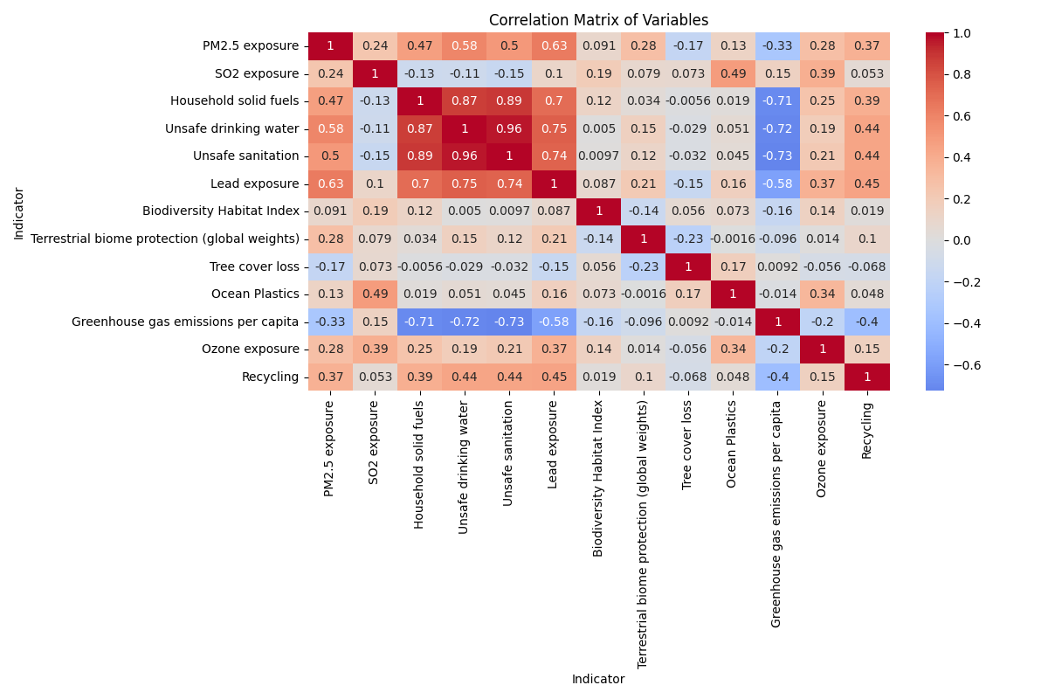

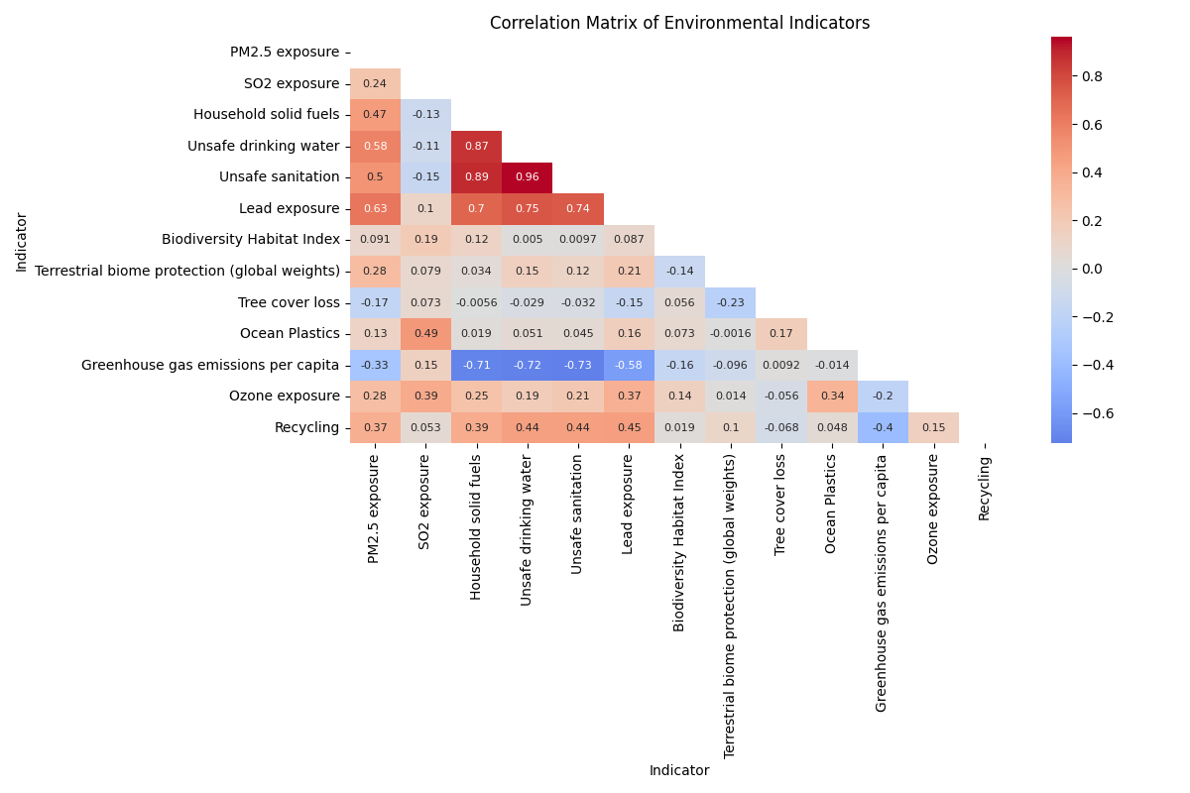

The heatmap shows strong positive correlations, like between Unsafe drinking water and Unsafe sanitation (0.96), suggesting countries with poor drinking water quality often have sanitation issues too. Negative correlations, such as Greenhouse gas emissions per capita with Household solid fuels (-0.71), indicate that higher emissions might be linked to lower use of solid fuels, possibly due to industrial activity. The correlations like Tree cover loss with Biodiversity Habitat Index (0.06), show some indicators are less connected.

### Correlation Significance

**Strong Positive Correlations**:

Unsafe drinking water vs. Unsafe sanitation (r = 0.961, p = 3.89e-118)

Extremely high correlation, indicating redundancy.

* Household solid fuels vs. Unsafe drinking water (r = 0.868, p = 3.63e-65) and Unsafe sanitation (r = 0.885, p = 5.03e-71): Strong links to health-related indicators.
* PM2.5 exposure vs. Lead exposure (r = 0.633, p = 6.36e-25)

Unsafe drinking water (r = 0.583, p = 1.61e-20), and Unsafe sanitation (r = 0.503, p = 7.53e-15): Indicates air and health pollution connections

**Moderate Positive Correlations**:

* SO2 exposure vs. Ocean Plastics (r = 0.486, p = 7.66e-14) and Ozone exposure (r = 0.390, p = 5.01e-09)

Suggests pollution interlinkages.

* Recycling vs. PM2.5 exposure (r = 0.370, p = 3.18e-08) and Household solid fuels (r = 0.386, p = 6.96e-09): Weak but significant waste management ties.

**Strong Negative Correlations**:

* Greenhouse gas emissions per capita vs. Household solid fuels (r = -0.706, p = 5.37e-33), Unsafe drinking water (r = -0.717, p = 2.19e-34), and Unsafe sanitation (r = -0.727, p = 7.95e-36): Suggests higher emissions correlate with better health infrastructure.
* Recycling vs. Greenhouse gas emissions per capita (r = -0.400, p = 1.74e-09): Indicates recycling reduces emissions.

Based on significant relationships (p < 0.05), I identified strong correlations, such as Unsafe drinking water and Unsafe sanitation (r = 0.961), indicating redundancy, and negative ties like Greenhouse gas emissions per capita with Household solid fuels (r = -0.706), suggesting trade-offs between emissions and health infrastructure. I selected 13 indicators

**PM2.5 exposure, SO2 exposure, Household solid fuels, Lead exposure, Biodiversity Habitat Index, Terrestrial biome protection, Tree cover loss, Ocean Plastics, Greenhouse gas emissions, Ozone exposure, and Recycling, Unsafe drinking water, Unsafe sanitation**

To represent diverse environmental aspects (health, ecosystems, waste, climate) while avoiding multicollinearity. Initially, I considered excluding "Unsafe drinking water" and "Unsafe sanitation" due to their high correlation to reduce redundancy and ensure PCA captures unique variance. However, I retained these variables in the final analysis to fully represent critical health-related environmental factors, allowing that PCA can handle correlated variables by combining their variance into principal components.

Below I show examples of plots that best illustrate key correlation findings and support PCA variable selection

### PM2.5 exposure vs Unsafe drinking water (r = 0.583, p = 1.61e-20)

scatter plot PM2.5 vs unsafe drinking water


The scatter plot above shows a strong positive correlation between air quality and health, supporting the inclusion of PM2.5 exposure in PCA. The high r-value and p-value indicate a reliable relationship

**Household solid fuels vs Unsafe sanitation (r = 0.885, p = 5.03e-71)**

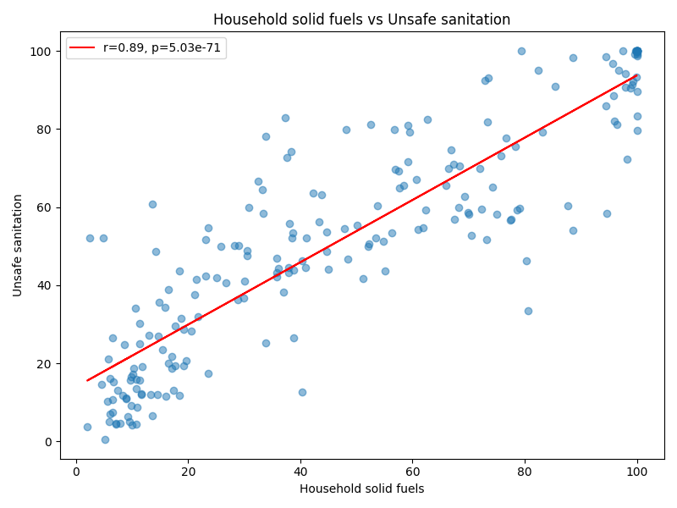

This shows a very strong correlation within health indicators, this plot also supports why I retained Household solid fuels but excluded Unsafe sanitation due to redundancy with Unsafe drinking water (r = 0.961)

### Greenhouse gas emissions per capita vs Household solid fuels

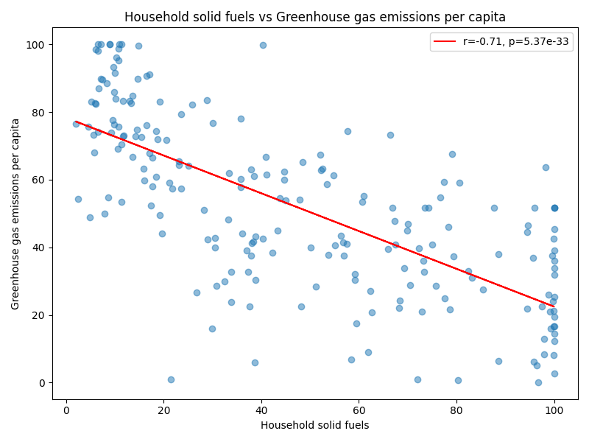

Greenhouse gas emissions per capita vs Household solid fuels Illustrated a strong negative correlation between climate and health indicators, suggesting countries with lower emissions may rely more on solid fuels.

### Ocean Plastics vs SO2 exposure (r = 0.486, p = 7.66e-14):

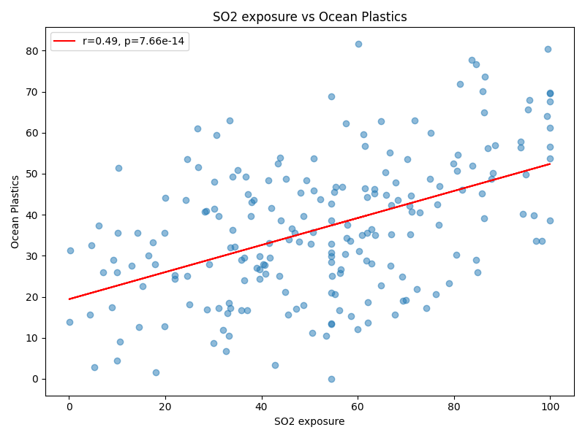

Ocean Plastics vs SO2 exposure represents a moderate positive correlation between waste and air pollution,

## Principal Component Analysis (PCA)

I applied PCA to reduce the dimensionality of the dataset while retaining most of its variance. I standardized the data using StandardScaler to ensure equal contribution from all indicators. PCA helped identify the most influential indicators and facilitated clustering by reducing noise. I plotted the explained variance

ratio and the first two principal components to visualize country distributions.

### Explained Variance (Individual and Cumulative)

|  |  |  |
| --- | --- | --- |
| PC | Individual | Cumulative |
| 1 | 0.375654762 | 0.375654762 |
| 2 | 0.150770897 | 0.526425659 |
| 3 | 0.107584083 | 0.634009741 |
| 4 | 0.076441413 | 0.710451154 |
| 5 | 0.060714003 | 0.771165157 |
| 6 | 0.057265637 | 0.828430794 |
| 7 | 0.045850869 | 0.874281662 |
| 8 | 0.042772742 | 0.917054405 |
| 9 | 0.028269299 | 0.945323704 |
| 10 | 0.022681225 | 0.968004929 |
| 11 | 0.019761339 | 0.987766268 |
| 12 | 0.009791819 | 0.997558086 |
| 13 | 0.002441914 | 1 |

The table shows that the first principal component (PC1) explains 37.57% of the variance, and PC2 adds 15.08%, totaling 52.64% for the first two components. By PC11 98.78% cumulative variance is reached meaning nearly all variability is captured. This is visualized better in the chart below.

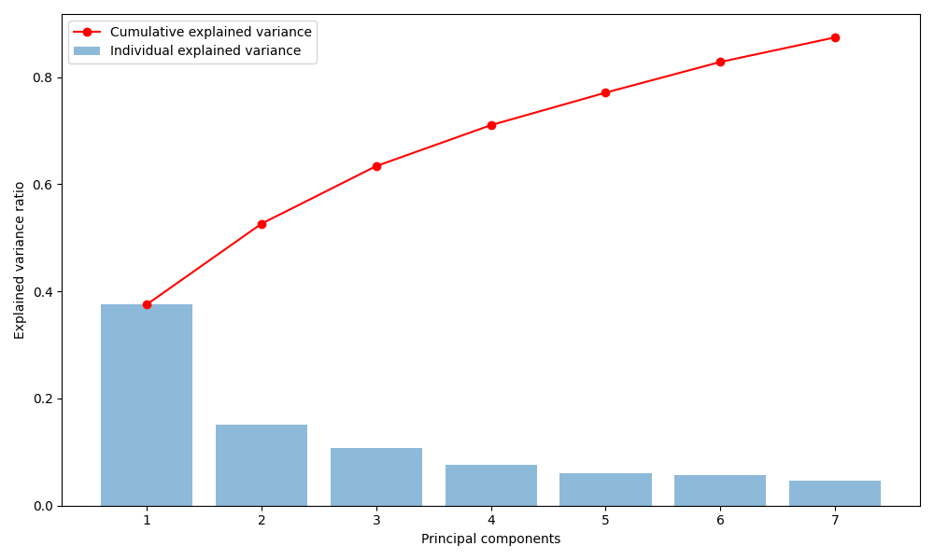

## Feature Importance

Main drivers of variance included unsafe drinking water (0.423) and unsafe sanitation (0.419),

while SO2 exposure (0.006) has little influence

|  |  |
| --- | --- |
| Feature | Importance |
| Unsafe drinking water | 0.422871 |
| Unsafe sanitation | 0.418707 |
| Household solid fuels | 0.401067 |
| Lead exposure | 0.392178 |
| Greenhouse gas emissions per capita | 0.353675 |
| PM2.5 exposure | 0.309275 |
| Recycling | 0.258087 |
| Ozone exposure | 0.165061 |
| Terrestrial biome protection (global weights) | 0.09326 |
| Ocean Plastics | 0.057795 |
| Biodiversity Habitat Index | 0.049089 |
| Tree cover loss | 0.046169 |
| SO2 exposure | 0.005963 |

## Country Scores (PC1 and PC2)

Stored in /results/pca_components

The PCA results show clear patterns in environmental performance across countries based on their PC1 and PC2 scores. Countries like Iceland (PC1: 5.337, PC2: 1.664) and Finland (PC1: 5.013, PC2: 1.052) have high PC1 values, indicating strong performance in key areas such as access to clean water and public health, which are the main drivers of PC1. On the other hand, countries like Yemen (PC1: -3.655, PC2: -0.982) and Lesotho (PC1: -3.635, PC2: -1.491) show low PC1 scores, pointing to serious gaps in these basic services.

PC2 captures different dimensions, highlighting variation in areas like biodiversity and waste management. The Marshall Islands (PC2: 3.506) and Palau (PC2: 3.235) score high here, while the UAE (-2.818) and Iran (-2.558) rank lower, suggesting weaker performance in these secondary factors. Together, PC1 and PC2 account for 52.64% of the total variance, offering a useful snapshot of environmental differences between countries.

Although “unsafe drinking water” and “unsafe sanitation” are highly correlated (r = 0.961), both were included to ensure that PC1 fully reflected public health differences — clearly shown by the strong contrast between countries like Iceland and Yemen.

## 

I’ve explored the first two principal components visually but found the scatter plots less informative due to data complexity

## Clustering Analysis

I performed three clustering methods to group countries by environmental performance:

• Hierarchical Clustering: I used single, complete, and average linkage methods to create dendrograms, revealing hierarchical relationships.

• K-means Clustering: I used the elbow method to select an optimal number of clusters (set to 3) and visualized cluster assignments.

• DBSCAN: I applied density-based clustering to identify outliers and dense

clusters, using default parameters (eps=0.5, min_samples=5).

For the clustering analysis I’ve used K-means and hierarchical clustering on the first 7 principal components (PCs), which together explain 87.43% of the variation in the environmental sustainability data. The first two PCs alone account for 52.64%, and the first three cover 63.40%.

The results are shown in the scatter plots where PC1 (37.57%) and PC2 (15.08%) are plotted and colored by cluster labels. Both methods found 3 main clusters, based on the elbow method and dendrogram.

From the PCA loadings (pca_loadings.csv), PC1 is mainly about environmental health. It’s most influenced by unsafe drinking water, sanitation, household fuels, lead, and PM2.5, with a strong negative weight from greenhouse gas emissions. So, countries with high PC1 values generally struggle with pollution and health, while those with low values tend to do better, though sometimes with higher emissions due to industrialization. PC2 picks up issues related to industrial pollution like SO2, ocean plastics, and ozone—with some influence from biodiversity. A chart of multiple colored dots

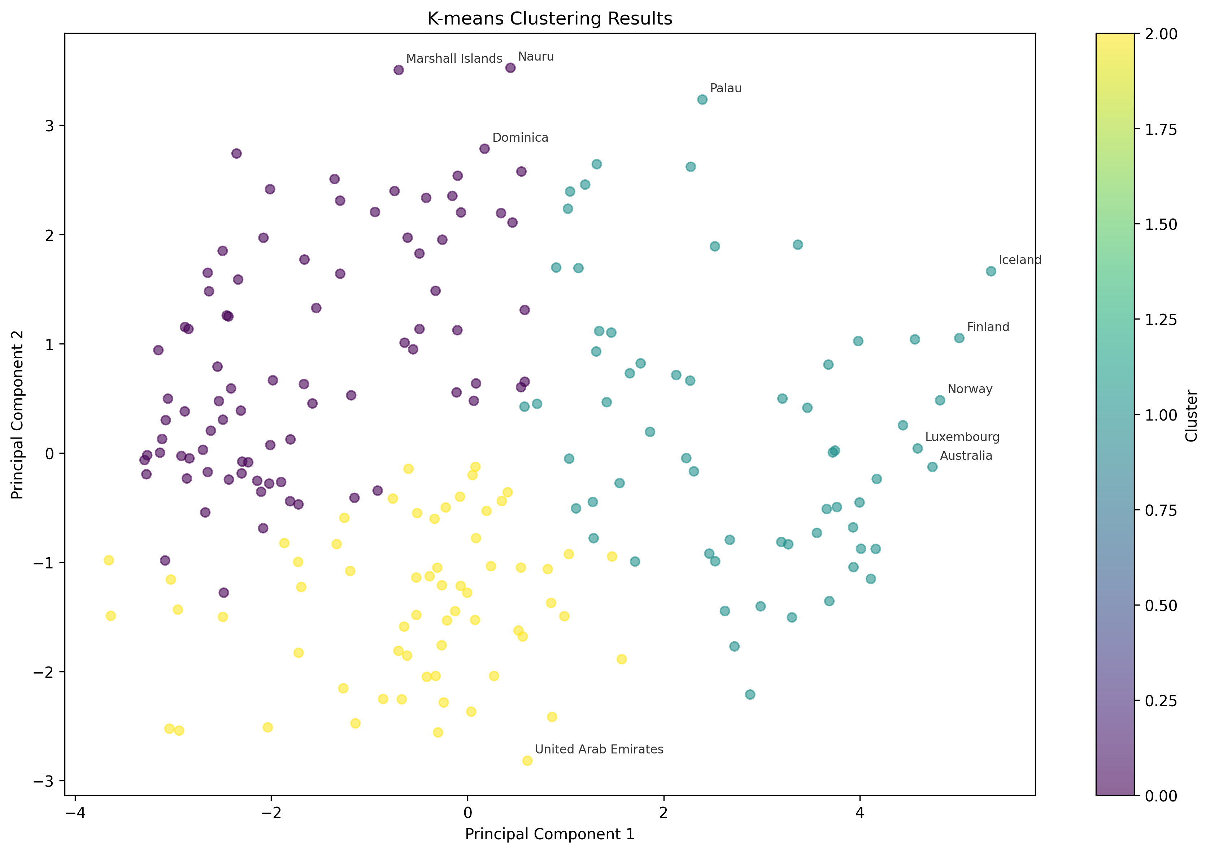

K-means and hierarchical clustering produced similar groupings, suggesting the clusters are stable. Cluster 0 includes countries with strong environmental health but higher emissions—such as Samoa (PC1: 0.918) and South Korea (0.742). Cluster 1 includes countries with weaker health outcomes but generally lower emissions, like Benin (0.745), Sweden (0.675), and Singapore (0.534). Cluster 2 represents a middle ground, with countries showing more balanced performance across indicators—examples include Iceland (0.878), Greenland (0.813), and Germany (0.632).

The scatter plots show that PC1 effectively separates countries based on environmental health, while PC2 captures differences related to industrial or emissions-related impacts. Countries with strong overall performance appear across different clusters—like Samoa in Cluster 0 and Iceland in Cluster 2—indicating that good sustainability outcomes can result from different strengths.

In short, three main profiles emerge: Cluster 0 with good health but higher emissions, Cluster 1 with health challenges and lower emissions, and Cluster 2 with balanced outcomes. These patterns, supported by the PCA and visualizations, offer a basis for targeted strategies—such as focusing on emissions reduction in Cluster 0 or improving health infrastructure in Cluster 1.

Average linkage Dendrogram

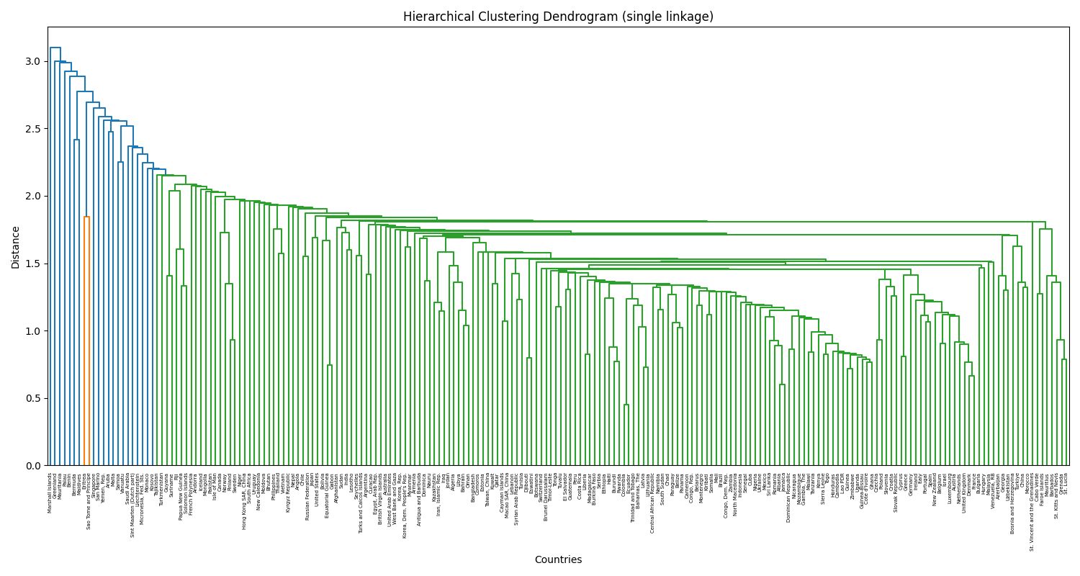

Single Linkage Dendrogram

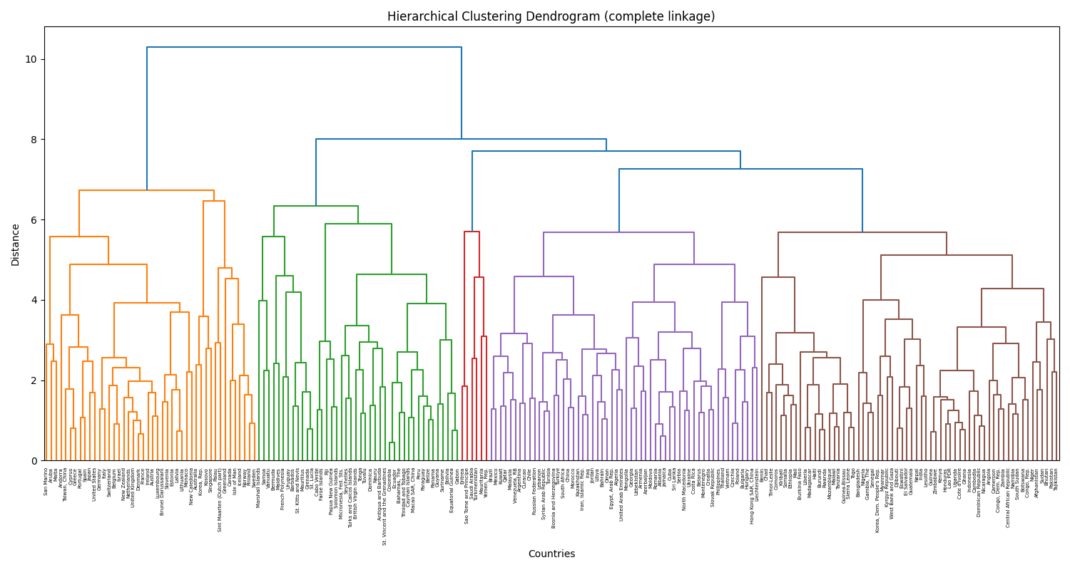

Complete Linkage Dendrogram

# 

DBSCAN was also tested, with results saved in dbscan_clusters.csv and shown above. But it didn’t work well here. Out of 210 countries, 165 were marked as noise (Cluster -1), meaning DBSCAN couldn’t group them. Only a few small clusters were formed: Cluster 0 (Albania, Jamaica, etc.), Cluster 1 (Burundi, Haiti, Rwanda), Cluster 2 (mostly African countries), Cluster 3 (some Western European countries), and Cluster 4 (a few Caribbean nations).

The poor results are mainly due to how DBSCAN works—it depends a lot on its parameters (eps=1.0, min_samples=3) and doesn't perform well in high-dimensional, standardized spaces like this one after PCA. The 7 principal components make space dense, and DBSCAN couldn’t find enough dense areas to form solid clusters, so most countries were marked as noise.

In the scatter plot, most points appear as the same color (noise), with just a few small groups, making it hard to get useful insights. Because of this, DBSCAN wasn’t helpful and was dropped from the analysis.

# Findings

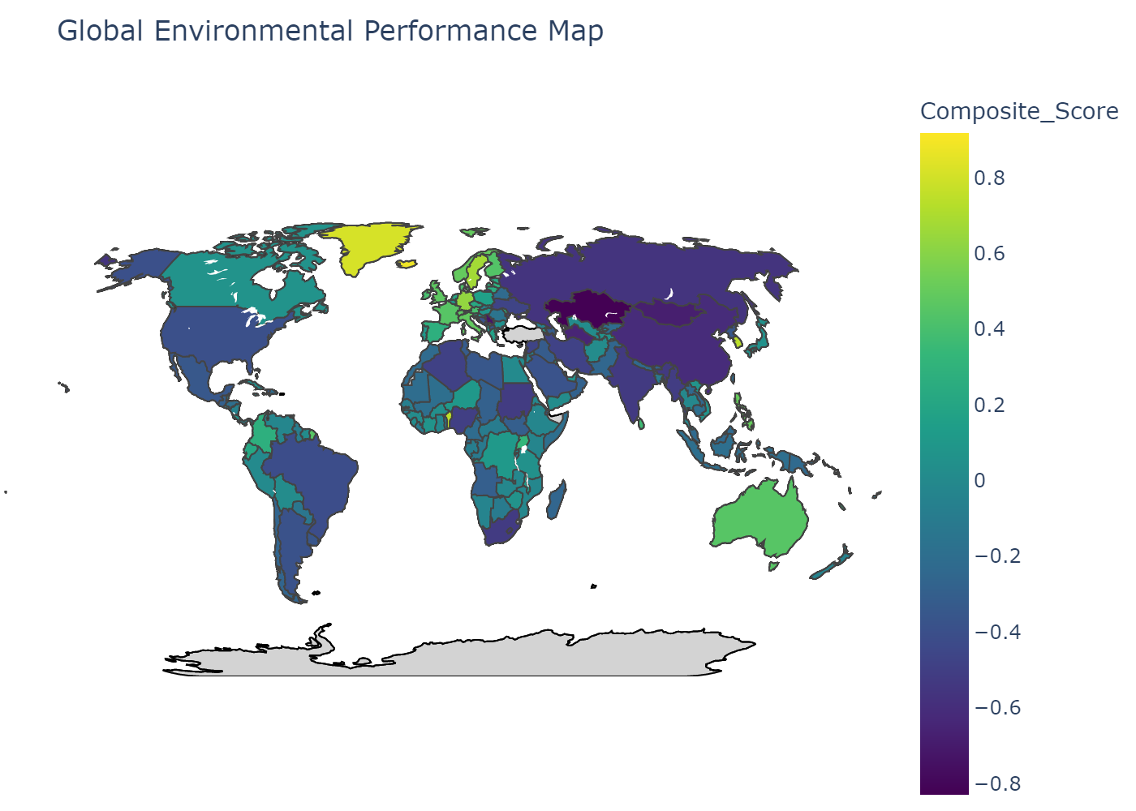

Global map displaying environmental performance scores by country. Colors indicate performance levels, with brighter shades showing higher scores of the index.

I constructed a composite environmental sustainability indicator by combining sub-indices (Health, Ecosystems, Waste, Climate) weighted by PCA feature importance. I normalized the weights and calculated sub-index scores, then averaged them to obtain a final score per country. I visualized the score distribution and created a world map to show global sustainability patterns.

The resulting composite scores reveal important variation in environmental sustainability across countries, with top countries like Samoa and Iceland demonstrating balanced strengths across multiple sub-indices, while lower-ranked countries such as Kazakhstan and Serbia face challenges in waste management and climate performance. Below, I elaborate on each sub-index and the insights obtained from the results.

Samoa ranked highest (0.918), mainly due to excellent waste management (2.815) and solid climate performance (0.574), even though its health score was reasonable. Iceland followed (0.878), with strong health (1.829) and waste (2.502) scores, but had a low climate score (-1.458) due to emissions. Greenland (0.813) stood out for ecosystem protection (1.504). Benin (0.745) and South Korea (0.742) showed strong performance in waste and climate. Liechtenstein (0.680) and Germany (0.632) had balanced scores in health and waste. Sweden (0.675) performed well in health (1.832), while Sao Tome and Principe (0.596) excelled in ecosystems and climate. Singapore (0.534) had solid scores in health and waste. Each country showed strengths in specific areas, though some still faced environmental challenges.

### Top 10 countries with the best environmental performance overall

|  |  |  |  |  |  |  |
| --- | --- | --- | --- | --- | --- | --- |
| Country | Composite Score | Health | Ecosystems | Waste | Climate | Rank |
| Samoa | 0.918456 | -0.04846 | 0.333163 | 2.814893 | 0.57423 | 1 |
| Iceland | 0.877561 | 1.82905 | 0.637308 | 2.501817 | -1.45793 | 2 |
| Greenland | 0.813386 | 0.738719 | 1.504235 | 1.16951 | -0.15892 | 3 |
| Benin | 0.744819 | -1.01672 | 0.176964 | 2.389373 | 1.429663 | 4 |
| Korea, Rep. | 0.741812 | 1.246104 | 0.162321 | 2.936907 | -1.37808 | 5 |
| Liechtenstein | 0.679505 | 0.298487 | 0.395588 | 2.222498 | -0.19855 | 6 |
| Sweden | 0.674621 | 1.831763 | 0.022581 | 1.348203 | -0.50406 | 7 |
| Germany | 0.631879 | 1.481778 | 0.217606 | 1.867306 | -1.03918 | 8 |
| Sao Tome and Principe | 0.596414 | -0.63415 | 1.287264 | -0.12971 | 1.86225 | 9 |
| Singapore | 0.53373 | 1.339219 | -0.10753 | 2.046292 | -1.14307 | 10 |

**Top 10 countries with the worst environmental performance overall**

|  |  |  |  |  |  |  |
| --- | --- | --- | --- | --- | --- | --- |
| Country | Composite Score | Health | Ecosystems | Waste | Climate | Rank |
| Sudan | -0.5185 | -1.23551 | -0.57645 | -0.8309 | 0.568852 | 201 |
| South Africa | -0.52089 | -0.61338 | -0.68236 | 0.305346 | -1.09319 | 202 |
| India | -0.52841 | -1.15152 | -1.38866 | -0.19491 | 0.621459 | 203 |
| Lesotho | -0.56002 | -1.37213 | -1.11278 | -0.60901 | 0.853828 | 204 |
| Russian Federation | -0.56707 | 0.337543 | 0.255426 | -1.18935 | -1.67191 | 205 |
| China | -0.61292 | -0.37317 | -1.06083 | -0.10968 | -0.90801 | 206 |
| Turkmenistan | -0.65024 | -0.16508 | -0.21245 | -0.23188 | -1.99156 | 207 |
| Mongolia | -0.68217 | -0.67603 | 0.213393 | -0.27869 | -1.98735 | 208 |
| Serbia | -0.72464 | 0.042192 | -0.62245 | -1.17045 | -1.14786 | 209 |
| Kazakhstan | -0.82967 | -0.22795 | 0.008404 | -1.30352 | -1.79563 | 210 |

## Sub Indexes

**Health Sub-Index**  
This measured factors like PM2.5, SO2, solid fuel use, unsafe water and sanitation, lead, and ozone exposure. High scores meant better public health and lower pollution. Finland (1.929) and Sweden (1.832) scored high due to strict air quality rules and strong health systems. Lesotho (-1.372) and Sudan (-1.236) scored low, likely due to poor access to clean water and high pollution levels. The gap showed how vital environmental health was for sustainability.

**Ecosystems Sub-Index**  
This measured biodiversity, biome protection, and tree cover loss. High scores suggested good conservation. Greenland (1.504) and Sao Tome and Principe (1.287) performed well due to low deforestation and protected habitats. India (-1.389) and Lesotho (-1.113) scored poorly, struggling with habitat loss and weak policies. Results showed that protecting ecosystems needed stronger support, especially in lower-income countries

**Waste Sub-Index**

The Waste sub-index focused on waste management practices, specifically ocean plastics and recycling rates. Countries with high scores demonstrate effective waste reduction and recycling systems. South Korea (Waste score: 2.937) and Samoa (2.815) top this category, reflecting advanced recycling infrastructure and policies to curb plastic pollution. On the other hand, nations like Kazakhstan (-1.304) and Serbia (-1.170) rank poorly, indicating inadequate waste management systems and high plastic pollution. Low-performing countries could benefit from adopting models like South Korea’s comprehensive recycling programs.

**Climate Sub-Index**  
The Climate sub-index looked at greenhouse gas emissions per person—higher scores meant lower emissions and better climate performance. Malawi (1.873) and Afghanistan (1.873) ranked high because of low emissions, mostly due to limited industrial activity. On the other hand, Turkmenistan (-1.992) and Mongolia (-1.987) ranked low because of high fossil fuel use. The data showed a tricky balance: poorer countries often had low emissions but still faced issues in areas like health or waste. Countries with high emissions need to focus more on renewables and cutting carbon to boost their scores and meet climate targets.

## Epilogue

This analysis of the YALE-EPI dataset provides a clear framework for understanding global environmental sustainability, revealing distinct patterns through PCA, clustering, and a composite indicator. By focusing on key variables, the analysis highlighted the health disparities and captured a wide range of environmental challenges. Countries like Samoa and Iceland stand out as leaders, while nations like Kazakhstan and Lesotho reveal areas needing attention. These findings can help promote actions, such as recycling in high-emission countries or improving health outcomes in low-scoring regions. Overall, this report shows how data can support progress toward sustainability goals.