**Code Commit:**

1. **Repositories:** Create new repository

(i)Repository name (ii)Description Optional (iii)Tags Optional

Enable Amazon Code Guru Reviewer for Java and Python*– optional Create*

There we can see HTTPS, SSH, HTTPS(GRC) --- > If SSH not enable then that could be a reason of not connecting through IAM user u connected through root account.

1. **Code:** U can see Create file/Upload file --- > then author name, email address & commit message then click on commit changes. [Default branch: Main/Master].
2. **Pull Requests:** It is used to allow developers to merge their changes from different branch into master/main branch
3. **Commits:** We can see the commits here. (ii) Commits Visualizer (iii) Compare commits with different branches.
4. **Branches:** We can create different branches from master branch here.
5. **Git Tags:** Regarding the tags we created
6. **Settings:** (i)General (ii)Notifications (iii)Triggers (iv)Repository Tags (v)Amazon Cloudguru review

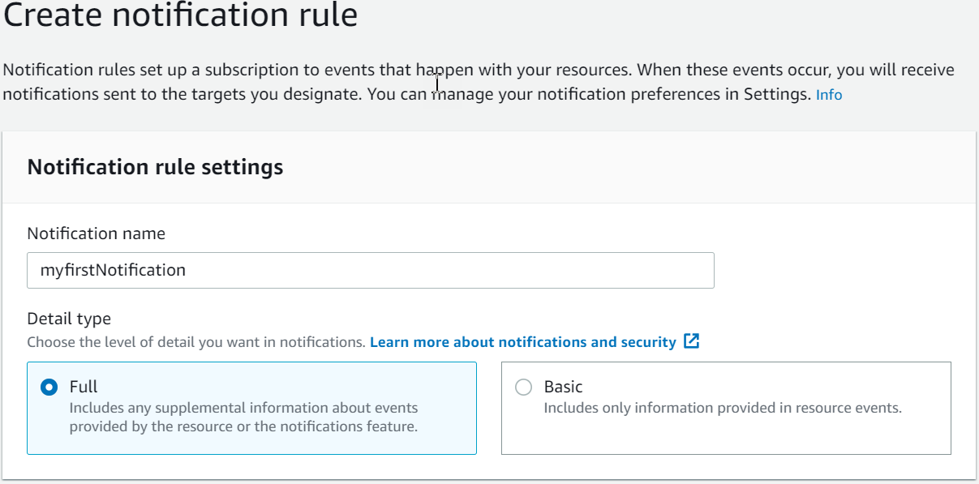

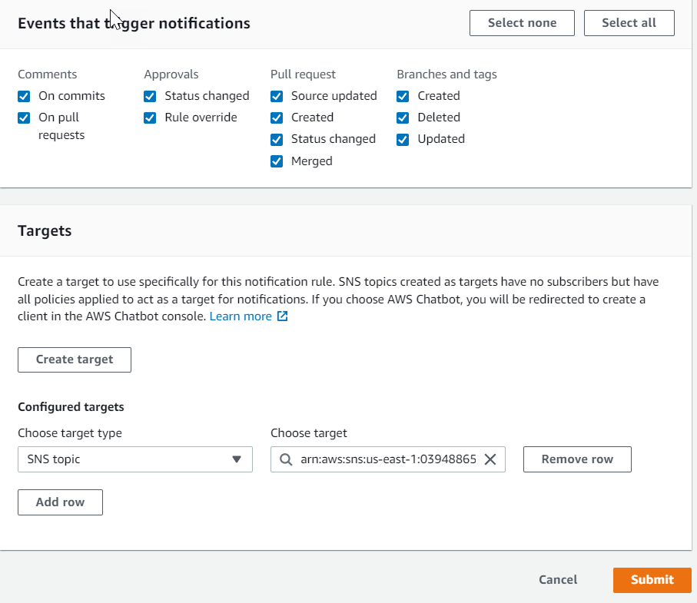

**Triggers:**

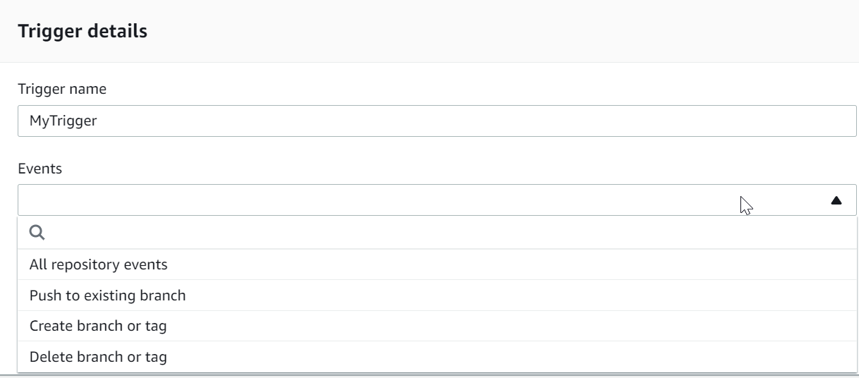

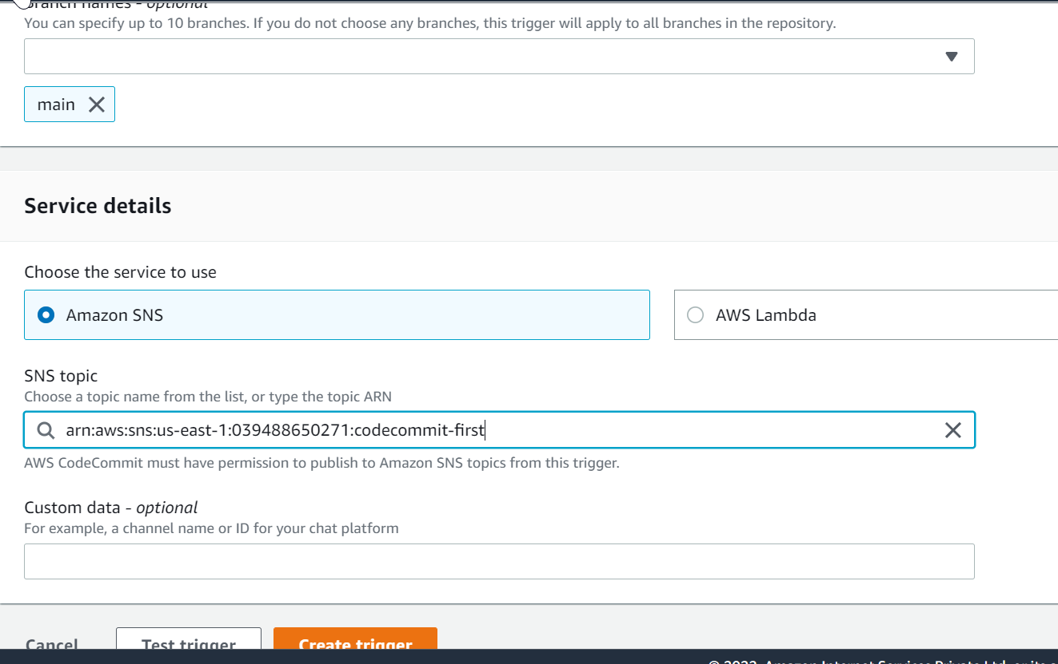

If we want to push the code from local to code commit, we should have created IAM user there we should generate git credentials, while cloning/pushing the code it will pop-up the credentials window. We should enter our IAM creds & we can do check-in & cloning the code.

**Code Pipeline:**

**1.Choose Pipeline Settings:** (i)Pipeline Name (ii) Service Role (iii) Role Name

Allow AWS CodePipeline to create a service role so it can be used with this new pipeline --- > should be checked

Advanced Settings: Artifactory Store --- > It could be a S3 bucket (Default Location) or we can specify a custom S3 bucket in Custom location.

Encryption key: default AWS Managed Key (KMS)

**2.Add Source Stage:**

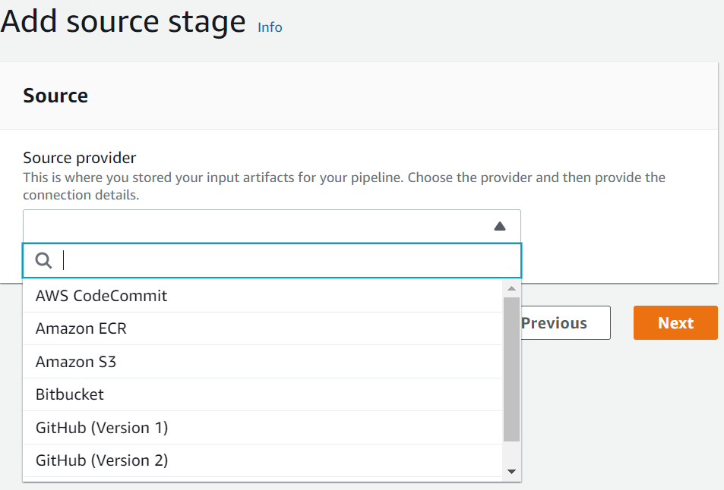

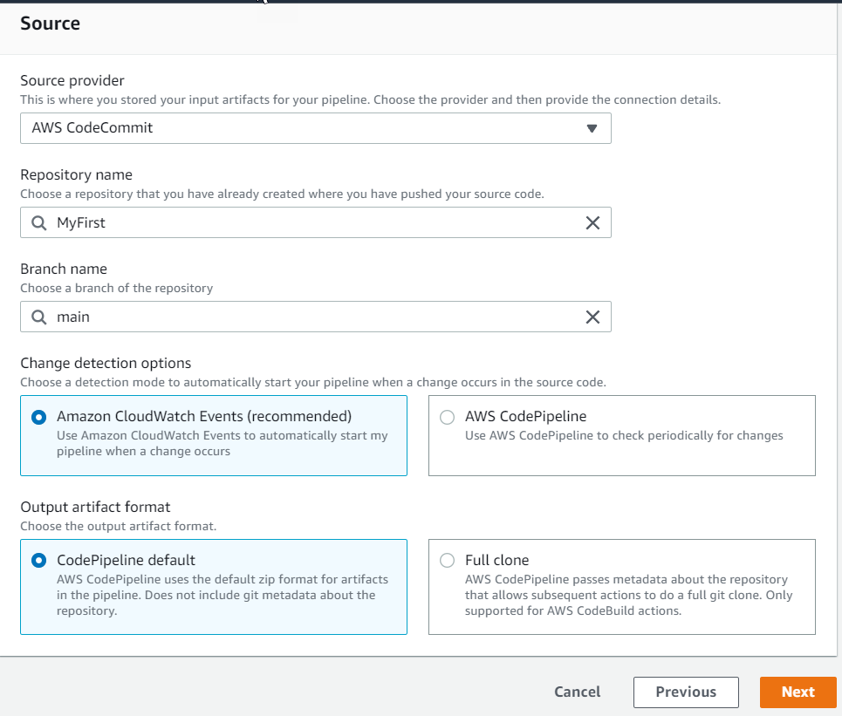

**3. Add Build Stage:**

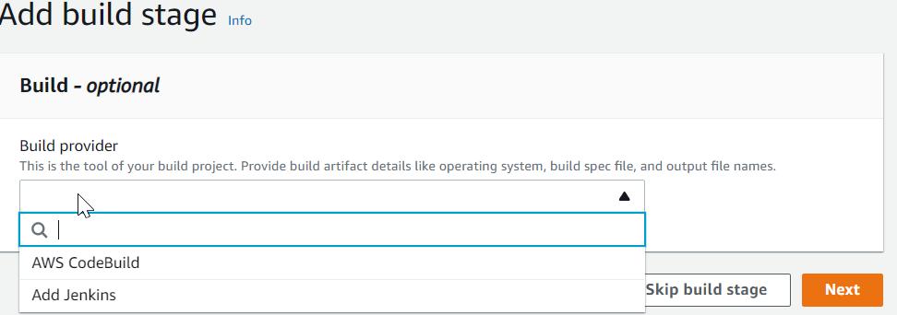

**4. Add Deploy Stage**:

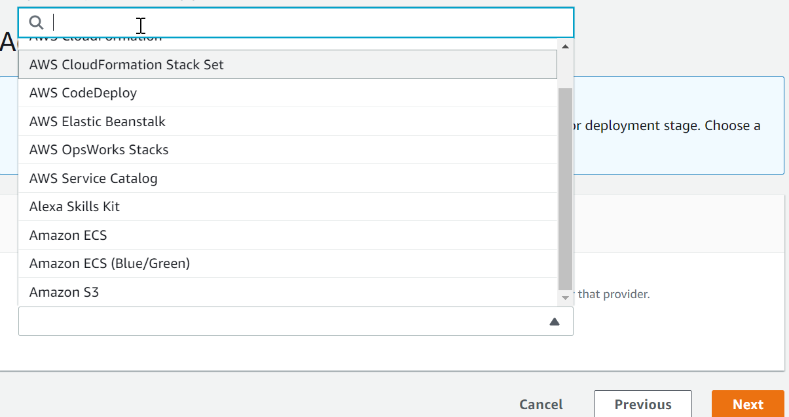

**5. And then review stage** ---- > Create Pipeline.

Code Build:

1.Build Projects:

(i) Project Configuration

(ii) Source

(iii)Environment

(iv) Build Spec (v) Batch Configuration (vi) Artifacts (vii) Logs

