# Introduction

Name of Project: Health Information Tracker

Author: Roderick DeValcourt

Date: 1/24/2021

Estimate to develop: 40 hours

## Health Information Tracker

Health Information Tracker will provide a GUI interface to allow a user to save various health information data points. These data points will drive the charts you see on some of the screens.

The health information this program will collect and display are:

1. Personally Identifiable Information
2. Blood Glucose readings
3. Pulse and Oxygen % readings

The application will read and write this information into a file layout as described in the File Layout section.

# Screens

## Main Menu

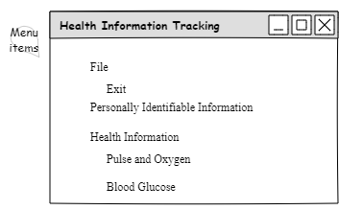

## About

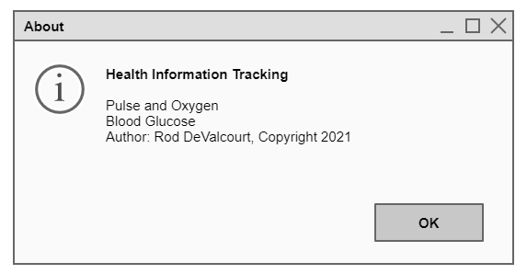

## Personally Identifiable Information

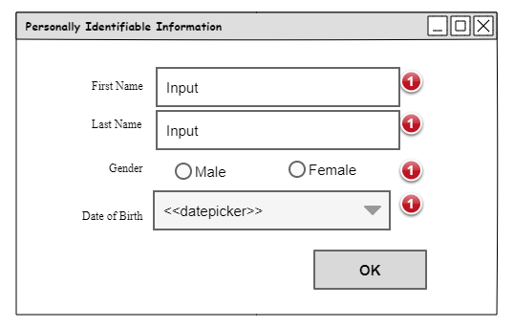

## Blood Glucose Chart

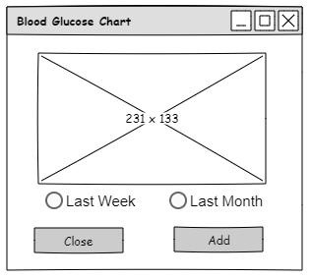

## Add Blood Glucose

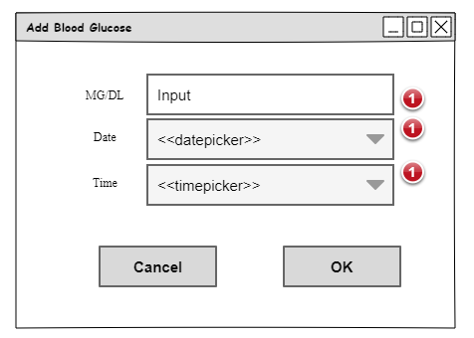

## Pulse and Oxygen Chart

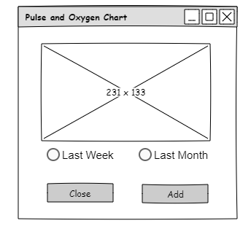

## Add Pulse and Oxygen

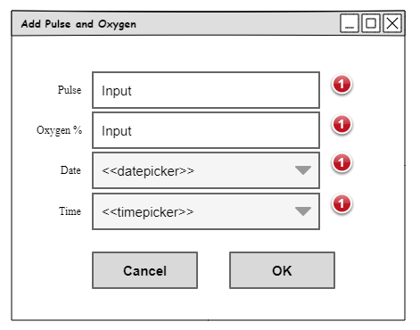

# Flowchart

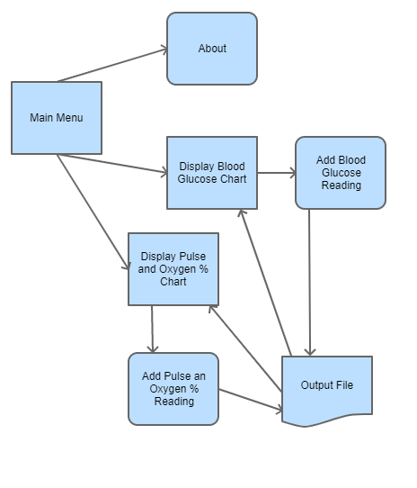

# File Layout

The health information this program will collect are important to be saved to a file on the user’s computer. Some, or all, fields will be encrypted and unreadable such as the personally identifiable information records.

File Name: TBD

File Location: TBD

The file layout will be as follows:

## Personally Identifiable Information

* PII|ID|FIRST NAME|LAST NAME|DATE OF BIRTH|GENDER
* PII is the record type
* ID is a unique identifier associated with a first name, last name, date of birth and gender.
* Date of birth: MM/DD/YYYY
* Gender is a zero (0) or a one (1)

## Blood glucose

* BG|ID|PII_ID|MG/DL|DATE READ|TIME READ
* BG is the record type
* ID is a unique identifier associated with a PII_ID, MG/DL, Date Read and Time Read
* PII_ID is a unique identifier tying a reading to a person found as a personally identifiable information identifier
* MG/DL: numeric value
* Date Read: MM/DD/YYYY
* Time Read: hh:mm:ss tt (where tt is AM or PM)

## Pulse and Oxygen

* PO|ID|PII_ID|PULSE|OXYGEN|DATE READ|TIME READ
* PO is the record type
* ID is a unique identifier associated with a PII_ID, PULSE, OXYGEN, DATE Read and Time Read
* PII_ID is a unique identifier tying a reading to a person found as a personally identifiable information identifier
* PULSE: numeric value
* OXYGEN: numeric value
* Date Read: MM/DD/YYYY
* Time Read: hh:mm:ss tt (where tt is AM or PM)