HXL importer QGIS
Author: Raymond Nijssen

Problem statement

The Red Cross and other humanitarian organizations are increasingly using QGIS to create map products for humanitarian operations. They currently spend a lot of time on repeatedly updating maps, by downloading remote data and importing these in different QGIS projects that result in standard maps and products.

Proposed solution
To import HXL data into a QGIS project and keep the data synced with an online source file that contains the HXL tags. The project map can link directly to the HXL data, which is imported as a dataset in QGIS.

We propose to develop a QGIS plugin, that is able to implement the proposed solution. See last paragraph for functionality that could be implemented by a QGIS plugin, compared to a script.

Roadmap
Before investing time to implement a QGIS plugin instead of the current script, we would like to know more from potential end users:
- If they would like to have this plugin
- What the requirements are for the plugin
- A wireframe that shows the expected layout of the QGIS plugin

Please express your interest to rnijssen@rodekruis.nl. Only if sufficient interest has been shown by different partners, a plugin development process will be initiated. We might reach out to interested partners to support the development of this plugin.

Work done to date

During the RCRC Go Tech Sprint in Geneva (1-3 March 2017) I’ve been working on a QGIS import script for HXL files. QGIS can be extended through both python scrips and plugins. Since the GUI part of plugins takes quite some effort and the functionality was not yet clear I decided to go for a script.
And since both plugins and scripts are python based, it won’t be hard to reuse the code for a plugin.

Actual functionality

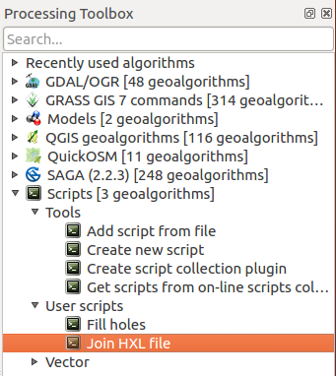
Basically, the script works pretty much like an ordinary QGIS join. But instead of joining to an already imported table in QGIS you can reference a remote HXL file on a server. The script contains input parameters to enable QGIS to run it as a tool with a dialog.

First you need to open a geographic file containing the administrative areas the HXL file refers to. Now run the tool from the Processing Toolbox.
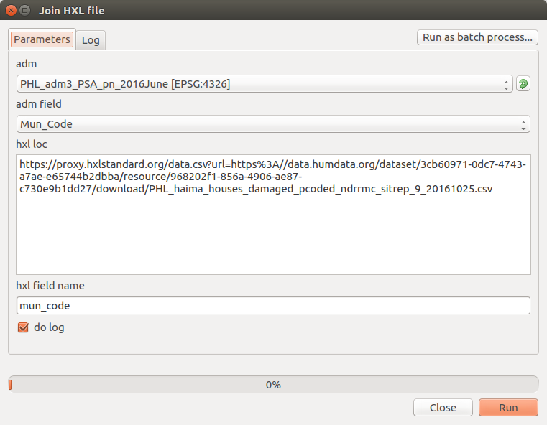

In the dialog, choose the layer with administrative areas (adm) and the field to join to (adm field or PCODE). Then add the URL to the HXL file and the name of the join field (HXL field name). The “do log” checkbox is for coding convenience by writing the steps into a log file.

While running, the script does:
- Download the HXL file to a temporary local place
- Remove all current joins from the administrative layer
- Remove all HXL tables
- Add new HXL table
- Join it to the administrative layer
- The map data is being refreshed and can be printed to PDF from the composer

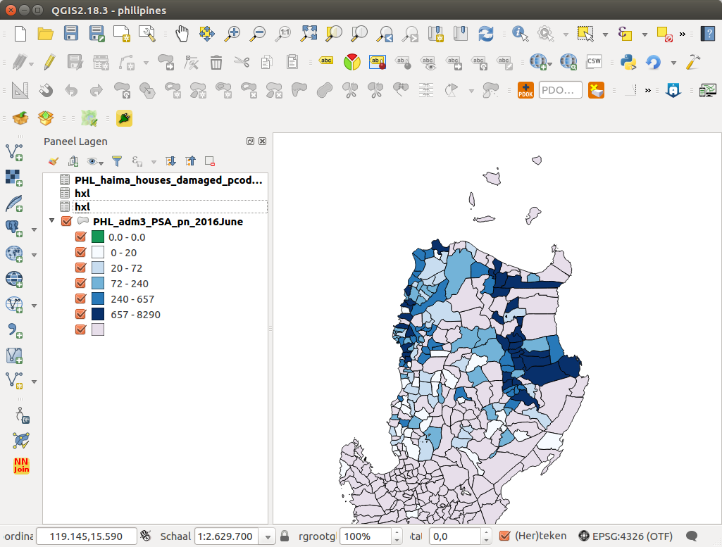
This way you can easily view your remote information on a map, and quite easily update your map to the current remote data set.

Realizing the QGIS plugin

A QGIS plugin offers more possibilities than a QGIS script:

- Plugin is easier to find if published in the QGIS repository
- Plugin is more user friendly. More interaction with the user, so that a two step process is possible:
- download and inspect remote dataset
- join to admin data
- Store links to connected HXL source data in the qgis project (a script cannot save the url)
- Auto detect join fields and Geo-fields from HXL standard

