**Whatsapp Images and Videos Scraper**

**User Guide**

This application automatically downloads images and videos from a Whatsapp chat in a selected interval of time.

Prerequisites:

* Windows
* Chrome
* Phone language English or French

Instructions**:**

Start the program by clicking on the icon.

Fill in all the required fields. Select a folder in which you want to download your files. It creates a new folder “*ChatName_StartDate_EndDate*” in which the files will be stored.

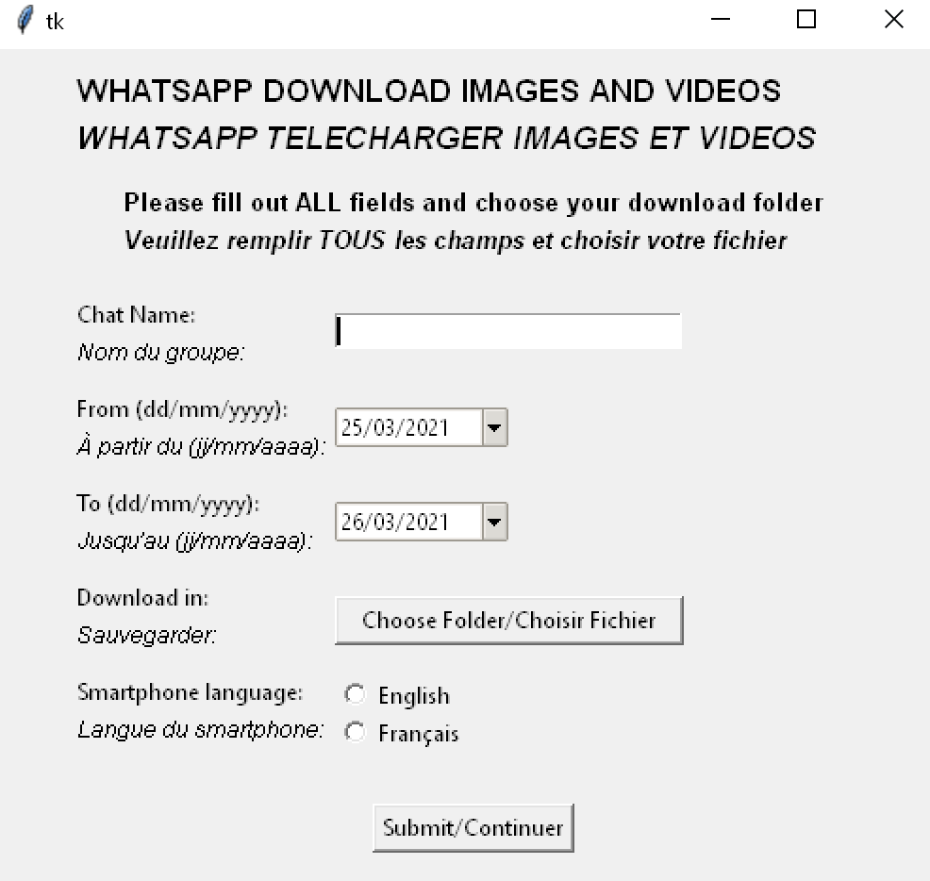

After pressing “Submit” a Chrome window with WebWhatsapp will open: log-in into your WebWhatsapp scanning the QRcode with your phone (for more information <https://faq.whatsapp.com/web/download-and-installation/how-to-log-in-or-out/>)

Next the application looks for the chat and downloads the media and the message sent with it (if any).

The media name is “img_*date*.jpg” (or “video_*date*.mp4”) and the message “message_img_*date*.jpg” (or “message_video_*date*.txt”).

Once all the files in the selected interval are downloaded a pop-up window informs you that “All the images have been scraped!”. By closing this window the program terminates.

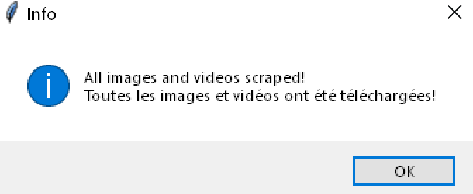

While the program saves the images it is possible to reduce the Chrome window to icon, do not close the Chrome window.