# Project assessment

## Criteria

### Social Media Module

Cl Basic Web

ICTWEB304 - Build simple web pages (1)

ICTWEB305 - Produce digital images for the web (1)

### Qualification/Course code and name

ICT30120 | Certificate III in Information Technology (2)

## Student details

### Student number

881826951

### Student name

Rodel Talampas

## Assessment declaration

*Note: If you are an online student, you will be required to complete this declaration on the TAFE NSW online learning platform when you upload your assessment.*

This assessment is my original work and has not been:

* plagiarised or copied from any source without providing due acknowledgement.
* written for me by any other person except where such collaboration has been authorised by the Teacher/Assessor concerned.

### Student signature and date

Rodel Talampas – 27/06/2025

Version: *20220809*

Date created: *19 August 2021*

Date modified: *27 June 2025*

For queries, please contact:

*Technology and Business Services*

*Ultimo*

© 2022 TAFE NSW  
RTO Provider Number 90003 | CRICOS Provider Code: 00591E

This assessment can be found in the: [Learning Bank](https://share.tafensw.edu.au/share/access/searching.do?doc=%3Cxml%2F%3E&in=P7ac4831b-430a-4b8d-8b56-f7b32ed5b9cf&q=&type=standard&sort=rank&dr=AFTER)

The contents in this document is copyright © TAFE NSW 2022 and should not be reproduced without the permission of TAFE NSW. Information contained in this document is correct at the time of printing: 27 June 2025. For current information please refer to our website or your Teacher/Assessor as appropriate.

## Assessment instructions

Table 1 Assessment instructions

| Assessment details | Instructions |
| --- | --- |
| **Assessment overview** | The aim of this assessment is to assess your knowledge and performance in using an integrated development environment (IDE) to create, modify and test, simple web pages and web content, according to client requirements. |
| **Assessment event number** | 2 of 2 |
| **Instructions for this assessment** | This is a project-based assessment that assesses your knowledge and performance of the unit.  This assessment is in five parts:   1. Plan the website 2. Manipulate and save images 3. Set up the website 4. Build the website 5. Upload, test and finalise the website.   And is supported by:   * Assessment Checklists 1, 2 * Observation Checklist * Supporting documents contained in Cl_BasicWeb_AE_Pro_Appx.zip.   **Note**: This assessment may contain links to external resources. If a link does not work, copy and paste the URL directly into your browser. |
| **Submission instructions** | On completion of this assessment, you are required to submit it to your Teacher/Assessor for marking. Where possible, submission and upload of all required assessment files should be via the TAFE NSW online learning platform.  It is important that you keep a copy of all electronic and hardcopy assessments submitted to TAFE and complete the assessment declaration when submitting the assessment. |
| **What do I need to do to achieve a satisfactory result?** | To achieve a satisfactory result for this assessment you must answer all the questions correctly.  If a resit is required to achieve a satisfactory result it will be conducted at an agreed time after a suitable revision period. |
| **What do I need to provide?** | * TAFE NSW student account username and password. If you do not know your username and password, contact your campus or service centre on 131601. * Computer or other device with word processing software and internet access * Writing materials, if required * Storage media.   If assessment is completed off campus:   * Integrated development environment (such as Adobe Dreamweaver) * FTP client software * Image manipulation software (such as Adobe Photoshop) * To host your website you can use a hosting service like Microsoft Azure or a free web hosting service such as [InfinityFree](https://share.tafensw.edu.au/share/items/9b075f3e-20d0-4707-b451-f282482625df/0/?attachment.uuid=69372eae-0e75-481c-b769-784d8e189506), [BYET Internet Services](https://share.tafensw.edu.au/share/items/9b075f3e-20d0-4707-b451-f282482625df/0/?attachment.uuid=7a1fa0bb-044c-48b7-b8b4-1e0142fd1d19), or [000webhost](https://share.tafensw.edu.au/share/items/9b075f3e-20d0-4707-b451-f282482625df/0/?attachment.uuid=83162643-50ac-4283-a1d0-ae9c5e8af05e). |
| **What the Teacher/Assessor will provide** | Access to the learning management systems.   * Integrated development environment (such as Adobe Dreamweaver) * FTP client software * Image manipulation software (such as Adobe Photoshop) * If an on-campus web server is available, passwords and access procedures to access the web server * Files contained within Cl_BasicWeb_AE_Pro_Appx.zip including:   + Client website specifications   + Images. |
| **Due date**  **Time allowed**  **Location** | Indicative time to complete assessment:   * In class: Three hours * Out of class: Four hours   This assessment will be completed both in and outside of the classroom.  The student may access their referenced text, learning notes and other resources.  If you are unable to verify the authenticity of the student’s submission you will need to gather additional evidence to confirm that the assessment task was completed by the student. This may include oral questioning, comparison with in-class work samples, or observation. |
| **Assessment feedback, review or appeals** | In accordance with the TAFE NSW policy *Manage Assessment Appeals,* all students have the right to appeal an assessment decision in relation to how the assessment was conducted and the outcome of the assessment. Appeals must be lodged within **14 working days** of the formal notification of the result of the assessment.  If you would like to request a review of your results or if you have any concerns about your results, contact your Teacher/Assessor or Head Teacher. If they are unavailable, contact the Student Administration Officer.  Contact your Head Teacher/Assessor for the assessment appeals procedures at your college/campus. |

## Specific task instructions

The instructions and the criteria in the tasks and activities will be used by your Teacher/Assessor to determine if you have satisfactorily completed this assessment event. Use these instructions as a guide to ensure you demonstrate the required knowledge and skills.

### Scenario

A local cake shop, Special Cakes for All Occasions,has approached Gelos Enterprises (GE) to build their website, including producing digital images for the website. As an Information Technology Trainee working for Gelos, you have been assigned the task to build the website using an integrated development environment (IDE).

Sam Rice, the owner of Special Cakes for All Occasions, wants to use the website to promote their products. In addition, they do not want to maintain the website themselves and has asked Gelos to maintain it.

Your Gelos supervisor for this task is Vinh Nguyen, the Web Development Team Leader. They have supplied you with the client requirements for the website, as outlined in the website specification brief (SpecialCakesWebsiteSpecifications.docx), as well as a CSS file (specialcakesstyles.css) containing suitable styles for the website.

Download and unzip the [resource folder](https://share.tafensw.edu.au/share/items/cf3540af-783f-4d19-9920-bb83226f2099/0/?attachment.uuid=2e28f3e1-055a-4128-9107-9702d0d54375) (Cl_BasicWeb_AE_Pro_Appx.zip), which contains the specifications for the website and other documents you will need in this assessment.

You will need access to a web server to upload the website. You can use a hosting service like Microsoft Azure or a free web hosting service such as [InfinityFree](https://share.tafensw.edu.au/share/items/9b075f3e-20d0-4707-b451-f282482625df/0/?attachment.uuid=69372eae-0e75-481c-b769-784d8e189506), [BYET Internet Services](https://share.tafensw.edu.au/share/items/9b075f3e-20d0-4707-b451-f282482625df/0/?attachment.uuid=7a1fa0bb-044c-48b7-b8b4-1e0142fd1d19), or [000webhost](https://share.tafensw.edu.au/share/items/9b075f3e-20d0-4707-b451-f282482625df/0/?attachment.uuid=83162643-50ac-4283-a1d0-ae9c5e8af05e).

## Part 1: Plan the website

Access and analyse the web specifications brief (SpecialCakesWebsiteSpecifications.docx) to determine the client requirements, as well as identify and plan your tasks for the project.

### Task 1

Use the Client Requirements Analysis template from the [resource folder](https://share.tafensw.edu.au/share/items/cf3540af-783f-4d19-9920-bb83226f2099/0/?attachment.uuid=2e28f3e1-055a-4128-9107-9702d0d54375) (Cl_BasicWeb_AE_Pro_Appx.zip), to write a requirements analysis report for the client (approximately 450-600 words).

Your analysis must include the following points:

1. Summary of the client’s requirements for the website which you should determine from the information provided. This must include:
   * Content
   * Style requirements including specific colours and any specifics about the logo
   * Size of the required images.

**Requirements:**  
Special Cakes for All Occasions wants to have a website promoting their products which should contain at least 3-4 pages (Home, Cakes for Sale, About us and Contact Us pages). The website needs to be fully functional and should be browsable using most common browsers such as Chrome or IE.

The Home page contains the location, contact number, email and trading hours. The Cakes for Sale list downs all the available cakes, prices and sizes. It also contains how many people can consume specific sizes.

See attached Client Requirements Analysis document.



1. Visit one or some of the following websites [Freepik](https://www.freepik.com/), [Pexels](https://www.pexels.com/) or [Unsplash](https://unsplash.com/) to source and access three appropriate images that follow organisational requirements on sourcing images. Ensure you meet copyright standards when choosing your images. For each image:
   * list the name of the website and the URL from where it was obtained
   * explain how it meets the requirements and copyright standards and legislation
   * include a screenshot of its licensing restrictions.

|  |  |  |
| --- | --- | --- |
| Image | Site | URL |
|  | freepik.com | https://img.freepik.com/free-photo/top-view-delicious-cake-arrangement_23-2148933608.jpg |
|  | | |
|  | freepik.com | https://img.freepik.com/free-photo/square-slice-cake-with-pink-cream-berries-another-slice-red-cake-with-cup-tea_114579-3030.jpg |
|  | | |
|  | pexels.com | https://images.pexels.com/photos/15419532/pexels-photo-15419532.jpeg |
|  | | |

1. Describe the purpose and specific functions of each of the following types of digital systems and tools used in building websites (100-200 words) (copy the following table into your report).

Table 2 Digital system/tool

|  |  |  |
| --- | --- | --- |
| Type of digital system/ tool | Purpose | Specific functions |
| Integrated development environment (IDE) | Use to modify code and any other text configurations | Code Applications |
| Image editing software | Use to edit images use for the web and any other purpose | Minify images for the web |
| File transfer protocol (FTP) software | Use to share files or transfer files between client and server | Deploy or transfer files to the server |
| Browser | Use to render web pages | Display html pages |

1. Use the internet to research three common systems and tools in each of the following categories. For each system or tool, describe at least two features of the system or tool.  (Copy the following table into your report).

Categories:

* Integrated Development Environment (IDE)
* Image software
* File Transfer Protocol (FTP)
* Internet Browsers

Table 3 Digital system/tool

| Type of digital system/ tool | Name of common digital system/ tool | Key features |
| --- | --- | --- |
| Integrated Development Environment (IDE) 1 | Visual Studio Code | **Lightweight & Fast**: Quick to install, starts up fast, and performs well  **IntelliSense**: Smart code completions based on variable types, functions, and imported modules.  **Multi-language Support**: Works well with JavaScript, TypeScript, Python, Java, Go, C++, and more. |
| Integrated Development Environment (IDE) 2 | IntelliJ | **Intelligent UI**: Code navigation, inspections, and suggestions are tightly integrated.  **Powerful Refactoring Tools**: Rename, move, change method signature, and more with confidence.  **Smart Code Completion**: Deep code analysis for context-aware suggestions. |
| Integrated Development Environment (IDE) 3 | Eclipse | **Enterprise Development**: Strong tools for J2EE and Web development.  **Cross-language Support**: Support for C/C++, PHP, JavaScript, Python (via plugins).  **Code Refactoring & Navigation**: Adequate but less polished compared to IntelliJ. |
| Image editing software 1 | ProCreate | **Realistic Drawing Tools**: Mimics pencils, inks, charcoals, and paints  **Layer System**: Layer blending modes, masks, and grouping.  **Precision Tools**: Drawing guides, symmetry tools, and quick shape recognition  **Animation Assist**: Frame-by-frame animation built in. |
| Image editing software 2 | Canva | **Drag-and-Drop Interface**: Very beginner-friendly, no design experience needed.  **Team Collaboration**: Share designs with others, leave comments, real-time editing.  **Basic Animation**: Animate objects and text for video/social media.  **Cross-Platform Access**: Use on desktop, tablet, or phone. |
| Image editing software 3 | Illustrator | **Vector-Based Design**: Create infinitely scalable graphics (logos, icons, illustrations).  **Advanced Typography**: Full control over kerning, tracking, styles, and OpenType features.  **Precision Drawing Tools**: Pen tool, curvature tool, grid snapping, anchor point control.  **Image Trace**: Convert raster images into editable vectors. |
| File Transfer Protocol (FTP )1 | FileZilla | **Support:** SFTP, FTP, and FTPS support  **Drag-and-drop UI** for easy file transfer  **Security:** Secure file transfer via SSH  **File:** Recursive file searching & filtering |
| File Transfer Protocol (FTP )2 | WinSCP | **Support:** SFTP, FTP, FTPS, and WebDAV support  **Explorer**: Commander & Explorer interface styles  **Security:** Secure file transfer via SSH  **Drag-and-drop UI** for easy file transfer |
| File Transfer Protocol (FTP )3 | Cyberduck | **Support:** SFTP, FTP, WebDAV, Amazon S3, Google Drive, Dropbox support  **Security:** Secure file transfer via SSH  **Bookmark management** with keychain/password manager integration |
| Browser 1 | Google Chrome | **Built-in security**: Safe Browsing, sandboxing, automatic updates  **Extensive extension library** via Chrome Web Store  **Google integration**: Translate, search, voice commands  **Powerful Developer Tools** for web development and debugging |
| Browser 2 | Mozilla Firefox | **Highly customizable**: UI, extensions, and themes  **Syncing**: bookmarks, open tabs, passwords across devices  **Strong security features**: frequent updates, sandboxing, HTTPS-Only Mode  **Speed improvements** via the Quantum engine |
| Browser 3 | Microsoft Edge | **Fast performance** (same core as Chrome)  **Built-in security features**: Microsoft Defender SmartScreen, tracking prevention  **Collections**: organize tabs and content into groups  Built-in PDF reader and annotation tools |

1. Select an Integrated Development Environment (IDE) that you will use to create the website and explain how this IDE will meet the requirements of the client.

Visual Studio Code should be a very easy tool to create web pages for the client. It is easy to use and supports different plugins for easy website development. Its feature is rich enough that you feel like working with just the normal file explorer with just an additional text editor. The HTML Plugin (Material Icon Template) is intuitive enough as its IntelliSense can make the life of the developer easy. Its folder structuring is simple, and images can easily be placed in an images folder under to root directory of the web application.

1. Select an industry-standard image editing software application that you will use to edit the required images for the website and explain why this software is applicable for this project.

Canva is my choice as it is very portable. I can use a browser or use my iPad to modify images. Since I am using free images, you can simply upload your images and resize as required. The only caveat though, if you are using a free Canva version, image size and image quality are limited.

1. Plan the navigation of the website by building a suitable sitemap showing the web pages and how they are linked to each other.

1. Use the [Task planner template](https://share.tafensw.edu.au/share/items/cf3540af-783f-4d19-9920-bb83226f2099/0/?attachment.uuid=2e28f3e1-055a-4128-9107-9702d0d54375) (GE_TaskPlanner-template.docx) to identify and plan your role and responsibilities within this website project. Include a list of ordered and prioritised tasks in your workload.

See attached Task Planner Document.

## Unit Code_AE_Pro_#of#

## *Special Cakes for All Occasions Website*

|  |  |  |  |  |  |
| --- | --- | --- | --- | --- | --- |
| Task number | Task description | Priority | Start date | Due date | Comments |
| 1 | Download Banner, Home and About images | Medium | 24/06/2025 | 24/06/2025 |  |
| 2 | Resize Banner, Home and About images | Medium | 24/06/2025 | 24/06/2025 |  |
| 3 | Prepare HTML Template for Common Objects (Logo, Navigation, Banner, Footer) | High | 24/06/2025 | 24/06/2025 |  |
| 4 | Create Home Page | High | 25/06/2025 | 25/06/2025 |  |
| 5 | Create Cakes for Sale Page | High | 25/06/2025 | 25/06/2025 |  |
| 6 | Create About Page | High | 26/06/2025 | 26/06/2025 |  |
| 7 | Create Contact Us Page | High | 26/06/2025 | 26/06/2025 |  |
| 8 | Test | Medium | 27/06/2025 | 27/06/2025 |  |
| 9 | Fix Bugs | High | 27/06/2025 | 27/06/2025 |  |
| 10 | Deploy | High | 27/06/2025 | 27/06/2025 |  |

### Task 2

1. When you have completed your report, write an email to your supervisor and the client using the [GE email template](https://share.tafensw.edu.au/share/items/02285ff1-cfb2-4af4-b402-fdc23bf4bf11/0/?attachment.uuid=2a6ed3d4-ca14-427f-8583-ceb6bcb08c1b) to submit the report.

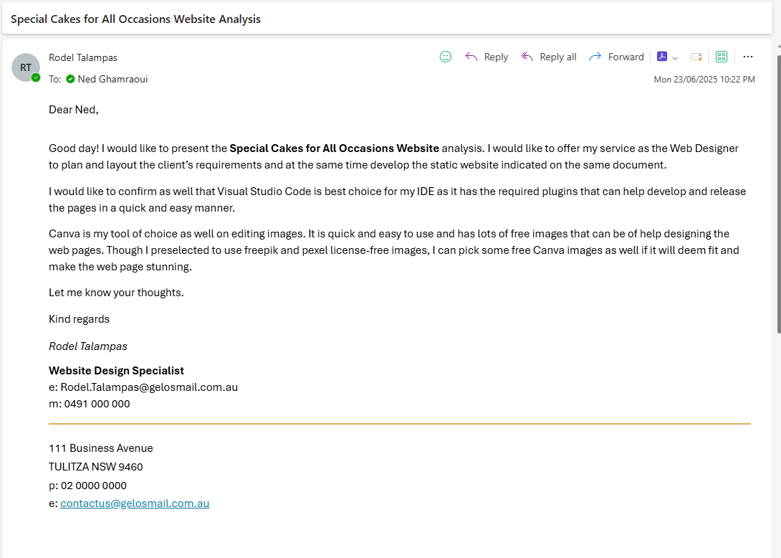

1. You will need to confirm the following items from your report with your supervisor:
   1. Your own role and responsibilities
   2. The use of the IDE that you have selected
   3. The purpose, functions and features of common digital systems and tools.

Discuss these (in person or writing) with another person acting as your supervisor. The other person could be a colleague, industry expert/representative or your teacher.

You will need to obtain and submit their confirmation as evidence. This may be in one of various forms such as a reply email or sign-off on your report.

**Task 1 – Images (**Identify 2 suitable image file formats**)**

|  |  |
| --- | --- |
| Type of File Format | Why |
| PNG | Raster (pixel-based)  Excellent Browser Compatibility  Transparency Support |
| SVG | Vector (math-based, not pixel-based)  Infinitely scalable without quality loss  Yes (CSS & JavaScript can animate SVGs)  Transparency Support |

## Submit Part 1

Submit the following:

* Requirements Analysis Report
* Task planner
* Email to supervisor and client
* Evidence of confirmation from supervisor

## Part 2: Manipulate and save images

Refer to Assessment Checklist 1 for the marking criteria for this part.

Using the industry-standard image editing software application that you previously selected, manipulate and save the three images you have sourced (in Part 1.2) as follows. Make sure that you follow the copyright standards and legislation for the images, as you outlined in Part 1 Task 1.2.

1. Before you start, make backups of the original images in a folder named “original_images”*.*
2. For each image you have sourced, edit it to:
   1. improve the image – this may include adjusting lighting and colour, or removing unwanted content
   2. resize to the required dimensions (including cropping where necessary), without distorting the image.
3. Create a range of effects on the images, appropriate to the client requirements.
4. Save the edited images in a folder named “modified_images”*,* ensuring that:
   1. you use the default file format of the image editing software with all layers intact (where appropriate), e.g., PSD for Photoshop files
   2. they are named according to the client requirements.
5. Save each image again, in a folder named “web_images”, so that it can be used in a website. For each image, ensure that:
   1. you use the most appropriate file format
   2. it is named according to the client requirements.

Zip the image folders into one file to submit.

## Submit Part 2

Submit the following:

* A zipped folder containing:
  + a folder of your original images
  + a folder of modified images
  + a folder of web images

## Part 3: Set up the website

Use your selected IDE to set up the website according to the website specifications. If you have been provided with access to an on-campus web server, use the provided passwords and access procedure. Otherwise, create a secure password to access your web server.

### Task 1

Set the preferences for the IDE that you are using, demonstrating two different settings. Include preferences for the:

* + correct directory structure and location (where your website files will be stored)
  + file transfer protocol (FTP) settings.

Take screenshots of this task and place in the box below.

### Task 2

Refer to the Observation Checklist for the marking criteria for this part.

The following tasks will be observed by your Teacher/Assessor or can be digitally recorded and submitted as evidence.

If you are submitting video evidence, you must:

* provide a video clearly meeting all requirements listed below
* ensure you have access to the equipment and resources required to participate in the demonstration
* follow the [Video recording instructions (pdf)](https://share.tafensw.edu.au/share/items/744af7d4-a241-45e2-adb0-0e13f2fe4950/0/?attachment.uuid=01c3c87a-4599-48c2-91f0-68a00b5bbb4c), which includes useful tips, links to resources and a demonstration video.  
  URL: <https://share.tafensw.edu.au/share/items/744af7d4-a241-45e2-adb0-0e13f2fe4950/0/?attachment.uuid=01c3c87a-4599-48c2-91f0-68a00b5bbb4c>.

The requirements of the task are as follows:

* Access and use **three** key features of the IDE to complete the following tasks which must include:

1. creating three web pages
2. accessing and editing the markup.

* Choose one other task to demonstrate, which may include (but is not limited to):

1. formatting text
2. inserting an image
3. creating a page from a template.

* Identify each feature used (features will depend on the tool being used).

**Note: This task can be performed while completing Part 4 below.**

## Submit Part 3

Submit the following:

* This document with screenshots (Task 1).
* A video of your demonstration (Task 2).

## Part 4: Build the website

Refer to Assessment Checklist 2 for the marking criteria for Tasks 1 and 3.

Use your selected IDE to create and edit the website according to the website specifications. Refer to and follow the client requirements. Make sure that you follow the copyright standards and legislation for the images, as you outlined in Part 1 Task 1.2.

**Note: You will need to submit two versions of your website, as outlined below.**

### Task 1

1. Create three different web pages as requested by the client, saving them and the web images (from Part 2.5) in the required directories.
2. Insert the relevant elements (including text content, images, tables, forms) on each page as required by the client.
3. Format the text content as required by the client.
4. Create a navigational menu of text links on each page, providing access to all pages on the website.
5. Include links on the relevant images to provide access between other pages, as outlined in the website specifications.
6. Access the markup and modify the code on each page to add your name as a comment. Ensure you use the correct syntax.

Zip the folder of all website files to submit (version 1).

### Task 2

Write an email to your supervisor using the [GE email template](https://share.tafensw.edu.au/share/items/02285ff1-cfb2-4af4-b402-fdc23bf4bf11/0/?attachment.uuid=2a6ed3d4-ca14-427f-8583-ceb6bcb08c1b) (GE_Email-template.docx) asking for feedback on the website.

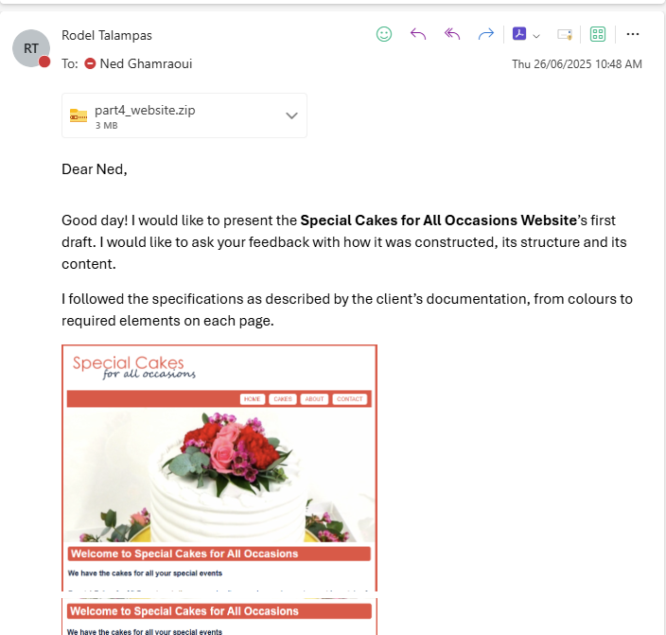

### Task 3

You receive the following reply from your supervisor:

Hi

Thanks, I like what you have done so far on the website, however I checked with the client, and they have some minor changes for you to do.

They thought it would be a good idea to include allergy statements for each product. Could you please include the following information with each product image on the Cakes for Sale page?

Table 4 Product

| Product | Allergy statement to display |
| --- | --- |
| Brownies | Contains dairy, nuts and eggs |
| Flavoured cakes | Contains gluten, dairy, nuts and eggs. Strawberry cakes contain strawberries. |
| Cheesecakes | Contains gluten and dairy |
| Cupcakes | Contains gluten, dairy, nuts and eggs |
| Speciality cakes | Can be made to match dietary requirements |
| Macarons | Contains gluten, dairy, nuts and eggs |

Also, they have changed the opening hours for Sundays only to 9:00 am to 12 noon. Could you please update these hours on the home page?

Thanks

1. Make a copy of your website and save as version 2.
2. Update the web pages as requested.

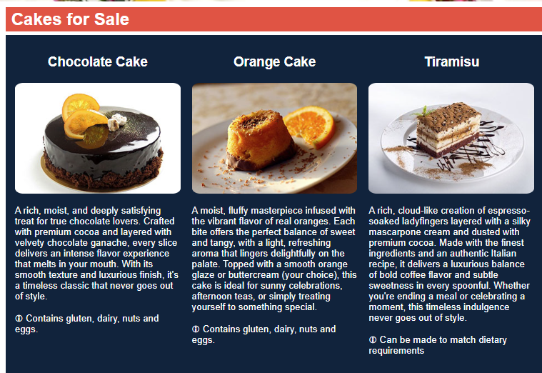

Zip the folder of all website files to submit as version 2.

## Submit Part 4

Submit the following:

* A zipped folder containing all website files (version 1)
* Email to supervisor
* A zipped folder containing all website files (version 2 with amendments)

## Part 5: Upload, test and finalise the website

Now that your website is complete, you need to upload it to the server, then test and validate it.

### Task 1

Use the secure version of FTP to upload and save the files to the web server location, maintaining the directory structure. Take screenshots of each step and place them in the box below.

### Task 2

Use the supplied website testing checklist (WebsiteTestingChecklist.docx) to test and validate your website, according to the client requirements. You will be completing tests for browser compatibility, browser functionality, validation, accessibility, and security.

Perform the following tests on each page in your website, completing each column in the checklist for each test. **Include the URL of your website in the document.**

Evaluate the test results by noting whether it has passed or failed the test and how to correct any errors. You must ensure that your website is fully functional, so you must correct any errors and rerun the tests, if needed.

1. Test each page of your website in the latest version of three different browsers (Chrome, Safari and Microsoft Edge) as well as a previous version of one of those browsers (a total of four website tests) to ensure it is functional and displays consistently in each browser.
   * Access and review all elements on each page to check that they display and work correctly.
   * Take screenshots of each browser test. For each screenshot, list the browser name and browser version. You must provide a minimum of 12 screenshots.
   * If you have difficulty accessing different browsers and versions you can use an online tool such as [Browser Shots](https://share.tafensw.edu.au/share/items/9b075f3e-20d0-4707-b451-f282482625df/0/?attachment.uuid=6e3d5883-d5f6-45c5-b555-b8c4f1582293) or [browserling](https://share.tafensw.edu.au/share/items/9b075f3e-20d0-4707-b451-f282482625df/0/?attachment.uuid=9a3f3939-bb2b-4d1c-86bc-7b4d7481fc38).
2. Validate your website against web standards using a validation tool such as [W3C Markup Validation Service](https://share.tafensw.edu.au/share/items/9b075f3e-20d0-4707-b451-f282482625df/0/?attachment.uuid=f2dea6e7-abe3-4106-bec7-0483d3ff1370).
   * Take screenshots of each page in the validation tool, listing the name of the tool used.
3. Confirm that the website meets the most current stable [Web Content Accessibility Guidelines](https://share.tafensw.edu.au/share/items/9b075f3e-20d0-4707-b451-f282482625df/0/?attachment.uuid=fa785f6e-d276-4118-9145-18a76cc74f14) (WCAG). You can use an online accessibility checking tool such as [Web accessibility](https://share.tafensw.edu.au/share/items/9b075f3e-20d0-4707-b451-f282482625df/0/?attachment.uuid=4ea1b521-7ef8-4e2a-900a-e45a345b1c23) and take screenshots of each page.
4. Test the security of your website by using an online tool such as [Mozilla Observatory](https://share.tafensw.edu.au/share/items/9b075f3e-20d0-4707-b451-f282482625df/0/?attachment.uuid=e498a7cc-04c0-46c9-b12c-8bc110a9049e) or [Sucuri](https://share.tafensw.edu.au/share/items/9b075f3e-20d0-4707-b451-f282482625df/0/?attachment.uuid=c01d2c06-23f6-45d7-98a8-3db275a9aa35). Note: if there are security issues outside of your control, such as with the webhost, note these in the checklist.
   * Take screenshots of the test results, listing the name of the tool used.

Submit the completed website testing checklist.

### Task 3

1. Complete the supplied client requirements checklist (ClientRequirementsChecklist.docx). Check your website and images against the checklist to confirm that they meet the client requirements.
2. In this part of the task, you need to gain sign off on the website from your client. You will need to find someone to play the role of your client, which might be your teacher, another student enrolled in the same unit, a colleague, industry expert or representative.
   1. You must provide them with the brief, the completed checklist and then show them through the website.
   2. You will need to obtain and submit their confirmation that the website and images have met the client requirements. This may be in one of various forms such as a reply email, signed minutes of a meeting, or video evidence of a meeting with them.
      1. If you are submitting video evidence, you must:
      2. provide a video clearly meeting all requirements listed above
      3. ensure you have access to the equipment and resources
      4. follow the [Video recording instructions (pdf)](https://share.tafensw.edu.au/share/items/744af7d4-a241-45e2-adb0-0e13f2fe4950/0/?attachment.uuid=01c3c87a-4599-48c2-91f0-68a00b5bbb4c), which includes useful tips, links to resources and a demonstration video.  
         URL: <https://share.tafensw.edu.au/share/items/744af7d4-a241-45e2-adb0-0e13f2fe4950/0/?attachment.uuid=01c3c87a-4599-48c2-91f0-68a00b5bbb4c>.

## Submit Part 5

Submit the following:

* This document with screenshots (Task 1)
* Completed testing checklist, including URL of uploaded website (Task 2)
* Completed client requirements checklist (Task 3)
* Evidence of confirmation from client (Task 3).

***Deployed in GitHub Pages***

<https://github.com/rodel-talampas/cakeshop-rmt>

<https://rodel.talampas.net/cakeshop-rmt/>

## Assessment Checklist 1

The following checklist will be used by your Teacher/Assessor to capture evidence of your performance in Part 2. Use this checklist to understand what skills and/or knowledge you need to demonstrate during this assessment event. All the criteria described in the Assessment checklist must be met.

Table 5 Assessment Checklist 1

| TASK/STEP # | Instructions | S | U/S | Assessor Comments |
| --- | --- | --- | --- | --- |
| 1 | Creates backups of images |  |  |  |
| 2 | Uses image editing software to create three different images, applying a range of effects, according to client requirements |  |  |  |
| 3 | Edits and resizes images as required |  |  |  |
| 4 | Saves the images with their effects in image editing software format, appropriately named |  |  |  |
| 5 | Saves the images in web format, appropriately sized and named |  |  |  |

## Observation Checklist 1

The Observation Checklist will be used by your Teacher/Assessor to mark your performance in Part 3. Use this Checklist to understand what skills you need to demonstrate in this section of the assessment. The Checklist lists the assessment criteria used to determine whether you have successfully completed this assessment event. All the criteria must be met. Your demonstration will be used as part of the overall evidence requirements of the unit. The Teacher/Assessor may ask questions while the demonstration is taking place or if appropriate directly after the task/activity has been completed.

Table 6 Observation Checklist 1

| Task # | Task/Activity Performed | S | U/S | S | U/S | Assessor Comments (Describe the student’s ability in demonstrating the required skills and knowledge) |
| --- | --- | --- | --- | --- | --- | --- |
| 1 | Accesses and uses three different features of the IDE to perform tasks, including creating three web pages and accessing and editing the markup. |  |  |  |  |  |

## Assessment Checklist 2

The following checklist will be used by your Teacher/Assessor to capture evidence of your performance in Part 4. Use this checklist to understand what skills and/or knowledge you need to demonstrate during this assessment event. All the criteria described in the Assessment checklist must be met.

Table 7 Assessment Checklist 2

| TASK/STEP # | Instructions | S | U/S | Assessor Comments |
| --- | --- | --- | --- | --- |
| 1 | Created three different web pages for a website and saved pages and web images in the required directories (T1.1) |  |  |  |
| 2 | Added text, images, tables and forms according to client requirements (T1.2) |  |  |  |
| 3 | Formatted text according to client requirements (T1.3) |  |  |  |
| 4 | Created links between pages using text (T1.4) |  |  |  |
| 5 | Created links between pages using images (T1.5) |  |  |  |
| 6 | Modified code using correct syntax (T1.6) |  |  |  |
| 7 | Maintained files to amend website according to client feedback (T3.1) |  |  |  |
| 8 | Followed organisational and copyright standards and legislation for images |  |  |  |

## Assessment feedback

*NOTE: This section must have the Teacher/Assessor and student signature to complete the feedback. If you are submitting through the TAFE NSW online learning platform, your Teacher/Assessor will give you feedback via the platform.*

### Assessment outcome

Satisfactory

Unsatisfactory

**Assessor feedback**

Has the assessment declaration for this assessment event been signed and dated by the student?

Are you assured that the evidence presented for assessment is the student’s own work?

Was reasonable adjustment in place for this assessment event?

*If yes, ensure it is detailed on the assessment document.*

*Comments*:

### Assessor name, signature and date

Ned Ghamraoui

### Student acknowledgement of assessment outcome

*Would you like to make any comments about this assessment?*

### Student name, signature and date

Rodel Talampas, 27/06/2025