**EAST WEST UNIVERSITY**

**SPRING 2022**

**Project Report**

Course Code: CSE435

Course Title: Software Quality Assurance  
Section: 01

**Submitted by:**

Name: Md. Nafi Bin HabibID: 2017-2-60-011

Name: Md. Shamsul Arafine

ID: 2017-2-60-012  
Name: Md. Apple Mahmud  
ID: 2017-2-60-110  
Name: Rodela Tarin Marjia  
ID: 2017-2-60-041

**Submitted to:**

Dr. Shamim Hasnat Ripon

Department of Computer Science & Engineering,

East West University

**Project Description:**

The system is created using various software which is compatible with the system’s necessary,computerized elements. To ensure safety of the information regarding the whole system , the system is linked to the database. So that it can be accessed at any time. The application can lead to an error-free, secure, reliable, and fast management system. Because of this, the data will get longevity. Patients booking records will be stored in the database and later patients can update or cancel their appointment

**Sequence Diagram 1:**

1. Patient login and update info

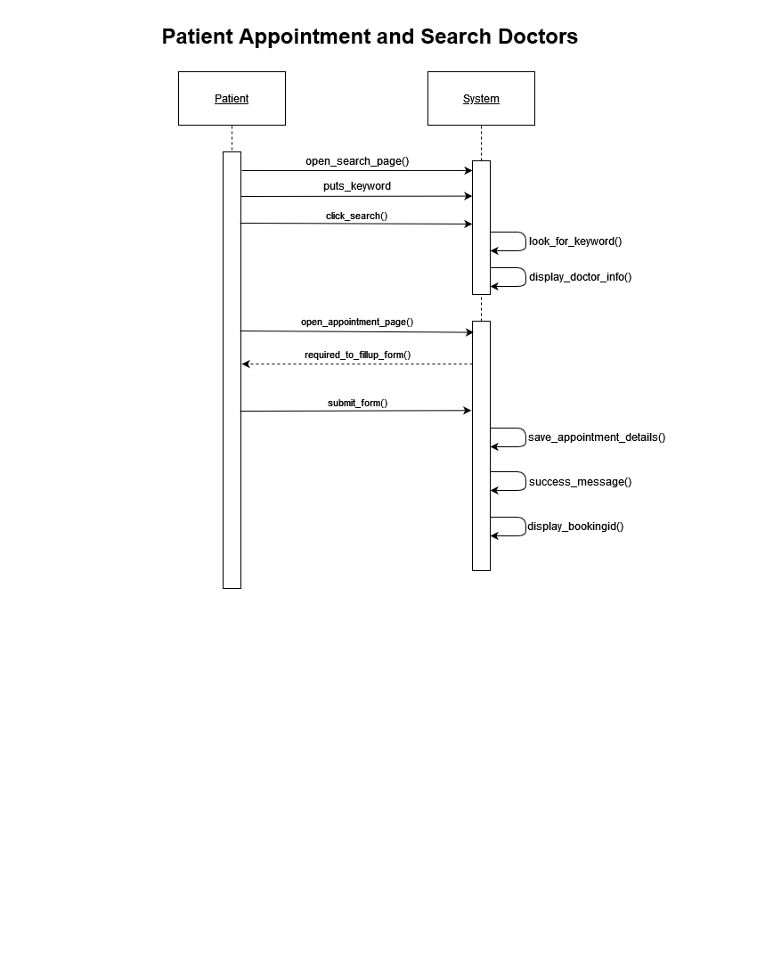

**Description 1:**

In this diagram, system utilizing from both end now here, patient is trying to get access to the system. When patient’s access is granted by the system, the system will for patient’s primary identity at login section which their bookingId. Then patients will directed towards viewpage where they can access to medical services. In this case it is appointing a doctor. After that, patients can change their info as they please. After making submitting the appointment form, patients can get access to medical service regarding appointing the doctor.

**FPS code 1:**

Patient = (open_login_page -> enter_bookingID -> submit_login -> ack -> open_own_appointment -> update_info -> submit_form -> ack2 -> Patient).

System = (request -> redirect_patient_view -> success_msg -> exit -> System).

||Patient_System = (Patient || System)

/{ack/request,ack2/exit}.

**State Transition Diagrams and Combined Diagram 1:**

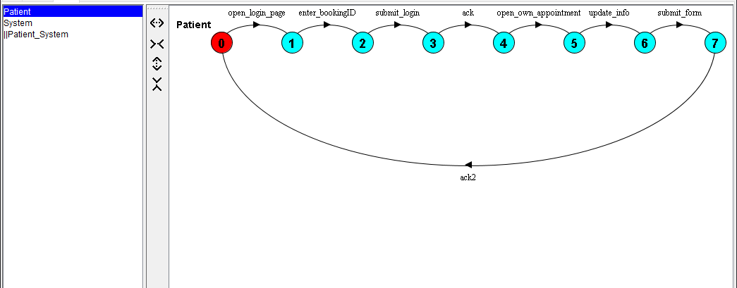

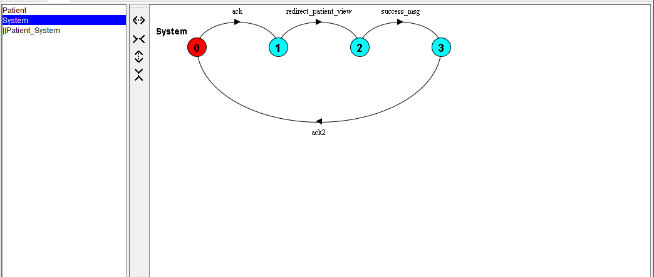

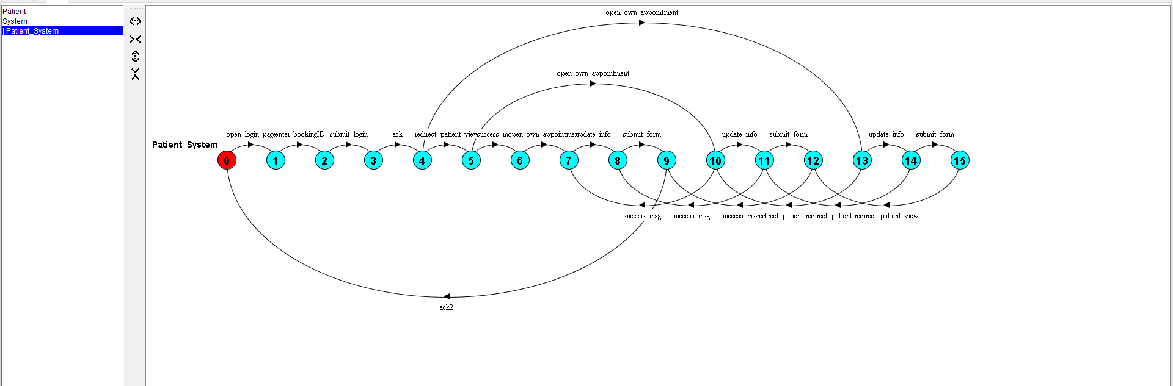

**Sequence Diagram 2:**

**2.Patient make an appointment and search for doctors  
  
  
  
  
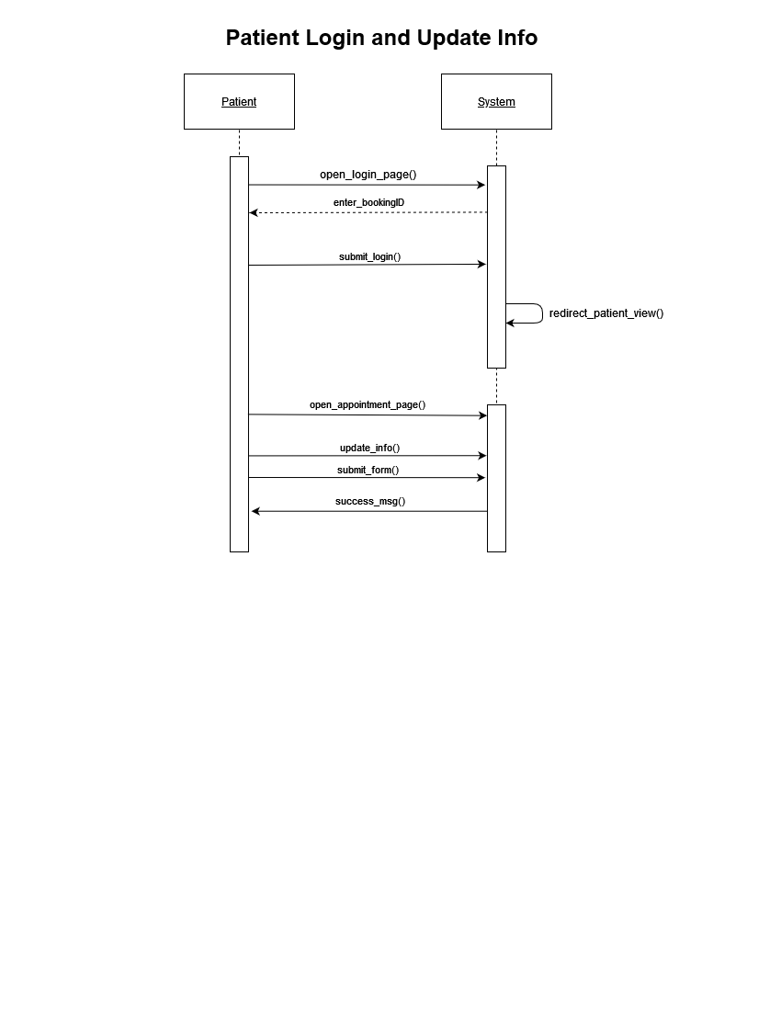  
  
  
  
  
  
  
  
  
Description 2:**

when patient doing query for searching the doctor, system will detect the keyword of the running query and then it will run search to match the list according to the keywords also it will show the availability of the doctors that are patients searching for. Database also take part in this action. The patient will open the appointment page. After filling up the necessary section, the system will get acknowledgement thus it will save the patient’s bookingid in the database and let the patient proceed to further operations.

**FPS code 2:**

Patient = (open_search_page -> puts_keyword -> click_search -> open_appointment_page -> required_to_fillup_form -> submit_form -> Patient).

System = (look_for_keyword -> info_found -> show_doctors_list -> save_appointment_details -> success_message -> display_booking_id -> System).

||Patient_System_AppointmentSearch = (Patient || System)

/{click_search/look_for_keyword,click_search/show_doctors_list,submit_form/display_booking_id}.

**State Transition Diagrams and Combined Diagram 2:  
