CMSC 215 – Programming Project 4

Time Interval Checker – Project Documentation
Author: Rodney
Date: August 2, 2026

1. Design and Implementation Approach
The program is organized into four classes that separate concerns cleanly: a reusable generic data structure, a domain-specific value type, a custom checked exception, and a GUI controller.
The Interval class is written as a generic class, Interval<T extends Comparable<T>>, rather than being hard-coded to work with Time values. This keeps it reusable for any type that defines a natural ordering – integers, dates, or Time objects – and keeps the comparison logic in one place. The class is immutable: its start and end fields are declared final and set only in the constructor, with no setter methods. Three behaviors were required: within(), which checks whether a point lies inside the interval inclusive of both endpoints; subinterval(), which checks whether another interval is completely enclosed by this one; and overlaps(), which checks whether two intervals share any point at all. Each of these is implemented with a small comparison expression built directly on compareTo(), so the class never needs to know anything about the concrete type T.
The Time class represents a single point in time on a 12-hour clock (hours 1–12, minutes 0–59, and an AM/PM meridian). It implements Comparable<Time> so Interval<Time> objects can rely on ordering. Internally, compareTo() converts each Time to “minutes since midnight” on a 24-hour scale before comparing, which avoids subtle bugs around the 12 AM / 12 PM boundary (12 AM is treated as hour 0, and 12 PM is treated as hour 12). Two constructors are provided: one that takes the hour, minute, and meridian directly, and one that parses a string such as “10:30 AM”. Both funnel into a shared validate() helper so the range checks (hours 1–12, minutes 0–59, meridian AM or PM) are written once. The string constructor additionally guards against non-numeric input with a try/catch around Integer.parseInt(), converting any NumberFormatException into a InvalidTime with a clear message rather than letting an unchecked exception escape.
InvalidTime is a checked exception (it extends Exception, not RuntimeException), which was a deliberate choice matching the assignment spec – it forces every caller that constructs a Time to explicitly handle the possibility of bad input, either by catching it or declaring throws InvalidTime, rather than letting invalid times fail silently or crash the program later.
Project4 is the JavaFX GUI layer and is kept intentionally thin – it holds no business logic of its own. A GridPane lays out labeled TextFields for both intervals’ start/end times, a field for the time to check, and two read-only output fields. The Compare Intervals and Check Time buttons are wired to private handler methods that parse the current field values into Time objects, build Interval<Time> objects, delegate the actual comparison logic to Interval and Time, and write the resulting message back into the output field. Both handlers are wrapped in a try/catch for InvalidTime so that malformed input (for example, “13:00 AM” or a typo) produces a friendly error message in the output field instead of crashing the application.
One subtlety worth documenting: the subinterval() method is invoked on the containing interval, not the contained one. To determine whether Interval 1 is a sub-interval of Interval 2, the code calls interval2.subinterval(interval1). In handleCompareIntervals(), the subinterval checks are performed before the overlap check, since a subinterval relationship is technically also an overlap and would otherwise be misreported.

2. UML Class Diagram
The diagram below shows the four classes written for this project, their key fields and methods, and the relationships between them (implements, extends, and uses/depends-on). Built-in JDK and JavaFX classes are shown with dashed borders for context only, per the assignment instructions to exclude predefined classes from the diagram itself.
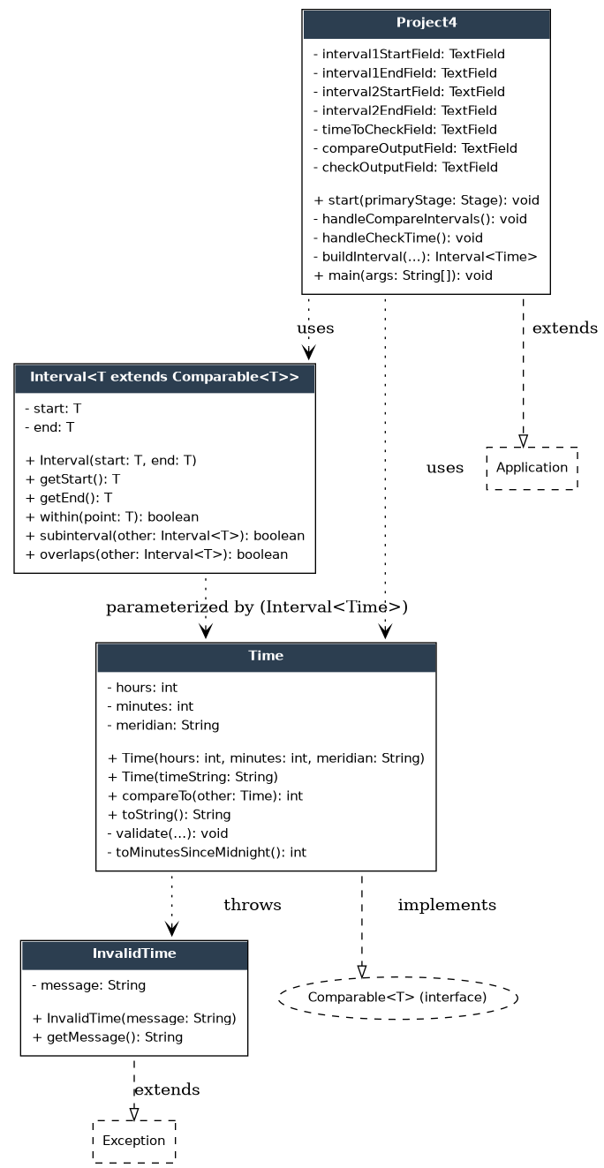

3. Test Plan
The test cases below exercise each required behavior: the four interval relationships (sub-interval in each direction, overlap, disjoint), all four time-check outcomes, boundary conditions at interval endpoints and at the 12 AM / 12 PM boundary, and invalid input handling. Run the application, perform each test, and paste a screenshot of the resulting output field into the “Actual Output / Screenshot” column below each row.
ID | Description | Input | Expected Output
T1 | Interval 1 is a sub-interval of Interval 2 | Int1: 11:00 AM–12:00 PM Int2: 10:00 AM–1:00 PM | “Interval 1 is a sub-interval of interval 2”
T2 | Interval 2 is a sub-interval of Interval 1 | Int1: 10:00 AM–1:00 PM Int2: 11:00 AM–12:00 PM | “Interval 2 is a sub-interval of interval 1”
T3 | Intervals overlap (neither contains the other) | Int1: 10:30 AM–12:30 PM Int2: 11:05 AM–1:00 PM | “The intervals overlap”
T4 | Intervals are disjoint | Int1: 9:00 AM–10:00 AM Int2: 11:00 AM–12:00 PM | “The intervals are disjoint”
T5 | Time is within both intervals | Int1: 10:30 AM–12:30 PM, Int2: 11:05 AM–1:00 PM Check: 12:00 PM | “Both intervals contain the time 12:00 PM”
T6 | Time is within Interval 1 only | Int1: 10:30 AM–12:30 PM, Int2: 11:05 AM–1:00 PM Check: 10:45 AM | “Only interval 1 contains the time 10:45 AM”
T7 | Time is within Interval 2 only | Int1: 10:30 AM–12:30 PM, Int2: 11:05 AM–1:00 PM Check: 12:50 PM | “Only interval 2 contains the time 12:50 PM”
T8 | Time is within neither interval | Int1: 10:30 AM–12:30 PM, Int2: 11:05 AM–1:00 PM Check: 9:00 AM | “Neither interval contains the time 9:00 AM”
T9 | Boundary: time equals an interval endpoint (inclusive check) | Int1: 10:30 AM–12:30 PM Check: 10:30 AM | Interval 1 counted as containing the time (endpoint inclusive)
T10 | Boundary: 12 AM / 12 PM conversion | Int1: 11:30 PM–12:30 AM Check: 12:00 AM | Interval 1 counted as containing the time (midnight handled correctly)
T11 | Invalid hour value rejected | Start Time field: “13:00 AM” | Error message shown in output field (e.g. “Hours must be between 1 and 12”), no crash
T12 | Invalid / non-numeric input rejected | Start Time field: “ten:30 AM” | Error message shown in output field (e.g. “Hours and minutes must be numeric values”), no crash

T1 – Interval 1 is a sub-interval of Interval 2
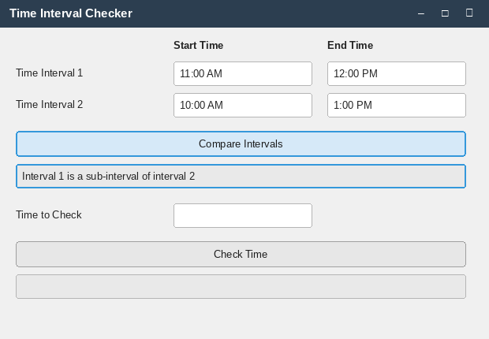

T2 – Interval 2 is a sub-interval of Interval 1
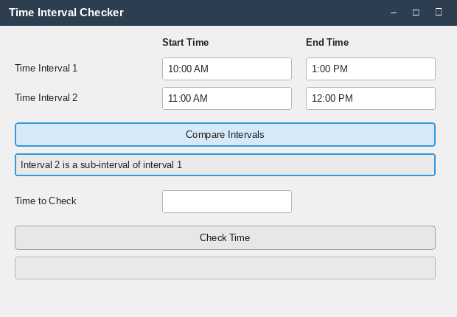

T3 – Intervals overlap
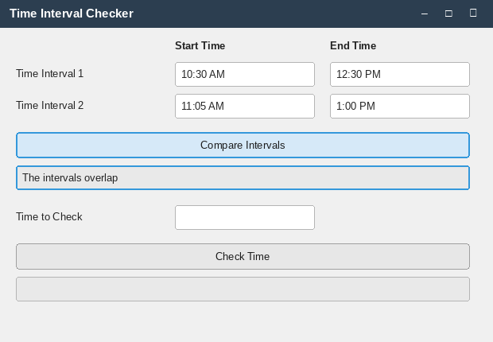

T4 – Intervals are disjoint
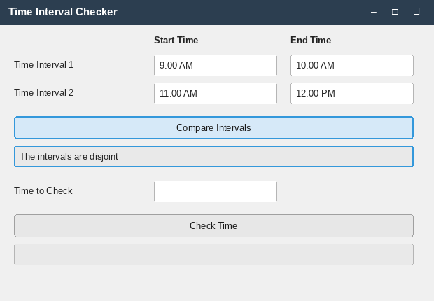

T5 – Time is within both intervals
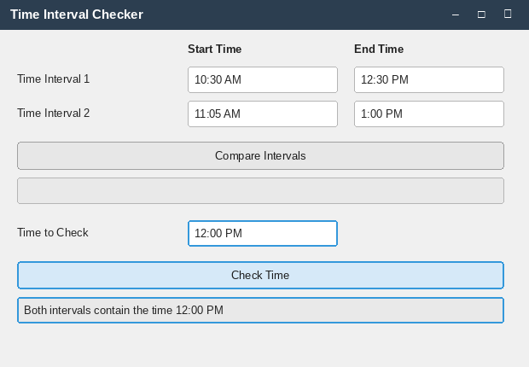

T6 – Time is within Interval 1 only
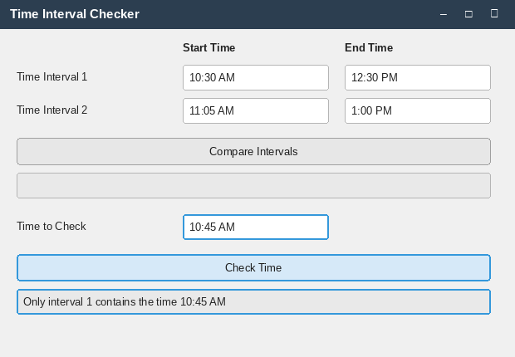

T7 – Time is within Interval 2 only
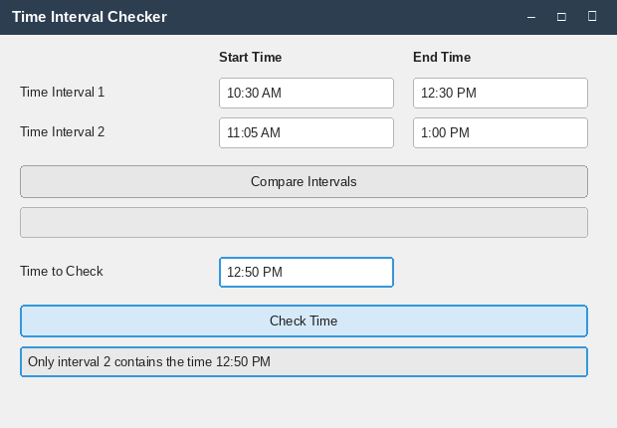

T8 – Time is within neither interval
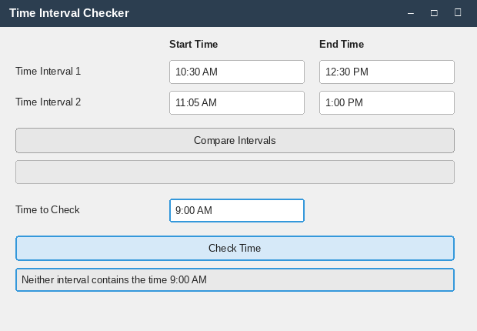

T9 – Boundary: time equals an interval endpoint
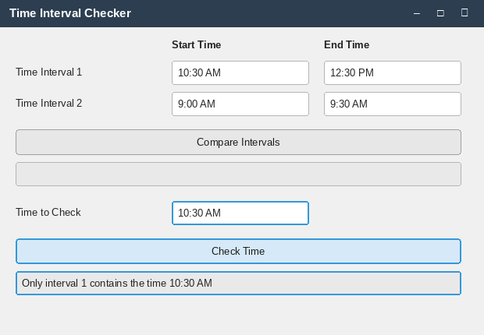

T10 – Boundary: 12 AM / 12 PM conversion
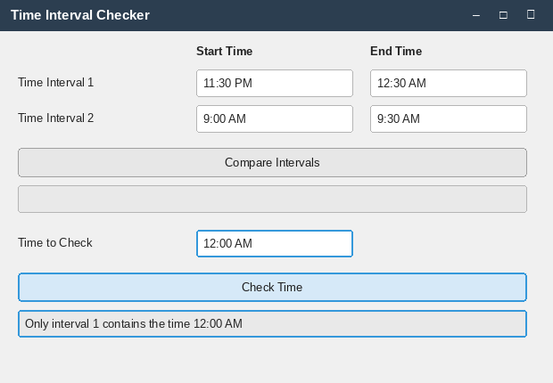

T11 – Invalid hour value rejected
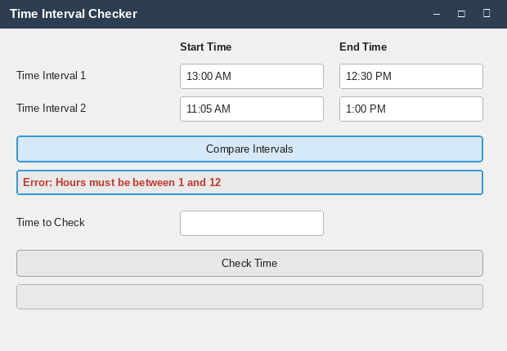

T12 – Invalid / non-numeric input rejected
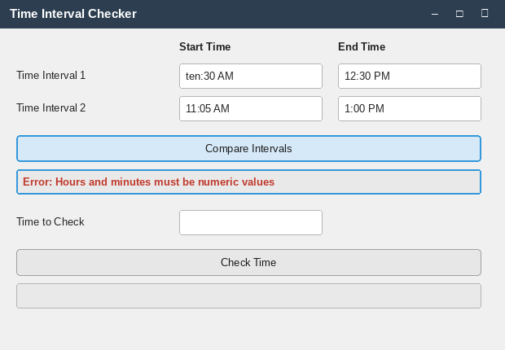

4. Lessons Learned
[Draft – personalize before submitting.] Writing Interval as a generic class reinforced how much cleaner it is to build reusable data structures around an interface like Comparable rather than hard-coding a single type; the same class could support Interval<Integer> or Interval<LocalDate> with no changes. Implementing compareTo() for a 12-hour clock was a good reminder that boundary values (12 AM and 12 PM) deserve dedicated test cases, since the naive “hour + 12 for PM” conversion is wrong exactly at those two points. Using a checked exception (InvalidTime) instead of an unchecked one also made the invalid-input handling more visible and deliberate throughout the codebase, since the compiler enforces that every call site consider the failure case.

