|  |  |
| --- | --- |
| **Project Case** |  |
| COMP6583 | COMP6583001  Computer Graphics |
| **Computer Science** | **O232-COMP6583-MZ03-00** |
| ***Valid on*** *Odd Semester Year 2022/2023* | **Revision 00** |

1. Seluruh kelompok tidak diperkenankan untuk:

*The whole group is not allowed to:*

* + - Melihat sebagian atau seluruh proyek kelompok lain,

*Seeing a part or the whole project from another groups*

* + - Menyadur sebagian maupun seluruh proyek dari buku,

*Adapted a part or the whole project from the book*

* + - Mendownload sebagian maupun seluruh proyek dari internet,

*Downloading a part or the whole project from the internet,*

* + - Mengerjakan soal yang tidak sesuai dengan tema yang ada di soal proyek,

*Working with another theme which is not in accordance with the existing theme in the matter of the project,*

* + - Melakukan tindakan kecurangan lainnya,

*Committing other dishonest actions,*

* + - Secara sengaja maupun tidak sengaja melakukan segala tindakan kelalaian yang menyebabkan hasil karyanya berhasil dicontek oleh orang lain / kelompok lain.

*Accidentally or intentionally conduct any failure action that cause the results of the project was copied by someone else / other groups.*

1. Jika kelompok terbukti melakukan tindakan seperti yang dijelaskan butir 1 di atas, maka **nilai kelompok** yang melakukan kecurangan (menyontek maupun dicontek) akan di – **NOL** – kan.

*If the group is proved to the actions described in point 1 above, the score of the group which committed dishonest acts (cheating or being cheated) will be “Zero”.*

1. Perhatikan jadwal pengumpulan proyek, segala jenis pengumpulan proyek di luar jadwal tidak dilayani.

*Pay attention to the submission schedule for the project, all kinds of submission outside the project schedule will not be accepted.*

1. Bila Anda tidak membaca peraturan ini, maka Anda dianggap telah membaca dan menyetujuinya.

*If you have missed to read these regulations, so you are considered to have read and agreed on it.*

1. Persentase penilaiaan untuk matakuliah ini adalah sebagai berikut:

*Marking percentage for this subject is described as follows:*

|  |  |  |
| --- | --- | --- |
| **Tugas Mandiri**  *Assignment* | **Proyek**  *Project* | **UAP**  *Final Exam* |
| 40% | 60% | - |

1. Software yang digunakan pada matakuliah ini adalah sebagai berikut:

*Software will be used in this subject are described as follows:*

|  |
| --- |
| **Software**  *Software* |
| Chrome / Firefox / Microsoft Edge  Three JS  Visual Studio Code |

1. Ekstensi file yang harus disertakan dalam pengumpulan tugas mandiri, proyek, dan uap untuk matakuliah ini adalah sebagai berikut:

*File extensions should be included in assignment, project, and final exam collection for this subject are described as follows:*

|  |  |  |
| --- | --- | --- |
| **Tugas Mandiri**  *Assignment* | **Proyek**  *Project* | **UAP**  *Final Exam* |
| HTML, CSS, JS, Image Files (JPG / PNG), GLB | HTML, CSS, JS, Image Files (JPG / PNG), GLB | - |

## Soal

*Case*

**MineZraft**

MoZak, a game developer is currently building his new sandbox game called MineZraft. The game will feature steve, creeper, and trees with some interactions. The game is scheduled to be completed in 6 months but MoZak is still having a bad time picturing what the final MineZraft scene will look like. As his friend and a three.js enthusiast, you are asked to design the scene using three.js library

1. **Project Structure**

Your project should contain a main html file, several JavaScript files, assets, and the three.js library. You are to acquire three.js either from the three.js [official website](https://threejs.org/), [github repository](https://github.com/mrdoob/three.js/), or [CDN link](https://cdnjs.com/libraries/three.js).

You are required to include the following piece of code in your html file.

|  |
| --- |
| <style>  * { margin: 0; padding: 0; }  body { width: 100vw; height: 100vh; overflow: hidden; }  </style>  <script src="[path to index.js file]" type="module"></script> |

You are free to split your code into several different JavaScript file, but code the main logic for creating the scene inside “index.js” file.

1. **Scene**

Create a **full screen** scene that can be **dynamically resized** to **fit the window**. The scene also has **shadow map** **enabled** using **PCFShadowMap** as the shadow map **type** and **anti-aliasing** turned on.

1. **Camera**

Create **camera** which details will be specified below.

* 1. **Third Person Camera**
     + This camera will have the following specifications:

|  |  |
| --- | --- |
| Property | Value |
| Type | Perspective Camera |
| FoV | 45 |
| Position | Vector3 (0, 50, 220) |

* + - This camera will focus on **Vector3 (0, 0, 0)** position and can be rotated around said position using **OrbitControls**

1. **Lighting**

There will be two global lights to illuminate the entire scene.

* 1. **Point Light**
     + Below are the specifications:

|  |  |
| --- | --- |
| Property | Value |
| Type | PointLight |
| Intensity | 0.9 |
| Color | #FFFFFF |
| Distance | 1000 |
| Cast Shadow | true |
| Position | Vector3(-30, 50, 70) |

* 1. **Spot Light**
     + Below are the specifications

|  |  |
| --- | --- |
| Property | Value |
| Type | SpotLight |
| Intensity | 1 |
| Color | #fad5a5 |
| Cast Shadow | true |
| Position | Vector3(-50, 50, 160) |
| Distance | 1000 |

1. **Objects**
   1. **Ground**

* Below are the specifications:

|  |  |
| --- | --- |
| Property | Value |
| Geometry Type | Plane |
| Width | 200 |
| Height | 200 |
| Material Type | Mesh Phong Material |
| Color | #FFFFFF |
| Position | Vector3 (0, 0, 0) |
| Receive Shadow | Yes |
| Texture Map |  |

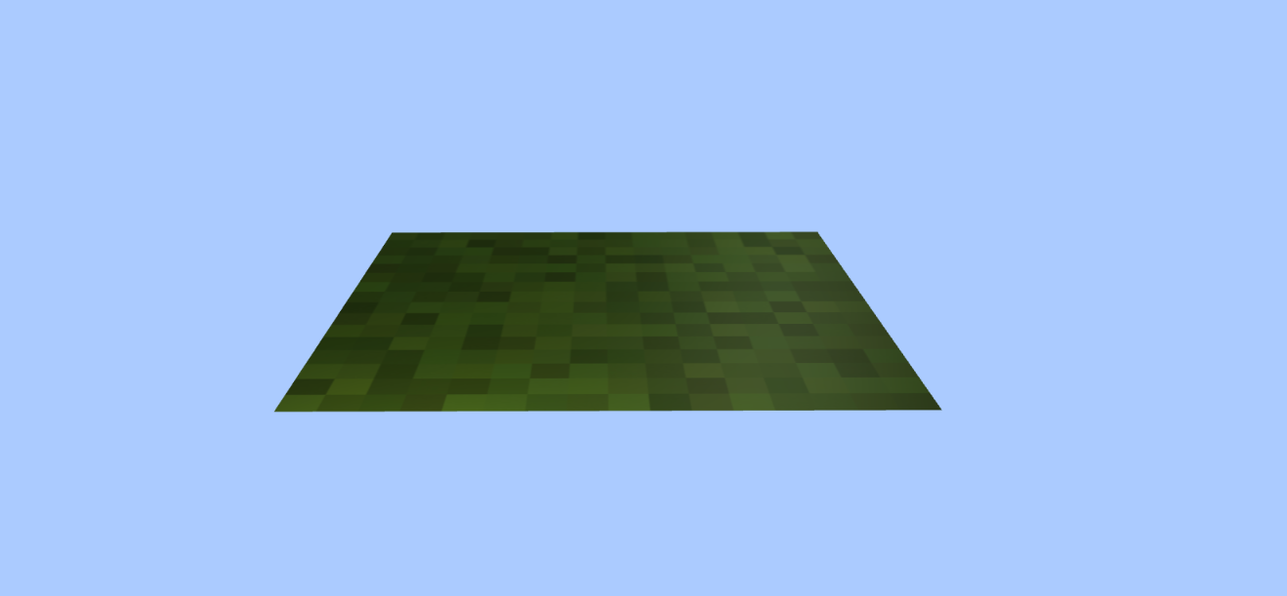

**Figure 1 Ground**

* 1. **Steve**
* Place Steve exactly at the **middle** of the scene
* Load model from the **GLTF** **file** **“**3dmodel/steve1/scene.gltf**”**
* Below are the specifications

|  |  |
| --- | --- |
| Property | Value |
| Cast Shadow | Yes |
| Receive Shadow | Yes |

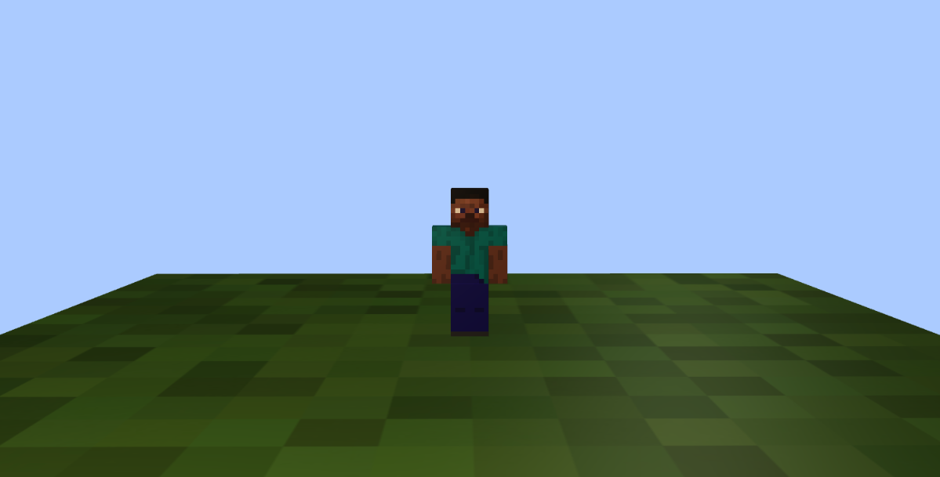

**Figure 2 Steve**

* 1. **Text**
     + Below are the specifications:

|  |  |
| --- | --- |
| Property | Value |
| String | MineZraft |
| Font Type | Droid sans bold |
| Material Type | Mesh Basic Material |
| Position | Vector3(0, 140, -140) |
| Color | #FFFFFF |
| Cast Shadow | Yes |
| Receive Shadow | Yes |

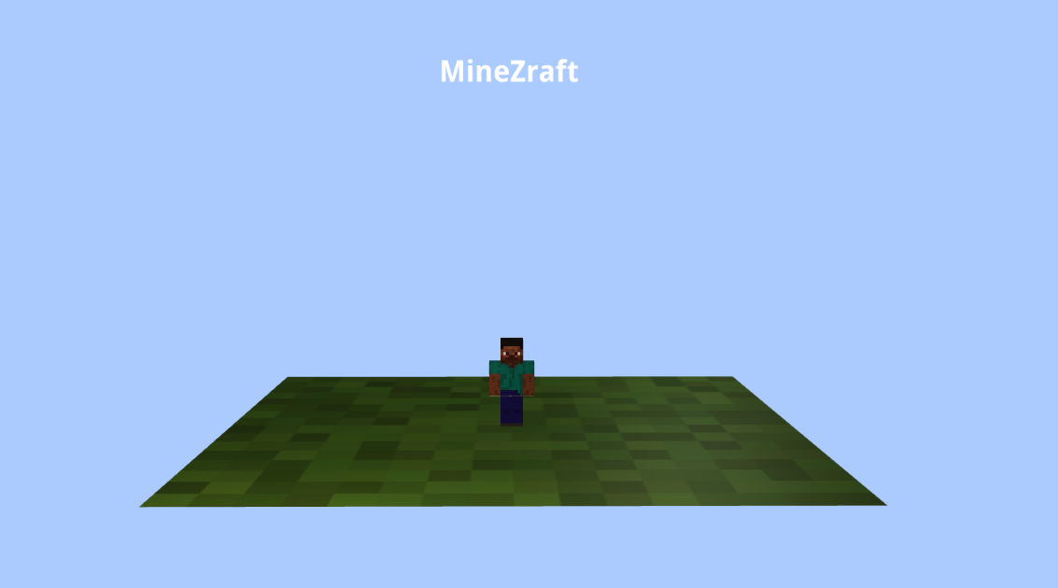

**Figure 3 Text**

* 1. **Creeper**

The Creeper will consist of few parts. Apply this property to each part of creeper:

|  |  |
| --- | --- |
| Property | Value |
| Rotation | Vector3(0, -7, 0) |

1. Head

This part uses:

|  |  |
| --- | --- |
| Property | Value |
| Geometry Type | Box |
| Width | 12 |
| Height | 10 |
| Depth | 15 |
| Material Type | Mesh Phong Material |
| Color | #FFFFFF |
| Position | Vector3 (66, 32, -60) |
| Receive Shadow | Yes |
| Texture Map |  |

1. Eyes

This part uses 2 planes, for left eye:

|  |  |
| --- | --- |
| Property | Value |
| Geometry Type | Plane |
| Width | 2.5 |
| Height | 2.5 |
| Material Type | Mesh Phong Material |
| Color | #000000 |
| Position | Vector3 (58, 33, -56) |
| Receive Shadow | Yes |

For right eye:

|  |  |
| --- | --- |
| Property | Value |
| Geometry Type | Plane |
| Width | 2.5 |
| Height | 2.5 |
| Material Type | Mesh Phong Material |
| Color | #000000 |
| Right Eye Position | Vector3 (63, 33, -52) |
| Receive Shadow | Yes |

1. Body

|  |  |
| --- | --- |
| Property | Value |
| Geometry Type | Box |
| Width | 10 |
| Height | 18 |
| Depth | 8 |
| Material Type | Mesh Phong Material |
| Color | #ffffff |
| Position | Vector3 (66, 18, -60) |
| Receive Shadow | Yes |
| Texture Map |  |

1. Legs

|  |  |
| --- | --- |
| Property | Value |
| Geometry Type | Box |
| Width | 12 |
| Height | 9 |
| Depth | 5 |
| Material Type | Mesh Phong Material |
| Color | #ffffff |
| Position | Vector3 (63, 5, -57) |
| Receive Shadow | Yes |
| Texture Map |  |

This part uses 2 boxes, for foreleg:

|  |  |
| --- | --- |
| Property | Value |
| Geometry Type | Box |
| Width | 12 |
| Height | 9 |
| Depth | 5 |
| Material Type | Mesh Phong Material |
| Color | #ffffff |
| Position | Vector3 (68, 5, -64) |
| Receive Shadow | Yes |
| Texture Map |  |

For hind leg:

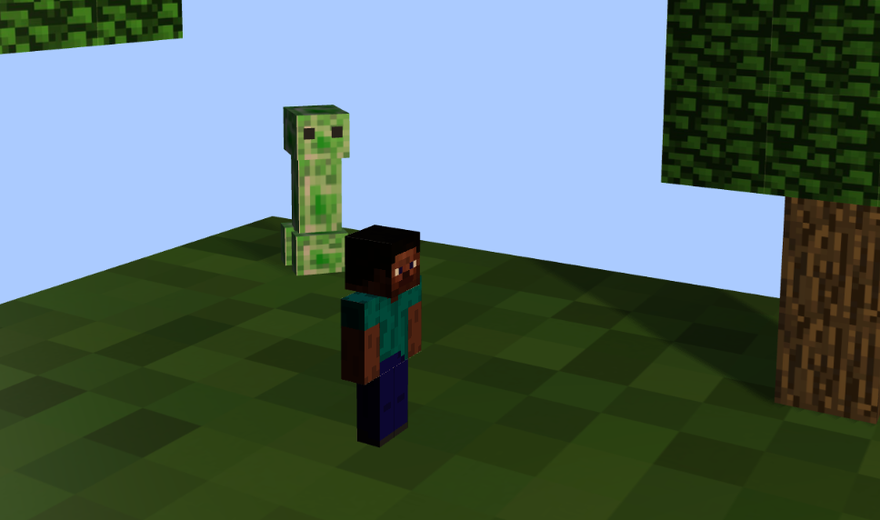

**Figure 4 Creeper**

* 1. **Trees**

Create 2 trees which consist of leaves and trunk.

1. Trunk

|  |  |
| --- | --- |
| Property | Value |
| Geometry Type | Box |
| Width | 15 |
| Height | 15 |
| Depth | 15 |
| Material Type | Mesh Phong Material |
| Color | #FFFFFF |
| Receive Shadow | Yes |
| Texture Map |  |

|  |  |
| --- | --- |
| Property | Value |
| Geometry Type | Box |
| Width | 15 |
| Height | 15 |
| Depth | 15 |
| Material Type | Mesh Phong Material |
| Color | #FFFFFF |
| Receive Shadow | Yes |
| Texture Map |  |

1. Leaves

Each of the trees will have different position. The positions are:

|  |  |
| --- | --- |
| Property | Value |
| First Tree center position | Vector3 (-60, y, -55) |
| Second Tree center position | Vector3 (50, y, 55) |
| y-axis value | 8 + (15 * level) |

These positions are the position of the trunk which also used as the center of the tree. For y-axis value, the value is calculated by formula and will increase for each level where level starts from 0.

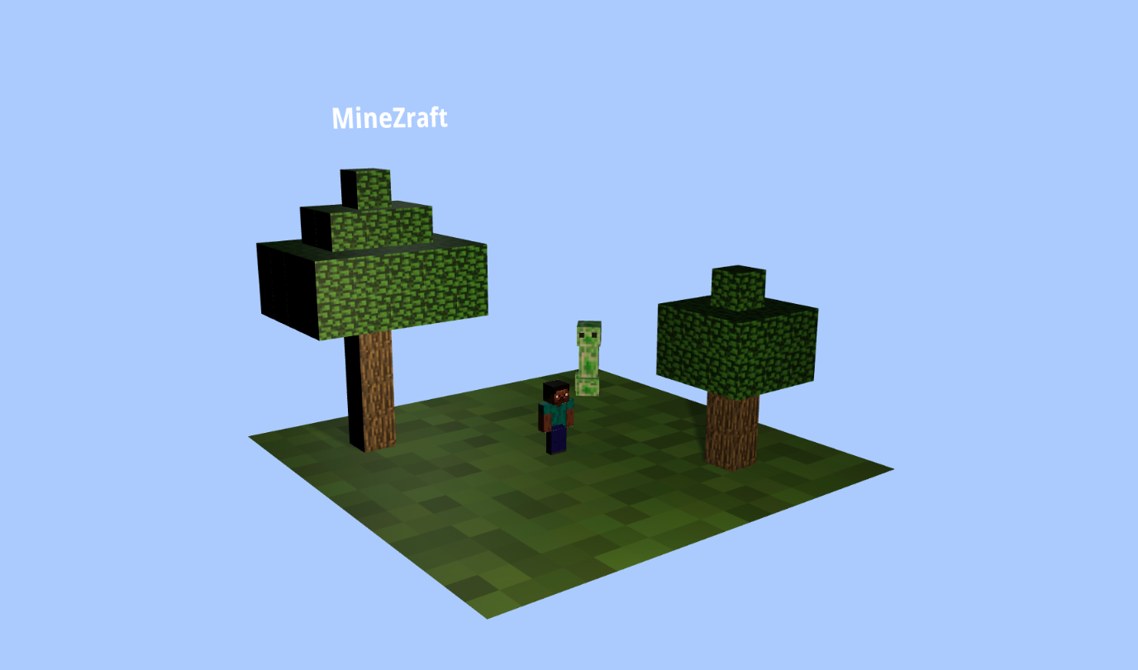

**Figure 5 trees**

1. **Skybox**

Create the skybox using **cube mapping technique.** MineZraft has two skybox.

1. Skybox Day

This skybox is the default theme where the game starts

|  |  |
| --- | --- |
| Property | Value |
| Size | 1200 x 1200 x 1200 |
| Texture  (In sequence: px, nx, py, ny, pz, nz) |  |

1. Skybox Night

This skybox is activated when user **click the title text** (‘**MineZraft**’) which will switch the skybox to night. The vice versa also applied (night to day). Apply this interaction by using **Raycast**

|  |  |
| --- | --- |
| Property | Value |
| Size | 1200 x 1200 x 1200 |
| Texture  (In sequence: px, nx, py, ny, pz, nz) |  |

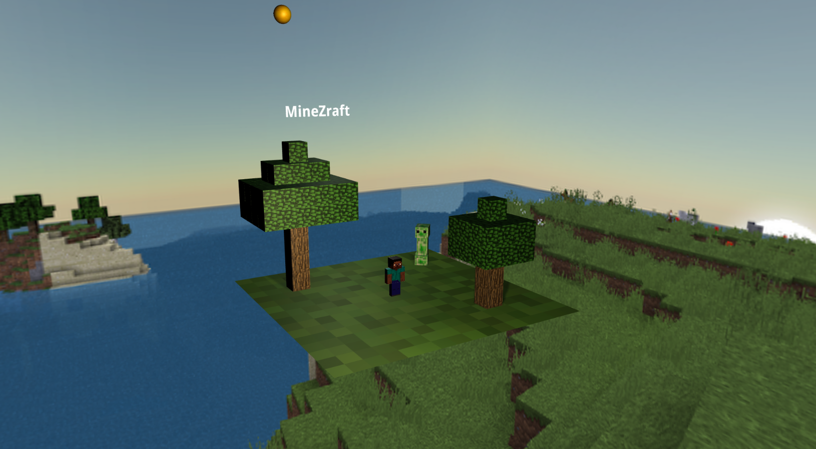

**Figure 8 Skybox day**

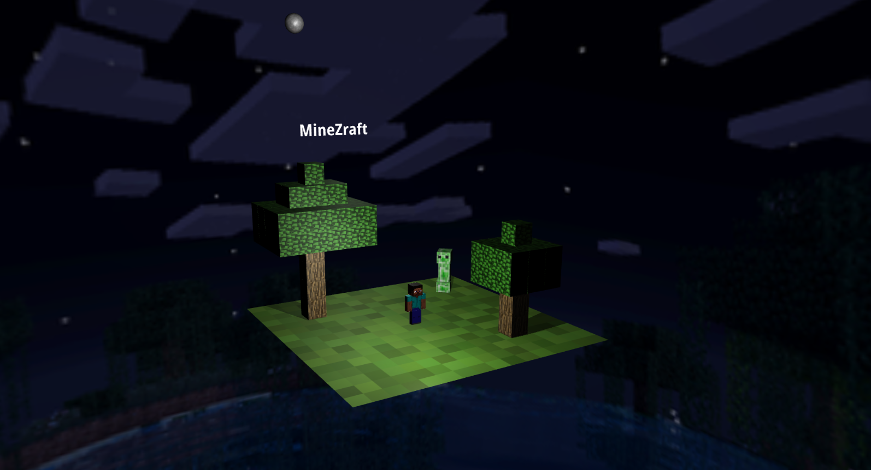

**Figure 9 Skybox night**

1. **Orbiting Objects**
   1. Sun

Sun is visible only when the active skybox is day

|  |  |
| --- | --- |
| Property | Value |
| Geometry Type | Sphere |
| Radius | 15 |
| Width Segment | 64 |
| Height Segment | 64 |
| Material Type | Mesh Phong Material |
| Color | #ffd500 |
| Position | Vector3(140, 280, -600) |
| Texture Map |  |

* 1. Moon

Moon is visible only when the active skybox is night

|  |  |
| --- | --- |
| Property | Value |
| Geometry Type | Sphere |
| Radius | 15 |
| Width Segment | 64 |
| Height Segment | 64 |
| Material Type | Mesh Phong Material |
| Color | #ffffff |
| Receive Shadow | No |
| Position | Vector3(140, 280, -600) |
| Texture Map |  |

These Orbiting objects will have interaction, where if user press/hold the space bar, the sun/moon will be orbiting around the center of the ground where steve stands.



**Figure 10 Sun**



**Figure 11 Moon**

**References**

https://www.brusheezy.com/textures/49324-surface-of-the-sun-texture

https://www.solarsystemscope.com/textures/download/8k_mercury.jpg

https://encrypted-tbn0.gstatic.com/images?q=tbn:ANd9GcS6nHCcQ1mkXzidszoa-pzvJQZh3x7AmivS5g&usqp=CAU

https://i.pinimg.com/originals/12/3f/f2/123ff2fe58086262ea9aad1811ffd2e8.jpg

https://static.planetminecraft.com/files/image/minecraft/texture-pack/2021/730/14974571-dirtpack_m.jpg

https://www.filterforge.com/filters/11635-v7.jpg

https://encrypted-tbn0.gstatic.com/images?q=tbn:ANd9GcTQ9Oq1x2iOXtFTVP30dV9uxI-o_HvMIYLiMw&usqp=CAU

https://sketchfab.com/3d-models/minecraft-steve-cb228dcc137042cc9a3dc588758cc6e9

https://media.minecraftforum.net/attachments/146/148/635767022736998562.png

Here are the **rules** that you must follow to create your project:

1. Use **appropriate software** for this subject based on **Sistem Praktikum** that can be downloaded from Binusmaya.
2. Collect **appropriate files** for this subject based on **Sistem Praktikum** that can be downloaded from Binusmaya.
3. Include the **other files** that can support your project, such as:
   * All files in your project.
   * Other files (image, audio, video, etc.) used in your project.
   * *.doc file (documentation of your project) that contains all pages in your project, reference links of additional files (image, audio, video, etc.) used in your project, the description about how to use your application, etc.

**If you do not understand, please ask your assistant! Do not make your own assumption!**