GIAC Enterprises
Firefox Web Browser Project

Update to Project Plan
ISE 6100 – Security Project Practicum
Authors

Jon Mark Allen, jonmark@allensonthe.net
Roderick Currie, roderick.h.currie@gmail.com
Seth Polley, coolfrogcatcher2001@gmail.com



Original Project Plan
The following project outline was created at the beginning of the project. Task durations were based on an optimistic estimate.
Fuzzing Firefox
Assigned to: Jon Mark
- Sully fuzzing – 2 days
  - Mac Fuzzing
  - Windows fuzzing
- Peach fuzzing – 2 days
  - Mac Fuzzing
  - Windows fuzzing
- Codenomicon fuzzing – 2 days
  - Mac Fuzzing
  - Windows fuzzing
- Fuzzing Summary – 4 days

Privacy Comparisons
Assigned to: Seth
- Firefox connections – 3 days
  - Outbound connections seen via Little Snitch
  - Outbound connections seen via pcap
- Opera connections – 3 days
  - Outbound connections seen via Little Snitch
  - Outbound connections seen via pcap
- Privacy Summary – 4 days

Firefox Management
Assigned to: Rod
- Deployment – 4 days
  - MSI (Windows Only)
  - Mozilla config files
  - RR (Rapid release)
  - ESR (Extended Support Release)
- Add-ons – 1 day
- Policy Management – 4 days
  - Restrictions
  - Certificate Authorities
  - Proxies
- Management Summary – 4 days

The team also accounted for an additional period of approximately seven days to compile its findings, publish the final paper, and create a CIO briefing of the team’s conclusions.

Modifications to Project Plan
As the project unfolded, it was found that several action items took longer than had been expected. As such, the overall project schedule shifted to the right.
The team had originally planned on finishing the research phase of the project by June 21st, but as illustrated in the v2 and v3 work schedules, research continued until June 27th. This resulted in the testing phase being pushed back to June 28th, rather than the original planned start date of June 20th. Consequently, documenting our findings and summarizing our research did not begin until July 1st, more than halfway through the project timeline. This stage had originally been planned to begin a week earlier.
Furthermore, towards the end of the project, the team discussed the addition of a new set of action items pertaining to GIAC Advisory Board interviews. It was decided that interview questions should be developed and shared with GIAC advisors, and the responses should be documented for inclusion in the project. This late addition can be found on the v3 version of the tracking spreadsheet, and spans the period from July 7th to July 12th. The final project deadline is July 14th.
A modified list of project plan deliverables is provided below…

Fuzzing Firefox
Assigned to: Jon Mark
- Sully fuzzing – Planned: 2 days // Actual: 4 days
  - Mac Fuzzing
  - Windows fuzzing
- Peach fuzzing – Planned: 2 days // Actual: 4 days
  - Mac Fuzzing
  - Windows fuzzing
- Codenomicon fuzzing – Planned: 2 days // Actual: 4 days
  - Mac Fuzzing
  - Windows fuzzing
- Fuzzing Summary – Planned: 4 days // Actual: 8 days

Privacy Comparisons
Assigned to: Seth
- Firefox connections – Planned: 3 days // Actual: 5 days
  - Outbound connections seen via Little Snitch
  - Outbound connections seen via pcap
- Opera connections – Planned: 3 days // Actual: 5 days
  - Outbound connections seen via Little Snitch
  - Outbound connections seen via pcap
- Privacy Summary – Planned: 4 days // Actual: 8 days

Firefox Management
Assigned to: Rod
- Deployment – Planned: 4 days// Actual: 7 days
  - MSI (Windows Only)
  - Mozilla config files
  - RR (Rapid release)
  - ESR (Extended Support Release)
- Add-ons – Planned: 1 day// Actual: 1 days
- Policy Management – Planned: 4 days// Actual: 2 days
  - Restrictions
  - Certificate Authorities
  - Proxies
- Management Summary – Planned: 4 days// Actual: 8 days

GIAC Advisory Board Interviews (New Item)
Assigned to: Team
- Development of Interview Questions – Planned: 2 days
- Conduct Interviews – Planned: 3 days
- Document Findings – Planned: 2 days

Work Schedules
The Microsoft Excel work schedule tracker had to be updated as the project schedule shifted. The 1st, 2nd, and 3rd versions of the work schedule are each provided below for comparison.
Appendix A – Project Work Schedule v1

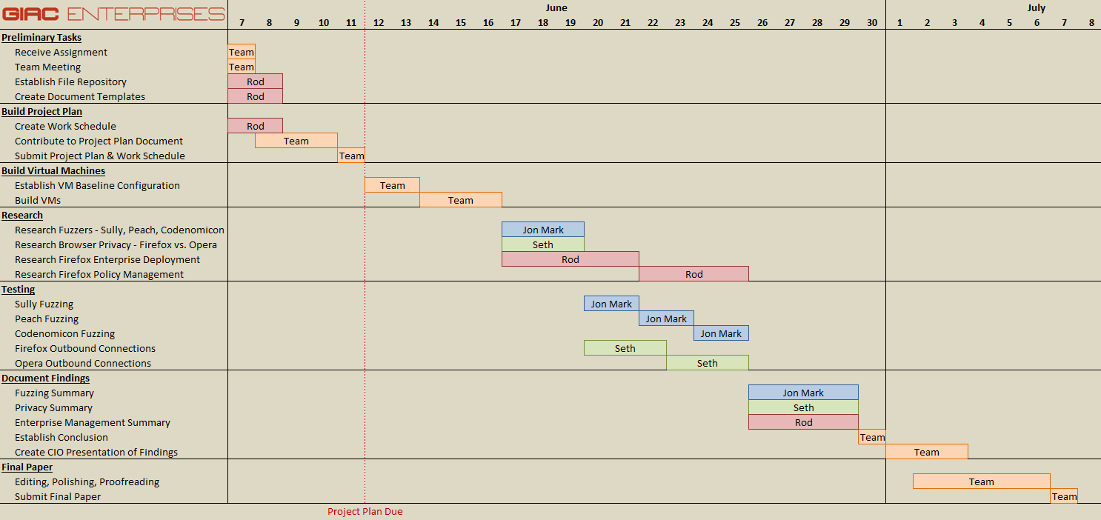

Appendix B – Project Work Schedule v2

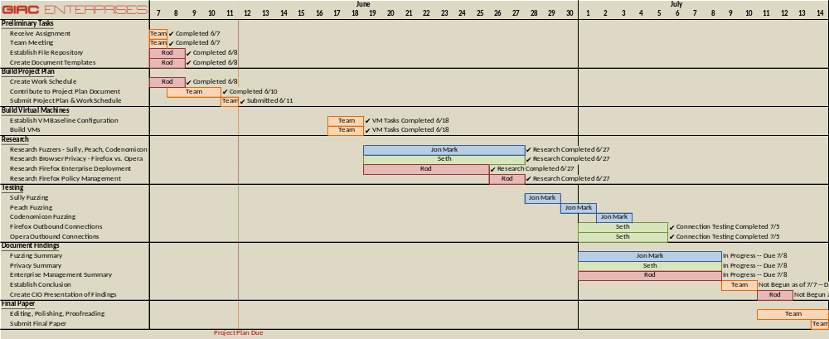

Appendix C – Project Work Schedule v3

