GIAC Enterprises
Firefox Web Browser Project
ISE 6100 – Security Project Practicum

CIO Recommendations

Authors

Jon Mark Allen, jonmark@allensonthe.net
Roderick Currie, roderick.h.currie@gmail.com
Seth Polley, coolfrogcatcher2001@gmail.com

Advisor: Stephen Northcutt
Accepted: July 10, 2016
Abstract

The team has been presented with a challenging scenario involving the fictitious company, GIAC Enterprises. GIAC Enterprises is a growing business of approximately 1,000 employees, and is a global leader in the supply of fortune cookie sayings. GIAC employees utilize MacBook Pro laptops as an enterprise standard. However, the company currently has no standard web browser. With a goal to increase the overall security posture of its employee endpoints, GIAC Enterprises is exploring the use of Mozilla Firefox as an enterprise standard for web browsing. Our team has been tasked with assessing whether the adoption of Firefox as an enterprise standard browser makes sense from a security standpoint.

Introduction
At the request of the CIO, this Tiger Team has been assigned the task of assessing the suitability of Mozilla Firefox for adoption as the corporate standard for web browsing at GIAC Enterprises. At the completion of our examination, we found Mozilla Firefox to be a good choice for implementation as the corporate standard web browser, and one that would increase the overall security posture of the employee endpoints.
Our assessment examined four areas to reach our conclusion: privacy, manageability, secure coding practices (via fuzzing), and an overall risk analysis of the browser.

Privacy
The overall privacy of user browsing activities and their associated connections continues to be an increasing concern for organizations. The organizational concern is two-fold: the individual privacy rights of the employees (where appropriate) and the confidentiality and integrity of outbound browsing connections, for both personal and business use. To this effect, the team captured and compared outbound connections from both Firefox and Opera to determine if either browser’s behavior might compromise or conversely better protect the privacy of the organization and its employees. Based upon the connections observed, the team concurs with the CIO’s previous assessment of the connection differences between these browsers, and the team recommends Firefox over Opera for privacy concerns.
To begin the assessment of outbound connections from Opera and Firefox, both browsers were installed on Mac OS X 10.11.5 (El Capitan) 64-bit edition. The latest version of Opera (as of this report: 38.0.2220.31) was used and compared against Firefox v 46.0.1, which matches the CIO’s laptop at the time of her request. To ensure impartial testing moving forward, the automatic updating was disabled in both Firefox and Opera.
Browser connections were captured using two sources at separate times: a network packet analyzer (Wireshark) and a Mac host-based firewall (Little Snitch). Each browser was launched and allowed to run alone for five minutes, while Wireshark captured all network traffic. After traffic from both browsers had been captured in this way, Little Snitch was installed and each browser was again launched and allowed to run alone for another five minutes, with Little Snitch recording outbound requests.
Comparing the outbound connections through these two tools, there was a considerable difference noted between Opera and Firefox. The web requests intercepted via Little Snitch showed few dissimilarities, but analysis of the Wireshark traffic revealed a significant increase in the number of DNS requests made, which would not be shown through Little Snitch. Firefox made only three unique calls (two to Google and a third to Mozilla), Opera quickly exceeded this with about nine unique calls (many to Amazon, Facebook, Google, and Opera). Though these are often considered trusted sources, Amazon (Amazon Web Services and CloudFront content delivery network) and Facebook are frequently associated with ad services, external hosted solutions, and general privacy concerns. As Opera initiated three times the DNS outbound connections than Firefox in a short five-minute window, the CIO’s assessment of the connection differences seems to be well founded, and the team recommends Firefox based on these results.

Enterprise Management
GIAC Enterprises desires a browser which is not only secure, but that can also be deployed and maintained from the enterprise level with minimal downtime, thereby maximizing user productivity and minimizing frustration.
The team’s research and testing found that the Extended Support Release (ESR) variant of Firefox would be a good fit for an enterprise the size of GIAC. The ESR model gives the enterprise a fully-supported version of Firefox for slightly over one year (54 weeks) at a time (Mozilla Developer Network, 2016). This gives the enterprise plenty of time to perform testing and deployment without worrying about support being dropped.
Enterprise installation of Firefox was found to be relatively easy, with the redistributable installer first being downloaded to the enterprise network for initial testing, before being silently pushed out to user workstations from a central server. Once installed on user workstations, Firefox may be configured according to enterprise policy to tighten up security of the browser. The use of centralized user browser configuration allows an enterprise to lock down the browser to enhance its security posture. Some security related settings which could be set include disabling the internal PDF viewer, disabling JavaScript, and disabling the Flash plugin. Enterprise administrators can also specify whether to use the built-in auto-updater, or whether updates will be pushed out manually from the enterprise server. Additionally, enterprise privacy concerns can be addressed by disabling reporting of health, telemetry, or usage data, and by disabling crash reporting to Mozilla.
The team also explored the installation of browser extensions in Firefox. Because of the security concerns surrounding untrusted and unofficial browser extensions, Mozilla recently began implementing an extension signing program. Beginning with Firefox ESR 45.0 in March 2016, Mozilla began requiring all extensions to be signed before allowing installation in Firefox (MozillaWiki, 2016). This solution represents a big step forward in protecting Firefox users from malicious add-ons. However, it is also possible for enterprise administrators to explicitly disable the signing checks for in-house extensions which are known to be non-malicious.
The team found that the enterprise management capabilities of Firefox ESR would suit the needs of GIAC Enterprises, particularly from a security standpoint.

Fuzzing
In order to evaluate the security of the source code in Mozilla Firefox, our team performed a cost-benefit analysis of full-scale fuzzing activities to determine if this could help GIAC Enterprises improve the security posture of our organization, as well as Firefox as a whole. Based on the team’s analysis, we do not recommend requiring fuzz testing of Firefox, but this is an activity that could be added as future budget allows.
Four fuzzing products were included in the analysis: two open source solutions (Sulley and Peach Community) and two commercial solutions (Peach Professional and Codenomicon Defensics). The team talked with sales staff of both Codenomicon and Peach Fuzzer for budgetary, ballpark cost estimates for their products. Both products are licensed on an annual subscription model, and costs will vary based on the number of protocols to be fuzzed. The team also interviewed external security professionals with experience in fuzzing, and have incorporated those results into our labor estimates.
 | Sulley | Peach  Community | Peach  Professional | Codenomicon
Implementation - Licensing (Year 1) | $- | $- | $21,000.00 | $15,000.00
Implementation - Labor ($45/man-hour) | $10,000.00 | $15,000.00 | $4,000.00 | $4,000.00
Software Maintenance (Year 2) | $- | $- | $21,000.00 | $15,000.00
Ongoing Labor (Year 2) ($45/man-hour) | $3,750.00 | $7,500.00 | $2,000.00 | $2,000.00
Software Maintenance (Year 3) | $- | $- | $21,000.00 | $15,000.00
Ongoing Labor (Year 3) ($45/man-hour) | $3,750.00 | $7,500.00 | $2,000.00 | $2,000.00
Total Estimated 3-Year Costs | $17,500.00 | $30,000.00 | $71,000.00 | $53,000.00

Internal labor cost for Security Engineers was based on GIAC Enterprises’ PMO chargeback rate of $45/hour. “Ongoing labor” would include creating new data models and tests as time passes. Running the same tests on new versions of Firefox is not included in the “ongoing labor” costs, as it would not contribute significantly in this area.
Should management decide to continue to pursue fuzzing across the enterprise, the team recommends hiring a Security Engineer with at least 5 years of experience in fuzzing applications, and would recommend Sulley over the other three options, due both to product cost and continued development status.

Risk Analysis
When considering a security-relevant change to the operating environment, it is important to perform a measured risk analysis. The risk analysis process takes into account the current level of risk versus the predicted post-change level of risk. Any change which lowers the organization’s overall risk exposure makes security sense.
In the current environment in which a variety of different web browsers are used, the team found that GIAC is exposed to some 804 recently documented (last 12 months) web browser vulnerabilities (NIST, 2016). It can therefore be said that the likelihood of an attacker gaining access to the GIAC network via a web browser vulnerability is currently high. The team found that standardizing on Mozilla Firefox would reduce the number of vulnerabilities by 74%. Subsequently, the likelihood of a successful web browser compromise becomes much lower.
While the impact of a compromise remains the same in either scenario, the lowering of the likelihood shifts the overall risk factor to the GIAC network from high (red) to medium (yellow), as illustrated in the risk matrix below:
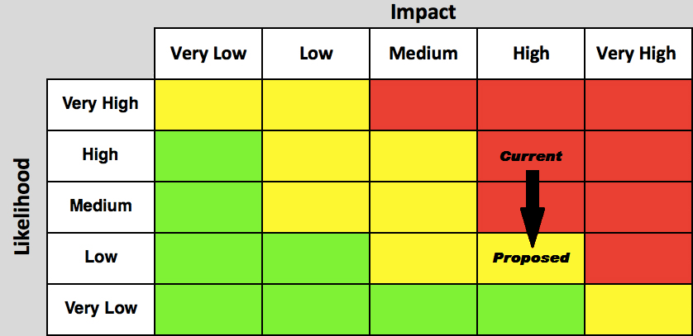

Conclusion
This team explored the possibilities of selecting Mozilla Firefox as the enterprise standard web browser for GIAC Enterprises. This exploration covered four areas of concern: privacy, manageability, secure coding practices, and an overall risk analysis. Privacy of the browser was reviewed in comparison with Opera, based on outbound requests and connections, and found to be more favorable in Firefox. The team researched and tested enterprise deployment and management of Firefox, and found Firefox ESR to be a good fit for GIAC Enterprises. The team also explored fuzz testing and its merits in making a security-based recommendation regarding enterprise implementation of the Firefox web browser. After performing a cost-benefit analysis, the team concluded that fuzzing is not a cost-effective approach at this time. Finally, after performing a risk analysis, the team concluded that making the shift to Firefox as an enterprise standard will lessen the attack surface of the GIAC network and will reduce overall risk to GIAC’s data.

