1. click on “Synchronize CoAs” red button
2. Click on the newly loaded CoA i.e TLCOA2023. This leads you to CoAs screen.

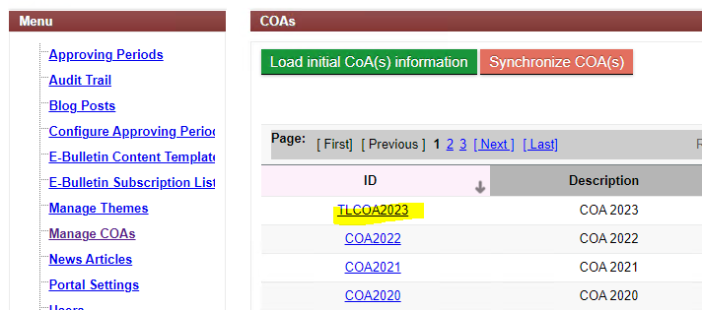

1. Click on "Load Detailed CoA" green button

