CS 340 Project Two README
Grazioso Salvare Rescue Dashboard
Roderick Scott

About the Project/Project Title
The Grazioso Salvare Rescue Dashboard is a client/server application that helps the client identify shelter dogs that may be good candidates for search-and-rescue training. The dashboard connects a Dash web interface to Austin Animal Center Outcomes data stored in MongoDB. It combines interactive rescue-type filters, a responsive data table, a breed distribution chart, and a geolocation map so users can explore records without working directly in the database.

Motivation
Grazioso Salvare needs a fast and intuitive way to narrow a large shelter data set to animals that match different rescue profiles. The dashboard reduces manual searching and keeps database-access logic reusable by placing MongoDB operations in the AnimalShelter CRUD module instead of embedding database code throughout the dashboard.

Getting Started
- Open the project in Codio and confirm that MongoDB is running.
- Confirm that the Austin Animal Center data is loaded into the aac database and animals collection.
- Confirm that the aacuser account has readWrite access to the aac database.
- Place CRUD_Python_Module.py, ProjectTwoDashboard.ipynb, and the Grazioso Salvare logo in the code_files directory.
- Enter the working aacuser credentials in the dashboard notebook and run the notebook cell.
- If a previous Dash application is using the default port, run Project Two on another available port such as 8052.
- Test Reset, Water Rescue, Mountain or Wilderness Rescue, and Disaster or Individual Tracking.

Installation
The project was developed in Codio with Jupyter Lab. The main software and libraries used are listed below.
Tool / Library | Purpose and Rationale
MongoDB | Stores the AAC shelter data as flexible documents and works well with Python through PyMongo.
PyMongo | Provides the Python driver used by the CRUD module to authenticate and query MongoDB.
Dash / JupyterDash | Provides the dashboard view and callback-based controller structure.
Dash DataTable | Displays sortable, filterable, paginated, and selectable animal records.
Plotly Express | Creates the dynamic breed distribution chart.
Dash Leaflet | Displays animal coordinates on an interactive map.
Pandas | Converts MongoDB query results into DataFrames used by the table and charts.

Usage
The dashboard begins in the Reset state with an unfiltered view of the AAC collection. The rescue-type radio buttons act as controller inputs. When the selected rescue type changes, a Dash callback sends the appropriate MongoDB query through the CRUD module. The returned records replace the data-table contents, and both charts update from the displayed records.
Reset: Runs an empty query and restores the complete data set.
Water Rescue: Filters the database for the implemented water-rescue profile using breed, sex, and age criteria.
Mountain or Wilderness Rescue: Filters the database for the implemented mountain/wilderness profile.
Disaster or Individual Tracking: Filters the database for the implemented disaster/tracking profile.
The data table also supports pagination, sorting, text filtering, and single-row selection. Selecting a row changes the Leaflet marker to that animal’s coordinates. The breed distribution chart is built from the same displayed records, so it changes automatically when a rescue filter is applied.

Code Example
The core filtering pattern converts the selected rescue type into a MongoDB query and retrieves matching documents through the CRUD module:
@app.callback(
[Output("datatable-id", "data"),
Output("datatable-id", "selected_rows")],
[Input("filter-type", "value")]
)
def update_dashboard(filter_type):
if filter_type == "Water":
query = {
"animal_type": "Dog",
"breed": {"$in": [
"Labrador Retriever Mix",
"Chesapeake Bay Retriever",
"Newfoundland"
]},
"sex_upon_outcome": "Intact Female",
"age_upon_outcome_in_weeks": {"$gte": 26, "$lte": 156}
}
else:
query = {}
records = db.read(query)

Tests
The dashboard was tested in all four required states. Reset returned the unfiltered collection. Water Rescue, Mountain or Wilderness Rescue, and Disaster or Individual Tracking each returned filtered records and caused the data table, breed distribution chart, and geolocation map to refresh. The screenshots below provide proof of these executions.

Challenges and Solutions
MongoDB authentication: A placeholder password caused an AuthenticationFailed error. Using the working aacuser credentials resolved the issue.
Module naming: The starter notebook referenced animal_shelter, while the completed Project One module was CRUD_Python_Module.py. Updating the import allowed the dashboard to use AnimalShelter.
Dash port conflicts: Earlier Dash applications were still using port 8050. Running Project Two on port 8052 resolved the Address already in use error.
ObjectId serialization: Dash cannot serialize MongoDB ObjectId values directly, so the _id column is removed before table data is created.
Dynamic map selection: The table uses single-row selection and defaults to the first row so the map always has a valid record to display.

Contact
Roderick Scott

Screenshots
The following screenshots show the required logo and unique identifier together with the selected rescue filter, interactive table, breed chart, and geolocation map.
Figure 1. Reset / Unfiltered Dashboard
The starting state displays the complete Austin Animal Center data set and the default breed distribution and geolocation map.
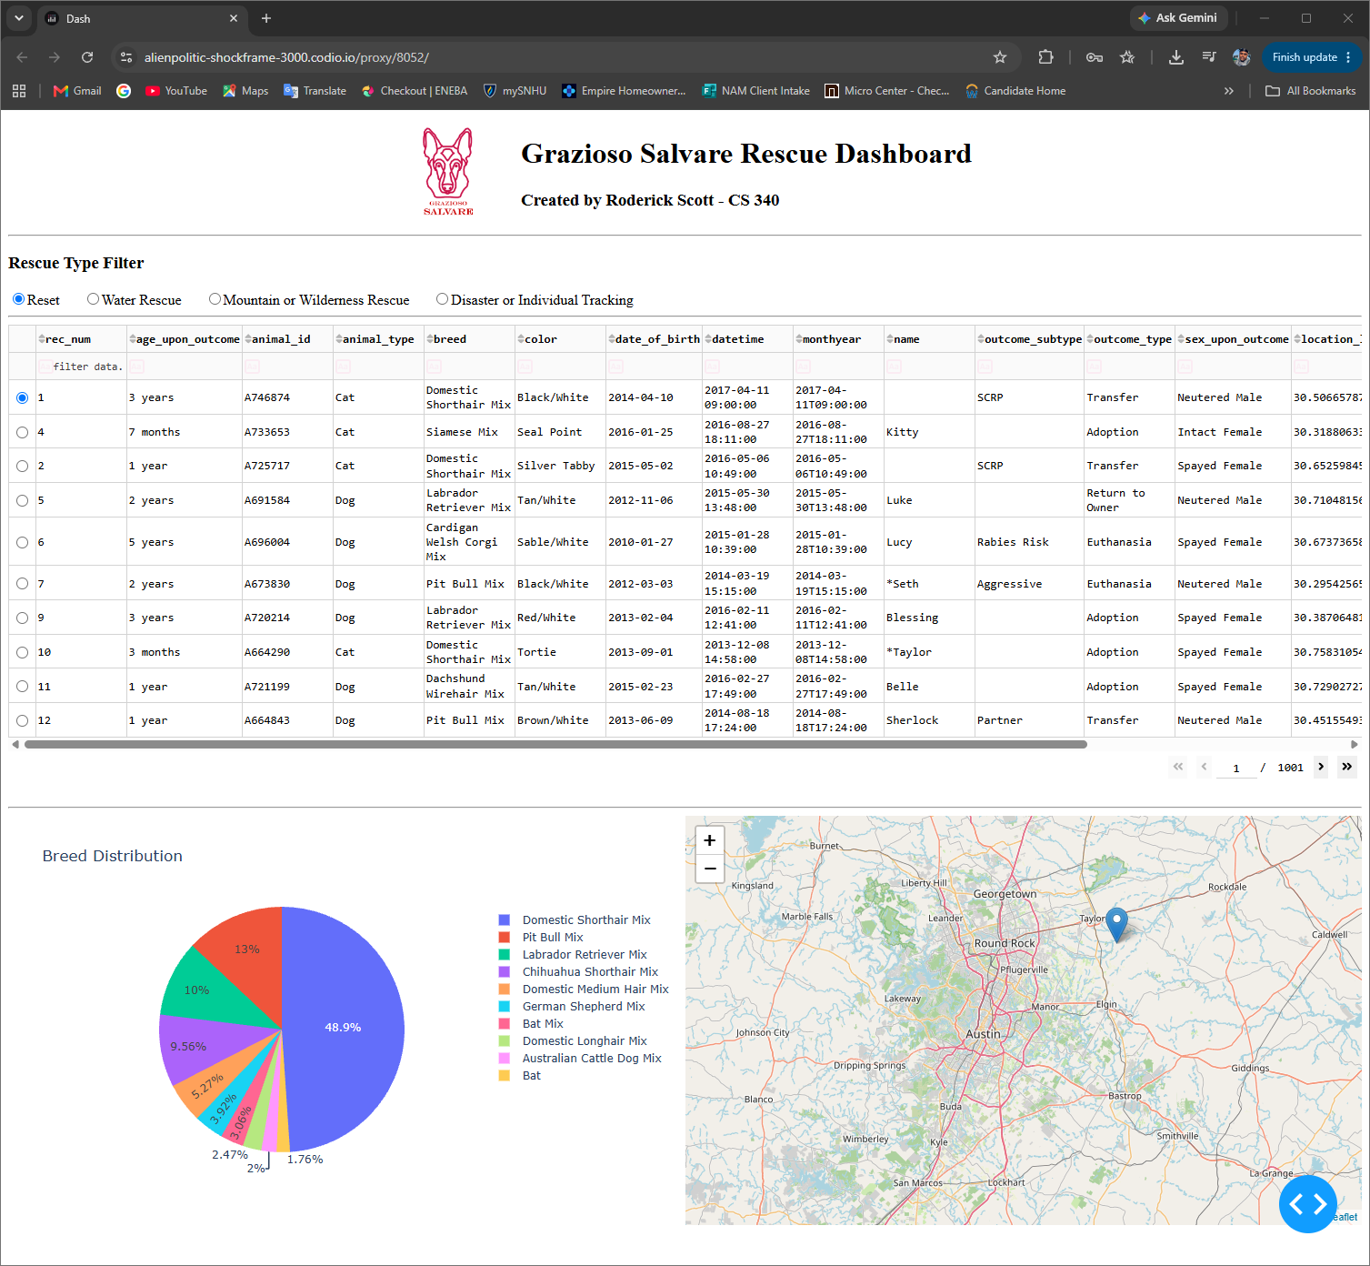
Figure 2. Water Rescue Filter
Water Rescue is selected. The data table, breed distribution chart, and map update to the matching rescue profile.
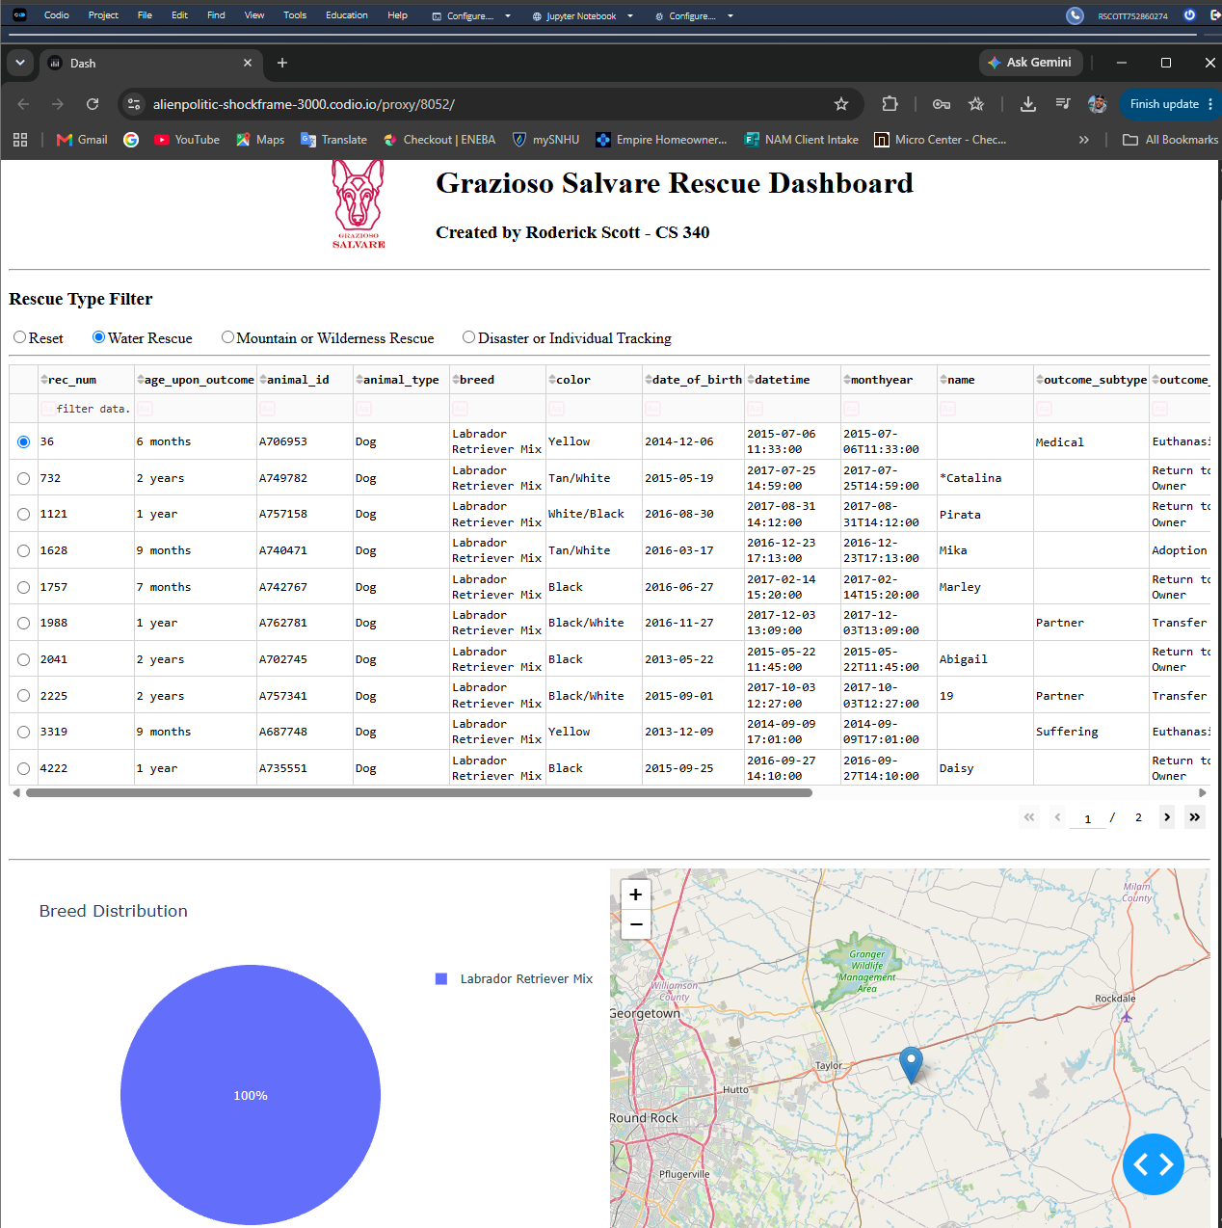
Figure 3. Mountain or Wilderness Rescue Filter
Mountain or Wilderness Rescue is selected, and all dashboard widgets respond to the filtered MongoDB query.
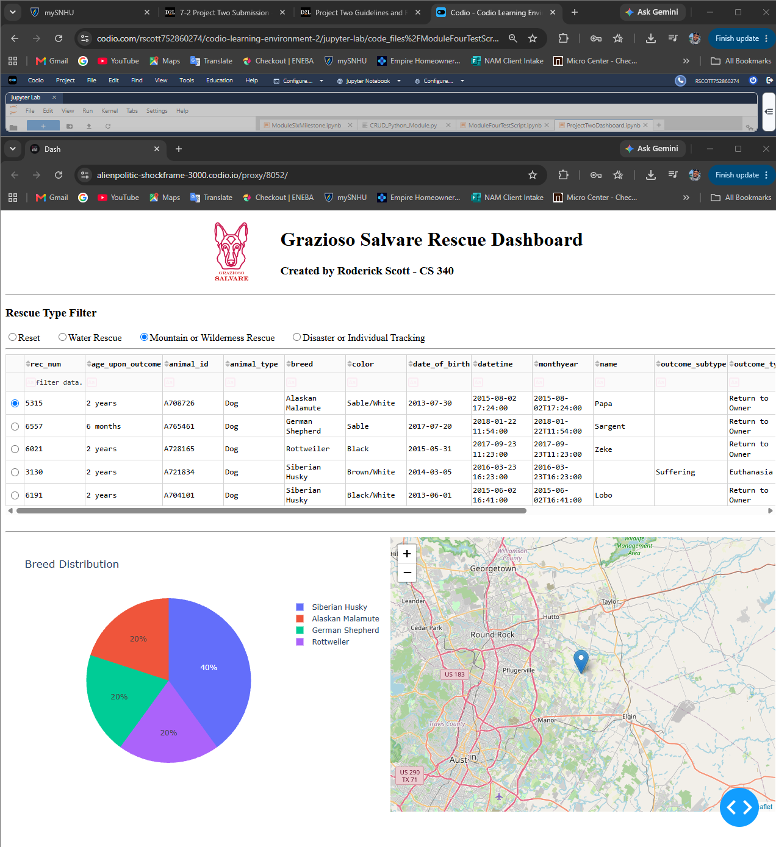
Figure 4. Disaster or Individual Tracking Filter
Disaster or Individual Tracking is selected, and the table, chart, and map display the matching records.
