Requirements Document

**CLIENT WEBSITE**

**http://www.dinsmorelandscape.com/**

**CLIENT DEFINITION**

Dinsmore Landscape Company is a full-service commercial landscape company headquartered in Santa Clara, California and operating in the southern region of the San Francisco Bay Area. They are a privately-held company of 100 employees that generates $100M in revenue. They perform landscape maintenance and enhancement work for property management companies and homeowner associations. They are a referral-only business, not employing a sales team. Their brand is customer service, responsiveness, and quality.

**OBJECTIVES/TASKS FOR THE WEBSITE**

Currently, in the eyes of the owner, the website has been an afterthought. The owner uses the telephone and his network of personal contacts to conduct business. New business is primarily referrals and comes via telephone. New clients of Dinsmore are given the direct telephone numbers of all of the responsible account managers. Therefore, this website update will focus on users who do not yet have direct phone numbers, which include prospective clients and non-clients who happen to interact with the properties.

Business Objectives:

1. increase new business
2. add a new customer service input path

User Objectives:

1. obtain general information about the company
2. report an issue

Design Objectives:

1. promote the quality and responsiveness brand
2. direct the user to call or email the company
3. make the site more vibrant
4. keep the site easy to maintain

**USER DEFINITION**

Primary User: Property Manager, prospective Dinsmore client

This user just heard about Dinsmore for the first time at a trade show and would like to find out if they are qualified to manage the landscape maintenance at a particular corportate office park, taking over for the current landscapers who are doing a poor job of keeping the property looking good. If Dinsmore is qualified, this user would like to request a quote.

Secondary User: HOA Tenant

This user lives in an apartment complex that is maintained by Dinsmore. He knows this because he has seen their trucks. He wants to request that they come by and trim the trees outside of his unit the next time they are around. He is younger and prefers to use the Web.

**TARGET TECHNOLOGY PLATFORM**

Most users are property managers. Their time is spent in the office on desktop computers handling paperwork. Their machines use the Internet Explorer browser because that is the only browser that their company’s internal applications are approved to run on.

**CLIENT’S EXISTING ASSETS**

There is no common visual design across company assets (logos, taglines, colors). Their brand of quality and customer service is only minimally conveyed in these assets.

1. website:

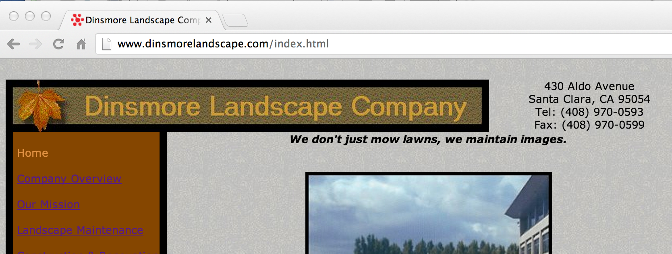

The information architecture is straightforward, designed around the services offered. The website navigation is easy, with a persistent left navigation and footer. But the color palette makes the entries difficult to read. The content text is dated in some places and overly-brief in others. And most of the image content is not engaging and looks grainy when displayed on a standard sized monitor. Generally these things along with no animation lead to a pretty dull presentation. And although the site does do a fair at describing the company, it fails to differentiate it from its competitors.

1. brochure: 3. business cards:

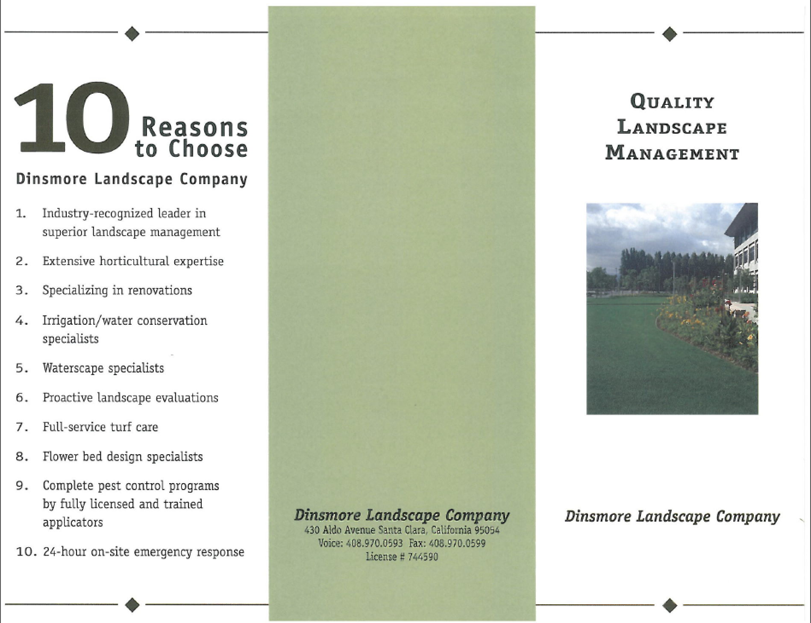 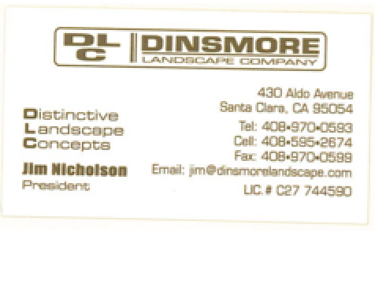

**WEBSITE RECOMMENDATIONS**

1. Convey a common look and feel with other printed material
   1. prominently display the logo
   2. use the logo’s color palette as webpage boilerplate
   3. choose the most desirable tagline and display it
   4. replace the favicon with the logo
2. Promote the “quality” message
   1. include a neutral/gray color component
   2. use a serif font
   3. include employee qualifications/bios
   4. include client testimonials
   5. highlight trade organization membership
3. Promote the “responsiveness” message
   1. describe the client experience, highlighting direct phone contact
   2. add a customer service email address
   3. include a web form for trouble reporting or general inquiry
4. Liven up the site
   1. replace the autumn colors with spring or summer colors
   2. include better quality images
   3. include bigger images
   4. include a changing landing image
   5. embellish selection effects beyond the existing vlink color changes
5. Improve maintainability
   1. add CSS, divs, and classes
   2. remove time-sensitive material