REPORT: ANALYSIS OF THE OTTER GROOMING PATTERNS

2022-05-12

## Introduction

load("classdata.RData")  
otter = as.data.frame(otter)  
head(otter)

## group season time groomer groomee frequency  
## 1 A N 127 F1 M2 6  
## 2 A N 127 F1 M3 1  
## 3 A N 127 F1 M4 2  
## 4 A N 127 M2 F1 0  
## 5 A N 127 M2 M3 0  
## 6 A N 127 M2 M4 0

otter = as_tibble(otter)  
head(otter)

## # A tibble: 6 × 6  
## group season time groomer groomee frequency  
## <chr> <chr> <dbl> <chr> <chr> <dbl>  
## 1 A N 127 F1 M2 6  
## 2 A N 127 F1 M3 1  
## 3 A N 127 F1 M4 2  
## 4 A N 127 M2 F1 0  
## 5 A N 127 M2 M3 0  
## 6 A N 127 M2 M4 0

# Adding column based on other column:  
otter_df = otter %>%  
 mutate(groomer_gender = case_when(  
 startsWith(otter$groomer, "F") ~ "FEMALE",  
 startsWith(otter$groomer, "M") ~ "MALE"  
 ))%>%  
 mutate(groomee_gender = case_when(  
 startsWith(otter$groomee, "F") ~ "FEMALE",  
 startsWith(otter$groomee, "M") ~ "MALE"  
 ))  
otter_df %>%   
 head() %>%  
 kable()

| group | season | time | groomer | groomee | frequency | groomer_gender | groomee_gender |
| --- | --- | --- | --- | --- | --- | --- | --- |
| A | N | 127 | F1 | M2 | 6 | FEMALE | MALE |
| A | N | 127 | F1 | M3 | 1 | FEMALE | MALE |
| A | N | 127 | F1 | M4 | 2 | FEMALE | MALE |
| A | N | 127 | M2 | F1 | 0 | MALE | FEMALE |
| A | N | 127 | M2 | M3 | 0 | MALE | MALE |
| A | N | 127 | M2 | M4 | 0 | MALE | MALE |

Before proceeding the Groomer and Gromee otters were paired together to form mates column:

otter_df = otter_df %>%   
 mutate(otter_df, mates = paste(otter_df$groomer, otter_df$groomee))  
  
otter_df %>%   
 head() %>%  
 kable()

| group | season | time | groomer | groomee | frequency | groomer_gender | groomee_gender | mates |
| --- | --- | --- | --- | --- | --- | --- | --- | --- |
| A | N | 127 | F1 | M2 | 6 | FEMALE | MALE | F1 M2 |
| A | N | 127 | F1 | M3 | 1 | FEMALE | MALE | F1 M3 |
| A | N | 127 | F1 | M4 | 2 | FEMALE | MALE | F1 M4 |
| A | N | 127 | M2 | F1 | 0 | MALE | FEMALE | M2 F1 |
| A | N | 127 | M2 | M3 | 0 | MALE | MALE | M2 M3 |
| A | N | 127 | M2 | M4 | 0 | MALE | MALE | M2 M4 |

otter_df = otter_df %>%  
 mutate(mating_type = case_when(  
 startsWith(otter_df$groomer_gender, "F")& startsWith(otter_df$groomee_gender, "M") ~ "HETEROSEXUAL",  
 startsWith(otter_df$groomer_gender, "M")& startsWith(otter_df$groomee_gender, "F") ~ "HETEROSEXUAL",  
 startsWith(otter_df$groomer_gender, "F")& startsWith(otter_df$groomee_gender, "F") ~ "HOMOSEXUAL",  
 startsWith(otter_df$groomer_gender, "M")& startsWith(otter_df$groomee_gender, "M") ~ "HOMOSEXUAL",  
 ))  
otter_df %>%   
 head() %>%  
 kable()

| group | season | time | groomer | groomee | frequency | groomer_gender | groomee_gender | mates | mating_type |
| --- | --- | --- | --- | --- | --- | --- | --- | --- | --- |
| A | N | 127 | F1 | M2 | 6 | FEMALE | MALE | F1 M2 | HETEROSEXUAL |
| A | N | 127 | F1 | M3 | 1 | FEMALE | MALE | F1 M3 | HETEROSEXUAL |
| A | N | 127 | F1 | M4 | 2 | FEMALE | MALE | F1 M4 | HETEROSEXUAL |
| A | N | 127 | M2 | F1 | 0 | MALE | FEMALE | M2 F1 | HETEROSEXUAL |
| A | N | 127 | M2 | M3 | 0 | MALE | MALE | M2 M3 | HOMOSEXUAL |
| A | N | 127 | M2 | M4 | 0 | MALE | MALE | M2 M4 | HOMOSEXUAL |

The following project was used to analyze the grooming patterns of Nothern America’s River Otters. The dataset had the following features:

Feature

Description

Group

This was a group of otters that was watched at one time. For instance group A had one female and 3 males

Season

There were only two categories; whether it was the breeding season or not

Time

The time in minutes the group was watched

Groomer

The otter that did the grooming. They were named by gender and a number was asssigned

Groomee

The otter that was groomed. The same naming convention was as the groomers

## objectives

The project had the following objectives:

Determine whether animals in each group groomed equally

Identify any preferences in terms of grooming in each group.

Determine if males groomed more than females

Mark any differences in the grooming rates in each season

## Tools Used

The analysis of the otter dataset was done in R and relied heavily on the Tidyverse package which included the ggplot plotting libarary that was used in the visualization that are featured in this report.

## Analysis:

### Grooming Patterns of Each Group

In the following two plots the first two objectives are met, that is:

Determine whether animals in each group groomed equally

Identify any preferences in terms of grooming in each group.

The first objective wa to determine if the animals in each group groomed equally. For instance, in Group A there was one female and three males. Did the female groom equally with all the females? The female otter groomed with all the males in the group, however, the highest number of grouping was done with M2. The least number of grouping was done between the males. The otters thefore do not groom equally between each other.

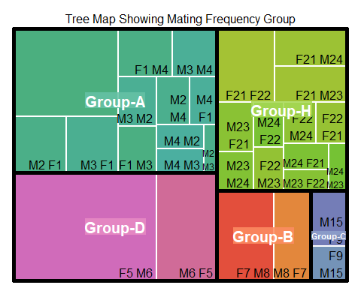

We also note that the frequency of grooming has reduces significantly when it is not the breeding season. Although the pattern of which otter grooms one with the other remains the same. From the plot below we note that the otters maintain their preference in the partners they groom with.

## No summary function supplied, defaulting to `mean_se()`  
## No summary function supplied, defaulting to `mean_se()`

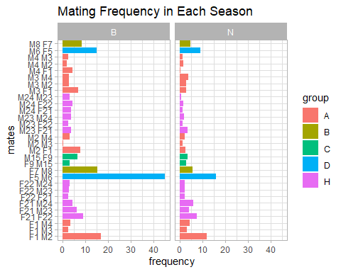

### Grooming Patterns For Each Gender:

| groomee_gender | n | prop |
| --- | --- | --- |
| FEMALE | 152 | 0.3857868 |
| MALE | 242 | 0.6142132 |

Females were observed to groomers 38.6% percent of the times.However, it is important to note that the number of males in this dataset is higher than that of females. The proportion does not change whether its the breeding season or not. The bar plot below for each group gives a more objective look at groomers for each group in each season

otter_df %>% # data # manipulation  
 ggplot()+  
 geom_bar(aes(x=season, y = frequency,   
 fill=groomer_gender), # separate by category  
 stat = "summary",   
 position="dodge")+ # make it side-by-side  
 theme_light()+facet_wrap(~group)+ggtitle("Grooming Patterns Group, Gender, and Season Wise Gender")

## No summary function supplied, defaulting to `mean_se()`  
## No summary function supplied, defaulting to `mean_se()`  
## No summary function supplied, defaulting to `mean_se()`  
## No summary function supplied, defaulting to `mean_se()`  
## No summary function supplied, defaulting to `mean_se()`

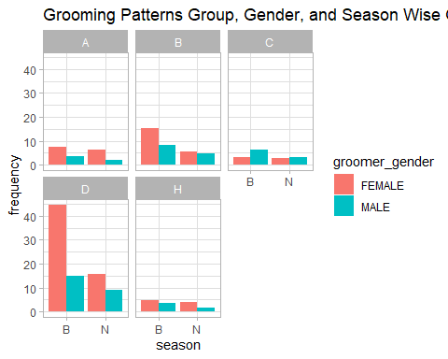

### Grooming Rates Per Season

otter_df %>% # data # manipulation  
 ggplot()+  
 geom_bar(aes(x=season, y = frequency,   
 fill=groomee_gender), # separate by category  
 stat = "summary",   
 position="dodge")+ # make it side-by-side  
 theme_light()+ggtitle("Grooming Frequency For Each Season")

## No summary function supplied, defaulting to `mean_se()`

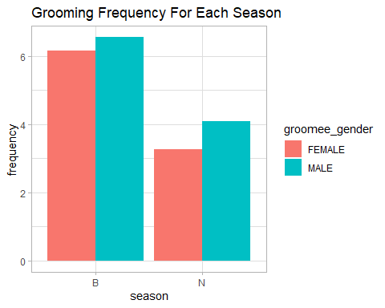

We note that the grooming frequency in the breeding season is higher, than when they are not breeding.

### Same Sex Grooming

Same Sex Grooming was also explored for each of the groups:

# create a dataset  
mating_type <- otter_df$mating_type  
group <- otter_df$group  
time <- otter_df$time  
season = otter_df$season  
data <- data.frame(mating_type,group,time, season)  
  
# Grouped  
ggplot(data, aes(fill=group, y=time, x=mating_type)) +   
 geom_bar(position="dodge", stat="identity") + facet_wrap(~season)+theme_light()+ggtitle("Observation Time for Each Group in each Season")

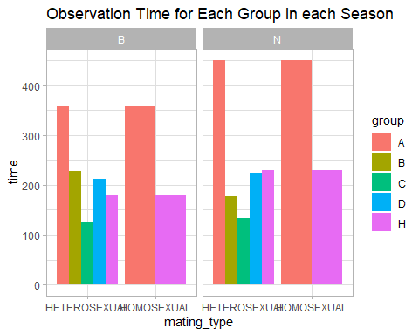

There were only two groups that displayed same sex grooming that is Group A and H In terms of time, the time of observation of the groups was shorter in the breeding season except for group B.

# create a dataset  
mating_type <- otter_df$mating_type  
group <- otter_df$group  
frequency <- otter_df$frequency  
season = otter_df$season  
data <- data.frame(mating_type,group,frequency, season)  
  
# Grouped  
ggplot(data, aes(fill=group, y=frequency, x=mating_type)) +   
 geom_bar(position="dodge", stat="identity") + facet_wrap(~season)+theme_light()+ggtitle("Grooming Frequency For Each Season")

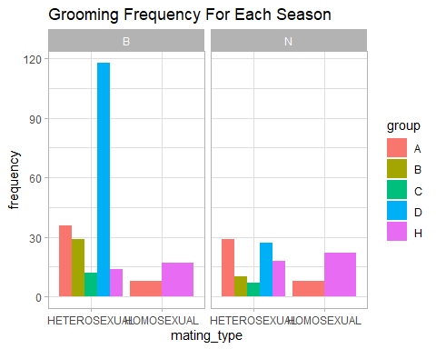

Same sex grooming was a bit higher in the Not breeding season while the opposite trend was observed in the heterosexual grooming(referring to grooming between different sexes), it was higher in the breeding season but dropped when it was not the breeding season.