REPORT: ANALYSIS OF THE OTTER GROOMING PATTERNS

2022-05-12

## Introduction

### Bacground Information

The following project was used to analyze the grooming patterns of Nothern America’s River Otters. Before doing any analysis on the dataset, it was a important to have some background information on the river residing animals. River otters can be diurnal or nocturnal, with most being more active at night.

Giant otters are only active during the day. Clawless otters are primarily nocturnal, though some individuals may be active during the day in remote areas where humans are not present. Sea otters are mostly active during the day. Feeding and grooming are the primary daily activities, which are interspersed with rest periods. Note that the claws aspects and sleeping patterns of otters are not explored for this project.

*Grooming*

To keep their fur insulating, all otters must groom it constantly. River otters spend a significant amount of time grooming, and many species have designated areas on land for drying and grooming their fur. The majority of them dry themselves vigorously by rolling on the ground or rubbing against logs or vegetation.

Researchers discovered that sea otters spend at least 11% to 48% of their day grooming. They comb their fur and remove debris with their paws and claws. They can also aerate their fur by blowing air into it and pounding the water with their feet to create foam. Because of its flexible body and loose-fitting skin, an otter can reach every part of its fur.

*The Dataset*

The dataset had the following features:

|  |
| --- |
| *Group-*This was a group of otters that was watched at one time. For instance group A had one female and 3 males  *Season -*There were only two categories; whether it was the breeding season or not  *Time -* The time in minutes the group was watched  *Groomer* - The otter that did the grooming. They were named by gender and a number was asssigned  *Groomee* - The otter that was groomed. The same naming convention was as the groomers  *Frequency* – The number of instances of grooming that occurred. |

## objectives

The project had the following objectives:

1. Determine whether animals in each group groomed equally
2. Identify any preferences in terms of grooming in each group.
3. Determine if males groomed more than females
4. Mark any differences in the grooming rates in each season

## Tools Used

The analysis of the otter dataset was done in R and relied heavily on the Tidyverse package which included the ggplot plotting libarary that was used in the visualization that are featured in this report.

## Data Engineering

Before the dataset could be summarized into plots, it was first mutated into a tibble to allow for better handling and summarizing of the data. The data was provided in the format of an R datafile.

load("classdata.RData")  
otter = as.data.frame(otter)

otter = as_tibble(otter)  
head(otter)

## # A tibble: 6 × 6  
## group season time groomer groomee frequency  
## <chr> <chr> <dbl> <chr> <chr> <dbl>  
## 1 A N 127 F1 M2 6  
## 2 A N 127 F1 M3 1  
## 3 A N 127 F1 M4 2  
## 4 A N 127 M2 F1 0  
## 5 A N 127 M2 M3 0  
## 6 A N 127 M2 M4 0

The first action that was done was to find the genders of the groomers and groomees. `Case_when` method was used to determine the genders of each otter since the first letter indicated the otter’s gender.

# Adding column based on other column:  
otter_df = otter %>%  
 mutate(groomer_gender = case_when(  
 startsWith(otter$groomer, "F") ~ "FEMALE",  
 startsWith(otter$groomer, "M") ~ "MALE"  
 ))%>%  
 mutate(groomee_gender = case_when(  
 startsWith(otter$groomee, "F") ~ "FEMALE",  
 startsWith(otter$groomee, "M") ~ "MALE"  
 ))  
otter_df %>%   
 head() %>%  
 kable()

Here is the code and results of the first step:

| group | season | time | groomer | groomee | frequency | groomer_gender | Groomie Gender |
| --- | --- | --- | --- | --- | --- | --- | --- |
| A | N | 127 | F1 | M2 | 6 | FEMALE | MALE |
| A | N | 127 | F1 | M3 | 1 | FEMALE | MALE |
| A | N | 127 | F1 | M4 | 2 | FEMALE | MALE |
| A | N | 127 | M2 | F1 | 0 | MALE | FEMALE |
| A | N | 127 | M2 | M3 | 0 | MALE | MALE |
| A | N | 127 | M2 | M4 | 0 | MALE | MALE |

Before proceeding the Groomer and Gromee otters were paired together to form mates column:

otter_df = otter_df %>%   
 mutate(otter_df, mates = paste(otter_df$groomer, otter_df$groomee))  
  
otter_df %>%   
 head() %>%  
 kable()

| group | season | time | groomer | groomee | frequency | groomer_gender | groomee_gender | mates |
| --- | --- | --- | --- | --- | --- | --- | --- | --- |
| A | N | 127 | F1 | M2 | 6 | FEMALE | MALE | F1 M2 |
| A | N | 127 | F1 | M3 | 1 | FEMALE | MALE | F1 M3 |
| A | N | 127 | F1 | M4 | 2 | FEMALE | MALE | F1 M4 |
| A | N | 127 | M2 | F1 | 0 | MALE | FEMALE | M2 F1 |
| A | N | 127 | M2 | M3 | 0 | MALE | MALE | M2 M3 |
| A | N | 127 | M2 | M4 | 0 | MALE | MALE | M2 M4 |

The other question that was explored was the time and frequency for same sex (homosexual) and heterosexual grooming that was observed:

otter_df = otter_df %>%  
 mutate(mating_type = case_when(  
 startsWith(otter_df$groomer_gender, "F")& startsWith(otter_df$groomee_gender, "M") ~ "HETEROSEXUAL",  
 startsWith(otter_df$groomer_gender, "M")& startsWith(otter_df$groomee_gender, "F") ~ "HETEROSEXUAL",  
 startsWith(otter_df$groomer_gender, "F")& startsWith(otter_df$groomee_gender, "F") ~ "HOMOSEXUAL",  
 startsWith(otter_df$groomer_gender, "M")& startsWith(otter_df$groomee_gender, "M") ~ "HOMOSEXUAL",  
 ))  
otter_df %>%   
 head() %>%  
 kable()

| group | season | time | groomer | groomee | frequency | groomer_gender | groomee_gender | mates | mating_type |
| --- | --- | --- | --- | --- | --- | --- | --- | --- | --- |
| A | N | 127 | F1 | M2 | 6 | FEMALE | MALE | F1 M2 | HETEROSEXUAL |
| A | N | 127 | F1 | M3 | 1 | FEMALE | MALE | F1 M3 | HETEROSEXUAL |
| A | N | 127 | F1 | M4 | 2 | FEMALE | MALE | F1 M4 | HETEROSEXUAL |
| A | N | 127 | M2 | F1 | 0 | MALE | FEMALE | M2 F1 | HETEROSEXUAL |
| A | N | 127 | M2 | M3 | 0 | MALE | MALE | M2 M3 | HOMOSEXUAL |
| A | N | 127 | M2 | M4 | 0 | MALE | MALE | M2 M4 | HOMOSEXUAL |

## Analysis:

### Grooming Patterns of Each Group

In the following two plots the first two objectives are met, that is:

* Determine whether animals in each group groomed equally
* Identify any preferences in terms of grooming in each group.

The first objective wa to determine if the animals in each group groomed equally. For instance, in Group A there was one female and three males. Did the female groom equally with all the females?

It is important to note that for each group the female partner had multiple partners.

The female otter groomed with all the males in the group, however, the highest number of grouping was done with M2. The least number of grouping was done between the males. The otters thefore do not groom equally between each other.

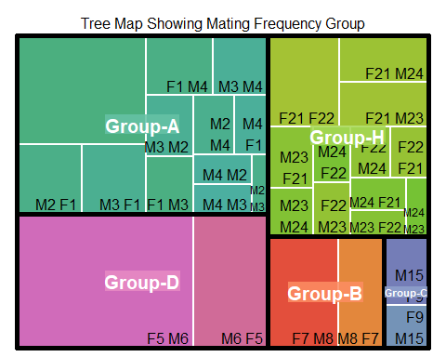

We also note that the frequency of grooming has reduces significantly when it is not the breeding season. Although the pattern of which otter grooms one with the other remains the same. From the plot below we note that the otters maintain their preference in the partners they groom with.

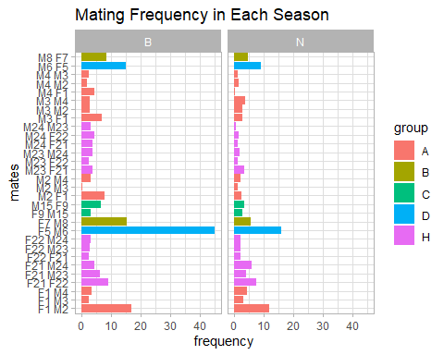

### Grooming Patterns For Each Gender:

| groomee_gender | n | prop |
| --- | --- | --- |
| FEMALE | 152 | 0.3857868 |
| MALE | 242 | 0.6142132 |

Females were observed to groomers 38.6% percent of the times.

However, it is important to note that the number of males in this dataset is higher than that of females. The proportion does not change whether its the breeding season or not. The bar plot below for each group gives a more objective look at groomers for each group in each season.

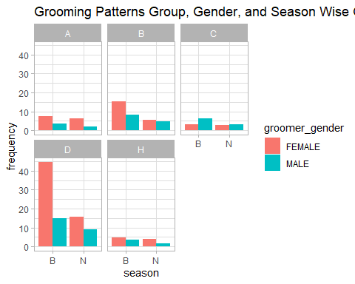

### Grooming Rates Per Season

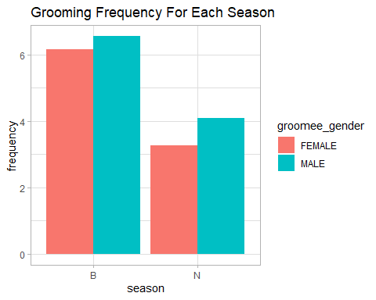

We note that the grooming frequency in the breeding season is higher, than when they are not breeding.

### Same Sex Grooming

Same Sex Grooming was also explored for each of the groups:

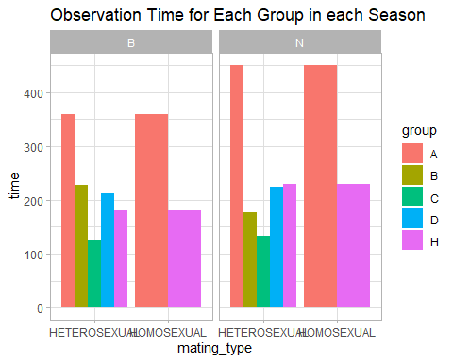

There were only two groups that displayed same sex grooming that is Group A and H In terms of time, the time of observation of the groups was shorter in the breeding season except for group B.

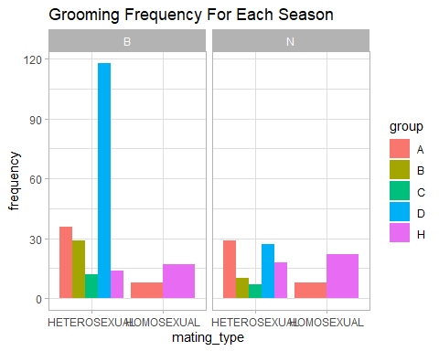

Same sex grooming was a bit higher in the Not breeding season while the opposite trend was observed in the heterosexual grooming(referring to grooming between different sexes), it was higher in the breeding season but dropped when it was not the breeding season.

## Conclusions

1. Note that for each group the female partner had multiple partners, therefore mated with the available otters.
2. The least number of grouping was done between the males. The otters thefore do not groom equally between each other.
3. We note that the grooming frequency in the breeding season is higher, than when they are not breeding.
4. Same sex grooming was slightly higher during the non-breeding season, whereas heterosexual grooming (referring to grooming between different sexes) was higher during the breeding season but decreased during the non-breeding season.