Assignment

2022-06-25

Table of Contents

## Importing Data

data = data <- readxl::read_excel("Dataset for regressions.xlsx")

data = data %>% clean_names()  
data %>% glimpse()

## Rows: 153  
## Columns: 17  
## $ car_1 <dbl> -0.0309, 0.0193, 0.1554, -0.0200, 0.0818, 0.0365, …  
## $ car_2 <dbl> -0.0391, 0.0512, 0.2336, -0.0104, -0.0858, 0.0939,…  
## $ covid_19 <dbl> 0, 0, 0, 0, 0, 0, 0, 0, 0, 0, 0, 0, 0, 0, 0, 0, 0,…  
## $ sector <chr> "Real Estate", "Real Estate", "Energy and Power", …  
## $ diversification <dbl> 0, 0, 0, 0, 0, 0, 0, 0, 0, 0, 1, 0, 0, 0, 0, 0, 0,…  
## $ cross_border <dbl> 1, 1, 1, 0, 1, 1, 1, 0, 1, 1, 0, 1, 0, 1, 1, 0, 0,…  
## $ cash <chr> "1", "1", "1", "0", "0", "1", "1", "1", "1", "0", …  
## $ shares <chr> "0", "0", "0", "1", "1", "0", "1", "1", "0", "1", …  
## $ both <dbl> 0, 0, 0, 0, 0, 0, 1, 1, 0, 0, 1, 0, 0, 1, 0, 0, 0,…  
## $ deal_value <chr> "3640", "433.11559999999997", "1500", "18.89999999…  
## $ ebitda_pos_2020 <dbl> 0, 0, 0, 0, 0, 0, 0, 1, 0, 1, 0, 1, 0, 1, 0, 0, 1,…  
## $ revenue_pos_2020 <dbl> 0, 1, 1, 1, 0, 0, 0, 1, 0, 1, 0, 0, 0, 1, 1, 0, 1,…  
## $ p_e_dummy <chr> "0", "1", "1", "1", "0", "0", "1", "1", "1", "0", …  
## $ size_revenue <dbl> 7631.00, 908.30, 13388.00, 328.78, 88.31, 23882.29…  
## $ size_category <chr> "large", "medium", "large", "medium", "medium", "l…  
## $ size_relative <chr> "0.47700170357751276", "0.4768441124919629", "0.11…  
## $ dummy_relative_size <chr> "1", "1", "0", "0", "0", "1", "n.d", "1", "0", "1"…

Below shows how to identfy null values which had been recorded as ND

data$p_e_dummy[which(data$p_e_dummy == "n.d.")] <- NA  
data$shares[which(data$shares == "n.d.")] <- NA

converrting character columns to factor/categorical data types

cols = c("covid_19", "sector", "cross_border", "diversification", "cash", "both", "dummy_relative_size", "size_category", "p_e_dummy", "shares")  
  
data %<>% mutate_at(cols, factor)

convert some character data types to numeric

cols_num = c("deal_value", "size_relative")  
  
data %<>% mutate_at(cols_num, as.numeric)

## Warning in mask$eval_all_mutate(quo): NAs introduced by coercion  
  
## Warning in mask$eval_all_mutate(quo): NAs introduced by coercion

kable(str(data))

## tibble [153 × 17] (S3: tbl_df/tbl/data.frame)  
## $ car_1 : num [1:153] -0.0309 0.0193 0.1554 -0.02 0.0818 ...  
## $ car_2 : num [1:153] -0.0391 0.0512 0.2336 -0.0104 -0.0858 ...  
## $ covid_19 : Factor w/ 2 levels "0","1": 1 1 1 1 1 1 1 1 1 1 ...  
## $ sector : Factor w/ 12 levels "Consumer Products and Services",..: 9 9 2 4 5 6 5 5 6 11 ...  
## $ diversification : Factor w/ 2 levels "0","1": 1 1 1 1 1 1 1 1 1 1 ...  
## $ cross_border : Factor w/ 2 levels "0","1": 2 2 2 1 2 2 2 1 2 2 ...  
## $ cash : Factor w/ 3 levels "0","1","n.d.": 2 2 2 1 1 2 2 2 2 1 ...  
## $ shares : Factor w/ 2 levels "0","1": 1 1 1 2 2 1 2 2 1 2 ...  
## $ both : Factor w/ 2 levels "0","1": 1 1 1 1 1 1 2 2 1 1 ...  
## $ deal_value : num [1:153] 3640 433.1 1500 18.9 13.7 ...  
## $ ebitda_pos_2020 : num [1:153] 0 0 0 0 0 0 0 1 0 1 ...  
## $ revenue_pos_2020 : num [1:153] 0 1 1 1 0 0 0 1 0 1 ...  
## $ p_e_dummy : Factor w/ 2 levels "0","1": 1 2 2 2 1 1 2 2 2 1 ...  
## $ size_revenue : num [1:153] 7631 908.3 13388 328.8 88.3 ...  
## $ size_category : Factor w/ 3 levels "large","medium",..: 1 2 1 2 2 1 2 2 1 1 ...  
## $ size_relative : num [1:153] 0.477 0.4768 0.112 0.0575 0.1548 ...  
## $ dummy_relative_size: Factor w/ 3 levels "0","1","n.d": 2 2 1 1 1 2 3 2 1 2 ...

|| || || || ## Convert Size_revenue to a log

data$size_revenue = log(data$size_revenue)

### Plotting the Distribution of Log Size Revenue

p1 = ggplot(data = data, aes(x = size_revenue)) +   
 geom_density(fill = "blue")+theme_light()+labs(title = "Distribtion of Revenue Size", caption = "Assignment")  
  
p2 = ggplot(data = data, aes(x = size_revenue)) +   
 geom_density(fill = "blue")+facet_wrap(~covid_19)+theme_light()+labs(title = "Distribtion of Revenue Size", caption = "Assignment")  
  
ggarrange(p1, p2)

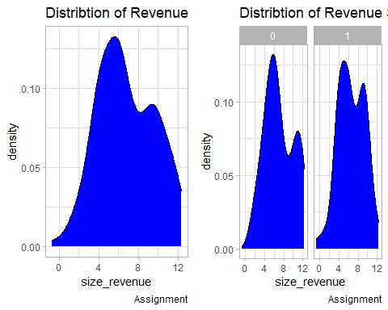

Distribution remains the same before and after covid

## Data Exploratory Analysis

library(skimr)  
skim(data)

Data summary

|  |  |
| --- | --- |
| Name | data |
| Number of rows | 153 |
| Number of columns | 17 |
| _______________________ |  |
| Column type frequency: |  |
| factor | 10 |
| numeric | 7 |
| ________________________ |  |
| Group variables | None |

**Variable type: factor**

| skim_variable | n_missing | complete_rate | ordered | n_unique | top_counts |
| --- | --- | --- | --- | --- | --- |
| covid_19 | 0 | 1.00 | FALSE | 2 | 1: 83, 0: 70 |
| sector | 0 | 1.00 | FALSE | 12 | Hig: 42, Ind: 22, Hea: 15, Inv: 13 |
| diversification | 0 | 1.00 | FALSE | 2 | 0: 121, 1: 32 |
| cross_border | 0 | 1.00 | FALSE | 2 | 0: 99, 1: 54 |
| cash | 0 | 1.00 | FALSE | 3 | 1: 83, n.d: 54, 0: 16 |
| shares | 54 | 0.65 | FALSE | 2 | 0: 55, 1: 44 |
| both | 0 | 1.00 | FALSE | 2 | 0: 125, 1: 28 |
| p_e_dummy | 14 | 0.91 | FALSE | 2 | 1: 79, 0: 60 |
| size_category | 0 | 1.00 | FALSE | 3 | med: 78, lar: 68, sma: 7 |
| dummy_relative_size | 0 | 1.00 | FALSE | 3 | n.d: 64, 1: 45, 0: 44 |

**Variable type: numeric**

| skim_variable | n_missing | complete_rate | mean | sd | p0 | p25 | p50 | p75 | p100 | hist |
| --- | --- | --- | --- | --- | --- | --- | --- | --- | --- | --- |
| car_1 | 0 | 1.00 | 0.02 | 0.10 | -0.20 | -0.03 | 0.00 | 0.04 | 0.65 | ▃▇▁▁▁ |
| car_2 | 0 | 1.00 | 0.01 | 0.14 | -0.50 | -0.06 | 0.00 | 0.05 | 0.71 | ▁▆▇▁▁ |
| deal_value | 64 | 0.58 | 1809.95 | 6730.18 | 0.83 | 18.90 | 95.00 | 730.00 | 53510.62 | ▇▁▁▁▁ |
| ebitda_pos_2020 | 0 | 1.00 | 0.45 | 0.50 | 0.00 | 0.00 | 0.00 | 1.00 | 1.00 | ▇▁▁▁▆ |
| revenue_pos_2020 | 0 | 1.00 | 0.58 | 0.50 | 0.00 | 0.00 | 1.00 | 1.00 | 1.00 | ▆▁▁▁▇ |
| size_revenue | 0 | 1.00 | 6.81 | 2.87 | -0.69 | 4.42 | 6.26 | 9.28 | 12.37 | ▁▆▇▆▅ |
| size_relative | 64 | 0.58 | 1.70 | 5.20 | 0.00 | 0.02 | 0.17 | 0.88 | 37.46 | ▇▁▁▁▁ |

### Plotting Distribution of the CAR Variables

p1 = ggplot(data = data, aes(x = car_1)) +   
 geom_density(fill = "blue") + theme_light()+labs(title = "Distribution of CAR1", caption = 'Assignment')  
  
  
p2 = ggplot(data = data, aes(x = car_2)) +   
 geom_density(fill = "blue") + theme_light()+labs(title = "Distribution of CAR2", caption = 'Assignment')  
  
ggarrange(p1, p2)

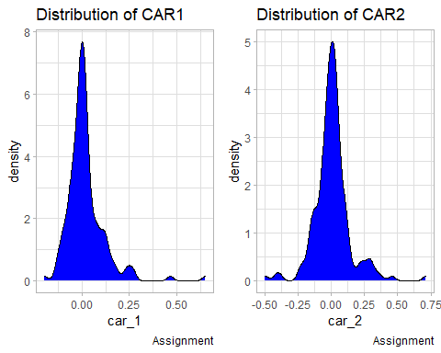 From the density plots above:Note that the distribution is almost Gaussian because most of the data is evenly distributed around the median, however, we note that it has a small left tail and a long right tail. The CAR2 variable has a normal distribution with almost equal length tails.

## Correlation Analysis of the various variables

#### Correlation

library(corrr)

##   
## Attaching package: 'corrr'

## The following object is masked from 'package:skimr':  
##   
## focus

library(dplyr, warn.conflicts = FALSE)  
  
data_cor = data %>%   
 select_if(is.numeric) %>%  
 correlate()

##   
## Correlation method: 'pearson'  
## Missing treated using: 'pairwise.complete.obs'

kable(data_cor)

| term | car_1 | car_2 | deal_value | ebitda_pos_2020 | revenue_pos_2020 | size_revenue | size_relative |
| --- | --- | --- | --- | --- | --- | --- | --- |
| car_1 | NA | 0.6803 | -0.0657 | 0.0192 | 0.0874 | -0.2352 | 0.1473 |
| car_2 | 0.6803 | NA | 0.0283 | 0.1239 | 0.1714 | -0.0873 | -0.0032 |
| deal_value | -0.0657 | 0.0283 | NA | 0.0088 | -0.0249 | 0.3129 | -0.0328 |
| ebitda_pos_2020 | 0.0192 | 0.1239 | 0.0088 | NA | 0.4601 | -0.0562 | -0.0080 |
| revenue_pos_2020 | 0.0874 | 0.1714 | -0.0249 | 0.4601 | NA | -0.3205 | -0.0128 |
| size_revenue | -0.2352 | -0.0873 | 0.3129 | -0.0562 | -0.3205 | NA | -0.4442 |
| size_relative | 0.1473 | -0.0032 | -0.0328 | -0.0080 | -0.0128 | -0.4442 | NA |

##### Correlation Plot

rplot(data_cor)+labs(title = 'Correlation Plot', caption = 'Assignment')

## Don't know how to automatically pick scale for object of type noquote. Defaulting to continuous.

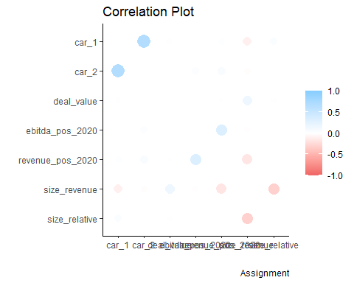 ### Covariance : Strength of Relationship between Variables

data_cov = data %>%   
 select_if(is.numeric) %>%  
 colpair_map(stats::cov) %>%  
 stretch()  
kable(data_cov)

| x | y | r |
| --- | --- | --- |
| car_1 | car_1 | NA |
| car_1 | car_2 | 0.0096 |
| car_1 | deal_value | NA |
| car_1 | ebitda_pos_2020 | 0.0010 |
| car_1 | revenue_pos_2020 | 0.0044 |
| car_1 | size_revenue | -0.0681 |
| car_1 | size_relative | NA |
| car_2 | car_1 | 0.0096 |
| car_2 | car_2 | NA |
| car_2 | deal_value | NA |
| car_2 | ebitda_pos_2020 | 0.0087 |
| car_2 | revenue_pos_2020 | 0.0119 |
| car_2 | size_revenue | -0.0352 |
| car_2 | size_relative | NA |
| deal_value | car_1 | NA |
| deal_value | car_2 | NA |
| deal_value | deal_value | NA |
| deal_value | ebitda_pos_2020 | NA |
| deal_value | revenue_pos_2020 | NA |
| deal_value | size_revenue | NA |
| deal_value | size_relative | NA |
| ebitda_pos_2020 | car_1 | 0.0010 |
| ebitda_pos_2020 | car_2 | 0.0087 |
| ebitda_pos_2020 | deal_value | NA |
| ebitda_pos_2020 | ebitda_pos_2020 | NA |
| ebitda_pos_2020 | revenue_pos_2020 | 0.1139 |
| ebitda_pos_2020 | size_revenue | -0.0806 |
| ebitda_pos_2020 | size_relative | NA |
| revenue_pos_2020 | car_1 | 0.0044 |
| revenue_pos_2020 | car_2 | 0.0119 |
| revenue_pos_2020 | deal_value | NA |
| revenue_pos_2020 | ebitda_pos_2020 | 0.1139 |
| revenue_pos_2020 | revenue_pos_2020 | NA |
| revenue_pos_2020 | size_revenue | -0.4566 |
| revenue_pos_2020 | size_relative | NA |
| size_revenue | car_1 | -0.0681 |
| size_revenue | car_2 | -0.0352 |
| size_revenue | deal_value | NA |
| size_revenue | ebitda_pos_2020 | -0.0806 |
| size_revenue | revenue_pos_2020 | -0.4566 |
| size_revenue | size_revenue | NA |
| size_revenue | size_relative | NA |
| size_relative | car_1 | NA |
| size_relative | car_2 | NA |
| size_relative | deal_value | NA |
| size_relative | ebitda_pos_2020 | NA |
| size_relative | revenue_pos_2020 | NA |
| size_relative | size_revenue | NA |
| size_relative | size_relative | NA |

### Assessing Siginificance of Relationship between numeric variables

calc_ttest_p_value <- function(vec_a, vec_b){  
 t.test(vec_a, vec_b)$p.value  
}  
data_num = data %>% select_if(is.numeric)  
dat_t = colpair_map(data_num, calc_ttest_p_value)  
kable(dat_t)

| term | car_1 | car_2 | deal_value | ebitda_pos_2020 | revenue_pos_2020 | size_revenue | size_relative |
| --- | --- | --- | --- | --- | --- | --- | --- |
| car_1 | NA | 0.3313 | 0.0129 | 0.0000 | 0.0000 | 0.0000 | 0.0031 |
| car_2 | 0.3313 | NA | 0.0129 | 0.0000 | 0.0000 | 0.0000 | 0.0029 |
| deal_value | 0.0129 | 0.0129 | NA | 0.0130 | 0.0130 | 0.0133 | 0.0130 |
| ebitda_pos_2020 | 0.0000 | 0.0000 | 0.0130 | NA | 0.0298 | 0.0000 | 0.0268 |
| revenue_pos_2020 | 0.0000 | 0.0000 | 0.0130 | 0.0298 | NA | 0.0000 | 0.0456 |
| size_revenue | 0.0000 | 0.0000 | 0.0133 | 0.0000 | 0.0000 | NA | 0.0000 |
| size_relative | 0.0031 | 0.0029 | 0.0130 | 0.0268 | 0.0456 | 0.0000 | NA |

At a 95% level of significance, all numeric variables have a statistically significant relationship with the CAR variable. However, CAR1 and CAR2, at the same level of significance, their relationship is not statistically significant.

T test was used to assess the relationship between numerical data, which was normally distributed as shown by the plots above.

#### Examining Statistical Significance of relationship between categorical Variables

There are a few different ways of finding the strength of the relationship between two categorical variables. One useful measure is called Cramer’s V, which takes on values between 0 and 1 depending on how closely associated the variables are.

library(data.table)

##   
## Attaching package: 'data.table'

## The following object is masked from 'package:DescTools':  
##   
## %like%

## The following object is masked from 'package:purrr':  
##   
## transpose

## The following objects are masked from 'package:dplyr':  
##   
## between, first, last

data_cat <- data[,colnames(data)[grepl('factor|logical|character',sapply(data,class))],with=F]  
  
library(rcompanion)  
  
kable(colpair_map(data_cat, cramerV, digits = 2))

| term | covid_19 | sector | diversification | cross_border | cash | shares | both | p_e_dummy | size_category | dummy_relative_size |
| --- | --- | --- | --- | --- | --- | --- | --- | --- | --- | --- |
| covid_19 | NA | 0.38 | 0.012 | 0.120 | 0.082 | 0.110 | 0.061 | 0.120 | 0.06 | 0.130 |
| sector | 0.380 | NA | 0.500 | 0.380 | 0.300 | 0.300 | 0.350 | 0.270 | 0.50 | 0.360 |
| diversification | 0.012 | 0.50 | NA | 0.250 | 0.500 | 0.023 | 0.120 | 0.110 | 0.22 | 0.330 |
| cross_border | 0.120 | 0.38 | 0.250 | NA | 0.520 | 0.250 | 0.031 | 0.120 | 0.15 | 0.360 |
| cash | 0.082 | 0.30 | 0.500 | 0.520 | NA | 0.280 | 0.430 | 0.072 | 0.16 | 0.400 |
| shares | 0.110 | 0.30 | 0.023 | 0.250 | 0.280 | NA | 0.560 | 0.066 | 0.26 | 0.160 |
| both | 0.061 | 0.35 | 0.120 | 0.031 | 0.430 | 0.560 | NA | 0.140 | 0.30 | 0.290 |
| p_e_dummy | 0.120 | 0.27 | 0.110 | 0.120 | 0.072 | 0.066 | 0.140 | NA | 0.15 | 0.072 |
| size_category | 0.060 | 0.50 | 0.220 | 0.150 | 0.160 | 0.260 | 0.300 | 0.150 | NA | 0.270 |
| dummy_relative_size | 0.130 | 0.36 | 0.330 | 0.360 | 0.400 | 0.160 | 0.290 | 0.072 | 0.27 | NA |

Note that Covid19 is most closely related with Sector than any other categorical variables.

#### Distribution of Car1 generally and During and After Covid19

p1 = ggplot(data = data, aes(x = car_1)) +   
 geom_density(fill = "blue")+theme_light()+labs(title = 'Distribution of CAR1', caption = 'Assignment')  
  
p2 = ggplot(data = data, aes(x = car_1)) +   
 geom_density(fill = "blue")+facet_wrap(~covid_19)+theme_light()+labs(title = 'Distribution of CAR1', caption = 'Assignment')  
  
ggarrange(p1, p2)

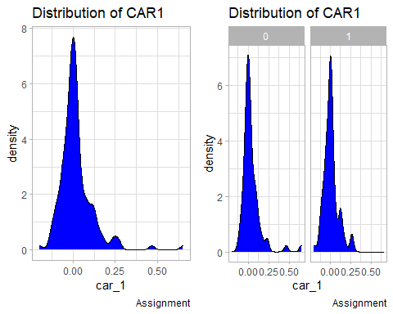

#### Distribution of Car2 generally and During and After Covid19

p1 = ggplot(data = data, aes(x = car_2)) +   
 geom_density(fill = "blue")+theme_light()  
  
p2 = ggplot(data = data, aes(x = car_2)) +   
 geom_density(fill = "blue")+facet_wrap(~covid_19)+theme_light()  
  
ggarrange(p1, p2)

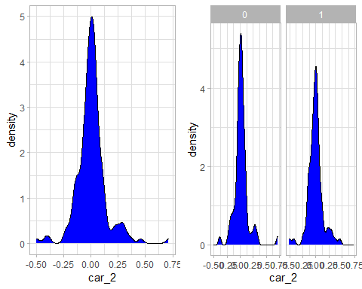 ## Winsorizing Winsorization is a way to minimize the influence of outliers in your data by either: Assigning the outlier a lower weight, Changing the value so that it is close to other values in the set.

data$car_1 = Winsorize(data$car_1)  
data$car_2 = Winsorize(data$car_2)

### Examining the change in Distributions after Winsorizing

#### CAR 1

p1 = ggplot(data = data, aes(x = car_1)) +   
 geom_density(fill = "blue")+theme_light()+labs(title = 'Distribution of CAR1', caption = 'Assignment')  
  
p2 = ggplot(data = data, aes(x = car_1)) +   
 geom_density(fill = "blue")+facet_wrap(~covid_19)+theme_light()+labs(title = 'Distribution of CAR1', caption = 'Assignment')  
  
ggarrange(p1, p2)

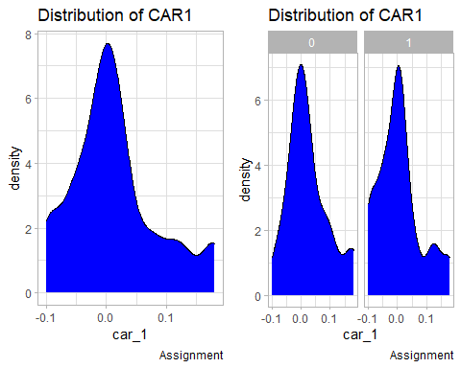

### Examining the change in Distributions after Winsorizing

#### CAR 2

p1 = ggplot(data = data, aes(x = car_2)) +   
 geom_density(fill = "blue")+theme_light()  
  
p2 = ggplot(data = data, aes(x = car_2)) +   
 geom_density(fill = "blue")+facet_wrap(~covid_19)+theme_light()  
  
ggarrange(p1, p2)

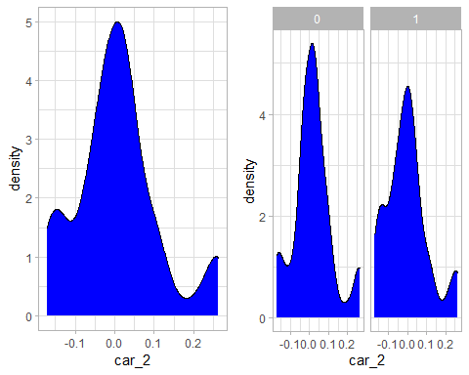 Outliers negatively affect the accuracy of the model, hence the winsoriizing

## HYPOTHESIS 1

*COVID-19 has a positive impact on the cumulative abnormal return (CAR = dependent variable).*

library(viridis)

## Loading required package: viridisLite

p1 = data %>%  
 ggplot( aes(x=covid_19, y=car_1, fill=covid_19)) +  
 geom_boxplot() +  
 scale_fill_viridis(discrete = TRUE, alpha=0.6) +  
 geom_jitter(color="black", size=0.4, alpha=0.9) +  
 theme_light() +  
 theme(  
 legend.position="none",  
 plot.title = element_text(size=11)  
 ) +  
 ggtitle("CAR 1 VS COVID 19") +  
 xlab("")  
p2 = data %>%  
 ggplot( aes(x=covid_19, y=car_2, fill=covid_19)) +  
 geom_boxplot() +  
 scale_fill_viridis(discrete = TRUE, alpha=0.6) +  
 geom_jitter(color="black", size=0.4, alpha=0.9) +  
 theme_light() +  
 theme(  
 legend.position="none",  
 plot.title = element_text(size=11)  
 ) +  
 ggtitle("CAR 2 VS COVID 19") +  
 xlab("")  
  
ggarrange(p1, p2)

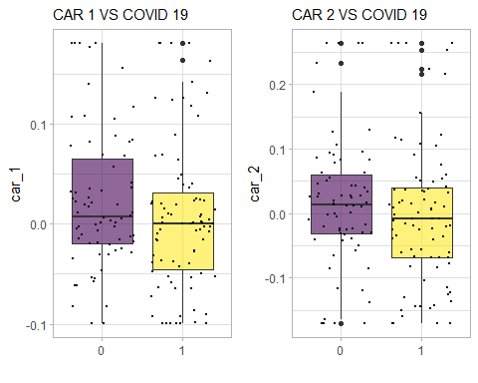 Note that for CAR1 before covid-19 there were no otlers and median/ and mean was higher. CAR2 in both Covid-19 instances had outliers, CAR1 in covid times and after has outliers. Without winsorizing, the number of outliers would have been many.

# function to extract coefficients  
extractCoefs <- function(x = mod1_CAR1){  
 sum <- summary(x)  
  
 df <- data.frame(sum$coefficients)  
 names(df) <- c("Estimate", "Std_error", "T_value", "P_value")  
 rownames(df)[1] <- "COVID190"  
 df <- round(df, 3)  
 df$Coefficient <- rownames(df)  
 df$Dependent <- names(x$model)[1]  
 rownames(df) <- NULL  
 df <- df[, c("Dependent", "Coefficient", names(df)[-which(names(df) %in% c("Coefficient", "Dependent"))]) ]  
 return(df)  
}

mod1_CAR1 <- lm(car_1 ~ covid_19, data = data)  
summary(mod1_CAR1)

##   
## Call:  
## lm(formula = car_1 ~ covid_19, data = data)  
##   
## Residuals:  
## Min 1Q Median 3Q Max   
## -0.12238 -0.04531 -0.00861 0.03309 0.17401   
##   
## Coefficients:  
## Estimate Std. Error t value Pr(>|t|)   
## (Intercept) 0.02302 0.00858 2.68 0.0081 **  
## covid_191 -0.01681 0.01165 -1.44 0.1512   
## ---  
## Signif. codes: 0 '***' 0.001 '**' 0.01 '*' 0.05 '.' 0.1 ' ' 1  
##   
## Residual standard error: 0.0718 on 151 degrees of freedom  
## Multiple R-squared: 0.0136, Adjusted R-squared: 0.00706   
## F-statistic: 2.08 on 1 and 151 DF, p-value: 0.151

extractCoefs(mod1_CAR1)

## Dependent Coefficient Estimate Std_error T_value P_value  
## 1 car_1 COVID190 0.023 0.009 2.682 0.008  
## 2 car_1 covid_191 -0.017 0.012 -1.443 0.151

mod1_CAR2 <- lm(car_2 ~ covid_19, data = data)  
summary(mod1_CAR2)

##   
## Call:  
## lm(formula = car_2 ~ covid_19, data = data)  
##   
## Residuals:  
## Min 1Q Median 3Q Max   
## -0.18780 -0.05860 -0.00542 0.04400 0.26554   
##   
## Coefficients:  
## Estimate Std. Error t value Pr(>|t|)  
## (Intercept) 0.0172 0.0126 1.37 0.17  
## covid_191 -0.0194 0.0171 -1.14 0.26  
##   
## Residual standard error: 0.105 on 151 degrees of freedom  
## Multiple R-squared: 0.0085, Adjusted R-squared: 0.00194   
## F-statistic: 1.29 on 1 and 151 DF, p-value: 0.257

extractCoefs(mod1_CAR2)

## Dependent Coefficient Estimate Std_error T_value P_value  
## 1 car_2 COVID190 0.017 0.013 1.370 0.173  
## 2 car_2 covid_191 -0.019 0.017 -1.138 0.257

There is a marginally significant negative effect of COVID19 on CAR1, using a confidence interval of 80% (p < 0.2) but not in CAR2.On this significant level, the relationship between Covid 19 and Car 2 is not statistically significant, which means, car 2 was not impacted heavily or in a meaningful manner by Covid 19

Note that a linear model with a two level factor (with similar sample size per factor) is equivalent to a T-student test. Then, coefficients here show the mean of the response variable for group COVID19 = 0 and the effect of the second level. Then, for CAR1, the mean of the COVID 19 = 0 group is 0.023, while the effect of the second level (COVID 19 = 1) is -0.017. Then, the mean for the second level in CAR1 is 0.023 - 0.017= 0.06). The significance of COVID191 shows whether the difference is statistically significative.

### Assumption One: Linearity of the Data

par(mfrow=c(2,3))  
plot(mod1_CAR1)

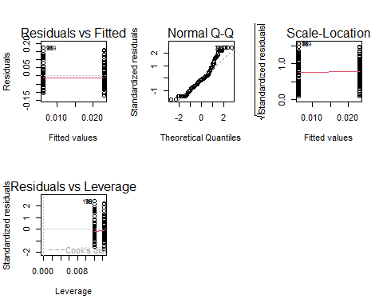

In the above plot we can see that there is no clear pattern in the residual plot. This would indicate that we meet the assumption that there is a linear relationship between the predictors and the outcome variable.

### Assumption Two: Predictors (x) Are Independent and Observed with Negligible Error

library(car)

## Loading required package: carData

##   
## Attaching package: 'car'

## The following object is masked from 'package:DescTools':  
##   
## Recode

## The following object is masked from 'package:purrr':  
##   
## some

## The following object is masked from 'package:dplyr':  
##   
## recode

durbinWatsonTest(mod1_CAR1)

## lag Autocorrelation D-W Statistic p-value  
## 1 -0.02223 2.041 0.87  
## Alternative hypothesis: rho != 0

The null hypothesis states that the errors are not auto-correlated with themselves (they are independent). Thus, if we achieve a p-value > 0.05, 0.836, we would fail to reject the null hypothesis. This would give us enough evidence to state that our independence assumption is met!

### Assumption Three: Residual Errors Have a Mean Value of Zero

In the above plot, we can see that the red line is below 0 for low fitted values and high fitted values. This indicates that the residual errors have a mean value of below 0

### Assumption Four: Residual Errors Have Constant Variance

We can check this assumption using the Scale-Location plot. In this plot we can see the fitted values vs the square root of the standardized residuals. Ideally, we would want to see the residual points equally spread around the red line, which would indicate constant variance.

par(mfrow=c(2,3))  
plot(mod1_CAR1)



library(car)  
ncvTest(lm(car_1 ~ covid_19, data = data))

## Non-constant Variance Score Test   
## Variance formula: ~ fitted.values   
## Chisquare = 0.2674, Df = 1, p = 0.61

The null hypothesis states that there is constant variance. a pvalue > 0.05, suggests you would fail to reject the null. This means you have enough evidence to state that your assumption is met!

All assumptions have been met, incuding the residually errors are normally distributed.

There is a marginally significant negative effect of COVID19 on CAR1 (p < 0.1) but not in CAR2.

Note that a linear model with a two level factor (with similar sample size per factor) is equivalent to a T-student test. Then, coefficients here show the mean of the response variable for group COVID19 = 0 and the effect of the second level. Then, for CAR1, the mean of the COVID 19 = 0 group is 0.035, while the effect of the second level (COVID 19 = 1) is -0.028. Then, the mean for the second level in CAR1 is 0.035 - 0.028 = 0.07). The significance of COVID191 shows whether the difference is statistically significative.

## HYPOTHESIS 2

**The size has a positive impact on the cumulative abnormal return (CAR = dependent variable) during COVID-19.**

### Plotting Covid19 against Revenue

data %>%  
 ggplot( aes(x=covid_19, y=size_revenue, fill=covid_19)) +  
 geom_boxplot() +  
 scale_fill_viridis(discrete = TRUE, alpha=0.6) +  
 geom_jitter(color="black", size=0.4, alpha=0.9) +  
 theme_light() +  
 theme(  
 legend.position="none",  
 plot.title = element_text(size=11)  
 ) +  
 ggtitle("Revenue Size VS COVID 19") +  
 xlab("")

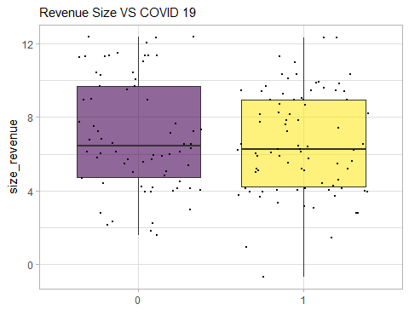 Note that there are no outliers.

mod2_CAR1 <- lm(car_1 ~ covid_19 * size_revenue, data = data)  
summary(mod2_CAR1)

##   
## Call:  
## lm(formula = car_1 ~ covid_19 * size_revenue, data = data)  
##   
## Residuals:  
## Min 1Q Median 3Q Max   
## -0.15359 -0.04855 -0.00343 0.03191 0.17294   
##   
## Coefficients:  
## Estimate Std. Error t value Pr(>|t|)   
## (Intercept) 6.50e-02 2.13e-02 3.05 0.0027 **  
## covid_191 -1.99e-02 2.94e-02 -0.68 0.5005   
## size_revenue -5.97e-03 2.78e-03 -2.14 0.0338 *   
## covid_191:size_revenue 9.62e-05 3.97e-03 0.02 0.9807   
## ---  
## Signif. codes: 0 '***' 0.001 '**' 0.01 '*' 0.05 '.' 0.1 ' ' 1  
##   
## Residual standard error: 0.0702 on 149 degrees of freedom  
## Multiple R-squared: 0.0691, Adjusted R-squared: 0.0503   
## F-statistic: 3.68 on 3 and 149 DF, p-value: 0.0135

kable(extractCoefs(mod2_CAR1))

| Dependent | Coefficient | Estimate | Std_error | T_value | P_value |
| --- | --- | --- | --- | --- | --- |
| car_1 | COVID190 | 0.065 | 0.021 | 3.050 | 0.003 |
| car_1 | covid_191 | -0.020 | 0.029 | -0.675 | 0.500 |
| car_1 | size_revenue | -0.006 | 0.003 | -2.143 | 0.034 |
| car_1 | covid_191:size_revenue | 0.000 | 0.004 | 0.024 | 0.981 |

mod2_CAR2 <- lm(car_2 ~ covid_19 * size_revenue, data = data)  
summary(mod2_CAR2)

##   
## Call:  
## lm(formula = car_2 ~ covid_19 * size_revenue, data = data)  
##   
## Residuals:  
## Min 1Q Median 3Q Max   
## -0.19515 -0.06106 0.00157 0.04684 0.27120   
##   
## Coefficients:  
## Estimate Std. Error t value Pr(>|t|)  
## (Intercept) 0.02710 0.03197 0.85 0.40  
## covid_191 0.00362 0.04417 0.08 0.93  
## size_revenue -0.00140 0.00418 -0.34 0.74  
## covid_191:size_revenue -0.00357 0.00597 -0.60 0.55  
##   
## Residual standard error: 0.105 on 149 degrees of freedom  
## Multiple R-squared: 0.0182, Adjusted R-squared: -0.00154   
## F-statistic: 0.922 on 3 and 149 DF, p-value: 0.432

kable(extractCoefs(mod2_CAR2))

| Dependent | Coefficient | Estimate | Std_error | T_value | P_value |
| --- | --- | --- | --- | --- | --- |
| car_2 | COVID190 | 0.027 | 0.032 | 0.848 | 0.398 |
| car_2 | covid_191 | 0.004 | 0.044 | 0.082 | 0.935 |
| car_2 | size_revenue | -0.001 | 0.004 | -0.336 | 0.737 |
| car_2 | covid_191:size_revenue | -0.004 | 0.006 | -0.598 | 0.551 |

par(mfrow=c(2,3))  
plot(mod2_CAR2)

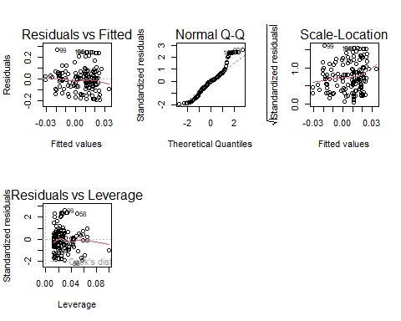

Use the principles of checking for assumptions on linear models from the first hypothesis test.

The effect of covid on CAR1 is maintained, but the relatiopnship is thought to be statistically significant at a much lower significant level, but there is no effect of size revenue nor interaction between size revenue and COVID. No significant effects are detected for CAR2.

## Hypothesis 3

**The financial strength has a positive impact on the cumulative abnormal return (CAR = dependent variable) during COVID-19.**

### COVID 19 VS EBITDA

data %>%  
 ggplot( aes(x=covid_19, y=ebitda_pos_2020, fill=covid_19)) +  
 geom_boxplot() +  
 scale_fill_viridis(discrete = TRUE, alpha=0.6) +  
 geom_jitter(color="black", size=0.4, alpha=0.9) +  
 theme_light() +  
 theme(  
 legend.position="none",  
 plot.title = element_text(size=11)  
 ) +  
 ggtitle("ebitda_pos_2020 VS COVID 19") +  
 xlab("")

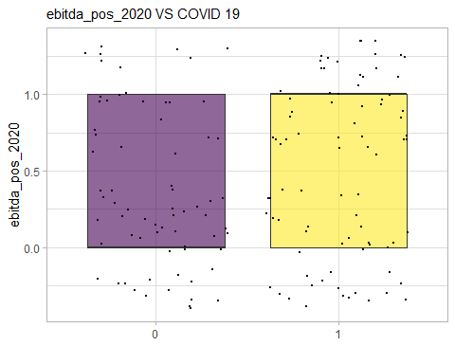 Note: Mean and median are equal, 1st quartile and minimum number are equal, 3rd quartile and max are equal

mod3_CAR1 <- lm(car_1 ~ covid_19 * ebitda_pos_2020, data = data)  
summary(mod3_CAR1)

##   
## Call:  
## lm(formula = car_1 ~ covid_19 * ebitda_pos_2020, data = data)  
##   
## Residuals:  
## Min 1Q Median 3Q Max   
## -0.12692 -0.04709 -0.00929 0.03414 0.17816   
##   
## Coefficients:  
## Estimate Std. Error t value Pr(>|t|)   
## (Intercept) 0.0276 0.0107 2.56 0.011 *  
## covid_191 -0.0255 0.0158 -1.62 0.108   
## ebitda_pos_2020 -0.0127 0.0180 -0.71 0.480   
## covid_191:ebitda_pos_2020 0.0205 0.0240 0.86 0.393   
## ---  
## Signif. codes: 0 '***' 0.001 '**' 0.01 '*' 0.05 '.' 0.1 ' ' 1  
##   
## Residual standard error: 0.0721 on 149 degrees of freedom  
## Multiple R-squared: 0.0185, Adjusted R-squared: -0.00126   
## F-statistic: 0.936 on 3 and 149 DF, p-value: 0.425

kable(extractCoefs(mod3_CAR1))

| Dependent | Coefficient | Estimate | Std_error | T_value | P_value |
| --- | --- | --- | --- | --- | --- |
| car_1 | COVID190 | 0.028 | 0.011 | 2.565 | 0.011 |
| car_1 | covid_191 | -0.026 | 0.016 | -1.617 | 0.108 |
| car_1 | ebitda_pos_2020 | -0.013 | 0.018 | -0.707 | 0.480 |
| car_1 | covid_191:ebitda_pos_2020 | 0.021 | 0.024 | 0.857 | 0.393 |

At a 90% level of siginificance, the relationship/interaction between car 1 and Covid is significant. The other interactions are considered not to be significant, at any other higher level of significance. Taking the p-value of the model at a 90% level of significance, the relationship between car1, EBITDA and COVID 19 is not significant. Examining the F-value, it is less than 1, suggesting that the null hypothesis: That the car 1 and covid19 + ebitda have a significant relationship is false.

mod3_CAR2 <- lm(car_2 ~ covid_19 * ebitda_pos_2020, data = data)  
summary(mod3_CAR2)

##   
## Call:  
## lm(formula = car_2 ~ covid_19 * ebitda_pos_2020, data = data)  
##   
## Residuals:  
## Min 1Q Median 3Q Max   
## -0.20229 -0.06318 -0.00208 0.04542 0.27601   
##   
## Coefficients:  
## Estimate Std. Error t value Pr(>|t|)  
## (Intercept) 0.00918 0.01571 0.58 0.56  
## covid_191 -0.02185 0.02305 -0.95 0.34  
## ebitda_pos_2020 0.02253 0.02628 0.86 0.39  
## covid_191:ebitda_pos_2020 -0.00277 0.03504 -0.08 0.94  
##   
## Residual standard error: 0.105 on 149 degrees of freedom  
## Multiple R-squared: 0.0181, Adjusted R-squared: -0.00164   
## F-statistic: 0.917 on 3 and 149 DF, p-value: 0.434

kable(extractCoefs(mod3_CAR2))

| Dependent | Coefficient | Estimate | Std_error | T_value | P_value |
| --- | --- | --- | --- | --- | --- |
| car_2 | COVID190 | 0.009 | 0.016 | 0.584 | 0.560 |
| car_2 | covid_191 | -0.022 | 0.023 | -0.948 | 0.345 |
| car_2 | ebitda_pos_2020 | 0.023 | 0.026 | 0.857 | 0.393 |
| car_2 | covid_191:ebitda_pos_2020 | -0.003 | 0.035 | -0.079 | 0.937 |

par(mfrow=c(2,3))  
plot(mod3_CAR2)

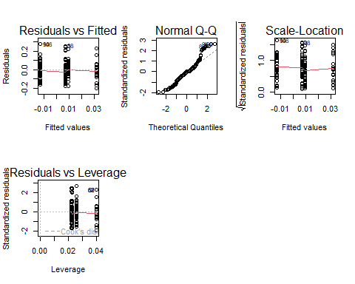

There are no significant effects on CAR2 that are detected.

data %>%  
 ggplot( aes(x=covid_19, y=revenue_pos_2020, fill=covid_19)) +  
 geom_boxplot() +  
 scale_fill_viridis(discrete = TRUE, alpha=0.6) +  
 geom_jitter(color="black", size=0.4, alpha=0.9) +  
 theme_light() +  
 theme(  
 legend.position="none",  
 plot.title = element_text(size=11)  
 ) +  
 ggtitle("revenue_pos_2020 VS COVID 19") +  
 xlab("")

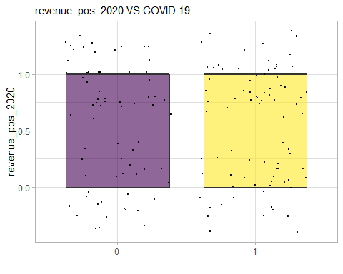 Revenue not affectd by Covid from plots

mod4_CAR1 <- lm(car_1 ~ covid_19 * revenue_pos_2020, data = data)  
summary(mod4_CAR1)

##   
## Call:  
## lm(formula = car_1 ~ covid_19 * revenue_pos_2020, data = data)  
##   
## Residuals:  
## Min 1Q Median 3Q Max   
## -0.13177 -0.04481 -0.00803 0.03097 0.17378   
##   
## Coefficients:  
## Estimate Std. Error t value Pr(>|t|)  
## (Intercept) 0.00973 0.01334 0.73 0.47  
## covid_191 -0.00382 0.01793 -0.21 0.83  
## revenue_pos_2020 0.02268 0.01744 1.30 0.20  
## covid_191:revenue_pos_2020 -0.02215 0.02361 -0.94 0.35  
##   
## Residual standard error: 0.0719 on 149 degrees of freedom  
## Multiple R-squared: 0.0247, Adjusted R-squared: 0.00505   
## F-statistic: 1.26 on 3 and 149 DF, p-value: 0.291

kable(extractCoefs(mod4_CAR1))

| Dependent | Coefficient | Estimate | Std_error | T_value | P_value |
| --- | --- | --- | --- | --- | --- |
| car_1 | COVID190 | 0.010 | 0.013 | 0.729 | 0.467 |
| car_1 | covid_191 | -0.004 | 0.018 | -0.213 | 0.832 |
| car_1 | revenue_pos_2020 | 0.023 | 0.017 | 1.301 | 0.195 |
| car_1 | covid_191:revenue_pos_2020 | -0.022 | 0.024 | -0.938 | 0.350 |

par(mfrow=c(2,3))  
plot(mod4_CAR1)

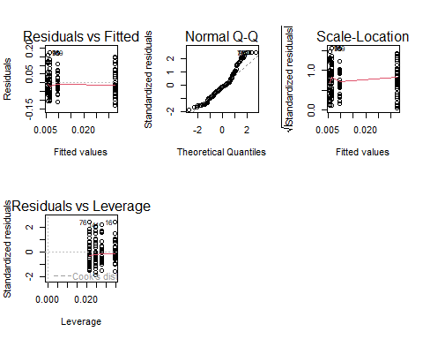

At a 90% level of siginificance, the relationship/interaction between car 1 and Covid is not significant. The other interactions are also considered not to be significant. However, Revenue and CAR1 seem to have a more significant relationship than the Covid and the Interaction between Revenue and Covid on CAR1.l Taking the p-value of the model at a 90% level of significance, the relationship between car1, revenue and COVID 19 is not significant, we reject the null hypothesis.

mod4_CAR2 <- lm(car_2 ~ covid_19 * revenue_pos_2020, data = data)  
summary(mod4_CAR2)

##   
## Call:  
## lm(formula = car_2 ~ covid_19 * revenue_pos_2020, data = data)  
##   
## Residuals:  
## Min 1Q Median 3Q Max   
## -0.21209 -0.06519 -0.00269 0.04705 0.28045   
##   
## Coefficients:  
## Estimate Std. Error t value Pr(>|t|)   
## (Intercept) -0.01711 0.01928 -0.89 0.376   
## covid_191 0.00526 0.02591 0.20 0.839   
## revenue_pos_2020 0.05862 0.02519 2.33 0.021 *  
## covid_191:revenue_pos_2020 -0.04158 0.03411 -1.22 0.225   
## ---  
## Signif. codes: 0 '***' 0.001 '**' 0.01 '*' 0.05 '.' 0.1 ' ' 1  
##   
## Residual standard error: 0.104 on 149 degrees of freedom  
## Multiple R-squared: 0.0467, Adjusted R-squared: 0.0275   
## F-statistic: 2.43 on 3 and 149 DF, p-value: 0.0675

kable(extractCoefs(mod4_CAR2))

| Dependent | Coefficient | Estimate | Std_error | T_value | P_value |
| --- | --- | --- | --- | --- | --- |
| car_2 | COVID190 | -0.017 | 0.019 | -0.887 | 0.376 |
| car_2 | covid_191 | 0.005 | 0.026 | 0.203 | 0.839 |
| car_2 | revenue_pos_2020 | 0.059 | 0.025 | 2.327 | 0.021 |
| car_2 | covid_191:revenue_pos_2020 | -0.042 | 0.034 | -1.219 | 0.225 |

par(mfrow=c(2,3))  
plot(mod4_CAR2)

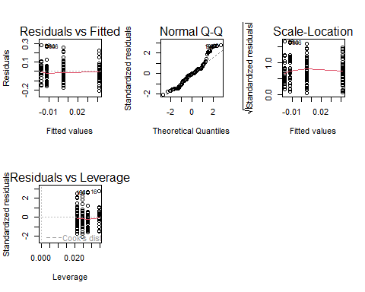

At a 90% level of siginificance, the relationship/interaction between car2 and revenue statistically significant. The other interactions are not considered to be statistically significant. Taking the p-value of the model at a 90% level of significance, the relationship between car2 and the predictors is statistically significant. Examining the F-value, suggests that the null hypothesis: That the car2 and covid19, revenue_pos have a significant relationship is True.

mod5_CAR1 <- lm(car_1 ~ covid_19 * p_e_dummy, data = data)  
summary(mod5_CAR1)

##   
## Call:  
## lm(formula = car_1 ~ covid_19 * p_e_dummy, data = data)  
##   
## Residuals:  
## Min 1Q Median 3Q Max   
## -0.13437 -0.04260 -0.00641 0.02678 0.18071   
##   
## Coefficients:  
## Estimate Std. Error t value Pr(>|t|)  
## (Intercept) 0.00733 0.01354 0.54 0.59  
## covid_191 -0.00782 0.01773 -0.44 0.66  
## p_e_dummy1 0.02768 0.01703 1.63 0.11  
## covid_191:p_e_dummy1 -0.02348 0.02342 -1.00 0.32  
##   
## Residual standard error: 0.0677 on 135 degrees of freedom  
## (14 observations deleted due to missingness)  
## Multiple R-squared: 0.0479, Adjusted R-squared: 0.0267   
## F-statistic: 2.26 on 3 and 135 DF, p-value: 0.0841

kable(extractCoefs(mod5_CAR1))

| Dependent | Coefficient | Estimate | Std_error | T_value | P_value |
| --- | --- | --- | --- | --- | --- |
| car_1 | COVID190 | 0.007 | 0.014 | 0.541 | 0.589 |
| car_1 | covid_191 | -0.008 | 0.018 | -0.441 | 0.660 |
| car_1 | p_e_dummy1 | 0.028 | 0.017 | 1.625 | 0.106 |
| car_1 | covid_191:p_e_dummy1 | -0.023 | 0.023 | -1.003 | 0.318 |

par(mfrow=c(2,3))  
plot(mod5_CAR1)

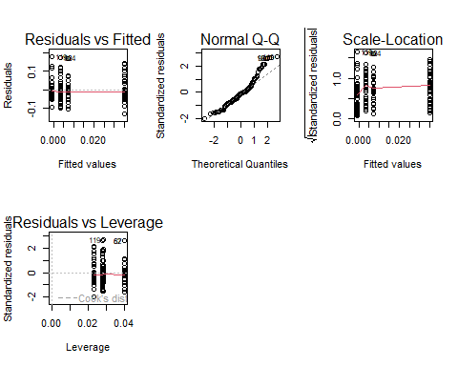

At a 90% level of siginificance, the relationship/interaction between car 1 and Covid is not statistically significant. The other interactions are also considered not to be significant. Taking the p-value of the model at a 90% level of significance, the relationship between car1, p_e_dummy and COVID 19 is statistically significant. Examining the F-value, suggests that the null hypothesis: That the car 1 and covid19, p_e_dummy does have a significant relationship is True.

mod5_CAR2 <- lm(car_2 ~ covid_19 * p_e_dummy, data = data)  
summary(mod5_CAR2)

##   
## Call:  
## lm(formula = car_2 ~ covid_19 * p_e_dummy, data = data)  
##   
## Residuals:  
## Min 1Q Median 3Q Max   
## -0.19602 -0.05785 -0.00435 0.04423 0.26952   
##   
## Coefficients:  
## Estimate Std. Error t value Pr(>|t|)  
## (Intercept) 0.0122 0.0203 0.60 0.55  
## covid_191 -0.0184 0.0266 -0.69 0.49  
## p_e_dummy1 0.0132 0.0256 0.52 0.61  
## covid_191:p_e_dummy1 -0.0106 0.0352 -0.30 0.76  
##   
## Residual standard error: 0.102 on 135 degrees of freedom  
## (14 observations deleted due to missingness)  
## Multiple R-squared: 0.0178, Adjusted R-squared: -0.00399   
## F-statistic: 0.817 on 3 and 135 DF, p-value: 0.487

kable(extractCoefs(mod5_CAR2))

| Dependent | Coefficient | Estimate | Std_error | T_value | P_value |
| --- | --- | --- | --- | --- | --- |
| car_2 | COVID190 | 0.012 | 0.020 | 0.601 | 0.549 |
| car_2 | covid_191 | -0.018 | 0.027 | -0.691 | 0.491 |
| car_2 | p_e_dummy1 | 0.013 | 0.026 | 0.517 | 0.606 |
| car_2 | covid_191:p_e_dummy1 | -0.011 | 0.035 | -0.301 | 0.764 |

par(mfrow=c(2,3))  
plot(mod5_CAR2)

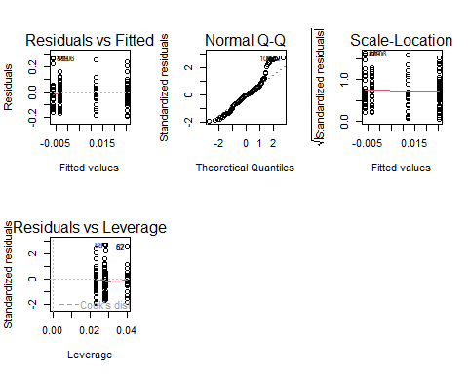

At a 90% level of siginificance, the relationship/interaction between car2 and the predictors is not statistically significant. Examining the p-value of the model at a 90% level of significance, the relationship between car1 and the predictors is not statistically significant. Examining the F-value, it is less than 1,suggests that the null hypothesis: That the car 1 and the predictors have a significant relationship is False.

PE dummy 1 have a marginally significant effect on CAR1, but no interaction with COVID is detected. When included, the relationship between CAR1 and COVID disappears.

Revenue pos 2020 have a significant positive effect on CAR2 (p < 0.05).

Note, however, that when relatively small sample sizes it is not recommended to estimate a relatively high number of parameters, so it would be better tbo test for simple effects with the given datsaet.

## Hypothesis 4

**The financial strength together with the size has a positive impact on the cumulative abnormal return (CAR = dependent variable) during COVID-19.**

mod6_CAR1 <- lm(car_1 ~ covid_19 * size_revenue * ebitda_pos_2020, data = data)  
summary(mod6_CAR1)

##   
## Call:  
## lm(formula = car_1 ~ covid_19 * size_revenue * ebitda_pos_2020,   
## data = data)  
##   
## Residuals:  
## Min 1Q Median 3Q Max   
## -0.15551 -0.04893 -0.00303 0.03084 0.17688   
##   
## Coefficients:  
## Estimate Std. Error t value Pr(>|t|)   
## (Intercept) 0.06489 0.02559 2.54 0.012 *  
## covid_191 -0.03863 0.03783 -1.02 0.309   
## size_revenue -0.00527 0.00329 -1.60 0.112   
## ebitda_pos_2020 0.00576 0.04739 0.12 0.903   
## covid_191:size_revenue 0.00171 0.00498 0.34 0.732   
## covid_191:ebitda_pos_2020 0.03587 0.06294 0.57 0.570   
## size_revenue:ebitda_pos_2020 -0.00279 0.00631 -0.44 0.659   
## covid_191:size_revenue:ebitda_pos_2020 -0.00262 0.00858 -0.31 0.760   
## ---  
## Signif. codes: 0 '***' 0.001 '**' 0.01 '*' 0.05 '.' 0.1 ' ' 1  
##   
## Residual standard error: 0.0707 on 145 degrees of freedom  
## Multiple R-squared: 0.0805, Adjusted R-squared: 0.0361   
## F-statistic: 1.81 on 7 and 145 DF, p-value: 0.0887

kable(extractCoefs(mod6_CAR1))

| Dependent | Coefficient | Estimate | Std_error | T_value | P_value |
| --- | --- | --- | --- | --- | --- |
| car_1 | COVID190 | 0.065 | 0.026 | 2.536 | 0.012 |
| car_1 | covid_191 | -0.039 | 0.038 | -1.021 | 0.309 |
| car_1 | size_revenue | -0.005 | 0.003 | -1.601 | 0.112 |
| car_1 | ebitda_pos_2020 | 0.006 | 0.047 | 0.122 | 0.903 |
| car_1 | covid_191:size_revenue | 0.002 | 0.005 | 0.343 | 0.732 |
| car_1 | covid_191:ebitda_pos_2020 | 0.036 | 0.063 | 0.570 | 0.570 |
| car_1 | size_revenue:ebitda_pos_2020 | -0.003 | 0.006 | -0.443 | 0.659 |
| car_1 | covid_191:size_revenue:ebitda_pos_2020 | -0.003 | 0.009 | -0.305 | 0.760 |

par(mfrow=c(2,3))  
plot(mod6_CAR1)

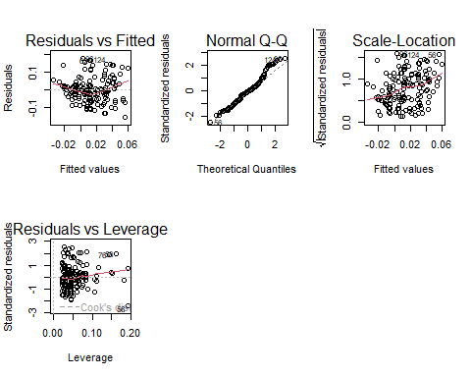

mod6_CAR2 <- lm(car_2 ~ covid_19 * size_revenue * ebitda_pos_2020, data = data)  
summary(mod6_CAR2)

##   
## Call:  
## lm(formula = car_2 ~ covid_19 * size_revenue * ebitda_pos_2020,   
## data = data)  
##   
## Residuals:  
## Min 1Q Median 3Q Max   
## -0.24934 -0.06392 -0.00343 0.04247 0.26982   
##   
## Coefficients:  
## Estimate Std. Error t value Pr(>|t|)  
## (Intercept) -0.00232 0.03827 -0.06 0.95  
## covid_191 0.01118 0.05658 0.20 0.84  
## size_revenue 0.00162 0.00492 0.33 0.74  
## ebitda_pos_2020 0.09760 0.07087 1.38 0.17  
## covid_191:size_revenue -0.00479 0.00745 -0.64 0.52  
## covid_191:ebitda_pos_2020 -0.05400 0.09413 -0.57 0.57  
## size_revenue:ebitda_pos_2020 -0.01080 0.00944 -1.14 0.25  
## covid_191:size_revenue:ebitda_pos_2020 0.00695 0.01283 0.54 0.59  
##   
## Residual standard error: 0.106 on 145 degrees of freedom  
## Multiple R-squared: 0.037, Adjusted R-squared: -0.00948   
## F-statistic: 0.796 on 7 and 145 DF, p-value: 0.592

kable(extractCoefs(mod6_CAR2))

| Dependent | Coefficient | Estimate | Std_error | T_value | P_value |
| --- | --- | --- | --- | --- | --- |
| car_2 | COVID190 | -0.002 | 0.038 | -0.061 | 0.952 |
| car_2 | covid_191 | 0.011 | 0.057 | 0.198 | 0.844 |
| car_2 | size_revenue | 0.002 | 0.005 | 0.330 | 0.742 |
| car_2 | ebitda_pos_2020 | 0.098 | 0.071 | 1.377 | 0.171 |
| car_2 | covid_191:size_revenue | -0.005 | 0.007 | -0.643 | 0.522 |
| car_2 | covid_191:ebitda_pos_2020 | -0.054 | 0.094 | -0.574 | 0.567 |
| car_2 | size_revenue:ebitda_pos_2020 | -0.011 | 0.009 | -1.145 | 0.254 |
| car_2 | covid_191:size_revenue:ebitda_pos_2020 | 0.007 | 0.013 | 0.542 | 0.589 |

par(mfrow=c(2,3))  
plot(mod6_CAR2)

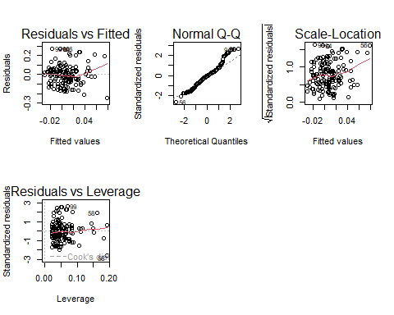

mod7_CAR1 <- lm(car_1 ~ covid_19 * size_revenue * revenue_pos_2020, data = data)  
summary(mod7_CAR1)

##   
## Call:  
## lm(formula = car_1 ~ covid_19 * size_revenue * revenue_pos_2020,   
## data = data)  
##   
## Residuals:  
## Min 1Q Median 3Q Max   
## -0.12528 -0.04802 -0.00587 0.03565 0.17974   
##   
## Coefficients:  
## Estimate Std. Error t value Pr(>|t|)  
## (Intercept) 0.02661 0.03274 0.81 0.42  
## covid_191 0.01134 0.04551 0.25 0.80  
## size_revenue -0.00206 0.00367 -0.56 0.57  
## revenue_pos_2020 0.07530 0.04611 1.63 0.10  
## covid_191:size_revenue -0.00214 0.00532 -0.40 0.69  
## covid_191:revenue_pos_2020 -0.04756 0.06335 -0.75 0.45  
## size_revenue:revenue_pos_2020 -0.00912 0.00613 -1.49 0.14  
## covid_191:size_revenue:revenue_pos_2020 0.00319 0.00868 0.37 0.71  
##   
## Residual standard error: 0.0702 on 145 degrees of freedom  
## Multiple R-squared: 0.0944, Adjusted R-squared: 0.0507   
## F-statistic: 2.16 on 7 and 145 DF, p-value: 0.0412

kable(extractCoefs(mod7_CAR1))

| Dependent | Coefficient | Estimate | Std_error | T_value | P_value |
| --- | --- | --- | --- | --- | --- |
| car_1 | COVID190 | 0.027 | 0.033 | 0.813 | 0.418 |
| car_1 | covid_191 | 0.011 | 0.046 | 0.249 | 0.804 |
| car_1 | size_revenue | -0.002 | 0.004 | -0.562 | 0.575 |
| car_1 | revenue_pos_2020 | 0.075 | 0.046 | 1.633 | 0.105 |
| car_1 | covid_191:size_revenue | -0.002 | 0.005 | -0.402 | 0.689 |
| car_1 | covid_191:revenue_pos_2020 | -0.048 | 0.063 | -0.751 | 0.454 |
| car_1 | size_revenue:revenue_pos_2020 | -0.009 | 0.006 | -1.486 | 0.139 |
| car_1 | covid_191:size_revenue:revenue_pos_2020 | 0.003 | 0.009 | 0.368 | 0.714 |

par(mfrow=c(2,3))  
plot(mod7_CAR1)

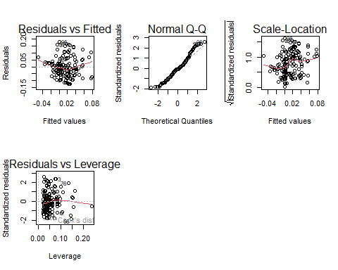

mod7_CAR2 <- lm(car_2 ~ covid_19 * size_revenue * revenue_pos_2020, data = data)  
summary(mod7_CAR2)

##   
## Call:  
## lm(formula = car_2 ~ covid_19 * size_revenue * revenue_pos_2020,   
## data = data)  
##   
## Residuals:  
## Min 1Q Median 3Q Max   
## -0.21322 -0.05721 -0.00152 0.04824 0.31420   
##   
## Coefficients:  
## Estimate Std. Error t value Pr(>|t|)   
## (Intercept) -0.09046 0.04778 -1.89 0.0603 .   
## covid_191 0.07524 0.06642 1.13 0.2592   
## size_revenue 0.00896 0.00536 1.67 0.0964 .   
## revenue_pos_2020 0.19942 0.06729 2.96 0.0036 **  
## covid_191:size_revenue -0.00852 0.00776 -1.10 0.2741   
## covid_191:revenue_pos_2020 -0.10910 0.09246 -1.18 0.2399   
## size_revenue:revenue_pos_2020 -0.01981 0.00895 -2.21 0.0285 *   
## covid_191:size_revenue:revenue_pos_2020 0.00742 0.01267 0.59 0.5586   
## ---  
## Signif. codes: 0 '***' 0.001 '**' 0.01 '*' 0.05 '.' 0.1 ' ' 1  
##   
## Residual standard error: 0.102 on 145 degrees of freedom  
## Multiple R-squared: 0.0966, Adjusted R-squared: 0.053   
## F-statistic: 2.22 on 7 and 145 DF, p-value: 0.0361

kable(extractCoefs(mod7_CAR2))

| Dependent | Coefficient | Estimate | Std_error | T_value | P_value |
| --- | --- | --- | --- | --- | --- |
| car_2 | COVID190 | -0.090 | 0.048 | -1.893 | 0.060 |
| car_2 | covid_191 | 0.075 | 0.066 | 1.133 | 0.259 |
| car_2 | size_revenue | 0.009 | 0.005 | 1.673 | 0.096 |
| car_2 | revenue_pos_2020 | 0.199 | 0.067 | 2.963 | 0.004 |
| car_2 | covid_191:size_revenue | -0.009 | 0.008 | -1.098 | 0.274 |
| car_2 | covid_191:revenue_pos_2020 | -0.109 | 0.092 | -1.180 | 0.240 |
| car_2 | size_revenue:revenue_pos_2020 | -0.020 | 0.009 | -2.213 | 0.028 |
| car_2 | covid_191:size_revenue:revenue_pos_2020 | 0.007 | 0.013 | 0.586 | 0.559 |

par(mfrow=c(2,3))  
plot(mod7_CAR2)

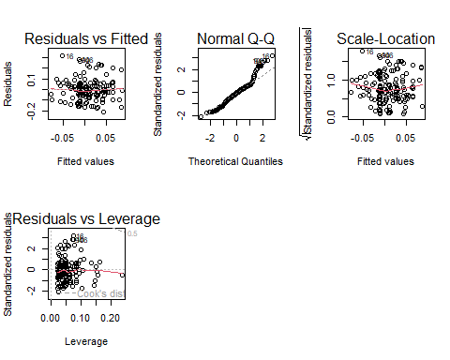

mod8_CAR1 <- lm(car_1 ~ covid_19 * size_revenue * p_e_dummy, data = data)  
summary(mod8_CAR1)

##   
## Call:  
## lm(formula = car_1 ~ covid_19 * size_revenue * p_e_dummy, data = data)  
##   
## Residuals:  
## Min 1Q Median 3Q Max   
## -0.12260 -0.03950 -0.00244 0.02695 0.17988   
##   
## Coefficients:  
## Estimate Std. Error t value Pr(>|t|)  
## (Intercept) 0.028285 0.038902 0.73 0.47  
## covid_191 -0.027319 0.053976 -0.51 0.61  
## size_revenue -0.002805 0.004895 -0.57 0.57  
## p_e_dummy1 0.062311 0.045930 1.36 0.18  
## covid_191:size_revenue 0.002608 0.006867 0.38 0.70  
## covid_191:p_e_dummy1 -0.018364 0.064846 -0.28 0.78  
## size_revenue:p_e_dummy1 -0.005228 0.005854 -0.89 0.37  
## covid_191:size_revenue:p_e_dummy1 -0.000899 0.008424 -0.11 0.92  
##   
## Residual standard error: 0.0664 on 131 degrees of freedom  
## (14 observations deleted due to missingness)  
## Multiple R-squared: 0.113, Adjusted R-squared: 0.0651   
## F-statistic: 2.37 on 7 and 131 DF, p-value: 0.0257

kable(extractCoefs(mod8_CAR1))

| Dependent | Coefficient | Estimate | Std_error | T_value | P_value |
| --- | --- | --- | --- | --- | --- |
| car_1 | COVID190 | 0.028 | 0.039 | 0.727 | 0.468 |
| car_1 | covid_191 | -0.027 | 0.054 | -0.506 | 0.614 |
| car_1 | size_revenue | -0.003 | 0.005 | -0.573 | 0.568 |
| car_1 | p_e_dummy1 | 0.062 | 0.046 | 1.357 | 0.177 |
| car_1 | covid_191:size_revenue | 0.003 | 0.007 | 0.380 | 0.705 |
| car_1 | covid_191:p_e_dummy1 | -0.018 | 0.065 | -0.283 | 0.777 |
| car_1 | size_revenue:p_e_dummy1 | -0.005 | 0.006 | -0.893 | 0.374 |
| car_1 | covid_191:size_revenue:p_e_dummy1 | -0.001 | 0.008 | -0.107 | 0.915 |

par(mfrow=c(2,3))  
plot(mod8_CAR1)

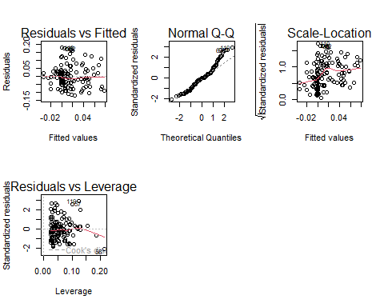

mod8_CAR2 <- lm(car_2 ~ covid_19 * size_revenue * p_e_dummy, data = data)  
summary(mod8_CAR2)

##   
## Call:  
## lm(formula = car_2 ~ covid_19 * size_revenue * p_e_dummy, data = data)  
##   
## Residuals:  
## Min 1Q Median 3Q Max   
## -0.19795 -0.05912 -0.00216 0.04843 0.26831   
##   
## Coefficients:  
## Estimate Std. Error t value Pr(>|t|)  
## (Intercept) -0.00215 0.06022 -0.04 0.97  
## covid_191 0.02414 0.08355 0.29 0.77  
## size_revenue 0.00192 0.00758 0.25 0.80  
## p_e_dummy1 0.05775 0.07110 0.81 0.42  
## covid_191:size_revenue -0.00573 0.01063 -0.54 0.59  
## covid_191:p_e_dummy1 -0.06847 0.10038 -0.68 0.50  
## size_revenue:p_e_dummy1 -0.00628 0.00906 -0.69 0.49  
## covid_191:size_revenue:p_e_dummy1 0.00781 0.01304 0.60 0.55  
##   
## Residual standard error: 0.103 on 131 degrees of freedom  
## (14 observations deleted due to missingness)  
## Multiple R-squared: 0.0271, Adjusted R-squared: -0.0248   
## F-statistic: 0.522 on 7 and 131 DF, p-value: 0.817

par(mfrow=c(2,3))  
plot(mod8_CAR2)

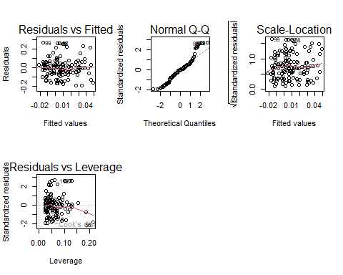

### Response to hypothesis 4

Revenue pos 2020 maintain its significat small positive effect on CAR2 when accounting for other explanatory variables. Revenue pos 2020 present a small negative marginally sigificant interaction with COVID19. The models are also not statistically significant at a 90% level of significance. However, these effects on CAR are very low (see estimates).

## HYPOTHESIS 5

**Local transaction (cross-border = 0) has a positive impact on the cumulative abnormal return (CAR = dependent variable).**

data_copy = data  
data$covid_19 = as.numeric(data$covid_19)

data = filter(data, covid_19!="0")  
mod9_CAR1 <- lm(car_1 ~ cross_border * covid_19, data = data)  
summary(mod9_CAR1)

##   
## Call:  
## lm(formula = car_1 ~ cross_border * covid_19, data = data)  
##   
## Residuals:  
## Min 1Q Median 3Q Max   
## -0.13813 -0.04589 -0.00797 0.03251 0.17535   
##   
## Coefficients:  
## Estimate Std. Error t value Pr(>|t|)  
## (Intercept) 0.01697 0.02429 0.70 0.49  
## cross_border1 0.05570 0.03879 1.44 0.15  
## covid_19 -0.00509 0.01463 -0.35 0.73  
## cross_border1:covid_19 -0.02881 0.02443 -1.18 0.24  
##   
## Residual standard error: 0.0717 on 149 degrees of freedom  
## Multiple R-squared: 0.0292, Adjusted R-squared: 0.0097   
## F-statistic: 1.5 on 3 and 149 DF, p-value: 0.218

kable(extractCoefs(mod9_CAR1))

| Dependent | Coefficient | Estimate | Std_error | T_value | P_value |
| --- | --- | --- | --- | --- | --- |
| car_1 | COVID190 | 0.017 | 0.024 | 0.698 | 0.486 |
| car_1 | cross_border1 | 0.056 | 0.039 | 1.436 | 0.153 |
| car_1 | covid_19 | -0.005 | 0.015 | -0.348 | 0.728 |
| car_1 | cross_border1:covid_19 | -0.029 | 0.024 | -1.179 | 0.240 |

par(mfrow=c(2,3))  
plot(mod9_CAR1)

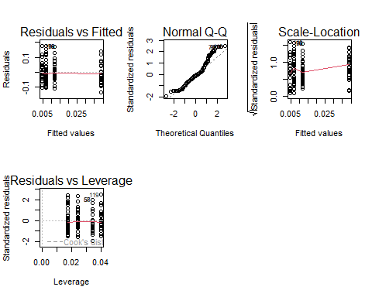

mod9_CAR2 <- lm(car_2 ~ cross_border * covid_19, data = data)  
summary(mod9_CAR2)

##   
## Call:  
## lm(formula = car_2 ~ cross_border * covid_19, data = data)  
##   
## Residuals:  
## Min 1Q Median 3Q Max   
## -0.19271 -0.06123 -0.00511 0.04549 0.26703   
##   
## Coefficients:  
## Estimate Std. Error t value Pr(>|t|)  
## (Intercept) 0.0291 0.0359 0.81 0.42  
## cross_border1 0.0189 0.0573 0.33 0.74  
## covid_19 -0.0153 0.0216 -0.71 0.48  
## cross_border1:covid_19 -0.0105 0.0361 -0.29 0.77  
##   
## Residual standard error: 0.106 on 149 degrees of freedom  
## Multiple R-squared: 0.00926, Adjusted R-squared: -0.0107   
## F-statistic: 0.464 on 3 and 149 DF, p-value: 0.708

kable(extractCoefs(mod9_CAR2))

| Dependent | Coefficient | Estimate | Std_error | T_value | P_value |
| --- | --- | --- | --- | --- | --- |
| car_2 | COVID190 | 0.029 | 0.036 | 0.811 | 0.419 |
| car_2 | cross_border1 | 0.019 | 0.057 | 0.329 | 0.742 |
| car_2 | covid_19 | -0.015 | 0.022 | -0.709 | 0.479 |
| car_2 | cross_border1:covid_19 | -0.010 | 0.036 | -0.291 | 0.771 |

par(mfrow=c(2,3))  
plot(mod9_CAR2)

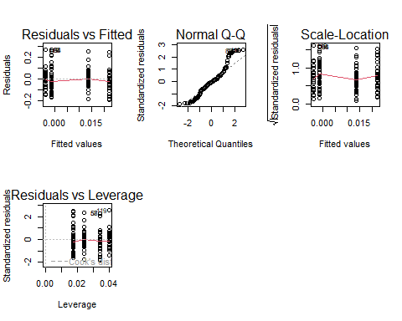

### Response to hypothesis 5

No effect of local transcation on CAR observed.

## Extra Models:

mod_1_car1 = lm(car_1~covid_19, data = data)  
summary(mod_1_car1)

##   
## Call:  
## lm(formula = car_1 ~ covid_19, data = data)  
##   
## Residuals:  
## Min 1Q Median 3Q Max   
## -0.12238 -0.04531 -0.00861 0.03309 0.17401   
##   
## Coefficients:  
## Estimate Std. Error t value Pr(>|t|)   
## (Intercept) 0.0398 0.0189 2.11 0.037 *  
## covid_19 -0.0168 0.0116 -1.44 0.151   
## ---  
## Signif. codes: 0 '***' 0.001 '**' 0.01 '*' 0.05 '.' 0.1 ' ' 1  
##   
## Residual standard error: 0.0718 on 151 degrees of freedom  
## Multiple R-squared: 0.0136, Adjusted R-squared: 0.00706   
## F-statistic: 2.08 on 1 and 151 DF, p-value: 0.151

mod_1_car2 = lm(car_2~covid_19, data = data)  
summary(mod_1_car2)

##   
## Call:  
## lm(formula = car_2 ~ covid_19, data = data)  
##   
## Residuals:  
## Min 1Q Median 3Q Max   
## -0.18780 -0.05860 -0.00542 0.04400 0.26554   
##   
## Coefficients:  
## Estimate Std. Error t value Pr(>|t|)  
## (Intercept) 0.0366 0.0277 1.32 0.19  
## covid_19 -0.0194 0.0171 -1.14 0.26  
##   
## Residual standard error: 0.105 on 151 degrees of freedom  
## Multiple R-squared: 0.0085, Adjusted R-squared: 0.00194   
## F-statistic: 1.29 on 1 and 151 DF, p-value: 0.257

mod_2_car1 = lm(car_1~covid_19+sector, data = data)  
summary(mod_2_car1)

##   
## Call:  
## lm(formula = car_1 ~ covid_19 + sector, data = data)  
##   
## Residuals:  
## Min 1Q Median 3Q Max   
## -0.12822 -0.04169 -0.00961 0.03495 0.16941   
##   
## Coefficients:  
## Estimate Std. Error t value Pr(>|t|)   
## (Intercept) 0.0942 0.0540 1.75 0.083 .  
## covid_19 -0.0248 0.0125 -1.98 0.049 *  
## sectorEnergy and Power -0.0691 0.0574 -1.20 0.231   
## sectorFinancials -0.0705 0.0559 -1.26 0.209   
## sectorHealthcare -0.0337 0.0539 -0.63 0.533   
## sectorHigh Technology -0.0242 0.0518 -0.47 0.641   
## sectorIndustrials -0.0629 0.0529 -1.19 0.236   
## sectorInvestment firm -0.0157 0.0543 -0.29 0.773   
## sectorMaterials -0.0389 0.0561 -0.69 0.490   
## sectorReal Estate -0.0348 0.0546 -0.64 0.525   
## sectorRetail -0.0597 0.0546 -1.09 0.276   
## sectorTelecommunications -0.0763 0.0563 -1.36 0.178   
## sectorTransportation -0.0240 0.0878 -0.27 0.785   
## ---  
## Signif. codes: 0 '***' 0.001 '**' 0.01 '*' 0.05 '.' 0.1 ' ' 1  
##   
## Residual standard error: 0.0715 on 140 degrees of freedom  
## Multiple R-squared: 0.092, Adjusted R-squared: 0.0142   
## F-statistic: 1.18 on 12 and 140 DF, p-value: 0.302

mod_2_car2 = lm(car_2~covid_19+sector, data = data)  
summary(mod_2_car2)

##   
## Call:  
## lm(formula = car_2 ~ covid_19 + sector, data = data)  
##   
## Residuals:  
## Min 1Q Median 3Q Max   
## -0.21059 -0.06004 -0.00334 0.05096 0.28433   
##   
## Coefficients:  
## Estimate Std. Error t value Pr(>|t|)  
## (Intercept) 0.0954 0.0799 1.19 0.23  
## covid_19 -0.0236 0.0185 -1.27 0.20  
## sectorEnergy and Power 0.0156 0.0849 0.18 0.85  
## sectorFinancials -0.1074 0.0828 -1.30 0.20  
## sectorHealthcare -0.0224 0.0799 -0.28 0.78  
## sectorHigh Technology -0.0416 0.0767 -0.54 0.59  
## sectorIndustrials -0.0573 0.0783 -0.73 0.47  
## sectorInvestment firm -0.0692 0.0805 -0.86 0.39  
## sectorMaterials -0.0727 0.0831 -0.87 0.38  
## sectorReal Estate -0.0749 0.0809 -0.93 0.36  
## sectorRetail -0.0576 0.0809 -0.71 0.48  
## sectorTelecommunications -0.0681 0.0833 -0.82 0.42  
## sectorTransportation -0.0432 0.1301 -0.33 0.74  
##   
## Residual standard error: 0.106 on 140 degrees of freedom  
## Multiple R-squared: 0.0675, Adjusted R-squared: -0.0124   
## F-statistic: 0.844 on 12 and 140 DF, p-value: 0.605

mod_3_car1 = lm(car_1~covid_19+diversification+cash+size_relative, data = data)  
summary(mod_3_car1)

##   
## Call:  
## lm(formula = car_1 ~ covid_19 + diversification + cash + size_relative,   
## data = data)  
##   
## Residuals:  
## Min 1Q Median 3Q Max   
## -0.12561 -0.04838 -0.00583 0.03072 0.17224   
##   
## Coefficients:  
## Estimate Std. Error t value Pr(>|t|)   
## (Intercept) 0.063366 0.032735 1.94 0.056 .  
## covid_19 -0.019300 0.016309 -1.18 0.240   
## diversification1 0.000412 0.028892 0.01 0.989   
## cash1 -0.019718 0.022634 -0.87 0.386   
## cashn.d. -0.005969 0.032376 -0.18 0.854   
## size_relative 0.001647 0.001628 1.01 0.315   
## ---  
## Signif. codes: 0 '***' 0.001 '**' 0.01 '*' 0.05 '.' 0.1 ' ' 1  
##   
## Residual standard error: 0.0745 on 83 degrees of freedom  
## (64 observations deleted due to missingness)  
## Multiple R-squared: 0.0421, Adjusted R-squared: -0.0156   
## F-statistic: 0.73 on 5 and 83 DF, p-value: 0.603

mod_3_car2 = lm(car_2~covid_19+diversification+cash+size_relative, data = data)  
summary(mod_3_car2)

##   
## Call:  
## lm(formula = car_2 ~ covid_19 + diversification + cash + size_relative,   
## data = data)  
##   
## Residuals:  
## Min 1Q Median 3Q Max   
## -0.2056 -0.0656 -0.0170 0.0454 0.2592   
##   
## Coefficients:  
## Estimate Std. Error t value Pr(>|t|)  
## (Intercept) 0.05179 0.04900 1.06 0.29  
## covid_19 -0.01673 0.02441 -0.69 0.49  
## diversification1 0.00858 0.04325 0.20 0.84  
## cash1 -0.02498 0.03388 -0.74 0.46  
## cashn.d. 0.03053 0.04847 0.63 0.53  
## size_relative -0.00112 0.00244 -0.46 0.65  
##   
## Residual standard error: 0.112 on 83 degrees of freedom  
## (64 observations deleted due to missingness)  
## Multiple R-squared: 0.0397, Adjusted R-squared: -0.0182   
## F-statistic: 0.686 on 5 and 83 DF, p-value: 0.636

mod_4_car1 = lm(car_1~covid_19+diversification+cash+size_revenue+size_relative +(covid_19*size_revenue), data = data)  
summary(mod_4_car1)

##   
## Call:  
## lm(formula = car_1 ~ covid_19 + diversification + cash + size_revenue +   
## size_relative + (covid_19 * size_revenue), data = data)  
##   
## Residuals:  
## Min 1Q Median 3Q Max   
## -0.12528 -0.05285 -0.00321 0.03170 0.16594   
##   
## Coefficients:  
## Estimate Std. Error t value Pr(>|t|)   
## (Intercept) 0.126046 0.072017 1.75 0.084 .  
## covid_19 -0.046308 0.043942 -1.05 0.295   
## diversification1 -0.003693 0.029105 -0.13 0.899   
## cash1 -0.013555 0.023305 -0.58 0.562   
## cashn.d. 0.000865 0.032797 0.03 0.979   
## size_revenue -0.009375 0.009340 -1.00 0.318   
## size_relative 0.001175 0.001831 0.64 0.523   
## covid_19:size_revenue 0.003722 0.005946 0.63 0.533   
## ---  
## Signif. codes: 0 '***' 0.001 '**' 0.01 '*' 0.05 '.' 0.1 ' ' 1  
##   
## Residual standard error: 0.0746 on 81 degrees of freedom  
## (64 observations deleted due to missingness)  
## Multiple R-squared: 0.0635, Adjusted R-squared: -0.0175   
## F-statistic: 0.784 on 7 and 81 DF, p-value: 0.603

mod_4_car2 = lm(car_2~covid_19+diversification+cash+size_revenue+size_relative +(covid_19*size_revenue), data = data)  
summary(mod_4_car2)

##   
## Call:  
## lm(formula = car_2 ~ covid_19 + diversification + cash + size_revenue +   
## size_relative + (covid_19 * size_revenue), data = data)  
##   
## Residuals:  
## Min 1Q Median 3Q Max   
## -0.2114 -0.0656 -0.0130 0.0491 0.2580   
##   
## Coefficients:  
## Estimate Std. Error t value Pr(>|t|)  
## (Intercept) 0.100154 0.108738 0.92 0.36  
## covid_19 -0.053811 0.066348 -0.81 0.42  
## diversification1 0.007018 0.043945 0.16 0.87  
## cash1 -0.027577 0.035189 -0.78 0.44  
## cashn.d. 0.030516 0.049521 0.62 0.54  
## size_revenue -0.006870 0.014102 -0.49 0.63  
## size_relative -0.000399 0.002764 -0.14 0.89  
## covid_19:size_revenue 0.005473 0.008978 0.61 0.54  
##   
## Residual standard error: 0.113 on 81 degrees of freedom  
## (64 observations deleted due to missingness)  
## Multiple R-squared: 0.0448, Adjusted R-squared: -0.0378   
## F-statistic: 0.542 on 7 and 81 DF, p-value: 0.8

mod_5_car1 = lm(car_1~covid_19+diversification+cash+size_revenue+size_category+size_relative +(covid_19*size_category), data = data)  
summary(mod_5_car1)

##   
## Call:  
## lm(formula = car_1 ~ covid_19 + diversification + cash + size_revenue +   
## size_category + size_relative + (covid_19 * size_category),   
## data = data)  
##   
## Residuals:  
## Min 1Q Median 3Q Max   
## -0.14289 -0.03963 -0.00408 0.02635 0.17019   
##   
## Coefficients:  
## Estimate Std. Error t value Pr(>|t|)  
## (Intercept) 0.019590 0.067346 0.29 0.77  
## covid_19 -0.014839 0.022861 -0.65 0.52  
## diversification1 0.002942 0.028585 0.10 0.92  
## cash1 -0.008194 0.022970 -0.36 0.72  
## cashn.d. 0.005952 0.032819 0.18 0.86  
## size_revenue 0.000897 0.006066 0.15 0.88  
## size_categorymedium 0.070110 0.058197 1.20 0.23  
## size_categorysmall 0.030647 0.134995 0.23 0.82  
## size_relative 0.002758 0.001910 1.44 0.15  
## covid_19:size_categorymedium -0.017125 0.032722 -0.52 0.60  
## covid_19:size_categorysmall -0.048251 0.083171 -0.58 0.56  
##   
## Residual standard error: 0.0725 on 78 degrees of freedom  
## (64 observations deleted due to missingness)  
## Multiple R-squared: 0.147, Adjusted R-squared: 0.0382   
## F-statistic: 1.35 on 10 and 78 DF, p-value: 0.22

mod_5_car2 = lm(car_2~covid_19+diversification+cash+size_revenue+size_category+size_relative +(covid_19*size_category), data = data)  
summary(mod_5_car2)

##   
## Call:  
## lm(formula = car_2 ~ covid_19 + diversification + cash + size_revenue +   
## size_category + size_relative + (covid_19 * size_category),   
## data = data)  
##   
## Residuals:  
## Min 1Q Median 3Q Max   
## -0.21162 -0.06912 -0.00952 0.04402 0.27595   
##   
## Coefficients:  
## Estimate Std. Error t value Pr(>|t|)  
## (Intercept) -0.02372 0.10428 -0.23 0.82  
## covid_19 0.00493 0.03540 0.14 0.89  
## diversification1 0.01122 0.04426 0.25 0.80  
## cash1 -0.02197 0.03557 -0.62 0.54  
## cashn.d. 0.03993 0.05082 0.79 0.43  
## size_revenue 0.00354 0.00939 0.38 0.71  
## size_categorymedium 0.10520 0.09011 1.17 0.25  
## size_categorysmall 0.05285 0.20903 0.25 0.80  
## size_relative 0.00114 0.00296 0.38 0.70  
## covid_19:size_categorymedium -0.04830 0.05067 -0.95 0.34  
## covid_19:size_categorysmall -0.07834 0.12878 -0.61 0.54  
##   
## Residual standard error: 0.112 on 78 degrees of freedom  
## (64 observations deleted due to missingness)  
## Multiple R-squared: 0.0856, Adjusted R-squared: -0.0317   
## F-statistic: 0.73 on 10 and 78 DF, p-value: 0.694

mod_6_car1 = lm(car_1~covid_19+diversification+cash+ebitda_pos_2020+size_relative +(covid_19*ebitda_pos_2020), data = data)  
summary(mod_6_car1)

##   
## Call:  
## lm(formula = car_1 ~ covid_19 + diversification + cash + ebitda_pos_2020 +   
## size_relative + (covid_19 * ebitda_pos_2020), data = data)  
##   
## Residuals:  
## Min 1Q Median 3Q Max   
## -0.1241 -0.0495 -0.0071 0.0331 0.1752   
##   
## Coefficients:  
## Estimate Std. Error t value Pr(>|t|)  
## (Intercept) 0.06361 0.03962 1.61 0.11  
## covid_19 -0.02072 0.02169 -0.96 0.34  
## diversification1 0.00101 0.02939 0.03 0.97  
## cash1 -0.02007 0.02294 -0.87 0.38  
## cashn.d. -0.00632 0.03282 -0.19 0.85  
## ebitda_pos_2020 0.00186 0.05591 0.03 0.97  
## size_relative 0.00165 0.00165 1.00 0.32  
## covid_19:ebitda_pos_2020 0.00186 0.03333 0.06 0.96  
##   
## Residual standard error: 0.0754 on 81 degrees of freedom  
## (64 observations deleted due to missingness)  
## Multiple R-squared: 0.0432, Adjusted R-squared: -0.0395   
## F-statistic: 0.522 on 7 and 81 DF, p-value: 0.815

mod_6_car2 = lm(car_2~covid_19+diversification+cash+ebitda_pos_2020+size_relative +(covid_19*ebitda_pos_2020), data = data)  
summary(mod_6_car2)

##   
## Call:  
## lm(formula = car_2 ~ covid_19 + diversification + cash + ebitda_pos_2020 +   
## size_relative + (covid_19 * ebitda_pos_2020), data = data)  
##   
## Residuals:  
## Min 1Q Median 3Q Max   
## -0.1906 -0.0656 -0.0116 0.0538 0.2537   
##   
## Coefficients:  
## Estimate Std. Error t value Pr(>|t|)  
## (Intercept) 0.03567 0.05852 0.61 0.54  
## covid_19 -0.01553 0.03204 -0.48 0.63  
## diversification1 0.01455 0.04341 0.34 0.74  
## cash1 -0.02796 0.03388 -0.83 0.41  
## cashn.d. 0.02951 0.04848 0.61 0.54  
## ebitda_pos_2020 0.05829 0.08259 0.71 0.48  
## size_relative -0.00106 0.00243 -0.44 0.66  
## covid_19:ebitda_pos_2020 -0.01411 0.04924 -0.29 0.78  
##   
## Residual standard error: 0.111 on 81 degrees of freedom  
## (64 observations deleted due to missingness)  
## Multiple R-squared: 0.066, Adjusted R-squared: -0.0148   
## F-statistic: 0.817 on 7 and 81 DF, p-value: 0.576

mod_7_car1 = lm(car_1~covid_19+diversification+cash+revenue_pos_2020+size_relative +(covid_19*revenue_pos_2020), data = data)  
summary(mod_7_car1)

##   
## Call:  
## lm(formula = car_1 ~ covid_19 + diversification + cash + revenue_pos_2020 +   
## size_relative + (covid_19 * revenue_pos_2020), data = data)  
##   
## Residuals:  
## Min 1Q Median 3Q Max   
## -0.12709 -0.04811 -0.00467 0.03098 0.17286   
##   
## Coefficients:  
## Estimate Std. Error t value Pr(>|t|)  
## (Intercept) 0.058078 0.046456 1.25 0.21  
## covid_19 -0.016167 0.025912 -0.62 0.53  
## diversification1 -0.000505 0.029973 -0.02 0.99  
## cash1 -0.020046 0.023058 -0.87 0.39  
## cashn.d. -0.005811 0.032859 -0.18 0.86  
## revenue_pos_2020 0.009199 0.056672 0.16 0.87  
## size_relative 0.001644 0.001648 1.00 0.32  
## covid_19:revenue_pos_2020 -0.005231 0.034176 -0.15 0.88  
##   
## Residual standard error: 0.0754 on 81 degrees of freedom  
## (64 observations deleted due to missingness)  
## Multiple R-squared: 0.0424, Adjusted R-squared: -0.0403   
## F-statistic: 0.512 on 7 and 81 DF, p-value: 0.823

mod_7_car2 = lm(car_2~covid_19+diversification+cash+revenue_pos_2020+size_relative +(covid_19*revenue_pos_2020), data = data)  
summary(mod_7_car2)

##   
## Call:  
## lm(formula = car_2 ~ covid_19 + diversification + cash + revenue_pos_2020 +   
## size_relative + (covid_19 * revenue_pos_2020), data = data)  
##   
## Residuals:  
## Min 1Q Median 3Q Max   
## -0.1858 -0.0699 -0.0101 0.0500 0.2682   
##   
## Coefficients:  
## Estimate Std. Error t value Pr(>|t|)  
## (Intercept) -0.00291 0.06882 -0.04 0.97  
## covid_19 0.00909 0.03838 0.24 0.81  
## diversification1 0.00300 0.04440 0.07 0.95  
## cash1 -0.02647 0.03416 -0.77 0.44  
## cashn.d. 0.02970 0.04868 0.61 0.54  
## revenue_pos_2020 0.08925 0.08395 1.06 0.29  
## size_relative -0.00112 0.00244 -0.46 0.65  
## covid_19:revenue_pos_2020 -0.04014 0.05063 -0.79 0.43  
##   
## Residual standard error: 0.112 on 81 degrees of freedom  
## (64 observations deleted due to missingness)  
## Multiple R-squared: 0.0599, Adjusted R-squared: -0.0214   
## F-statistic: 0.737 on 7 and 81 DF, p-value: 0.641

mod_8_car1 = lm(car_1~covid_19+diversification+cash+p_e_dummy+size_relative +(covid_19*p_e_dummy), data = data)  
summary(mod_8_car1)

##   
## Call:  
## lm(formula = car_1 ~ covid_19 + diversification + cash + p_e_dummy +   
## size_relative + (covid_19 * p_e_dummy), data = data)  
##   
## Residuals:  
## Min 1Q Median 3Q Max   
## -0.14065 -0.04412 -0.00483 0.02212 0.16726   
##   
## Coefficients:  
## Estimate Std. Error t value Pr(>|t|)   
## (Intercept) 0.087185 0.046401 1.88 0.064 .  
## covid_19 -0.022960 0.024245 -0.95 0.347   
## diversification1 0.018047 0.030162 0.60 0.551   
## cash1 -0.048441 0.023502 -2.06 0.043 *  
## cashn.d. -0.047667 0.034211 -1.39 0.168   
## p_e_dummy1 0.008038 0.052839 0.15 0.880   
## size_relative 0.000383 0.001671 0.23 0.820   
## covid_19:p_e_dummy1 0.005711 0.032621 0.18 0.862   
## ---  
## Signif. codes: 0 '***' 0.001 '**' 0.01 '*' 0.05 '.' 0.1 ' ' 1  
##   
## Residual standard error: 0.0703 on 72 degrees of freedom  
## (73 observations deleted due to missingness)  
## Multiple R-squared: 0.102, Adjusted R-squared: 0.0152   
## F-statistic: 1.17 on 7 and 72 DF, p-value: 0.328

mod_8_car2 = lm(car_2~covid_19+diversification+cash+p_e_dummy+size_relative +(covid_19*p_e_dummy), data = data)  
summary(mod_8_car2)

##   
## Call:  
## lm(formula = car_2 ~ covid_19 + diversification + cash + p_e_dummy +   
## size_relative + (covid_19 * p_e_dummy), data = data)  
##   
## Residuals:  
## Min 1Q Median 3Q Max   
## -0.19660 -0.06872 0.00102 0.04955 0.27517   
##   
## Coefficients:  
## Estimate Std. Error t value Pr(>|t|)   
## (Intercept) 0.06676 0.07203 0.93 0.357   
## covid_19 -0.00723 0.03764 -0.19 0.848   
## diversification1 0.01871 0.04682 0.40 0.691   
## cash1 -0.06378 0.03648 -1.75 0.085 .  
## cashn.d. -0.03980 0.05311 -0.75 0.456   
## p_e_dummy1 0.04003 0.08203 0.49 0.627   
## size_relative -0.00295 0.00259 -1.14 0.259   
## covid_19:p_e_dummy1 -0.01011 0.05064 -0.20 0.842   
## ---  
## Signif. codes: 0 '***' 0.001 '**' 0.01 '*' 0.05 '.' 0.1 ' ' 1  
##   
## Residual standard error: 0.109 on 72 degrees of freedom  
## (73 observations deleted due to missingness)  
## Multiple R-squared: 0.068, Adjusted R-squared: -0.0226   
## F-statistic: 0.75 on 7 and 72 DF, p-value: 0.631

mod_9_car1 = lm(car_1~covid_19+diversification+cash+ebitda_pos_2020+size_revenue+size_relative +(covid_19*ebitda_pos_2020*size_revenue), data = data)  
summary(mod_9_car1)

##   
## Call:  
## lm(formula = car_1 ~ covid_19 + diversification + cash + ebitda_pos_2020 +   
## size_revenue + size_relative + (covid_19 * ebitda_pos_2020 *   
## size_revenue), data = data)  
##   
## Residuals:  
## Min 1Q Median 3Q Max   
## -0.12437 -0.04971 -0.00731 0.03104 0.17683   
##   
## Coefficients:  
## Estimate Std. Error t value Pr(>|t|)  
## (Intercept) 0.12314 0.08690 1.42 0.16  
## covid_19 -0.05631 0.05415 -1.04 0.30  
## diversification1 -0.00485 0.02988 -0.16 0.87  
## cash1 -0.01607 0.02376 -0.68 0.50  
## cashn.d. -0.00419 0.03351 -0.12 0.90  
## ebitda_pos_2020 0.04670 0.15682 0.30 0.77  
## size_revenue -0.00898 0.01141 -0.79 0.43  
## size_relative 0.00117 0.00186 0.63 0.53  
## covid_19:ebitda_pos_2020 0.00718 0.09209 0.08 0.94  
## covid_19:size_revenue 0.00535 0.00748 0.72 0.48  
## ebitda_pos_2020:size_revenue -0.00602 0.02081 -0.29 0.77  
## covid_19:ebitda_pos_2020:size_revenue -0.00122 0.01248 -0.10 0.92  
##   
## Residual standard error: 0.0756 on 77 degrees of freedom  
## (64 observations deleted due to missingness)  
## Multiple R-squared: 0.0849, Adjusted R-squared: -0.0458   
## F-statistic: 0.65 on 11 and 77 DF, p-value: 0.78

mod_9_car2 = lm(car_2~covid_19+diversification+cash+ebitda_pos_2020+size_revenue+size_relative +(covid_19*ebitda_pos_2020*size_revenue), data = data)  
summary(mod_9_car2)

##   
## Call:  
## lm(formula = car_2 ~ covid_19 + diversification + cash + ebitda_pos_2020 +   
## size_revenue + size_relative + (covid_19 * ebitda_pos_2020 *   
## size_revenue), data = data)  
##   
## Residuals:  
## Min 1Q Median 3Q Max   
## -0.1767 -0.0717 -0.0125 0.0523 0.2592   
##   
## Coefficients:  
## Estimate Std. Error t value Pr(>|t|)   
## (Intercept) -0.018646 0.127967 -0.15 0.885   
## covid_19 0.000353 0.079747 0.00 0.996   
## diversification1 0.017916 0.044006 0.41 0.685   
## cash1 -0.036088 0.034997 -1.03 0.306   
## cashn.d. 0.020873 0.049347 0.42 0.673   
## ebitda_pos_2020 0.433405 0.230945 1.88 0.064 .  
## size_revenue 0.007953 0.016807 0.47 0.637   
## size_relative -0.000517 0.002738 -0.19 0.851   
## covid_19:ebitda_pos_2020 -0.196677 0.135624 -1.45 0.151   
## covid_19:size_revenue -0.001719 0.011012 -0.16 0.876   
## ebitda_pos_2020:size_revenue -0.052257 0.030642 -1.71 0.092 .  
## covid_19:ebitda_pos_2020:size_revenue 0.025215 0.018374 1.37 0.174   
## ---  
## Signif. codes: 0 '***' 0.001 '**' 0.01 '*' 0.05 '.' 0.1 ' ' 1  
##   
## Residual standard error: 0.111 on 77 degrees of freedom  
## (64 observations deleted due to missingness)  
## Multiple R-squared: 0.112, Adjusted R-squared: -0.0147   
## F-statistic: 0.884 on 11 and 77 DF, p-value: 0.559

mod_10_car1 = lm(car_1~covid_19+diversification+cash+ebitda_pos_2020+size_revenue+size_relative +(covid_19*revenue_pos_2020*size_revenue), data = data)  
summary(mod_10_car1)

##   
## Call:  
## lm(formula = car_1 ~ covid_19 + diversification + cash + ebitda_pos_2020 +   
## size_revenue + size_relative + (covid_19 * revenue_pos_2020 *   
## size_revenue), data = data)  
##   
## Residuals:  
## Min 1Q Median 3Q Max   
## -0.13017 -0.05471 -0.00489 0.03300 0.16773   
##   
## Coefficients:  
## Estimate Std. Error t value Pr(>|t|)  
## (Intercept) 0.135251 0.109700 1.23 0.22  
## covid_19 -0.060228 0.066512 -0.91 0.37  
## diversification1 -0.004777 0.030516 -0.16 0.88  
## cash1 -0.016754 0.024341 -0.69 0.49  
## cashn.d. -0.002545 0.034259 -0.07 0.94  
## ebitda_pos_2020 0.009654 0.019262 0.50 0.62  
## size_revenue -0.009890 0.012867 -0.77 0.44  
## size_relative 0.001153 0.001896 0.61 0.54  
## revenue_pos_2020 -0.009149 0.152954 -0.06 0.95  
## covid_19:revenue_pos_2020 0.026975 0.090204 0.30 0.77  
## covid_19:size_revenue 0.005472 0.008031 0.68 0.50  
## size_revenue:revenue_pos_2020 0.000467 0.019982 0.02 0.98  
## covid_19:size_revenue:revenue_pos_2020 -0.004435 0.012212 -0.36 0.72  
##   
## Residual standard error: 0.0762 on 76 degrees of freedom  
## (64 observations deleted due to missingness)  
## Multiple R-squared: 0.0822, Adjusted R-squared: -0.0627   
## F-statistic: 0.567 on 12 and 76 DF, p-value: 0.861

mod_10_car2 = lm(car_2~covid_19+diversification+cash+ebitda_pos_2020+size_revenue+size_relative +(covid_19*revenue_pos_2020*size_revenue), data = data)  
summary(mod_10_car2)

##   
## Call:  
## lm(formula = car_2 ~ covid_19 + diversification + cash + ebitda_pos_2020 +   
## size_revenue + size_relative + (covid_19 * revenue_pos_2020 *   
## size_revenue), data = data)  
##   
## Residuals:  
## Min 1Q Median 3Q Max   
## -0.1690 -0.0708 -0.0225 0.0569 0.2838   
##   
## Coefficients:  
## Estimate Std. Error t value Pr(>|t|)  
## (Intercept) -0.069685 0.160581 -0.43 0.67  
## covid_19 0.010180 0.097361 0.10 0.92  
## diversification1 0.003889 0.044670 0.09 0.93  
## cash1 -0.043688 0.035631 -1.23 0.22  
## cashn.d. 0.010619 0.050149 0.21 0.83  
## ebitda_pos_2020 0.026568 0.028197 0.94 0.35  
## size_revenue 0.008699 0.018835 0.46 0.65  
## size_relative -0.000266 0.002776 -0.10 0.92  
## revenue_pos_2020 0.289279 0.223897 1.29 0.20  
## covid_19:revenue_pos_2020 -0.100302 0.132042 -0.76 0.45  
## covid_19:size_revenue 0.000733 0.011755 0.06 0.95  
## size_revenue:revenue_pos_2020 -0.028051 0.029250 -0.96 0.34  
## covid_19:size_revenue:revenue_pos_2020 0.007054 0.017876 0.39 0.69  
##   
## Residual standard error: 0.112 on 76 degrees of freedom  
## (64 observations deleted due to missingness)  
## Multiple R-squared: 0.12, Adjusted R-squared: -0.0187   
## F-statistic: 0.865 on 12 and 76 DF, p-value: 0.585

mod_11_car1 = lm(car_1~covid_19+diversification+cash+ebitda_pos_2020+size_revenue+size_relative +(covid_19*p_e_dummy*size_revenue), data = data)  
summary(mod_11_car1)

##   
## Call:  
## lm(formula = car_1 ~ covid_19 + diversification + cash + ebitda_pos_2020 +   
## size_revenue + size_relative + (covid_19 * p_e_dummy * size_revenue),   
## data = data)  
##   
## Residuals:  
## Min 1Q Median 3Q Max   
## -0.1253 -0.0494 -0.0047 0.0325 0.1600   
##   
## Coefficients:  
## Estimate Std. Error t value Pr(>|t|)   
## (Intercept) 0.198801 0.143610 1.38 0.171   
## covid_19 -0.092565 0.085811 -1.08 0.285   
## diversification1 0.019267 0.031407 0.61 0.542   
## cash1 -0.051331 0.026510 -1.94 0.057 .  
## cashn.d. -0.048763 0.036785 -1.33 0.189   
## ebitda_pos_2020 0.009380 0.017066 0.55 0.584   
## size_revenue -0.014095 0.016532 -0.85 0.397   
## size_relative -0.000807 0.002085 -0.39 0.700   
## p_e_dummy1 -0.056293 0.165544 -0.34 0.735   
## covid_19:p_e_dummy1 0.068935 0.105011 0.66 0.514   
## covid_19:size_revenue 0.008622 0.010282 0.84 0.405   
## size_revenue:p_e_dummy1 0.007636 0.020966 0.36 0.717   
## covid_19:size_revenue:p_e_dummy1 -0.008188 0.013520 -0.61 0.547   
## ---  
## Signif. codes: 0 '***' 0.001 '**' 0.01 '*' 0.05 '.' 0.1 ' ' 1  
##   
## Residual standard error: 0.0713 on 67 degrees of freedom  
## (73 observations deleted due to missingness)  
## Multiple R-squared: 0.142, Adjusted R-squared: -0.0118   
## F-statistic: 0.923 on 12 and 67 DF, p-value: 0.529

mod_11_car2 = lm(car_2~covid_19+diversification+cash+ebitda_pos_2020+size_revenue+size_relative +(covid_19*p_e_dummy*size_revenue), data = data)  
summary(mod_11_car2)

##   
## Call:  
## lm(formula = car_2 ~ covid_19 + diversification + cash + ebitda_pos_2020 +   
## size_revenue + size_relative + (covid_19 * p_e_dummy * size_revenue),   
## data = data)  
##   
## Residuals:  
## Min 1Q Median 3Q Max   
## -0.19429 -0.06745 -0.00703 0.04979 0.26838   
##   
## Coefficients:  
## Estimate Std. Error t value Pr(>|t|)   
## (Intercept) 0.13180 0.22222 0.59 0.555   
## covid_19 -0.09406 0.13278 -0.71 0.481   
## diversification1 0.02320 0.04860 0.48 0.635   
## cash1 -0.08402 0.04102 -2.05 0.044 *  
## cashn.d. -0.05757 0.05692 -1.01 0.315   
## ebitda_pos_2020 0.02817 0.02641 1.07 0.290   
## size_revenue -0.00737 0.02558 -0.29 0.774   
## size_relative -0.00373 0.00323 -1.16 0.252   
## p_e_dummy1 0.02295 0.25615 0.09 0.929   
## covid_19:p_e_dummy1 0.06170 0.16249 0.38 0.705   
## covid_19:size_revenue 0.01055 0.01591 0.66 0.510   
## size_revenue:p_e_dummy1 0.00166 0.03244 0.05 0.959   
## covid_19:size_revenue:p_e_dummy1 -0.00849 0.02092 -0.41 0.686   
## ---  
## Signif. codes: 0 '***' 0.001 '**' 0.01 '*' 0.05 '.' 0.1 ' ' 1  
##   
## Residual standard error: 0.11 on 67 degrees of freedom  
## (73 observations deleted due to missingness)  
## Multiple R-squared: 0.115, Adjusted R-squared: -0.0438   
## F-statistic: 0.724 on 12 and 67 DF, p-value: 0.723

mod_12_car1 = lm(car_1~covid_19+diversification+cross_border+cash+size_relative +(covid_19*cross_border), data = data)  
summary(mod_12_car1)

##   
## Call:  
## lm(formula = car_1 ~ covid_19 + diversification + cross_border +   
## cash + size_relative + (covid_19 * cross_border), data = data)  
##   
## Residuals:  
## Min 1Q Median 3Q Max   
## -0.13344 -0.04381 -0.00587 0.02908 0.16779   
##   
## Coefficients:  
## Estimate Std. Error t value Pr(>|t|)  
## (Intercept) 0.03573 0.04485 0.80 0.43  
## covid_19 -0.00301 0.02390 -0.13 0.90  
## diversification1 0.00239 0.02923 0.08 0.94  
## cross_border1 0.05047 0.05484 0.92 0.36  
## cash1 -0.02039 0.02290 -0.89 0.38  
## cashn.d. -0.00771 0.03380 -0.23 0.82  
## size_relative 0.00175 0.00164 1.07 0.29  
## covid_19:cross_border1 -0.03074 0.03308 -0.93 0.36  
##   
## Residual standard error: 0.075 on 81 degrees of freedom  
## (64 observations deleted due to missingness)  
## Multiple R-squared: 0.0524, Adjusted R-squared: -0.0295   
## F-statistic: 0.64 on 7 and 81 DF, p-value: 0.722

mod_12_car2 = lm(car_2~covid_19+diversification+cross_border+cash+size_relative +(covid_19*cross_border), data = data)  
summary(mod_12_car2)

##   
## Call:  
## lm(formula = car_2 ~ covid_19 + diversification + cross_border +   
## cash + size_relative + (covid_19 * cross_border), data = data)  
##   
## Residuals:  
## Min 1Q Median 3Q Max   
## -0.1979 -0.0673 -0.0126 0.0496 0.2556   
##   
## Coefficients:  
## Estimate Std. Error t value Pr(>|t|)  
## (Intercept) 0.03244 0.06742 0.48 0.63  
## covid_19 -0.00506 0.03593 -0.14 0.89  
## diversification1 0.01011 0.04394 0.23 0.82  
## cross_border1 0.03553 0.08244 0.43 0.67  
## cash1 -0.02534 0.03442 -0.74 0.46  
## cashn.d. 0.02877 0.05081 0.57 0.57  
## size_relative -0.00104 0.00247 -0.42 0.68  
## covid_19:cross_border1 -0.02227 0.04973 -0.45 0.66  
##   
## Residual standard error: 0.113 on 81 degrees of freedom  
## (64 observations deleted due to missingness)  
## Multiple R-squared: 0.042, Adjusted R-squared: -0.0407   
## F-statistic: 0.508 on 7 and 81 DF, p-value: 0.826

## cash MOdels

cash_CAR1_mod_1 = lm(car_1~covid_19+cash+(covid_19*cash), data = data)  
summary(cash_CAR1_mod_1)

##   
## Call:  
## lm(formula = car_1 ~ covid_19 + cash + (covid_19 * cash), data = data)  
##   
## Residuals:  
## Min 1Q Median 3Q Max   
## -0.13717 -0.04384 -0.00714 0.02965 0.16854   
##   
## Coefficients:  
## Estimate Std. Error t value Pr(>|t|)  
## (Intercept) 0.047054 0.059282 0.79 0.43  
## covid_19 -0.009243 0.036162 -0.26 0.80  
## cash1 0.000556 0.064337 0.01 0.99  
## cashn.d. -0.027882 0.067907 -0.41 0.68  
## covid_19:cash1 -0.008724 0.039444 -0.22 0.83  
## covid_19:cashn.d. -0.003970 0.041263 -0.10 0.92  
##   
## Residual standard error: 0.0718 on 147 degrees of freedom  
## Multiple R-squared: 0.0406, Adjusted R-squared: 0.00795   
## F-statistic: 1.24 on 5 and 147 DF, p-value: 0.292

cash_CAR2_mod_1 = lm(car_2~covid_19+cash+(covid_19*cash), data = data)  
summary(cash_CAR2_mod_1)

##   
## Call:  
## lm(formula = car_2 ~ covid_19 + cash + (covid_19 * cash), data = data)  
##   
## Residuals:  
## Min 1Q Median 3Q Max   
## -0.18902 -0.05914 -0.00371 0.04329 0.27584   
##   
## Coefficients:  
## Estimate Std. Error t value Pr(>|t|)  
## (Intercept) 0.029656 0.087919 0.34 0.74  
## covid_19 -0.014425 0.053630 -0.27 0.79  
## cash1 -0.000836 0.095416 -0.01 0.99  
## cashn.d. 0.019721 0.100711 0.20 0.85  
## covid_19:cash1 0.002519 0.058498 0.04 0.97  
## covid_19:cashn.d. -0.016516 0.061195 -0.27 0.79  
##   
## Residual standard error: 0.106 on 147 degrees of freedom  
## Multiple R-squared: 0.0119, Adjusted R-squared: -0.0217   
## F-statistic: 0.354 on 5 and 147 DF, p-value: 0.879

cash_CAR1_mod_2 = lm(car_1~covid_19+shares+(covid_19*shares), data = data)  
summary(cash_CAR1_mod_2)

##   
## Call:  
## lm(formula = car_1 ~ covid_19 + shares + (covid_19 * shares),   
## data = data)  
##   
## Residuals:  
## Min 1Q Median 3Q Max   
## -0.14599 -0.05221 -0.00447 0.05294 0.15361   
##   
## Coefficients:  
## Estimate Std. Error t value Pr(>|t|)   
## (Intercept) 0.0718 0.0322 2.23 0.028 *  
## covid_19 -0.0452 0.0210 -2.16 0.034 *  
## shares1 -0.0427 0.0510 -0.84 0.404   
## covid_19:shares1 0.0540 0.0317 1.70 0.092 .  
## ---  
## Signif. codes: 0 '***' 0.001 '**' 0.01 '*' 0.05 '.' 0.1 ' ' 1  
##   
## Residual standard error: 0.0774 on 95 degrees of freedom  
## (54 observations deleted due to missingness)  
## Multiple R-squared: 0.0984, Adjusted R-squared: 0.0699   
## F-statistic: 3.46 on 3 and 95 DF, p-value: 0.0195

cash_CAR2_mod_2 = lm(car_2~covid_19+shares+(covid_19*shares), data = data)  
summary(cash_CAR2_mod_2)

##   
## Call:  
## lm(formula = car_2 ~ covid_19 + shares + (covid_19 * shares),   
## data = data)  
##   
## Residuals:  
## Min 1Q Median 3Q Max   
## -0.18843 -0.06703 -0.00276 0.04767 0.25459   
##   
## Coefficients:  
## Estimate Std. Error t value Pr(>|t|)  
## (Intercept) 0.03232 0.04648 0.70 0.49  
## covid_19 -0.01636 0.03023 -0.54 0.59  
## shares1 -0.00538 0.07354 -0.07 0.94  
## covid_19:shares1 0.00727 0.04567 0.16 0.87  
##   
## Residual standard error: 0.112 on 95 degrees of freedom  
## (54 observations deleted due to missingness)  
## Multiple R-squared: 0.00413, Adjusted R-squared: -0.0273   
## F-statistic: 0.131 on 3 and 95 DF, p-value: 0.941

cash_CAR1_mod_3 = lm(car_1~covid_19+both+cash+shares+(covid_19*both), data = data)  
summary(cash_CAR1_mod_3)

##   
## Call:  
## lm(formula = car_1 ~ covid_19 + both + cash + shares + (covid_19 *   
## both), data = data)  
##   
## Residuals:  
## Min 1Q Median 3Q Max   
## -0.1555 -0.0519 -0.0020 0.0510 0.1639   
##   
## Coefficients: (1 not defined because of singularities)  
## Estimate Std. Error t value Pr(>|t|)   
## (Intercept) 0.0907 0.0349 2.60 0.011 *  
## covid_19 -0.0371 0.0185 -2.00 0.048 *  
## both1 -0.0405 0.0582 -0.69 0.489   
## cash1 -0.0306 0.0222 -1.38 0.172   
## shares1 NA NA NA NA   
## covid_19:both1 0.0554 0.0353 1.57 0.120   
## ---  
## Signif. codes: 0 '***' 0.001 '**' 0.01 '*' 0.05 '.' 0.1 ' ' 1  
##   
## Residual standard error: 0.0778 on 94 degrees of freedom  
## (54 observations deleted due to missingness)  
## Multiple R-squared: 0.0993, Adjusted R-squared: 0.0609   
## F-statistic: 2.59 on 4 and 94 DF, p-value: 0.0416

cash_CAR2_mod_3 = lm(car_2~covid_19+both+cash+shares+(covid_19*both), data = data)  
summary(cash_CAR2_mod_3)

##   
## Call:  
## lm(formula = car_2 ~ covid_19 + both + cash + shares + (covid_19 *   
## both), data = data)  
##   
## Residuals:  
## Min 1Q Median 3Q Max   
## -0.18666 -0.06886 -0.00256 0.04765 0.26319   
##   
## Coefficients: (1 not defined because of singularities)  
## Estimate Std. Error t value Pr(>|t|)  
## (Intercept) 0.032003 0.050346 0.64 0.53  
## covid_19 -0.015927 0.026759 -0.60 0.55  
## both1 -0.005627 0.084024 -0.07 0.95  
## cash1 -0.000311 0.031995 -0.01 0.99  
## shares1 NA NA NA NA  
## covid_19:both1 0.009375 0.050993 0.18 0.85  
##   
## Residual standard error: 0.112 on 94 degrees of freedom  
## (54 observations deleted due to missingness)  
## Multiple R-squared: 0.00492, Adjusted R-squared: -0.0374   
## F-statistic: 0.116 on 4 and 94 DF, p-value: 0.977