Alexa – Drone Pilot

SHREY PAREKH   
B.Tech IT,  
Smt. Kundanben Dinsha Patel Department of Information Technology.

Rajkot, India.  
[shreyparekh1199@gmail.com](mailto:shreyparekh1199@gmail.com)

SANDIP P. PATEL  
Assistant Professor,  
Smt. Kundanben Dinsha Patel Department of Information Technology.

Anand, India.  
sandippatel872@gmail.com

MANUSH PARIKH  
B.Tech IT,  
Smt. Kundanben Dinsha Patel Department of Information Technology.

Nadiad, India.  
manushparikh12@gmail.com

ROHAN MODI  
B.Tech IT,  
Smt. Kundanben Dinsha Patel Department of Information Technology .

Surat, India.  
rohanymodi@gmail.com

Abstract

A voice-based control of a drone with the help of Alexa ECHO for unmanned aerial vehicles (UAVs of “drones”). We gathered all the required components required for the task like Drone, Alexa echo, all software technologies like IOT Services, AWS Cloud, Alexa skills Kit, Lambda function, Cognito, Android application. We discuss work flow of the whole project, how will the technologies work after being integrated and how will the data flow from one technology to other.

Keywords: Drones, Lambda function, Alexa echo, Cognito, Alexa Skills Kit, IOT Services.

# **Introduction**

Unmanned aerial vehicles (UAVs or “drones”) have a long history in many different fields like military applications, Law enforcement, surveying, shooting great commercials and movies, Delivery of small items and they will be seen delivering all the ecommerce deliveries in the future soon. They are also able to carry heavy loads over long distances, while being controlled remotely by an operator. However, there are many drones available now a days that provide us with many non-military uses also but they come with some restrictions like limited range, time etc. But all this drones available are all handled using remote or mobile application, so the objective was to handle the drone with the help of the command that are provided by the human handling the drone.

This Paper considers the use of the voice command provided by the pilot to the Alexa echo and the drone follow the command. When using the voice as the input the input is provided to the drone by following a specific flow that is predefined. There are various number of uses of drones some of them are listed below:

* Military uses
* Bomb detection
* Surveillance
* Air strikes
* Non-Military uses
* Film and Journalism
* Shipping and Delivery

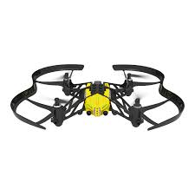

Fig.1 Drone

|  |  |
| --- | --- |
| Applications | Uses |
| AERIAL PHOTOGRAPHY | Professional wedding photoshoots, easy view at a height human cannot reach easily, etc... |
| SHIPPING AND DELIVERY | To deliver goods in lesser time compared to human delivery system |
| GEOGRAPHIC MAPPING | Used to create 3D maps of remote locations where human activities are not possible. |
| DISASTER MANAGEMENT | To look for any injured victims, saving the need to spend on manned helicopters. |
| PRECISION AGRICULTURE | Monitor their crops, detect crop deases |
| SEARCH AND RESCUE | Drones can be integrated with thermal sensing cameras thus to protect some kid lost somewhere, detect some accused who is on run after committing crime. |
| WEATHER FORECAST | drones can be sent into hurricanes and tornadoes, so that scientists and weather forecasters acquire new insights into their behaviour and trajectory |
| WILDLIFE MONITORING | to monitor and research on wildlife without causing any disturbance and provides insight on their patterns, behaviour, and habitat. |
| LAW ENFORCEMENT | They help with the surveillance of large crowds and ensure public safety. They assist in monitoring criminal and illegal activities. |
| ENTERTAINMENT | Take selfies, instead of helicopter shots can be taken using these drones etc... |

Table. 1 Contains some of the fields where drone is being used.

|  |  |  |  |  |
| --- | --- | --- | --- | --- |
| No. | Projects | Aim | Components | Advantages |
| 1 | Delivering essentials to remote places | Provide people living in remote places with medicines, blood, food etc.. | Drones that can travel long distances | Help people with all the essential needs to save their lives and livelihood |
| 2 | For Safety Analysis | Keep an eye beyond visual line of sight for infrastructure inspections, rural areas and over people | Drones that are small and can go Beyond Visual Line of Sight. | Keep an eye over remote places to ensure no illegal activities are going on. |
| 3 | Remote monitoring | Help taking real time data, images and providing progress reports | Drone deploy  Pix4D mapper  Agisoft  Propeller network  Precision Hawk | We can do Forest management, Urban planning, Exploration of minerals, oil and gas |
| 4 | Hunting Drone | Detects the intruding target with the help of sensors and camera which enters the airspace | Brushless motor  Propellers  Electronic Speed Controller  Flight Controller Board  Batteries | In real-time, many accidents can be prevented without creating any damages or debris to the surrounding environment. |
| 5 | Saucer solar drone | Shape gives a advantage of it being more aerodynamic | Rechargeable batteries ESC KK Board GPS Module Battery Charger Transmitter Receiver Solar cell, DC Motor | It saves battery as it can work on solar cell. |
| 6 | Drone Tours In Security Systems | Operation of security systems in particular surveillance systems. | At least one sensor carried by the unmanned aerial vehicle, | It's not stationary like surveillance camera so it can monitor more area |

Table. 2 Consist of various components used in drones and their advantages.

# **Motivation**

Why would anyone like to steer a drone with voice? Voice interaction has been successful in providing accessibility for the people who are not able to use their hand. For instance, disabled people cannot use their hand so they can use the voice interaction to be able to fly the drone. Drones can offer the people not to move anywhere and have a look of their surroundings using the drone just with the help of the voice command. This could improve, for instance, the experience of hiking in nature areas. Similarly, a partially paralyzed person who is able to talk is able to participate remotely in home-life activities while being in bed.

Drones are for professional purposes. For instance, drones are used as a machine on modern farms to optimize the spread of fertilizers and pesticides. Thousands of drone pilots are licensed to inspect and spray paddy fields in many countries they can use the voice-based drone to command the drone to stop spreading the pesticides on that particular area and to move forward. Professional photographers can mount a camera on a drone and deliver free-space video data at a very low cost, some of the shots that require top view in films can also be shot using the drones at a very low cost compared to all the human efforts and money required if used helicopters. While handling various activities at a single time for instance, the pilot integrated a motor machine that can spray insecticides using a button so the pilot can command the drone using the command-based drone and thus at the same time can spray the pesticides.

In summary, we have several reasons to consider voice for control of drones: It offers a direct, immediate mode of interaction where the pilot sees what the drone sees; voice offers a hand-free control option for people with mobility difficulties; and voice may assist hands-busy operators when combined with other input modalities.

# **Problem Statement**

Here we need to know that there are drones that can be controlled using gesture controlling, Wearable devices for gesture controlling of drones and even there should be a connection between transmitter and app device for some of the drones. The aim of this work is to build a drone using Arduino and Alexa echo. Integrating the capabilities of Alexa skill kit and make the drone work completely a voice-based drone. Thus, anyone can drive the drone without wearing any physical wearables.

We know that there are many different types of drones with several shapes like X (4 motors), Hexagonal (6 motors), Octagonal (8 motors), etc in the world. Also, we know UAV’s which are working with the wearables. On the other hand, we know about Alexa, which is a virtual assistant developed by Amazon. Alexa supports almost many devices like phones and tablets, smart speakers, TV’s, and Media Boxes, Smart homes, Automotive, etc.

**A. Drones Classification**

Drones are classified based on capability of flight and configuration or structure. As Shown in Fig. 3 the capability of flight is again sub-classified into three types of Drones:

* One is HALE (High Altitude Long Endurance), these drones can fly more than 9000 m and also has long flight capacity.
* Second is MALE (Medium Altitude Long Endurance), these are the drones which can fly up to 9000 m.
* Third is VTOL (Vertical Take-off and Landing) has the ability to take off and land vertically. Furthermore, VTOL can shift to horizontal flight by the motion of the propeller after rising to a certain altitude above sea level.
* Below are some of the reference images of different kinds of drones.

**Following are the examples of different kind of drones being used**

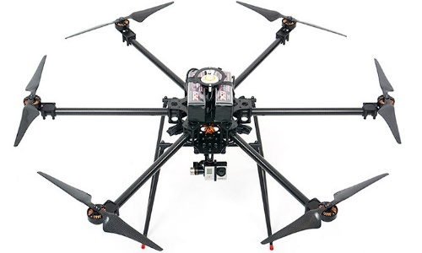

Fig. 2.1 Multi-rotor drone

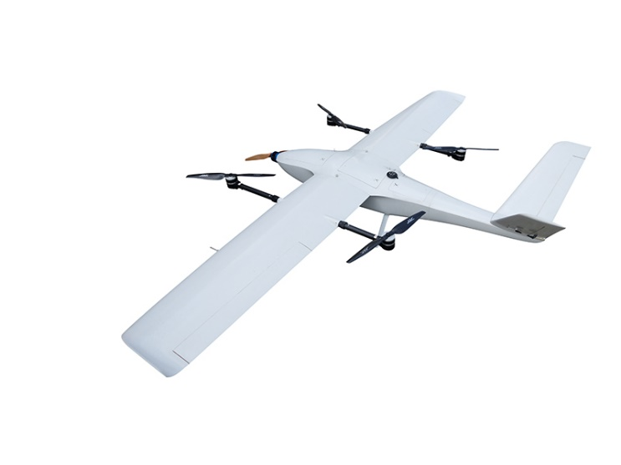

Fig. 2.2 Fixed-wing drone

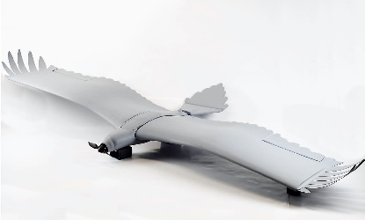

Fig. 2.3 Flap-wing drone

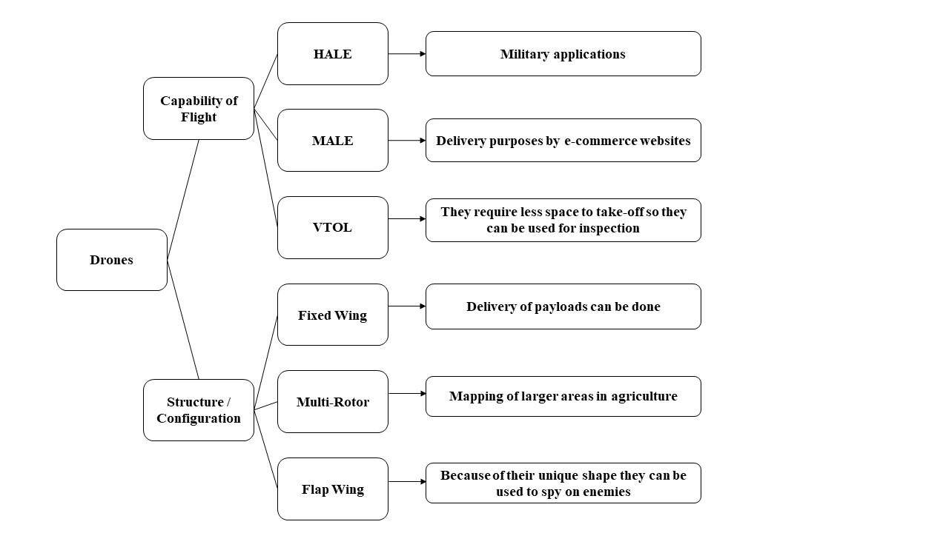

Fig. 3. Classification of Drones.

Based on Structure the Drones also classified into three types, they are:

* ” fixed-wing”
* ” multi-rotor”
* ” flap wing”.

Fixed wing drones have more range and flexibility compared to multi-rotor UAV’s. Fixed wing drones have a swinging capability and are easier to use as they can easily move in any directions. Multi-rotor UAVs have more drain on the battery as there are multiple rotors consuming energy. Flap wing UAVs are known to face difficulties in autopilot design because the wings have to assist movement control in the direction like an aircraft. We have tried to implement a drone that is controlled by Amazon Alexa by using some of the available Amazon Web Services (AWS). Also, the drone was developed by using Arduino and some of the sensors discussed above. The reason behind using is one of the best voice assistants and also is very compatible with amazon web services**.**

# **Methodology**

The research method used in this research is   
Qualitative because the description of the whole research is detailed known but the required materials, software are known in advance. On the other hand, the research design followed in this research is Applied Research Design as there is an interaction between the real-world components. Figure 4.1 represents the process flow which starts with Alexa voice service from Amazon Web Services (AWS). Echo Dot is used for the Alexa voice service transferring the voice command to the cloud services that are working in the AWS cloud. The foremost cloud service is Alexa Skills Kit which is created in the AWS cloud. Then the request is sent to the AWS Lambda function which is created using python file later the request is sent for updating the IoT shadow thing created in the AWS IoT cloud service. Once this is correctly recognized then the request is transferred to the Arduino where the drone is built with. The drone is controlled based on the commands given to Alexa.

## Process Flow

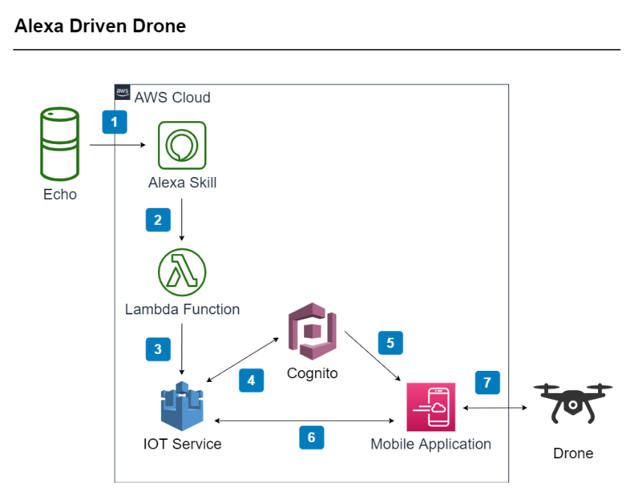

Fig. 4.1 Process Flow

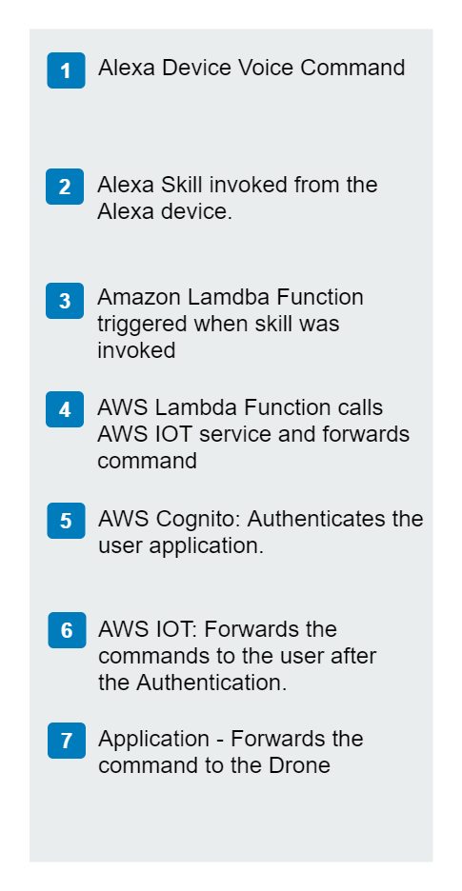

Fig. 4.2 Process Flow

### Flow of the interaction of the data that the human pilot provide to the amazon alexa as a voice command and then it will furthur move to the cloud system and from there the data will move to the arduino.

### **Alexa Skill Kit**

Alexa provides a set different capability, referred to as skills. For example, Alexa's abilities include playing music from different music platforms available online, providing weather forecasts, answering questions and querying google or any other search engines available. The Alexa Skills Kit provides you with facilities where you can teach Alexa new skills. Customers can access these new abilities by asking Alexa questions or making requests. You can build skills that provide users with many different types of abilities. For example, a skill might do any one of the following:

* Look up to specific answers ("Alexa, ask weather forecast to provide me the weather of Gujarat.")
* Challenge with puzzles or games ("Alexa, play History game zone.")
* Control lights, fans and other electronics devices in the home ("Alexa, turn on the room lights.")
* Provide audio or text content for a Business meeting ("Alexa, give me my meeting files.”)

### Alexa skill kit provides with all the facilities, we just need to add skills as we intend it to work. There are different utterances and we just need to add utterances that we need alexa to add or respond on the basis of the command we provide. These are the use of Alexa skill kit.



Fig. 5 Alexa skill kit

### **Lambda Function**

AWS Lambda, you can run code for virtually any type of application or backend service - all with no requirement of any physical or hardware services for the user to maintain as AWS lambda function can maintain it with zero administration. Lambda function is a structureless architecture which will take care of all the functionalities that we require and the user needs not to worry about anything. It provides a trigger facility that lets many AWS technologies to integrate with itself and process further. AWS Lambda runs your code on a high-availability compute infrastructure and performs all of the administration of the compute resources, including server and capacity provisioning, operating system maintenance and automatic scaling, logging and code monitoring.

All you need to do is supply your code in one of the [languages that AWS Lambda supports](https://docs.aws.amazon.com/lambda/latest/dg/lambda-runtimes.html). languages supported by AWS lambda functions are as follows:

* Java
* Go
* PowerShell
* Node. Js
* C#
* Python
* Ruby Code

It provides with runtime API which allows you to use any additional programming languages to author your functions. Lambda function is one of the most important and useful function provided by the AWS. Thus, it will help process the input provided by the amazon skill kit and then further send those instructions to a destination where we need it to reach.



Fig. 6 AWS Lambda function

**Key Product Feature**

* Extend other AWS services with custom logic.
* Build custom back-end services.
* Bring your own code.
* Completely automated administration.
* Built-in fault tolerance.
* Automatic scaling.
* Connect to relational datasets.
* Fine grained control over performance.
* Run code in response to Amazon CloudFront request.
* Integrated security model.
* Only pay for what you use.
* Flexible resource model.

### **Cognito**

### Amazon Cognito is a service of AWS that provides us with authentication,user management and authorization for mobile applications and web applications. Users can Login/sign in/sign up easily using the login option or they can directly use any of the other sign in options such as google, Apple etc. The two main components of Amazon Cognito are:

### user pools

### identity pools

### User pools helps the user with already designed and ready to use sign in/sign up options for the users of the application . Identity pool helps with the validation of the user and identify the user and lets the user access other services provides by AWS. You can use both the pools the identity pool and the user pool seperately or together as per your convinience. It manages everything that includes data base, security criteria’s required for any application. It simplifies work to a great level.

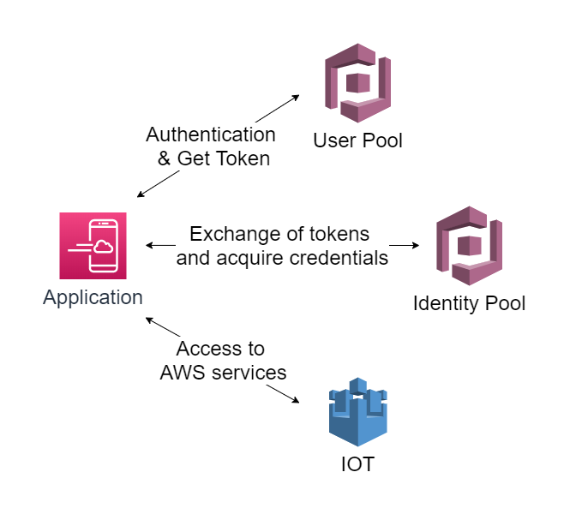

Fig. 7 AWS Cognito Service

**An Amazon Cognito user pool and identity pool used together:**

The main reason one uses these services is to validate the authenticity of the user and grant access to various services provided by AWS. There are various steps the process is divided into

* first step:
  + In first step the user signs in to the application and a token will be generated for each user once the user signs in by the user pool.
  + Now in the second step the token that is generated is exchanged with the identity pool for AWS credentials.
  + Thus, in the final step the user is authenticated successfully and is allowed to access all the other services provided by AWS.

**Features of Amazon Cognito**

* **User pools**
* **Identity pools**

**User pools**

User pools helps the user with already designed and ready to use sign in/sign up options for the users of the application. Identity pool helps with the validation of the user and identify the user and lets the user access other services provides by AWS. If the user uses the third-party login system then there are different files they are stored in and we can access it using SDK.

**User pools provide:**

* AWS user pool provides with the sign-in/sign-up options and a customizable UI option which one can directly use for own application. User can sign in using different social media platforms such as Facebook, google, Apple and through SAML and OIDC identity providers from your user pool. User directory management and user profiles. Security features such as multi-factor authentication (MFA), checks for compromised credentials, account takeover protection, and phone and email verification. Customized workflows and user migration through AWS Lambda triggers.

**Identity pools**

As identity pool allows user with the credential that is provided to them and thus, they can get temporary access to the services such as DynamoDB, S3 etc. The following identity providers that you can use to authenticate users for identity pools:

* Amazon Cognito user pools Social sign-in with:
  + Facebook
  + Google
  + Login with Amazon
  + Sign in with Apple

To save user profile information, your identity pool needs to be integrated with a user pool.

### **Application**

The application will help communicate with the drone, the application is just the path through which the data will pass to the drone. The interface of the application consists of a Login screen and after the user registers itself or logs-in to the application there will be a joystick to control the drone and ON/OFF button for the drone.

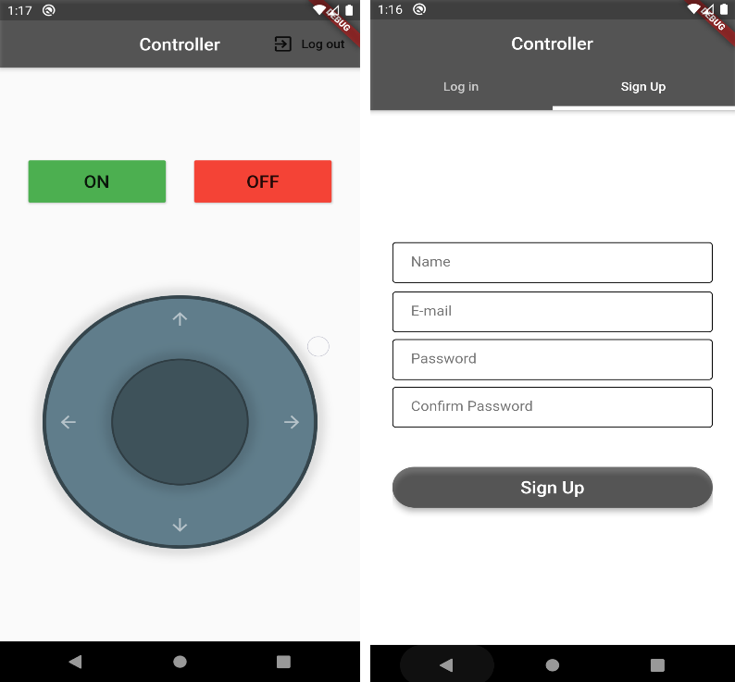

Fig. 8 Application U/I

# **Conclusion**

##### **References**

[1] Radosveta Sokullu, Abdullah Balcı, and Eren Demir, ”The Role of Drones in Ambient Assisted Living Systems for the Elderly,” Enhanced Living Systems pp 295-321 January 2019

[2] Rashidi P, Mihailidis A, ”A survey on ambient-assisted living tools for older adults,” IEEE J. Biomed. Health Inform. 17(3), 579–590 (2013)

[3] Wan J, Gu X, Chen L, Wang J, ”Internet of Things for ambient assisted living challenges and future opportunities,” In 2017 International Conference on Cyber-Enabled Distributed Computing and Knowledge Discovery, Nanjing, pp. 354–357 (2017)

[4] Niraj Dawar, ”Marketing in the age of Alexa,” May–June 2018 issue (pp.80–86) of Harvard Business Review.

[5] Megan Landau, Sebastian van Delden, ”A System Architecture for Hands-Free UAV Drone Control Using Intuitive Voice Commands,” HRI ’17 Companion, March 06-09, 2017, Vienna, Austria. ACM 978-1-4503- 4885-0/17/03. http://dx.doi.org/10.1145/3029798.3038329.

[6] Abdur Razzaq Fayjie, Amir Ramezani, Doukhi Qualid, Deok Jin Le,”Voice Enabled Smart Drone Control,” 978-1-5090-4749-9/17/ ©2017 IEEE.

[7] Morgan Quigley, Ken Conley, Brian P. Gerkey, Josh Faust, Tully Foote, Jeremy Leibs, Rob Wheeler, Andrew Y. Ng, ”ROS: an open-source Robot Operating System ICRA Workshop on Open Source Software,” 2009.

[8] A. Menshchikov, D. Ermilov, I. Dranitsky, L. Kupchenko, M. Panov, M. Fedorov, A. Somov, ”Data-Driven Body-Machine Interface for Drone Intuitive Control through Voice and Gestures,” 978-1-7281-4878-6/19/©2019 IEEE

[9] Yuki Yamazaki, Masaya Tamaki, C. Premachandra, et al. ”Victim Detection Using UAV with On-board Voice Recognition System,” IEEE Computer Society 2019. DOI: 10.1109/IRC.2019.00114

[10] Y. Ham, ”Visual monitoring of civil infrastructure systems via camera equipped Unmanned Aerial Vehicles (UAVs): a review of related works,” visualization in Engineering, 2016.

[11] S. Lee, D. Har, and D. Kum, ”Drone-Assisted Disaster Management: Finding Victims via Infrared Camera and Lidar Sensor Fusion,” Computer Science and Engineering (APWC on CSE), 2016.

[12] J. Yoon, I. Kim, W. Chung and D. Kim, ”Fast and Accurate Car Detection in Drone-view,” IEEE International Conference on Consumer Electronics-Asia (ICCE-Asia), 2016.

[13] Arijit Ghosh, Hiranmoy Roy, Soumyadip Dhar, ”Arduino Quadcopter,” 2018 Fourth International Conference on Research in Computational Intelligence and Communication Networks (ICRCICN).

[14] Vibha Kishor, Ms. Swati Singh Design and Development of Arduino Uno based QuadcopterInternational Journal of Engineering and Manufacturing Science. ISSN 2249-3115 Vol. 7, No. 1 (2017).

[15] Amazon Alexa supported devices: https://en.wikipedia.org/wiki/Amazon Alexa#Supported devices

[16] Echosim: https://echosim.io/

[17] AWS Developer Console: https://developer.amazon.com/alexa/console/ask?

[18] AWS IoT Device SDK Arduino Yun: https://github.com/aws/aws-iotdevice-sdk-arduino-yun/blob/master/README.md

[19] Arduino Built Drone: https://github.com/cparisa1/arduino-dron