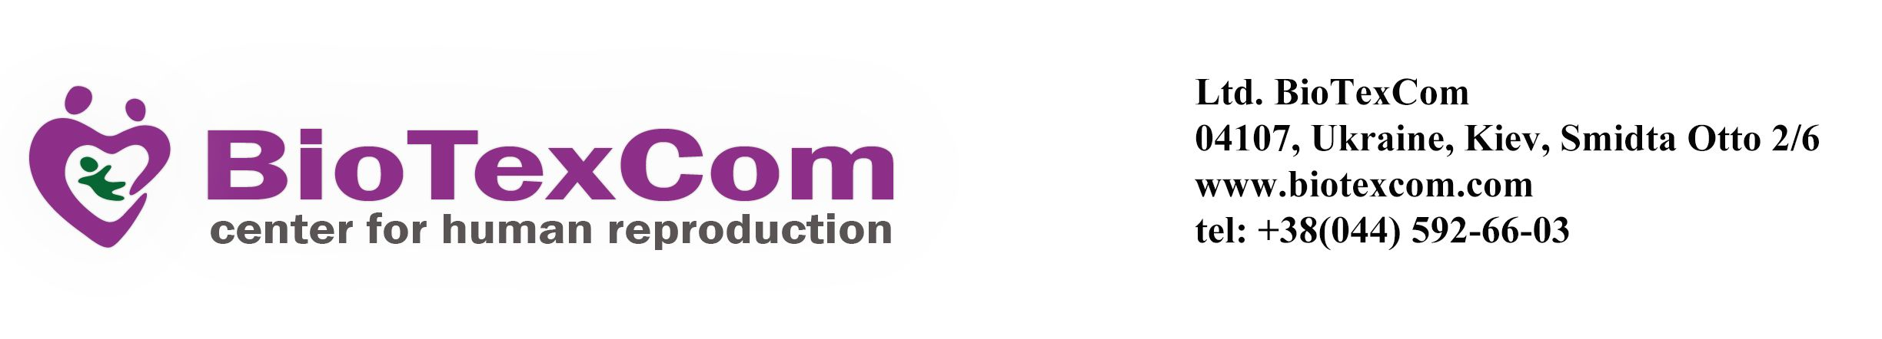

__________________________________________________________________________________________________Ihor Pechenoha, M.D.  
Otto Schmidta Street, 2/6  
[info@biotexcom.com](mailto:info@biotexcom.com)

**Date: 14/11/2023**

**Date: 08/5/2024**

**Re: MRS Saydaeva Shohksanam D.O.B.: 16/02/1998**

**HOSPITAL DISCHARGE LETTER**

Mrs Saydaeva Shohksanam is undergoing treatment at BioTexCom Center for Human Reproduction located in Kyiv, Ukraine.

To support the treatment cycle, these are the medications Dr. Kristina Bozhok prescribed for Mrs Saydaeva Shohksanam which she has to take until the 4th week of gestation (see the copy of an exact treatment schedule attached):

Injesta 2.5%–24;

Utrogestan 200 mg –13; Estradiolum – 6; Folic acid 5 mg – 50tab; Pentoxyphyllinium 3; Syringe 5ml – 70; Methylprednisolonium – 2;

Etamzilate – 4pack.

Kind regards

Medical Director,  
Ihor Pechenoha _______________________________________

State License No. AB №554391  
[info@biotexcom.com](mailto:info@biotexcom.com)