IIR filters

Setting up the IIR Filter functions

The IIR filter design makes use of several MATLAB functions that can be enabled at will to allow the user to select between the IIR filter types (butterworth, elliptical, cheby1 and cheby2.) The M-file contains certain elements shared between all filters (such as filter order, and band limiters), as well as the sample rate and number of samples to normalize the frequency the filter acts on.

All of the IIR filter functions have placeholders in the IIR filter function, and can be switched out easily. Upon running, the program will create the plots of the frequency response as well as the stem plot of the impulse response, and the pole-zero map. The frequency response will be cut in half (from 0 to 0.5 normalized frequency) before plotting, in order to focus on the usable band. Instructions for use are in the M-file for the IIR filter design segment itself. This documentation focuses primarily on the use of this file to generate the filter required.

Designing the IIR Filter

In order to reach the lowest filter order possible, an elliptical filter is recommended. However, the maximum allowable pass-band ripple is fairly low, so a Chebyshev type 2 filter could be a better choice. As we are required to make a -70dB jump in the space of very little frequency, a butterworth filter will likely cause us to need a significantly higher filter order than either of the two other options. The elliptical and cheby2 functions will be tested first. The primary concerns with this are
- The elliptical filter could exceed the permissible amount of pass-band ripple without going to high filter order
- The Chebyshev type 2 filter has slower transition than elliptical or Chebyshev type 1 filters, it may be too slow to implement without going to high filter order.

It is likely that the solution will be found within these filters, the Chebyshev type 1 filter minimizes stop-band ripple, but this is not a concern as long as the filter correctly attenuates the stop-band. The butterworth filter is unnecessary for the same reason, except it would require even higher filter order to be usable.

Testing the elliptical filter

To build the filter, the pass-band given (12.3KHz to 15KHz) was put into the pass-band specification in the m-file, this is automatically normalized to 50KHz. 8X1024 N (samples) were used, changing this number had little effect on the performance of the filter.

Ellip was first tested with ellip(n, 0.2, 70.2, Wn) where n was the filter order, and Wn was the pass-band frequency. This filtered correctly at n = 7, at which point the pass-band requirement was almost satisfied, the response came in through the bottom of the box. Changing the specification fed to the filter to 12295 – 15005 Hz fixed this issue. The filter appropriately attenuated the stop-band, reaching the -70dB mark before the requirement. Changing the filter to n=6 (in an attempt to reduce filter order), made it unable to attenuate quickly enough to meet the stop-band specification.

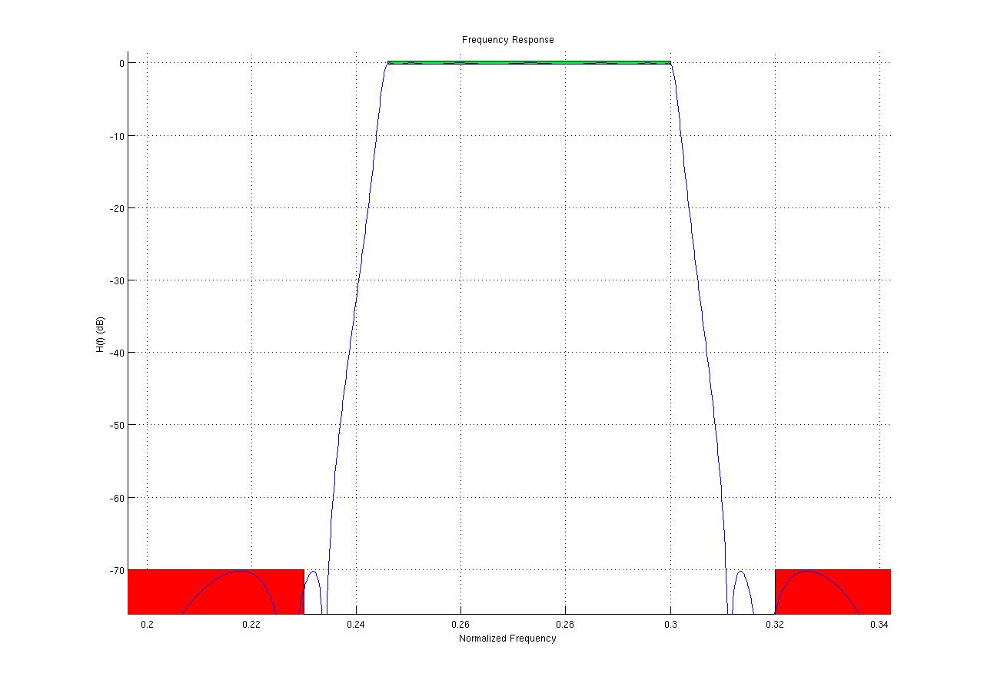
Elliptical filter test, n=7 (14th order), 12295-15005Hz pass-band specified

Testing the Chebyshev type 2 filter

Cheby2 was tested next, this was not likely to be necessary as the elliptical filter satisfied the requirements for pass-band ripple and stop-band attenuation with a 14th order filter (specifying a band-pass filter to any of the IIR filter functions causes the function to create a filter with double the specified order n.) The Chebyshev type 2 filter was unable to meet the requirements specified as a 14th order filter, it had to be increased to 22nd order to achieve a fast enough falloff. The pass-band for this filter also had to be adjusted to be wider than the specified pass-band, as it started rolling off into the stop-band sooner than necessary. The Chebyshev type 2 filter was unnecessary for this requirement, its frequency response is shown below.

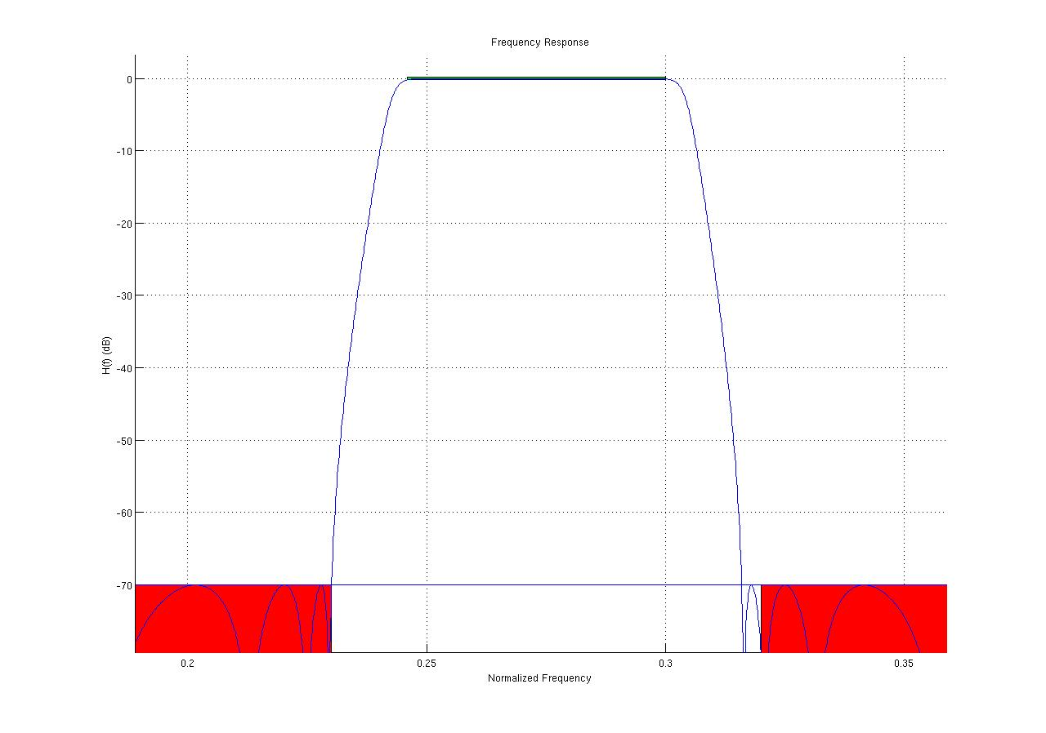
22nd order Chebyshev type II filter.

