ECE477 Lab 7
AVR Battery Tester
Cameron McGary, Joel Castro
April 9, 2010

Introduction

This lab focused on using some of the functionality in the AVR to do things we could not do on just the PC. Instead of performing simple tasks like changing the case of numbers, the plan is to use the A-D converter in the AVR ATMEGA88 to read the voltage off a battery in use and report it back to the computer. The computer will poll the AVR at specified intervals, in order to receive data. The battery will be left on the tester using relatively low-valued resistors, in order to observe it's draining characteristics.

Synopsis – A, PC Side

The computer is responsible for polling the AVR and receiving the data it returns. After the PC sends the comma (and prints the system time to file,) the AVR will be triggered to calculate the A-D conversion and return it to the PC. After the PC transmits, it will clear its serial buffer, and prepare to receive.
Upon receiving a value, the PC will convert the value (encoded into a character value from 0-255) it will do a conversion to double and output this information and the system time-stamp to a file. The format is:
System Time,vout(V)
Example - 12234105,1.2210

This process will repeat every second, in order to receive a detailed enough data set. Offloading the conversion math from the AVR to the PC saves both memory in programming the AVR, and serial transmit time. Every value the AVR returns is effectively just one byte, so this sampling method can achieve relatively high sample rates.

Initializing the serial communication

Initializing the serial communication is done much the same way it was done in previous labs. The serial communication initialization was mostly a port of the linux dumb_terminal.c provided in the code bits. A new terminal (termios) structure is created and modified to remove features that are not normally used and unnecessary fort our use in serial terminal mode. For example, canonical input is disabled, echoes are disabled, all lflags and oflags are disabled. In addition, the terminal is set to raw mode and the serial link is set to 9600 baud, no parity, 1 stop bit. This option is not user configurable.

Communicating with the chip

The PC performs a function that is more or less the same as can be done from a user, manually from minicom. The PC just sends a comma to the AVR at specified intervals, and receives the data and writes it to a file. The connection is locked in a #define as /dev/ttyUSB0, and is not user configurable. This could easily be changed (since the program accepts arguments) by allowing the user to specify a connection through the command line arguments passed to the program.

A-D Converter

The process of setting up the AVR for A-D conversions was a pretty straight forward process once you know what to use with reference to the AVR ADMUX register. The main components of this register, are 2 bits for the reference voltage, 1 bit for position of the sent data, and 4 bits for the A-D converter pin choice. This register can be seen in the figure below.

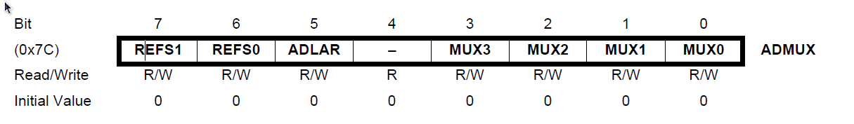

The reference voltage we wanted was the 1.1V internal voltage for the AVR. We decided to use this voltage since, it provides more accurate values for the conversion as well as not requiring an external voltage to just supply a reference. Other reference options can be seen in the table below.

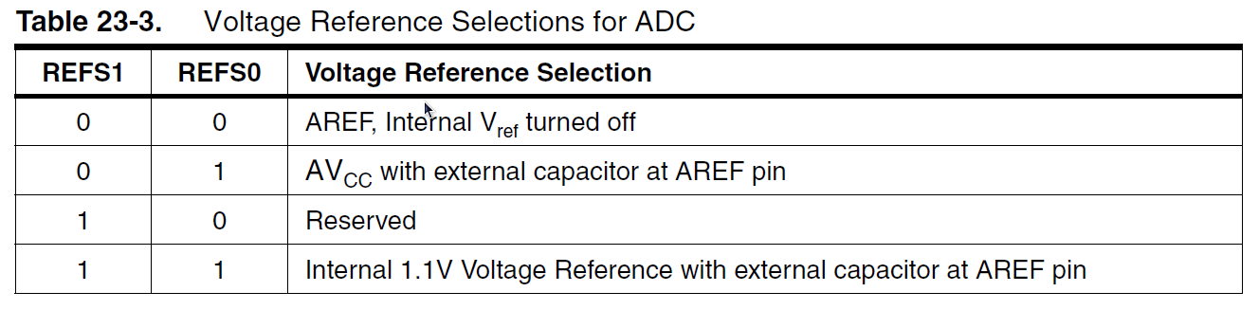
The 5th bit in the ADMUX register is labeled ADLAR and what it does is just “left justify” or “right justify”. The output of the A-D converter is stored in two 8 bit registers but the amount of data is in 10 bits. This means that only 2 bits of one of the registers will be used. Leaving the ADLAR at 0 makes the data “right justified” , that is make the lower 8 bits appear in the lower register ADCL and the 2 most significant bits are stored in ADCH. We only felt the need for the most significant bits so we set it “left justified” so the 8 most significant bits appear in ADCH and the least significant bits remaining are stored in ADCL. The data storage can be seen in the figure below.

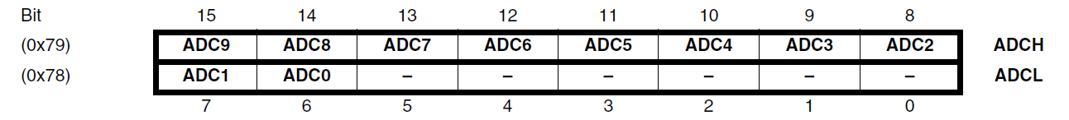

The 4th bit cannot be written to so we won't manipulate this bit. As for MUX bits 0-3, these bits assign the pin used. For simplicity of circuit design, we decided to use pin 28 (the last pin) for our ADC pin. This pin is for ADC5 which has a MUX value of 0101 for bits 3-0. Other ADC choices can be seen in the table below.

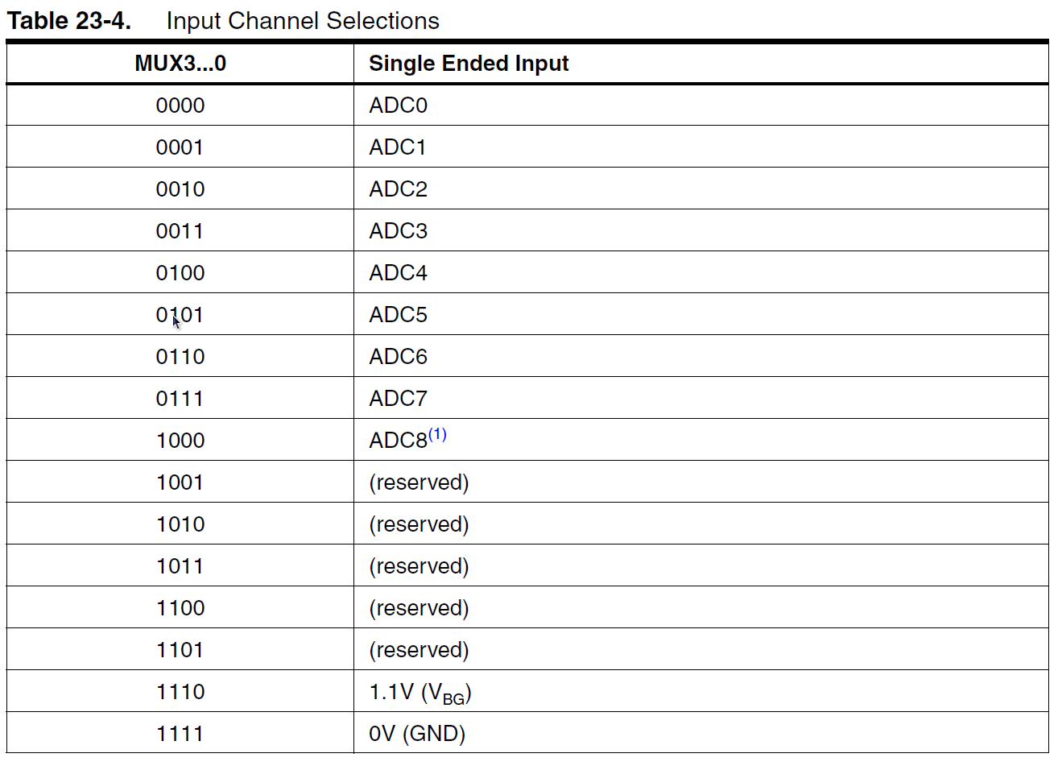
That's about it for initialization; for our code we compiled all three lines to do each individually and just wrote the value 0b11100101 to the ADMUX.

For doing a conversion, the ADC is initialized through the ADMUX and then the power is supplied to the converter. The converter starts when a 1 is written to the ADSC bit in the ADCSRA register and the other bits in the ADCSRA register can be seen in the register picture below.

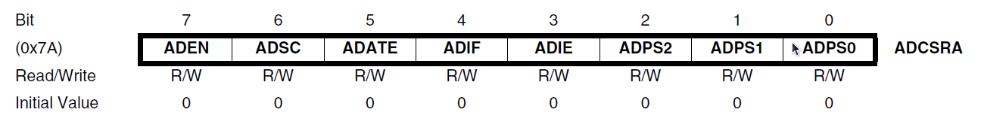
The program then waits for the conversion to be done which is detected when the ADSC bit in the register is reset to zero. Once the reset occurs, we return the ADCH register to a variable. Once again, we felt that the 8 highest bits will serve as a high enough accuracy for this lab.

AVR – Main

The main program, after initializing for serial communications, simply waits for a comma to be sent by waiting for a character to be sent and comparing the character to a ','. When a character not a comma is sent, the character is essentially ignored and not echoed. When the input is a comma from the computer, the input is saved and echoed back just so the comma is written to file, and the input variable is reset. Once this is done the A-D conversion is done and the the value is stored in a character that is then sent to the UDR register to send it back to the computer. That's about all that was necessary for the main code.

Hardware

There isn't much for the hardware. We were looking for quick results so we wanted the lowest amount of resistance in the circuit so that it would have a high current and drain the battery better. The circuit can be seen below.

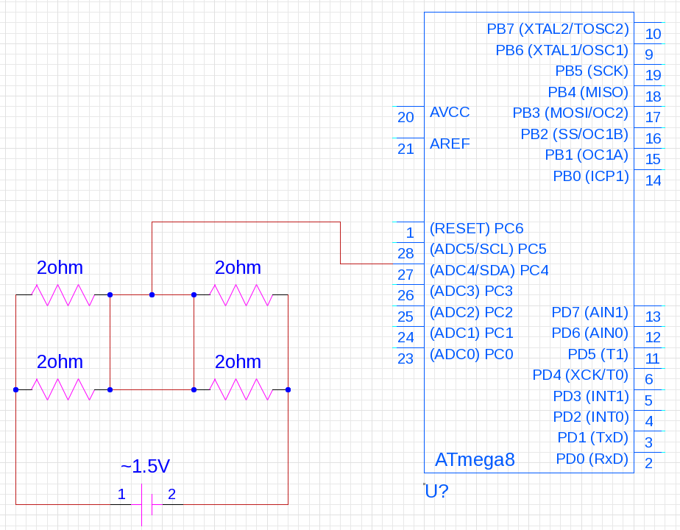

We used two 2Ω resistors in parallel to simulate a single 1Ω resistor while splitting the current since these were regular ½ watt resistors and not high power ones. That aside, it was a pure voltage division.

