ECE 486 – Digital Signal Processing

FIR and IIR filter routines

April 8, 2010

Group #8

Cameron McGary, Dylan Godwin, Joel Castro, Mark Hebert

FIR Filter Design

The code for the FIR filter is rather straightforward. The first thing that was done was a plotting of what the pass-band and stop-band was to be on the graph. This was just a graphical presentation of what was desired so that it would be easier to tell if the specifications had been met. The next part was to record the number of samples and the order of the filter to be used in the function to actually create the filter. By simply changing the stored value of the filter order, modifying the filter t meet specs would be much easier. It is also necessary to normalize all frequencies which was done by simply creating a array that went from 0 to N-1 and dividing all of these by the number of samples N. This would give a frequency range of 0 to 1. Another important step is to make sure filter is linear phase. In order to make sure it is linear phase, the filter must have symmetry around around the center of the samples. The operation to make it symmetric was to simply duplicate the left half of the frequency range on the right side in reverse. Since the function is symmetric around the origin or at the first sample 0, the left side can be replaced by the N/2 sample that are immediately left of the origin. This is expressed in the following excerpt from the code : f(N/2+1+1:end) = f(N/2+1+1:end)-1;.

Now that the filter specifications and frequencies have been set up, the desired filter can be defined according to those specifications. To do this, the equation for the desired filter looks like this:
Hd = (abs(f) < wp) .* 10.^(Ap/20). Here, the wp refers to the pass-band frequency for a simple low-pass filter. The Ap refers to the maximum gain that can be attained at the pass-band frequencies. The attenuation of the stop-band can be determined by the filter order as well as the values chosen for wp and Ap. The desired filter in this case was a low pass filter so a filter defined as Hd = (abs(f) < .1) .* 10.^(.1/20) would be satisfactory for a start. Setting the filter order to a relatively high filter order and then lowering it down gave a function closer to the edge of the specifications. To also help lower the filter order, which is a primary goal of filter design, the values of Ap and wp were changed but kept close to the original. Lower both these values gave the filter more room – that is improved the gain and attenuation – so that the order of the filter could be decreased more as well.

Once the filter was designed, it was made casual by shifting it right. This was accomplished in the code by multiplying the function be e^{-j2πf*(M-1)/2,} where M is the filter order. It was also critical to decide the type of filter to be used on the design process. After taking the inverse fast Fourier transform, the desired filter we designed needs to be used by a MATLAB filter generating function such as kaiser() or butter(). These will create different kinds of filters that have different properties that may require lower filter orders or be more equiripple. For the FIR filter, the Kaiser filter was initially used and lowered to the lowest filter order using the method discussed previously. We set the Beta value to 8 which provided a sidelobe attenuation of 80dB based on the equation for the value found in the help files. The equation is shown below where β is the value to be input into the function and α is the attenuation desired.
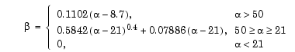
The Chebyshev (Чебышёв) filter turned out to be more efficient requiring a filter order of only 72. The factor that needed to be included for for this function was r which was equivalent to the attenuation desired for the filter. This function guarantees that the attenuation will not be more than -r in decibels. The value are can be decreased and still provide the 80 dB attenuation desired; we were able to allow this value to drop as low as 68.

Setting up the IIR Filter functions

The IIR filter design makes use of several MATLAB functions that can be enabled at will to allow the user to select between the IIR filter types (butterworth, elliptical, cheby1 and cheby2.) The M-file contains certain elements shared between all filters (such as filter order, and band limiters), as well as the sample rate and number of samples to normalize the frequency the filter acts on.

All of the IIR filter functions have placeholders in the IIR filter function, and can be switched out easily. Upon running, the program will create the plots of the frequency response as well as the stem plot of the impulse response, and the pole-zero map. The frequency response will be cut in half (from 0 to 0.5 normalized frequency) before plotting, in order to focus on the usable band. Instructions for use are in the M-file for the IIR filter design segment itself. This documentation focuses primarily on the use of this file to generate the filter required.

Designing the IIR Filter

In order to reach the lowest filter order possible, an elliptical filter is recommended. However, the maximum allowable pass-band ripple is fairly low, so a Chebyshev type 2 filter could be a better choice. As we are required to make a -70dB jump in the space of very little frequency, a butterworth filter will likely cause us to need a significantly higher filter order than either of the two other options. The elliptical and cheby2 functions will be tested first. The primary concerns with this are
- The elliptical filter could exceed the permissible amount of pass-band ripple without going to high filter order
- The Chebyshev type 2 filter has slower transition than elliptical or Chebyshev type 1 filters, it may be too slow to implement without going to high filter order.

It is likely that the solution will be found within these filters, the Chebyshev type 1 filter minimizes stop-band ripple, but this is not a concern as long as the filter correctly attenuates the stop-band. The butterworth filter is unnecessary for the same reason, except it would require even higher filter order to be usable.

Testing the elliptical filter

To build the filter, the pass-band given (12.3KHz to 15KHz) was put into the pass-band specification in the m-file, this is automatically normalized to 50KHz. 8X1024 N (samples) were used, changing this number had little effect on the performance of the filter.

Ellip was first tested with ellip(n, 0.2, 70.2, Wn) where n was the filter order, and Wn was the pass-band frequency. This filtered correctly at n = 7, at which point the pass-band requirement was almost satisfied, the response came in through the bottom of the box. Changing the specification fed to the filter to 12295 – 15005 Hz fixed this issue. The filter appropriately attenuated the stop-band, reaching the -70dB mark before the requirement. Changing the filter to n=6 (in an attempt to reduce filter order), made it unable to attenuate quickly enough to meet the stop-band specification.

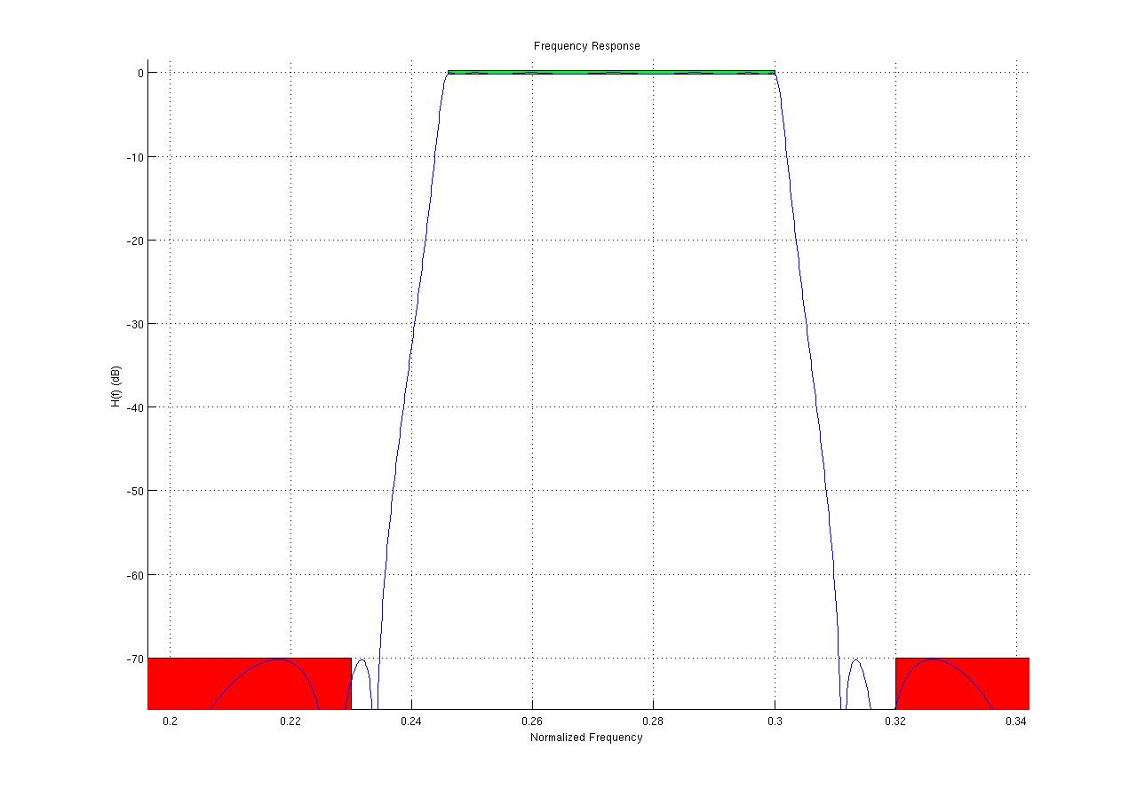
Elliptical filter test, n=7 (14th order), 12295-15005Hz pass-band specified

Numerator coefficients (in order from s^14 to s^0)
0.0006 0.0009 0.0026 0.0030 0.0043 0.0033 0.0023 0.0000
-0.0023 -0.0033 -0.0043 -0.0030 -0.0026 -0.0009 -0.0006

Denominator coefficients
1.0000 2.1422 8.1559 12.4531 25.8121 29.5816 42.2750 36.7971
39.0897 25.2814 20.3979 9.0872 5.5017 1.3321 0.5748
Testing the Chebyshev type 2 filter

Cheby2 was tested next, this was not likely to be necessary as the elliptical filter satisfied the requirements for pass-band ripple and stop-band attenuation with a 14th order filter (specifying a band-pass filter to any of the IIR filter functions causes the function to create a filter with double the specified order n.) The Chebyshev type 2 filter was unable to meet the requirements specified as a 14th order filter, it had to be increased to 22nd order to achieve a fast enough falloff. The pass-band for this filter also had to be adjusted to be wider than the specified pass-band, as it started rolling off into the stop-band sooner than necessary. The Chebyshev type 2 filter was unnecessary for this requirement, its frequency response is shown below.

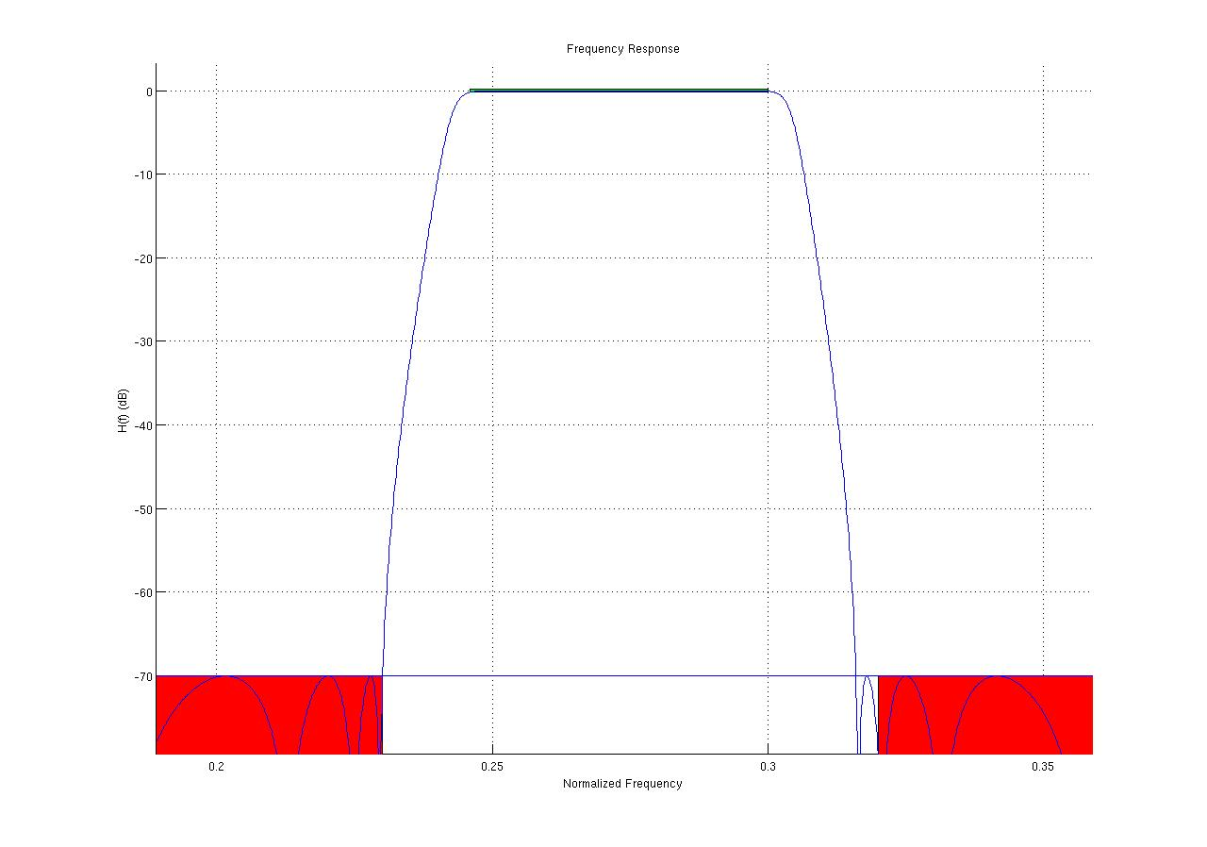
22nd order Chebyshev type II filter.

