Companies Report

Sberbank
Code: 12643748382  Director: Pavel Romanov  General Office: Business center 'Ordzhonikidze' | 

Additional Offices

Business center 'Technopark'
Location: Novosibirsk, st. Nikolaeva 20, office 2002  Resources: open-spaces food places | 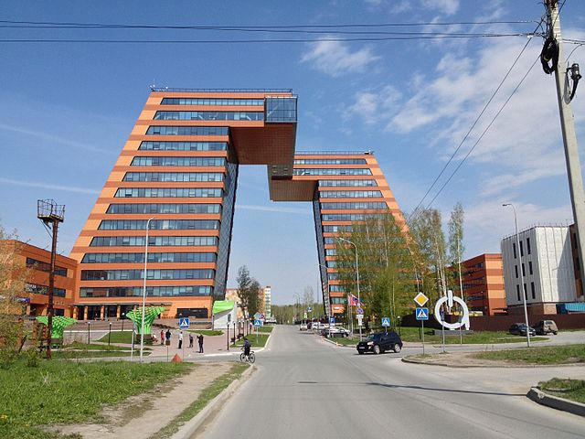

Personal Table | Name | Project | Position | Salary | Experience (years)
7 | Egor Popenko | Egor Popenko | Middle Backend Java | 100,000 | 4
10 | Anna Andeeva | Anna Andeeva | HR Specialist | 150,000 | 10

Business center 'Ordzhonikidze'
Location: Omsk, st. Ordzhonikidze 211
Resources: open-spaces gym

Personal Table | Name | Project | Position | Salary | Experience (years)
1 | Pavel Romanov | Pavel Romanov | Team Lead | 200,000 | 15
3 | Igor Panko | Igor Panko | QA | 90,000 | 5
5 | Marina Volkova | Marina Volkova | Team Lead | 120,000 | 12
8 | Alexey Fedorov | Alexey Fedorov | HR Specialist | 120,000 | 12

Business center 'Bubnova'
Location: Tomsk, st. Bubnova 99
Resources:

Personal Table | Name | Project | Position | Salary | Experience (years)
2 | Olga Pavlova | Olga Pavlova | Finance Manager | 100,000 | 5
4 | Tatyana Pomogaeva | Tatyana Pomogaeva | Middle Backend-dev | 100,000 | 5
9 | Svetlana Karpova | Svetlana Karpova | HR Specialist | 100,000 | 5

Business center 'Oasis'
Location: Novosibirsk, st. Titova 12, office 2002
Resources: open-spaces food places gym pool

Personal Table | Name | Project | Position | Salary | Experience (years)
6 | Egor Popenko | Egor Popenko | Middle Backend Java | 100,000 | 3
11 | Ekaterina Volkova | Ekaterina Volkova | HR Specialist | 130,000 | 7

Sbt
Code: 1264378383873739
Director: Pavel Lomov
General Office: Business center 'Moscow2'

Additional Offices

Business center 'Evid'
Location: Novosibirsk, st. Radnikova 12, office 202
Resources: open-spaces food places gym pool

Personal Table | Name | Project | Position | Salary | Experience (years)
12 | Pavel Lomov | Pavel Lomov | Team Lead | 100,500 | 10

Business center 'Red Book'
Location: Novosibirsk, st. Popova 20, office 102
Resources: open-spaces food places

Personal Table | Name | Project | Position | Salary | Experience (years)
13 | Nikita Zonov | Nikita Zonov | Middle Backend Java | 100,000 | 5
20 | Anna Annovna | Anna Annovna | HR Specialist | 150,000 | 10

Business center 'Logika'
Location: Omsk, st. Lomova 211
Resources: open-spaces gym

Personal Table | Name | Project | Position | Salary | Experience (years)
14 | Boris Elevoy | Boris Elevoy | Middle Backend Java | 100,000 | 4
15 | Marina Kolova | Marina Kolova | Team Lead | 200,000 | 12

Business center 'Volga'
Location: Tomsk, st. Bubnova 100
Resources:

Personal Table | Name | Project | Position | Salary | Experience (years)
16 | Egor Jurelvo | Egor Jurelvo | Middle Backend Java | 102,000 | 3
17 | Alexey Bulka | Alexey Bulka | HR Specialist | 120,000 | 12

Business center 'Moscow2'
Location: Moscow, Novodanilovskaya embankment 12
Resources: open-spaces food places gym pool

Personal Table | Name | Project | Position | Salary | Experience (years)
18 | Katerina Karpova | Katerina Karpova | HR Specialist | 100,000 | 5

