WEEK 3 | PROJECT MODULE 1
PASSWORD CRACKING WITH JOHN THE RIPPER (JTR)
NetworkWalks Cybersecurity Internship • Intern: Rodgers Moonde • B083

1. Background
John the Ripper (JTR) is a widely used password-cracking tool employed by security professionals to evaluate password strength. Originally developed for Unix systems, it now runs on Windows, Linux and macOS. It supports a large number of hash formats and can unlock password-protected files such as PDF, ZIP and Microsoft Office documents.
Johnny is the graphical user interface (GUI) for John the Ripper. It provides a point-and-click environment that allows beginners to use the power of JTR without having to master lengthy command-line syntax. Both tools are standard in cybersecurity training labs and authorised penetration-testing engagements.
In this lab the objective was to recover the password of a protected PDF file (My Locked PDF1.pdf) using JTR John and the Johnny GUI on a Windows 11 host.

2. Task
Crack the password of the attached PDF file (My Locked PDF1.pdf) using JTR JOHN and JTR JOHNNY tools on a Windows PC.

3. Lab Environment
Component | Details
Host Operating System | Windows 11
Password Cracking Tool | John the Ripper (john.exe) + Johnny GUI 2.2
Hash Extraction Tool | OnlineHashCrack PDF Hash Extractor
Target File | My Locked PDF1.pdf (password-protected)

4. Procedure Followed

4.1 Installation of John the Ripper & Johnny
- Downloaded John the Ripper from the official Openwall website: https://www.openwall.com/john/
- Downloaded Johnny GUI (johnny_2.2_win.zip) from the official wiki / Google Drive link provided by NetworkWalks.
- Extracted the archive and ran the Johnny installer.
- Opened Johnny → Settings → Browse and pointed it to the john.exe executable located in the run folder of the JTR installation.
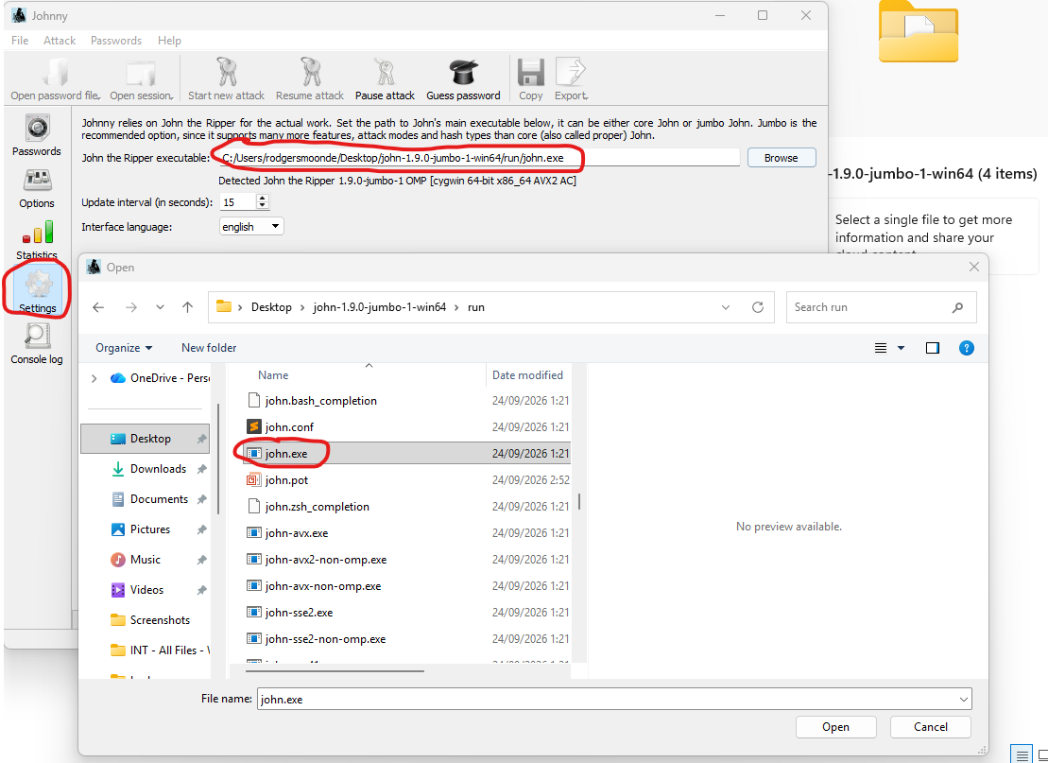

4.2 Hash Extraction
- Downloaded the encrypted PDF file (My Locked PDF1.pdf) supplied for the lab.
- Opened the OnlineHashCrack PDF Hash Extractor: https://www.onlinehashcrack.com/tools-pdf-hash-extractor.php
- Uploaded the locked PDF. The tool returned a hash in the format starting with $pdf$.
- Copied the complete hash (ensuring no extra leading characters) and saved it as hash1.txt in Notepad.

4.3 Cracking the Password with Johnny
- Opened Johnny GUI and loaded the hash1.txt file.
- Started a new attack (dictionary / default mode).
- The attack completed successfully and the password was recovered.

5. Result
Password successfully recovered:
good-luck
The recovered password was verified by opening the original locked PDF file.



6. Key Findings & Lessons Learned
- Even relatively short or common passwords can be cracked quickly when the correct hash format and a suitable wordlist are used.
- Johnny GUI significantly lowers the barrier to entry for beginners while still leveraging the full power of John the Ripper.
- Correct extraction of the $pdf$ hash (without extraneous characters) is critical for a successful attack.
- This exercise reinforces the necessity of strong, unique passwords (preferably 12+ characters with mixed case, numbers and symbols) for protecting sensitive documents.

7. Ethical Notice
All activities were performed solely against the lab-provided encrypted PDF supplied by NetworkWalks for authorised training. Password-cracking tools must never be used against any system, file or account without explicit written permission from the owner.

8. Project Status
Status: Week 3 – Project Module 1 Completed
Author: Rodgers Moonde | NetworkWalks Cybersecurity Internship B083

