WEEK 3 | PROJECT MODULE 2
PASSWORD CRACKING WITH NETWORKWALKS TOOLS
NetworkWalks Cybersecurity Internship • Intern: Rodgers Moonde • B083

1. Background
Password cracking is the process of recovering a password from stored data or a protected file. Security professionals use it to test password strength and to demonstrate why weak passwords present a real risk. When a file is locked, the password is stored as a hash – a one-way scrambled value. To recover the password we first extract this hash, then run it through a cracking tool that tries candidate passwords until a match is found.
In this lab two free browser-based tools developed by NetworkWalks were used: the Hash Calculator (to extract the PDF hash) and the Password Cracker (to perform a dictionary attack against that hash). No software installation was required.

2. Task
Crack the password of the attached PDF file (My Locked PDF1.pdf) using the NetworkWalks Hash Calculator and Password Cracker tools on a Windows laptop (or any system with a modern web browser).

3. Lab Environment
Component | Details
Host / Browser | Windows 11 + modern web browser
Hash Extraction Tool | NetworkWalks Hash Calculator (https://networkwalks.com/hash-calculator/)
Cracking Tool | NetworkWalks Password Cracker (https://networkwalks.com/password-cracker/)
Target File | My Locked PDF1.pdf (password-protected)

4. Procedure Followed

4.1 Obtain the Target File
- Downloaded the encrypted PDF file (My Locked PDF1.pdf) from the NetworkWalks lab page.

4.2 Extract the Hash
- Opened the NetworkWalks Hash Calculator: https://networkwalks.com/hash-calculator/
- Switched to the File tab and uploaded (or dragged) My Locked PDF1.pdf.
- The tool extracted a crackable hash beginning with $pdf$. The complete hash was copied.
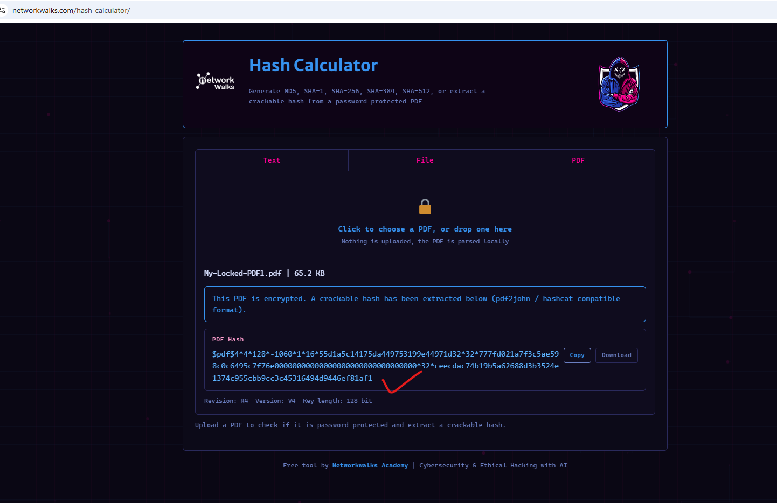

4.3 Crack the Password
- Opened the NetworkWalks Password Cracker: https://networkwalks.com/password-cracker/
- Pasted the full $pdf$ hash into the input field.
- Selected the built-in wordlist (or uploaded a custom list) and clicked Start Cracking.
- The tool performed a dictionary attack and successfully recovered the password.

5. Result
Password successfully recovered:
password1
The recovered password was verified by opening the original locked PDF file and confirming that the document contents were accessible.

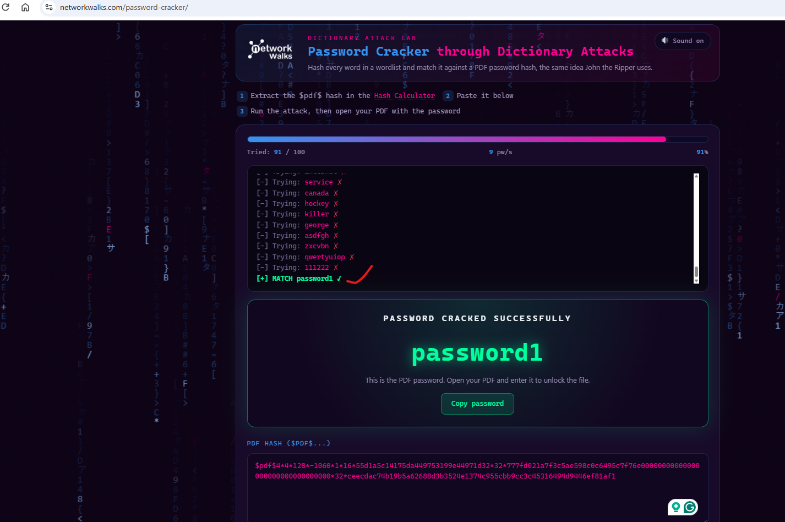

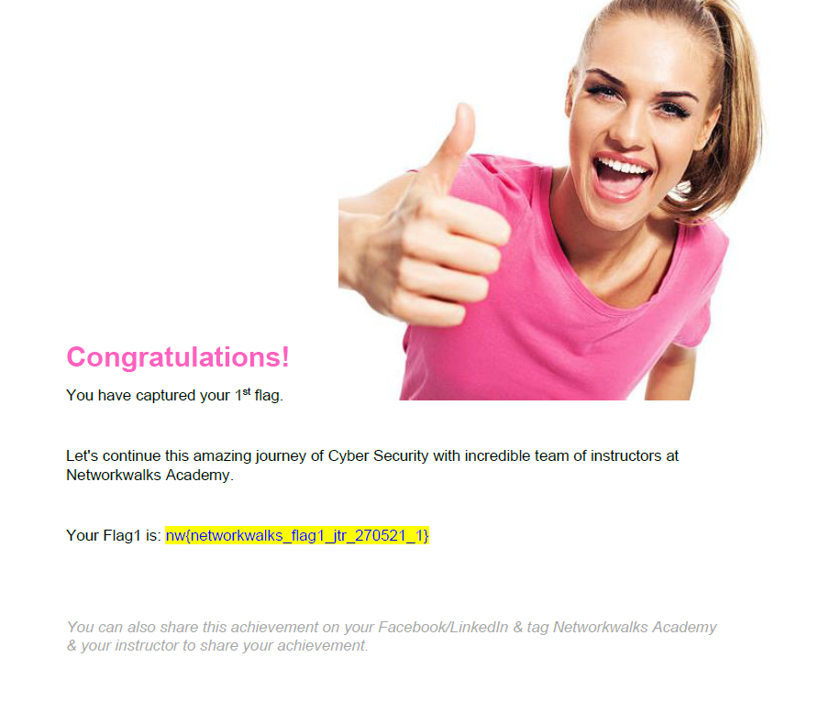

6. Key Findings & Lessons Learned
- Browser-based tools remove the need for local installation and are ideal for quick laboratory exercises.
- Hash extraction is the critical first step; an incomplete or malformed hash will cause the attack to fail.
- Common passwords (e.g. “password1”) are cracked almost instantly by modern dictionary attacks.
- Encryption is reversible with the correct key; hashing is a one-way function. Password cracking works by computing candidate hashes until a match is found.
- Strong passwords (12+ characters, mixed case, numbers, symbols) dramatically increase the time required for a successful crack.

7. Ethical Notice
All activities were performed solely against the lab-provided encrypted PDF supplied by NetworkWalks for authorised training. These tools must never be used against any system, file or account without explicit written permission from the owner.

8. Project Status
Status: Week 3 – Project Module 2 Completed
Author: Rodgers Moonde | NetworkWalks Cybersecurity Internship B083

