Clustering of Yoga Studios in New York City

**1. Introduction**

**1.1 Background**

Yoga, which originated in India over 4000 years ago, is grounded in a holistic integration of body and mind. Although there are many types of yoga practices, it typically combines stretching exercises and different poses with deep breathing and meditation. Yoga is designed to stretch and tone muscles and keep joints mobile. Some suggest that the bending, twisting and stretching movements also massage the internal organs and glands. Yoga poses are generally done with deep, diagrammatic breathing that is thought to increase oxygen flow to the brain. In a recent survey, approximately 21 million Americans have been noted to have practiced yoga during the past year. The main reasons given for such participation included athleticism, health promotion, emotional well-being, seeking pain relief and a sense of community. Yoga is considered a safe practice, with women being the most common practitioners. New York City (NYC) is the most densely populated city in the US. With nearly 10 million people distributed over a land area of approximately 300 square miles. As a global city, NYC is often described as the cultural capital of the world and exerts a significance impact on field of health and fitness practices. As a fast moving large city, NYC can cater for many diverse interests and requirements.

**1.2 Problem**

Barriers to practicing yoga exist and have been extensively studied. The main barriers given included time, cost, lack of pragmatic information about access to yoga classes and stereotypes related to flexibility, athleticism and typical yoga practitioners.

**1.3 Interest**

To help combat some of these reported barriers, it may be useful to identify where Yoga Studios are located in NYC and to further identify where clusters of studios are located. Such information may potential users identify where they should live to be in a ‘yoga neighbourhood’ with a range of options to fulfil their yoga needs.

**2. Data Sources**

Latitude and longitude values will be obtained from Foursquare API to explore neighbourhoods in NYC. Neighbourhood has a total of 5 boroughs and 306 neighbourhoods. The dataset exists free on the web, see link:

<https://geo.nyu.edu/catalog/nyu_2451_34572>

**3. Methodology**

The file was placed on a server and can be obtained with a **wget** command.



The data is loaded.



The data is transformed into a dataframe and explored.



A folium map of NY neighbourhoods was plotted using a latitude [40.7127281] and longitude [-74.0060152] and a zoom start of 10.

The Foursquare category for a ‘Yoga Studio’ [4bf58dd8d48988d102941735] was used to search NYC. A folium map was plotted using the GPS data for each unique location.

‘Yoga Studio’ clusters in NYC were identified using DBSCAN. The following criteria were used: kms_per_radian = 6371.0088; epsilon = 1.5 kms_per_radian; min samples = 5.

**4. Results**

**Table 1.** List of neighborhoods in NYC with latitude and longitude data.

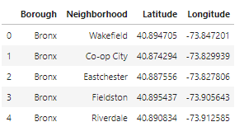

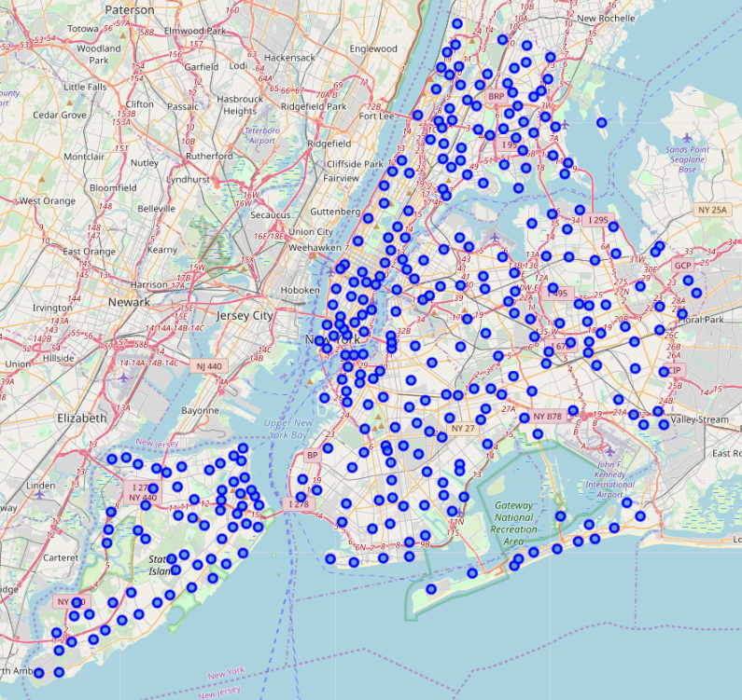

**Figure 1.** A map of the neighborhoods locations in NYC

The Foursquare search resulted in 625 unique locations were found based on a search for ‘Yoga Studios’, see Table 2.

**Table 2.** List of the location of ‘Yoga Studios’ in NYC

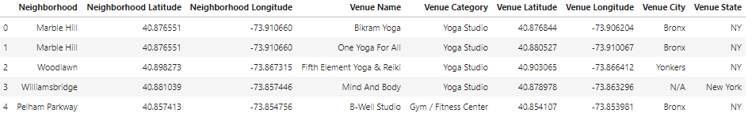

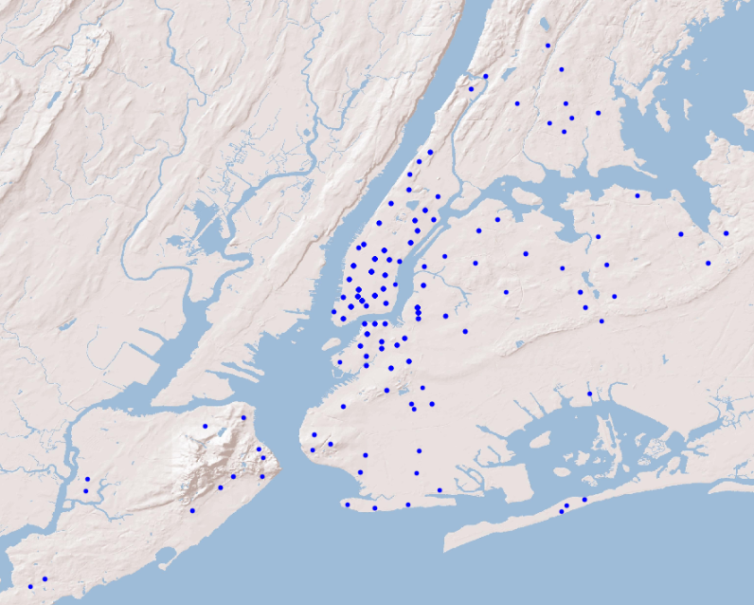

**Figure 2.** A map of the ‘Yoga Studio’ locations in NYC.

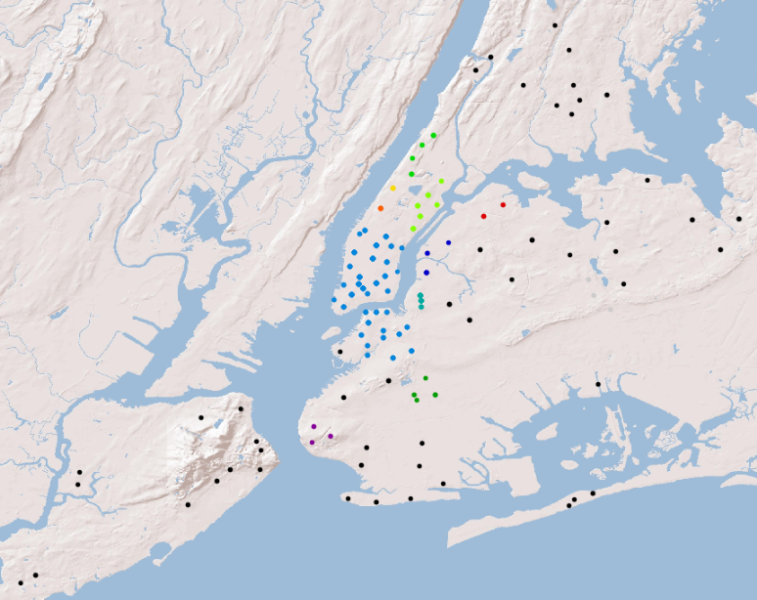

**Figure 3.** A map of the clusters of ‘Yoga Studios’ in NYC. * black dot denotes outlier

**5. Discussion**

NYC encompasses five administrative divisions called boroughs: The Bronx, Brooklyn, Manhattan, Queens, and Staten Island. The most densely populate borough is Manhattan, with approximately 30,000 persons per sq km. There are hundreds of distinct neighborhoods throughout the five boroughs, see Table 1, with their names and borders not officially defined, and subject to change from time to time. A map of the neighborhoods locations in NYC can be seen in Figure 1.

The Big Apple, the City That Never Sleeps, NYC… call it what you will, but there is no denying that residents of NYC have a genuine love of yoga practice. With so many options to choose from, I was interested to know initially how many there were and where they can be found. The Foursquare search resulted in 625 ‘Yoga Studios’ with their locations reported numerically in Table 2 and visually in Figure 2. Most NYC studios offer classes for $10-15, with many studios offering unlimited classes for $40.

There is a massive amount of respect between the various studios in NYC. Teachers and students frequent more than one studio throughout the city, which allows for a beautiful cross-pollination of ideas that contributes to a vibrant yoga community. To help a potential yoga student, I thought it would be a good idea to establish where clusters of yoga studios are located. Such information might help to gauge where a strong yoga community existed, rather than a yoga studio that was a great distance from any other studio.

Although several yoga studios do exist in Staten Island and The Bronx, no clusters of studios exist, and they may therefore not be locations that offer a range of options for the yoga practitioner. Furthermore, although Queens does have a single cluster of studios, it may always not be able offer a community of yoga studios. Manhattan and Brooklyn however are the boroughs that offer the best options with regard clusters of yoga studios. Specifically, the neighbourhoods that are connected via the Brooklyn Bridge, spanning the East River.

**6. Conclusion**

The yoga practitioner that is seeking a vibrant community in NYC should strongly consider the boroughs of Manhattan and Brooklyn, as they have large clusters of yoga studios. The neighborhood that surrounds the Brooklyn Bridge can be considered the hub or epicentre for yoga in NYC. In addition, potential business developments may find this clustered location information useful.