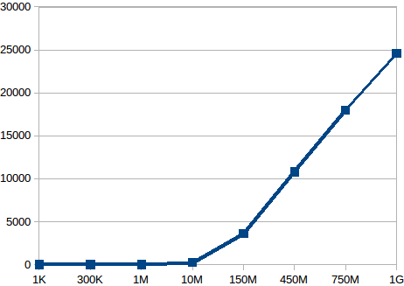

Graph of minor faults on increasing file size

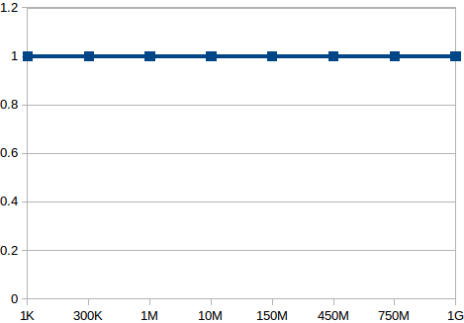

Graph of major faults on increasing file size

Analysis of graph plot:
On plotting the graph for different file sizes, it is found that as the file size increases, so does the
number of minor page faults.
The number of major page faults remain 1 irrespective of file size

