DATA DESIGN AND PREPARATION FOR DATA WAREHOUSING
Coursework 4 | Rockshell International Ltd. | Academic prototype
All company-like data in this exercise is synthetic. The database and ETL demonstration were executed locally in SQLite using Python. This is not a Rockshell production deployment.

1. THEORETICAL UNDERSTANDING

1.1 Data warehousing and decision-making
A data warehouse stores integrated, historical information optimized for analysis rather than daily transaction processing. For the Rockshell construction case, a warehouse enables consistent comparisons of project costs, purchasing, material consumption and labor by project and time. Management can identify expenditure patterns and supplier activity without manually combining multiple spreadsheets.

1.2 Warehouse architecture
The prototype uses a four-layer structure: (1) synthetic source CSV files representing finance, purchasing, site materials and timesheets; (2) Python extraction, validation and transformation, with a record-rejection log; (3) SQLite dimensional tables and fact tables; (4) SQL analytical queries and CSV reports that could later feed a BI tool such as Power BI. Python plus SQLite were chosen for a reproducible, lightweight student demonstration, not as a confirmed company technology decision.

1.3 Data categories
Structured data includes project IDs, costs, dates, quantities and wages in relational tables and CSVs. Semi-structured data may include JSON API exports or tagged procurement messages. Unstructured data may include construction photographs, site-report narratives and scanned correspondence. The implementation loads structured examples; JSON and unstructured file processing are discussed but not implemented here.

1.4 Quality, consistency and integrity
Data quality requires correct types, valid dates, unique source transaction IDs and nonnegative monetary values. Business integrity requires valid links between activities and projects, suppliers, materials and employees. A consistent unit such as bags or tonnes must be attached to material definitions; otherwise a sum of quantities can be misleading. Enforced foreign keys and rejected-row logging are used in the prototype.

2. DATA DESIGN

2.1 Dimensional versus normalized models
Normalized operational systems divide records into narrowly focused tables to reduce redundancy and support reliable transaction updates. Dimensional models arrange business measurements in fact tables surrounded by descriptive dimensions, simplifying analytical filtering and aggregation. A star schema keeps descriptive attributes together in dimensions; a snowflake normalizes some of these attributes into additional linked tables. For Rockshell, mostly denormalized dimensions improve report readability. Several stars reuse the same project and date dimensions, forming a fact constellation.

2.2 Fact grains and measures
Fact table | One row represents | Core measures
Fact_Project_Cost | One ledger cost transaction | Actual_Cost_GHS
Fact_Procurement | One purchase line | Quantity, Unit_Price_GHS, Purchase_Cost_GHS
Fact_Material_Usage | One site material-usage entry | Quantity_Used, Unit_Cost_GHS, Total_Material_Cost_GHS
Fact_Labor | One employee work entry for one project/date | Hours_Worked, Hourly_Rate_GHS, Labor_Cost_GHS

2.3 Dimensions and relationships
Shared dimension | Description | Used by
Dim_Project | Project, type, location, client link and approved budget | All four facts
Dim_Date | Day, month, quarter, year | All four facts
Dim_Supplier | Supplier identifiers and names | Procurement
Dim_Material | Material names and canonical units | Procurement, material usage
Dim_Employee | Employee roles; names are synthetic | Labor
Dim_Cost_Category | Expense category classification | Project cost
Dim_Client | Client details linked to project | Via Dim_Project, not directly to every fact

Each fact foreign key points to one dimension row; a dimension row may describe many fact rows. The client is linked through the project dimension, and approved project budget is stored once per project rather than repeated on every cost transaction. For production, changes to budgets and client associations would require explicit history/version rules.
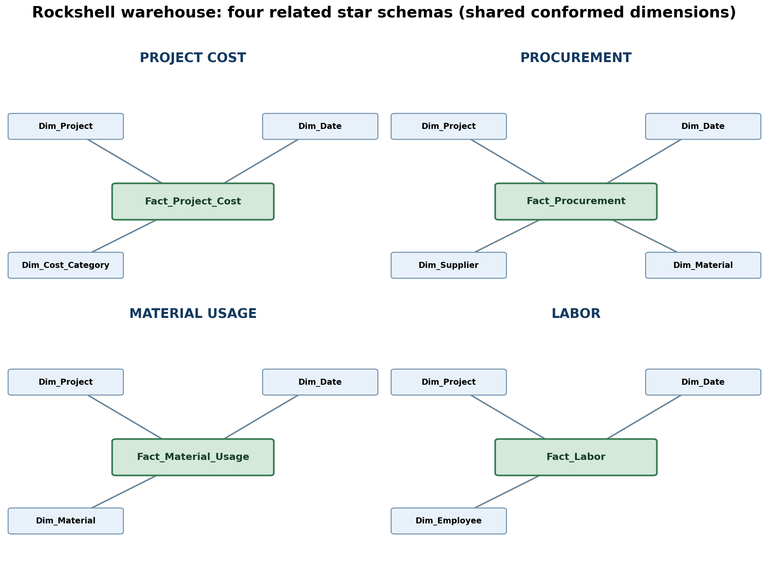
Figure 1. Four star schemas sharing conformed dimensions. This is a conceptual relationship view; the runnable SQL schema contains exact keys and data types.

2.4 Proposed physical tables
The provided schema.sql defines seven dimensions and four fact tables. Dimensions use surrogate integer primary keys alongside unique business IDs; fact tables use surrogate keys, unique source transaction identifiers and foreign keys. CHECK constraints enforce nonnegative costs and positive quantities/hours. Foreign key enforcement is explicitly switched on in SQLite.

3. DATA PREPARATION

3.1 Extract
The demonstration generates separate CSV files for projects, clients, suppliers, materials, employees, cost categories and four operational transaction datasets. Each source has its own columns and identifiers; a real implementation would replace these files with approved Rockshell source extracts, relational SQL queries or APIs.

3.2 Cleanse and validate
Python checks for duplicate transaction IDs, nonexistent project/supplier/material/employee references, invalid dates, negative or zero measurements and incorrect data types. Failed rows are rejected with a reason in outputs/rejected_records.csv. No invalid records are silently changed into plausible transactions.

3.3 Transform and enrich
Source business IDs are mapped to dimension surrogate keys. Dates are joined to Dim_Date. Purchase totals are calculated as quantity × unit price; material usage cost as quantity used × unit cost; and labor cost as hours worked × hourly rate. Amounts are rounded to two decimals. These represent analytic transformations rather than verified Rockshell accounting policies.

3.4 Load and tools
Dimension tables are populated before fact tables. Python’s standard csv module reads files and sqlite3 loads a local SQL warehouse. The same logical preparation process could be implemented with SSIS, Talend or another ETL platform; the lecturer lists such tools as examples, not mandated technologies. This prototype runs with Python 3 without external packages for the data processing.

4. PRACTICAL EXERCISES AND VERIFIED RESULTS

4.1 Implementing the star schema
Run “python build_warehouse.py” from the coursework4 folder. It deterministically creates raw_data/*.csv, schema.sql, rockshell_warehouse.sqlite, analysis_queries.sql and the output validation files. If run again, it recreates the sample database from scratch. The dataset deliberately contains three invalid records per fact source to demonstrate quality controls.

4.2 Data loads and row rejection
Fact area | Input rows | Loaded | Rejected
Project Cost | 403 | 400 | 3
Procurement | 603 | 600 | 3
Material Usage | 703 | 700 | 3
Labor | 903 | 900 | 3

Verified totals: 2,600 fact records loaded; 12 invalid or duplicate rows rejected. A SQLite PRAGMA foreign_key_check returned 0 violations.

4.3 Sample queries and results
Project budget versus ledger expenditure is calculated by LEFT JOIN between Dim_Project and Fact_Project_Cost, grouped at the project grain. Because synthetic finance costs do not exhaustively represent company spending, this report is a test of SQL logic, not a real project profitability statement. Procurement and labor analyses are provided in analysis_queries.sql.
Project | Approved budget (GHS) | Ledger cost (GHS) | Budget less ledger cost (GHS)
P009 | 777,461.00 | 217,339.21 | 560,121.79
P003 | 1,450,763.00 | 212,453.18 | 1,238,309.82
P005 | 255,315.00 | 197,866.56 | 57,448.44

Reproducible query excerpt:
SELECT p.project_id, ROUND(SUM(c.actual_cost_ghs),2) AS ledger_cost_ghs
FROM dim_project p JOIN fact_project_cost c ON p.project_key=c.project_key
GROUP BY p.project_key ORDER BY ledger_cost_ghs DESC;

4.4 Data-integrity testing
Validation checks include COUNT(*) per fact, rejection counts versus raw inputs, foreign-key verification, uniqueness of source IDs, and comparisons between reported totals and fact-table sums. The outputs/validation.json file captures the actual executed counts, and project_cost_report.csv contains one analytical query result. No external company data is used.

5. DISCUSSION

5.1 Large volumes and performance
For production-scale data, add indexes on common dimension foreign keys, partition large dated fact tables where supported, perform incremental loads and maintain load-watermark metadata. Use bulk loading rather than inserting individual rows when volumes grow. The small demonstration is intended for validation of the logical design, not a performance benchmark.

5.2 Consistency across systems
Shared dimensions prevent different departments from assigning conflicting meanings to project and date identifiers. A source-to-target mapping document should define units, currencies and whether prices include taxes. The chosen example uses GHS and does not mix bag quantities with tonnes. Employee information would require additional privacy controls if real data were used.

5.3 Integrating disparate formats and avoiding misleading totals
A staging area should preserve source rows and capture transformation outcomes, particularly when combining CSV, databases, PDFs or APIs. Procurement amounts, material consumption costs and ledger expenses can describe overlapping economic activity. Consequently, the three financial measures must not be indiscriminately summed to create a total project cost. The project budget comparison in this exercise uses ledger costs only; further reconciliation would be necessary for a real implementation.

5.4 Limitations and next step
This is a self-contained, synthetic academic prototype. It does not establish the availability of actual Rockshell extracts, validate historical budget changes, implement secure user accounts, or publish an operational Power BI dashboard. Coursework 5 will expand the ETL discussion to orchestration, incremental loads, CDC, monitoring and tool comparisons, as required by its separate brief.

6. DELIVERABLES AND REFERENCES
Included files: build_warehouse.py (generation and ETL), schema.sql (DDL), analysis_queries.sql, rockshell_warehouse.sqlite, raw_data/*.csv, outputs/validation.json, outputs/rejected_records.csv, outputs/project_cost_report.csv and star_schema_four_subjects.png.
Course sources: Assignment Title: Data Design and Preparation for Data Warehousing (CourseWork4); the group’s revised Coursework 3 business requirements and earlier Rockshell case-study documents. Conceptual design choices beyond those documents are identified in this report as prototype decisions.

