Passo a passo para realizar o deploy do componente Axis.

**1 - Extrair todos os anexos desse e-mail numa pasta de fácil acesso. Ex. Desktop/Deploy_Axis**

**2 – Renomear o arquivo “sdaMakerTool.jar.zip” para “sdaMakerTool.jar” ou seja, remover o .zip do nome do arquivo. Esse jar é a ferramenta utilizada para gerar o arquivo SDA.**

**3 – Extrair o arquivo “Axis.rar” dentro da pasta “JAR”.**

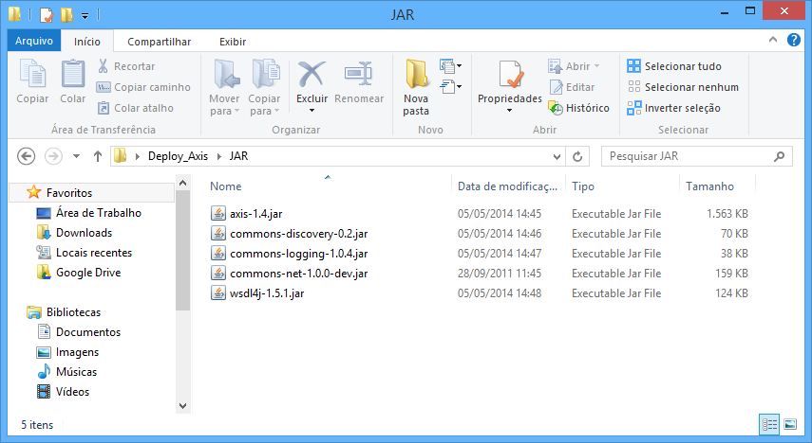

**4 – Voltar para pasta “Deploy_Axis” e executar o arquivo “sdaMakerTool.jar”.**

**5 – Executar o passo a passo no documento “1028961.pdf” e gerar o arquivo na pasta SDA**

*Use the sdaMakerTool.jar file, attached to this SAP Note, to create an XI Axis provider library*

*SDA.*

*1. Start the tool directly or from the command line via command: java -jar axisMakerTool.jar.*

*2. Select a specific version '7.0' , '7.10 , '7.11', '7.30', '7.31' , or '7.40' from the combobox.*

*3. Select SDA name:*

*\* 'aii_af_axisprovider.sda' for Axis Adapter for version 7.0*

*\* 'aii_af_jmsproviderlib.sda' for JDBC\JMS Adapter for version 7.0*

*\* 'com.sap.aii.af.axisproviderlib.sda' for Axis Adapter for version 7.10 and higher*

*\* 'com.sap.aii.adapter.lib.sda' for JDBC\JMS Adapter for version 7.10 and higher*

*4. Checkbox "Don't use SAP XI 3RD PARTY SCA" is visible only for releases 7.11 and higher. If you are not able to find such an SCA file in SAP Service Marketplace, you can use it in order to create an SDA file without using SCA.*

*5. The tool consists of text fields in which the following information is displayed by pressing the "Browse" buttons:*

*\* Directory where SAP XI 3RD PARTY SCA is stored (only for releases 7.11 and higher).*

*\* Path to the copied Axis framework JAR files (see step 2 from the Prerequisites section).*

*\* Directory for output data (see step 3 from Prerequisites section).*

*6. When the "Start" button is pressed, the newly created SDA will be created in the directory for output data.*

**6 – Para realizar o deploy do arquivo gerado pasta seguir o passo a passo no documento “deploy-sda-files-without-jspm.pdf”**