KWAME NKRUMAH UNIVERSITY OF SCIENCE AND TECHNOLOGY COLLEGE OF ENGINEERING

DEPARTMENT OF ELECTRICAL AND ELECTRONIC ENGINEERING
A DETAILED DESIGN AND IMPLEMENTATION OF A 3D PRINTER USING PHOTOGRAMMETRY FOR 3D MODELLING
BY
APPIAH-KUBI KWABENA 4106615
ASANTE RODNEY 4107015
PESSEY PAUL MICHAEL 4113015
DECEMBER 2018

INTRODUCTION
3D Printing is a process for making a physical object from a three-dimensional digital model, typically by laying down many successive thin layers of a material. It brings a digital object (its CAD representation) into its physical form by adding layer by layer of materials.
There are several different techniques to 3D Print an object. 3D Printing brings two fundamental innovations: the manipulation of objects in their digital format and the manufacturing of new shapes by addition of material, thus digital and additive manufacturing.
The most basic, differentiating principle behind 3D printing is that it is an additive manufacturing process. And this is indeed the key because 3D printing is a radically different manufacturing method based on advanced technology that builds up parts, additively, in layers at the sub mm scale. This is fundamentally different from any other existing traditional manufacturing techniques.
There are several limitations to traditional manufacturing, which has widely been based on human labour and made by hand. However, the world of manufacturing has changed, and automated processes such as machining, casting, forming and moulding, complex processes that require machines, computers and robot technology.
However, these technologies all demand subtracting material from a larger block whether to achieve the end product itself or to produce a tool for casting or moulding processes and this is a serious limitation within the overall manufacturing process.
For many applications traditional design and production processes impose a number of unacceptable constraints, including the expensive tooling as mentioned above, fixtures, and the need for assembly for complex parts. In addition, the subtractive manufacturing processes, such as machining, can result in up to 90% of the original block of material being wasted. In contrast, 3D printing is a process for creating objects directly, by adding material layer by layer in a variety of ways, depending on the technology used. Simplifying the ideology behind 3D printing, for anyone that is still trying to understand the concept (and there are many), it could be likened to the process of building something with Lego blocks automatically.
3D printing is an enabling technology that encourages and drives innovation with unprecedented design freedom while being a tool-less process that reduces prohibitive costs and lead times. Components can be designed specifically to avoid assembly requirements with intricate geometry and complex features created at no extra cost. 3D printing is also emerging as an energy-efficient technology that can provide environmental efficiencies in terms of both the manufacturing process itself, utilising up to 90% of standard materials, and throughout the products operating life, through lighter and stronger design.
In recent years, 3D printing has gone beyond being an industrial prototyping and manufacturing process as the technology has become more accessible to small companies and even individuals. Once the domain of huge, multi-national corporations due to the scale and economics of owning a 3D printer, smaller (less capable) 3D printers can now be acquired at affordable prices.
This has opened up the technology to a much wider audience, and as the exponential adoption rate continues apace on all fronts, more and more systems, materials, applications, services and ancillaries are emerging. [1]

An image is a picture representing visual information. A 2D image has only two dimensions height and width, while in a 3D image along with height and width it contains a third parameter called depth. The 3D image provides more information and gives better real-time world experience than 2D image.
Despite the advent of 3D technology, the availability of 3D content is still hindered by that of its 2D correspondent. To close this gap, many 2D-to-3D image conversion methods have been proposed.
The main difference between 2D and 3D images is clearly the presence of depth in 3D images which makes the calculation of depth the most important factor in the conversion of images from 2D to 3D.
Many different 3D scanning technologies exist to 3D scan objects, environments, and people. Each 3D scanning technology comes with its own limitations, advantages, and costs.
3D scanning technologies rely on different physical principles and can be classified in categories:
- Laser triangulation 3D scanning technology, as illustrated on the image, projects a laser beam on a surface and measures the deformation of the laser ray.
- Structured light 3D scanning technology measures the deformation of a light pattern on a surface to 3D scan the shape of the surface.
- Photogrammetry, also called 3D scan from photography, reconstructs in 3D a subject from 2D captures with computer vision and computational geometry algorithms.
- Contact-based 3D scanning technology relies on the sampling of several points on a surface, measured by the deformation of a probe.
- Laser pulse (also called time of flight) 3D scanning technology is based on the time of flight of a laser beam. The laser beam is projected on a surface and collected on a sensor. The time of travel of the laser between its emission and reception gives the surface’s geometrical information.

AIM
Design and implementation of a 3D printer using photogrammetry for 3d modelling.

OBJECTIVES
The main objectives of the project are as follows:

- To review literatures on similar works and come up with better design concepts.
- Design and build 3d printer which uses a microcontroller to control extruder and motor.
- Test the system

LITERATURE REVIEW

Article 1
Study, Design and Construction of a 3D printer implemented through a Delta Robot
Ricardo Celi, Ana Sempértegui, Derlin Morocho, David Loza, Darwin Alulema & Mariela Proaño [3], (2015) presented a paper which describes the design and implementation of a 3D printer prototype based on a delta parallel robot. For the design of the printer the project was divided into four parts:

For mechanical design, the kinematic analysis of the robot system comprising the 3D printer, is based on a parallel robot, composed of three kinematic chains, which was analysed taking one as reference. The calculations and simulations for each of the mechanical parts were designed by analysing the stress that they will be subjected to and they will help to determine the deformations and safety factors.

The electronic design comprises selecting electronics, control cards, sensors and actuators. In the selection analysis, the advantages and disadvantages of each electronic component were considered. The electronic devices used in the prototype implementation are Arduino Mega, Ramps 1.4, End Switch, Bipolar stepper motors. The Rep Rap Ramps 1.4 board was designed for 3D printers, where its function is to expand the Arduino Mega. In addition, it has all the characteristics and requirements for implementing a printer, such as driver compatibility for stepper motors, power connections to 16 Amps, power outputs, pin thermistors, limit switches, and wireless LCD screen.

For the control system, the control elements for each loop were determined. A PID control was performed for temperature control. To achieve the smelting media of the printing material, the extruder tip is heated using a nickeline. Its control was performed using a process of temperature auto calibration. For proper handling, it was necessary to establish the parameters to manipulate the prototype, where the most important are: speed, position of rest, arm length, print area, and maximum print height.

The 3D printer was successfully implemented using REPETIERS HOST software and a PID control temperature. Using the Auto-Tune commands, the optimum values for proportional, integral and derivative controls were found. The firmware, REPETIER, which provides free software, allows controlling stepper motors and implementing a self-levelling system, for printing complex samples with good quality results.

Merits
- The benefit of a Delta is that the moving parts are lightweight so that it’s easier to travel. That results in faster printing with greater accuracy.
- Delta’s are generally better in building higher objects like for instance a vase because the build platform is fixed.
Demerit
- More complicated calibration procedure

Article 2
DESIGN AND DEVELOPMENT OF LOW COST 3D PRINTER
This project emphasizes on the design and development of a low-cost 3D printer [4]. 3D printers available now are of higher costs which is due to the printing technology used and the material used in 3D printer. This projects focuses on making the 3D printer low cost by using the scrap materials and low cost materials.
The aim of the project was to make the 3D printer available to an average earning person and making this equipment easy to operate and automate once the command and specific design is given to this device. So operating time will automatically decrease as it can handle the task without any human intervention. This also makes this device usable by everyone. The 3D printer was designed and built for people who have cost as a main constrain and thus making it available for use in school laboratories, making imitation jewelry for women, automobile industries, making a prototype material in industries etc. The 3D printer was being designed to produce a plastic 3D output and make it as accurate as possible compared to the present 3D printer requirements.
The frame of the printer was self-designed to utilize the scrap materials acquired. Kossel, a delta based robot was considered in their design of the framework. Five stepper motors were used for the movement of the extruder since they have high torque at low speeds, high accuracy of motion and inexpensive. One motor each to control the Y and the X-axis, two to control Z-axis and one to control the extruder. The driver features adjustable current limiting, over current protection, and five different micro step resolutions. Arduino mega 2560 was used as the microcontroller.
The Software That Needs to Be Installed On the Computer to Run the Model:
Arduino Software: This application allows installing the printer firmware on the ATMEGA 2560 microprocessor. To update the firmware each time this installation is required.
• Skien Software: The application to slice STL files into the G-Code is called as Skein Software. Each time the part that needs to be printed needs this type of software.
• Host Software: Before the print job this application is responsible for the communication with the electronics. In simple words it makes the printing output to be ready before the actual printing job.
The low cost 3D printer was successfully implemented. It was easy to operate but it had issues with accuracy
Merits
  - The printer is inexpensive and can be purchased by average earning people.
  - The printer is easy to operate and automate.

Demerits

- Printed products are of poor accuracy due to the use of scrap materials.
- Printing is time consuming

Article 3
Development of a 3D Printer and a Supervision System Towards the Improvement of Physical Properties and Surface Finish of the Printed Parts
Blandon, Amaya and Rojas proposed a supervision system that uses closed control loop for the material output, reducing the printing defects produced by interruptions in the material flow [5].
The supervision system aims to improve the surface quality of the fabricated object. The 3D printing system would be able to take corrective actions to prevent unwanted discontinuities and material waste that result in imperfections.
A variation of the Cartesian system (Core-XY) was selected for the printer because of its flexibility and ease of access to the actuators and sensors.In this configuration, movement in each direction is a combination of the movement of the two motors.
The 3D printing would address the concerns of printing area, the robustness to changes of printing parameters, flexibility to test different materials and even to change the print head. Additionally, with the new 3D printer the hope is to reduce many imperfections of the printed object caused by the vibrations of the structure, which are propagated through the printing platform.
The development of this system has been divided into three subsystems:
- Supervision of material output.
- Feedback of the system actuators.
- Supervision of the printed part throughout the printing process.

Supervision of material output.
The supervision system of material output focuses on the extrusion nozzle and tries to know if the head extruder is really extruding material, this way covering problems related to the movement of the material. The intent in this phase is to detect the material output or absence using a camera positioned near the extrusion nozzle and digital image processing algorithm comparing the output of the nozzle to the intended output

Feedback of the system actuators.
One of the principal problems of the printing process is that the movement system is open loop, using stepper motors the printing process are not free of losing steps, this could happen because the mechanical fittings are no well-done (pulleys that do not engage correctly, backlash), failures caused by voltage and current adjustment, jams on the mechanisms, or because the motors do not have enough torque. This issue was fixed by ensuring the real position of the printhead and the building platform must coincide with the simulated position; this was achieved by adapting sensors to the actuators or the printhead and platform to determine actual positions and compare with the G-Code generated by the printing software.

Supervision of the printed part throughout the printing process.
This implies that the system should verify if the material is being deposited where is supposed to and whether the layers on the partially printed object are indeed what it should be. A monitoring system that focuses on the printed part and verifies the status of the print throughout the process, allowing corrective actions to obtain the desired geometry. The solution for this case is to install a camera that captures images of the printed object and compares it with the 3D model of the intended object as it is being printed.

The initial corrective action for each section of the supervision system consists in stopping the printing process sending the head extruder to a predefined safe position where the heat of the nozzle and any undesired material output do not affect the printed object, and in this position the extruder can be verified and corrected before resuming the printing process.

Merits
- Improvement of the surface quality.
- Reduction in vibrations caused by movements of the actuators. The fast and constant movement of the actuators during the printing process can affect the surface quality of the final printed product.
- Detects correct movement of the filament. The movement of the filament has to be the same and constant, if the filament takes more time moving this can cause overheating of the material and affect its mechanical considerations.

Demerit
- Time consuming: The system will pause the printing process and send the printhead to a predefined position where a corrective action can be taken before resuming the process.

Article 4
Mechatronic System Design Project: A 3D Printer Case Study

Range Kayfi, Dana Ragab and Tarek A. Tutunji [6], (2015) presented a paper which highlights the success of developing a fully-integrated engineering system that incorporates a mechanical plant, electronics, drivers, embedded controllers, and software interface. The project objective was to realize a 3D printer prototype with relatively simple design. The described work can be used as an educational reference for proper mechatronics design.

In this project, an extrusion technique was selected because of its simple mechanical structure, parts availability, and low-cost technology. Furthermore, it is ideal for desktop printer and provides most practical prototype for educational purposes. The contribution of this paper will be that it provides: A step-by-step approach to design a fully-integrated mechatronics system that can be used for educational projects. A review of available 3D printer designs and resources.
3D printing follows the sequential stages of design, printing, and post production. 3D printer's software functionality can be divided into three steps:
Generating CAD models with STL extensions. Slicing the 3D model into layers. The objects are built by laying out material layer by layer. Generating the G- code (a series of commands that drive the printer) and interpreting the commands via the firmware. The firmware and G-code are then uploaded to the microcontroller. The microcontroller sends the appropriate pulses to the drivers to control speed and direction of axes motors. Feedback signals from thermistor are used to control heat generated by the hot end. In 3D printing, the user-interface software is an important element that should be chosen carefully. This host software has several tasks that include creating 3D model, slicing objects and converting STL file to G-Code.

Different design options were studied and an Arduino MEGA 2560 was used as the microcontroller because of its good performance, interface capability, ease-of-use and availability. A special shield (signal conditioning circuits) for Arduino Mega microcontrollers is required to fit the entire electronic needed for FDM printers. A RAMP shield 1.4 version was selected because it provides good features when developments are needed. Also, it offers SD card reader which allows the using of printer without a computer. Extruder is the mechanism responsible for feeding the printing filament to the hot end. The hot end melts the filament and thus allowing the filament to flow according to the supplied 3-Dimensional data. An all metal hot end extruder was selected because it works with different type of materials and provides a detachable filament guide.
Three stepper motors (with their associated drivers) were selected to position the 3-axes. As for the sensors, six hall effect sensors were chosen to detect the limits of each axis. The distance between the hot end and the plate is very crucial and therefore hall effect sensor provide more practical solution than moving mechanical or optical end stops up and down by allowing tuning for this distance using potentiometer.
PLA and ABS are the most common materials for 3D printing because of their relatively low melting temperature and cost compared to other materials. In this project, PLA filament was selected.

Merits
- They used FDM 3d printer due to its simple mechanical structure and availability of components.
- It is ideal for desktop printer and provides most practical prototype for educational purposes.
Demerit
- The print size is small as compared to the standard desktop size.

Article 5

AN EDUCATIONAL PURPOSE BUILT THREE DIMENTIONAL PRINTER
A three dimensional printer using stepper motors from 3.5-inch disk drives was built for undergraduate research thesis project [7]. An Arduino microcontroller was in charge of controlling the steppers through the DC drivers and a 3D pen was used as the printing unit. The program was created with the Arduino suite and the design of the drawing using g code. For the axes, three disk drives were reassembled to form the X, Y and Z levels. The 3D printer will be used for educational purposes, as a teaching tool in laboratory projects.
For this project, the base was created where the disk drive frames would be installed. A metal was used for its first tests, although Plexiglas was used for better aesthetic result. The Plexiglas was reshaped with heat and drilled with a stationary electric drill for best precision. A3967 Allegro microsystems was used as the drives, which was proven to be reliable and cost efficient. The effective space was 38mm x 38mm x 38mm and the stepper motors had a resolution of 0.1mm per pulse.
The project was divided into two parts, the construction of the printer and the coding of the microcontroller. During the construction, the axes were perfectly aligned to avoid mismatches with the original design. All excess componenets from the 3.5 inch disk drives were removed and the frames with embedded axes and stepper motors were kept. For the coding part, a G code interpreter using Adruino suite was used.
Fig. Complete construction mounted on the base

Merits
- Easy to transport since all electric circuits were soldered together on a perforated circuit board.
- Components can be easily disassembled, modified and reassembled again.

Demerits
- 3D pen used in this project is expensive compared to other extruding devices.eg. Bowden extruder
- Micro controller used limited to only beginners, hence lesser input and output ports.

Article 6
3D PRINTING USING DIGITAL PHOTOGRAMMERIC DATA
This project focuses on modelling of non-topographic objects based on photogrammetry field of studies. By using 3D printing technology that is widely used nowadays, a real object could be reproduced again exactly as it is through post processing of object model formed by RGB-D Camera and printing out of the post processed file using 3D printer. In this project, a cylinder box and half part of human body are chosen for the printing purpose to represent simple and complex object respectively. The chosen scanner capable to detects the shape of an object in our surrounding in range 80cm to 3.5 m.
Reconstruct me software was used to scan the object. distances of 0.8m, 1.0m and 1.5m were selected to scan both objects. The formed models were uploaded in Meshmixer to filter unnecessary features like noise and unfilled holes. Selection tool was used to remove unnecessary features. The hole at base of the model is filled either by using plane cut tool, form solid tool or erase and fill tool. The hole at base of the model was filled using plane cut tool. The complexity of the objects is determined by the size, shape and detail of the actual objects.
The cleaned model was also saved in STL file format to enable it to be uploaded in XYZ Ware software before it can be printed in the 3D printer.
From this study, it was found that the methodology used can produce the exact model of the chosen objects in three dimensional copies with the reduced scale. In term of analysis, the studies show that the time acquired to form the 3D model increases significantly between non-complex and complex object. The concept of 3D printing is much related to the field of Photogrammetry especially in generating the 3D model because it involves the use of image photos, triangulation network and contouring of the object models.

Digital image capturing using close range photogrammetry was applied during scanning and modeling process to achieve a complete model of an object. Good illumination of light was an important factor in achieving good quality of close-range photogrammetric data. The distance taken in scanning process is dependent on the size of the object.
Merit

- Maintaining fixed distance between objects and RGB-D camera produces the best quality of final output.
Demerit
- Poor quality of final product in the absence of factors such as good illumination.

Article 7
DESIGN, FABRICATION AND TESTING OF A 3D IMAGE RECONSTRUCTION PROCESS
This project involves optimizing a workflow for photogrammetry [9]. This includes the redesign of an existing 3D scanning stage, the use of multiple Raspberry Pi cameras for image acquisition, as well as the selection of the best software and settings to use in order to render the 3D model. Once a 3D model is generated, it is brought into a model editing environment or sent directly to a 3D printer. The objective was to develop a complete 3D image reconstruction package that is easier to use for the general user. The first step was to select a stage that had potential for modification. For hardware, they chose to use a Raspberry Pi and its camera for image acquisition. This allowed for easy programming of the capture timing and manipulation of image qualities. They experimented with multiple software products on the market to determine which option would perform best. They also described categories for an object’s levels of difficulty to reconstruct. The levels "easy, medium, and hard” were defined by how complex of geometry and the variance of color that the object had. An easier object would have detailed patterns or multiple colors, while a harder object would have a more uniform shape, texture, and color.
They modified a design to utilize a circular platform rather than a hexagonal one. They also introduced a solid white background to the scene rather than keeping the background unconsidered. All of this helps the software find better anchor points for image orientating. They then added a second camera for more convenience and improved the white background with a light box. This final setup returned the cleanest models after processing.
The final stage allows for a consistent method of imaging. The notched rotating platform and the light box is a simple solution to help generate quality 3D models. Using two Raspberry Pi cameras was for convenience alone, as it expedited the process of imaging multiple angles.

Merit
- The 3d scanner tends to reconstruct more accurately because of the fixed rotational motion of the object and the same distance between the camera and object.
Demerit
- Objects must be of smaller size than the scanning surface.

Article 8

A CLOSE PHOTOGRAMMMETRY LABORATORY ACTIVITY FOR MECHANICAL ENGINEERING UNDERGRADUATES

This paper describes a new laboratory activity used to introduce undergraduate mechanical engineering students to close-range photogrammetry mechanical engineers typically use close-range photogrammetry for the non-contact dimensioning of objects ranging in area.[10]
Photogrammetry software allows the computation of the three-dimensional location of each target based on its two-dimensional coordinate in each image, through the process of triangulation. While triangulation calculations can be performed using information from only two images of a particular target, the use of additional photos allows camera location to be automatically calculated.
The camera used to take the photographs was a Sony DSC-PI owned by the course instructor. This is a consumer grade, digital camera with a 3.34 Megapixel resolution. In general, higher-resolution cameras allow sharper, more details images, which improves the resolvability of the target points.
The software chosen for this activity was PhotoModeler Lite. a stripped down but fully functional package that was available free by download. The purpose of this laboratory was to expose students to a technique for measuring dimensions to which they had no previous knowledge. Photographs of the objects were taking and files transferred to the software. The software creates a three-dimensional wire-frame model and measure all its edges and curves. For each dimensioned edge or feature, show the mechanically-measured dimension with an uncertainty appropriate to the measurement tool, and the mean photogrammetrically- determined dimension.

In general, the introduction of a photogrammetry activity to the Measurement and Instrumentation lab sequence required of students majoring in mechanical engineering at was successful.

Merits
- They were able to use photogrammetry to create orthographic projections of objects.
- They also used photogrammetry to get approximate dimension of objects.

Demerit
- Higher resolution cameras and additional light sources were required in order to get better performance.

Article 9
3D MODELLING FROM 2D IMAGES
This article gives an overview of the methods of transition from the set of images into 3D model [11]. The method used in this article, unlike traditional approach explains ways to create photorealistic 3D models from 2D images. It is mostly focused on detection, grouping, and extraction of features (edges, faces, etc.) present in a given picture and then trying them as three-dimensional clues.

High Dynamic Range Imaging (HDR) method is used to obtain high quality illumination on image. It contains three shots filmed from the same position and embedded in one image. The difference between these shots is the length of exposure. The first shot must be over exposed, second under exposed, and third under optimal exposure. By combining these three shots we obtain the optimal tone values in all areas, with more detail in bright and dark areas. In such a way we increase the quantities of small details, and face acquires specific character.

When it comes to facial reconstruction from series of photographs, there will almost always be some errors that occur due to the moving of the person. One of possible solutions is to simultaneously record with multiple cameras from different angles. Three cameras are distributed in a circle around the subject, angle set to 90° (profiles and in front of the face) simultaneously recording the subject. In such a way we obtain images in which the error of changing the position of the object will be minimal. But in most cases, while recording, there is only one camera, which circles around the subject.

Merits
1. Less time and effort are required to obtain realistic models (because the process is semiautomatic).
2. It provides a greater chance of creating realistic models, and finally, getting the texture-mapping arranged by UV coordinates is automatic.

Demerit
Inability to determine the age and characteristic features of the person, because the model is formed by a few given points which are marked on it, while overall appearance is identical to any model constructed in such a way (shape of the head, ears, hair, and lack of facial detail).

Article 10

USE OF PHOTOGRAMMETRY IN 3D MODELING AND VISUALIZATION OF BUILDINGS
For this project, an experiment was conducted to check the accuracy of the 3D model generated using the photogrammetric technique. The complete orientation and calibration was done automatically only based on the images. There were no markers, or any approximations used. The object selected was the Institute of Engineers building, located in the Indian Institute of Technology Roorkee campus area. In the project, the camera used was Kodak CX7300 and the processing was done using photogrammetric software package Photomodeler 5.
In the frame of this work, the following activities were performed: photo acquisition, processing of photographs, 3D model generation and Texturing and Visualizations. The data acquired may be either hard copy photographs taken with film cameras or digital photographs taken with a digital camera. If hard copy photographs are available, these photographs are to be scanned with high resolution scanner. Other way is to acquire digital data directly by means of digital CCD cameras. The photographs acquired were imported into photogrammetric modeling software, Photomodeler. Reference points were selected on the building like corners which are easily identifiable and separable.
3D model generation was done interactively to segment the points into separate objects and also to edit the output. For large environments, since the technique may require large number of images, model generation still necessitates significant human interaction, regardless of the fact that 3D point coordinates were computed automatically. To get the realistic impression of the building, textures are added for each side of the building. Textures give a new quality to a 3D model making it more similar to real object and more adequate for human perception and understanding.

Merits
- Offers the best alternative technique to any other CAD based technique used.
- Less time is spent to generate a 3D model of an object using photogrammetry.

Demerit
- The technique requires a large number of images, the 3D model generation might need significant human intervention.
CHAPTER 3: DESIGN CONSIDERATION
3.1 INTRODUCTION.
This chapter provides a detailed review of the various components and explanations on the design and working principles of the 3D printer. Also, the selected components for this project are justified.

Workflow

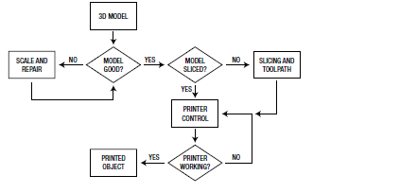

Flow Chart of Operation
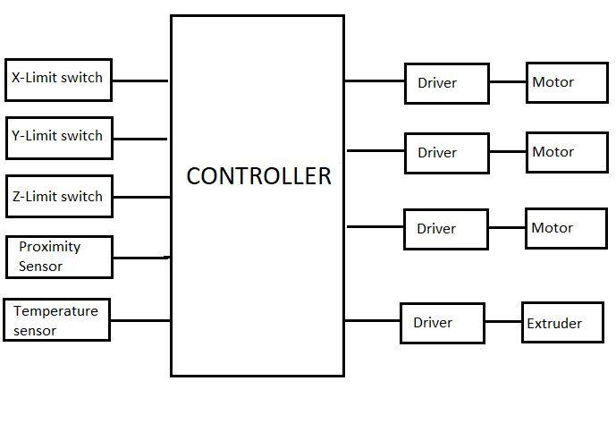

CAD Drawing of 3D printer
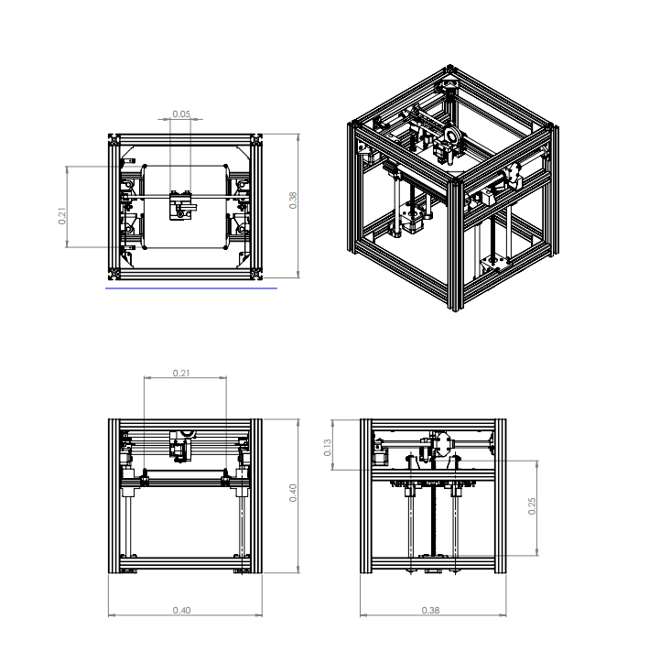
Fused Deposition Modelling Technique
Fused Deposition Modelling(FDM) creates objects by extruding hot melted plastic in a defined layout to create objects. The FDM is a method of additive manufacturing where layers of materials are fused together in a pattern to create an object. The material is usually melted just past its glass transition temperature, and then extruded in a pattern next to or on top of previous extrusions, creating an object layer by layer.
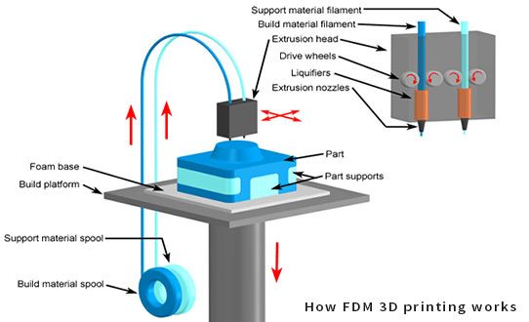

Properties of FDM
Materials | Thermoplastics (PLA, ABS, PETG, PC, PEI etc)
Dimensional accuracy | ± 0.5% (lower limit ± 0.5 mm) - desktop  ± 0.15% (lower limit ± 0.2 mm) - industrial
Typical build size | 200 x 200 x 200 mm - desktop  1000 x 1000 x 1000 mm - industrial
Common layer height | 50 to 400 microns
Support | Not always required (dissolvable available)

Benefits & Limitations of FDM
The key advantages and disadvantages of the technology are summarised below:
- FDM is the most cost-effective way of producing custom thermoplastic parts and prototypes.
- The lead times of FDM are short (as fast as next-day-delivery), due to the high availability of the technology.
- A wide range of thermoplastic materials is available, suitable for both prototyping and some non-commercial functional applications.
- FDM has the lowest dimensional accuracy and resolution compared to other 3D printing technologies, so it is not suitable for parts with intricate details.
- FDM parts are likely to have visible layer lines, so post processing is required for a smooth finish.
In this project, the FDM is considered because of its reduction in build time and manufacturing cost and production material wastage as compared to Stereo Lithography(SLA). The SLA uses ultraviolet light to particular cure liquid material. [13]

Techniques | SLA | FDM
Cost | expensive | Cheaper
Mechanism and use | complex | Simple
Quality | Better | Low quality
Material flexibility | Difficulty in changing filament | Easy to change filament

Design Variation
Cartesian 3D printers are the most common FDM 3D printer found on the market. Based on the Cartesian coordinate system in mathematics, this technology uses three-axis: X, Y, and Z to determine the correct positions and direction of the print head. With this type of printer, the printing bed usually moves only on the Z-axis, with the print head, working two-dimensionally on the X-Y plane.
The Delta printers on the other hand involves a round printing plate that is combined with an extruder that is fixed at three triangular points. Each of the three points then moves up and down, thereby determining the position and direction of the print head. However these printers are not as accurate as a conventional Cartesian printer.
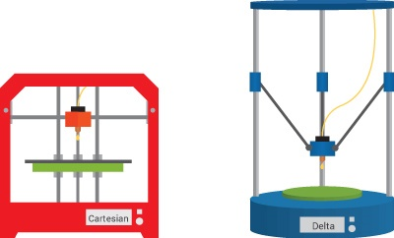

Factor | Cartesian | Delta
Finish | better surface finish. This is because Cartesian printers have more rigid axes, which allow less room for error when the print head moves within the 3D space. | Poor surface finish
Speed | Cartesian has slower speed | Delta printer are faster
Precision | Better precision | As the speed of the printer increases, its precision decreases.

CoreXY
A CoreXY printer will have a square Cartesian design. In that, the print bed moves only on the vertical Z axis, while the extruder moves on the horizontal X and Y axes. A long belt and pulley system is used in the CoreXY system which eliminates the excess torque that causes faster wearing in the belts and gantry. The extruder moves by employing two long timing belts, each of them connected to a stepper motor. Depending on which way each motor is spinning, the extruder will move in different directions. An interesting quirk of the CoreXY design is that the print head will only move diagonally when a single stepper motor is activated.

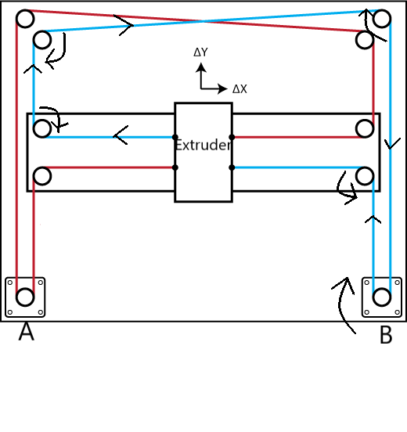
MOTOR B ONLY
The Extruder moves diagonally along the x and y axis from bottom right to the top left when motor B alone rotates a clockwise direction and moves diagonally along the x and y axis from top left to the bottom right when motor B alone rotates a anticlockwise direction
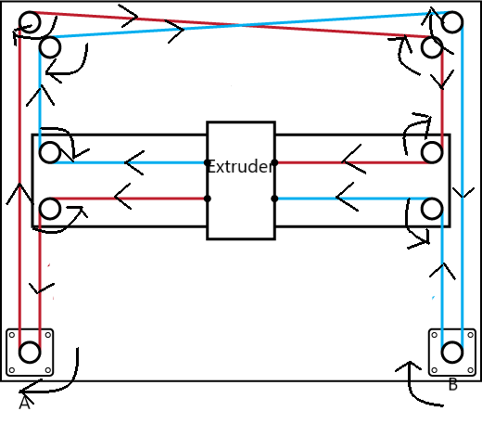

A + B
The extruder moves along the X axis from right to left when both motors A and B rotate in a clockwise direction and moves along the X axis from left to right when both motors A and B rotate in a anticlockwise direction

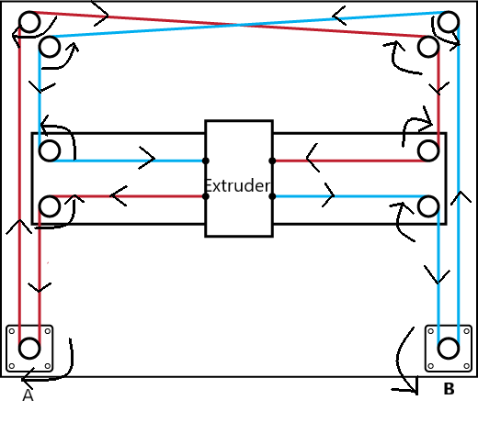 A – B
The extruder moves along the Y axis from top to bottom when motor A rotates in the clockwise direction and motor B rotates in the anti-clockwise direction. It moves along the Y axis from bottom to top when motor A rotates in the anti-clockwise direction and motor B rotates in the clockwise direction.
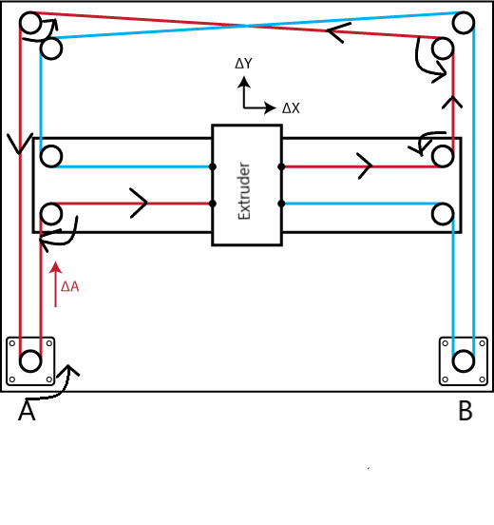

MOTOR A ONLY
The Extruder moves in a diagonal direction along the x and y axis from bottom left to the top right when motor A alone rotates in an anti-clockwise direction and moves in a diagonal direction along the x and y axis from top right to the bottom left when motor A alone rotates in clockwise direction.

Design Component
Filament (Polylactic acid)
- The PLA is biodegradable and bioactive thermoplastic aliphatic polyester derived from renewable resources, such as corn starch. The PLA is considered in this project because of its lower printing temperature than ABS. It has a print temperature of 180°C – 230°C. It doesn’t warp easily and therefore it doesn’t require a heating bed. Warping of a model is a result of uneven thermal contraction during printing. Most materials when heated expand and as they cool, they contract. Another benefit to using PLA is that it doesn’t give off an evil smell during printing. It’s generally considered an odourless filament.[14]
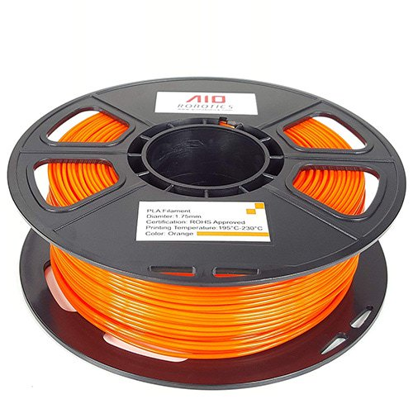

3D PRINTER FILAMENT PROPERTIES: PLA
- Strength: High | Flexibility: Low | Durability: Medium
- Difficulty to use: Low
- Print temperature: 180°C – 230°C
- Filament size 1.75 mm
- Shrinkage/warping: Minimal
- Soluble: No
- Food safety: Refer to manufacturer guidelines

MICROCONTROLLER
In simple terms a microcontroller is a small computer on a single integrated circuit containing a processor core, memory (RAM and ROM) and programmable input / output peripherals. A microcontroller can also be said to be a self-contained system with peripherals, memory and a processor that can be used as an embedded system. Microcontrollers are mostly for automatic control in various devices like engines, implantable medical devices and a host of other embedded systems. In the project being undertaken, the microcontroller is required to interface a number of peripherals, do the distance calculation and also calculate the cost accrued after every journey. The microcontroller chosen for the project must therefore:
- Have 54 pins.
- Have a memory more than 167kb
Based on these factors, a number of microcontrollers were considered.
Factors | Cost | Speed | Memory | Power consumption | Hardware Interfacing
Raspberry pi | Expensive | Very Fast | No internal memory | High | Hard
Arduino Mega | Cheap | Fast | Has Internal memory 256KB | Low | Easy 54 pins
Atmel ATmega168 | Cheap | Fast 20MHz | Has Internal memory 16KB | Low | Easy 32 pins

Based on the comparison in table 3.1, the Arduino Mega was found to be the most suitable for the project as it compares favourably against the rest in terms of programmability, cost, speed and memory size. Below is a detailed review of the Arduino Mega.

ARDUINO MEGA
Arduino Mega board is an open source hardware based on the ATmega2560 AVR microcontroller. The board has 54 digital input/ output pins, 16 analog inputs, 4 UARTs, 16 MHz crystal oscillator, a USB connection, a power jack, an ICSP header and a reset button [12]. The Arduino mega comes with 54 pins and can therefore integrate with the ramp, a special pcb board that requires 54 pins. The firmware used on the microcontroller has a size of 167kb and can therefore be stored on the flash memory which has a size of 256kb. The SRAM creates and manipulate variables when it runs and has a size of 8kb.
.

SUMMARY
Microcontroller | ATmega2560
Operating Voltage | 5V
Input Voltage (recommended) | 7 – 12V
Digital I/O Pins | 54 (of which provide PWM output)
Analog Input Pins | 16
DC Current per I/O Pin | 40mA
Flash Memory | 256KB of which 4KB used by bootloader
DC Current for 3.3 V Pin | 50mA
SRAM | 8KB
EEPROM | 4KB
Clock Speed | 16MHz

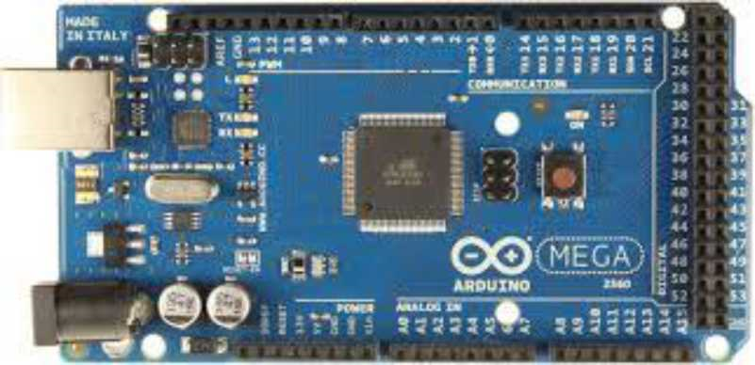

Stepper Driver
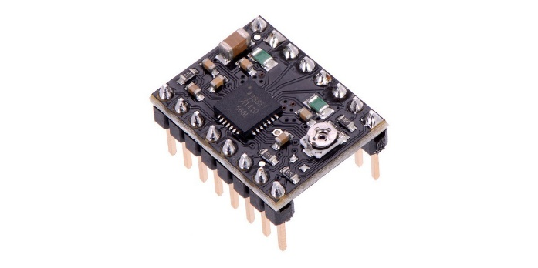
Stepper drivers are specifically designed to drive stepper motors, which are capable of continuous rotation with precise position control, even without a feedback system.
The stepper driver to be used should have adjustable current limiting, over-current and over-temperature protection, and five different micro step resolutions (down to 1/16 –step). It should operate from 8 V to 35 V and deliver up to approximately 1 A per phase without a heat sink or forced air flow (it is rated for 2 A per coil with sufficient additional cooling).

EXTRUDER
The extruder is one of the most important components on a 3D printer. It is responsible for sending the correct amount of filament to the hot end where it’s melted and extruded down in thin layers to make your part. We wanted an extruder that keeps its tension setting when the filament is released, and we wanted it to be easy to use and maintain while looking more finished. To do this, we chose a concept that closes around the drive gear and the tension mechanism so that the filament is found completely encapsulated in the extruder and protected from external elements. There should be low inertias in the axis of displacement of the hotend to allow very fast and high quality printing. Also, the extruder should have a high drag power of the filament to be able to move coils larger than normal, such as coils of PLA or 3.3Kg Smartfil ABS. Based on these requirements we decided to use the Bowden Extruder. A bowden extruder is not directly attached to the hot end. Instead, a tube extends from the extruder body to the hot end. This is called a bowden tube. It is most commonly a section of PTFE (Teflon ™ ) tubing. The filament is constrained by the tube and travels through it to the hot end. [16]

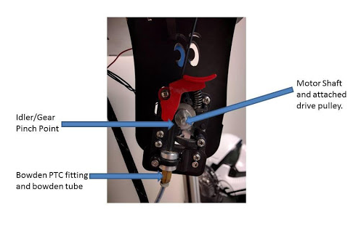

Inductive Proximity Sensor
Inductive proximity sensors are used to detect the presence of nearby objects without any physical contact.. The type of sensor considered in this project is the NPN inductive sensor which is directly connected on the RAMP. This sensor should have an operating distance of 4mm between the extruder and the printing bed. The NPN sensor detects magnetic objects which is essential in this project since the printing bed is made of such material. The NPN should be able to operate within a voltage of 6Vdc-36Vdc with a frequency of 50Hz. The table below summarizes the essential specification of the sensor:
External dimensions | M12x 60
Detection distance | 4mm
Setting distance | 0-3.2mm
Supply voltage | 6-36Vdc, 5Vdc, 90-250Vac, 36ac, 380Vac, 50/60Hz
Output current | DC type: 300mA max; AC Type 400mA
Standard detected Object | Mild steel (12x12x1mm)
Sensing object | Magnetic metals (if it is not magnetic metals, the sensing distance would decrease
Response frequency | 500Hz
Matched mounting bracket | M12 mounting bracket
matched mounting connector | Only for connector type: 3 wires bend connector, 3 wires straight connector
Output indication | Red LED
Short-circuit protection | No
Reverse connection protection | Yes
Insulation resistance | 50MΩ min (between charging part and housing)
Dielectric strength | 1000Vac, 1min (between charging part and housing)
Operating temperature | -25 to 70 °C (13 to 158 °F)
Cable length | 1.2m, PVC cable
Material | Case: Brass-nickel plated; Sensing surface: ABS

NTC thermistor
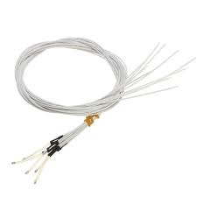
NTC stands for “Negative Temperature Coefficient”. NTC thermistors are resistors with a negative temperature coefficient, which means that the resistance decreases with increasing temperature. They are primarily used as resistive temperature sensors and current-limiting devices. The thermistor is used in the hot end and the firmware uses it to keep temperatures at the least. The thermistor used in this project has a resistance of 100kΩ which is conducive for high printing temperature of 270̊ C. It should also be of high resistance accuracy between 1% and 2%.

Comparison to other temperature sensors
Compared to RTDs, the NTCs have a smaller size, faster response, greater resistance to shock and vibration at a lower cost. They are slightly less precise than RTDs. When compared to thermocouples, the precision obtained from both is similar; however thermocouples can withstand very high temperatures (in the order of 600°C) and are used in such applications instead of NTC thermistors, where they are sometimes referred to as pyrometers. Even so, NTC thermistors provide greater sensitivity, stability and accuracy than thermocouples at lower temperatures and are used with less additional circuitry and therefore at a lower total cost. The cost is additionally lowered by the lack of need for signal conditioning circuits (amplifiers, level translators, etc.) that are often needed when dealing with RTDs and always needed for thermocouples
Specification of thermistor
Thermistor with heat resistant wiring
100k Ohm NTC 3950
Glass encapsulated for long term stability & reliability
Small Size: φ1.25mm x 2.0mm glass orb
B-value R25/50: 3950K
High Resistance Accuracy: 1%
Wide Temp. Range: −40°C to 270°C
Length: Approx. 1m/ 39.37"

Temperature Calculation
To determine the resistance of the thermistor $R_{1}$ given B(material constant) as 3950, ,nominal temperature $T_{0}as 25$◦C and nominal resistance $R_{0}$ as 100$K_{Ω}$, we use the equation below:
B=$\frac{T_{1}xT_{0}}{T_{1}-T_{0}}+ln⁡(\frac{R_{0}}{R_{1}})$
The resistance value obtained is used to compute the voltage $V_{0}$ sent to the microcontroller assuming it has a voltage source $V_{s}$ as 5V and series resistance R_{s}= 4.7K.
To measure the temperature, we need to measure the resistance. However, a microcontroller does not have a resistance-meter built in. Instead, it only has a voltage reader known as an analog-digital-converter. What we have to do is convert the resistance into a voltage, and we'll do that by adding another resistor and connecting them in series. Now you just measure the voltage in the middle, as the resistance changes, the voltage changes too, according to the simple voltage-divider equation. We just need to keep one resistor fixed
$$V_{o}=V_{cc}(\frac{R_{th}}{R_{th}+R_{s}})$$
$$ADC=\left(\frac{R_{th}}{R_{th}+R_{s}}\right)*1023$$
At the controller side, we compute the resistance based on the voltage obtained.

$$R_{th}=\frac{R_{s}}{\frac{V_{cc}}{V_{o}}-1}$$

$$R_{th}=\frac{R_{s}}{\frac{1023}{ADC}-1}$$
With the use of Steinhart-Hart equation

$$\frac{1}{T}=\frac{1}{T_{0}}+\frac{1}{B}ln⁡(\frac{R_{1}}{R_{0}})$$
$$\frac{1}{T}=\frac{1}{T_{0}}+\frac{1}{B}ln⁡(\frac{ADC}{1023-ADC})$$

Optical endstop limit switch
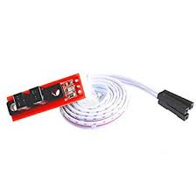
A limit switch is a switch operated by the motion of a machine part or presence of an object.it also consists of an actuator mechanically linked to a set of contacts. When an object comes into contact with the actuator, the device operates the contacts to make or break an electrical connection. The optical endstop which is considered in this project rely on a flag blocking a window between a light emitter and a detector. The exact trigger position (and thus precision) may depend on ambient light levels in the room, because the sensor is monitoring for light to decrease below a specific intensity. Switching tends to be more consistent and reliable if the flag enters the window from the side, rather than the top. [18]

Features
- Very precise in terms of accuracy and repeatability.
- Consume little electrical energy.
- Can switch loads with high inductance.
- Can control multiple loads.

Limitation
Generally restricted to equipment operating at relatively low speed.
Item specification
- Size:32mm x 10mm
- Cable Length:50cm

RAMPS 1.4
It is a two-board solution that consists of a separate Arduino Mega microcontroller board and a specially designed shield that plugs on top of the Arduino. The Arduino Mega provides the brains of the platform, while the shield provides the switching hardware for the heater and printbed, along with the option to interface with up to five Pololu stepper driver boards. Because of its shear capacity for possible future upgrades, RAMPS has become very popular and will most likely be the platform that paves the way for dual extruders on platforms outside of the MakerBot. This platform is in use by many RepRaps, the MakerGear Mosaic, and a distantly related version of the board is used by the Ultimaker. [19]
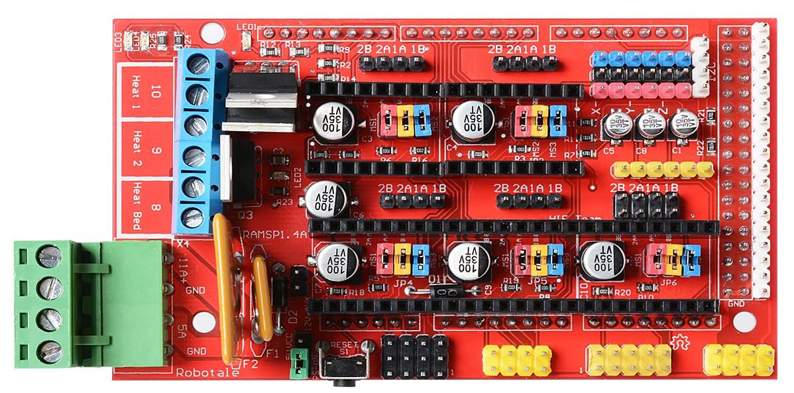

The RAMPS highlights include the following:

• Uses standard Arduino electronics, making the platform easier to use

• Additional power output for switchable cooling fans

• Future support for dual extruders built right in

• Mid-range cost, sometimes difficult to source

Mechanical Calculation
Based on Marlin Firmware, the standard acceleration is 3000mm/$s^{2}$, which is a good value for rigid setup and speed of 300mm/s.
Motion

$$Time to accelerate= \frac{speed}{acceleration}= \frac{300 mm/s}{3000 mm/s^{2}}= 0.1s$$

$$minimum distance= \frac{1}{2}*Accelaration*{Time}^{2}$$
$$= \frac{1}{2}*3000*{0.1}^{2}=15mm$$

Hotend
With a nozzle diameter of 0.4mm the maximum flow rate is about ${15mm}^{3}/s$
^{layer Height =} $\frac{flow}{line width*speed}=\frac{{15mm}^{3}/s}{0.5mm*300mm/s}=0.1mm$
0.1mm layer is a good setting for printing great quality prints.

Extruder
PLA has a filament size of 1.75mm
$$filament Speed=\frac{4*Flow}{π*{filament diameter}^{2} }$$

=$\frac{4*{15mm}^{3}/s}{π*{({1.75mm}^{2})}^{2}}=6.23mm/s$

Motors

Belt
For a 20 teeth GT2 2mm pitch pulley:
Pulley Radius=$\frac{teeth*pitch}{2*π}$

=$\frac{20*2mm}{2*π}$=6.36mm

Pulley turn=teeth*pitch=20*2mm=40mm

X Axis
A general NEMA17 stepper motor has a rotor inertia of about 6.8 kg.mm²
MaxRPM=$\frac{speed}{pulleyTurn}*60$

=$\frac{300mm/s}{40mm}*60=450RPM$

Moment of Inertia=Carriage Mass*${Pulley Radius}^{2}$+Rotor Inertia

= 0.35kg*${(6.36mm)}^{2}$+6.8kg.${mm}^{2}$=20.98kg.${mm}^{2}$

Angular Acceleration=$\frac{linear acceleration}{pulleyRadius}$
=$\frac{3000mm/s^{2}}{6.36mm}=471rads/s^{2}$

AccelerationTorque=Moment of inertia*angular acceleration=
20.98kg.${mm}^{2}$*471rads/$s^{2}$=9889kg.${mm}^{2}$/$s^{2}$=9.889mN.m

Y AXIS
The same calculation is done for the y axis since it we are using the corexy belt configuration.
Moment of Inertia=Carriage Mass*${Pulley Radius}^{2}$+Rotor Inertia

= 0.35kg*${(6.36mm)}^{2}$+6.8kg.${mm}^{2}$=20.98kg.${mm}^{2}$

Angular Acceleration=$\frac{linear acceleration}{pulleyRadius}$
=$\frac{3000mm/s^{2}}{6.36mm}=471rads/s^{2}$

AccelerationTorque=Moment of inertia*angular acceleration=
20.98kg.${mm}^{2}$*471rads/$s^{2}$=9889kg.${mm}^{2}$/$s^{2}$=9.889mN.m

Ball Screw

Load torque=$\frac{pitch*friction*mass*gravity}{2*π}$

=$\frac{4mm*0.10*1.015kg*9807m/s^{2}}{2*π}=633kg.{mm}^{2}/s^{2}=0.633mN.m$

Angular Acceleration=$\frac{linear Acceleration}{pitch}=750revs/s^{2}=4712rads/s^{2}$

Moment of inertia = Carriage Inertia + screw Inertia +Rotor Inertia

Carriage Inertia=Mass*${(\frac{Pitch}{2*π})}^{2}=1.015kg*{\left(\frac{4mm}{2*π}\right)}^{2}=0.41kg.{mm}^{2}$

Screw Inertia=$\frac{Mass*{Radius}^{2}}{2}=\frac{π*{Radius}^{2}*length*denity*{Radius}^{2}}{2}$
=$\frac{π*length*density*{radius}^{4}}{2}=\frac{π*350mm*0.00785g/{mm}^{3}*6{mm}^{4}}{2}=5.59kg.{mm}^{2}$
Moment of inertia=0.41kg.${mm}^{2}$+5.59kg.${mm}^{2}$+6.8kg.${mm}^{2}$=12.8kg.${mm}^{2}$

Acceleration Torque=12.8kg.${mm}^{2}$*4712rads/$s^{2}$=60319kg.${mm}^{2}$/$s^{2}$=60.319mN.m
Therefore two motor in the z axis will be needed overcome this torque.

MOTORS
The two types of motors considered here are stepper and servo motors. Steppers are an Open Loop system. A stepper motor has more poles than a servo, typically between 50 and 100. A single step pulse is the movement from one pole to the next. With the absence of an encoder in a stepper system there is no way to know and correct off positions when steps are missed. Servos are closed-loop systems, meaning they use an encoder, or resolver, to provide feedback. The servo then adjusts the current to control the motor position. A servo motor will typically have between 4 and 12 poles.
Stepper motors are limited to around 2000rpm, and about 1HP. A servo is able to achieve speeds many times that, and control much larger motors. Since the Stepper motor has more poles, at higher speeds the stepper's torque will be degraded. Whereas servos are not only able to maintain their torque at high speeds but even have a power reserve to accommodate short bursts, such as a rapid acceleration. Conversely, at lower speeds, the stepper will have a torque advantage over the same size servo and is able to provide a holding torque, without the motor being powered.
Stepper systems are a fairly simple way to integrate motion control. The hardware requirements are relatively low cost, and they are easy to setup and maintain. A servo has a much higher hardware cost. A typically forgotten cost is the additional time required to properly setup, configure, and then tune for optimal performance.
We selected the type of motor to use for our project based on its cost and holding torque generated. Since stepper motors are less expensive and optimal for applications that require low-to-medium acceleration and high holding, we chose that over the servo motor. The price of the stepper motor should be between $6 to $10. We want a stepper motor that makes about 180 to 210 steps per revolution so it should have a step angle within the range 1.7ﹾ to 2ﹾ. Four stepper motors would be used. Two to control the horizontal movement of the extruder in the X and Y axis and the remaining two to control the vertical movement of the print bed in the Z axis.
Based on the mechanical calculations shown above we decided to use stepper motor with the following parameters in the table below:

SUMMARY OF STEPPER MOTOR
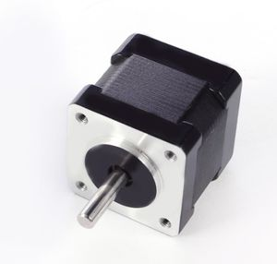
Parameter | Specification
Size | NEMA 17 (42mm*42mm*42mm)
Step Angle (degrees) | 1.8
Current/Phase | 1.7A
Holding Torque | 4kg.cm
Step Angle Accuracy | ± 5%
Voltage | 2.55
Insulation Resistance | 100 MΩMin. , 500VDC

Firmware
The firmware on a 3D printer is the programming within the control board on the printer. The primary function of the firmware is to interpret the G-code commands and control the movement of the stepper motors based on these commands. The G-code is a list of movement commands, created by a slicer program based on the CAD model that the printer needs to perform to create the final part. These commands are uploaded from a computer to the control board, where the firmware reads the code and sends signals to the stepper motor drivers, which then properly move the print head to create the final part. Firmware needs to be configured specifically for each 3D printer to operate properly. There are many types of firmware available for use in a 3D printer. Table 2.2 outlines some popular types of firmware used in 3D printers. We selected the Marlin firmware given its popularity and extensive support. Sprinter and Sailfish are also popular firmware choices. Teacup is an easy-to-use firmware designed for beginners. Each firmware has different features available and is compatible with a selection of control boards. The firmware for the printer should be selected based on the required features, compatibility with the selected control board, and the amount of support available.

Firmware Name | Features | Compatible Controllers
Marlin | CoreXY support,interrupt-based temperature protection and movement, full endstop support, SD card support, LCD support, Arc support, temperature oversampling, Dynamic Temperature setpointing (AutoTemp), heat power reporting | RAMPS  RAMBo  RUMBA  Sanguinololu  Ultimaker’s v 1.0-1.5  Gen 6 and Gen 7  Duemilanove 328P  Melzi  Azteeg X1, X3  Megatronics
Sprinter | SD card reader, stepper extruder, extruder speed control, movement speed control, constant or exponential acceleration, heated build platform | RAMPS  Sanguinololu  Teensylu  Ultimaker’s v 1.0-1.5  Gen 6
Teacup | Moves steppers smoothly, start-stop ramping, lookahead, printing from SD card, unlimited number of heaters, devices, and temperature sensors | 8-, 32-, and 64-bit controllers  Most ATmega boards  Teensy3, HBox, and NXP LPC1114 based controllers

COST OF DEVELOPMENT
This section of the report evaluates the estimated cost of the proposed design based on the components selected in the previous sections. A table of selected components and their prices is summarized below

Description | Quantity | Price($) | Total($)
420mm 3030 Black Al profiles | 4 | 2.2 | 8.8
410mm 3030 Black Al profiles | 6 | 2.1 | 12.6
500mm 3030 Black Al profiles | 4 | 2.5 | 10
415mm 2020 Black Al profiles | 2 | 1.2 | 2.4
235mm 2020 Black Al profiles | 2 | 1 | 2
Dia 8mm linear rods 450mm | 2 | 2.1 | 4.2
Dia 10mm linear rods 410mm | 2 | 2.3 | 4.6
Dia 12mm linear rods 400mm | 4 | 2.5 | 10
LM8UU linear bearings | 4 | 0.9 | 3.6
LM10UU linear bearings | 4 | 1 | 4
LM10LUU linear bearings | 2 | 1.5 | 3
LM12UU linear bearings | 8 | 1 | 8
L type bracket for 3030 extrusion | 30 | 0.4 | 12
L type bracket for 2020 extrusion | 20 | 0.3 | 6
Black 3030 corner brackets | 20 | 0.3 | 6
100 pcs Black M5*10 Button Head Socket Bolts | 1 | 3 | 3
Black M6*10 Button Head Socket Bolts with 30-M6 Hummer nuts | 20 | 0.05 | 1
Black M3 Socket head screws | 1 | 5 | 5
100pcs M5 T Hammer Nuts for 3030 extrusion | 1 | 5 | 5
100pcs M5 T Hammer Nuts for 2020 extrusion | 1 | 4.5 | 4.5
3mm dowel pins | 10 | 0.2 | 2
100pcs M3 5x5 Brass knurled insert | 1 | 5 | 5
10cps 3030 end Caps | 1 | 2 | 2
D50 8*50 Levelling feet | 4 | 1 | 4
Nema17 350mm Tr8*8 leadscrew linaer steppper with Anti-backlash nuts | 2 | 30 | 60
NEMA 17 40mm Stepper Motors | 3 | 6.5 | 19.5
GT2 Timing Pulley (20 teeth) 5mm bore for 6mm belt | 2 | 1.75 | 3.5
GT2 Idler Pulley (20 teeth) 3mm bore | 6 | 2 | 12
GT2 Idler Pulley without teeth (20 teeth) 3mm bore | 2 | 2 | 4
5m Polyurethane GT2 6mm belt | 1 | 6 | 6
MK2A Heated Bed 300x300*3mm with Glass 300*300*3mm | 1 | 35 | 35
6pcs Levelling screws | 1 | 2 | 2
Insulation Pad 300*300*0.5mm | 1 | 5 | 5
100kohm NTC3950 thermistor | 1 | 0.8 | 0.8
24V 500W power supply | 1 | 24 | 24
RAMPS 1.4 with stepper drivers and display | 1 | 20 | 20
RAMPS 1.4 fan extender module | 1 | 6.5 | 6.5
DC-DC 24V-12V step down module | 1 | 1.5 | 1.5
Arduino MEGA 2560 | 1 | 7 | 7
Power expansion module | 1 | 1 | 1
5V NPN M12 inductive sensor | 1 | 3 | 3
Optical end stops | 4 | 1.6 | 6.4
AC rocker switch power inlet socket w/ fuse | 1 | 1 | 1
5m x 24AWG 4 core UL2464 cable | 1 | 6.6 | 6.6
5m x 24AWG 2 core UL2464 cable | 1 | 4 | 4
2m x 14AWG Silicone cable | 1 | 3 | 3
5m x 24AWG 3core UL2464 cable | 1 | 5 | 5
Titain Extruder with motor+E3D V6 hotend with nozzels | 1 | 30 | 30
8pcs Metric Wrenches | 1 | 2 | 2
110V/220V 40W Welding Kits | 1 | 10 | 10
10pcs Black and 10pcs Red Y Type Termimals | 1 | 2 | 2
Total : $409.5

CHAPTER FOUR

PROPOSED DESIGN AND SIMULATION

INTRODUCTION
In this chapter of the report, the details of the proposed design is captured and its mode of operation explained. The key design features are also pointed out. The chapter ends with an explanation of the methods employed in the simulation of the virtual working device.

MAJOR COMPONENTS OF DEVICE
The device to be built will employ the following components:
- An LCD screen to interface with the microcontroller to control various settings for printing and display the various parameters such as speed, temperature and position.
- A microcontroller to interpret the gcode and control the motors and extruder
- Stepper motors to move the extruder and print bed
- An extruder for ejecting materials in liquid or semi-liquid form in order to deposit it in successive layers within the 3D printing volume.

CONNECTIONS
The RAMPS 1.4 shield is stacked on top of the Arduino mega 2560 board. Next, the Pololu steppers is stacked on top of the RAMPS 1.4 shield. The LCD start adapter will also sit on the top of the RAMPS 1.4. Power comes in on two tracks into the Ramps 1.4 shield. One track is 12V 5A which powers the board and motors, the second track is 12V 11A which powers the heated elements like the extruder and heated bed. Connect the wires as shown in the image (figure). Connect the stepper motors also on the RAMPS 1.4. The RAMPS 1.4 has 6 end stop connections (X -, X +, Y -, Y +, Z- and Z+) where the end stops are connected. Connect the extruder motor to the connector labelled E0.
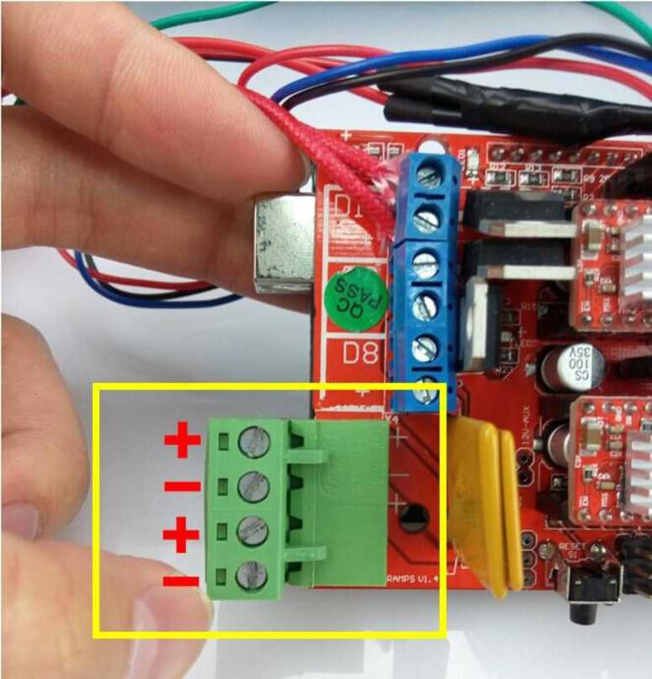

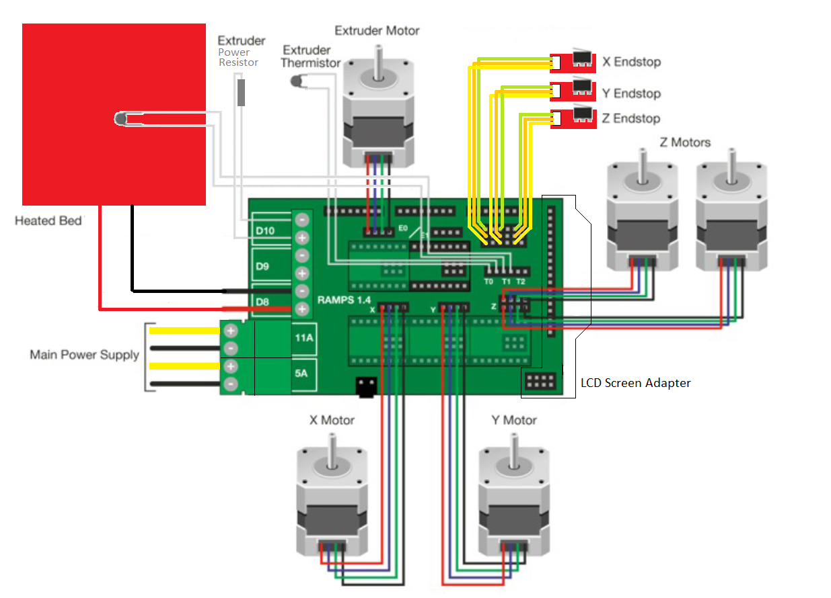

MODE OF OPERATION
There are 3 main steps in 3D printing. The first step is the preparation just before printing, when you design a 3D file of the object you want to print. This 3D file can be created using CAD software, with a 3D scanner or by using a photogrammetry software. Once you have checked that your 3D file is ready to be printed, you can proceed to the second step.
The second step is the actual printing process. First, you need to choose which material will best achieve the specific properties required for your object. The variety of materials used in 3D printing is very broad. It includes plastics, ceramics, resins, metals, sand, textiles, biomaterials, glass, food and even lunar dust! Most of these materials also allow for plenty of finishing options that enable you to achieve the precise design result you had in mind, and some others, like glass for example, are still being developed as 3D printing material and are not easily accessible yet.
The third step is the finishing process. This step requires specific skills and materials. When the object is first printed, often it cannot be directly used or delivered until it has been sanded, lacquered or painted to complete it as intended.
The material chosen for the project will determine which printing methods are most suitable. Among these, the most commonly used techniques for each group of materials are described next.

Here is a summary of the operations in a 3d printer:
Generating CAD models with STL extensions. Slicing the 3D model into layers. The objects are built by laying out material layer by layer. Generating the G- code (a series of commands that drive the printer) and interpreting the commands via the firmware. The firmware and G-code are then uploaded to the microcontroller. The microcontroller sends the appropriate pulses to the drivers to control speed and direction of axes motors. Feedback signals from thermistor are used to control heat generated by the hot end.

4.5 SIMULATION
In order to test the design before building, a simulation of the design must be run. There are a number of software used for electrical/electronic schematics. Among the choices were LabCenter Proteus, Fritzin, EAGLE , LTSpice etc.
LabCenter Proteus is the most suitable for the simulation of the project due to the following reasons:
- Very flexible
- Near real time simulation
- Debugging

The schematic of the project can be seen below
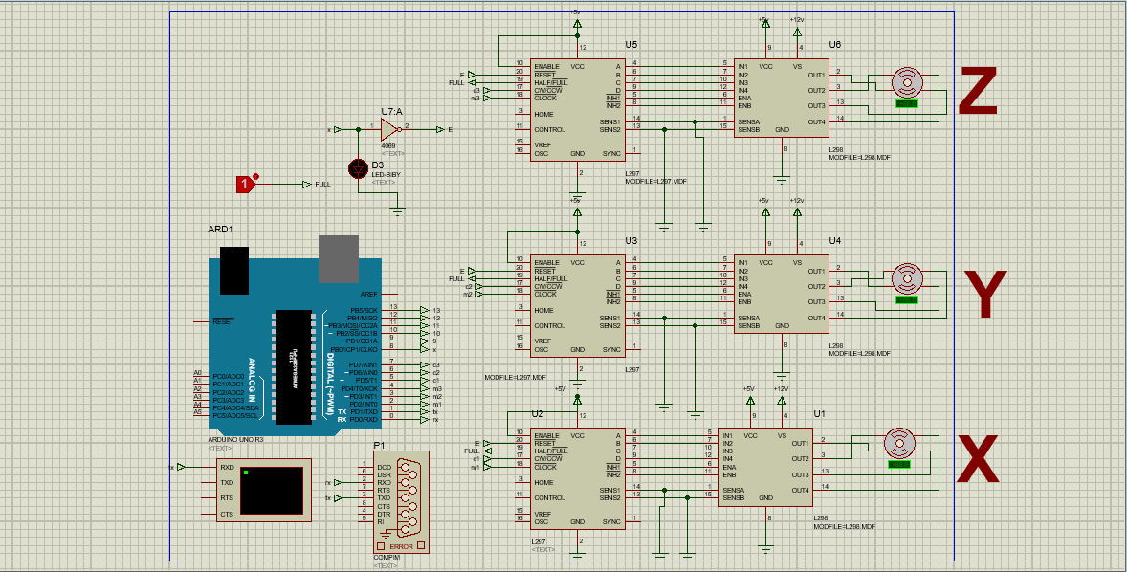

REFERENCES
- 3D Printing Industry. 2018. The Free Beginner's Guide - 3D Printing Industry. [ONLINE] Available at: https://3dprintingindustry.com/3d-printing-basics-free-beginners-guide#02-history. [Accessed 10 October 2018].
- Aniwaa. 2018. 3D scanning technologies - what is 3D scanning and how does it work?. [ONLINE] Available at: https://www.aniwaa.com/3d-scanning-technologies-and-the-3d-scanning-process/. [Accessed 18 October 2018].
- Ricardo Celi, Ana Sempértegui, Derlin Morocho, David Loza, Darwin Alulema & Mariela Proaño, “Study, Design and Construction of a 3D printer implemented through a Delta Robot”, 2015 CHILEAN Conference on Electrical, Electronics Engineering, Information and Communication Technologies (CHILECON), 2015.
- Tolia, Apurva, et al. “Design and Development of a Low Cost 3d Printer.” Slide Share, May 2016, www.slideshare.net/ApurvaTolia1/report-on-design-and-development-of-low-cost-3d-printer.
- Santiago Blandon, Juan Camilo Amaya and Alvaro Jose Rojas, “Development of a 3D Printer and a Supervision System Towards the Improvement of Physical Properties and Surface Finish of the Printed Parts”,2015 IEEE 2nd Colombian Conference on Automatic Control (CCAC), 2015.
- Range Kayfi, Dana Ragab and Tarek A. Tutunji, “Mechatronic System Design Project: A 3D Printer Case Study”, 2015 IEEE Jordan Conference on Applied Electrical Engineering and Computing Technologies (AEECT), 2015.
- George Issakids, Antonis Spiropoulos, Maria Drakaki,” An Educational Purpose Built Three Dimentional Printer”, 2017 6th International Conference on Modern Circuits and Systems Technologies(MOCAST), 2017
- Norsyafikah Kamarauzaman, Nazirah Md Tarmizi, Muhd Safarudin Chek Mat, Abd. Manan Samad, “3D printing using digital photogrammetric data”, 2015 IEEE 11th International Colloquium on Signal Processing & Its Applications (CSPA), 2015
- Jendritz, Stephen. Design, Fabrication, and Testing of a 3D Image Reconstruction Process. Prof. John M. Sullivan, Project Advisor, web.wpi.edu/Pubs/E-project/Available/E-project-042618-141456/unrestricted/3D_Image_Reconstruction_Final_Report.pdf.
- Jack Leifer, “A CLOSE-RANGE PHOTOGRAMMETRY LABORATORY ACTIVITY FOR MECHANICAL ENGINEERING UNDERGRADUATES”, 33'd ASEE/IEEE Frontiers in Education Conference, vol. 4, 2003.
- Lana Madracevic and Sogoric, “3D Modeling From 2D Images”, The 33rd international Convention MIPRO, May 24-28, 2010.
- Shashi, Mesapam, and Kamal Jain. Use of Photogrammetry in 3d Modelling and Visualisation of Buildings. Asian Research Publishing Network, Apr. 2007, citeseerx.ist.psu.edu/viewdoc/download?doi=10.1.1.114.849&rep=rep1&type=pdf.
- Brockotter, Robin. “Key Design Considerations of 3D Printing.” 3D Hubs, www.3dhubs.com/knowledge-base/key-design-considerations-3d-printing.
- Rohringer, Sean. “3D Printer Filament Guide.” ALL3DP, HTTPS://ALL3DP.COM/1/3D-PRINTER-FILAMENT-TYPES-3D-PRINTING-3D-FILAMENT/.
- Wikipedia, en.wikipedia.org/wiki/Stepper_motor.
- Landry, Taylor. “A Crash Course on an Essential Component of Your 3d Printer.” MatterHackers, www.matterhackers.com/articles/extruders-101:-a-crash-course-on-an-essential-component-of-your-3d-printer16) https://www.matterhackers.com/articles/extruders-101:-a-crash-course-on-an-essential-component-of-your-3d-printer.
- “ How to Build an NPN Inductive Proximity Sensor Circuit.” Learning About Electronics, www.learningaboutelectronics.com/Articles/NPN-inductive-proximity-sensor-circuit.php.
- “Which Endstops Are Most Precise.” Stack Exchange, 3dprinting.stackexchange.com/questions/1109/which-endstops-are-most-precise.
- “RAMPS 1.4.” RepRap, reprap.org/wiki/RAMPS_1.4.

