[](https://camo.githubusercontent.com/a3e5598db134838eeb384428095e1deea8e1fe98ff27034d58cdccb9a7bdeaad/68747470733a2f2f692e696d6775722e636f6d2f4c78666b3949452e706e67)

**Description**

Spring Application With Prometheus and Grafana

**Docker**

**Network creation**

docker network create my-network

**Docker build**

docker build --tag my-spring-app .

**Docker run**

docker run --name my-spring-app -p "8080:8080" my-spring-app

**Docker creation**

# For Prometheus and Grafana

# docker-development-environment folder

docker-compose up -d

or

docker-compose -f <docker-filename> up -d

**Manual QA / Validation**

Endpoint: <http://localhost:8080/>

**Prometheus**

Prometheus: <http://localhost:9090/>

Main endpoint: <http://localhost:8080/actuator>

[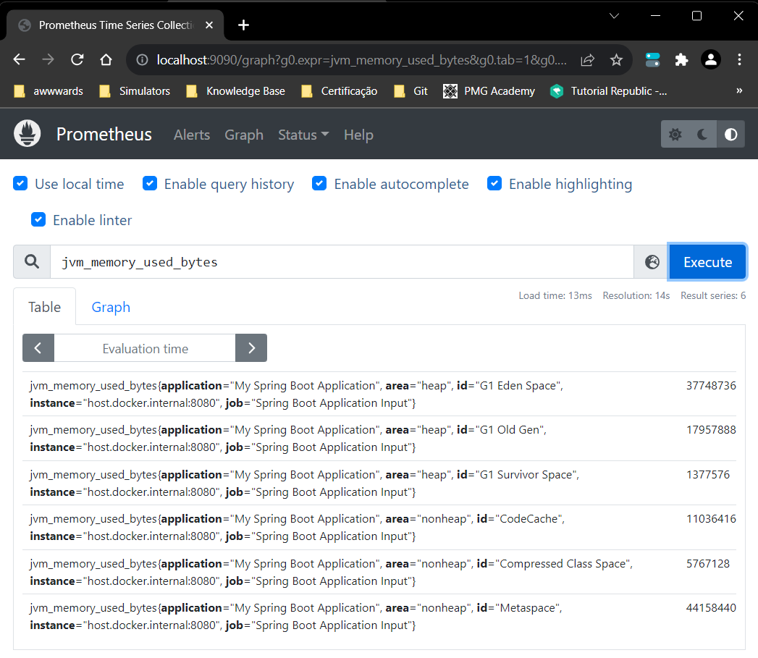](https://camo.githubusercontent.com/3679c53bb0a042a81c8628116e238c8a2a91ff6e8121553794366c0dd6f7a1f2/68747470733a2f2f692e696d6775722e636f6d2f6b544852426d342e706e67)

[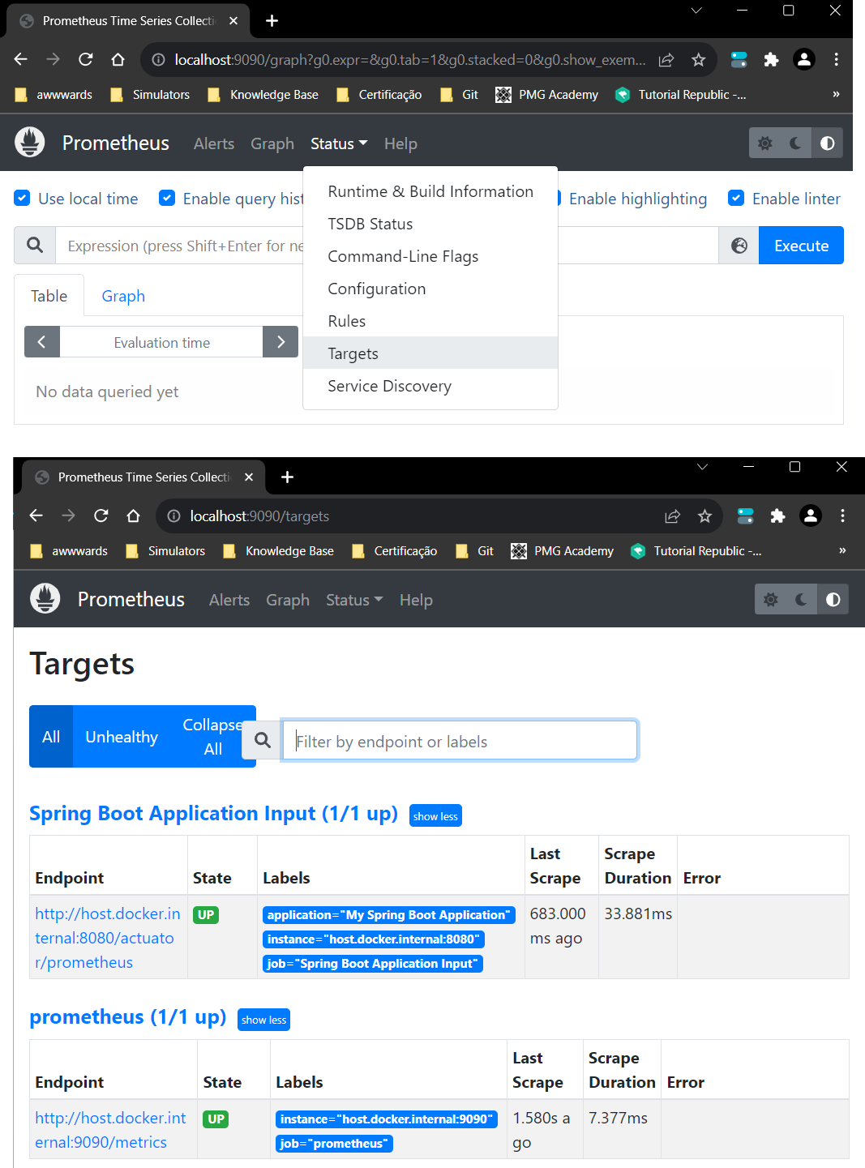](https://camo.githubusercontent.com/a6bc5ecc25064ce445e974f80f4cedcdd39cd7c6bd55aec516a3e03356b439ae/68747470733a2f2f692e696d6775722e636f6d2f57776a367a666d2e706e672077696474683d)

**Grafana**

Grafana: <http://localhost:3000/>

username: grafana

password: grafana

**Create Dashboard**

* Add Visualization
* Add Prometheus Data Source
* Add Prometheus Server URL: [http://host.docker.internal:9090](http://host.docker.internal:9090/)
* Save and Test (**Explore view** link)

**Access application endpoint to produce Grafana data view**

P.S.: You also can import "Spring Boot Statistics Dashboard.json" dashboard.

[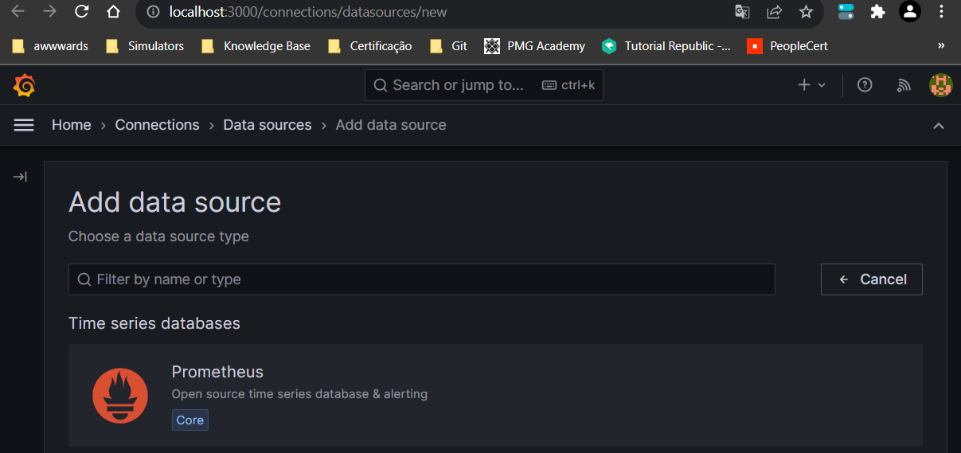](https://camo.githubusercontent.com/b8b0af84453dae91ee26d75bdbd5ec024aa4b6937ccadb7d17012afa48294ffa/68747470733a2f2f692e696d6775722e636f6d2f3649746d4f6e522e706e67)

[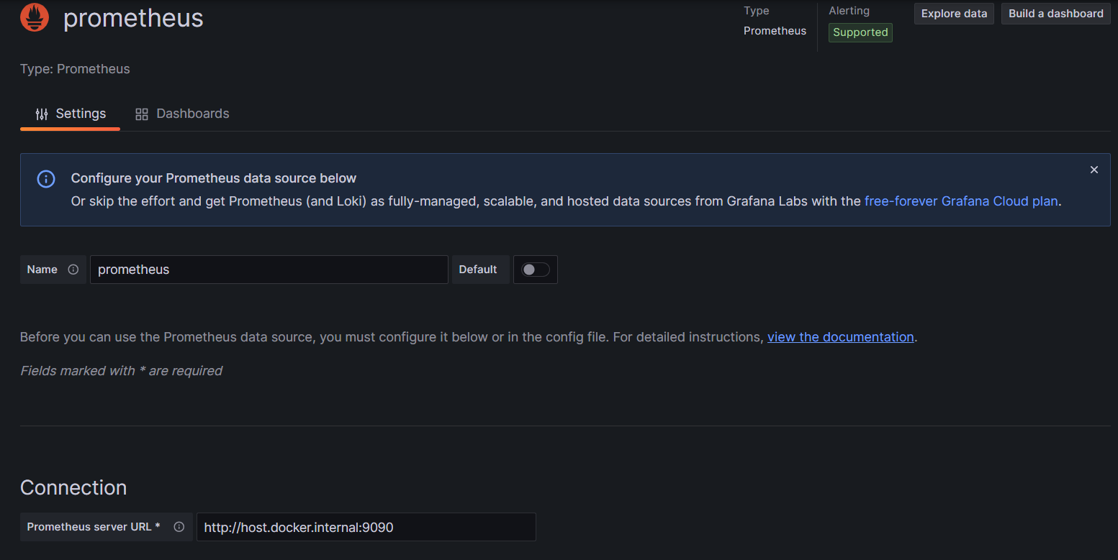](https://camo.githubusercontent.com/e7ac0b72517dd309d861606c5347ed4975c9edbb0da4cb2f108510677d462472/68747470733a2f2f692e696d6775722e636f6d2f7533565a564a412e706e67)

[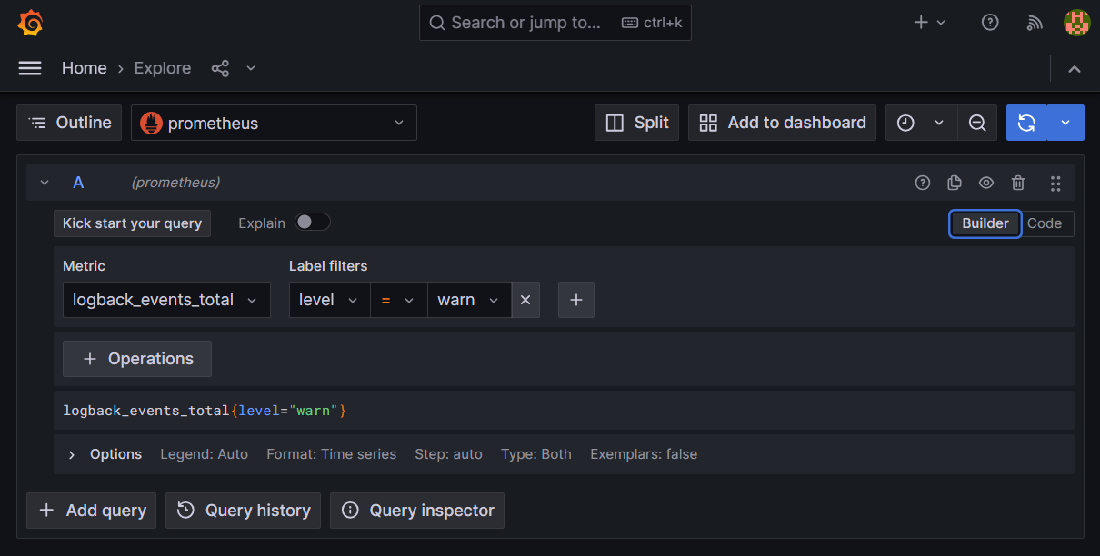](https://camo.githubusercontent.com/0fe90bdd495a39241f2ba5567398e4e6a6d9f27554e43af94137b7c44d9d3819/68747470733a2f2f692e696d6775722e636f6d2f6c316a484248642e706e67)

[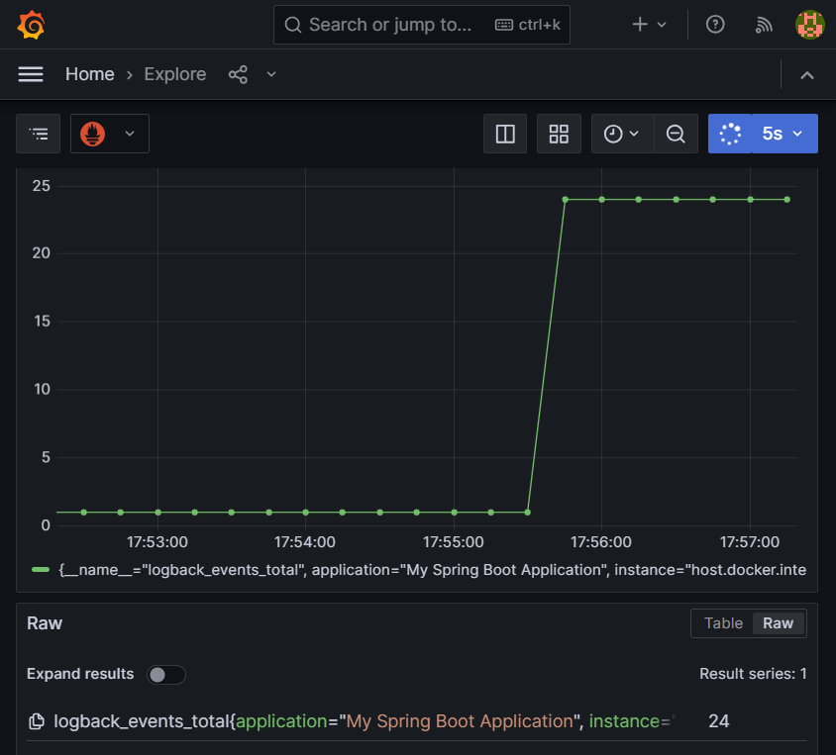](https://camo.githubusercontent.com/9ff1d4ee0e99d3a67ab782a5a570c941c0aa10c9c7d03112635c1225210133bf/68747470733a2f2f692e696d6775722e636f6d2f76437976737a7a2e706e67)

[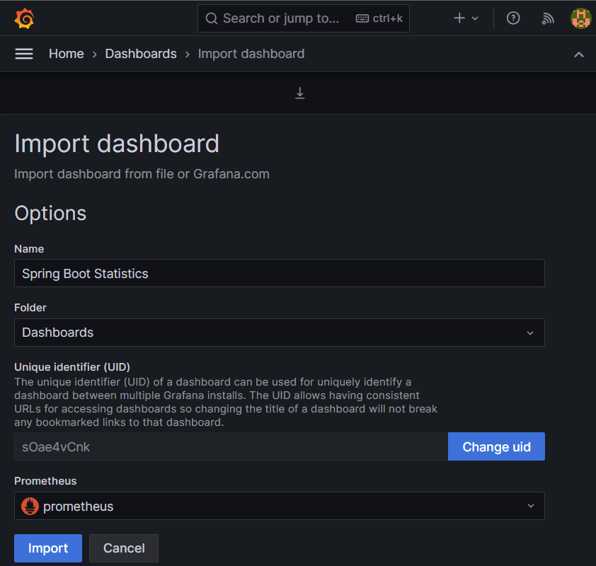](https://camo.githubusercontent.com/30c32b1308d2deefbc66ac53597cc0b2dbc0c3d65f5634e7d23567ff13b60541/68747470733a2f2f692e696d6775722e636f6d2f584163694648322e706e67)

[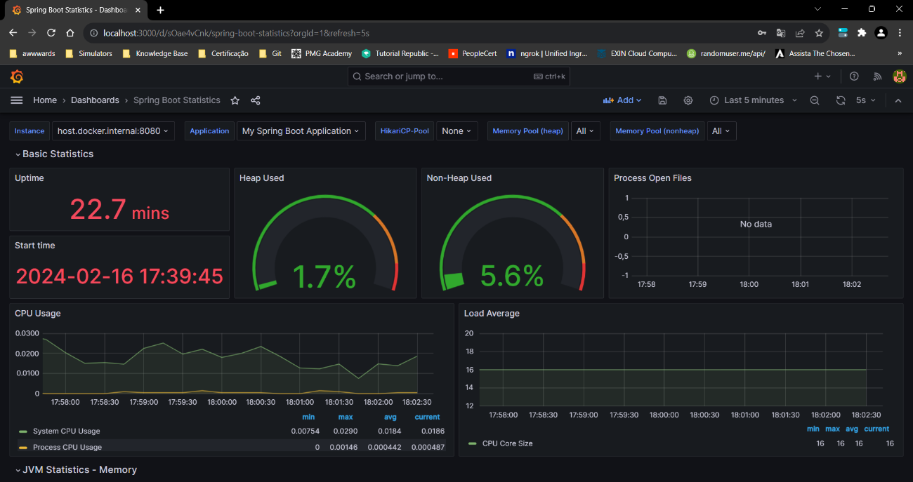](https://camo.githubusercontent.com/7d8aa3adf02508ab3255bddceaf56ee71d9308f759c6dd08822d6cb9f174a500/68747470733a2f2f692e696d6775722e636f6d2f457846546c67782e706e67)