[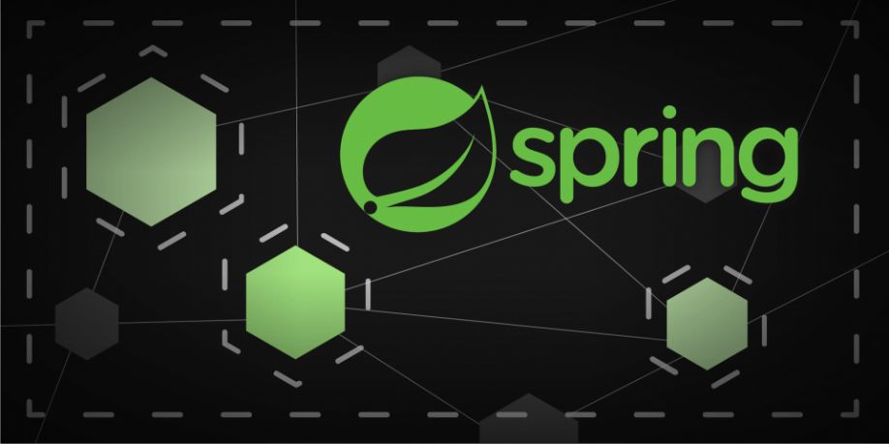](https://camo.githubusercontent.com/a3e5598db134838eeb384428095e1deea8e1fe98ff27034d58cdccb9a7bdeaad/68747470733a2f2f692e696d6775722e636f6d2f4c78666b3949452e706e67)

**Description**

Spring Microservice - Config Server + Discovery Server + API Gateway + Schools & Students API's + Zipkin

**Docker**

**Network**

# Containers Docker Network Creation

docker network create my-network

**Containers**

docker-compose up -d

or

docker-compose -f <docker-filename> up -d

**- PostgreSQL**

# PGAdmin (Local)

Use host.docker.internal or postgres instead of localhost

**Zipkin**

Zipkin: <http://localhost:9411/>

**API Gateway**

Now we can access API's via API Gateway url:

api-service-endpoint:

[http://localhost:8222/{api-service-endpoint}](http://localhost:8222/%7Bapi-service-endpoint%7D)

**Schools**: /api/v1/schools

**Students**: /api/v1/students

**Endpoints**

# - schools

POST -> http://localhost:8222/api/v1/schools

{

"name":"My's School",

"email":"{{$randomEmail}}"

}

GET -> http://localhost:8222/api/v1/schools/with-students/{id}

# - students

POST -> http://localhost:8222/api/v1/students

{

"firstname":"{{$randomFirstName}}",

"lastname":"{{$randomLastName}}",

"email":"{{$randomEmail}}",

"schoolId": 1

}