[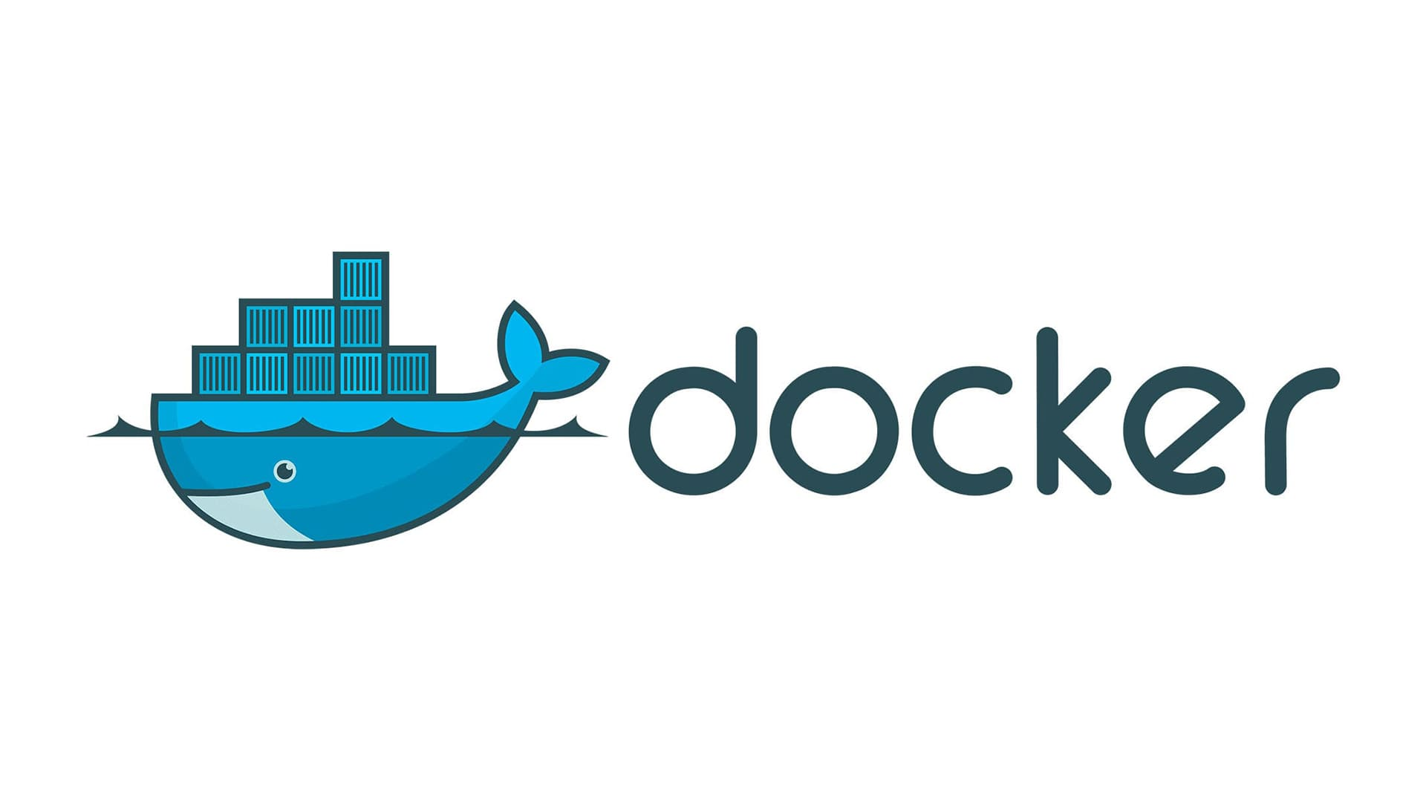](https://camo.githubusercontent.com/f08bbb9a32216a34a155a543286525b9cdba85bebc1cb5b9348f23809e2b7903/68747470733a2f2f692e696d6775722e636f6d2f7a365352784b762e6a7067)

**About containers**

**Users and passwords**

*Passwords that are not in the docker-compose.yml file will be in the .env files within the same directory.*

**Docker**

**Network creation**

docker network create my-network

**Docker creation**

docker-compose up -d

**- RabbitMQ**

# Login / Authentication

User: rabbitmq

Password: rabbitmq