[](https://camo.githubusercontent.com/a3e5598db134838eeb384428095e1deea8e1fe98ff27034d58cdccb9a7bdeaad/68747470733a2f2f692e696d6775722e636f6d2f4c78666b3949452e706e67)

**Description**

Spring Security AWS Cognito Authentcation Example

**Application properties**

[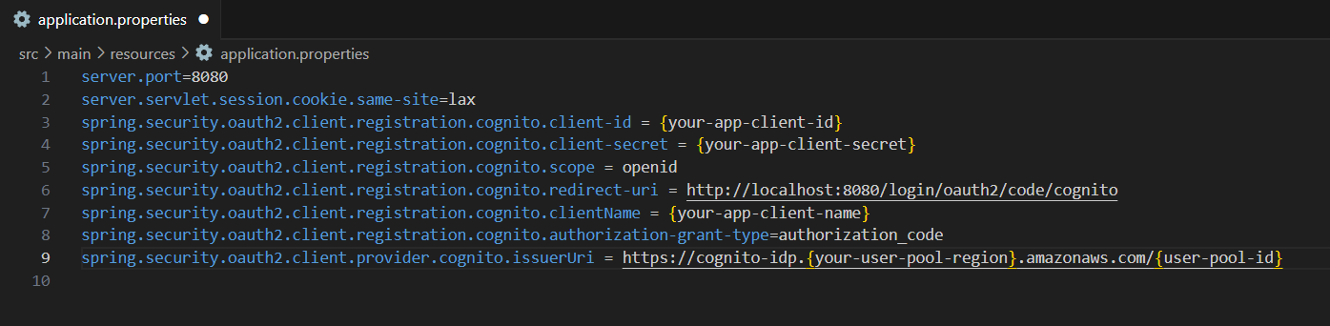](https://camo.githubusercontent.com/4cdcc5d6996148bc47ee62fc33303ba1b0e81b00cff4593cef67e6ae80ba30d6/68747470733a2f2f692e696d6775722e636f6d2f596a38567551442e706e67)

server.port=8080

server.servlet.session.cookie.same-site=lax

spring.security.oauth2.client.registration.cognito.client-id={your-app-client-id}

spring.security.oauth2.client.registration.cognito.client-secret={your-app-client-secret}

spring.security.oauth2.client.registration.cognito.scope=openid

spring.security.oauth2.client.registration.cognito.redirect-uri=http://localhost:8080/login/oauth2/code/cognito

spring.security.oauth2.client.registration.cognito.clientName={your-app-client-name}

spring.security.oauth2.client.registration.cognito.authorization-grant-type=authorization_code

spring.security.oauth2.client.provider.cognito.issuerUri=https://cognito-idp.{your-user-pool-region}.amazonaws.com/{user-pool-id}

**Create user pool**

[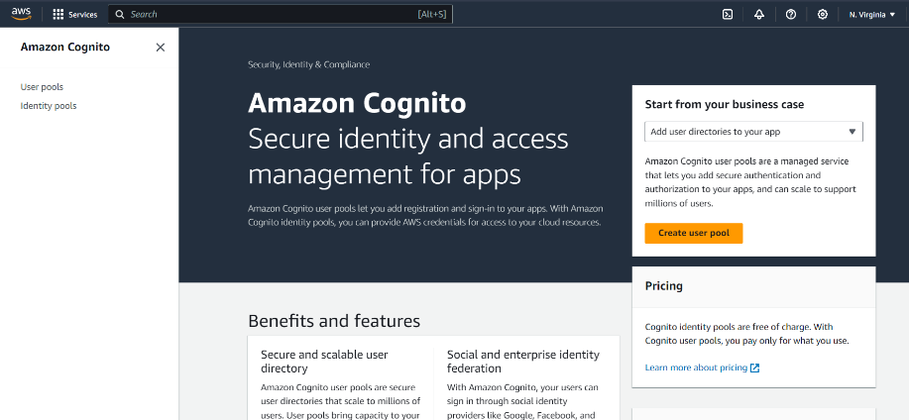](https://camo.githubusercontent.com/32da2f716dd5c7cbc88a5012d15215e29be69728b71ee255cc2afd84822e87ee/68747470733a2f2f692e696d6775722e636f6d2f6972516b5674662e706e67)

**Configure sign-in experience**

[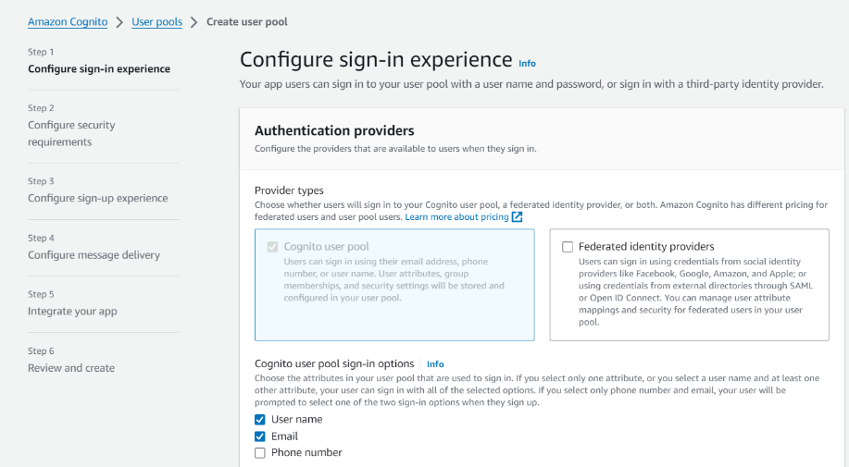](https://camo.githubusercontent.com/4b08e928fdae69c960e8e870bf152e5f2c71e29b892d22662e0fe1c62a140881/68747470733a2f2f692e696d6775722e636f6d2f5765527136726f2e706e67)

[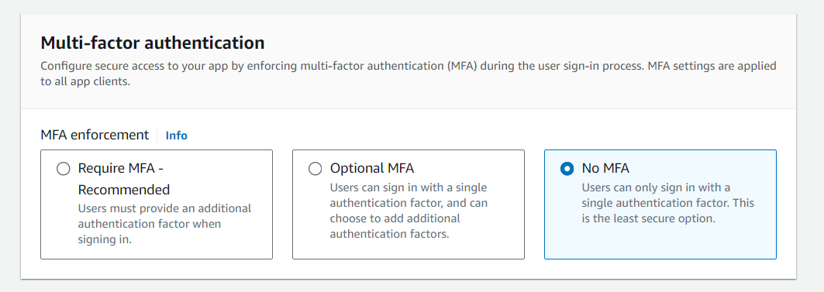](https://camo.githubusercontent.com/dd312b15072d590c275a905ff771a0fbab251cec4e8c98c605f4c8f0aed18793/68747470733a2f2f692e696d6775722e636f6d2f726f6b374757692e706e67)

[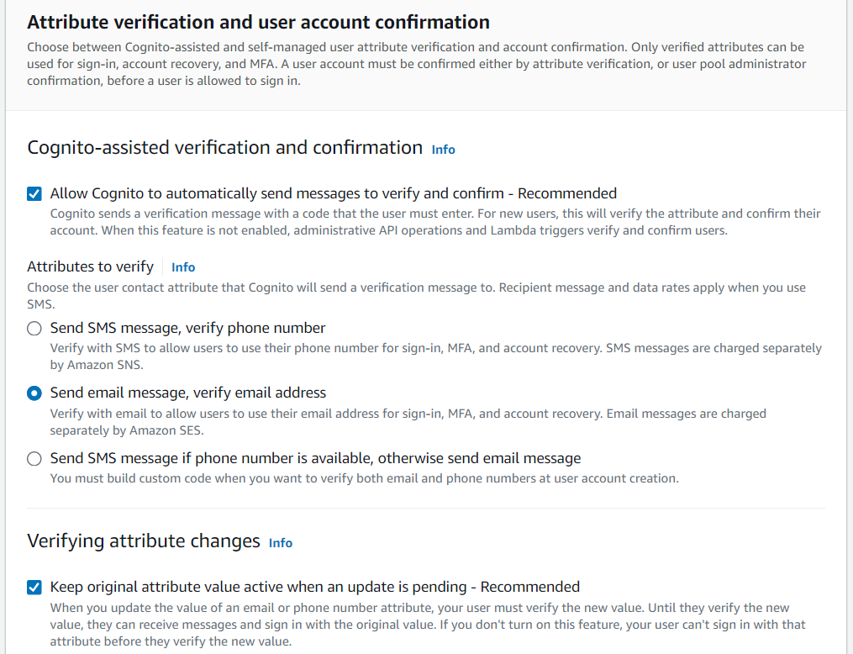](https://camo.githubusercontent.com/5c4fcecc23904cc86b8729c1290abbcd45a4ba2631de724a7f715f97369e13b8/68747470733a2f2f692e696d6775722e636f6d2f4e4465417635312e706e67)

[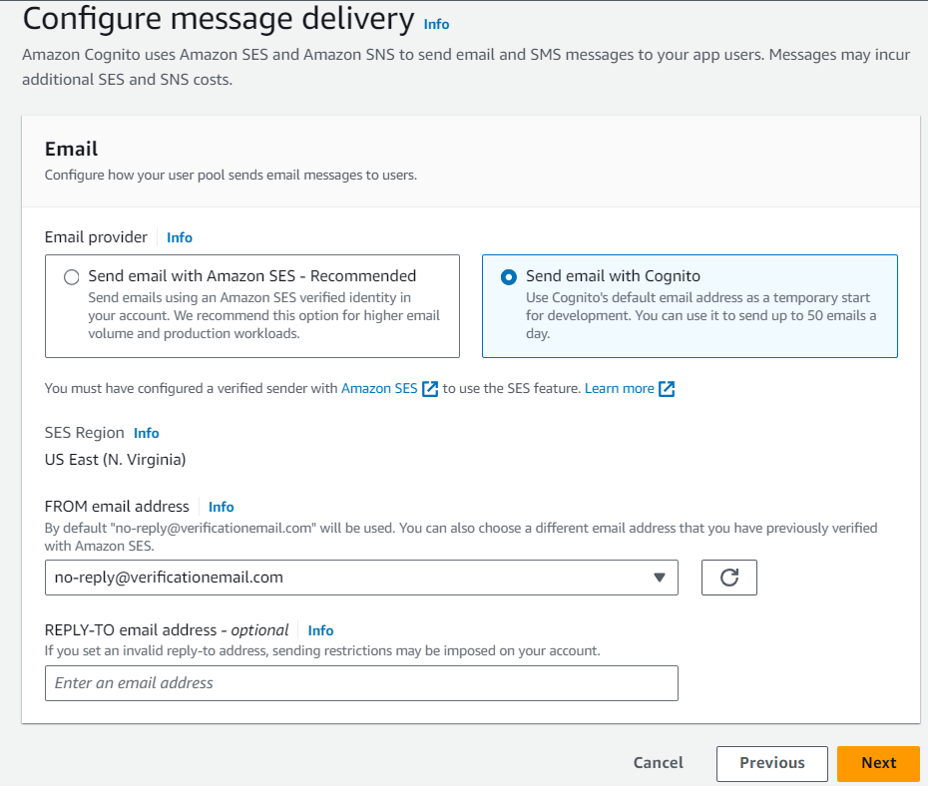](https://camo.githubusercontent.com/7ea4dcad1bdcc118f59b565588ac88336e0464d8cd28ad9deae59063520a4d7e/68747470733a2f2f692e696d6775722e636f6d2f4f7830345242502e706e67)

**User pool name**

[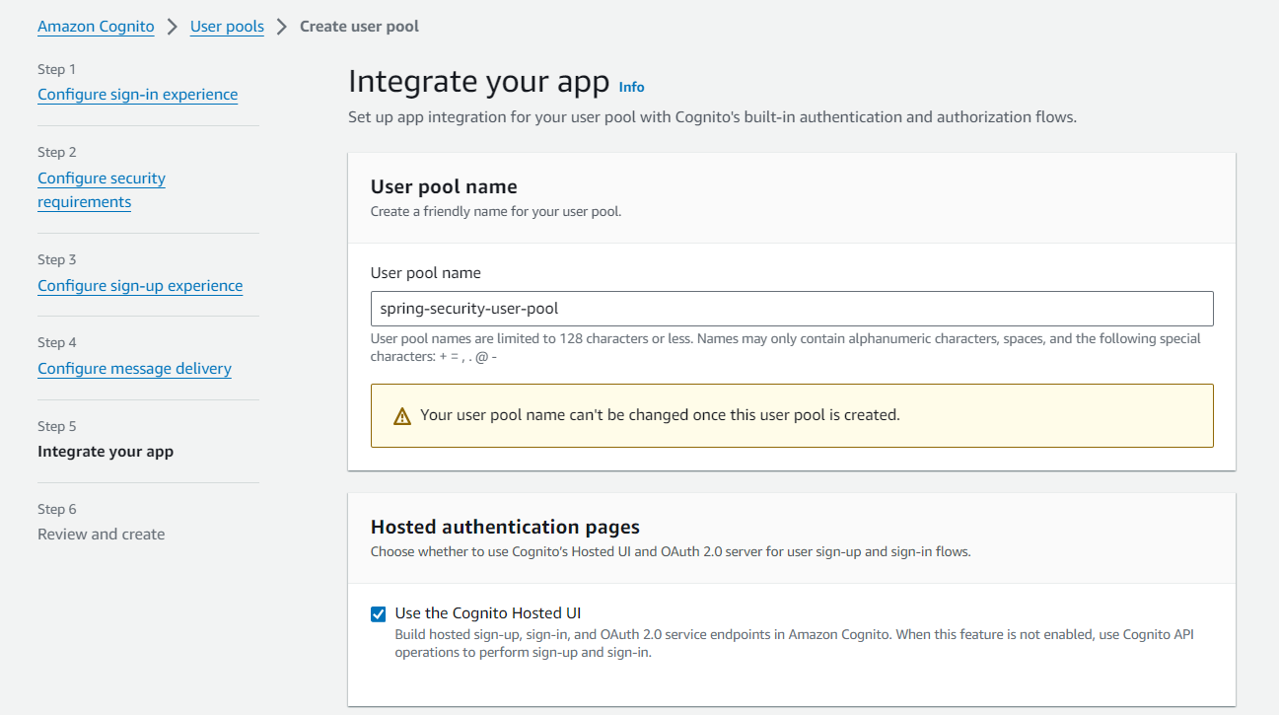](https://camo.githubusercontent.com/b71291dca2bc62fab829a280b1255d7aca811ce0796653b62e69a2955a9dc433/68747470733a2f2f692e696d6775722e636f6d2f776676623268522e706e67)

**Cognito domain prefix**

[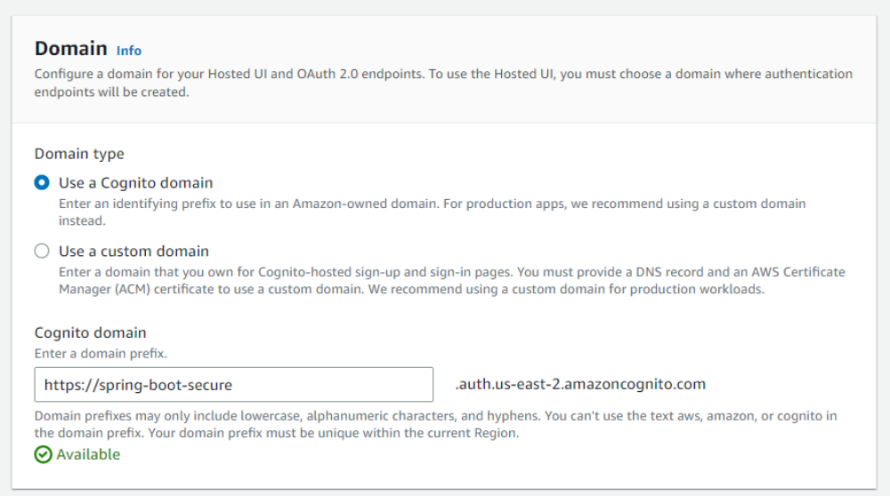](https://camo.githubusercontent.com/b51d58e6814344455788c87a41265358feed7bca3f5c95ac6ab8e5ef7fcff456/68747470733a2f2f692e696d6775722e636f6d2f366f42565754352e706e67)

URL: http://localhost:8080/login/oauth2/code/cognito

[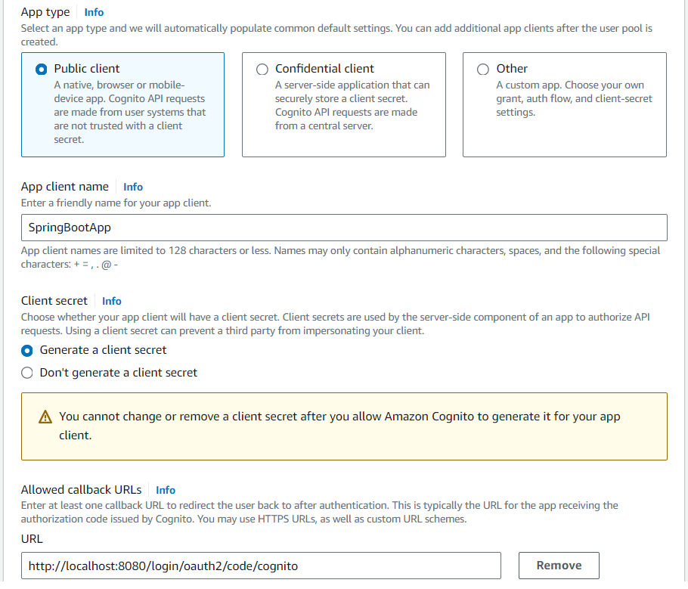](https://camo.githubusercontent.com/1fed572b2a85af87c0f3f0c5eb86c726820a91008c361cf048eb5143a95ca177/68747470733a2f2f692e696d6775722e636f6d2f5550313779345a2e706e67)

[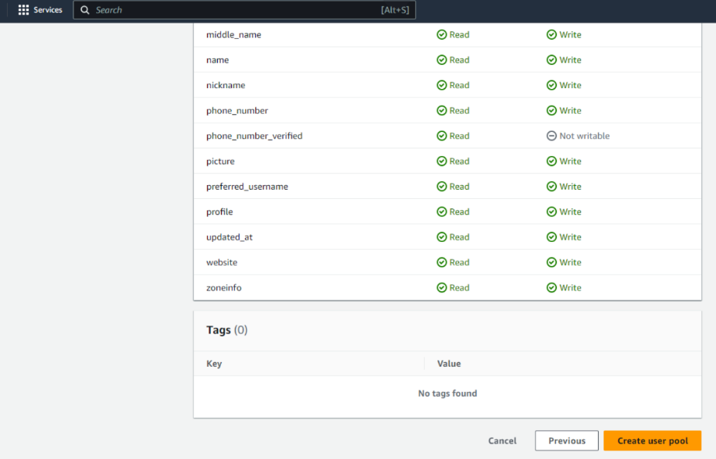](https://camo.githubusercontent.com/ef65821608b3304b82f420f1369971c5601bbdb6dff76d72232831ed35ac3b3e/68747470733a2f2f692e696d6775722e636f6d2f354a4c684275792e706e67)

**Create USER and ADMIN group**

[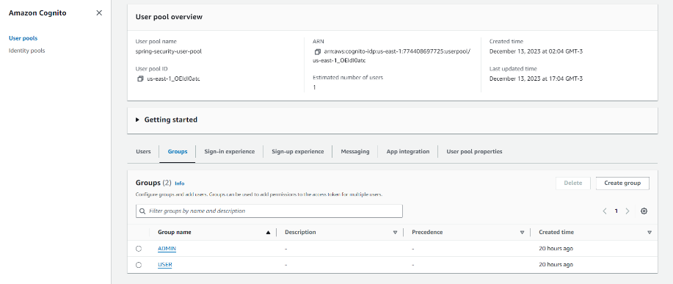](https://camo.githubusercontent.com/6ac288ab7ba86ed1b7d119a1268279a19eed7d0bf25a89113c5caeda8e40a524/68747470733a2f2f692e696d6775722e636f6d2f6d594843354f332e706e67)

**User Pool Test**

Click on **View Hosted UI** button

[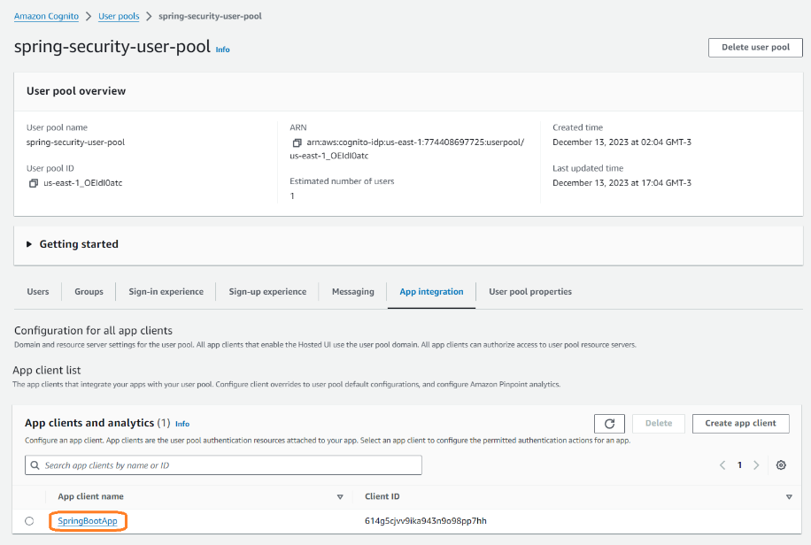](https://camo.githubusercontent.com/f46a882c780582d259a6189bb77a4b7bdbb3ae7c0efe3e50eb41f3e325b555de/68747470733a2f2f692e696d6775722e636f6d2f4b514c646a44622e706e67)

[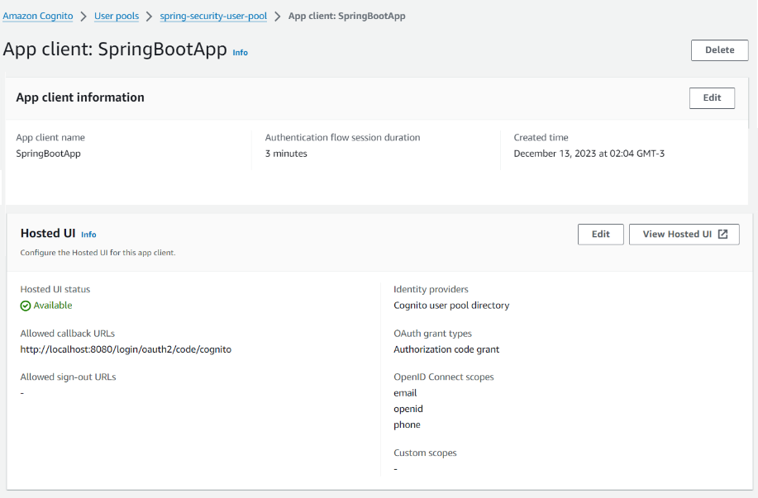](https://camo.githubusercontent.com/e3e172894dd81cea4a2ac3fbeb0496196ee88fe6fc65af2d5b1fe8cd61863d59/68747470733a2f2f692e696d6775722e636f6d2f61326b786d49622e706e67)

[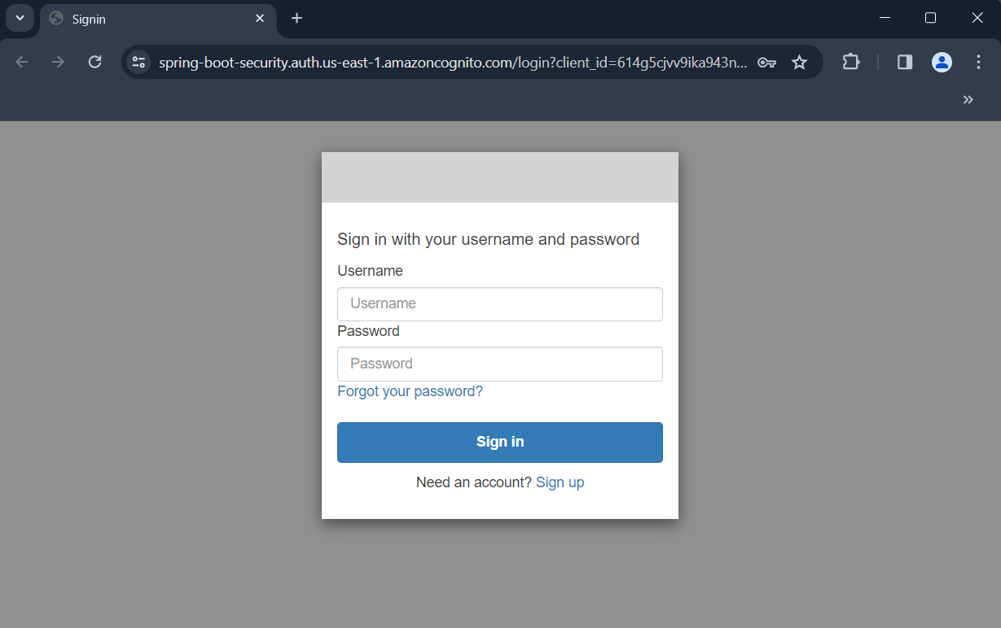](https://camo.githubusercontent.com/f6c67b6d9afcd38b454f12ea4552e09204cbd72fa2402938365ae4ef9e568777/68747470733a2f2f692e696d6775722e636f6d2f65426a62534f502e706e67)

**User sign up**

[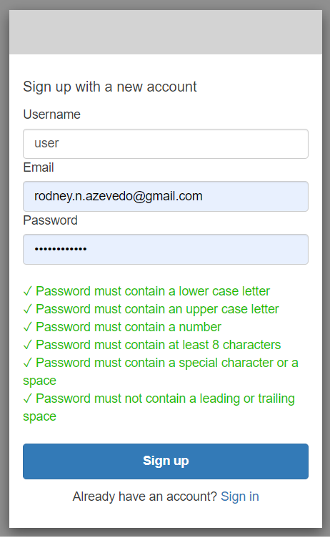](https://camo.githubusercontent.com/fd928b006eaae8662b37ae8da462a3af19192819d95a937305f50059fe4811bf/68747470733a2f2f692e696d6775722e636f6d2f61354e387263392e706e67)

[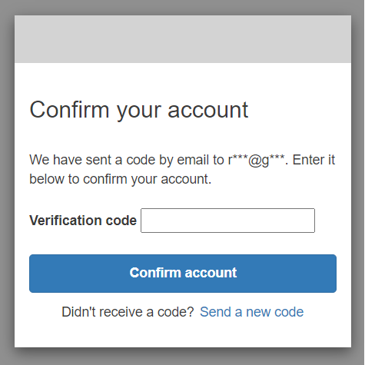](https://camo.githubusercontent.com/e07e1f6dd832eb0e183dfdd4781aff65ab7e91013c368db9739618a4e222de35/68747470733a2f2f692e696d6775722e636f6d2f6f7334563362622e706e67)

[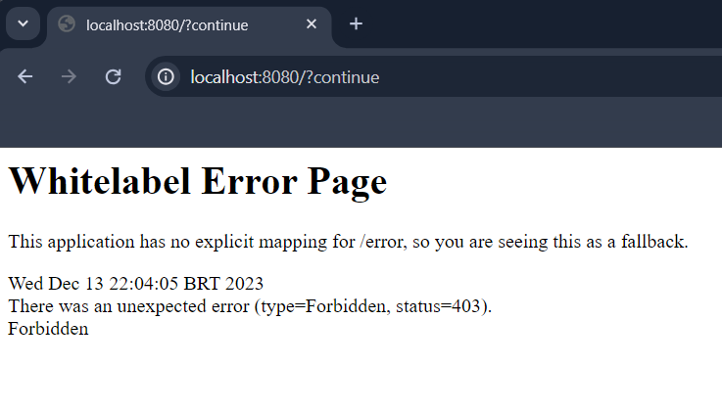](https://camo.githubusercontent.com/043bd4883fb5e624dfb7742bff43ab4d90e10b0ff5a659006e2bd330cbb416c8/68747470733a2f2f692e696d6775722e636f6d2f416d51386d46672e706e67)

**Assign user to a group**

[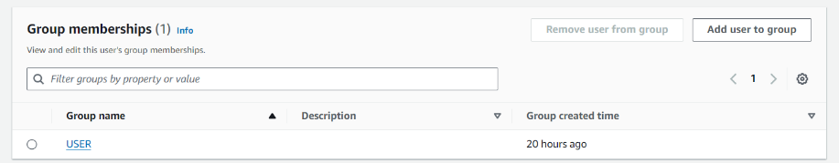](https://camo.githubusercontent.com/ae90d1492139357573d2c237ba8bf7d0f809576b9e4966b69b7b85e531c6c59b/68747470733a2f2f692e696d6775722e636f6d2f586a525a5269422e706e67)

[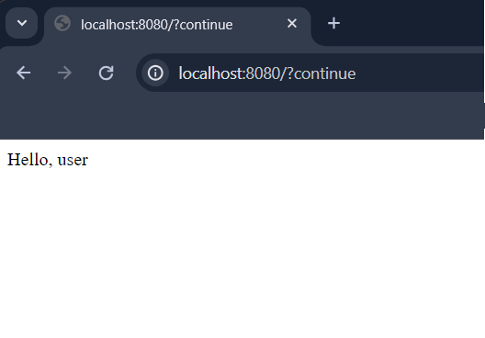](https://camo.githubusercontent.com/6fdaf46a1960f0c15a5abe3c085b50ec8c6ee2acb869d402528cb81684f244f0/68747470733a2f2f692e696d6775722e636f6d2f4a6254467654502e706e67)

*If necessary, clean you web browser cache.*

*P.S.: You can assign the user to a group appropriately using AWS Lambda.*

**Source file / directory structure**

[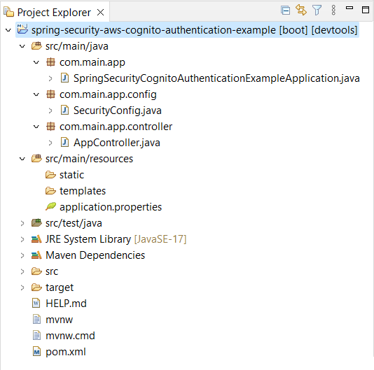](https://camo.githubusercontent.com/506967c057c5fdec46e46464a93a33aa40808e0130511a2e2be3aee48ea8da49/68747470733a2f2f692e696d6775722e636f6d2f495a735978534d2e706e67)