[](https://camo.githubusercontent.com/a3e5598db134838eeb384428095e1deea8e1fe98ff27034d58cdccb9a7bdeaad/68747470733a2f2f692e696d6775722e636f6d2f4c78666b3949452e706e67)

**Description**

Spring Security Embedded LDAP Server Authentcation Example

**Swagger**

Swagger: <http://localhost:8080/swagger>

**Login link (users.ldif)**

<http://localhost:8080/user>

* Username: ben
* Password: benspassword

**Test**

# unit test

$ mvn test -e

**Source file / directory structure**

[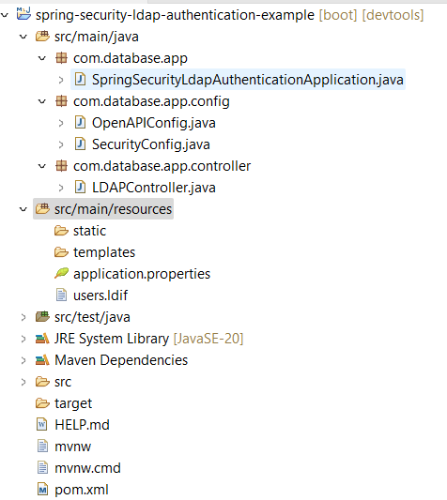](https://camo.githubusercontent.com/43cf8c15eb4a1d23066183fb2220c11139a0b70c52026f6a7da458ca0bb3b3c7/68747470733a2f2f692e696d6775722e636f6d2f576f4b4a5862372e706e67)

**Java Version Troubleshooting (if necessary)**

*Change to the most current version*

[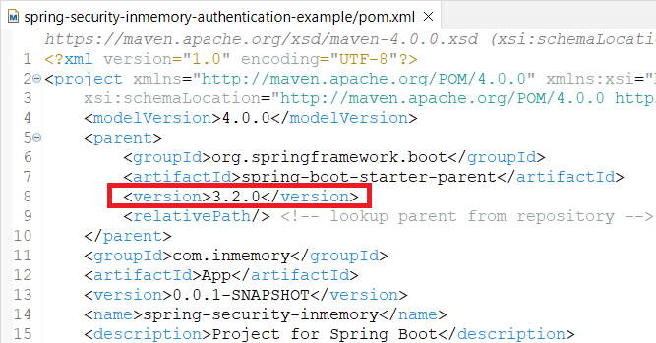](https://camo.githubusercontent.com/e2e82ad5129338c065b7c027150f847f8ae5717b33e516dd031a1477f2b57f74/68747470733a2f2f692e696d6775722e636f6d2f6d7067644461322e706e67)

*Uncheck****Enable project specific settings****option*

[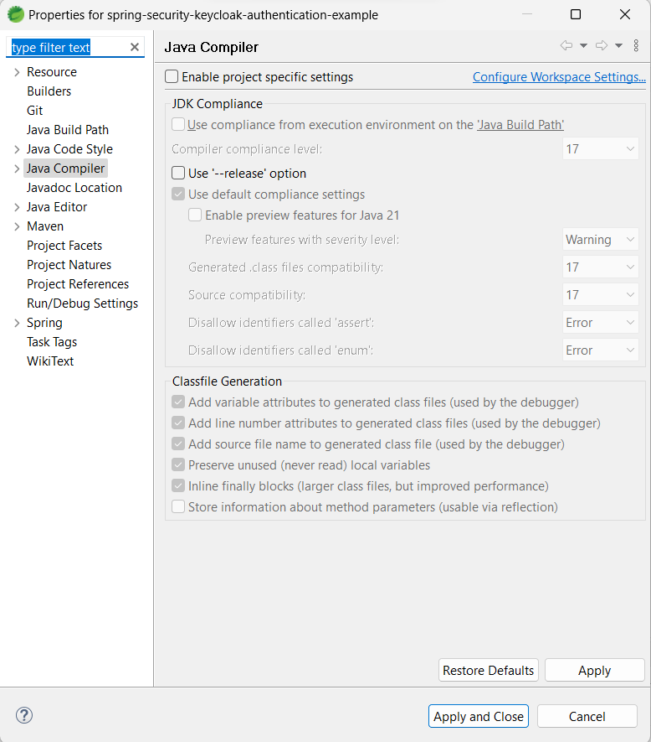](https://camo.githubusercontent.com/635255017474a6952e856d7940e1f76537f53176ec8d461805ec07a2489c278e/68747470733a2f2f692e696d6775722e636f6d2f4d35444155744d2e706e67)