[](https://camo.githubusercontent.com/a3e5598db134838eeb384428095e1deea8e1fe98ff27034d58cdccb9a7bdeaad/68747470733a2f2f692e696d6775722e636f6d2f4c78666b3949452e706e67)

**Description**

Spring Security In-Memory Authentcation Example

**Swagger**

Swagger: <http://localhost:8080/swagger>

**Login links**

<http://localhost:8080/user>

* Username: user
* Password: password

<http://localhost:8080/admin>

* Username: admin
* Password: password

<http://localhost:8080/guru>

* Username: guru
* Password: password

**Test**

# unit test

$ mvn test -e

**Source file / directory structure**

[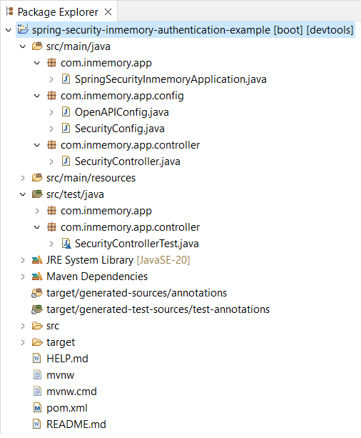](https://camo.githubusercontent.com/cc3094256decf7ce1650f0496ced5d4d87f44dabfa9b89e2d303575b6d47486a/68747470733a2f2f692e696d6775722e636f6d2f44613263764e492e706e67)

**Java Version Troubleshooting (if necessary)**

*Change to the most current version*

[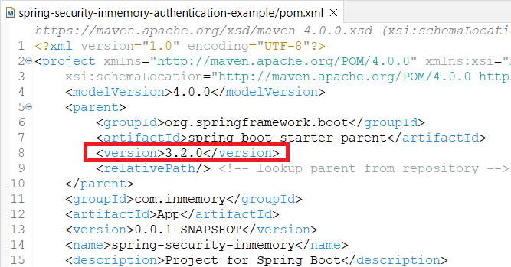](https://camo.githubusercontent.com/e2e82ad5129338c065b7c027150f847f8ae5717b33e516dd031a1477f2b57f74/68747470733a2f2f692e696d6775722e636f6d2f6d7067644461322e706e67)

*Uncheck****Enable project specific settings****option*

[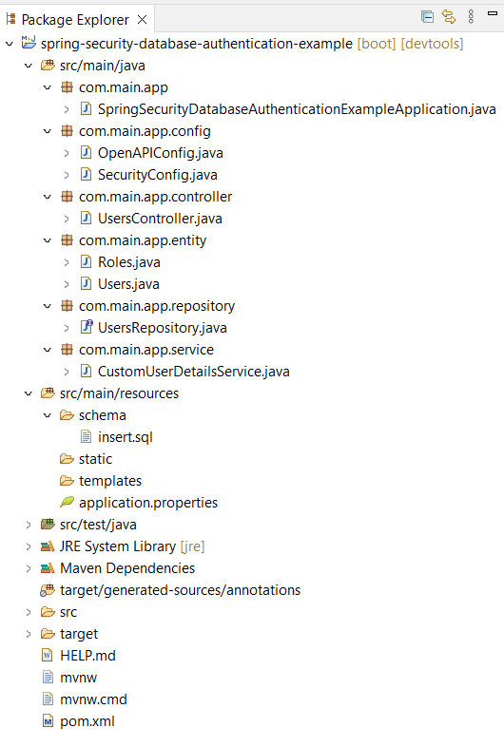](https://camo.githubusercontent.com/576b319b0bd99f1f3a51b76da34dd4b13f3c2e7191353c7c555720e9b4a894a9/68747470733a2f2f692e696d6775722e636f6d2f384657644768322e706e67)